
Module Name: Academic Skills in the Digital Era
Module Code: BMSW4013
Assessment 1: E-Portfolio
Student Name: Elena Alexandra Benghiac
Student Number: 1812479
Lecturer: Ffion Cumberpatch
Deadline: 27.02.2026
AI Acknowledgement
I acknowledge that I have not used any AI tool to support none of the parts of my research.
I confirm that I have not presented any AI-generated text as my own work.

Table of Contents
Component 1 – Development of Academic Skills 4
Component 2 – Application of Academic Skills 8
Component 3 – Academic Poster 14

Component 1 – Development of Academic Skills
Evaluation of Academic Sources Using the CRAAP Test
Source 1: Amhag, L., Hellström, L. and Stigmar, M. (2019) ‘Teacher educators' use of digital tools and needs for digital competence in higher education,’ Journal of Digital Learning in Teacher Education, 35(4), pp. 203-220.
Accessed via - Google Scholar
Authors - Lisbeth Amhag, Lisa Hellström and Martin Stigmar
Date - 2019
Currency - The article is published in 2019 hence it can be considered fairly current.
Relevance - It directly addresses the main topic i.e., the role of digital skills in higher education. However, it specifically focuses on the perspectives of the teachers, their digital competence and the need to be adept in digital tools in a higher education setting.
Authority - All the authors are associated with Malmo University. Higher education and their various forms (e.g., distance education) has been the area of interest of both Amhag (teaches education science) and Stigmar. Hellström focuses on child and adolescent mental health and thus can bring the perspective regarding cognitive impact of digital tools in higher education. So, the authors are adequately qualified to write on this topic.
Accuracy - All the claims made here are supported by evidence. Furthermore, the article is published in JDLTE, which is a peer-reviewed journal.
Purpose - The article essentially intends to inform about the digital tools used by teachers in Sweden. It also explores gaps in their digital competence.
Source 2: Saienko, V., Kurysh, N. and Siliutina, I. (2022) ‘Digital competence of higher education applicants: new opportunities and challenges for future education,’ Futurity education, 2(1), pp. 45-54.
Accessed via - University Library Database
Authors - Volodymyr Saienko, Natalia Kurysh and Iryna Siliutina
Date - 2022
Currency - The article is published in 2022 thus it can be considered fairly current.
Relevance - It directly addresses the topic by highlighting the opportunities and challenges faced by higher education aspirants regarding digital competence.
Authority - The authors are professors or assistant professors in esteemed educational institutions across Poland and Ukraine. Their areas of interest mainly include pedagogical sciences that demonstrate their authority to write in this subject.
Accuracy - The authors use an elaborate reference list, which implies that they have substantiated the claims made with proper evidence. Moreover, the article is published in a peer-reviewed journal titled Futurity Education.
Purpose - The main purpose of the article is to chart the opportunities and challenges of digitally-aided distance learning, which became a norm during the Covid era. It also discusses the importance of digital competence for the higher education system.
Synthesis of Academic Sources
The theme shared by the sources is the development and implications of digital competence in the context of higher education. In other words, the common issue that these articles comment on is digital competence. Both the sources agree that, though digital competence is pivotal to quality education, there exist skill gaps both in higher education applicants/students and teachers (Amhag, Hellström and Stigmar, 2019; Saienko, Kurysh and Siliutina, 2022). However, the article by Amhag, Hellström and Stigmar (2019) focus more on the pedagogical use of digital tools and sees digital competence as a professional development need for teachers whereas Saienko, Kurysh and Siliutina (2022) focus on the higher education aspirants’ readiness to become digitally competent and the systemic challenges they have to encounter. Cumulatively, the sources present a holistic view of digital learning by focusing on both teachers and students. It improves understanding of digital learning essentially by highlighting how, instead of ‘access,’ the relevant authorities must focus on ‘competence’ characterised by pedagogical integration and digital skills of the students.

Key Challenge and Opportunity
One key challenge for students in the digital era, as highlighted by Saienko, Kurysh and Siliutina (2022), is uneven development of digital skills otherwise crucial for developing digital competence. In other words, these scholars highlight how elementary digital literacy is the foundation of using digital tools to serve academic ends.
Nevertheless, the major opportunity that this digital integration into higher education offers is the ability to learn flexibly and in an interactive manner. The article by Amhag, Hellström and Stigmar (2019) highlights how these tools are crucial for delivering educational content in multiple modes while creating opportunities for collaborative learning.
Academic Planning for Component 2
In Component 2, the task of identifying opportunities and challenges faced by students in the digital era must be prioritised, followed by the adaptation strategies. The lecture content on ‘Digital Literacy’ needs to be developed further, along with critical evaluation and analytical skills. The Component 2 will begin with an Introduction, followed by identification of key challenges and opportunities. Before concluding, three adaptation strategies will be highlighted.
Timeline
Task | Date/Deadline
Finish research | 27.02.26
Draft first section | 06.03.26
Complete first draft | 15.03.26
Final editing | 25.03.26

Reference List - Component 1
Amhag, L., Hellström, L. and Stigmar, M. (2019) ‘Teacher educators' use of digital tools and needs for digital competence in higher education,’ Journal of Digital Learning in Teacher Education, 35(4), pp. 203-220.
Saienko, V., Kurysh, N. and Siliutina, I. (2022) ‘Digital competence of higher education applicants: new opportunities and challenges for future education,’ Futurity education, 2(1), pp. 45-54.

Component 2 – Application of Academic Skills
Introduction
Digital learning in higher education roughly refers to the delivery of education or learning experience of any kind using digital technologies that, in effect, supports or enhances it. In other words, digital learning in higher education is essentially about transforming traditional classrooms into interactive and flexible learning environments (Suri and Sharma, 2025). It is important to understand the opportunities and challenges related to digital learning in higher education to accomplish desired student engagement while addressing major problems like digital divide and pedagogical integration of digital tools. In this regard, this report highlights challenges and opportunities students face in the digital era after this Introduction segment, which will be followed by discussion on strategies to adapt and succeed. This report ends with a brief Conclusion segment.
Challenges for Students in the Digital Era
One major challenge that students face in the digital era is information overload. Though the availability of information in abundance has expanded knowledge, it has also made critically evaluating and synthesising information difficult. It is directly related to academic success since, as shown by Melisa et al., (2025), critical evaluation of sources or analysing them are crucial skills that aspirants of higher education must have. Due to this abundance, students now struggle to differentiate between rich, scholarly sources and information from unreliable sources, which leads to risks like poor argumentation and propagating biased information. This challenge is thus integral to multiple academic skills including critical analysis and research skills.
The digital era is often studied as a threat to deep engagement with learning by referring essentially to the possibilities of distraction (Wang, 2022). Though this can be linked to the normalisation of multitasking culture as well, distractions like social media notifications often come in the way of learning. Unsurprisingly, it affects academic performance adversely since it depends largely on concentration, setting goals and time management. It has been discovered that yielding to these distractions led to fragmented learning and diminishing knowledge retention capacity. This is directly related to critical digital literacy that must teach aspirants self-regulation.
Opportunities for Students in the Digital Era
One of the biggest opportunities that these digital tools offer is personalised learning thanks to different learning management systems and platforms powered by artificial intelligence (AI). These tools carve out tailored learning pathways essentially by allowing content adjustment, providing prompt feedback and monitoring personal progress. In simple words, here instructions are adapted to the student's knowledge, speed of learning and potential to perform. Critically speaking, this adaptation makes learning environments more inclusive, as these tools can serve diverse learning needs (Baysan and Naeem, 2023). Nevertheless, the threat of replacing human interaction is a risk that looms large. In any case, given the ability to adapt, these tools are suitable for what Acosta-Gonzaga and Ramirez-Arellano (2022) called ‘scaffolding’ i.e., offering elementary support to develop competence.
Another major opportunity that these digital tools offer is interactive learning. For example, by means of these tools, educators now can share documents, whiteboards or discussion boards, which essentially makes learning interactive and collaborative. This aspect of interactivity offered by these digital tools is praised by scholars like Derakhshandeh and Esmaeili (2020) for promoting active learning (i.e., they enable learners to actively participate rather than resorting to listening passively). These tools, furthermore, makes real-time collaboration with peers possible. Nevertheless, the chances of cognitive overload cannot be ruled out, as exposure to multiple channels at a time can translate to superficial engagement (Costley, 2020). Clearly, this discussion relates to the classroom learning concept of active learning, which is said to promote organic engagement with learning materials.
How Students Can Adapt to Succeed
Three strategies for students to adapt to digital learning are as follows:
Digital Research Training - Students should be engaged in guided training of digital research where they are likely to learn: a) navigating digital databases effectively, b) assessing trustworthiness of digital resources and c) synthesising findings from multiple resources to form coherent arguments. According to Leshchenko et al. (2021), training in digital research will enable students to filter out unreliable or biased information while circumventing possibilities of information overload effectively. In this sense, this strategy addresses the challenge regarding information overload. This is, furthermore, related to academic skills like research skills and critical thinking.
Self-regulated learning routines development - In this strategy, students are asked to structure their study sessions by setting goals. Since digital distraction is a reality, students can also consider installing tools like application blockers to manage it. Scholars like Yeoh (2017) recommended reflective logging to keep track of progress of catching up with the set schedule. It is evident that these self-regulated study schedules address the challenge of digital learning while enabling students to capitalise on the opportunity of personalised learning that these tools offer. This strategy does so mainly through allowing students to participate in digital learning environments in a disciplined fashion. It is, moreover, related to academic skills like independent learning and, most importantly, time management.
Active participation in digitally-enabled peer collaboration - This strategy prompts students to organise online discussion forums and set collaborative tasks or activities that are dependent on peer feedback to facilitate active participation in learning and collaboration with peers. Existing studies have shown how study groups - both virtual and blended - can facilitate active participation in studies through participation in activities that collectively generate knowledge (Gorgônio et al., 2017). This strategy mainly leverages the opportunity of interactive learning that these digital tools provide to transform these online platforms into places of social learning. In any case, this strategy is related to academic skills like communication, coherent argumentation and collaborative learning.
Conclusion
This report primarily aimed to identify the opportunities and challenges related to digital learning and offer strategies to adapt to them and ensure academic success. Challenges like information overload and digital distraction are highlighted here that, inter alia, prevents sustained attention and deeper understanding of learning materials. Opportunities highlighted here include personalised learning pathways supported by digital tools and scope for interactive learning. Strategies offered here like digital research training or self-regulated study schedules addresses challenges like information overload and digital distraction while contributing to academic skills like research skills or time management. The students are also prompted here to leverage the opportunity of active learning to engage more with peers to co-construct knowledge actively.

Reference List - Component 2
Acosta-Gonzaga, E. and Ramirez-Arellano, A. (2022) ‘Scaffolding matters? Investigating its role in motivation, engagement and learning achievements in higher education,’ Sustainability, 14(20).
Baysan, A. and Naeem, U. (2023, September) ‘Inclusive education: pedagogical approach to online versus face-to-face teaching,’ in Frontiers in Education (Vol. 8, p. 1148344). Frontiers Media SA.
Costley, J. (2020) ‘Using cognitive strategies overcomes cognitive load in online learning environments,’ Interactive Technology and Smart Education, 17(2), pp. 215-228.
Derakhshandeh, Z. and Esmaeili, B. (2020) ‘Active-learning in the online environment,’ Journal of Educational Multimedia and Hypermedia, 29(4), pp. 299-311.
Gorgônio, F.L., Vale, K.M., Silva, Y.K.N. and Silva, H.M. (2017, March) ‘Grouping students for cooperative and collaborative learning: Challenges and trends in virtual learning environments,’ in Proceedings of the IEEE World Engineering Education Conference, Santos, Brazil (pp. 19-22).
Leshchenko, M.P., Kolomiiets, A.M., Iatsyshyn, A.V., Kovalenko, V.V., Dakal, A.V. and Radchenko, O.O. (2021, March) ‘Development of informational and research competence of postgraduate and doctoral students in conditions of digital transformation of science and education,’ in Journal of physics: Conference series (Vol. 1840, No. 1, p. 012057). IOP Publishing.
Melisa, R., Ashadi, A., Triastuti, A., Hidayati, S., Salido, A., Ero, P.E.L., Marlini, C., Zefrin, Z. and Al Fuad, Z. (2025) ‘Critical Thinking in the Age of AI: A Systematic Review of AI's Effects on Higher Education,’ Educational Process: International Journal, 14.
Suri, K. and Sharma, A. (2025) ‘Digital Learning in Higher Education in India: An Exploration of Government Initiatives at the University of Jammu,’ International Journal of Scientific Research and Technology.
Wang, C. (2022) Comprehensively summarizing what distracts students from online learning: A literature review. Human Behavior and Emerging Technologies, 2022(1).
Yeoh, K.K. (2017) ‘Entrepreneurship students distilled their learning experience through reflective learning log,’ Journal of Research in Innovative Teaching & Learning, 10(2), pp. 126-142.

Component 3 – Academic Poster
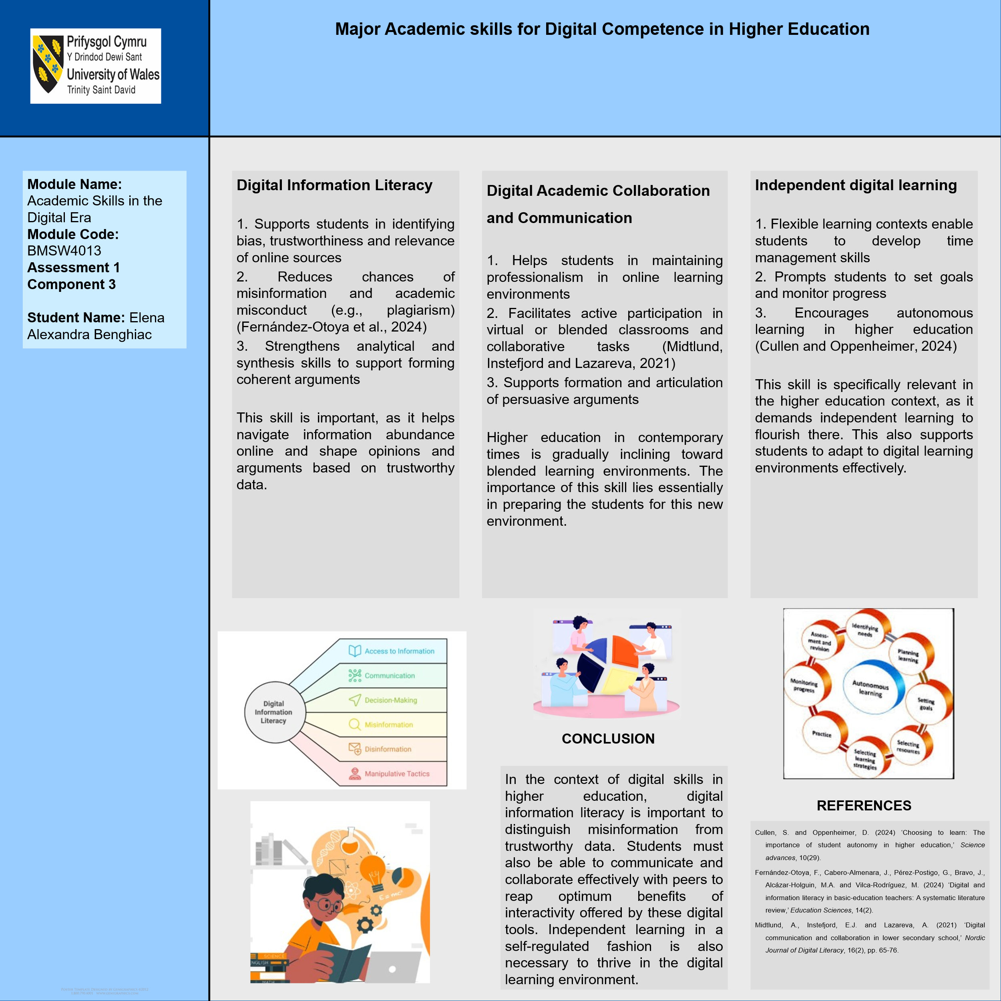
Reference List - Component 3
Cullen, S. and Oppenheimer, D. (2024) ‘Choosing to learn: The importance of student autonomy in higher education,’ Science advances, 10(29).
Fernández-Otoya, F., Cabero-Almenara, J., Pérez-Postigo, G., Bravo, J., Alcázar-Holguin, M.A. and Vilca-Rodríguez, M. (2024) ‘Digital and information literacy in basic-education teachers: A systematic literature review,’ Education Sciences, 14(2).
Midtlund, A., Instefjord, E.J. and Lazareva, A. (2021) ‘Digital communication and collaboration in lower secondary school,’ Nordic Journal of Digital Literacy, 16(2), pp. 65-76.

