

Student Learning Log

Module: Level 6 Placement – Managing Guest Services Operations
Module code: BMIH6003
Lecturer Name: Jessica Newport
Student name: Elena Stenic
Student ID: 2246472
Word count: 1245

I acknowledge the use of Grammarly (https://www.grammarly.com/) on 10 November 2025 to check my work using the prompt(s):
- Please check the following text for readability, grammar and syntax.
I confirm that I have not presented any AI generated text as my own work. I confirm I have copies of my drafts, notes, and other resources I used before, and after the use of AI tools which I may be asked to provide in evidence.

Introduction
Maintenance management has been defined as distinct managerial activities determining objectives, priorities and strategies concerning the maintenance function, with subsequent responsibilities (Longart, 2020). Such responsibilities include maintenance planning, control and supervision, which will be highlighted in the learning log, considering cultural and teamwork issues. I have been placed at Leonardo Hotel East Midlands Airport for around 10 weeks. Leonardo Hotels is headquartered in the United Kingdom and was established in 1986, with currently 164 elegantly designed rooms and a wide range of facilities (Leonardo Hotels, 2025a; Travel Weekly, 2025). The maintenance department of Leonardo Hotels has been equipped with effective components that can serve as great experiences for guests, making sure that such facilities are maintained. For instance, free Wi-Fi, bar, restaurant, spa, swimming pool, gym, conference halls, events and a 24-hour front desk are the amenities served by the hotel (Leonardo Hotels, 2025b).

Department Reflection
Culture and Teamwork in the Maintenance Department
Culture & teamwork
The Gibbs Reflective Cycle reflects on the experiences of individuals depending upon description, feelings, evaluation, analysis, conclusion and action plan (Adeani, Febriani and Syafryadin, 2020). With the help of this model, I have recognised that my experience across Leonardo Hotels outlines that teamwork and culture have been adversely influenced across the organisation, and this requires immediate attention from organisational managers. This relates to my personal development and resourcing, taking into account the issue that I have experienced across the maintenance department of Leonardo Hotels. In description, I have been engaged in conflicts in the team as a result of a high-pressure environment, mostly the culture being individualistic in the UK. I have witnessed disrupted guest and staff experiences too, which were subject to this cultural and teamwork issue, relating to conflict.
Concerning my feelings, the staff members, including my team members, have been impacted by communication silos between departments, a lack of inter-departmental synergy and stress levels. It increased my work pressure, and I missed out on guest requirements or demands, which, in turn, led to guest dissatisfaction. In terms of evaluating the situation, across the maintenance department of Leonard Hotels, I have come across a communication breakdown which resulted in a conflict between my team manager and me. However, I have also been able to build a healthier emotional quotient after the conflict. Herein, concerning analysis, my team manager asked me to look at the Wi-Fi since lots of complaints had been registered by guests regarding the device not working. However, when I informed my manager that the Wi-Fi was switched off and that there may have been a mistake by this department, he refused to believe me and framed it on me, denying responsibility and accountability.
Significance of the Issue
In conclusion, my manager had simply refrained from taking responsibility or accountability, which, I believe, needs to be the first and foremost quality in a leader. Guests being dissatisfied with a hotel is one of the most negative outcomes, and it lies at the core of productivity. Prior to carrying out the action plan, the significance of this issue will be evaluated. Organisational culture has been interpreted as a set of assumptions and values inherent in the behaviours of organisational members, ensuring the collaboration of common characteristics in terms of achieving collective goals (Oh and Han, 2020). Culture has evolved to be imperative since power relations across an organisation are capable of shaping not only beliefs and values, but also play a pivotal role in strategic success (Oriade et al., 2021). It is a significant medium to shape action and communication necessary to achieve sustainable development in social, ecological and economic fields.
Culture has often been associated with the total of all the taken-for-granted and shared assumptions that a group has learned throughout its history. This has led to a lack of empathy across the maintenance department of Leonard Hotels, focusing on their inability to deliver guest satisfaction. In the context of the hospitality sector, the development of organisational culture has evolved to be of significance, resulting from the intangible nature of all operations carried out. The competitive nature of the hospitality sector, along with its expanding importance to the national and local economies, has ensured that organisational culture has been deemed a common agenda. This has been helping organisational managers strive towards the establishment of a competitive edge (Oriade et al., 2021). Wallach’s Framework highlights innovative, bureaucratic and supportive cultures to be prevalent, with the supportive culture showcasing a teamwork environment (Sarhana et al., 2020).
Three-Step Improvement Plan
Specific Operational Change
The specific organisational change that Leonard Hotels can implement considers the improvement of the quality of its Wi-Fi offered, which is the responsibility of the maintenance department. This is also reliant on the subjective perception of the quality of products and services offered. Amenities need to be in efficient condition and running smoothly across the hotel, which can deliver effective guest satisfaction. For instance, Wi-Fi accounts for 84% of the primary technologies impacting the decisions of guests to book a hotel or not (Escandell, 2025).
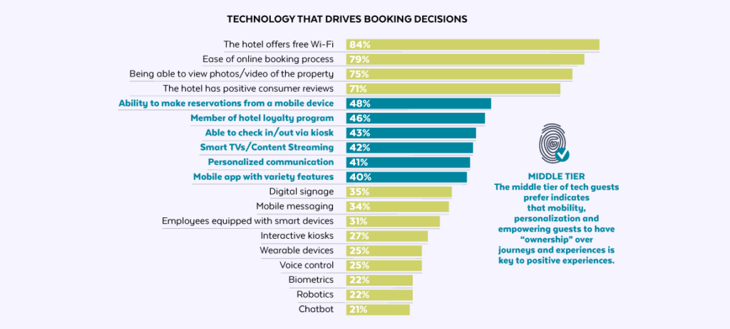
Figure 1: Technology Driving Booking Decisions
(Source: Escandell, 2025)
Alignment with Industry Practices
Wi-Fi across the hotel industry has been deemed one of the most highly valued services, and is the core expectation when it comes to guest satisfaction (Escandell, 2025). Herein, the major change to improve the quality of Wi-Fi can make the stay of guests across Leonard Hotels enjoyable and content. Correctly functioning hotel Wi-Fi holds an immense amount of significance. Guests often view Wi-Fi as a primordial necessity when on holiday, and if it fails to work properly, the hotel can receive a wide range of complaints and may even lose brand perception quality (Escandell, 2025).
Impact on Business Performance and Guest Satisfaction
Experiences that are offered not only across the hotel but also those connected to the brand in its entirety also need to be taken care of as much as possible, since they are likely to influence the opinions of guests (Escandell, 2025). Such opinions also influence customer loyalty and the ability of hotels to attract new guests. In consequence, this may adversely impact the income generated by Leonard Hotels. Testimonials from hotel guests have emerged as a crucial factor in the field of decision-making, much more than the incentives that loyalty programmes offer.
Conclusion
In conclusion, unsought workplace conflicts between the team members and managers of the maintenance department of Leonard Hotels have been prevalent and require common ground from both entities. This has resulted in poor communication, low morale and inefficiencies across the maintenance department of Leonard Hotels, indicating cultural flaws and a lack of bonding between team members and their managers. It even caused burnout and stress, creating an adverse workplace environment in which workers are likely to sense a lack of value. However, with understanding and empathy, one can build healthier bonding among team members, especially in the hospitality sector.
Recommendations
- Simple improvements by the maintenance department, such as UV reflective films across windows, air conditioning, mechanical ventilation systems, and blinds, can help significantly improve room temperatures (Ratcliffe, 2023).
- Leonard Hotels can train the staff members of the maintenance department and offer them equal opportunities in terms of reducing conflicts.
- Hotels can also engage in optimising the thermal efficiency of the building by identifying fields of significant water ingress or heat escape (Ratcliffe, 2023).
- It is important for Leonard Hotels not to overlook the concerns, feedback and reviews against the hotel by hoteliers since these can help recognise required changes.

Reference List
Escandell, M. (2025) How does WiFi quality affect a hotel’s online reputation? Available at: https://www.hotelinking.com/en/online-reputation/how-does-wifi-affect-hotels-online-reputation/ (Accessed: 17 October 2025).
Leonardo Hotels (2025a) Leonardo Hotel East Midlands Airport. Available at: https://www.leonardo-hotels.com/east-midlands/leonardo-hotel-east-midlands-airport (Accessed: 17 October 2025).
Leonardo Hotels (2025b) Leonardo Royal Hotel London City. Available at: https://www.leonardo-hotels.com/london/leonardo-royal-hotel-london-city (Accessed: 17 October 2025).
Longart, P. (2020) ‘Understanding hotel maintenance management’, Journal of Quality Assurance in Hospitality & Tourism, 21(3), pp. 267-296. Available at: https://doi.org/10.1080/1528008X.2019.1658148
Oh, S.Y. and Han, H.S. (2020) ‘Facilitating organisational learning activities: Types of organisational culture and their influence on organisational learning and performance’, Knowledge Management Research & Practice, 18(1), pp. 1-15. Available at: https://doi.org/10.1080/14778238.2018.1538668
Oriade, A., Osinaike, A., Aduhene, K. and Wang, Y. (2021) ‘Sustainability awareness, management practices and organisational culture in hotels: Evidence from developing countries’, International Journal of Hospitality Management, 92, p. 102699. Available at: http://dx.doi.org/10.1016/j.ijhm.2020.102699
Ratcliffe, J. (2023) Trouble In Paradise: How Hotels And Guest Houses Can Improve Their Facilities. Available at: https://www.forbes.com/councils/forbesbusinesscouncil/2023/08/16/trouble-in-paradise-how-hotels-and-guest-houses-can-improve-their-facilities/ (Accessed: 17 October 2025).
Sarhana, N., Harbb, A., Shrafata, F. and Alhusbana, M. (2020) ‘The effect of organizational culture on the organizational commitment: Evidence from hotel industry’, Management Science Letters, 10, pp. 183-196.
Travel Weekly (2025) Leonardo Hotel East Midlands Airport. Available at: https://www.travelweekly.com/Hotels/Castle-Donington-England/Leonardo-Hotel-East-Midland-Airport-p58341747 (Accessed: 17 October 2025).

