WALT DISNEY SFF CASE STUDY

Lu Hengrun (1704344)
Contemporary Themes in e-Business
SBUS6104
Executive Summary
This report will use Strategy Formulation Framework (SFF) to analyze Walt Disney in the past ten years, and evaluate its strengths and weakness. At the end of the report, the author will give her own recommendation and evaluation.
Background Information
Disney founded by Walt Disney and his brother Roy Disney in the United States in 1923, California Burbank, was called the Disney Brothers Studio, in February 6th, 1986, officially changed its name to The Walt Disney Company (Disney, 2018). Now Disney has become the second largest multinational entertainment media company in the world. There are five major business segments: Disney's Studio Entertainment, Media network, Disney interactive, Disney consumer products and Disneyland (Disney, 2018).
Walt Disney Resort includes five already opened theme park: California Disneyland (1939), Tokyo Disneyland (1983), Paris Disneyland (1992), Hong Kong Disneyland (2005) and Shanghai Disneyland (2016).
Strategy Formulation Framework
Strategies can be identified, evaluated and selected by this framework that includes three stages: (1) input stage, (2) matching stage, and (3) decision stage (Fred D. David, 1995).
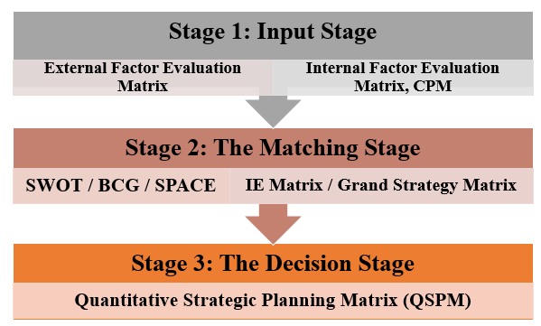
Stage 1: Input Stage
External Factor Evaluation (EFE) Matrix
Table 1: (2008)
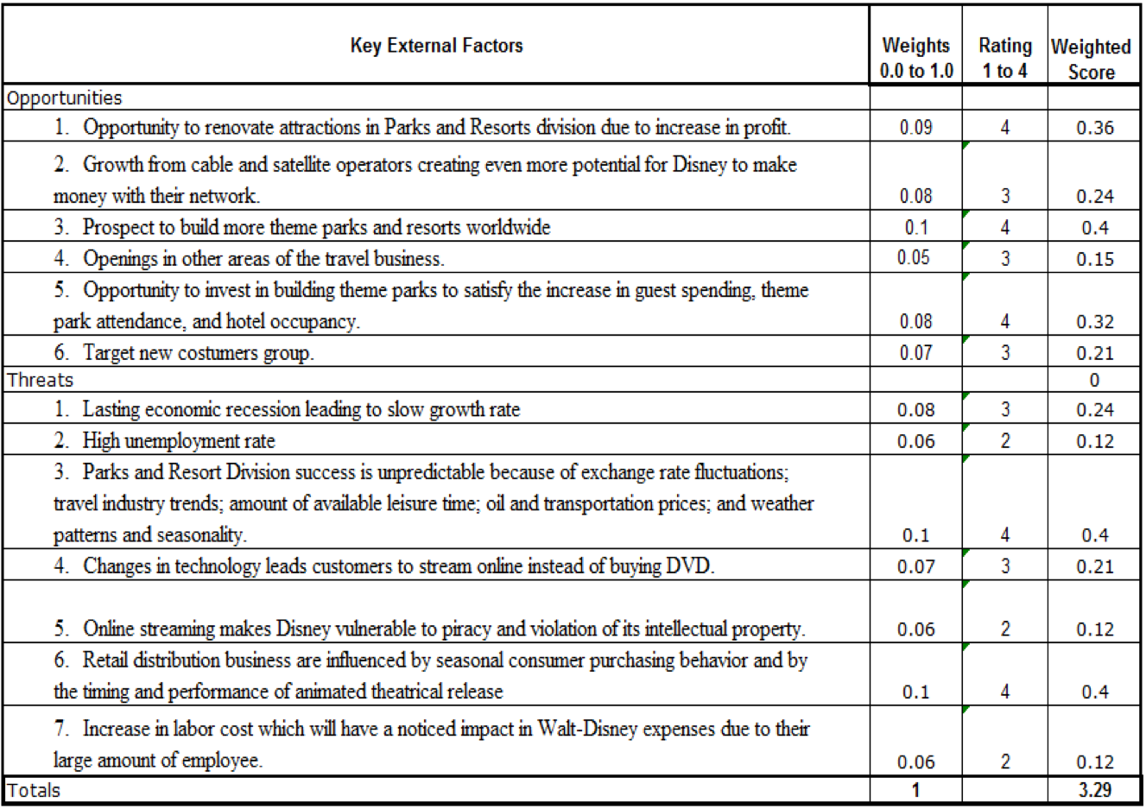
Table 2: (2018)
Key External Factors | Weights  0.0 to 1.0 | Rating  1 to 4 | Weight  Score
Opportunities
- Opportunity to renovate attractions in Parks and Resorts division due to increase in profit. | 0.09 | 4 | 0.36
- Growth from cable and satellite operators creating even more potential for Disney to make  money with their network. | 0.08 | 3 | 0.24
- Prospect to build more theme parks and resorts worldwide. | 0.10 | 4 | 0.40
- Openings in other areas of the travel business. | 0.05 | 4 | 0.20
- Opportunity to invest in building theme parks to satisfy the increase in guest spending, theme. | 0.08 | 4 | 0.32
- Target new costumers group. | 0.07 | 3 | 0.21
Threats
- Lasting economic recession leading to slow growth rate. | 0.08 | 3 | 0.24
- High unemployment rate | 0.06 | 3 | 0.18
- Parks and Resort Division success is unpredictable because of exchange rate fluctuations;  travel industry trends; amount of available leisure time; oil and transportation prices; and weather patterns and seasonality. | 0.10 | 4 | 0.40
- Changes in technology leads customers to stream online instead of buying DVD. | 0.07 | 4 | 0.28
- Online streaming makes Disney vulnerable to piracy and violation of its intellectual property. | 0.06 | 4 | 0.24
6.Retail distribution business are influenced by seasonal consumer purchasing behavior and by  the timing and performance of animated theatrical release. | 0.10 | 4 | 0.40
7.Increase in labor cost which will have a noticed impact in Walt-Disney expenses due to their  large amount of employee. | 0.06 | 4 | 0.24
Total: | 1 |  | 3.71

Through EFE Matrix, this report analyzes the main changes in the past ten years are: 1. Openings in other areas of the travel business 2. Disney’s extended communications and business network.

- In addition to Disneyland Disney films, Disney games etc., Disney also extends the voyage of the sea to provide a sea holiday experience. There are four large ships in total: Disney Dream, Disney Magic, Disney Wonder and Disney Fantasy （Cruise Trip, 2018）.
- Disney media network has four main directions: Cable TV network, radio and television network, publishing and Internet. Cable networks mainly includes the world's largest sports media ESPN, ABC Family and Disney Channel obtained through the acquisition of Fawkes's global home entertainment channel. Radio and television network mainly includes ABC domestic TV, ESPN, Disney radio etc. Among them, ABC has 225 affiliated TV stations, 8 domestic TV stations and 21 wireless TV stations. They were bought by Disney for 18 billion 900 million dollars in 1996 (China Daily, 2016). Disney published by Hyperion publishing, mainly publishes books and audio-visual products. The Internet is made up of ABC, Hulu etc. The mass media network has made a great contribution to the spread of Disney. Through the dissemination of books, TV, radio and the Internet, Disney has been closer to the masses, creating a good opportunity for Disney's future development.

Internal Factor Evaluation (IFE) Matrix
Table 3: (2008)
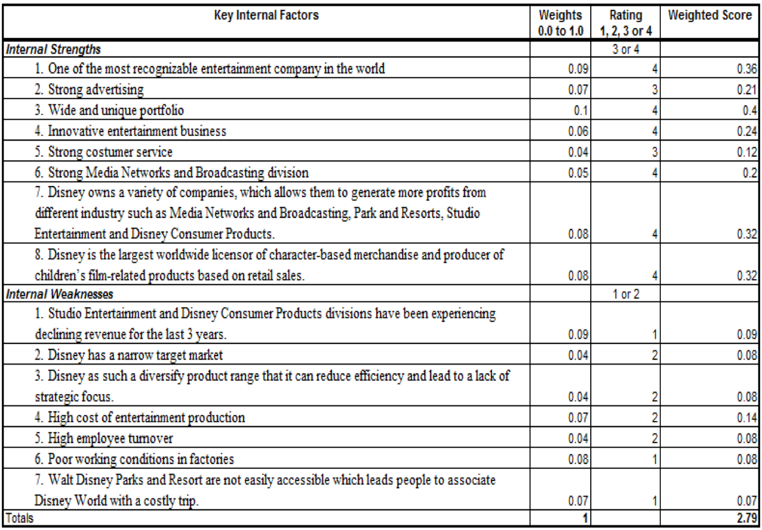
Table 4: (2018)
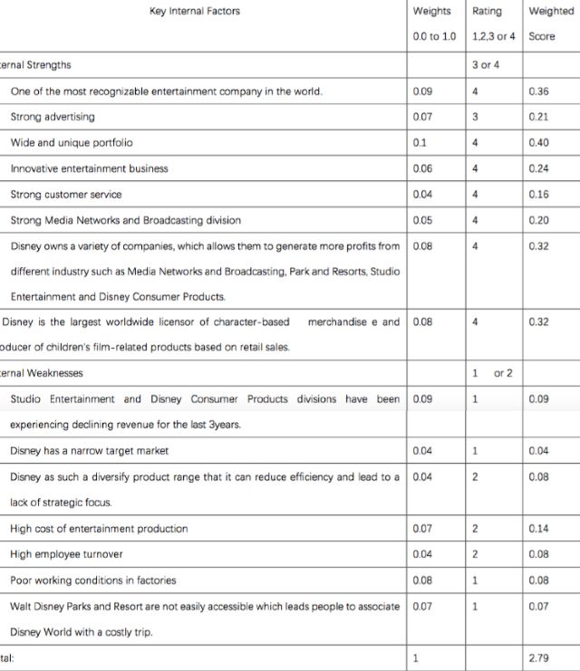
Through IFE Matrix, this report analyzes the main changes in the past ten years are: 1. Strong customer service 2. Narrow target market

1. The first Disney store opened in California (Disney, 2018). Today, the offline entity stores are all over the world, and DisneyStore.com, MarvelStore.com, and Taobao flagship stores in China are also launched. The opening of the Internet store makes Disney fans do not have to spend time to buy products in the store. And the Disney products purchased online can be refunded for 30 days, which greatly improves customer satisfaction (China Daily, 2016).

2. Disney’s film and television entertainment is the foundation of Disney's huge commercial empire. It is also the initial business at the beginning of the company's creation, including the production of movies, music and stage plays, of which the core business is the world-famous animated feature film and live movie business. The first long animation "Snow White and the Seven Dwarfs" won the Oscar special achievement award (Academic Awards, 1939). At the same time, the characters of these animations are integrated into Disney's consumer goods, which provides sufficient impetus for the expansion of Disney's production. In order to expand the layout of the movie business, Disney bought Pixar studios in 2006, bought M & E studio in 2009, bought Lucas studios in 2012, and bought 20th Century Fox in 2017 (Disney, 2017). These four mergers and acquisitions have enabled Disney to gain rich image assets and cover more users of different ages, sexes and preferences. These three studios, coupled with Disney's own animation studio, have created a large number of high-quality films for Disney. Not only animated films, but real-life movies, Disney has done extremely well (China Daily, 2017).
Competitive Profile Matrix (CPM)
Table 5: (2008)
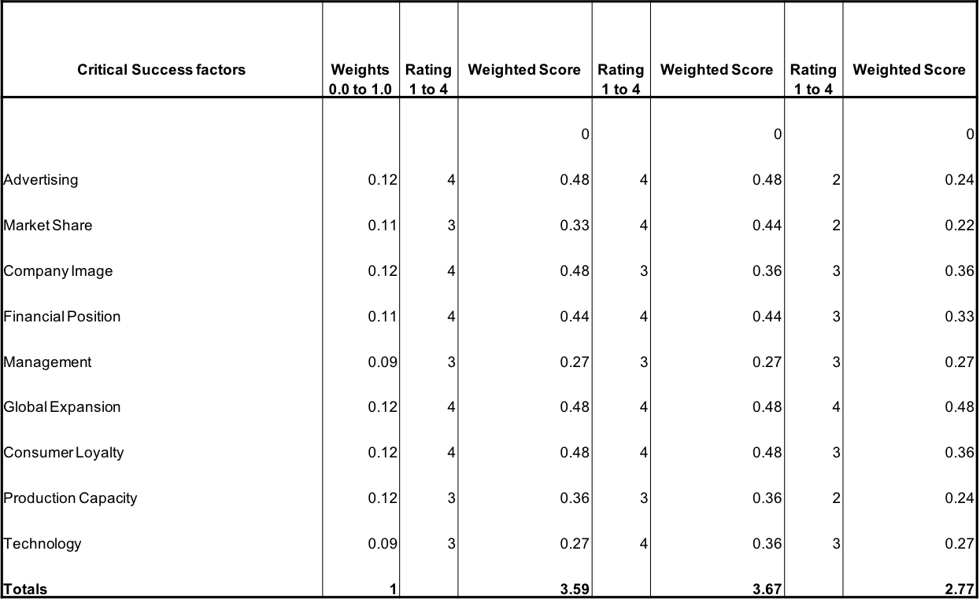
Table 6: (2018)
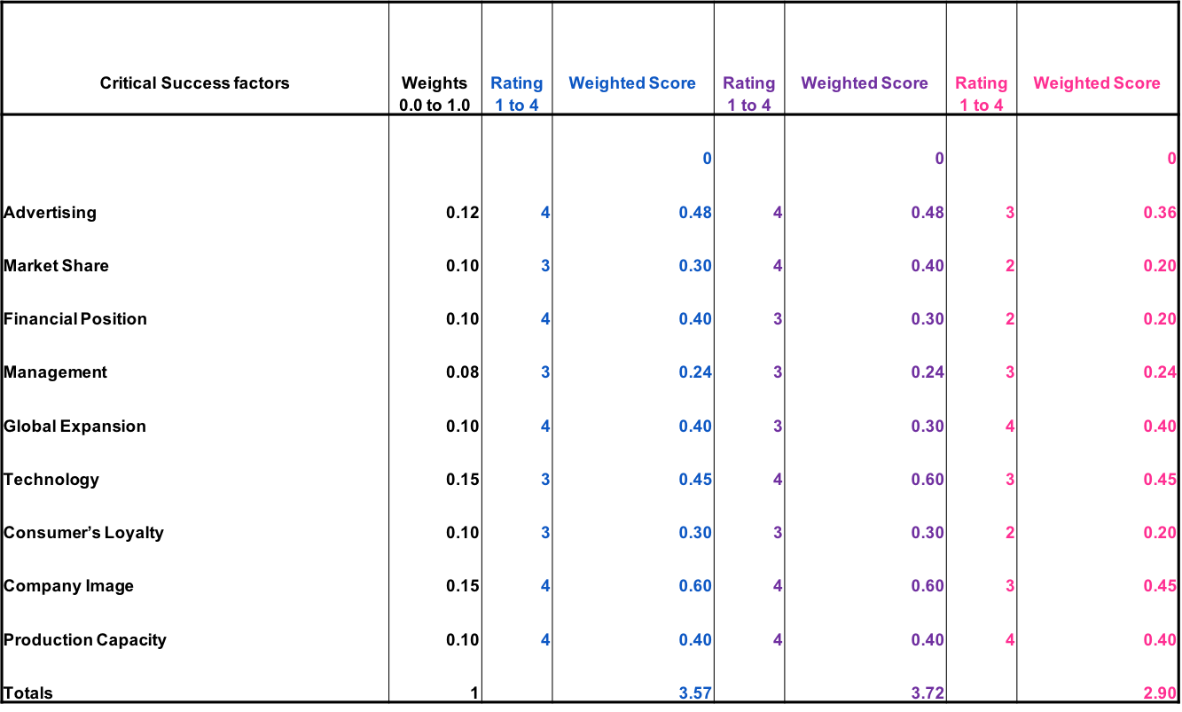
This report selects two other companies, Warner Bros. (in purple) and Universal (in pink), compared with Walt Disney (in blue). Through CPM Matrix, it can analysis that thought ten years past Warner Bros. still be the most competitive one in these three companies.
Stage 2: Matching Stage
SWOT Matrix
Table 7: (2018)
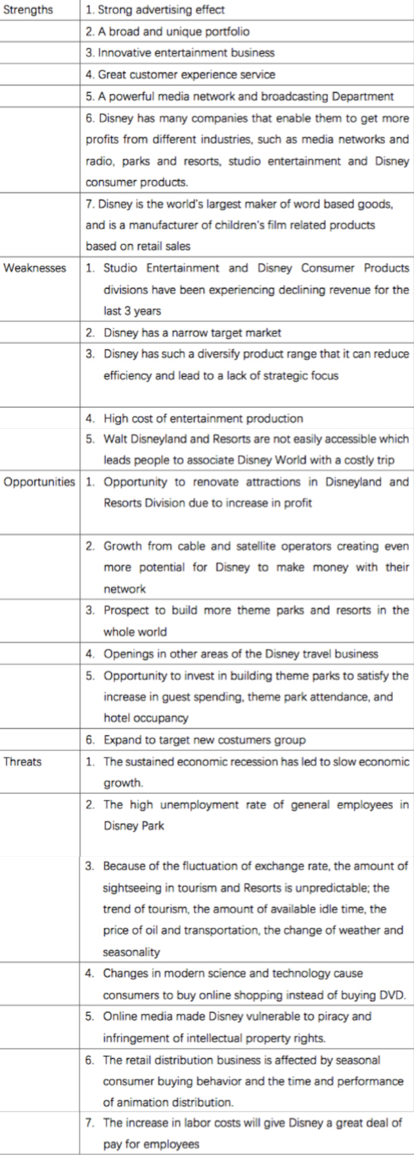
Disneyland is one of the most recognizable entertainment theme park in the world, ten years ago this is its strength, however, “the most recognizable entertainment company” means “old fashioned” for today’s changing entertainment needs of customers. More and more kids, even adults, like chasing fashionable activities, Disneyland cannot satisfy their yearning for new things. At the same time, with the rapid technical development’s of the economy, Disney's employees no longer have to face the poor working conditions in factories, which is no longer one of the weaknesses of Disney.

Therefore, the following matrix based on the SWOT analysis.
Table 8: (2018)
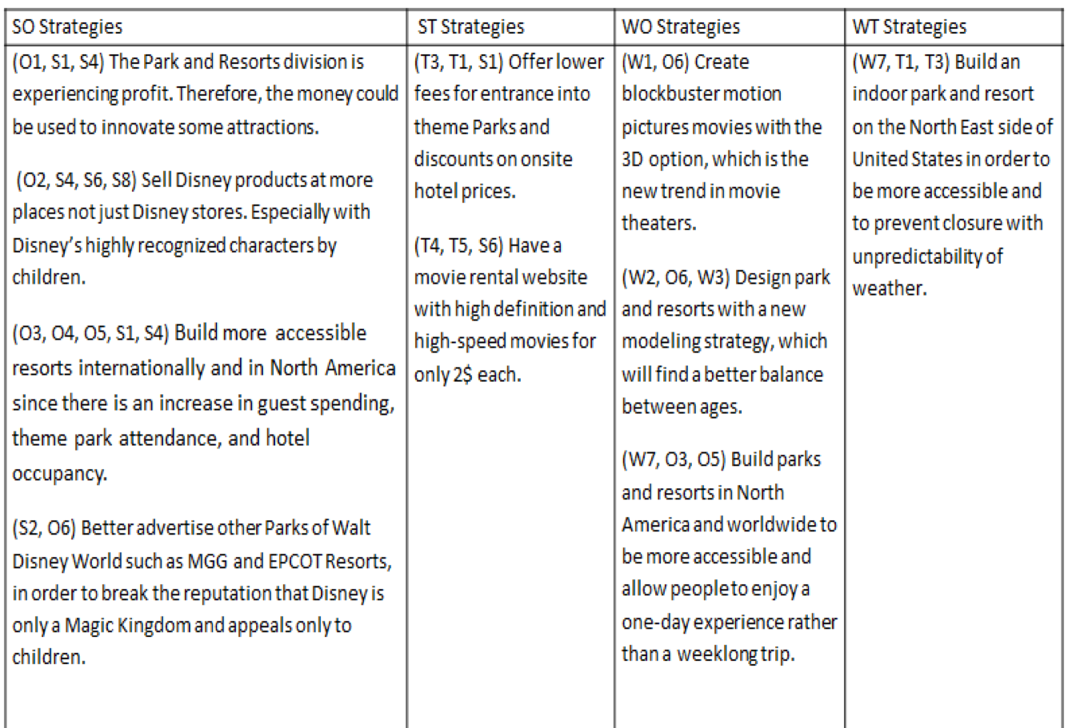
SPACE Matrix
Table 9: (2008)
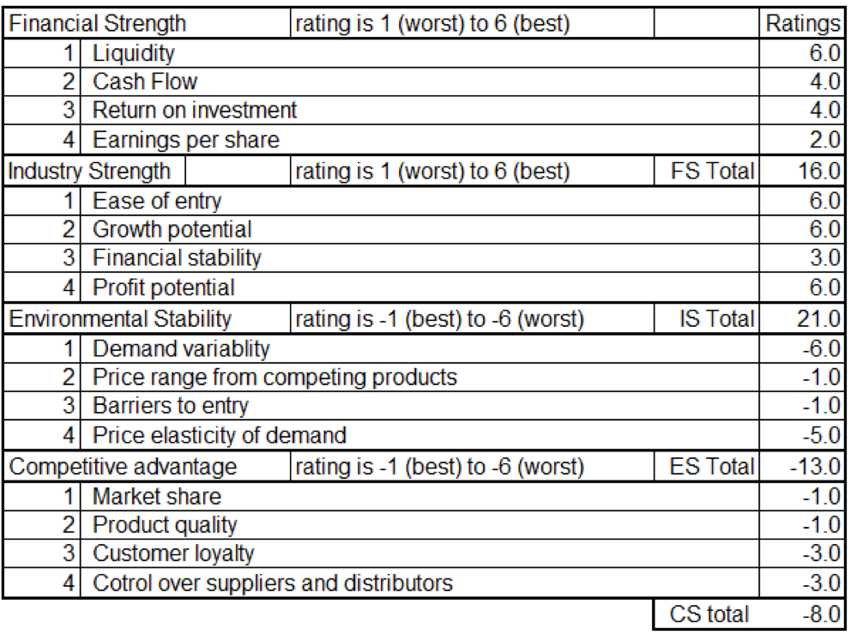
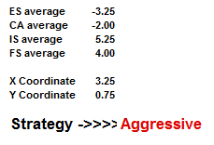
Table 10: (2018)
Financial Strength | Rating is 1(worst) to 6(best) | Ratings
1 | Liquidity | 6.0
2 | Cash Flow | 6.0
3 | Return on investment | 5.0
4 | Earnings per share | 2.0
Industry Strength | Rating is 1(worst) to 6(best) | FS Total: 19.0
1 | Ease of entry | 5.0
2 | Growth potential | 6.0
3 | Financial stability | 2.0
4 | Profit potential | 5.0
Environmental Stability | Rating is -1(best) to -6(worst) | IS Total: 18.0
1 | Demand variability | -6.0
2 | Price range from competing products | -1.0
3 | Barriers to entry | -2.0
4 | Price elasticity of demand | -6.0
Competitive advantage | Rating is -1(best) to -6(worst) | ES Total: -15.0
1 | Market share | -1.0
2 | Product quality | -1.0
3 | Customer loyalty | -4.0
4 | Control over suppliers and distributors | -3.0
 |  | CA Total: -9.0

ES AVERAGE: -3.75
CA AVERAGE: -2.25
IS AVERAGE: 4.50
FS AVERAGE: 4.75
X COORDINATE: 2.25
Y COORDINATE: 1.0
STRATEGY>>> AGGRESSIVE
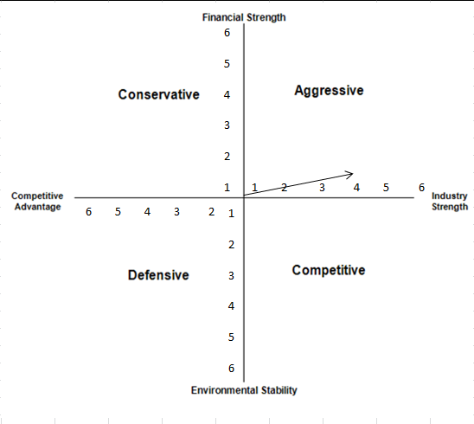
Through SPACE Matrix, this report analyzes the strategy of Walt Disney, from ten years ago to now, it still be aggressive.
In 1988, the Disney computer software was established, including the Disney interactive media and the Disney interactive game. The Disney interactive game business was reorganized in 2011, focusing on the traditional host games to the social and mobile fields. The adaptation of movies and games enriches the anime image of Disney. For example, the movie "Invincible Destruction of King", which was shown in 2013, was adapted from the game, and the film also got good box office results and word of mouth (Disney, 2013). In order to develop interactive entertainment, Disney acquired Penguin club, Tapulous and Playdom in 2007 and 2010. The interactive media includes the construction of websites such as Disney.com, Disney Family etc. The Disney consumer goods department was established in 1929 and is mainly responsible for the empowerment of consumer goods around Disney. Prior to 1987, consumer goods authorization was mainly a franchise model, and then Disney had organized restructuring and strategic adjustment. In 1999, Andy Muni, the marketing master of Nike, served as president of the consumer product department of Disney. He made a great reform to the consumer product department, subdivided the authorized products, and established seven departments, such as toys, fashion, furniture and food (Disney, 2010).
Grand Strategy Matrix
Table 11: (2018)
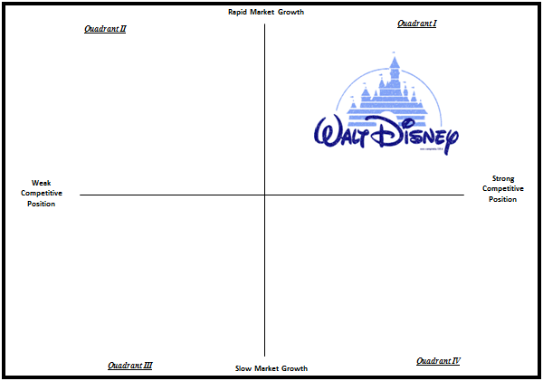

Disney's brand has been heard by almost everyone around the world. It has become a symbol of the United States and has become a part of American culture (Steven Watts, 2013). In 2014, Disney and Google were ranked first (Forbes, 2014) in the world's most respected list of the companies in Forbes. When I think of Disney's brand, someone will think of animation immediately. Some people will think of the pleasant experience of playing in Disney Park, and others immediately think of Mickey Mouse and Donald Duck. Disney's brand association is no doubt rich and colorful. The four is brand loyalty, which is the tendency to rely on the brand when consumers prefer specific products and buy products. Disney's brand loyalty has been reflected in the revisit rate of Disney park. The average revisit rate of Disney theme park has reached 60-70%, while China even has a good 30-35% theme park.
Stage 3: Decision Stage
Quantitative Strategic Planning Matrix (QSPM)
Table 12: (2008)
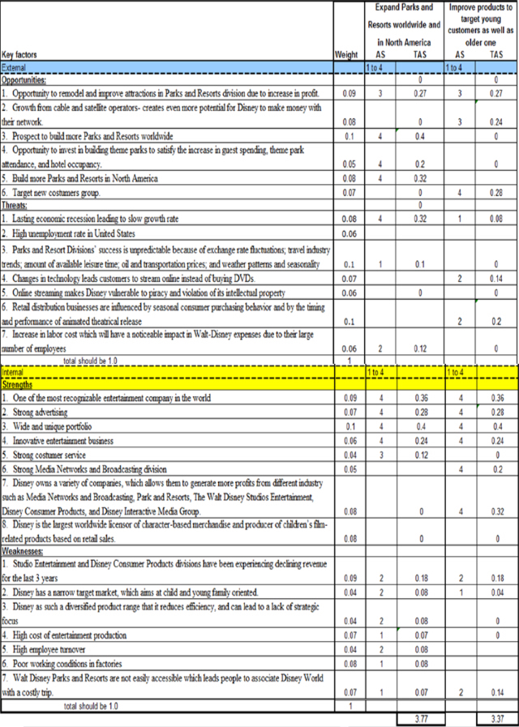
Table 13: (2018)
Key External Factors |  | 1to 4 |  | 1to 4
Opportunities
- Opportunity to renovate attractions in Parks and Resorts division due to increase in profit. | 0.09 | 4 | 0.36 | 4 | 0.36
- Growth from cable and satellite operators creating even more potential for Disney to make money with their network. | 0.08 |  | 0 | 3 | 0.24
- Prospect to build more theme parks and resorts worldwide. | 0.10 | 4 | 0.4 |  | 0
- Opportunity to invest in building theme parks to satisfy the increase in guest spending, theme park attendance, and hotel company. | 0.05 | 4 | 0.2 |  | 0
- Build more Parks and Resorts in North America | 0.08 | 4 | 0.32 | 4 | 0
- Target new costumers group. | 0.07 |  | 0 | 4 | 0.28
Threats |  |  | 0
- Lasting economic recession leading to slow growth rate. | 0.08 | 4 | 0.32 | 1 | 0.08
- High unemployment rate in the US | 0.06 |  | 0 |  | 0
- Parks and Resort Division success is unpredictable because of exchange rate fluctuations; travel industry trends; amount of available leisure time; oil and transportation prices; and weather patterns and seasonality. | 0.10 | 1 | 0.1 |  | 0
- Changes in technology leads customers to stream online instead of buying DVD. | 0.07 |  | 0 | 4 | 0.28
- Online streaming makes Disney vulnerable to piracy and violation of its intellectual property. | 0.06 |  | 0 |  | 0
6.Retail distribution business are influenced by seasonal consumer purchasing behavior and by the timing and performance of animated theatrical release. | 0.10 |  | 0 | 2 | 0.2
7.Increase in labor cost which will have a noticed impact in Walt-Disney expenses due to their large amount of employees. | 0.06 | 2 | 0.12 |  | 0
Total: | 1 |  | 1.82 |  | 1.44

Key Internal Factors |  | 1 to 4 |  | 1 to 4
Strengths
1. One of the most recognizable entertainment company in the world. | 0.09 | 1 | 0.09 | 4 | 0.36
- Strong advertising | 0.07 | 4 | 0.28 | 4 | 0.28
- Wide and unique portfolio | 0.1 | 4 | 0.4 | 4 | 0.4
- Innovative entertainment business | 0.06 | 4 | 0.24 | 4 | 0.24
- Strong customer service | 0.04 | 4 | 0.16 |  | 0
- Strong Media Networks and Broadcasting division | 0.05 | 3 | 0.15 | 4 | 0.20
- Disney owns a variety of companies, which allows them to generate more profits from different industry such as Media Networks and Broadcasting, Park and Resorts, Studio Entertainment and Disney Consumer Products. | 0.08 |  | 0 |  | 0
7. Disney is the largest worldwide licensor of character-based merchandise e and producer of children's film-related products based on retail sales. | 0.08 |  | 0 | 4 | 0.24
Weaknesses
- Studio Entertainment and Disney Consumer Products divisions have been experiencing declining revenue for the last 3years. | 0.09 | 2 | 0.18 | 2 | 0.18
- Disney has a narrow target market | 0.04 | 2 | 0.08 | 2 | 0.08
- Disney as such a diversify product range that it can reduce efficiency and lead to a lack of strategic focus. | 0.04 |  | 0 |  | 0
- High cost of entertainment production | 0.07 | 1 | 0.07 |  | 0.07
- High employee turnover | 0.04 | 2 | 0.08 | 2 | 0.08
- Poor working conditions in factories | 0.08 | 1 | 0.08 | 1 | 0.08
- Walt Disney Parks and Resort are not easily accessible which leads people to associate Disney World with a costly trip. | 0.07 | 1 | 0.07 | 2 | 0.14
Total: | 1 |  | 1.88 |  | 2.27
TOTAL: |  |  | 3.70 |  | 3.71

Maybe ten years ago, Disney should open another Disneyland in North America. But ten years later, now, through the result of QSPM Matrix, Disney should develop existing products, not only to attract young people, but also to attract older people. Because ten years ago, due to the underdeveloped network, people still yearned for Disney, however, now people seem to prefer to travel in developing countries with high experience but low price rather than the mysterious American Disneyland.

Recommendation & Evaluation
In author’s point of view, Walt Disney should:
- Maintaining competitive advantages will strengthen the market position of the company.
- Attach to the recent social trend, further develop of mobile, online and Virtual Reality game market.
- Build a new Disneyland in developing countries.
According to SFF case study, Disney has made its original advantage more distinct in ten years. Because anything should be identified to be remembered. At the same time, Disney seize every opportunity to improve their brand while diversifying. Disney is good at using people, hiring new leadership new style of doing things, to bring new progress to Disney.
The author analyzes the SFF’s evaluation to two part. The first part is strengths. It includes three parts. They are direction, guidance and confidence. SFF give leaders and followers clear direction, because of 3 stages, with clear guidance and confidence, it helps people understand what should they do and what they are doing is right. The last and most important evaluation is:
“You're dead if you aim only for kids. Adults are only kids grown up, anyway.”
----Walt Disney
Reference List
- The Walt Disney Company－2008-2017 annual reports
http://thewaltdisneycompany.com/
- Disney
http://www.disney.cn
- Fred D. David (1995) Strategic Management- Page 198
https://books.google.co.uk/books?id=LIBZAAAAYAAJ
- Walt Disney Company News-The New York Times
http://topics.nytimes.com/top/news/business/companies/disney_walt_company/index.html
- DIS: Summary for Walt Disney Company (The) Common－Yahoo! Finance
http://finance.yahoo.com/q?s=dis&ql=1
- China Daily (2017) 2017-2018 peak travel analysis and forecast of consumption
http://paper.people.com.cn/
- Steven Watts (2013) The Magic Kingdom: Walt Disney and the American Way of Life
https://books.google.co.uk/books?isbn=0826273009

Warner Bros.

https://www.warnerbros.com
- Universal Studios Hollywood
https://www.universalstudioshollywood.com
- Cruise Trip
http://cruise.ctrip.com/company/12
- China Daily (2016) Research on the transformation of International Radio and television media group in the era of financial media
- 11th Academic Awards (1939) “Snow White and the Seven Dwarfs"
- Forbes (2014) http://www.forbeschina.com/review/list/002173.shtml

