BUILDING A PERSONAL BRAND FOR SUSTAINABLE HEALTHCARE ENTREPRENEURSHIP: A PROFESSIONAL PORTFOLIO OF EVIDENCE
BY SAJIDA POSELAY

STUDENT ID: 2407315
MODULE TITLE: CHANGEMAKERS: BUILDING YOUR PERSONAL BRAND FOR SUSTAINABLE EMPLOYMENT
MODULE CODE: BMHP5015
ASSIGNMENT TITLE: COMPONENT 1: ONLINE PORTFOLIO OF SET EXERCISES
UNIVERSITY OF WALES TRINITY SAINT DAVID
SUBMISSION TITLE: JULY 5TH, 2026

Table of Contents
Task 1: Personal Brand 3
Task 2: Network map and Rationale 4
Task 3: Blog 5
Task 5: A letter to yourself 9
Task 6: Gantt Chart 10
Task 7: Report on Making changes 11
Reference list 13

Task 1: Personal Brand
I'm passionate about combining clinical skills with an entrepreneurial mindset. I present myself as a credible, solution-oriented practitioner who grasps the concepts of patient-centred care and understands the business of health, which is an increasingly important combination in our changing health care environment. My brand is not just based on the knowledge that I provide in clinical care, but it's the ability to see the missing components in the delivery and understand how to turn it into something viable and impactful.
Zhang et al. (2021) showed that when healthcare professionals strategically position themselves and build their online reputation, they are likely to gain significantly stronger career benefits, such as increased patient trust and engagement. I can build a clear value proposition for potential clients, collaborators, and funders with whom I interact on platforms like LinkedIn.
My efforts for building a brand will involve picking three areas of focus: establishing a consistent thought leadership presence, defining my niche (private practice, health consultants, or digital healthcare solutions), and critically shaping my narrative to echo Lim et al. (2024) main drivers of healthcare entrepreneurship today: innovation, systems improvement, and patient empowerment. My clinical background gives me credibility, and my thoughtful and genuine writing will help turn that credibility into career opportunities.

Task 2: Network map and Rationale
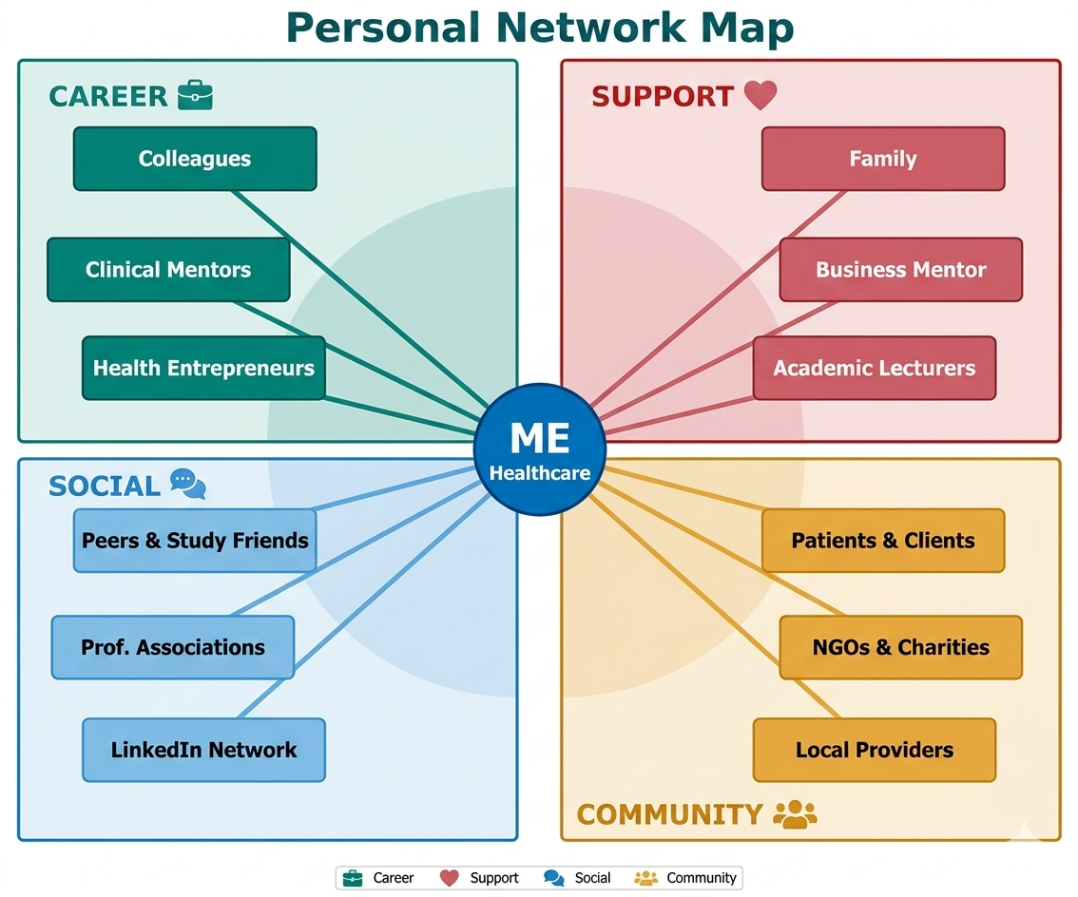
Rationale
My network is a good representation of a solid foundation along the four dimensions. Wang et al. (2024) discovered that knowledge sharing in social networks among primary healthcare professionals had a direct positive effect on job performance - which highlights the strategic importance of my career-dimension relationship as an active source of expertise sharing and problem-solving. Spann et al. (2025) also note that at large career changes, specifically when I am taking place between employed practice and self-employment, structured and intentional networking is particularly important.
More importantly, I have a need for more investors, health-technology incubators and startup advisors. These are what Granovetter (1973) referred to as weak ties: ties that exist beyond existing networks that carry information and opportunities that are not found in strong-tie networks. The most important near-term networking priority to me is cultivating these cross-sector weak ties by establishing accelerator programmes and doing specific outreach.

Task 3: Blog
Target audience: Healthcare professionals and aspiring health entrepreneurs

Burning Out Before Burning Bright: Why Staff Wellbeing Is the Most Urgent Crisis in UK Care Homes
Without doubt, the same crisis is silently unfolding in most care homes throughout the UK, run down on staff. It has been proven that employee burnout in care homes is directly associated with increased turnover rates - and with the average turnover of part-time carers reaching more than 25 workers per year, the consequences of burnout on the residents are critical (Costello et al., 2019). But at the majority of homes, the answer is reactive: A poll of staff members here, a pizza Friday there.
The scale has to be given a structural form. UNISON (2024) revealed that almost a third (31%) of all NHS employees and nearly a third of social care staff (27%) took a break from work in the last 12 months due to a mental health issue, while 45% of employees and 43% of social care workers felt their manager wouldn't support them if they disclosed the true reason. This organisational culture of silence is not an individual failure, but an organisational failure, which is facilitated by an organisational environment where throughput is more important than the people.
Evidence-based wellbeing combines three key elements: psychological safety – where you can speak up without fear, structured reflective practice – doing more to intentionally process emotionally charged work within your teams and visible leadership commitment – where there is visible commitment from leaders and managers around self-care and checking in on their teams' wellbeing.
But for care entrepreneurs and future leaders, it is not just a market gap; it is a moral imperative in the care home sector. Any organisation that is successful in the coming decade will consider staff wellbeing a key quality indicator. Staff wellbeing is clear evidence that when staff aren't well, residents don't do well either. Investing money in the labour force is investing in the quality of care.

Task 4: NHS Equality, Diversity and Inclusion Quiz
Q1. What is the NHS EDI Improvement Plan's main aim?
The overarching aim will be to drive equality, diversity and inclusion for everyone in the NHS workforce so that they all feel they belong, which will also help to ensure staff stay, and diversity attracts staff to join. outlines six high impact actions to tackle direct and indirect discrimination within behaviours, policies and cultures of organisations (NHS England, 2023).
Q2. How does the Plan propose to tackle the gender pay gap?
The Plan calls on NHS organisations to deliver gender and ethnicity pay gap reports, which are due by 2024 for sex and 2025 for ethnicity, as well as to create targeted plans to make improvements in these areas. It also calls for supportive action to be taken to promote flexible working for all staff as structurally driven factors are largely responsible for pay inequalities (NHS England, 2023).
Q3. What does 'intersectionality' refer to, in the Plan?
Intersectionality refers to the interconnections among the various factors of social identity, such as gender (women, men), race or ethnicity (Black, White, Asian) and disability (including chronic conditions like arthritis, diabetes, hypertension), which can interact to produce inequalities for some individuals that are more extreme than others; a black female doctor can have worse inequalities than a white female doctor or black male doctor. The Plan identifies that data analysis will be included that explores these compounding effects instead of looking at protected characteristics individually (NHS England, 2023).
Q4. Why do they feel psychological safety is important in the NHS?
For patient safety and organisational learning, psychological safety is a crucial factor as staff can voice concerns and acknowledge errors. The Plan is aware that inclusive settings that allow for different minds to feel safe are the settings that unlock the power of diverse workforces, leading to increased innovation, staff engagement and care (NHS England, 2023).
Q5. What recommendations does the Plan have to enhance the experience for internationally recruited staff?
Five high impact actions must include a thorough induction programme to be carried out before immigrants join and involve providing clear guidance on conditions of employment to international recruits and immigration. Line managers need to be culturally aware and ensure that opportunities for development and progression are the same for international staff as for domestically trained staff (NHS England, 2023).
Q6. How is leadership contributing to furthering EDI?
Leadership is the most effective lever for cultural change, with the Plan setting out a commitment of all chief execs, chairs and board of directors to have specific EDI objectives that are measurable, time-bound and due for review annually, as part of the annual appraisal. The Messenger Review (2022) highlighted that, if not held accountable, commitments on EDI will be performative – not transformative (NHS England, 2023).
Q7. Give one example of how the Plan will work to decrease health disparities amongst the workforce.
Action 4 is a high-impact action and requires line managers to have regular well-being conversations (using the NHS Health and Wellbeing Framework) and to work with community organisations to enhance employment pathways for minority groups, as health inequalities amongst groups in the workforce are both a fairness argument and a stay argument (NHS England, 2023).
Q8. Why is it important for the Plan to gather information on 'protected characteristics'?
This is vital as without assured and consistent data, organisations are unable to establish gaps, prioritise and allocate resources, and/or determine the effectiveness of interventions. The Plan proposes to enhance data standards, such as introducing new gender identity data requirements and new questions in the NHS Staff Survey on international recruitment status (NHS England, 2023).
Q9. In what ways can flexible working help to promote equality and inclusion?
Flexible working is a good leveller for the playing field for staff who are more likely to have disabilities, health or caring issues – more likely to be women, older or ethnic minority. Accessible flexible working policies are needed in the Plan, which should be made positive and introduced as a universal benefit, underpinned by the Employment Relations (Flexible Working) Act 2023 (NHS England, 2023).
Q10. What could be one solution to the problem of bullying/harassment?
High Impact Action 6 involves looking into bullying and harassment issues by protected characteristic and providing psychological support for all who raise concerns. However, there needs to be strong procedures in place to safeguard staff who raise concerns; otherwise, harmful behaviours may go unchallenged in a culture of silence (NHS England, 2023).

Task 5: A letter to yourself
Dear Sajida Poselay,
I write letters from the far side of a tunnel you couldn't see so far. Yes, I know how tired you are, with your work and academic obligations and carrying the burden of carving out dreams in systems that aren't always the most encouraging. The fact that you are about to find out about yourself is going to be important throughout the remainder of your career.
You might not have heard of emotional intelligence as a term – your own ability to know, understand and manage your feelings and emotions as well as your ability to read and respond to others. Goleman (1995) identified self-awareness, self-regulation, motivation, empathy and social skills as its five core domains. All of these you had already, present in embryo: that you had compassion instinctively for those entrusted to you, but you wouldn't have been able to carry many of your own. However, you didn't have the language and frameworks to apply these capacities deliberately, as opposed to reactively.
Resilience isn't "adversity-free," as described by Robertson (2012), but can be defined as the ability to adapt, recover and grow amid adversity. You were already being resilient and just didn't realise it! It would have been different if you had known this, so you may have sought help earlier and believed that it wasn't a failure to struggle.
So this is my take on it: clinical empathy is a skill as a professional, take time to build it! Identify a place for reflection: journal, structured de-brief or mentor. Treat yourself with the same kindness as you would another person. What is to follow is an epic quest. Trust it.
In love and earned perspective, Sajida Poselay

Task 6: Gantt Chart
Goal / Activity | M1 | M2 | M3 | M4 | M5 | M6 | M7 | M8
Complete BSc Health & Social Care | ✓ | ✓ | ✓ | ✓ | ✓ | ✓ | ✓ | ✓
Build LinkedIn & online brand | ✓ | ✓ | ✓
Publish thought leadership content |  | ✓ | ✓ | ✓ | ✓
Network: events & accelerators |  |  | ✓ | ✓ | ✓ | ✓
Define niche & business plan |  |  |  | ✓ | ✓ | ✓
Secure mentor / startup advisor |  |  | ✓ | ✓
Pilot / freelance consultancy |  |  |  |  | ✓ | ✓ | ✓
Launch enterprise / self-employment |  |  |  |  |  |  | ✓ | ✓
✓ = Active phase Green shading = milestone in progress

Task 7: Report on Making changes
Introduction
What I'm proposing is a staff wellbeing and psychological safety programme that is structured. This is a strategic move in response to a well-evided crisis: care home workers are more likely to leave their jobs and offer less quality care when suffering from burnout (Costello et al., 2019). When staff continuity is central to person centred care, wellbeing is a matter for patient safety – it isn't just about HR.
The Proposed Change
The programme will consist of three elements: regular protected reflective practice sessions led by clinical lead teachers; having a wellbeing champion within shift teams, and a confidential reporting process to allow staff to raise concerns for the addressing of issues without fear of reprisals or retaliation. These directly address the most effective organisational levers identified in the evidence: this includes psychological safety, peer support and visibility of leadership.
Change Model: Kotter's 8-Step Framework
The implementation will be done according to the 8-Step model developed by Kotter (1996), and proved to be valid in implementation in health care improvement situations (Alqahtani et al., 2021). Step 1–2, involves setting up and showing leadership the Urgency & Coalition, Staff Survey data and turnover data. The next 3–4 steps develop and communicate a clear vision via team briefings. Barriers, especially those involving disclosing mental health issues, are dismantled, and early wins are created through reaching out in steps 5–6 by celebrating the first cohort of reflective practice. Steps 7-8 help incorporate wellbeing into the appraisal system, making the programme part of the organisational culture.
The Skills required and Barriers available to tackle the challenge.
Successful implementation depends on transformational leadership, facilitation skills and emotional intelligence, which involves being able to read the team dynamics and being empathetic to the resistance. Some challenges are that there is pressure on care workers' time and cultural resistance to vulnerability. These will be reduced by arranging sessions on the days when the boys are changing sessions and will also be addressed by leaders doing open reflections first.
Conclusion
Staff wellbeing is a measure of quality indicator that has a direct impact on resident outcomes and on CQC ratings. With a real commitment of leadership, the application of Kotter's approach to the culture of the home can lead to a culture of sustainable care quality, and may well be the same decision – investing in people and investing in care.

Reference list
Alqahtani, F., Alshahrani, A., Al-Shehri, A., Bakarman, M., Al-Zahrani, M. and Miskeen, E. (2021) 'Where do models for change management, improvement and implementation meet? A systematic review of the applications of change management models in healthcare, Journal of Healthcare Leadership, 13, pp. 61–75. https://doi.org/10.2147/JHL.S289176
Costello, H., Walsh, S., Burns, A. and Murphy, C. (2019) 'Burnout in UK care home staff and its effect on staff turnover: MARQUE English national care home longitudinal survey', Age and Ageing, 48(4), pp. 531–536. https://doi.org/10.1093/ageing/afz018
Goleman, D. (1995). Emotional intelligence: Why it can matter more than IQ. New York: Bantam Books.
Granovetter, M.S. (1973) 'The strength of weak ties', American Journal of Sociology, 78(6), pp. 1360–1380. https://doi.org/10.1086/225469
Kotter, J.P. (1996). Leading change. Boston: Harvard Business Review Press.
Lim, W.M., Ciasullo, M.V., Escobar, O. and Kumar, S. (2024) 'Healthcare entrepreneurship: current trends and future directions', International Journal of Entrepreneurial Behaviour & Research, 30. https://doi.org/10.1108/IJEBR-02-2023-0197
NHS England (2023) NHS equality, diversity and inclusion improvement plan. https://www.england.nhs.uk/publication/nhs-edi-improvement-plan/
Robertson, I. (2012) The stress test: How pressure can make you stronger and sharper. London: Bloomsbury Publishing.
Spann, M.N., Hua, M., Shimbo, D., Begg, M., Gartrell, R. and Momen-Heravi, F. (2025) 'Keeping the network alive: The importance of professional social networks for long-term research career development', Journal of Clinical and Translational Science, 9. https://doi.org/10.1017/cts.2025.10105
UNISON (2024) Healthcare workers' mental health survey. London: UNISON. https://www.unison.org.uk/news/2024/04/healthcare-workers-burnout/
Wang, X., Hou, S., Lv, Q., Liu, Y., Wu, H. and Liu, Z. (2024) 'The association of social networks with the job performance of primary health care professionals: the mediating effect of knowledge sharing', Frontiers in Medicine, 11. https://doi.org/10.3389/fmed.2024.1324939
Zhang, T., Yan, X., Wang, W.Y.C. and Chen, Q. (2021) 'Unveiling physicians' personal branding strategies in online healthcare service platforms', Technological Forecasting and Social Change, 171. https://doi.org/10.1016/j.techfore.2021.120964

