University of Wales
Trinity Saint David
Student Name: Hopeton Edwards
Student ID: 1709391
Lecturer Name: Mushfiqur Rahman

Code & Module: BMSK5005-Workplace Culture and its Impact on Organisational Efficiency

Date of Submission: 7th of May2019

Table of Contents
1.0 Introduction 1
2.0 A critical assessment of workplace/organisational culture 2
2.1 Theoretical overview of organisational culture 2
2.2 An assessment of Hilton’s organisational culture 5
3.0 A critical evaluation of the organisation in its broader environment 5
3.1 What is an organisation? 5
3.2 The organisation in its broader environment 6
3.3 Features of the business environment 7
3.4 Components of Business Environment 7
3.5 An analysis of the business environment of the Hilton Hotel 10
3.5.1 PESTEL analysis of Hilton Hotel 10
3.6 SWOT analysis of Hilton Hotel 15
4.0 An evaluation of cultural and ethical behaviour of an organisation and evaluating own cultural and ethical behaviour relating to an organisation 17
4.1 Ethical and cultural behaviour of an organisation 17
4.2 Personal ethical and cultural behaviour 19
5.0 Conclusion 19
References 21

1.0 Introduction
In this paper, the author intends to achieve the aims of assessing workplace culture, evaluating the broader environment from which an organisation operates, evaluate the organisation’s cultural and ethical behaviour as well as own ethical and cultural behaviour in relation to the organisation. The case organisation that will be used for the above-mentioned analysis is Hilton hotel, UK. Specifically, the paper will examine into details what organisational culture is, what the business environment is and how it influences the operations of the organisation, and discuss the SWOT and PESTEL of the organisation. Hilton Hotel is into the in owning, managing, leasing, and franchising hotels and resorts. By December 2016, Hilton has 4,875 managed, owned, franchised, and owned resorts and hotel properties in 104 countries and territories. Hilton Hotels competes with Accor S.A., Hongkong and Shanghai Hotels, Movenpick Hotels and Resorts, Carlson Rezidor Group, Intercontinental Hotel Group, Marriott International, Hyatt Hotels Corporation, and Wyndham Worldwide Corporation. Hilton is the fastest growing company in the hotel/ lodging industry and has Grown 22 percent compounded annually over the years (Tourism Report, 2010).

2.0 A critical assessment of workplace/organisational culture

2.1 Theoretical overview of organisational culture
The culture of every organisation begins with the values or beliefs the entrepreneur or the founder of the organisation had before starting the business. The entrepreneur’s beliefs and values which formed the basis of the organisation’s culture with time will change as the environment in which the organisation operates changes.
Organisational/workplace culture is the organisation’s behaviour, values, shared vision that creates a framework for organisational behaviour (ERC, 2019). Organisational culture, according to Schein (2004), gives an organisation an identity that is exhibited through its rituals, meanings, beliefs, values, norms, language and the way things are done in the organisation. The ERC (2019) reported that workplace culture is relevant because it can strengthen or undermine the objectives of the organisation. In this regard, the ERC (2019) identified the following as the significance of a positive and an effective organisational culture: it attracts the best of talents, it improves employee engagement and retention, it impacts happiness and satisfaction of employees and affects organisational performance. The workplace culture of the organisation is influenced and shaped by management, workplace practices, policies and philosophies, people (employees), mission, vision, and values, work environment, and communication in and of the organisation.
Hofstede (1980) analysed organisational culture from four dimensions: Power Distance - It refers to the extent to which people accept the uneven distribution of power frequently. It is the extent to which people will accept dissimilarities in mental and physical capabilities which results in increases in inequalities for their welfare. Individualism versus Collectivism - Individualism: this is the quality of the national culture and how it defines the flexible social framework within which people voice out their stress on the protection of their families and themselves, on the other hand, Collectivism: refers to a way of behaviour where people believe in close-knit relational framework and expect care and protection form group, members. Masculinity/Femininity: Masculinity is a preference for heroism, achievement, assertiveness and material reward for success. Femininity is a preference for emotions, coordination, caring for the weak and care for the quality of life of people. Uncertainty Avoidance: this describes the extent to which people (employees) are threatened by the unknown.
Furthermore, Johnson and Scholes (1993) examined organisational culture from six dimensions. They argue that corporate culture is made up of six components as shown in Figure 1. These components according to the researchers guide employees of an organisation in regards to how things are done in the organisation.

Figure 1: Elements of the cultural web of an organization

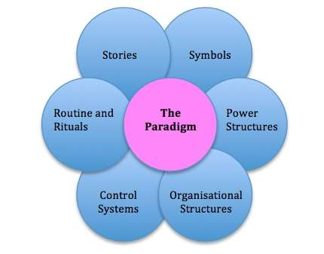
Source: Johnson and Scholes (1993)
Structure -this is the organization’s structure in terms of the management and supervisory control. In this regard, the Hilton Hotel should operate a flat organisational structure that will function with enhancing employee empowerment, giving opportunity for control at lower levels of management and this opens room for creativity; Power structure – this talks about the distribution of power within the organisation as well as those who have and exercise power in the organisation, including how they use the power they have. From the perspective of power structure, Hilton Hotel should work towards making leaders and others to accept change which is necessary due to the dynamic nature of the hotel business environment. This can be achieved by operating with higher ranked job functions; Symbols – this talk about the symbols the organisations held in high esteem and indicate relevant things in the organisation. Hilton must emphasize on symbols of uniqueness, creativity, respect for clients, excellent services, and good customer care; Stories – this consist of all stories told by all people about the organisation- stories about the history of the organisation, success stories of the organisation etc. Hilton have good stories of worldwide coverage, good brand, franchising, leasing and owning; Rituals – these are the organization’s maintained practices over years of its existence including daily practices in the organisation; Control- this is how management control the activities of employees, i.e. measures put in place by management to check behaviour within the organisation. It indicates what is accepted as good behaviour and what is not accepted as good behaviour.

2.2 An assessment of Hilton’s organisational culture
The corporate culture of the Hilton company was developed by the founder of company Conrad Hilton and influenced by his principles of investing in team members, consistent customers delight, provision of innovative services and products, environment protection, serving the community, provision of healthy and safer environment for the customers, guests and team members, expansion of the family brands, creation of a proud culture, and strengthening the loyalty of the company’s constituents (Hilton family, 2009). The above influenced and shaped behaviour in the Hilton hotel.

3.0 A critical evaluation of the organisation in its broader environment

3.1 What is an organisation?
The existence of organisations in the human regulated society has become the major mechanism of doing things and achieving collective and individual goals (Parsons, 1960). The concept organisation has been defined by Buchanan and Huczynski (2003) ‘Organisations are social arrangements for the controlled performance of collective goals.’ their definition of ‘organisation’ brings to mind two important features: first, organisations are social arrangements and second, organisations exist to perform. In more general terms, inside organisations are people who are normally referred to as employees, the employees performed assigned roles and their membership status is contingent on the performance of the assigned roles, the organisation has and pursues collective goals and all the members of the organisation must subscribe to these goals, tasks in the organisation are shared among members on the basis of their interest/expertise which leads to specialism in the organisation, the hierarchy of authority in the organisation is clearly defined and the employees must know where to fit into in the hierarchy. Having examined what the organisation is, the next section will examine the business environment as the regulatory framework within which the organisation operates.

3.2 The organisation in its broader environment
Every organisation operates in an environment and the activities of the organisation is regulated by the business environment. Thus it is important to understand the environment the organisation is operating as it is now the key to managing/operating a business to succeed because the business environmental factors have the capacity of influencing the operative aspects of the business, either the businesses’ location, prices, nature, products, personnel policies, distribution systems etc. (Cartwright, 2001). If business persons understand the business environment and how it operates, they can easily recognise, analyse and react to the forces that affect the business as it operates in its environment.
The business environment refers to a collection of all entities, individuals including other factors (internal or external) either under the control or not under the control of the organisation, but have the capability of affecting the performance of the organisation - profitability, growth, survival etc.
(Businessjargons.com, 2019). Additionally, the business environment can be defined as all the factors that are internal and external to the organisation that has the capacity of influencing the activities of the organisation.

3.3 Features of the business environmen
Researchers of business environment (Cartwright, (2001); Buchanan and Huczynski (2003); Worthington and Britton (2004) have agreed that Characteristically, the business environment in which the organisation operates is dynamic- the varied factors in the environment change frequently and continuously, complex- as the sources of the forces in the environment are different, it makes it complex and difficult to comprehend the relative impacts of the forces on the organisation, uncertain- the complex nature of the forces makes it difficult to predict how they will behave in the future, multi-faceted- the perceptions of the actors of the business environment differ from each other hence they perceive and understand changes in the business environment differently , far-reaching impact – changes in the forces that compose the business environment- regardless of the size of the change – has a great impact on the organisations in different ways, and relative – the business environment varies from different locations, the business environment of one country differs from that of another country in nature.

3.4 Components of Business Environment
The business environment can be classified into two types such as the internal and the external business environment (Businessjargons.com, 2019). The internal environment consists of all the factors/forces internal to the organisation which may be imparting strength or causing weaknesses to the organisation – the internal forces include: Vision and Mission, Technology, Labor Union, Value System, Corporate Culture, Human Resources, Objectives, products, organisational structure etc. while the external business environment of the organisation refers to all the forces that are external to the organisation creating opportunities or posing threats to the organisation, these forces are normally represented with the acronym PEST – i.e. is the political environment, economic environment, social environment and the technological environment (Worthington & Britton, 2004). The PESTEL has become a managerial strategic tool used to analyse the external environment of the organisation. It is important to note that the organisation do not have control over the external business environment but rather has to respond to its demands.
The external business environment is further classified into the specific external business environment/micro external business environment and general external business environment where the first is the immediate market in which the organisation operates which has a direct and continuous impact on the activities of the business. The forces at play in the specific external business environment include customers, competitors, suppliers, market, intermediaries, etc. The general external business environment consists of the forces external to the organisation but has a strong influence on the activities of the organisation, these factors include the political environment, economic environment, social environment, technological environment and the legal environment (Iksha, 2019).
A detailed analysis of the general specific business environment is given by Iksha (2019) as follows:
The political environment – consist of all governmental rules and regulations that regulate the activities of businesses. It borders on the governmental factors in relation to the government in power, governmental policies, the attitude of government towards different groups of societies, etc. It is a must that managers of businesses must introduce changes in their organisations to match with the demands and changes of the political environment. Specific aspects of the political environment include the constitution of a country, the present political system, government intervention in businesses, the values and ideology of political parties, foreign policies of governments (Cartwright, 2001); the economic environment- refers to the direct market forces such as demand, supply, Gross Domestic Product, Profit earning rate, Income level at national level and per capita level, Productivity and Employment rate, Industrial, monetary and fiscal policy of the government etc. that impact on businesses (Iksha, 2019). Specifically, the forces in the economic environment include Rate of growth of GDP, GNP, and Per Capita Income, Role of Private and Public sector, Balance of Payment, Rate of Saving and Investment, Balance of Trade, International Debt, Money Supply in the Economy, and Transport and Communication Systems (Worthington & Britton, 2004); the social environment – consist of the traditions and customs of the society in which the organisation operates. The common forces at play in the social environment include taste and preferences, standard of living, level of education of people, Quality of life, Birth and Death rates, Attitude of customers towards innovation, lifestyle etc., Importance or place of women in workforce, Consumption habits, Tradition, customs and habits of people and population. These forces of the social business environment may not have an immediate impact on the business but should not be ignored by the managers as their impact, in the long run, is very great; the technological environment- this aspect of the business environment refers to the use of technology to do business, that is the changes that are taking place in regards to the use of new machinery and equipment, methods of production, Various Innovations and Inventions, Developments in IT sector, Scientific Improvements, Technological Advances in Computers, Import and Export of Technology etc. (Cartwright, 2001); the legal environment- is the various legislations and laws passed in the parliament of a country. This ensures that businesses are carried out within a country’s legal framework. The forces in the legal business environment can be identified as the Various laws and legislative acts, Legal policies related to foreign trade, Legal policies related to licensing, Laws to keep a check on Advertisements, Statutory warnings essential to be printed on the label, Foreign Exchange Regulation and Management Act etc (Worthington & Britton, 2004).
Figure 2: PESTEL Analysis
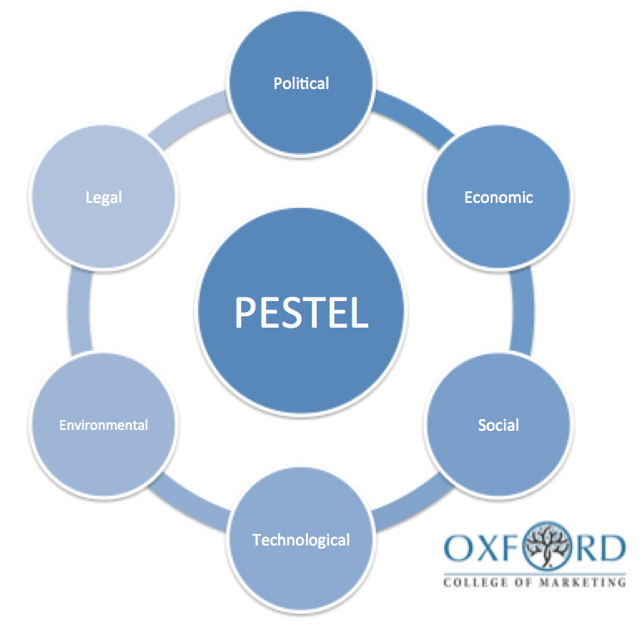
Source: Oxford College of Makrting (2016)

3.5 An analysis of the business environment of the Hilton Hotel
From 1907 when Conrad Hilton opened the first hotel, Hilton worldwide has grown to be included in the world’s well known and largest hotels. Worldwide, Hilton owns over 4,300 properties, Hampton Inn, Hilton Hotels & Resorts, Hilton Worldwide brands, over 630000 rooms in service, and over 16, 3000 workers (Statista, 2016)

3.5.1 PESTEL analysis of Hilton Hotel
PESTEL is a managerial tool used by managers to examine the political, economic, social, technological, environmental and legal factors confronting the operations of organisations (Dudovskiy, 2016). The following is a PESTEL analysis of Hilton Hotel for the UK market in particular but will also include some factors for Hilton Worldwide.
Political factors of Hilton
Businesses in all industries need political stability. The political environment can influence the hotel industry in which Hilton hotel operates because the stability or instability of the political environment can influence the number of visitors who may come in the form of business travellers or tourists. For instance, acts of terrorism in London branded the UK as an operative region for religious terrorist or the Northern Ireland’s political situation can discourage visitors to these regions for safety reasons and this will mean the number of customers for Hilton Hotel operating there will decrease consequently affecting its profit margin. As a result of this influence of the political environment, Hilton Worldwide spends more than $1.5 million on lobbying as a strategy of responding to this political environmental influence (Hilton Worldwide, 2016). This demonstrated in Figure 3.

Figure 3: Budget of Hilton Worldwide

Figure: Annual lobbying budget of Hilton Worldwide

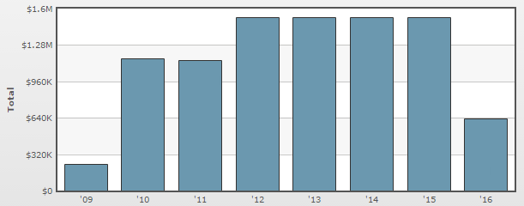
Source: Hilton Worldwide (2016)
Other forces in the political environment that influence the operations of Hilton Worldwide include Risk of military invasion, Bureaucracy and interference in Lodging industry by government, Level of corruption - especially levels of regulation in Services sector, Intellectual property protection,
The legal framework for contract enforcement, Anti-trust laws related to Lodging, Favoured trading partners, Trade regulations & tariffs related to Services, Pricing regulations, Taxation - tax rates and incentives, Mandatory employee benefits, Wage legislation - minimum wage and overtime, and Workweek regulations in Lodging.
Economic Factors of Hilton
In the economic environment, the forces at play include employment or unemployment rates, interest rates, foreign exchange rates, raw material costs, demand/supply etc. The macroeconomic factors (national and international) impacts on Hilton hotels and Resorts. Inflation, Euro-zone crisis, unemployment, fluctuations in interest rates are economic factors influencing the operations of Hilton hotel and Resorts. There can be high demand for Hilton’s services during occasions, for instance, the Olympic games – rooms will be fully occupied while in the absence of such occasions. In addition, a global economic and financial crisis such as what the UK experienced from 2007 to 2009 which continue to affect the economy influences the operations of the Hilton Hotel. For instance, the financial crisis resulted in a drop in the sales of Hilton Hotel UK by 20 per cent and profits by 40 per cent in the 4th quarter of 2008 (Heath, 2014). In addition, the Hilton performance is influenced by the GBP exchange rate compared to other currencies couple with the fluctuations in the country’s inflation rate. Other economic environmental factors that influence the operations of Hilton Worldwide include the type of economic system in countries of operation – what type of economic system there is and how stable it is, Skill level of workforce in Lodging industry, Government intervention in the free market and related Services, Infrastructure quality in Lodging industry, Economic growth rate, Labour costs and productivity in the economy, Efficiency of financial markets, Education level in the economy, Discretionary income, Unemployment rate, Interest rates, Inflation rate etc. (Worthington & Britton, 2004).
Social Factors of Hilton
The culture of a society which refers to the way things are done in society influences the culture of the organisation (ERC, 2019). The attitudes and beliefs of a society in which Hilton operates influences how Hilton’s marketers understand the customers and design their marketing message for consumers in the lodging industry. The emerging trends in consumer demographic variables, consumer lifestyle, the growth rate of the UK population, and the impact of role models in consumer decision making also form the social environment in which Hilton operates. For example, the large numbers of youths coming into the UK from the emerging economies – China, India -, changes in family patterns in the UK in regards to the numbers of people who are single, families without children and same-sex marriages are forces in the social environment that affects the performance of Hilton Hotel.

The other forces that operate in the social environment of Hilton Hotel include demographics and skill level of the population, Leisure interests, hierarchy, Class structure, and power structure in the society, level of education as a standard in the Hilton Worldwide Holdings Inc.’s industry.
Technological Factors of Hilton
Hilton Hotel is influenced mainly by the technological infrastructure of the catering industry which is seriously evolving on the basis of energy usage and its cost associated with innovations within the hotel industry (Hilton Worldwide, 2016). Hilton’s operations are also technologically been controlled by the order of the day in hotel bookings systems which is now been controlled by the internet – customers booking at the comfort of their homes, changes in the check-in services, the use of online services or smartphones which are cutting down cost and making provision of services fast and effective.
Environmental factors of Hilton Hotel
The environmental factors regulating the activities of Hilton Hotel are those concerned with polluting the environment through the emissions of carbon which has been agreed to have negative implications on global warming (Cartwright, 2001). Consequently, Hilton is confronted with rigid regulations to control how it goes about its activities, these regulations inevitably lead to increasing operation cost of the Hilton Hotel. Other regulations of the European Union in regards to protecting the environment impacts directly on the operations of Hilton Hotel.
Legal Factors of Hilton
The legal environment of Hilton Hotel consists of the jurisdiction of the UK and other countries and regions in which Hilton operates (Worthington & Britton, 2004). Changes in these jurisdictions will directly or indirectly influence the operation of the Hilton Hotel. For instance the immigration procedures and rules for getting UK visa or that of other countries are legal forces that impacts on the number of customers the hotel gets, an increase in the minimum wage, increases in maternity/paternity pay and statutory sick pay increase can increase the operation cost of the hotel which will reflect in the cost of its rooms and other services it renders. The other legal forces Hilton have to respond to include anti-trust law in the Lodging industry and overall in the country, Data Protection laws, Copyright, patents /Intellectual property law, Consumer protection and e-commerce, Health and safety law, Employment law, Discrimination law etc.

3.6 SWOT analysis of Hilton Hotel
The SWOT analysis is a strategic planning tool used to understand Strengths (S), Weakness (W), Opportunities (O) & Threats (T) (Dudovskiy, 2016). Table 1 exhibits an analysis of the SWOT of the Hilton Hotel.
Table 1: SWOT analysis of Hilton Hotel
STRENGTHS  - Good reputation in the market  - High brand recognition  - Technical innovations to improve customer experiences and regular upgrading of business processes  - The vast scope of the business area – over 540 hotels in over 78 countries  - Many years of operating in the industry –over 93 years now making them real experts at what they do  - Strong property portfolio  - Good employee retention  - Good customer retention schemes/approaches  - Strong and effective leadership (provided by Christopher Nassetta) | WEAKNESSES  - despite good brand, it has limited market share  - The influence of different Government policies and parameters on its operations globally  - High levels of debts  - Lack of flexibility due to its large size  - The high attrition rate in its workforce leading to huge expenditure on training and development of its employees.
OPPORTUNITIES  - High potential in emerging markets, Further International market expansion  - Innovation in customer services, Establishing a presence in the mid-level budget hotel sector  - Digitalization and better use of technology  - Formation of strategic alliances | THREATS  - The threats of terrorism  - Adverse changes in the macroeconomic climate  - Competition on price point  - political instability in some countries or regions of operation  - Ethics-related issues in Hilton hotels  - Loss of key talent and key personnel  - Entry of several strong international brands – the well-established Indian brands with long standings  - Stagnated growth

4.0 An evaluation of cultural and ethical behaviour of an organisation and evaluating own cultural and ethical behaviour relating to an organisation

4.1 Ethical and cultural behaviour of an organisation
Ethical behaviour in the organisation refers to what is accepted as a morally “good” and “right” against that which is “bad” and “wrong” (Simms, 1992). To put it differently, Naran (1992) explained ethical behaviour as acting in ways consistent with personal, organisational and societal values. Culture, on the other hand, is the shared experience between members of a group that shapes the behaviour of the group members as well as how they perceive their environment (Chen, 2005). Viewing organisational culture from this perspective is very relevant because it contextualizes the organisation in an interactive environment where social interaction becomes the means for transferring culture between employees. Arguing from a sociological perspective, the outcome of all human endeavours is referred to as culture ( Anissa, 2006). This definition presents a broader perspective that interweaves humanity and culture. The people in the organisation constitute varied cultures, culture in nature is dynamic and can evolve with new experiences that the people bring to the organisation and management as well as leadership approaches (Christensen, 2006). This dynamism as explained above forms the springboard on which an ethical climate of the organisation can be built into the organizational culture.
Militaru and Zanfir (2012) argued that the culture of an organisation influences employees behaviour that leads to work-related ethical approach or breaking the ethical principles of the organisation. The relationship between the culture of the organization and business ethics is preserved by management and transmitted to the workers of the organisation, this is because managers are the behavioural models for the employees in the organisation (Militaru & Zanfir, 2012). Robbins and Judge (2009) argued that managers can create a good ethical organisational structure by being a good role model that is visible to the employees to learn what is accepted as good behaviour and what is not accepted as good behaviour in the organisation, communicating the ethical expectations of the organisation to the employees – this helps to remove ethical ambiguities, provide ethics training to the employees using seminars and workshops, these training sections helps to reinforce standards in the organisation and acceptable and unacceptable behaviours; rewarding ethical acts and punishing unethical acts visibly to ensure people in the organisation embrace ethicals acts; and provide mechanisms that will enable employees to discuss ethical dilemmas and have the courage to report unethical behaviour. A survey on workplace values conducted by Clutch in 2018 revealed the workplace values ranked as the first and most important as shown in Figure 4.

Figure 4: Survey on Workplace Value
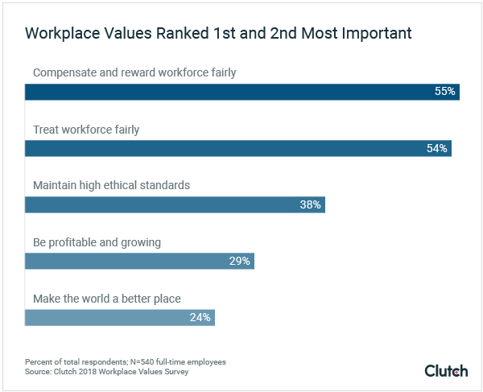
Source: Clutch (2018)

4.2 Personal ethical and cultural behaviour
The cultural background of an individual first defines his/her ethical principles and then enhanced by the individual’s education and work experience (Naran, 1992). This defines an individual’s perception of what is right and what is wrong and then informs how to behave in the society. My personal ethical values that shape my behaviour in life and in business include impartiality; objectivity, avoiding a potential or apparent conflict of interest, confidentiality, due diligence/ duty of care, openness; full disclosure and fidelity to professional responsibilities.

5.0 Conclusion
In conclusion, the paper examined the workplace culture, evaluating the broader environment from which an organisation operates, evaluated the organisation’s cultural and ethical behaviour from the practical perspective the Hilton Hotel as well as own ethical and cultural behaviour in relation to the organisation. Hilton Hotel as any other organisation operates in a business environment that is very dynamic. To survive in this dynamic business environment the Hilton Hotel needs to perform an environmental scan to examine and understand the internal and external factors which are affecting its activities. It needs to respond to the external factors in the business environment – the political factors, economic factors, social factors and the legal factors which will normally act as push factors to compel Hilton Hotel to make changes. Even though all the factors in the business environment are relevant and needs to be considered when making management decisions, the Hotel industry is now heavily regulated by the social and technological factors in terms of advance equipment and systems used to serve clients and give them the comfort they want and value for money.

References
Buchanan, D. & Huczynski, A., 2003. Organisational Behaviour An Introductory Text, 5th edn. London ed. London: Prentice Hall.
Businessjargons.com, 2019. Business Environment. [Online]
Available at: https://businessjargons.com/business-environment.html
[Accessed 10 April 2019].
Cartwright, R., 2001. Mastering the Business Environment. Basingstoke: Palgrave Macmillan.
Dudovskiy, J., 2016. Hilton Hotels PESTEL Analysis. [Online]
Available at: https://research-methodology.net/hilton-hotels-pestel-analysis/
[Accessed 12 April 2019].
ERC, 2019. Workplace Culture: What It Is, Why It Matters, and How to Define It. [Online]
Available at: https://www.yourerc.com/blog/post/workplace-culture-what-it-is-why-it-matters-how-to-define-it
[Accessed 2 April 2019].
Heath, T. (. h. W. P., 2014. “Christopher Nassetta: The man who turned around Hilton”. Washington.
Hilton Worldwide, 2016. Open Secrets, [Online]
Available at: www.opensecrets.org/lobby/firmsum.php?id=D000000503&year=2014
Hofstede, G., 1980. Culture’s consequences: International differences in work-related values. Beverly Hills: CA: Sage.
Iksha, S., 2019. 5 Major Components of Business Environment | Business Studies. [Online]
Available at: http://www.yourarticlelibrary.com/business-environment/5-major-components-of-business-environment-business-studies/8638
[Accessed 7 April 2019].
Johnson, G. & Scholes, K., 1993. Exploring corporate strategy. New York: Prentice Hall.
Military, C. & Zanfir, A., 2012. The Influence of Organizational Culture over the Ethical Principles in International Businesses. International Journal of Academic Research in Accounting, Finance and Management Sciences, 2(1), pp. 26-33.
Naran, F., 1992. Your Role in Shaping Ethics Ethics. Executive Excellence, Volume 7, pp. 11-12.
Parsons, T., 1960. Structure and Process in Modern Societies.. Glencoe : IL:Free Press.
Robbins, S. & Judge, T., 2009. Organizational behaviour. 13 ed. Upper Saddle River: NJ: Pearson Education, Inc.
Schein, E., 2004. Organizational Culture and Leadership. 3rd ed. San Francisco: Jossey-Bass.
Simms, R. R., 1992. The Challenge of Ethical Behaviour in Organizations. Journal of Business Ethics, pp. 505-513.
Statista, 2016. Numbers of employees in Hilton. [Online]
Available at: statista.com/statistics/297758/number-of-hilton-worldwide-employees
[Accessed April 2019].
Worthington, I. & Britton, C., 2004. The Business Environment. 4th ed. Harlow: FT Prentice Hall.

