UNIVERSITY OF WALES: TRINITY SAINT DAVID

NOELLA WUDALA PASHOME
ID: 1707065

BA Leadership and Management Skills for the Workplace

Developing Working Critical Thinking

By HUSAM HELMI
h.alharahsheh@uwtsd.ac.uk
BMSK5001

Executive Summary

- Introduction

- Concept and literature

  - Concept of Critical thinking in the workplace and it is importance

  - Literature review and importance of key words
2.1.1. Belief
2.1.2. Attitudes
2.1.3. Value System

- Management

  - Management definition

  - Types of management Theory and definition
3.2.1 Types of management
3.2.2 Definition

- Case study

- Conclusion

References

Executive Summary

As the world is increasing and globalisation is requesting more interactivities among people from different backgrounds. Humans are no longer life and work in a detached ambiance; but they want now to be part of a worldwide organisation within a global framework. For this acumen, profit and non-profit companies wish to develop more diversified to remain competitive, “Maximizing and capitalizing on workplace in an important issue for management.” (Betchoo, 2015)
Managers as well as supervisors have to appreciate the ways in which the workplace is growing and expanding. According to Agarwala (Agarwala, 2010) “Managing is a significant organizational challenge, so managerial skills must adapt to accommodate a multicultural work environment.”
According to Mbonea (Mbonea, 2017) “It is an evidence that diversity is increasing more considerably today than ever before given that the world better accommodates people with differences since it has transformed into a global village, a term that looked distant in the past but looks more apparent today than ever before.” This rings a bell for acknowledge of differences among us which are, in aspect, the ingredient of diversity. According to Betchoo (Betchoo, 2015), “Diversity could mainly focus on gender, age and ethnicity issues but there are new concepts like HIV/AIDS workers, dual career couples, mobile workers that have become part of the workplace and have their role to play in the society.”
The existence of diversity within a workplace is acknowledge when an organisation starting to hire people from various background and experience. Many organisations see workplace diversity as a contribution towards developing a better business. Although workplace diversity implements many benefits, it also comes out with many threats to both, employees and managers. To gain the benefit of workplace heterogeneity, managers as well as employees must perceive the threat and should figure out how to productively compromise with them.

- Introduction
The aim of this report is to talk about Midland Cleaning Service for which I worked few months ago.
Midland Cleaning Service (MCS) has been helping client with their needs for over 10 years now and Mrs Chirou is the co-founder of this company. She came up with this idea as one of her closest friends was in need of help in her house and Mrs chirou proposed to send her personal cleaner to help her friend.

As this one was very pleased with the service offered, she requested again the same service with more hours and few weeks later, Mrs Chirou started to receive calls from different people in the neighbourhood and all around requesting for her services. In July 2009, she decided to register and open her own company (Midland Cleaning Service) and hired more staff. A year later, in 2010, she started to form and recruit housekeeping and introduce her new service in different hostels.
At this stage, the company was in its apogee, she signed a few contracts with different hostels and had good deals with few offices. One of her great deal was the contract signed with Clink, both 261 and 78, over 35 housekeepers were recruited for this deal.
Today, MCS has more than 200 employees all from all over the world, with different culture, background, beliefs, attitudes and system value. I will personally say that with this new service, the company started to grow but at the same time, it was held back by the worker as most of them were from different background and no English speaker.
MCS saw itself growing, service was always delivered as the management and employees both worked together to make sure that the standard is maintained. MCS spirit is to always respond to a customer within 1 hour and deal with complains as quickly as possible. I was Proud to be part of the management team and rushing to assist both customers and employees when needed.
According to Pantea (Pantea, 2017):” Enabling people to perform up to their maximum potential, it is focusing on changing the organizational culture and infrastructure such that people provide the highest productivity possible.” And that was the spirit of the company and Mrs Chirou focused most of her energy on this theory in which I did not agree and I will explain myself a little bit later in the development.
At this level, MCS had a Human Resource consultant to help dealing with any matters in that sense, a consultant accountant to deal with any payment or any issue related to it, 1 part time (self-employed) secretary who was in charge of any enquiries or customer request and was in charge of sales as well, 1 full time area manager who was in charge of employees and their performance and later on, MCS employed 2 other area managers (myself and 1 more girl) to help the senior manager in her task as she had to deal with more than 20 clients and 200 employees.
This assessment will apply critical thinking and evaluation in the context of beliefs, attitudes, value systems and management theories in which we should be able to demonstrate the application of an appropriate level of workplace critical thinking and to conduct an evaluation of the agreed scenario. We will also identify relevant management theories and make clear why they are relevant to us on this precisely topic. Literature review on managing workplace diversity as well as reviewing on case study on the topic.

- Concept and Literature

  - Concept of Critical thinking in the workplace and it is importance:
According to Chatfield (Chatfield, 2018) “Critical thinking means actively setting out to understand what is really going on, by carefully evaluating information, ideas and arguments and thinking carefully about the process of thinking itself.” Critical thinking can be seeing as an activity which entails more than just the skills of logic analysis and it engages examining the assumption elemental customary, habitual ways of thinking, doing or acting; in other words, Critical thinking is being ready to think and act differently on the basis of a critical questioning.

  - Literature review and importance of key words:
Belief, Attitude and Value system
As human beings, we all have our personal beliefs, attitudes and value that we might have developed throughout the progression of our lives. Our community, friends, family and the savoir-faire we had sharpened all participate to our faculty of who we are, how we see things and how we view the world.

2.1.1. Belief: According to Anderson and De Silva (2009), “A belief is an internal feeling that something is true, even though that belief may be unproven or irrational. e.g. I believe that walking under a ladder brings bad luck, or I believe that there is life after death”, In the other hand, Goerge Clooney in his movie “Dusk till Dawn” has defined BELIEF as something more concrete by saying: “… but I believe in what I see…”.
Belief can be seen as internal feeling and, on this point, I agree with Anderson and De Silva, but I do agree with Goerge Clooney as well as you need to see in order to believe. E.g. We see tree that is why we believe that them exist. If I have to redefine Belief, I will say it is an internal feeling that something is true, either you can see it or not. People believe in different things for different reasons, some of them can see it or feel it and some other cannot but and no one is right or wrong.

Importance of belief in a workplace
Beliefs are influential because they can define someone’ s behaviour, they are supporting any of our action, thought, decision or even our communication. Our believes are made of billions of unexplored thoughts that we have overspread with emotional content since our childhood. We should know that some of our believed are more present than others because they bear with them emotional core content.
In summarizing on a study considering faith and beliefs, the author Lisa Miller (2009) said:” Belief in God, disbelief in God and belief in simple empirically verified facts all lit up the ventromedial prefrontal cortex, the area of the brain that governs your sense of self. “We are, she wrote, in some sense, what we believe.”
That is why it is critical to understand the beliefs that shape our thinking are extremely important in order to understand our work performance. Note that unexplored beliefs will always conduct and limit our motivation by influencing our relationship and defining our acknowledgement to change.
We should be able to believe in us, in our potentiality to get things done accordingly to the request, change our mindset to positive thinking.
2.1.2. Attitudes: According to Anderson and De Silva, (2009) “An attitude is the way a person expresses or applies their beliefs and values, and is expressed through words and behaviour. e.g. I get really upset when I hear about cruelty to children and animals, or I hate school.”
We are all familiar to drag in energy level when we are about to enter a meeting with mindset person who always criticizes every single idea on the table during the meeting. We are also aware with how our mood can be changed when the senior manager passes by with a simple smile on his face and a tray of croissants on a very busy Friday. As these may been seen as a massive bounce on the rate of negative-to-positive energies in a workplace, subconsciously, attitude has a powerful impact on a workplace, along with our morale and productivity level.
According to Lisa McQuerrey (2019), “It’s important to note that everyone has good days and bad days.”
E.g. Losing a deal or client, blowing your presentation or having to deal with a frustrated day can generally put someone in a bad mood.
Furthermore, she (Lisa McQuerrey) added:” A bad attitude, however, is typically a state of mind, and it has the potential to permeate a workplace and drag everyone down with it.” As a colleague, we should be able to turn down this personality type or avoid, if necessary, any interactions with the concern staff; as a manager, we should be able to decide on either deflect the person/employee behaviour or let the bad attitude person/employee go away with it, instead of taking the risk of alienating other employees.

How Negative Attitude can impact our workplace
We should know that negative attitude does not only put other around us in a bad mood but also, has a palpable and significant impact on a function of an organisation. Negative attitude can create issues among staff and generate a climate where there is no encouragement to try, colleagues will not be able to trust each other’s and they will come to work just to try to get through the day rather than work together succeed or for better performance.
How Positive Attitude can impact our workplace
Where there is positive attitude in a workplace, there is a feeling that we as a team can accomplished anything and everything. We will see colleagues supporting each other and work in coordination.
Positive attitude can be very contagious, as everyone sense like they are all part of the same team, the effort will collective and everyone’s ideas will be valued and considered. This will impact positively the workplace and the outcome will be materialized. We will notice:
- Increased productivity
- Greater collaboration and teamwork
- Improved morale
- Ability to overcome adversity
- Willingness to think creatively and try new things
- Willingness to share information and ideas
- Increased sense of camaraderie
- Improved customer service

How to cultivate and increase Positive Attitude
As a manager, we are in charge of making sure that a good climate defines our workplace, all among us and staff. To do so, we need to cultivate a positive attitude by being respectful, inclusive and supportive to each one of our staff. We should:
- Not allow gossip or cliquish behaviour to overrule the workplace
- Always express appreciation for a job well done
- Make sure to share credit
- Always celebrate successes

According to Lisa McQuerry (2019),” You can also increase the odds of having a positive workforce by hiring people with positive outlooks. Question future candidates about how they handle disappointment and setbacks and whether they enjoy team-working environments.”

2.1.3. Value System: According to Anderson and De Silva (2009) “A value is a measure of the worth or importance a person attaches to something; our values are often reflected in the way we live our lives e.g. I value freedom of speech, or I value my family, morals.” Value can be seen as an ensemble of principles or qualities that a group of people or a person hold in high appreciation. These values conduct our way to think and we live our lives and the way we are taking decision.
Values are principles, standards or qualities that an individual or group of people hold in high regard. These values guide the way we live our lives and the decisions we make. A value may be defined as something that we hold dearly, those things/qualities which we consider to be of worth.
In 2014, Sean Hale defined value as:” A ‘value’ is commonly formed by a particular belief that is related to the worth of an idea or type of behaviour. Some people may see great value in saving the world’s rainforests. However, a person who relies on the logging of a forest for their job may not place the same value on the forest as a person who wants to save it.”

According to Milton (1973):” Personal values provide an internal reference for what is good, beneficial, important, useful, beautiful, desirable and constructive. Values are one of the factors that generate behaviour and influence the choices made by an individual.”

Values often influence many of our judgements and decisions that we take as well as it has a massive impact on how we provide our support to others.
Workplace value in the other hand, is an ensemble of instructing rules that are very important to us regarding our way to work or we choose our work. We usually operate these intensely held rules to judge between right and wrong practice of working, and they help us through our career decision such as: being honest; focus on details; being accountable; making a difference…

In this essay, we will talk about Value system and it is importance in the workplace. We will define a “Value System” and “Workplace Value” for better understanding. Furthermore, we need to keep in mind that Value can be seen as Culture as well.
Value system: According to Wiktionary: value system (Noun) is a chain of command of values that all moral operators hold, determined by their judgements. Most organization's value systems diverge, making the impact of a remarkable value system by the constant of social strategies. This is an egomaniacal concept. One's value system is forged by one's ethic or vices.

According to Freebase: value system (Noun) is a personal standards or self-discipline set of rules, based on the familiar feelings and judgement of discerning what the clear moral orders and education are, and the number of eagerness to see themselves and others tolerate by them.

Importance of Value System

A Value system is an ensemble of principles that rules an organisation and identify what a company, as an institution, cares about. It is essential to regulate our personal value to the Value system.
It is very important for the directors and the managements to precisely determine, as soon as possible, on what a value of the organization is based on for taking decisions and this should be demonstrate to the staff through their actions.
According to Chukwuma Asala (2019):” Having a value system means you have one system of belief from which you make all your decisions, which includes your business decisions as well.” This will allow staff the respect and understand one another, they will be doing the appropriate things for the right reasons, and this common determination and consideration for each other will allow them to build a perfect working environment. Value system helps an organization to achieve its fundamental objective. When an organisation does not have a Value system, people tend to work towards diverse objectives, with various goals, and with different result. This mostly impact the work environment, the productivity and the job performance.
Mind Tools in their blog said that” The most important thing that you need to do when interviewing someone is understand his or her workplace values. After all, you can train people to cover skills gaps, and you can help people gain experience. But it's really hard to get people to change their values; and they will be "problem workers" until they do.”
It is therefore, essential for an organisation to define clearly to the staff its value system in order to prevent organisational conflict and avoid interpersonal issue. In relation to our case study, this was one of the main issues that we had as we are just sending new staff to the work place without having to interview them or talking to them about the company rules and objectives. One of the big problems we had was a fight among staff, as they came from totally different background and culture, having them work together without clarification of rules and goals was a mistake. Staff will start to work with their personal Value/Culture and background, regardless any respect to one another, and this often create a clash between staff and at one occasion led to a fight.
That is why it is very essential for a company to always define their goals and make sure they have been told to employees, new or in the company already.

I still think that as a start up company, MCS had no time to define its Value System and when its started to get more client, it became quite impossible to do so.

- Management

  - Management definition:
According to Parasu Raman and all (1985):” Management refers to the tasks and activities involved in directing with people in an organization: It has four major functions: planning, organizing, leading, and controlling. In a word, management is the process of dealing with or controlling things or people individual or in an organisation.” Regrettably, I do not agree with this definition as I personally think that management involved more than just controlling things or people. Managing includes being responsible of your department and being aware of any details within your department. A good manager always seeks to resolve problem first before to try to submit it above.
According to Ricketts (2009) “in today’s world effective leadership and management is essential in order to archive success. Terms of leadership and management are being seen as synonyms and often used interchangeably.”
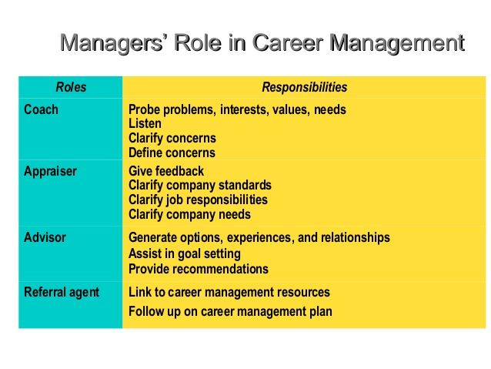
Image by Career Management

  - Types of management Theory and definition

3.2.1 Types of management:
There are 5 types of management theories: Human relations (HR), scientific management, Contingency theory, Systems theory and Bureaucratic management.
3.2.2 Definition:
- Human relations (HR): According to Hashaw Elkins (2019) “Human Relations Theory considers the organization as a social entity. This theory recognizes that money alone is not enough to satisfy employees. Morale is considered to be integral to employee performance. The major weakness of this theory is that it makes several assumptions about behaviour.” It can be defined as well as controlling actions in function with the teamwork, social behaviour…
This is very important for a company as it consider every employee equally, despite their role or their position and acknowledge with details every matter.

- Scientific management: Hashaw Elkins (2019) defined this theory as:” Scientific Management Theory is a very early management theory focused on minimizing waste and reducing production times. It was developed by Frederick Taylor, who attempted using a scientific approach for improving operations. Taylor’s theory emphasizes incentivizing employee performance and reducing “hit and trial” practices.” In another word, scientific management is controlling different actions by following a scientific method rather than relying on different theories.

- Contingency theory: It is: “Contingency Theory was developed by the sociologist Joan Woodward after she examined why some companies performed better than others. She found that high performing organizations make better use of technology and their managers made better decisions in situational contexts. This theory recognizes that effective managers must be adaptable to unique situations and circumstances.” By Hashaw Elkins (2019). This theory consists on controlling actions based on an important aspect created by a specific situation.

- System theory: Hashaw Elkins (2019) said: “Systems Theory views management as an interrelated component of the organization. Instead of viewing the organization as a series of silos, each department is part of an overall system or organism. Management must support goals and process flows that serve the overall organizational health.” This is based on controlling action by acknowledging how the system can influence an employee.

- Bureaucratic management: According to Hashaw Elkins (2019): “Bureaucracy Theory promotes reason to guide management decisions, rather than charisma or nepotism. Developed by sociologist Max Weber, this theory emphasizes formal authority systems. Unity and the authority of organizational hierarchies are central to Bureaucracy Theory.” It is controlling behaviour by following an ensemble of rules of an “ideal bureaucracy”

- Case study

Midland Cleaning Service critical thinking in its management.
This case study looks at Midlands Cleaning Service on how management theories as impact the company’s activities and growing.
After defining different management theories below, I can now confirm that MCS was overrule by the “System theory”. Why? According to Devra Gartenstein (2018):” Management is an art and a science. Managers deal with human beings whose behaviour cannot be reduced to formulas. Managers can benefit from learning and implementing best practices or studied and tested approaches to running an organization. Management theories are visions of different ways to run a business based on differing assumptions about how people and systems operate. They have evolved considerably over time from traditional top-down authoritarian paradigms to more human-centred contemporary adaptations.” And she defines the system theory as a system that looks for holistic patterns in scientific and metaphysical contexts, and she even said:” The management approach to systems theory aims for achieving an integrated and balanced whole in business as well. Features include identifying the overall goal of the organization, working so that its various elements function cohesively to achieve this goal, and understanding the cycles regulating a system's inputs and outcomes. This management theory is especially effective for recognizing and leveraging the particular patterns that a company's operations follow.”
From the management’s definition above, we can see that according to Devra Gartenstein (2018), the success of an organization resides on its management. Management its not only the key for a successful team but also it plays an important role on the success of a company, on its whole. Referring to our case study, that was the main problem. Management was not trained at all. Few of them had management experience must most of them had been given the position because they knew someone who was in the company. Once recruited, management will be given a brief vision of the company and explained quickly how to deal with a crisis.
A training last less than a week. Managers will be working around with the senior manager who will show them what to do and how to check. For a big such as MCS, who accounted more than 200 employees and more than 20 customers, managers should have received a proper training in order to provide an adequate one as well. Managing staff at MCS consisted on making sure that staff was on their delegated site. We did not pay attention to the quality as Mrs Chirou big concern was to make sure that someone is on the site, either they were doing job or not; and our main focus as a manager was to make sure that we always had people to send in case of someone calling sick. With this type of business, running all the time, no time to meet and interview staff, we were just sending them on the site. But it was a mistake, because we had to deal with so many people and from different background, and dealing with a diversity require a strong management training. In fact, it requires a clear, well-trained, qualified and strong-minded management to make sure that the staff will work as one to achieve a common goal instead of working as an individual. Which impacted the performance and the relation between MCS and its clients. In 2019, MCS lost 8 clients (in what 3 big clients).
A system theory is good for a start up or small business, where management is dealing with less than 20 people and can easily control anything without being in the same place with the staff. For a big company like MCS, the Human Relation management will be effective and efficient as the management will be dealing straight with the staff and create a deep relationship with the. In 1946, the results of Professor Elton Mayo's Hawthorne studies proved that the factor most influencing productivity are relationships. This means that for MCS to be consistence, efficient and effective; management needs to develop relationship with the staff in order to increase their productivity also, MCS’s management needs to create a supportive group where each employee’s contribution will have a significant impact on the team output, which will motivate workers/staff and will have a positive impact in their productivities. Most of all, staff will feel the need to express themselves or talk to the management before taking any decision that can affect the organization.

Here are few benefits of Human relation theory:
- Employee collaboration
- Improving employee retention
- Increasing motivation and productivity
- Fostering employee creativity

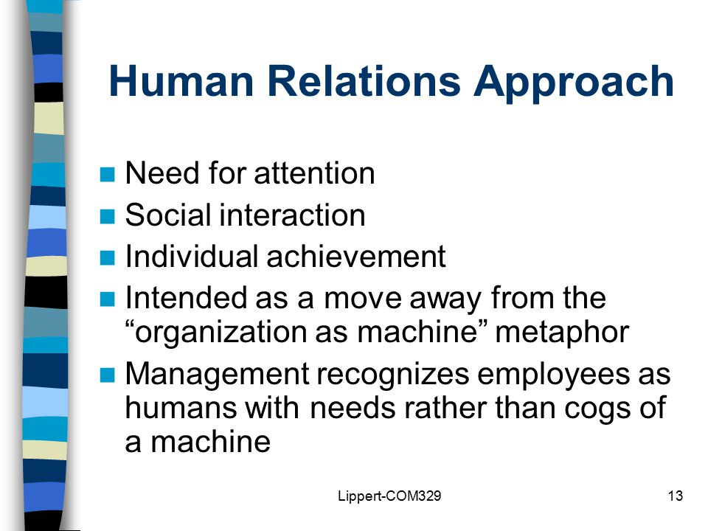

By Evelyn Casey

How to select a suitable management theory

Each management theory provides important vision to the organisational requirements. As Each organisation it is unique on its way of dealing with staff and matters, we should know that there is no an individual theory that will work for every company.
According to Hashaw Elkins (2019):” Many modern organizations apply a combination of theories to realize management success. This has led to the creation of newer organizational models with less structured hierarchies. Effective management is the backbone of any business. It is important to consider several factors when deciding which theories are most ideal for a small business. Often, small businesses are less rigidly hierarchical and must operate with minimal staff. It is important to select management theories and practices that are sustainable, especially if business resources are limited.”

- Conclusion

A company needs to define which management will apply to the organisation according its goals and Value system before starting any recruitment. The board of the company must make sure that the chosen theory has been communicated with details to the management who will apply it to the staff, mostly when it comes to an organisation with a remarkable diversity of staff as diverse work team, well-coordinated, can bring high value to an organisation.

REFERENCES

- Agarwala, T (2010). Strategic human resource management, Oxford University Press, New Delhi, India
- Anderson, M., De Silva, S., (2009). Believes, Values, Attitudes, Me and us Ltd.
- Armstrong M. (2008) How to Manage People. 1st ed. London: Kogan Page Ltd
- Asala, C. (2019). The Importance of A Values System. [online] Gaebler.com. Available at: http://www.gaebler.com/The-Importance-of-A-Values-System.htm [Accessed 27 Apr. 2019].
- Betchoo, N.K. (2015). Managing Workplace Diversity: A Contemporary Context-eBooks and textbooks from bookboon.com
- Casey, E. (2015). Human Relations Approach. [online] slideplayer. Available at: https://slideplayer.com/slide/4482788/ [Accessed 29 Apr. 2019].
- Chatfield, T. (2018). Critical Thinking. 1st ed. london: SAGE Publications Ltd, p.16.
- Dusk Till Dawn. (1996). [film] Directed by R. Kurtzman. mexico: Universal pictures.
- Elton, M. (1946). The human problems of an industrial civilization. 2nd edition, Boston, Mass: Harvard University
- Gartenstein, D. (2018). Four Types of Management Theory. [online] Available at: https://bizfluent.com/info-8375509-four-types-management-theory.html [Accessed 28 Apr. 2019].
- https://www.newsweek.com/brain-processes-facts-and-beliefs-same-way-79125 [Accessed 25 Apr. 2019].
- https://smallbusiness.chron.com/negative-positive-attitudes-affect-workplace-21287.html [Accessed 25 Apr. 2019].
- https://seanhale.wordpress.com/2014/02/16/the-difference-between-beliefs-attitudes-and-values/
- https://image.slidesharecdn.com/careermanagement-140620185604-phpapp02/95/career-management-18-638.jpg?cb=1403290891
- Mbonea, D. (2017). Essay on Managing Workplace Diversity. Phd in Human Resource Management. Atlantic International University of Honolulu
- Pantea, R.M (2007). Managing work force diversity, Volume VI (XVI)
- Parasu R. et al. (1985) Developed the cap model and Servqual
- Rokeach, Milton (1973). The Nature of Human Values. New York: The Free Press
- Understanding Workplace Values. (2018). [Blog] Mindtools. Available at: https://www.mindtools.com/pages/article/understanding-workplace-values.htm [Accessed 27 Apr. 2019].
- "value system." Definitions.net. STANDS4 LLC, 2019. Web. 25 Apr. 2019. https://www.definitions.net/definition/value+system

