
To Evaluate the Extent that Green Roofs Reduce Pollutant Concentrations in Urban Water Runoff Compared with Traditional Roofing Systems
[Document subtitle]

Tomos butterworth
2409888
Civil Engineering

Abstract

This report describes proposed research into green roofs effectiveness into reducing pollutant concentrations, compared to traditional roofs in South Wales. It describes issues with urbanisation, such as an increase in impermeable surfaces, increased rainfall, and combined sewer systems, stressing the importance for change and an improvement in runoff quality. This literature adopts quantitative, comparative research which involves field sampling from both green roofs and traditional roofs under three different categories of rainfall intensity. The samples will be analysed, using industry standard testing, for key pollutants, such as nitrogen, and phosphorus and heavy metals, such as zinc, copper, and nickel, as well as checking Ph and runoff quantity. The research will evaluate green roofs effectiveness, providing reliable, region specific data to support the implementation of SuDs in South Wales.

Table of Contents
1.0 Introduction 3
1.1 Background of the Study 3
1.2 Research Questions 6
1.3 Study Objectives 6
2.0 Literature Review 6
2.1 Review of Relevant Literature 6
2.2 Gaps in Current Research 7
2.3 How the Research Will Address These Gaps 9
2.4 Pollutant Removal in Green Roofs 9
2.5 Gaps in Current Research 12
3.0 Research Design and Methodology 13
3.1 Research Design 13
3.2 Data Collection Methods 14
3.3 Sampling Methods 15
3.4 Data Analysis Plan 15
3.5 Ethical Considerations 16
4.0 Timeline 16
5.0 Expected Outcomes 17
6.0 Conclusion 18
7.0 References 18

1.0 Introduction
1.1 Background of the Study

By 2050, it is predicted that two thirds of the world’s population will be concentrated in urban areas (Kundu and Pandey, 2020). It is critical that the runoff water leaving these urban areas is as clean and pure as possible. With rainfall increasing, this issue has a detrimental impact on urban areas in South Wales.
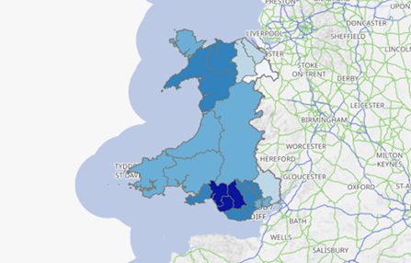

Figure 1. The Precipitation Map of Wales (DataMapWales, 2024)

South Wales is one of the highest precipitation regions in Wales, as shown in figure 1. In September 2025, Wales recorded 174% of its average September precipitation, placing significant stress on existing infrastructure (Met Office, 2025). This was shown by flash flooding events in September 2025, which affected communities in Cwmbwrla and surrounding areas, resulting in substantial property damage and major disruption to traffic routes (Jones, 2025). This issue was further exacerbated due to the number of impermeable surfaces in urban areas, stopping most soil infiltration, directing the runoff towards the sewers.
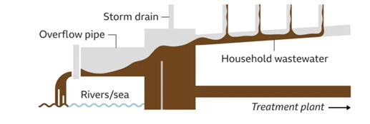
With an increase in rainfall over the last few years, the frequency that water companies, such as Welsh Water, release sewage into waterways has also increased. During heavy rainfall, rainwater mixes with sewage in the sewers in a combined sewage system (CSS) (Chaplin, 2020). CSS were made over 100 years ago during the Victorian era (Welsh Water, n.d) being designed for a smaller population. When heavy downpours occur, CSS release overflow via combined sewage overflows (CSO) to prevent sewage returning to properties, as shown in figure 2 (Welsh Water, n.d). In 2024, Welsh Water’s CSS’s released raw sewage 118,276 times, for a total of 968,340 hours (Surfers Against Sewage, 2025). This is the equivalent of over 110 years’ worth of sewage discharge (Surfers Against Sewage, 2025).
Figure 2. How Sewage Spills into Waterways (River Action, 2024)

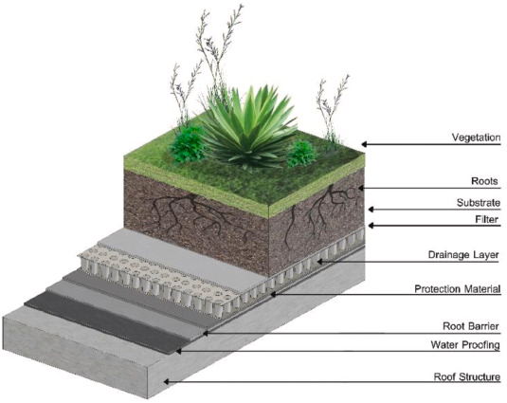
There are two types of green roofs: extensive and intensive green roofs (CIRIA, 2015) This document contains regulatory framework for the design and maintenance of sustainable urban drainage systems (SuDS). Extensive roofs have more shallow substrate depth, usually only 20-150mm deep, having less loading on the structure, whereas intensive roofs have much deeper substate levels, therefore greater loading on the building (CIRIA, 2015). Intensive green roofs support a wider range of vegetation but require much more intensive maintenance and management to ensure its efficiency (CIRIA, 2015). Integrated green roofs usually consist of 6 main components: vegetation layer, solid layer, filter layer, drainage material, root barrier, and waterproof layer, as shown in figure 3 (Mihalakakou et al, 2023). This review paper discusses green roofs, with focusing on their ability to act as an environmentally friendly solution to enhancing urban sustainability.

Figure 3. The layers of a typical green roof (Mihalakakou et al, 2023)

Ensuring high-quality runoff is necessary as rainfall in Wales and the wider UK contains harmful pollutants, including nitrates, phosphates, heavy metals, which pose risks to sewerage infrastructure and aquatic ecosystems. This research will examine the ability of green roofs to filter out pollutants and enhance the overall water quality.
.
Urbanisation has seen an increase of the proportion of impermeable surfaces, such as roofs, pavements, and roads, which prevents runoff water infiltering the soil, directing the water into overwhelmed sewage systems or to nearing waterways. In response to these issues, sustainable urban drainage systems (SuDS) have become an increasingly popular solution across the United Kingdom, and more recently, South Wales, due to its climate, aiming to manage stormwater runoff and reduce the environmental impact of urbanisation. SuDS represent a significant shift in how runoff is managed across the UK and the rest of the world, implementing a natural and integrated approach that can emulate the environment’s ability to slow the flow of runoff water, promoting infiltration as shown in figure 4 in the Netherlands (Monachese et al, 2025).
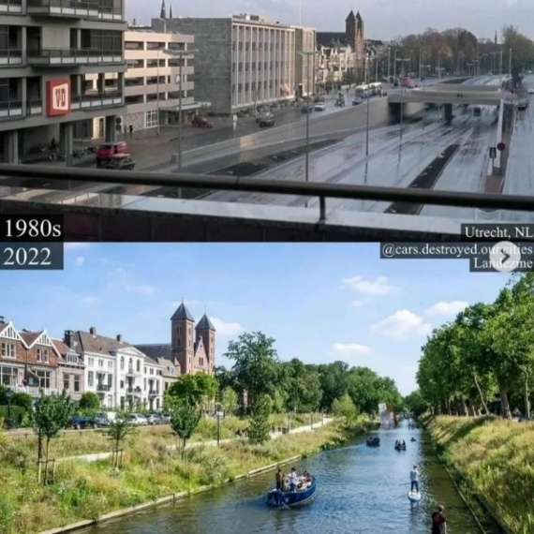
One method of SuDS that has become increasingly popular in urban areas are green roofs. Green roofs are designed as an “artificial ecosystem”, as described by Mihalakakou et al (2023). They have been found to improve environmental markers, such as air quality, heat island effect- which is a phenomenon where urban areas experience a hotter climate compared with surrounding rural areas due to human activity (Hao et al, 2025) and most importantly, water runoff quality (Mihalakakou et al, 2023).
Figure 4. A comparison within Utrecht, Netherlands, from the 1980s and 2022 after a successful greenery restoration project (Proctor, 2023).

1.2 Research Questions
To evaluate the extent green roofs could reduce pollutant concentrations, including nitrates, phosphates, and heavy metals in urban water runoff compared with traditional roofing systems in South Wales.

1.3 Study Objectives
To identify and characterise the heavy metals and contaminants-such as zinc, copper, nickel, nitrogen, and phosphorus- most frequently reported in urban roof runoff.
To analyse the influence of design- such as substrate type and depth, vegetation type and drainage configuration- on the filtration of rainwater and retention of impurities.
To conduct a comparative analysis of rainwater runoff quality between traditional and green roofs in South Wales, with a particular focus on the presence of heavy metals and other impurities as documented in relevant literature.

2.0 Literature Review
2.1 Introduction
Research into the implementation of green roofs in urban areas has increased exponentially over the previous ten years, particularly in managing diffuse urban pollution (pollution from multiple sources) (CIRIA, 2015). Much of the research is focused on green roofs ability to reduce the quantity of water runoff, however, focus is beginning to shift towards the quality of the runoff, including research from Marín et al (2023), Mihalakakou et al (2023) and Baryła et al (2023). Research from Baryła et al (2023) focuses on water retention, and runoff quality of a green roof. This literature review aims to analyse current research regarding the quality of urban water pollution, and the effectiveness of green roof systems in reducing pollution concentrations, including nitrogen, phosphorus, and other common heavy metal pollutants. This literature review also aims to address gaps seen in the current literature regarding the runoff quality in urban areas using green roofs in South Wales, having a differing climate to locations used in the current literature, such as Asia, and Central Europe.

2.2 Urban Runoff Pollution
As of 2022, 247 billion m² of the world was estimated to be covered by roofs, which is only expected to increase (Charters et al, 2025). Traditional roofing in the United Kingdom, especially in South Wales, are seen as a significant source of pollution due to their impermeability. Traditional roofing, including roofing made using natural materials such as slate, metal, and clay tiling and man-made roofing using materials, including ethylene propylene diene monomer (EPDM) and glass reinforced plastic (GRP) (Bennett, 2025) are naturally impermeable, often redirecting contaminated runoff directly to receiving waterbodies. This online article discusses an overview of different materials used in traditional roofing, including slate, metal and other man-made alternatives. Pollutants commonly mentioned in current research include nitrogen and phosphorus, as described by De Buyck et al (2021). This literature discusses roof water runoff concentrations, with a particular focus on different pollutant types, and different material leaching conditions.
Traditional metal roofing has been found in research to leach heavy metal- such as zinc and copper- during heavy rainfall, directing them towards waterways, causing long-term damage to aquatic life (Charters et al, 2025). This research reviews heavy metal concentrations leaching from different roofing materials. These increasing impermeable surfaces usually flow onto other impermeable surfaces, as shown in figures 5 and 6, such as roads, pavements and other urban areas, before being flushed into sewers. These surfaces are contaminated with traffic emissions, which include chemicals such as Carbon Dioxide, Carbon Monoxide, and Nitrogen Oxides, onto road and roof surfaces before being washed into waterways during heavy rainfall events.
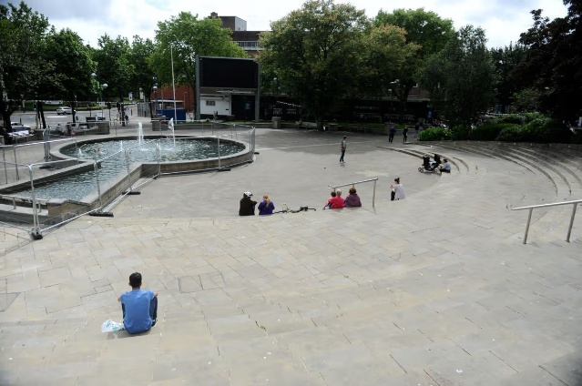
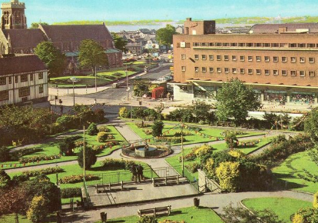

Figure 5. Castle gardens, Swansea, in the 1980s (Pinterest, n.d) compared to Figure 6. The same area in 2019 (Dalling, 2019) showing an increase in impermeable surfaces.

These high quantities of nitrogen can further contribute to the eutrophication of waterways. (Institute for Environmental Research and Education, 2025). This online source discusses which pollutants are commonly emitted by traffic, which includes nitrogen oxides, and carbon monoxide. Eutrophication is the enrichment of water bodies with excess nitrogen and phosphorus, promoting algal blooms, blanketing the water surface and limiting sunlight, ultimately damaging aquatic ecosystems and negatively effecting the water quality (Oluwaseun Akinnawo, 2023). This research paper discusses eutrophication, detailing mitigation strategies. Improving runoff water quality from urban surfaces represents a critical challenge for sustainable urban water management.
One way the UK government has aimed to confront this issue is to introduce new requirements for property developers, namely nutrient neutrality. The developer must prove that runoff by the development is equal, or less than the nutrients being produced by the land prior to construction, aiming to reduce the ecological damage construction can cause to the environment and the negative impact it commonly has on water quality (Planning Portal, n.d). The planning portal describes nutrient neutrality, in regulatory terms, and how it helps to reduce pollutant runoff concentration.

2.3 Hydrological benefits of green roofs
The reduction of runoff volume has direct correlation to improving water runoff quality, making it a crucial consideration for the overall evaluation into their effectiveness. By reducing the volume and the rate of flow of runoff water, research from Ercolani et al (2018) showed that green roofs can influence the transport of pollutants within stormwater runoff, showing it can be a viable and effective method to reducing pollutant concentrations. This research paper discusses how green roofs can mitigate stormwater runoff in urban regions, using different reduction techniques. Research into the ability of green roofs in reducing the volume of water runoff and its ability to delay peak flow during storm events is extensive, including research from Leite and Antunes (2023). This research describes the design of green roofs to control runoff, particularly focusing on hydrology. The reduction of runoff can be achieved by retaining water between the vegetation and solid layer, temporarily storing the water before releasing it gradually and slower into sewers (Environmental Agency, 2025b). This governmental resource discusses different water management practices in flood management, using the Environment Agency’s research as evidence.

2.4 Pollutant Removal in Green Roofs
2.4.1 Nitrogen
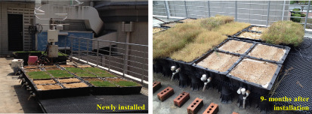
Literature has indicated that green roofs, and other vegetated roofs, can reduce nitrogen concentrations below the regulatory standard through the process of plant uptake within the green roof, reducing nutrient enrichment (Marín et al, 2023), (Karczmarczyk et al, 2018). This study from Karczmarczyk et al (2018) is crucial to understanding green roofs, and their role in nutrient leaching. Nutrient enrichment has commonly been found to cause eutrophication in waterbodies, causing serious and lasting damage to the environment. Marín et al (2023) found that the concentration of nitrogen was heavily dependent on the type of plant, the age of the green roof, and its maintenance. This paper from Marín et al (2023) reviews existing literature on green roofs, and the impact they have on urban runoff quality. The development of a green roof in a nine month period is show in figure 6.
Figure 6. Green roof after installation vs nine months after installation (Lim, 2023)

Other literature has found that green roofs can sometimes act as a source of nitrogen, rather than a sink, including research from Gong et al (2021). This research compares the performance of four varying green roofs vegetation. The discussion of sink versus source has been discussed in detail in research, including from Wang et al (2017). This literature investigates if green roofs are a sink or source for pollutants. A sink green roof retains and then removes pollutants, whereas a source green roof contributes to the pollutants found in the runoff, being a net negative to the environment (Wang et al, 2017). When green roofs are first introduced, it is common for there to be a ‘flush’ of nitrogen, with the levels eventually reducing. Research conducted by Lim (2023) found that after the green roof’s installation, nitrogen concentration in the runoff was found to be 0.08-100 mg/L whereas, one year after installation, the levels dropped to 0.05-7 mg/L. This paper reviews how green roofs efficiency change over time, with a focus on nitrogen and phosphorus.

2.4.2 Phosphorus
Research into phosphorus concentrations in green roof runoff provide contrasting results. Literature published by Marín et al (2023), and Karczmarczyk et al (2018) report that green roofs can act as a source of phosphorus, like nitrogen, rather than a sink, which can potentially negatively contribute to nutrient enrichment in receiving waterbodies. While much of the current literature reports phosphorus leaching from green roof structures, others suggest phosphorus concentrations in runoff can be comparable to conventional roofs overtime, and that the ‘phosphorus flush’ is a temporary issue faced in the first few months and years of its life cycle (Cheng et al, 2022) dependant on the type, condition, and age of the green roof. This study investigates phosphorus discharge from extensive green roofs over the long-term, with a focus on how changing the substate can influence runoff quality. Due to variations in results found in current literature, greater research must be undertaken to give definitive results.
2.4.3 Heavy Metals
Heavy metals, such as zinc, copper, and nickel, are commonly found in urban water runoff, as zinc and copper are commonly used in urban roofing in the UK (Zinc and Copper Works, 2025). This article describes traditional zinc and copper roofing in the UK. Heavy metals are toxic to plant and animal life in waterbodies, and negatively affect human health (Marín et al, 2023).
Metal roofs, particularly zinc and copper roofs, are a significant source of heavy metal pollution due to their corrosion in heavy rainfall periods (Galster and Helmreich, 2022). This paper reviews the presence of zinc and copper in roof runoff, looking into mitigation. Green roofs have been implemented to help retain heavy metals, but prominent research has found varying results. Later research conducted by Karczmarczyk et al (2020) found that green roofs can release detectable amounts of copper and zinc after being exposed to water, showing that green roofs may not be efficient at filtering out copper and zinc from rainwater. This literature investigates phosphorus and heavy metal leaching from green roofs.
Furthermore, the same research found highly elevated levels of nickel from certain roofing aggregate material, including red brick, finding levels four times above the testing limit, showing that the type of aggregate used in the roof can affect the removal of metals in green roofs (Karczmarczyk et al, 2020). In contrast, green roofs have been found to act as a sink for heavy metals, reducing concentrations of zinc by around 99%, copper by 98%, and nickel by 76% (Vijayaraghavan and Joshi, 2014). This literature explores green roofs with a focus on their ability to function as a sink for different nutrient contaminants, investigating the approaches used in testing the runoff quality. In much of the current literature, green roofs were found to reduce metal loading in runoff water, compared to corroding metal roofs. However, their performance has been found to vary between research, being heavily dependent on factors such as vegetation type, maturity of the roof, and environmental conditions, such as rainfall intensity.

2.5 Gaps in Research
Despite growing research into green roofs effectiveness into improving runoff quality, research into climates, such as South Wales, remains under-researched. Much of the existing research is focused on mainland Europe, Asia, and North America, which differ drastically from the climate in South Wales. Furthermore, literature published reports inconsistent findings, especially regarding heavy metals. Karczmarczyk et al (2020) states that green roofs aren’t effective in reducing copper and zinc levels in runoff, whereas (Vijayaraghavan and Joshi, 2014) reports a 99% decrease in zinc, and a 98% decrease in copper levels. In current research, there is a lack of long-term, in-situ examples of how green roofs behave, especially in coastal areas with abundant rainfall, such as South Wales. Precipitation tests in laboratory do not saturate the green roof such as what would occur with real rainfall due to rainfall intensity varying greatly. Another gap in research is a lack of literature comparing green roof urban runoff and traditional roof urban runoff, especially in South Wales, makeing it difficult to draw conclusions from the literature. With green roofs becoming more popular in Swansea, as show in figure 7, and figure 8 it is important for region specific data.
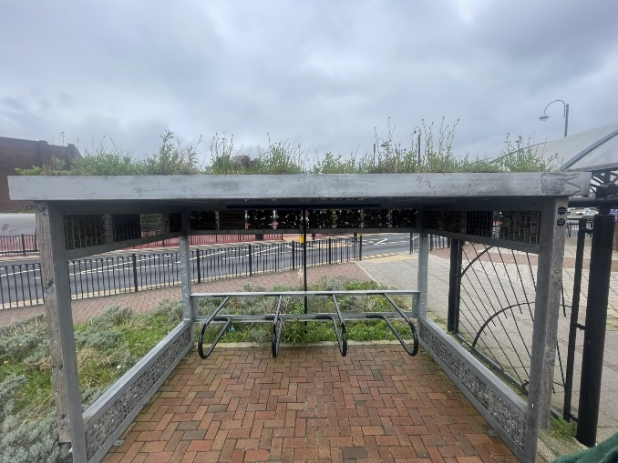
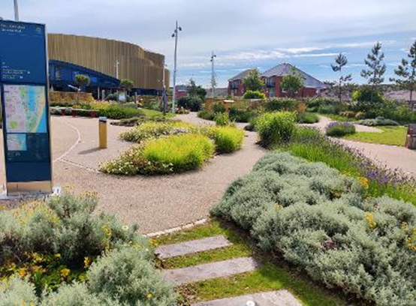
Figure 8. Green roof upon a bike shed in Cross Hands (Butterworth, 2026)
Figure 7. Wales’s largest green roof, at 1.1 acres upon the Amy Dillwyn Carpark, Swansea (Swansea Council, 2024)

2.5.1 How This Research Will Adress the Gaps
This research aims to address these gaps in current literature by producing a comparative analysis of runoff quality from green roofs in urban environments and traditional roof systems in South Wales. By analysing pollutants, including nitrogen, phosphorus, and heavy metals under local conditions, this research will provide region specific data, which is lacking in current literature. This research will also consider key green roof factors, such as design, vegetation type, and drainage configuration, according to British building standards, helping to provide a South Wales and UK specific study. By directly comparing green roofs to traditional roofs, this research will aim to offer a sustainable option to improve runoff quality, while addressing inconsistencies in the current literature, particularly in the findings published regarding heavy metals.

3.0 Design and Methodology

3.1 Research Design

This research will adopt a quantitative, comparative design, aiming to evaluate the extent to which green roofs reduce pollutant concentrations in urban runoff compared to conventional roofing systems. Field experiments will be undertaken, collecting and analysing runoff from different roofing systems under varying, natural conditions. This design will allow for different quality markers to be tested, including nitrogen, phosphorus, and heavy metals, allowing for comparison between green roofs and traditional roofs (CIRIA, 2015).
A comparison is important due to inconsistencies found in existing literature, many finding that green roofs act as a sink for contaminants, and many finding it to be a source depending on the type of green roof, roof age, and vegetation and substrate type. By conducting a comparative analysis of runoff from both roof types, it allows for a more location- specific conclusion. This is due to an under-representation of South Wales in current literature, results found in different, dryer climates may not be relevant to a coastal, inclement environment.

3.2 Data Collection Methods
Data will be collected through field sampling, collecting the rain from vegetated and conventional roofs during different rainfall intensities. The data will be collected from designated collection points, meaning that the data collected is consistent. One location that runoff water will be collected from is the Amy Dillwyn carpark green roof, as shown in figure 7, due to its size and age. Ensuring that the containers used to collect the runoff is clean and sterile is a crucial step, as any pollutants in the collection containers can affect the sample analysis.
The sample must be collected, and stored according to British standards, such as BS EN ISO 5667-1:2023 (European Standards, 2023) and BS EN ISO 5667-1:2023 (BSI, 2023) BS EN ISO 5667-1:2023 states the standards for water sampling techniques (European Standards, 2023), whereas the BS EN ISO 5667-3:2023 describes the handling, preservation, and storage of the sample, ensuring its integrity with mitigations such as ensuring it is kept out of direct sunlight (Environment Agency, 2025). Sampling container size must be suited to fit the research, as no fixed size is given.
To improve the reliability of the data, runoff water will be collected during different rainfall intensities, and duration. To test for heavy metal pollutants, atomic absorption spectroscopy (AAS) will be used as it is widely recognised for its ability to test water quality (Thomas, 2025) and for nutrient testing, UV-vis spectrophotometry (colorimetric test) is appropriate due to its high level of accuracy (Mettler Toledo, n.d.). These methods must be undertaken according to British standards. Using the AAS and colorimetric test will give quantitative data, allowing for the comparison between the two roofing types.
In addition to testing for heavy metals and nutrients, testing for pH is also important as they can influence pollutant behaviour. This will allow for a comprehensive evaluation of green roof runoff quality.

3.3 Sampling Methods
It is important that the samples collected come from a South Wales climate. Using stratified sampling, grouping roofs by roof type (conventional and green roof), roof age, and substrate type, as these have all been found to affect runoff quality in existing literature. This insures a balanced, unbiased comparison. Selection for testing will take into consideration the size of the roof, and environmental conditions, ensuring a fair and balanced comparison between green roofs and traditional roofs. This research will conduct testing at 3 green roofs, and 3 traditional roofs under 3 different rainfall categories. These will be calculated using the equation
$$Rainfall Intensity \left(\frac{mm}{h}\right)= \frac{Total Rainfall (mm)}{Duration (Hours)}$$
The three categories of rainfall will be identified as: light rain (<2.5mm/h), moderate rain (2.6- 7.4mm/h) and heavy rain (>7.5mm/h). this information will be taken from reliable sources, such as the met office.
This will improve the reliability of the conclusions drawn, allowing for better generalisation. Furthermore, when testing, it is important to test green roofs with varying age, and design to investigate how these factors affect pollutant concentration in runoff in a South Welsh climate, comparing the findings to global literature.

3.4 Data Analysis Plan
Data analysis will be focusing on the comparison of pollutant concentrations in runoff between green roofs and traditional roofs in South Wales. Statistical methods of analysis will also be used to summarise the results, including calculating the concentration mean, ranges, and standard deviation of each sample, providing an overview of the data and allowing for the detection of anomalous results.
A comparative analysis will then be conducted, evaluating the extent to which green roofs reduce or increase pollutant concentrations in urban runoff water. Percentage differences between the two roof types will then be calculated, allowing for a clear comparison between the two. Results will then be presented graphically to display differences in pollutant concentrations and rainfall intensity from both roof types. Furthermore, external factors, such as rainfall patterns and intensity, roof and green roof age, and substrate, must be considered during analysis.

3.5 Ethical Considerations
There are minimal ethical considerations involving people due to the nature of the research. This research must not interfere with human movement and must cause no emotional or physical harm. The collection of the water must not disturb any personnel in the surrounding area. The research must not contribute to any environmental issues, such as pollution or nutrification of water. After testing and analysis, the water is considered contaminated, so must be labelled, stored according to the hazard type, and disposed of according to the universities lab waste management system. Health and safety are also a considered during analysis, as different chemicals may be used during the testing and analysis. Personal protective equipment must be worn.

4.0 Timeline
The research will be conducted over 12-14 weeks, allowing for ample time for sampling different rainfall intensities, laboratory testing, and data analysis. The first 1 to 2 weeks will involve preparation, including resolving any issues in the methodology, the selection of collection points site for both green roofs and traditional roofs, and analysing any threats.
In weeks 3-4, a pilot study will be conducted, aiming to test different sampling methods during different rainfall events, and refining any issues found in the methodology. The main collection of data will be conducted between weeks 5-9, where runoff samples will be taken from both green roofs and traditional roofs across multiple different rainfall intensities. Other considerations, such as duration, and any dry spells will be recorded.
The main laboratory analysis will be carried out between weeks 10-12, testing for nutrients, such as nitrogen and phosphorus, and heavy metals found in the samples. The testing of pollutants must be carried out in accordance with British standards, such as atomic absorption spectrometry in accordance with BS EN ISO 15586:2003, which is the most current version (ISO, 2026). Data analysis will be completed in weeks 13-14, comparing results across roof type and rainfall conditions.

Figure 9. A table showing the timing of each step in the research.

5.0 Expected Outcomes
It is expected that the results of the green roof runoff will be complex. It is expected that green roofs will reduce pollutant and heavy metal concentrations, such as what was found in studies conducted by Marín et al (2023) and Karczmarczyk et al (2018). However, it is expected that samples of green roof runoff may contain elevated levels of these heavy metals and nutrients, acting as a source of pollution rather than a sink. This is commonly observed during heavy precipitation periods, a variable to be considered in this research. Any source green roofs may also display higher levels of pollutants compared with traditional roofs, something shown by Gong et al (2021).
While analysing the runoff quantity generated from both green roofs and traditional roofs, it is expected that green roofs will reduce the runoff volume, whilst delaying peak flow, as discussed by Ercolani et al (2018).
In addition, the pH levels in the green roof runoff are expected to be comparable to traditional roofs, possibly finding levels slightly above in the green roof whilst staying within regulatory parameters, as discussed by Jati et al (2024).

6.0 Conclusion
This study has discussed research proposals into testing the performance of green roofs, comparing the results to traditional roofing systems in South Wales with a particular focus on the pollutant removal of green roofs, and the runoff quality. The literature review found that green roofs reduce pollutant concentrations under certain conditions, filtering heavy metals- such as zinc, copper, and nickel, and nutrients- such as phosphorus, and nitrogen, through the process of filtration and absorption. However, contrasting results have been found in existing literature which indicates that green roofs can contribute to water pollution, acting as a source, rather than a sink. This is common in young green roofs that have recently been incorporated into a building, or during prolonged, heavy rain. The topic of green roofs reducing pollutant concentration is complex, with many contrasting pieces of literature published. This means more South Wales specific research must be conducted before a conclusion can be reached.
In addition to improving the runoff quality, green roofs have been found to reduce runoff volume, whilst delaying peak flow times. These results are commonly reported in CIRIA (2015), aligning with other sustainable drainage methods. In conclusion, this literature aims to evaluate the findings whilst making it more region specific, contributing to a balanced comparison between green roofs and traditional roofs, helping to understand its effectiveness.

7.0 References

Baryła, A. Karczmarczyk, A. Bus, A. and Sas, W. (2024) ‘Water retention and runoff quality of a wildflower meadow green roof with different drainage layers’, Ecohydrology & Hydrobiology, 24(3). Available at: https://www.sciencedirect.com/science/article/pii/S1642359323001386? (Accessed: 19 March 2026).
Bennett, O. (2025) ‘Exploring Traditional UK Roofing Materials: Historical Insights and Modern Applications’ Online Roofing Services. Available at: Fhttps://onlineroofingservices.co.uk/blog/exploring-traditional-uk-roofing-materials (Accessed: 1 April 2026).
BSI (2023) BS EN ISO 5667-3, Water quality. Sampling. Preservation and handling of water samples. Available at: https://landingpage.bsigroup.com/LandingPage/Undated?UPI=000000000000716647 (Accessed: 19 April 2026).
Chaplin, P. (2020) ‘Combined Sewer Overflows Explained’, Environmental Agency. Available at: https://environmentagency.blog.gov.uk/2020/07/02/combined-sewer-overflows-explained/ (Accessed: 13 March 2026).
Charters, F.J. Javid, L. Cochrane, T. A. and Gaw, S. K. (2025) ‘Heavy metal pollutant contributions from roofing materials: A systematic review of pollutant generation processes, influencing factors and quality of roof runoff’ Journal of Hazardous Materials Advances, 19. Available at: https://www.sciencedirect.com/science/article/pii/S2772416625002803 (Accessed: 19 March 2026).
Cheng, Y. Vaccari, A. Johannesson, B.G. and Fassman-Beck, E. (2022) ‘Multiyear Study on Phosphorus Discharge from Extensive Sedum Green Roofs with Substrate Amendments’, Journal of Sustainable Water in the Built Environment, 8(4). Available at: https://researchwith.stevens.edu/en/publications/multiyear-study-on-phosphorus-discharge-from-extensive-sedum-gree (Accessed: 6 March 2026).
CIRIA (2015) The SuDS manual (C753). London, CIRIA, p51.
Cope, L. (2025) ‘What Are Green Roofs and How Do They Work?’, Engineer Fix. Available at: https://engineerfix.com/what-are-green-roofs-and-how-do-they-work/ (Accessed: 2 March 2026).
Dalling, R. (2019) ‘How Swansea's Castle Square went from beautiful greenery to derided concrete crater’, Wales Online, 22 December. Available at: https://www.walesonline.co.uk/news/wales-news/castle-square-swansea-history-past-17427107 (Accessed: 23 March 2026).
DataMapWales (2024) Annual Precipitation. Available at: https://datamap.gov.wales/layers/geonode:annual_precipitation (Accessed: 30 October 2025).
De Buyck, P. J. Van Hulle, S.W.H. and Dumoulin, A. (2021) ‘Roof runoff contamination: a review on pollutant nature, material leaching and deposition’ Reviews in Environmental Science and Bio/Technology. Available at: https://link.springer.com/article/10.1007/s11157-021-09567-z (Accessed: 19 March 2026).
Environmental Agency (2025a) MCERTS standard for organisations undertaking sampling and chemical testing of water. Available at: https://assets.publishing.service.gov.uk/media/688b5bbc2c36111a67d5b80a/MCERTS_standard_for_organisations_sampling_and_chemically_testing_water.pdf (Accessed: 7 April 2026).
Environmental Agency (2025b) Run-off management. Available at: https://www.gov.uk/government/publications/natural-flood-management-evidence/run-off-management (Accessed: 28 March 2026).
Ercolani, G. Chiaradia, E.A. Gandolfi, C. Castelli, F. and Masseroni, D. (2018) ‘Evaluating performances of green roofs for stormwater runoff mitigation in a high flood risk urban catchment’, Journal of Hydrology, 566. Available at: https://www.sciencedirect.com/science/article/pii/S0022169418307443 (Accessed: 25 March 2026).
European Standards (2023) BS EN ISO 5667-1:2023, Water quality. Sampling Guidance on the design of sampling programmes and sampling technique. Available at: https://www.en-standard.eu/bs-en-iso-5667-1-2023-water-quality-sampling-guidance-on-the-design-of-sampling-programmes-and-sampling-techniques/ (Accessed: 19 April 2026).
Galster, S. and Helmreich, B. (2022) ‘Copper and Zinc as Roofing Materials—A Review on the occurrence and Mitigation Measures of Runoff pollution’, Water, 14(3). Available at: https://www.mdpi.com/2073-4441/14/3/291#Characterization_of_Metal_Roof_Runoff (Accessed: 29 March 2026).
Gong, Y. Zheng, X. Li, H. Zheng, X. He, S. and Miao, Y. (2021) ‘A comparison of the growth status, rainfall retention and purification effects of four green roof plant species’, Journal of Environmental Management, 278. Available at: https://www.sciencedirect.com/science/article/abs/pii/S0301479720313761 (Accessed: 28 March 2026).
Hao, M. Liu, X. and Li, X. (2025) ‘Quantifying heat-related risks from urban heat island effects: A global urban expansion perspective’, International Journal of Applied Earth Observation and Geoinformation, 136. Available at: https://www.sciencedirect.com/science/article/pii/S1569843224007027 (Accessed: 11 March 2026).
Institute for Environmental Research and Education (2025) What Pollution Do Cars Emit?. Available at: https://iere.org/what-pollution-do-cars-emit/ (Accessed: 7 March 2026).
ISO (2026) ISO 15586:2003 Water quality — Determination of trace elements using atomic absorption spectrometry with graphite furnace. Available at: https://www.iso.org/standard/38111.html (Accessed: 20 April 2026).
Jati, A.C. Luthfi, A. Mahendra, I.I.B. Puwanto, Y.A. Kurniawan, A. Chadirin, Y. (2024) ‘Analysis of Rainwater and Runoff Water Quality on Vegetated and Unvegetated Green Roof’, Bio Web of Conferences, 123 (August) article 04004. Available at: https://www.researchgate.net/publication/383573268_Analysis_of_Rainwater_and_Runoff_Water_Quality_on_Vegetated_and_Unvegetated_Green_Roof (Accessed: 20 April 2026).
Jones, B. (2025) ‘Flash-flooding leaves cars submerged under water at Swansea roundabout’, Wales Online, 14 September. Available at: https://www.walesonline.co.uk/news/wales-news/flash-flooding-leaves-cars-submerged-32474669 (Accessed 30 October 2025).
Karczmarczyk, A. Bus, A. and Baryła, A. (2018) ‘Phosphate Leaching from Green Roof Substrates—Can Green Roofs Pollute Urban Water Bodies?’ Water, 10(2). Available at: https://www.mdpi.com/2073-4441/10/2/199 (Accessed: 6 March 2026).
Karczmarczyk, A. Baryła, A. Fronczyk, J. Bus, A. and Mosiej, J. (2020) ‘Phosphorus and Metals Leaching from Green Roof Substrates and Aggregates Used in Their Composition’ Minerals, 10(2). Available at: https://www.researchgate.net/publication/338880920_Phosphorus_and_Metals_Leaching_from_Green_Roof_Substrates_and_Aggregates_Used_in_Their_Composition (Accessed: 29 March 2026).
Kundu, D. and Pandey, A. K. (2020) ‘World Urbanisation: Trends and Patterns’ Developing National Urban Policies. Available at: https://link.springer.com/chapter/10.1007/978-981-15-3738-7_2 (Accessed: 19 March 2026).
Leite, F. R. and Antunes, M. L. P. (2023) ‘Green roof recent designs to runoff control: A review of building materials and plant species used in studies’, Ecological Engineering, 189. Available at: https://www.sciencedirect.com/science/article/pii/S0925857423000332 (Accessed: 2 April 2026).
Lim, H. S (2023) ‘What happens to nitrogen and phosphorus nutrient contributions from green roofs as they age? A review’, Environmental Advances. Available at: https://www.sciencedirect.com/science/article/pii/S2666765723000261 (Accessed: 28 March 2026).
Marín, C. El Bachawati, M. and Pérez, G. (2023). ‘The impact of green roofs on urban runoff quality: A review’, Urban Forestry & Urban Greening, 90. Available at: https://www.sciencedirect.com/science/article/pii/S1618866723003096#ab0020 (Accessed: 6 March 2026).
Met Office (2025) September 2025 weather stats: A regional breakdown. Available at: https://www.metoffice.gov.uk/blog/2025/met-office-weather-stats-for-september-2025 (Accessed: 30 October 2025)
Mettler Toledo (n.d.) UV/Vis Water Testing. Available at: https://www.mt.com/us/en/home/applications/Application_Browse_Laboratory_Analytics/uv-vis-spectroscopy/uv-vis-water-testing.html (Accessed: 7 April 2026).
Mihalakakou, G. Souliotis, M. Papadaki, M. Menounou, P. Dimopoulos, P. Kolokotsa, D. Paravantis, J. A. Tsangrassoulis, A. Panaras, G. Giannakopoulos, E. and Papaefthimiou, S. (2023) ‘Green roofs as a nature-based solution for improving urban sustainability: Progress and perspectives’, Renewable and Sustainable Energy Reviews, 180. Available at: https://www.sciencedirect.com/science/article/pii/S1364032123001624#abs0015 (Accessed: 11 March 2026).
Monachese, A.P. Gómez-Villarino, M.T. López-Santiago, J. Sanz, E. Almeida-Ñauñay, A.F. and Zubelzu, S. (2025). ‘Challenges and Innovations in Urban Drainage Systems: Sustainable Drainage Systems Focus’. Water, 17(1). Available at: https://www.proquest.com/docview/3153865861/fulltext/CEBEE926F4AF4BE2PQ/1?accountid=130472&sourcetype=Scholarly%20Journals (Accessed: 11 March 2026).
Oluwaseun Akinnawo, S. (2023) ‘Eutrophication: Causes, consequences, physical, chemical and biological techniques for mitigation strategies’, Environmental Challenges, 12. Available at: https://www.sciencedirect.com/science/article/pii/S2667010023000574#sec000 (Accessed: 8 March 2026).
Pinterest (n.d) ‘Castle Gardens Swansea’. Available at: https://uk.pinterest.com/pin/castle-gardens-swansea--198580664794540674/ (Accessed: 23 March 2026).
Planning Portal (n.d) What is nutrient neutrality? Available at: https://www.planningportal.co.uk/planning/sustainability-and-planning/nutrient-neutrality/what-is-nutrient-neutrality (Accessed: 19 April 2026).
Proctor, S. (2023) ‘City's stark before-and-after photos reveal unrecognizable highway transformation: 'Best thing I've seen all week' ‘The Cool Down. Available at: https://www.thecooldown.com/green-business/utrecht-netherlands-highway-transformation/ (Accessed: 11 March 2026).
River Action (2024) Chronic Underinvestment, Consistently Poor Regulation, and Reckless Profiteering Have Led to the Infestation of our Rivers with Sewage. Available at: https://kit.riveractionuk.com/sewage/ (Accessed: 13 March 2026).
Surfers Against Sewage (2025) Water Quality Report ‘25. Available at: https://www.sas.org.uk/wp-content/uploads/2025/04/SAS-WQR25-V6-Digital.pdf (Accessed: 14 March 2026).
Swansea Council (2024) Swansea's newest park is in fact Wales's largest green roof. Available at: https://www.swansea.gov.uk/citynatureamydillwynpark?lang=en (Accessed: 23 March 2026).
Thomas, R. (2025) Atomic Absorption Spectrophotometry (AAS): Principles, Instrumentation, and Comparisons with Other AS Techniques. Available at: https://www.sepscience.com/atomic-absorption-spectrophotometry-aas-principles-instrumentation-and-comparisons-with-other-as-techniques-12134 (Accessed: 7 April 2026).
Van Noorden, R. (2014) Online collaboration: Scientists and the social network, Nature. Available at: https://www.nature.com/news/online-collaboration-scientists-and-the-social-network-1.15711 (Accessed: 25 November 2025).
Vijayaraghavan, K. and Joshi, U.M. (2014) 'Can green roof act as a sink for contaminants? A methodological study to evaluate runoff quality from green roofs,' Environmental Pollution, 194. Available at: https://www.sciencedirect.com/science/article/pii/S0269749114003133#sec3 (Accessed: 30 March 2026).
Vijayaraghavan. K, (2016) ‘Green roofs: A critical review on the role of components, benefits, limitations and trends’ Renewable and Sustainable Energy Reviews, 57. Available at: https://www.sciencedirect.com/science/article/pii/S1364032115015026#s0050 (Accessed: 21 March 2026).
Wang, H. Qin, J. and Hu, Y. (2017) ‘Are green roofs a source or sink of runoff pollutants?’, Ecological Engineering, 107. Available at: https://www.sciencedirect.com/science/article/abs/pii/S0925857417303634 (Accessed: 28 March 2026).
Welsh Water (n.d) Combined storm overflows. Available at: https://corporate.dwrcymru.com/en/community/environment/combined-storm-overflows (Accessed: 13 March 2026).
Zinc and Copper Works (2025) A Complete Guide to Zinc and Copper Roofing. Available at: https://zincandcopperworks.co.uk/guide-to-zinc-and-copper-roofing/ (Accessed: 29 March 2026).

