Ryan Hopkins (2221956)
2221956@Student.uwtsd.ac.uk
Abstract
This report outlines, the database design, development and testing for the contracted database from Adventureworks cycles
Databases and Application Development
ACCA5026

Contents
Part 1- Design 2
Introduction 2
Considerations 2
Normalisation 2
Entity relationship diagram 3
Part 2- Database development 4
Introduction 4
SQL Queries 4
Table Creation 4
When setting up the tables, I can look back on the previous normalisation for the majority of the naming of tables, and attributes with a few changes, when I created the order table I decided to show that reserved words can be used just with a modification that being the backtick, this simplifies a difficult to read database in my opinion, however this can cause issues further on in queries, such as difficulties reading code, or incorrect quote, instead of the database engineer using a backtick(`) they use a single quote (‘). See the file name TableCreation for the full file 4
Table Insertion 4
Indexing and Optimisation 4
Testing 5
Backups and Rollbacks 6
Conclusion 7
Bibliography 7

Part 1- Design

Introduction
Adventureworks Cycles is a Bicycle manufacturer that is aiming to start up an online marketplace. Their aim is to allow customers to explore purchase and accessories from their own marketplace, their main request is a data infrastructure that selects the most optimal solution, as Adventureworks cycles is planning to expand their organisation after this the aim of the code should be scalability.

Considerations
When creating an online marketplace a number of considerations needs to be addressed, this will include the type of data saved in the database, such as passwords, and banking information in this application. The company must also comply with general data protection act, this will prohibit the selling of any personal data such as emails, first name, last name, addresses and phone numbers without the express permissions from the customer, this will be discussed later in the document, specifically in the data indexing portion.

Normalisation
Data normalisation is one of the primary concepts in database design, this concept is the reorganising the structure of a database to make it the most optimal. When designing a database you simply cannot jump from un-normalised data to the 3rd normal form, as the 1st and 2nd normal form removes duplicate columns and removes partial as Gary Andrus of DePaul university said [1] “A table is in 2NF if it met all database requirements for 1NF, and if each non-key attribute is fully functionally dependent on the whole primary key” when this theory is put into practice it lowers the operation cost to run queries on the database

Adventureworks Cycles 3rd Normal form:
Manufacturer(ManufacturerID(PK), ManufacturerName, ManufacturerEmail, ManufacturerAddress, ManufacturerPhoneNumber)
Product(ProductID(PK), ProductName, ProductDescription, Price, ManufacturerID(FK))
Customer(CustomerID(PK), FirstName, LastName, Email, PhoneNumber, Address, BillingAddress)
Category(CategoryID(PK, CategoryDescription)
Product Category(ProductID(FK), CategoryID(FK)) Composite Key
Order(OrderID(PK),CustomerID(FK), Total, OrderDate)
OrderDetails(OrderDetailID(PK), OrderID(FK), ProductID(FK), Total Amount, Quantity)
Feedback(FeedbackID (PK), CustomerID(FK), OrderID(FK), Feedback, Rating)
Product feedback(ReviewID(PK), CustomerID(FK), ProductID(FK), Review, Rating)

Entity relationship diagram
When designing for the future, its always best to leave the blueprints, this is what the ERD is used for, if a new database developer takes over the design of the Database this serves as a visual representation of the database and its connections. If the database grows to a size which is unmanageable they might start to redesign the database to become more optimised for the database size, for example if the server is running slow due to the amount of items hosted in the products table, they might attempt to split up products into their own category tables, such as Bike Table, Supplies table and so on.

My design is a little bit convoluted, where the main tables align with the specification, product categories has been added to show a proof of concept for joins in the database. If I were to keep working on the database I would remove Product Category, replace it with an attribute in category such ProductID (FK). This would have the same outcome for the end user, but make the backend a lot more reliable, as its one less foreign key condition. See figure 1 for the ERD design.

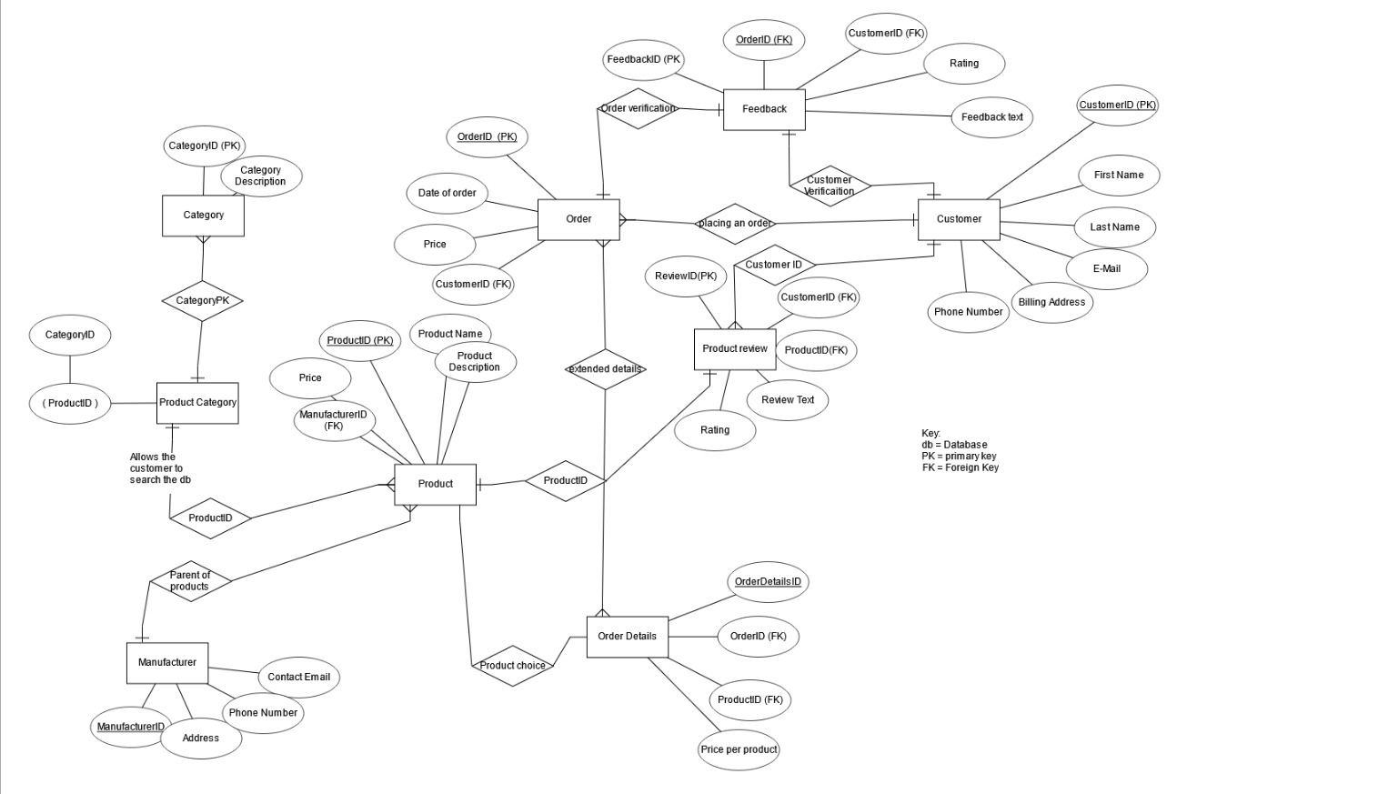
Figure 1 The erd of the database, full scale photo available in the uploaded file

Part 2- Database development

Introduction
With the database design complete the development can begin, this would typically start with Table creations, this is based off the normalised data previously discussed in part 1 Normalisation. This database will not be managed by me after the handover to Adventureworks Cycles, which means the sql queries require a level of comments, to allow for easy cross team cooperation, in an essence I cannot leave them with a piece of code that doesn’t have any comments, as this is bad practice when handing over project to different teams.

SQL Queries
The sql queries I have created are simple, and in smaller files, while this might cause an issue if one file corrupts, it’s a lot safer than having the majority of the database creation, insertion and testing in one file, as the only way to ensure that the root of the database is not lost is by having off site backups such as cloud backups, which would be paying for another service incase of server issues. With my previous experience in database development, I always split the database into multiple sql files, as it increases the readability of the code, and if issues arise they are typically localised to the file that im working on unless foreign keys are used.

Table Creation
When setting up the tables, I can look back on the previous normalisation for the majority of the naming of tables, and attributes with a few changes, when I created the order table I decided to show that reserved words can be used just with a modification that being the backtick, this simplifies a difficult to read database in my opinion, however this can cause issues further on in queries, such as difficulties reading code, or incorrect quote, instead of the database engineer using a backtick(`) they use a single quote (‘). See the file name TableCreation for the full file

Table Insertion
Mass table insertions can cause unexpected issues arise such as formatting for a specific table, if this happens the likelihood of partial data being inserted into the database is incredibly high when this happens it requires the truncate command, to remove the entries into the table, but not delete the table.

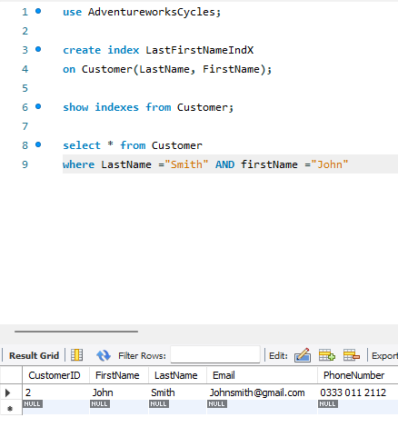
Indexing and Optimisation
Indexing are typically used for just searching through tables, this is incredibly useful for optimisation. However this cannot be repeated for writing into the database as this be much slower than a regular insert into with a rollback feature for the example shown in figure 2, shows an index of the lastname and firstname from the customer table, this will be a much faster way of searching in large scale databases, however as the current scale of this is incredibly small it does not effect the operational efficiency of the server. Figure 2 indexing

Testing
The testing process for this database will be constraint testing plus insertion testing, updates, constraints and joins, the purpose of testing these parameters, is to ensure that the database, works, and is optimised to an extent and can handle being updated without errors. Katalons example states [2] “The components to be tested are usually database schema, tables, and database triggers. Testers leverage SQL queries, data comparison tools, automation frameworks, or load testing” typically in smaller scale operations the testers that they talk about will be the database developer, this is especially challenging when they test each table to ensure the reliability of the data being entered, as sometimes they will modify the code instead of documenting it correctly, which can cause issues in backups.

Constraint testing
When developing a database, its detriment to data validity that there are some constraints setup. Sometimes they are setup in the creation of the database tables, which you can see inside the SQL file for table creation with Ratings in feedback and product feedback, or they might be added later which is kept inside of the SQL query file named alters. A database administrator might add constraints after the setup of the table as it might prevent them from inserting data into the table at a mass rate which happened with my insertion query, to fix this I had to remove the predefined foreign key restrictions, which MySQL automatically creates, Sam Bendayan describes constraints [3] as “Constraints are declarative” this means that once they are declared as a rule they are required to be adhered too. I also tested the attribute of price decimal(10,2) this constrains the data to 2 decimal place, additionally the feedback rating has been tested, this verified that the attribute didn’t allow anything over the number 5 was allocated, See figure 3 for the result.

Backups and Rollbacks
The purpose of a rollback is to revert from a potentially harmful update to the last consistent state, if no backup/ rollback it could result in a completely ruined table or database, depending on the severity of the mistake. In my case if the mistake changed the wrong product id it rolled back to just before the update, the harmful update was set for product id1 (A.200.2 bike) to be reduced to 50% off which could’ve costed the company money however the correct update was pushed which was increasing product id 2 (a200 frame) see below images to see the before, after and during the rollbacks (figures 4, 5, and 6). As geeksforgeeks said [4] “Understanding the differences between these commands is critical for database administrators, developers, and anyone working with transactional data to ensure reliable and error-free database operations. Proper usage of these commands ensures reliable and error-free database operations while maintaining data stability.” The purpose of the rollbacks is to ensure that the database doesn’t run into reliability issues in the data, if it does it can negatively impact the other tables and the overall server efficiency.

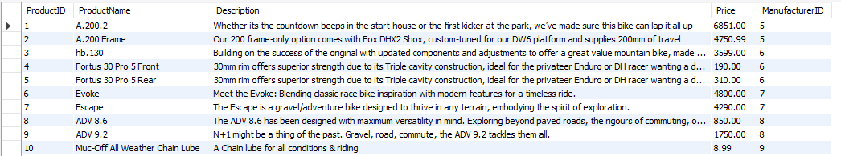
Figure 4 Before roll back
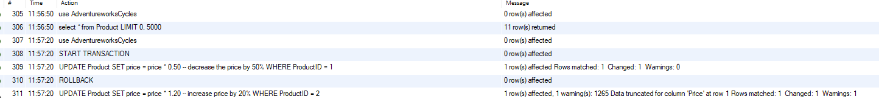
Figure 5 Action output after running roll back.
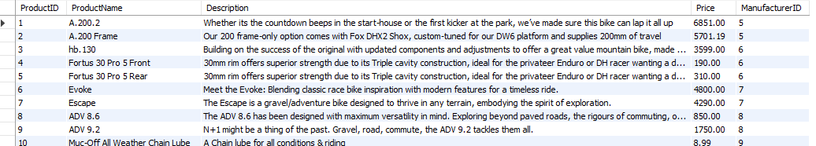
Figure 6 After rollback

Joins
A join is very effective way to approach designing a database, they help retrieve data from two different tables, and display it to read on one there is 4 different types of joins in sql, that being. Left join, inner join, right join and full join. In this example I used productcategory and product, to set category to the product, see figure 7 below:
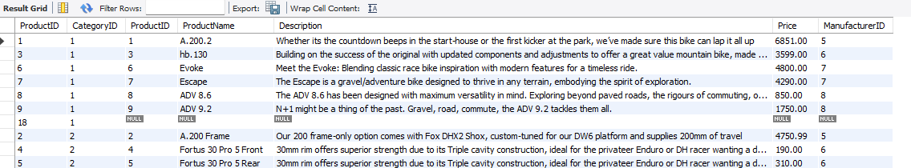
Figure 7 join table, with category and product

Conclusion
To recap, the adventureworks cycles has setup an effective database system which allows orders to be placed, with enough constraints to ensure the data is reliable, which removes a possible liability in the database, along with the joins, which prove that the database is able to handle a number of tables joining together, and provide accurate data to the end user. The normalised data in the design process helped the development with accurate table names and attributes. Overall I believe there is a lot of improvements I could’ve been able to make, such as more constraints for attributes like the phone number, however this solution both works and is effective in optimisation.

Bibliography

[1] | G. Andrus, “Normalization,” DePaul University, 01 01 2025. [Online]. Available: https://condor.depaul.edu/gandrus/240IT/accesspages/normalization3.htm. [Accessed 03 01 2025].
[2] | Katalon, “Database Testing: A Full Guide,” Katalon, 01 jan 2025. [Online]. Available: https://katalon.com/resources-center/blog/database-testing. [Accessed 9 Jan 2025].
[3] | S. Bendayan, “Constraints and the Test-Driven Database,” Redgate, 14 Dec 2011. [Online]. Available: https://www.red-gate.com/simple-talk/databases/sql-server/database-administration-sql-server/constraints-and-the-test-driven-database/. [Accessed 9 Jan 2025].
[4] | geeks for geeks, “ Difference Between COMMIT and ROLLBACK in SQL,” Geeks for Geeks, 19 Dec 2024. [Online]. Available: https://www.geeksforgeeks.org/difference-between-commit-and-rollback-in-sql/. [Accessed 9 jan 2025].

