University of Wales Trinity Saint David
Wales Institute of Science and Art


Engine Performance Characteristics

Vehicle technology ACHA4004

Ben Ellis-Jones
2204298
26/03/23
Contents
1 Introduction 1
2 Methodology and apparatus 2
3 Data 3
4 Conclusions 4
5 References 5

Introduction

Aims of the session
Before the session starts, we will understand the safety features that the dyno has and the precautions we will take to minimise the chance of an accident.
During the session we aim to know how to operate the machine and how the machine gathers raw data.
By the end of the session we aim to have collected a repeatable set of raw data, to understand what the raw data means and then learn how to manipulate the data into values that are more useful and we aim to be able to display the correct information in a clear and helpful manner.
Finally, we aim to have an in depth understanding of what the results mean in terms of engine performance.

The dynamometer is an eddy current dyno. An eddy current is simple a circular current. The dyno is connected to the engine directly through a drive shaft that is bolted at one end to the crankshaft and the other it is connected to the inner casing. When the engine is running, a turning force is applied on the inner casing of the dyno by the engine through the drive shaft. The inner casing moves freely within the outer casing, the rotation of the inner casing creates a changing flux density which in turn crates an eddy current which opposes the motion of the inner casing. This eddy current applies a turning force on the outer casing which is in a fixed position due to the string gage which will give us a reading of between 0 and 10 volts to tell us how strong the eddy current. The faster the inner casing spins, the stronger the eddy current produced will be and the stronger the reading on the string gage.
(Fall, 2020)
(Kola, 2021)

Methodology and apparatus

The dyno is the Schenck WS230 and it only gives one reading which is the voltage measured by the string gage with a range of 0 to 10 volts. It has a maximum power of 230 Kilo watts and a max rpm of 10,000.
Other sensers such as fuel flow metre, Throttle %, Lambda are used along with the dyno results to calculate values of power, torque SFC and others and can be found connected to the engine or on the fuel supply board. Sensors such as fuel and coolant temp gages are there to ensure that the conditions are stable.
The system consists of the engine, a drive shaft which connects the engine to the dynamometer, the dynamometer, fuel injection system, exhaust extraction system, a cooling system, sensors and a computer.
Most of the feeling system is located on the fuel supply board. The fuel starts in the main tank. A lift pump moves the fuel from the main tank to the filter, the fuel then flows through the flow metre on its way to the secondary fuel pod. The fuel the runs through the regulator to the engine. The regulator enables the system to work with a fuel injected engine or non-fuel injected engines.
There is a return line how either, the fuel does not pass through the flow metre in the return line so flow is not measured at this part of the circuit.
The Engine in attached to the dyno for this session was a1.6 litre V-Tech engine produced by Honda out of a 2000/2001 Honda jazz or cr-x. The engine has had a non-original equipment manufacturer (oem) air filter fitted to from a lawn mower and has an alternative silencer fitted to it.
There are three ways to run tests on this dyno. The two main ones are manual and automatic. When in a manual run you have two dials to control the machine. The first dial is for your dynamometer and the second is for your engine. The first dial changes the torque acting against the engine. The second is the throttle, it affects the rpm. In a manual test you twist the dials to get results allowing you to perform sweep tests . In automatic you select specific rpm’s and instead of going up in a smooth curve you go up in increments. In this session we did an automatic test from 1000 rpm up to 5500 rpm increasing with increments of 50 rpm. You have more accuracy and control when performing an automatic test when compared to a manual test.

Data

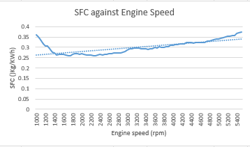
Graphs as seen in my excel submission.
Graph 1 – SFC against Engine speed

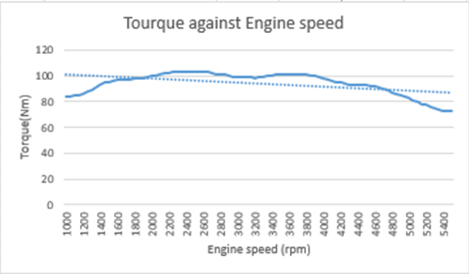
Graph 2 – Torque against Engine speed

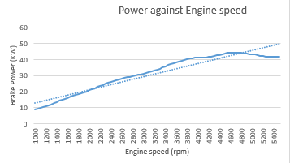
Graph 3 – Power against Engine speed
My raw Data and manipulated data.
(Honda, n.d.)
The equations that I used in order to turn the raw data into other values. Manipulation of data is a critical skill to have especially when working with equipment like an eddy current dyno that gives only one reading. This is because you have to take that singular set of values and work out a completely different set a value. With one set of values this is impossible to find so we can use sensors to gather data. With the dyno results, sensor results and data manipulation we are able to find the values that we want. These are the equations that I used to BMEP, Torque, corrected power and SFC.
To find thermal efficiency I took used Power (KW) / fuel flow (Kg/s) / 100
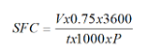
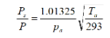
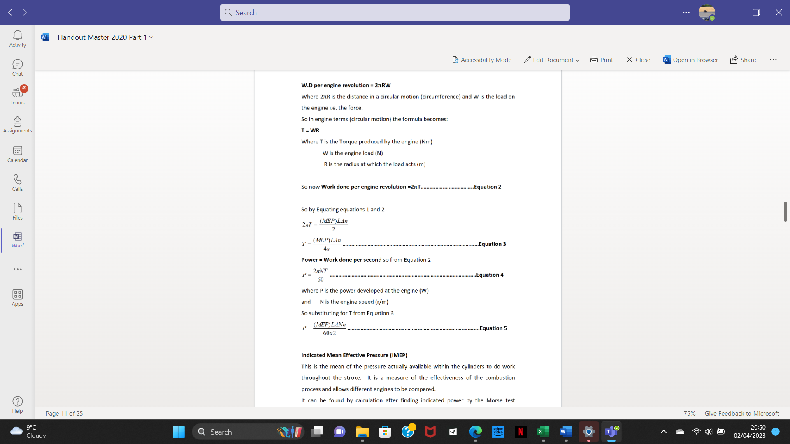
(summerfield, n.d.)

Conclusions
In graph one we can see that the SFC starts at 0.360 at 1000 rpm and decreases rapidly to 0.273 at 1400 rpm. It then steadily increases to a value of 0.374 at 5500 rpm.
SFC is Specific Fuel Consumption so this engine is burning the least amount of fuel at 1750 rpm with an SFC of 0.259.
Overall this engine does not vary too much ranging from 0.259 at its lowest to 0.374 at its peak
In Graph two we can see that the Torque starts at 83.433 NM at 1000 rpm, slowly increases till 2350 rpm where it hits its peak value of 103.458 NM. After decreasing to 98.379 NM at 3200 rpm, the torque climbs back to 101.323 NM at 3550 rpm before steadily decreasing to 72.316 at 5500 rpm.
Graph three shows us the power curve. The graphs shows us that the power increases at a seemingly steady rate before reaching its peak power output of 44.43195 Kilo watts of power at 4700 rpm or 59.58 Brake horsepower (bhp). The power then tapers off as the revs increase to 5500 rpm where the engine is producing 41.912 Kilo Watts of power.
By todays standard this is low performance engine. When comparing this set of results to what we would have see when this engine was new you can see a significant drop in performance. This is to be expected as the engine is now 23/22 years old. Engines lose power when they get older if parts are not replaced due to parts wearing and seals becoming brittle
A typical value for thermal efficiency is 20-30 % and this set of results falls in that bracket.

References
Fall, M., 2020. Engine Dyno Overveiw. [Online]
Available at: https://www.youtube.com/watch?v=-WajOAp2LUE
[Accessed 02 April 2023].
Honda, n.d. [Online]
Available at: https://uowtsd.sharepoint.com/teams/Level4874_GRP/Shared%20Documents/Forms/AllItems.aspx?FolderCTID=0x0120009FC06F482AA0344ABB4797B1F63A1AC8&id=%2Fteams%2FLevel4874%5FGRP%2FShared%20Documents%2FACHA4012%20Vehicle%20Motorsport%20Technology%2FPowertrain%20N
[Accessed 02 03 2023].
Kola, S., 2021. [Online]
Available at: https://www.youtube.com/watch?v=zDRc01bD6a8
[Accessed 03 April 2023].
summerfield, a., n.d. Handout Master 2020 Part 1. [Online]
[Accessed 02 03 2023].

