
Strategic Management (LCMB7003)
Strategic Management of American Express

Student name: Chirag Shaileshbhai Kiyada
Student Number: 2212576
Lecturer: Dr. Hossein Shokri
Submission Date: 08/05/2023

TABLE OF CONTENTS
1.0 Introduction..........................................................................................................................3
1.1 Background...................................................................................................................... 3
1.1.1 Mission and Objectives..............................................................................................4
2.0 Macro-Environment Analysis.............................................................................................. 4
2.1 PESTEL Analysis.............................................................................................................4
2.1.1 Political Factor...........................................................................................................5
2.1.2 Economic Factor........................................................................................................ 5
2.1.3 Social Factor.............................................................................................................. 6
2.1.4 Legal Factor............................................................................................................... 6
2.1.5 Environment Factor................................................................................................... 6
3.0 Micro-Environment Analysis...............................................................................................6
3.1 Industry Life Cycle...........................................................................................................7
3.2 Porter’s Industry Five Forces Analysis............................................................................ 7
3.2.1 Existing competitors (High).......................................................................................7
3.2.2 New Entrants (High)..................................................................................................7
3.2.3 Substitution threats (Low)..........................................................................................8
3.2.4 Bargaining power of buyers (Low)............................................................................8
3.2.5 Bargaining power of suppliers (Medium)..................................................................9
4.0 Internal Analysis.................................................................................................................. 9
4.1 Strategic Resources and Capabilities............................................................................... 9
4.2 Value Chain Analysis..................................................................................................... 10
4.2.1 Primary activities..................................................................................................... 10
4.2.2 Supportive Activities................................................................................................11
4.3 VRIO Analysis of Distinctive Resources and Capabilities............................................ 11
4.3.1 Valuable....................................................................................................................11
4.3.2 Rare..........................................................................................................................12
4.3.3 Imitable.................................................................................................................... 12
4.3.4 Organisation.............................................................................................................12
4.4 SWOT analysis...............................................................................................................13
5.0 Strategies to Sustain Competitive Advantage....................................................................14
6.0 Growth Strategies...............................................................................................................16
6.1 Integration Strategy........................................................................................................ 16
6.2 Application of Spencentric business model................................................................... 16
7.0 Green Strategy and CSR.................................................................................................... 17
8.0 Conclusion..........................................................................................................................18
9.0 Recommendation................................................................................................................19
References................................................................................................................................19
Appendices...............................................................................................................................23
Appendix 1: PESTEL Analysis of American Express......................................................... 23
Appendix 2: American Express Revenue Growth............................................................... 24

1.0 Introduction
This assignment is associated with evaluating the business process of American Express to understand the business strategies for managing long-term growth. It has been focused on the strategic management process for evaluating the CSR strategies, growth strategies as well as strategies for gaining competitive advantages. It has been focused on making micro as well as macro environmental evaluation with some effective theories and models for understanding the current business situation and strategy of the business to deal with different external forces. The business corporation has made the decision to sell off the majority of its assets in order to raise money and strengthen what was then considered to be the centre card business including travel services. In this dimension, some have also applied some models for making internal analyses for evaluating the strategic management process of the business for managing long-term process growth.

1.1 Background
American Express offers financial, network, plus travel services internationally. It was established in 1850 and has subsequently developed into a Fortune 500 firm. The business offers customers charges as well as credit cards, traveller's checks, as well as other stored-value goods. This world's leading travel agency, charge credit card company, plus issuer of traveller's checks are all affiliated with American Express. Additionally, it provides investment services like insurance, mutual funds, and brokerage, including organising your finances. It has 2,300 offices worldwide and serves 175 countries.
"American Express Travel Related Services (TRS), The American Express Bank Ltd. (AEBL), and American Express Financial Advisers" are some of its primary subsidiaries. American Express has been led by a set of values that are unwaveringly committed to conducting business in further than 130 nations with honesty including integrity while providing our cherished clients with high-quality goods plus services (Khalid and Rahman, 2019). As a well-known brand leader worldwide, they take their dedication to "Merchants seriously". This manual aims to enlighten readers regarding American Express as well as the advantages of using the "American Express® Card for merchants". In 1915, the corporation made the decision to engage the travel industry in order to transform this into a financially sustainable activity. its company was offering excursions to "South Africa, India, Europe, and the Far East", and it had established a reputation for providing opulent travel plans. The business issued its first credit card around 1958, but according to Amex executives, a billion cards were in use within five years.
In the 1970s, "American Express" made investments within or bought a variety of businesses in an effort to expand into a large conglomerate, including "Shearson Loeb, First Data, Investors Diversified Services, Trade Development Bank, and Lehman Brothers" (Saudi, 2021). In order to form a joint venture with "French investment group Certares" and operate the travel business as an equal shareholder, "American Express" divested itself of its travel business in 2014.

1.1.1 Mission and Objectives
The mission statement of American Express might be to give the biggest global consumer experience each day. The business demonstrates its unwavering resolve to go above and beyond to satisfy its clients including its offerings. It is offering of banking services plus related goods have been "American Express's" primary business activity. The company provides appealing, dependable, as well as secure products including credit cards plus commercial credit cards to its professionals with integrated systems. Its many corporate programs including savings accounts are some more offerings that demonstrate its maturity.
As per the Mission, the main objective of the company is as follows:
- To identify the different types of issues American Express has been facing.
- To analyze the economic growth with the help of strategic management of American
Express

2.0 Macro-Environment Analysis
Macro environment analysis is involved with analyzing external macro aspects where application of PESTEL analysis would be effective for analyzing some major dimensions.

2.1 PESTEL Analysis
The firm's strategies are assessed in "An American Express PESTLE Analysis" using a variety of criteria. PESTEL Analysis is related to several extrinsic factors that have an impact on the business of this brand are highlighted in this PESTLE Analysis. Businesses such as American Express must employ the PESTLE analysis approach since it enables them to fully comprehend market trends as well as continuously enhance their operations.

2.1.1 Political Factor
Politics play a significant role whenever businesses like American Express are involved. Several factors had an impact on the firm's profitability & long-term viability. As a result, the political system of government is crucial. A country's political stability must be taken into consideration while the firm develops its strategy. Since local governments implement the entirety of a country's policies, it has an essential function. Businesses such as American Express are constantly in danger of political turmoil (Benitez, 2019). Adopting security measures and insurance that covers any potential losses from such assaults may therefore be wise. Government finances have an effect on businesses in addition because long-term budget deficits by states can increase inflation. It can also be found that Political difficulties have a significant impact on such elements that could affect "American Express Company's long-term profitability" in a given country or region. " American Express Company" is subject to risks associated with an assortment of political settings as well as systems as a result of its activities in more than a dozen different nations. To prosper in a dynamic industry like financial services across numerous countries, it is vital to diversify all systemic risks associated with this political climate.

2.1.2 Economic Factor
The company must therefore evaluate the exchange risk when expanding to a new country. Rising consumption levels in the US combined with stagnant average earnings fueled credit-fueled spending binges. When individuals lack the means to save, this culture has been destroyed. Amex Express needs to use prudence when developing a marketing plan based on "Purchase on Credit" consumer behaviour (Saari, 2022). A high "unemployment rate" will affect Amex Express's plans in two ways: first, it will ensure that there are enough consumers for such company's products, and second, this must raise the cost of hiring talented and qualified employees. It can also be observed that the macro-environmental elements, like the "inflation rate, savings rate, interest rate, foreign exchange rate, and economic cycle", impact the aggregate demand along with total investment in a country (Dyer et al., 2021). Even so, small-scale factors like industry standards mostly affect a company's competitive advantage. By using national economic indicators such as growth rate plus inflation along with business economic indicators such as "Credit Services industry growth rate, consumer spending", etc., "American Express Corporation" may be able to predict the future growth of such complete —sectoryname— sectors along with the company.

2.1.3 Social Factor
The level of schooling together in society affects both the quality and pay of the job that is produced. Higher levels of education have traditionally been associated with greater salaries, increased income, and expenditure on expensive plus aspirational goods. The quality of such a company’s products including the “cost structures” of its production processes frequently reflects its firm's "health and safety" philosophy. Due to its strict health & safety requirements, American Express may compete in developing areas with businesses that do not have a similar "high-cost structure as American Express". It can also be found that its organisational culture inside a specific situation is influenced by the way of life along with societal culture (Ballesteret al., 2019). “Marketers at American Express Corporation" take into account the common beliefs & values of the populace when trying to understand a company's customers, such as when creating marketing messages for consumers in the "Credit Services business".

2.1.4 Legal Factor
American Express shouldn't have to be overly concerned regarding monopoly and restrictive competition law restrictions because it is a relatively young company. Amex Express is required to evaluate the extent to which legal protection is provided for "intellectual property rights" in the country. When moving into a fresh market, Amex Express must learn about the local business rules and how they differ from those found in its own country.

2.1.5 Environment Factor
American Amex should look into how concerned consumers are about environmental issues. Amex Express would be able to provide ecologically friendly goods and avoid PR stumbling blocks as a result (Anastasiuet al., 2020). To maintain norms, organisations which maintain environmental standards are crucial. Yet, those groups frequently use stalling tactics to demand bribes from impoverished countries. American Express must be made aware that similar activities are being carried out in several countries. [Referred to Appendix 1]

3.0 Micro-Environment Analysis
This section of the assignment is related to applying some models to evaluate the micro-environmental aspects of American Express. Micro analysis shows some changing in micro business environment that can directly affect the business process.

3.1 Industry Life Cycle
There is very little product differentiation. Exception for company-internal discounts & rates, none of the main credit/debit card firms actually differentiate themselves since all of them operate electronically including there hasn't been any significant advancement recently. Both the industry life cycle along with the industries life cycle was still in the growth stage for the company including its rivals. Its only viewpoint worth addressing pertains to research & development inside the business sector since all other parts of such four competitive settings were previously covered in the article. The limitations around what American Express is able to do to gain a competitive advantage somewhere at the moment have already been addressed. Technology, as well as innovation, constitutes the most crucial component because until something new is developed, there won't be several changes within the business.

3.2 Porter’s Industry Five Forces Analysis
Porter’s five force model is used to analyze the micro environmental factors including existing rival businesses, new businesses, buyers’ and suppliers’ power for bargaining, substation threat and others.

3.2.1 Existing Competitors (High)
The intense competition amongst existing businesses may lead to price reductions as well as a loss in the firm's corporate profitability. American Express Inc competes in a very cutthroat market for credit services. Its rivalry has an impact mostly on the business's overall long-term profits. by forging a long-lasting differentiation and growing in size to boost its competitiveness. Also, research has found that expanding the market together with competitors is better than merely battling for a small market.

3.2.2 New Entrants (High)
New competitors within the financial services market have put "American Express Corporation" under a lot of strain by utilizing a lower price strategy, decreasing costs, and providing innovative value propositions to customers. "American Express Company" should handle all those challenges & create strong barriers to safeguard its competitive edge (Irfan et al., 2019). by creating new products including services. By achieving scale savings which would lower the variable price of every unit, innovative products not only draw in new clients but also encourage current ones to keep doing business with American Express Company.
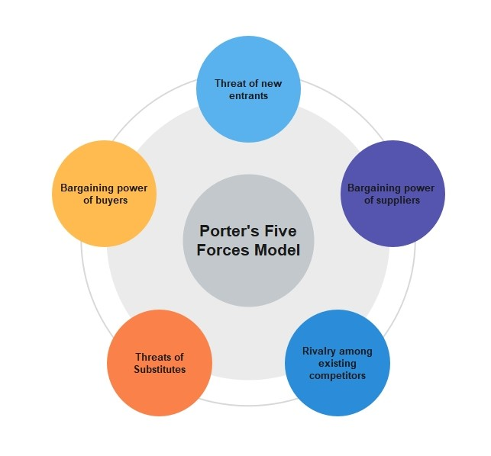
Figure 1: Porter’s five force model
(Source: drawing, 2021)

3.2.3 Substitution threats (Low)
In this context, industry profitability declines anytime a fresh service or product addresses a comparable client demand in an innovative way. Services such "As Dropbox and Google Drive" can totally replace disc drives. A significant threat exists whenever a rival good or service provides a value proposition that differs significantly from the ones provided by the products that are already accessible by focusing on services as opposed to mere products. and by focusing on the fundamental requirements that the consumer has instead of the item they are purchasing (Henry, 2021).

3.2.4 Bargaining power of buyers (Low)
Due to the availability of different alternatives in the market environment, the power of buyers is increasing and this is a challenge for the business to maximize the profits. In this context, American Express is associated with the strategy of bringing differentiated solutions by considering the great customization for different audience groups for generating higher value. As a result, they have the option to decide what meets their financial needs as well as help them achieve financial independence.

3.2.5 Bargaining power of suppliers (Medium)
The majority of companies, mostly in the credit services industry, get their raw materials from a range of suppliers. There is a chance that competitors inside a "dominant position" will cut into any margins which American Express could otherwise make in that area. Powerful financial industry providers use their negotiating position to pressure credit providers for higher fees. Increased "supplier bargaining power" often results in fewer profit possibilities for Credit Services.

4.0 Internal Analysis
This section of the report is associated with the application of different models for making an internal analysis of the business process of American Express. The internal analysis is related to is to understand the business strategy to manage different activities to bring greater efficiency to the internal environment.

4.1 Strategic Resources and Capabilities
Strategic resources and capabilities model assists the business to the staff members to enhance their abilities. American express can also consider this for hiring staff members with better salaries and bonuses, work environments, benefits, and growth opportunities, among other things.
Effective consideration of the motivation of employees and the development and retention of talent can assist the organisation in developing an innovative process and enhancing the productivity level. As a consequence, workers for American Express have become a valuable resource that gives them a short-term competitive advantage. They might eventually be purchased by rivals (Gehl and Porter, 2020). American Express' supply chain is also very expensive, making it an excellent source of information for gaining an advantage. American Express must have slowly developed this over the course of years. Competing companies must invest significantly to replicate a similar supply system.
In the context of the capabilities, Company’s cost structure is associated with some inefficiency. This is because the processing techniques have increased expenses more than their rivals, which has an impact on the company's net revenue. This cost basis is a significant flaw that needs to be fixed as a consequence. At American Express, the promotion appears to be an unnecessarily wasted opportunity. This is a consequence of the reality that the costs associated with research and development far outweigh the benefits it provides in terms of innovation. Merely a few businesses have recently introduced cutting-edge features plus revolutionary items (Iruthayasamy and Iruthayasamy, 2021). American Express is consequently at a disadvantage compared to the field of research including development. This is recommended that its development & research groups be bolstered but that expenses be decreased.

4.2 Value Chain Analysis
The application of Porter’s value chain model can assist in understanding the primary as well as secondary activities of American Express and business strategies to gain efficient internal efficiency.
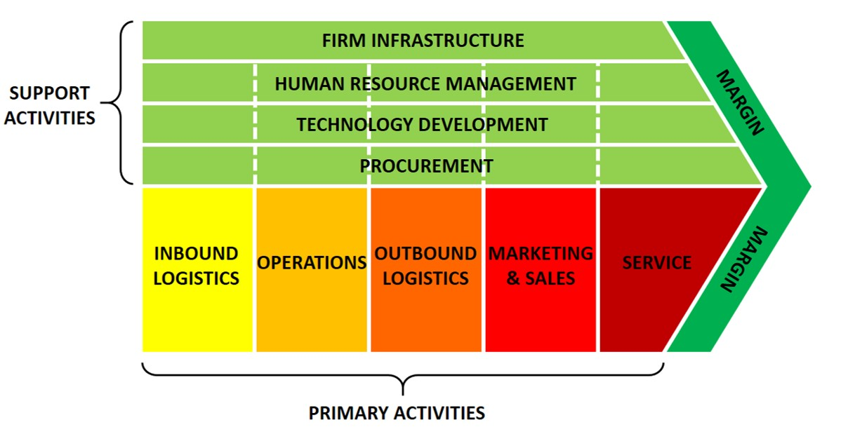
Figure 2: Value chain Analysis
(Source: business, 2022)

4.2.1 Primary activities
It is essential to develop lasting connections with vendors because receiving must begin with their support, retail outlet, and selling the goods. Without evaluating logistics activities, Several challenges could arise for American Express even during the production process. "Inbound logistic support" assessment demands that a business pay close attention to each step of the procedure, from start to finish. American Express has prepared to transform the raw data into the finished product as well as launch it towards the market whenever the collected items are obtained, and the analysis of organizational operations grows (Kaliannanet al., 2022). Machine tools, packing, constructing, and checking are instances of operating processes. This group additionally encompasses equipment service and repairs. American Express would then demonstrate the value and differentiators of its product offerings in order to persuade consumers that its providing is superior to competitors. Less than producing an elevated item at a reasonable cost with unique features could indeed generate wealth till American Express puts money into sales and marketing operations (Hridoy, 2020). Salespeople and advertising agencies are crucial in this situation.

4.2.2 Supportive Activities
Quality assurance, legal matters management, financial reporting, financing, preparing, and strategic leadership are all examples of firms overall in the project. American Express could maximize this same value of the entire value chain with efficacious infrastructure. American Express could indeed maintain influence over the potential of this technology (also known as overhead expenses) in order to strengthen its market share (Henry, 2021). American Express can assess the handling of human resources by examining various HR aspects such as recruitment and selection, selection, training, appreciation, reward systems, or other managerial actions. Based on the encouragement, dedication, and skill sets of its workforce, efficient handling of human resources can enable American Express to lessen market rivalry.

4.3 VRIO Analysis of Distinctive Resources and Capabilities
VIRO analysis is associated with such an analysis that can help a business in determining the current competitive position and manage continuous growth in the existing environment.

4.3.1 Valuable
This same American Express VRIO Assessment demonstrates that American Express's monetary support is extremely valuable because it assists in wanting to invest in the outside possibilities which arise. These then aid American Express through its fight against external enemies. According to the American Express VRIO Study, local packaged goods are an incredibly valuable resource cos of their wide variety. As a consequence, customers highly value these. Due to their differentiation, consumers value such product lines above that of their competitors.
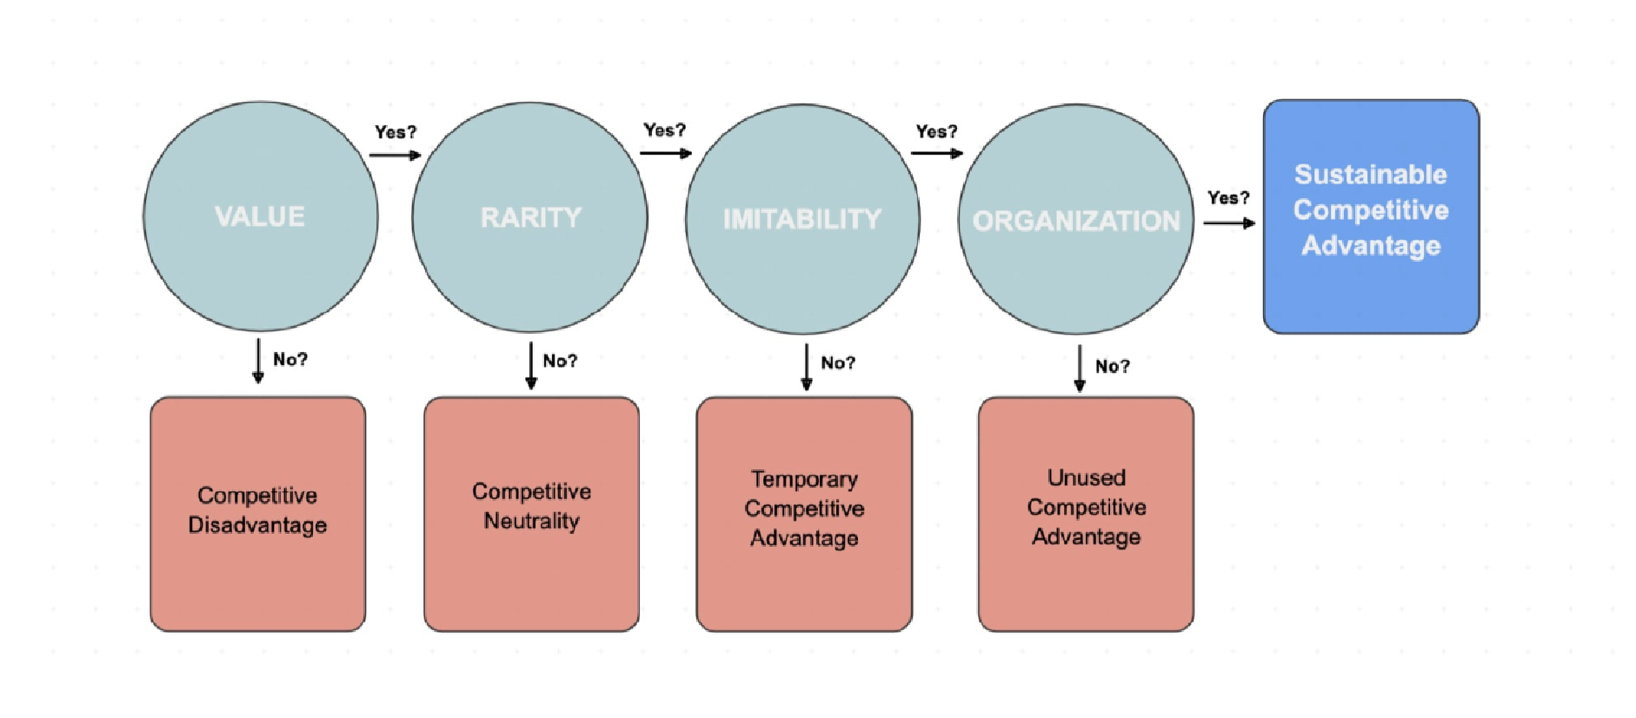
Figure 3: VRIO Analysis
(Source: question, 2022)

4.3.2 Rare
Based on the VRIO Assessment of American Express, the Firm's financial assets were in short supply. American Express businesses associated with the have significant financial resources (Younas et al. 2022). According to the VRIO of American Express, its staff members are a scarce resource. The above staff members are exceptionally educated and talented, A concept that's not applicable to staff members at other businesses. Even these employees are kept from considering departing for other organisations thanks to better compensation plus working circumstances (Dyer et al., 2021).

4.3.3 Imitable
Based on the VRIO Analysis, imitating American Express's monetary resources is difficult and expensive. This same company bought these assets in the past through sustained profits. To accumulate those same quantities of cash, new competitors and competition would need similar revenues for a lengthy amount of time. As recognised by this analysis, American Express's patent claims are extremely challenging to replicate (Read et al., 2020). This is the reason why it is unlawful to attempt to copy a specific idea. Comparable resources should be established, as well as acquiring the necessary "intellectual property rights" might be costly.

4.3.4 Organisation
American Express's money and resources are arranged to capture value, as determined by the VRIO Evaluation of American Express. These funds are smartly deployed to make investments that are appropriate, capitalising on possibilities as well as combating threats. As a consequence, these resources give American Express its long-term competitive advantage. This company's patent rights really aren't properly organised, based on the VRIO Study. This indicates that a company is not utilising its "intellectual property rights" to their maximum potential (Puytet al., 2023). If American Express begins selling patented goods before their patents lapse, unused competitiveness can indeed be converted into a profitable competitive edge.

4.4 SWOT analysis
In the context of American Express, The SWOT analysis is the process of evaluating strengths, weaknesses, threats as well as opportunities of business.
Strengths  - The greatest attribute of American Express is its staff members. There are 64,500 workers at American Express. This company upholds business performance and offers personnel training to strengthen the organisational framework. A happy, diverse workforce is a wonderful place to work. Dedication and skill sets of its workforce.  - American Express has a solid financial standing. In 2019, American Express seems to have $8.41 billion in operational profit & $43.56 billion in revenue.  - American Express, furthermore named AMEX, has the benefit of falling into the category of many vital businesses on the planet. As of  2016, it was the 59th least-valuable | Weaknesses  - American Express's line of products focuses on one as well as two key things. Still, AMEX would undoubtedly gain from more U.s.-based economic and past product lines.  - Another issue is the lack of  American Express card payments. Whilst also American Express credit card numbers Debit cards have yet to be frequently examined. The business may benefit if such a constraint is met (Cai et al., 2021).

brand worldwide. It may utilize the goodwill it has established to its advantage to attract system inspectors toward its future endeavours.
Opportunities  - It presents an excellent chance to boost the use of credit cards in global economies. In countries with emerging markets, the usage of credit cards is widespread. Because internet buying is becoming more and more popular, credit cards seem to be popular. American Express is therefore acceptable for use  (Hepburn et al., 2021).  - American Express is rapidly growing its operations. This same business doesn't have a large global footprint and therefore will compete throughout overseas markets. Innovative strategies - Another option for American Express seems to be the development of new programmes to attract new  customers. (Dyer et al., 2021) | Threats  - Although Americans appear to be industry leaders, they aren't the only people. In the waters, there are several enormous fish frantically pursuing overall sales. Maintaining a competitive edge is a danger along with a task.  - American Express' biggest competitor seems to be Visa but also MasterCard, both of which have well-known brands. Among the nation's biggest lenders, American Express needs to compete in the market for credit cards to  Uncovering, Visa, as well as  Mastercard.

5.0 Strategies to Sustain Competitive Advantage
A number of American Express credit payment advantages are extremely beneficial.
Warranties, transportation protection laws, and connecting directly to pre-sale ticket holders to concerts and sports competitions are common Amex prepaid debit benefits that can justify a higher annual membership fee. Furthermore, Amex account holders receive continuous benefits such as a free ShopRunner subscription but instead special offers here on the American Express Observations hub. In the context of sustaining competitive advantage, the business is associated with a strong service differentiation strategy for establishing greater value from the potential customers. Apart from that business process is associated with a strong digital marketing strategy to position value stronger where the digital presence of business has grown thanks to industry-leading intelligent automation and the acquisition of millennial customers (Shapiro, 2019). The premium product is a distinct competitive advantage on its own. No contender can start competing with their rewards programme or customer base of corporate donations, which effectively forces merchants worldwide to accept Amex. Some essential differentiated services of the organisation are as follows: Effective Travel Protection: American Express credit prepaid debit advantages include travel benefits when making reservations. Because of these valuable benefits, readers can often refrain from buying liability coverage to insure someone's trip. This travel insurance is included as part of the annual membership fee. Trip withdrawal or trip interference medical coverage, trip delay insurance, hand luggage insurance, and vehicle rental safeguards vary depending on the particular American Express card.
Complimentary hotel nights as well as property credit: When booking two successive nights or perhaps more through business Transportation, card members with both the Amex Metal, and American Express Business Prepaid Card, but also Centurion Representatives can appreciate The Hotel Data gathering benefits. These American Express prepaid debit advantages may also include free nights or real estate credits (Moldoveanu and Narayandas, 2019). Furthermore, when making reservations for Fine Hotels + Resort towns or Perhaps the Hotel Collection characteristics through the borrower's portal, qualified cardholders can have capabilities nights or hospitality credits of $100 or maybe more.
Augmented level services out of Amex card benefits: Some provide benefits such as spending free extra categories, additional product safeguards, and cash rewards special offers. Learn about American Express cards available to determine the best fit for oneself based on the willingness to pay interest charges, the spending maximum allowed, the likelihood that someone is a frequent traveller, and one's credit score. A few really ultra-premium cards have especially high extra fees, but they may provide more important advantages to compensate.

6.0 Growth Strategies

6.1 Integration strategy
American Express has so far been starting to work to strengthen its worldwide, interconnected system by continuing to increase merchant recognition, offering merchants embezzlement additional security, marketing knowledge and insight, as well as connections to relatively high Cardholders, and collaborating with network suppliers to provide increasingly broad services and goods. American Express plans to further strengthen its premium consumer governance by trying to continue to provide a membership that covers its customers' daily spending, lending, travel, and way of life needs, broadening its lineup of business collaborators worldwide, as well as developing a broad range of offerings that generate large clients (Ebrahim and Buheji, 2020.). American Express aims to strengthen its stance in advertising payments by developing its card product offerings, trying to distinguish corporate credit card and payables expense management services, as well as designing innovative services and amenities for some of its corporate customers, such as sources of finance, financial services, and payment services.

6.2 Application of Spend-centric business model
American Express seems to have a "spend-centric" company model that generates revenue primarily through card expenditure and secondary revenue through finance charges and other expenses. American Express prepaid debit expenditure, which would be larger on overall mean per card than competitors, provides excellent value to vendors in the shape of loyal customers as well as larger money transfers (Harrison, 2021). Given the substantial revenues that are generated by spending heavily on Card Members and indeed the yearly basis card fees charged by American Express on a variety of its merchandise, the business may provide appealing benefits and some other advantages to Cardholders, as well as direct advertising and other programmes and investments to merchants. This encourages Card Representatives to splurge on more one‘s cards as well as helps American Express credit cards stand out. Discount revenue, the business's largest source of revenue, is indeed the funds it earns and keeps from merchant payments made for acting as an intermediary among both Card Members as well as merchants using American Express disbursement products. Discount income grew by 25% in 2022, potentially resulting in an increment in Card members having to spend volumes throughout the year. The rate of return is primarily made up of investment earnings on absolutely stellar loan balances. This same average daily alignment method is used to calculate involvement in Card Member debts. Net interest margin increased whilst also 28% in 2022, owing primarily to increases in Consumer Credit loans. Net card fees are revenue generated from yearly basis card subscription fees, which differ depending on the kind of card as well as the multitude of cards associated with each consideration (Colleoni et al., 2022). Net card payments were enhanced by 17% throughout 2022 even though new credit card mergers and acquisitions managed to reach all-time highs and Card Member retention kept rising, displaying the impact of premium superior value assets. Service charges as well as other earnings mainly portray service charges earned from vendors and other consumers, travel committees and fees, delinquency processing fees to Cardholders, currency exchange processing fees to Cardholders, and revenue (decrease) from investments. In 2022, service charges and other ways of increasing by 36%, owing in part to higher transportation revenues. [Referred to Appendix 2]

7.0 Green Strategy and CSR
The ESG objective at American Express would be to help both individuals and companies thrive while also creating equitable, resilient, and financially viable communities around the world. We aim to mobilise with the company to discuss important global challenges while also delivering the highest initiatives that benefit our coworkers, clients, and neighbourhoods. Researchers introduced an updated road - map for the global ESG strategic approach in 2021, developing innovative long-term objectives and targets in three areas of the greatest importance for our corporation, interested parties, and culture: Promote Diversity, Fairness, and Participation (DE&I); Advance Climatic change Solutions; and Create Financial Self-belief. Through the 2021-2022 ESG Document, researchers achieved significant achievements towards the goals in 2021 and 2022. incredibly important ways a business can support the stakeholders is to protect as well as preserve the natural world on which survival depends. So even though changing climate ranks as one of the most significant challenges they face, business is dedicated to decreasing our carbon dioxide emissions in accordance with the International Commission on Climate Anthropogenic climate recommendations (IPCC).
Environmental Sustainability: Energy use and carbon leadership, wastewater treatment, third-party green construction accreditations, and strategic sourcing are among the environmental priorities. In addition to the commitments to minimise energy use, water usage, and end up wasting in the processes, the business is also working to develop more environmentally conscious goods within the company, including one with a payment method made from salvaged marine plastic in collaboration with Bilateral meeting again for Oceans (Islam, 2019). Finally, designers strive to supply environmentally as well as socially conscious goods and assistance from fourth vendors who have been approved by the business.
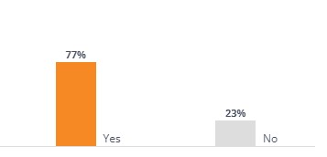

Figure 4: Employees' pride in the CSR efforts of the companies
(Source: comparably, 2022)
Community impacts and philanthropy: The Company supports the communities in which the clients and colleagues reside as well as work. It is investing cash and personnel in ways that meet the cultural, environmental, as well as financial interests of the communities, consumers, colleagues, and shareholders, but instead partners benefit both with business and the community members.

8.0 Conclusion
It can be concluded that American Express offers financial, network, plus travel services internationally. It has been found that this business was founded in 1850 and has since grown to become a Fortune 500 company. It can also understand that American Express might be given the biggest global consumer experience each day. It has been found that this business offering banking services plus related goods has been "American Express's" primary business activity. It has been identified that PESTLE analysis helps to understand the company's different types of issues like "political, economic, social, technological, environmental and legal factors. This PESTLE Study highlights the different extrinsic factors that affect its brand's business. It has been shown that using the PESTLE analysis methodology is essential to businesses such as American Express since it enables them to fully comprehend market trends & keep their operations improving. It can also understand that there is very little product differentiation. Exception for company-internal discounts & rates, none of the main credit/debit card firms actually differentiate themselves since all of them operate electronically including there hasn't been any significant advancement recently. It can also be observed that different internals has been applied for this research and which is gein the proper analysis of the chosen organization. It can help to gain knowledge of the value chain analysis and also learn the value chain evaluation techniques of the American Express company. It can VIRO analysis which explains the valuable, rare and immutable organisation. aim to mobilise with the company to discuss important global challenges while also delivering the highest initiatives that benefit our co-workers, clients, and neighbourhoods.

9.0 Recommendation
This section is associated with recommending some essential strategies that can assist the business process of American Express to gain more effective results from the strategic management process. Some essential strategies are as follows:
- American Express can strongly consider the affinity marketing process by collaborating with different other organisations. This collaboration can assist the business in enhancing the customer base by offering different effective values for the potential audience (Martínez-Hernández et al., 2022). For instance - the use of the business can offer discounts to people to gain different products or services.
- It can be applied to the Stakeholders Matrix for understanding the power or influence and the interests of different stakeholders (internal as well as external both). Based on this consideration, businesses can make a decision to consider generating high value for those stakeholders who have higher power and are associated with high influence as well as interests.
- American Express can also apply the content marketing strategy for influencing customers and converting them to consumer business offerings. Strategic and customised online content marketing can assist businesses in generating value for different audience groups based on their occupation, income and interests.

References
Anastasiu, L., Gavriş, O. and Maier, D., 2020. Is human capital ready for change? A strategic approach adapting Porter’s five forces to human resources. Sustainability, 12(6), p.2300.
Ballester, B., CALÁS, E., LABARCA, R., PESTLE, W., GALLARDO, F., CASTILLO, C., PIMENTEL, G. and OYARZO, C., 2019. anthropozoologica.
Benitez, C.J.R., 2019, October. Poetics of Pestle and Mortar: An Ecofeminism after Tuglibung and Mebuyan. In The 7th LITERARY STUDIES CONFERENCE (p. 24).
Cai, Y.J., Choi, T.M. and Zhang, J., 2021. Platform supported supply chain operations in the blockchain era: Supply contracting and moral hazards. Decision Sciences, 52(4), pp.866-892.
Colleoni, E., Romenti, S., Valentini, C., Badham, M., Choi, S.I., Kim, S. and Jin, Y., 2022. Does culture matter? Measuring cross-country perceptions of CSR communication campaigns about COVID-19. Sustainability, 14(2), p.889.
Ebrahim, A.H. and Buheji, M., 2020. A pursuit for a ‘holistic social responsibility strategic framework’addressing COVID-19 pandemic needs. American Journal of Economics, 10(5), pp.293-304.
Gehl, K.M. and Porter, M.E., 2020. The politics industry: How political innovation can break partisan gridlock and save our democracy. Harvard Business Press.
Harrison, V.S., 2021. Does your corporation “care”? Exploring an ethical standard for communicating CSR relationships online. Public Relations Inquiry, 10(3), pp.333-356.
Hepburn, C., Qi, Y., Stern, N., Ward, B., Xie, C. and Zenghelis, D., 2021. Towards carbon neutrality and China's 14th Five-Year Plan: Clean energy transition, sustainable urban development, and investment priorities. Environmental Science and Ecotechnology, 8, p.100130.
Hridoy, R.A., 2020. SWOT Analysis of City Bank Ltd.
Irfan, M., Zhao, Z.Y., Ahmad, M., Batool, K., Jan, A. and Mukeshimana, M.C., 2019. Competitive assessment of Indian wind power industry: A five forces model. Journal of Renewable and Sustainable Energy, 11(6), p.063301.
Iruthayasamy, L. and Iruthayasamy, L., 2021. The resource-based view. Understanding Business Strategy: Confusion and Consensus, pp.63-74.
Islam, S.B., 2019. American Express Card of The City Bank Limited.
Kaliannan, M., Darmalinggam, D., Dorasamy, M. and Abraham, M., 2022. Inclusive talent development as a key talent management approach: A systematic literature review. Human Resource Management Review, p.100926.
Khalid, L.S. and Rahman, I.A., 2019. Conceptual model for the external factors affecting project performance using PESTLE factors. Journal of Advanced Research in Dynamical and Control Systems, 11(3), pp.246-250.
Martínez-Hernández, J., Parra-Reyes, N., Guerrero-Martín, L.E., Camacho Galindo, L.S., Salinas Silva, R., Alberto Guerrero, W. and Andrés Guerrero-Martín, C., 2022. A SWOT Analysis for Wind Energy Potential Assessment in Colombia. Revista Fuentes, El
ReventónEnergético, 20(1).
Moldoveanu, M. and Narayandas, D., 2019. The future of leadership development. Harvard business review, 97(2), pp.40-48.
Puyt, R.W., Lie, F.B. and Wilderom, C.P., 2023. The origins of SWOT analysis. Long Range Planning, p.102304.
Read, Q.D., Brown, S., Cuéllar, A.D., Finn, S.M., Gephart, J.A., Marston, L.T., Meyer, E., Weitz, K.A. and Muth, M.K., 2020. Assessing the environmental impacts of halving food loss and waste along the food supply chain. Science of the Total Environment, 712, p.136255.
Saari, M., 2022. Combining SWOT and PESTLE to a new strategic tool: A new approach on researching and internationalization strategy.
Saudi, M.H., 2021. Risk Management Analysis for ICT Strategic Plan by Using PESTLE: A Case Study. Turkish Journal of Computer and Mathematics Education (TURCOMAT), 12(8), pp.1732-1737.
Shapiro, C., 2019. Protecting competition in the American economy: Merger control, tech titans, labor markets. Journal of Economic Perspectives, 33(3), pp.69-93.
Younas, M., Hussain, K., Ghaffar, A., Atiq, M., Hussain, N., Abbas, W., Khan, M.A., Nadeem, M., Irshad, M., Khan, N.A. and Zubair, M., 2022. Assessment of Genetic Variability in Onion against Purple Leaf Blotch Disease under Field Conditions and its Management.
Sarhad Journal of Agriculture, 38(431).

Books
Dyer, J.H., Godfrey, P.C., Jensen, R.J. and Bryce, D.J., 2021. Strategic management: Concepts and cases. John Wiley & Sons. “This book represents the strategic management concept to determine the way business should adopt different strategic level activities for gaining long term value”
https://books.google.co.in/books?hl=en&lr=&id=6vmgEAAAQBAJ&oi=fnd&pg=PR5&dq= Dyer,+J.H.,+Godfrey,+P.C.,+Jensen,+R.J.+and+Bryce,+D.J.,+2021.+Strategic+management:
+Concepts+and+cases.+John+Wiley+%26+Sons.&ots=LgjbxJAPJd&sig=yOVfiC4K4-5mxO
Pjaq6SppnrYB0&redir_esc=y#v=onepage&q&f=false
Henry, A., 2021. Understanding strategic management. Oxford University Press. “The strategic management is the process of designing long-term growth strategy based on business, corporate and functional level”
https://books.google.com/books?hl=en&lr=&id=M7wyEAAAQBAJ&oi=fnd&pg=PP1&dq= Strategic+Management+of+American+Express&ots=Z3A0wjaAAt&sig=HUUFzLsYpeN0bs qGiF6cwi_s_Ko
Websites
Business, 2022
https://i0.wp.com/www.business-to-you.com/wp-content/uploads/2018/03/Value-Chain-1.png Comparably, 2022 https://www.comparably.com/companies/americanexpress/sustainability
Edrawmind,
2021https://images.edrawmind.com/article/porters-five-forces-analysis-definition-and-examp les/porters-five-forces-model.jpg
Questionpro, 2021
https://www.questionpro.com/blog/wp-content/uploads/2021/10/VRIO-analysis-how-to-min.j pg

Appendices

Appendix 1: PESTEL Analysis of American Express
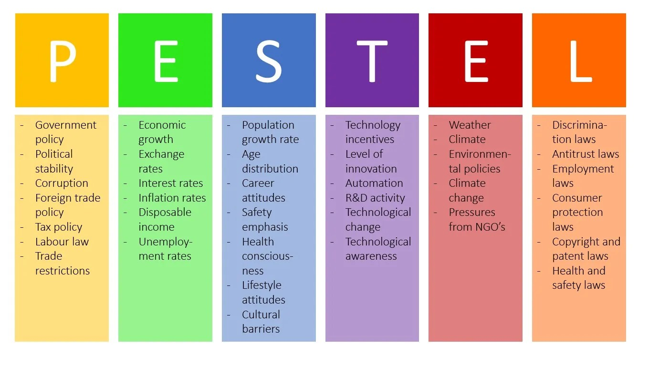
(Source:
https://i0.wp.com/www.business-to-you.com/wp-content/uploads/2016/09/PESTEL.jpg)

Appendix 2: American Express Revenue Growth
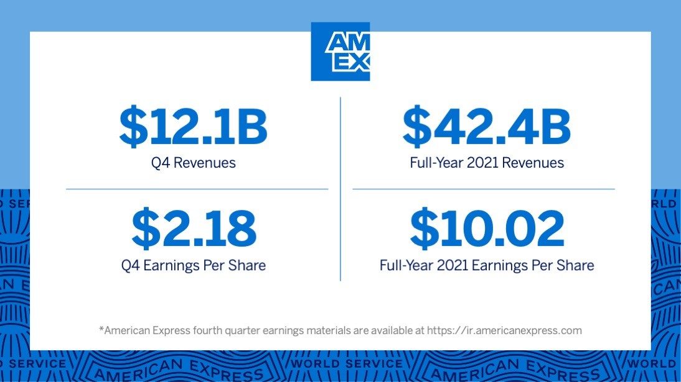
(Source:
https://s29.q4cdn.com/330828691/files/doc_news/2022/03/V2Amex_Q4EarningsStatement_
Newsroom.jpg)

