Research on the Application of machine learning technology in building emergency accident prediction in China
Xu Yingjian
Abstract：Construction accidents are easy to cause heavy casualties and property losses.This study used machine learning techniques to analyze 16 key factors and evaluate the impact of different combinations of factors on the performance of predicting the severity of a construction accident.In this paper, eight algorithms include logistic regression, decision tree, support vector machine, naive Bayes, k-nearest neighbor, random forest, multilayer perceptron and AutoML.The results show that (1) Naive Bayes and logistic regression achieved the best F1.3% of 78 points on the original dataset based on 16 accident factors.(2) Using the AutoML method, the severity classification can reach 84% of the mean F1 score.(3) Analysis of the confusion matrix shows that the subjective classification of the original data and the specific abnormal accidents are the causes of the prediction errors.(4) "Accident type" and "accident reporting and handling" are the most critical factors, and "emergency management" and "safety training" are important subsystems with a significant impact on the severity of the accident.(5) Based on a decision tree, there is a set of evaluation rules.
- Introduction
Construction industry is one of the most risky industries in the world.Construction workers are reportedly three to six times more likely to have fatal accidents than in other industries.According to a statistical report released by the Ministry of Housing and Urban-Rural Development, there were 1,326 accidents (resulting in 1,542 deaths) in the housing and municipal construction industries in 2016 and 2017.A series of laws have been launched to reduce accidents.Professionals also began to supervise the project construction and study the safety risk level of the project in order to actively implement the interventions.It would be beneficial to society if the severity of potential harm can be accurately predicted.Therefore, researchers have been seeking how to better understand the factors affecting the occurrence and severity of accidents, rule-based analysis, and improve the accuracy of predicting the likelihood of future injuries.
Past accidents can be used as a basis for preventing future accidents.In the past few years, a large number of studies have analyzed accidents, factor analysis, regulations and management in the construction industry from risk assessment.A large number of historical cases were also used for the analysis.For example, informative work injury data provide useful detailed information such as injury cause and body injury sites.Injury data are used to identify common causes of accidents in order to design appropriate precautions.In particular, machine learning techniques have been used to estimate the consequences of accidents.This is because ML-based methods can handle large amounts of data and, more importantly, they have great potential to predict and interpret results.For example, random forest and stochastic gradient tree augmentation were used for damage prediction.A comprehensive analysis of the application of machine learning methods to engineering risk assessment was conducted by Hegard, Roxes and Patrinelli et al.
Use the reaction data in the severity analysis of construction accidents."Reaction data" represents data collected after the accident (e. g., frequency of injuries, workday losses, compensation costs).For example, Sarkar et al used proactive and reactive data, four data preprocessing methods, six machine learning algorithms, and three types of metrics to predict and analyze the severity of damage.Reactivity data describe the accident in great detail.If these data are manually summarized and analyzed, more abstract factor data could be obtained.We call these generalized factors as system factors.The system is an organic ensemble with a specific structure that can be broken down into two or more connected and interacting elements.While the whole system problem can be huge and complex, it can be decomposed into smaller and simpler problems.Although the use of reactive data is increasingly frequent, it is noteworthy that in many areas, a large number of experts have summarized cases with systemic risk factors.Zhang et al.(2019) Investigation reports of 571 construction accidents in China were collected, and the causes of each accident were analyzed from 39 accident factors, using systematic thinking and gray correlation analysis.Construction accident is a typical systematic problem, and it is easy to explore the relationship between various factors by using systematic thinking.System factors summarize the causes of the accident and are easily transferred to other areas.Using machine learning to efficiently analyze these data can be a promising direction.However, when the number of one category of an attribute is much larger than that of other categories, the prediction results will be biased towards most classes.Therefore, appropriate data preprocessing methods are crucial.
The literature review in the second part of this paper shows that machine learning methods are widely used in the prediction of accident consequences in different domains.However, few studies have evaluated the performance of ML techniques in classifying the severity of construction accidents from the perspective of accident system factors.Emergency management, safety training, contract management, and resource support).The aim of this study is to apply, validate and compare the performance of different ML methods in the severity classification of construction accidents in China.Based on effective prediction models, the result analysis can reveal some unique safety risk rules.For example, identifying important factors can provide decision support to relevant departments and strengthen some types of preventive measures.Social resources can be allocated according to these conclusions, such as arranging relevant educational courses to increase safety awareness and taking specific precautions to reduce risk.
- Method summary
General descriptive statistical analysis has been widely used to analyze workplace accidents.ML performs better at predicting future events.Therefore, ML has implemented accident or event classification and prediction in many areas, such as bankruptcy, medical, financial, natural disasters.According to a literature review by Hegde and Rokseth, the construction industry is a popular area for using ML methods.
In Table 1, we briefly introduce the eight machine learning algorithms and discuss their advantages and disadvantages.Among these machine learning methods, logistic regression is a relatively simple one, a generalized linear regression analysis model commonly used in data mining.Logical regression analysis mainly forms the multiple regression relationship between the dependent variables and multiple independent variables.The advantage of a logistic regression is that the independent variables can be continuous or discrete when performing a statistical analysis.Moreover, logistic regression can generally yield better results for binary classification problems.For example, Garmdi) uses logistic regression to estimate the impact of accident factors on accident severity.
In addition to logistic regression, there are algorithms like SVM, naive Bayes, and decision tree.All show great potential on specific datasets in the construction industry.The two most extensive classification models are decision trees and naive Bayes.Compared with decision trees, the Naive Bayes algorithm has a solid mathematical foundation and stable classification efficiency.Bayesian classifier based on Bayesian rule uses conditional probability to classify target variables based on the input variables.NB models are generally more accurate when predictor variables include two types (e. g., accident consequences are divided into small and big accidents), respectively.
The decision tree can be viewed as a tree-like predictive model.The central problem of DT is how to select segmentation properties and pruning.The DT algorithm includes ID3, C4.5, cards, etc.DT can be used to interpret quantitative and qualitative patterns in the data and to explore hidden information.For example, DT is used to study cognitive factors that influence safety behavior at high altitude.Kim et al.Use the DT to determine which factors in the current construction project are the biggest cause of delays.Support vector machine (SVM) is a machine learning method based on statistical learning theory, dimension theory and structural risk minimization principle.The SVM shows many unique advantages in solving small-sample, nonlinear, and high-dimensional pattern recognition problems.SVM largely overcomes the problem of ¨ dimensional disaster ¨ and ¨ overlearning ¨.Many practical applications have emerged in the construction industry.Pre-project planning variables are used to predict the cost performance of commercial building projects based on master component analysis and support vector machine model.The SVM classification and integration model was used to predict controversies in public-private partnership projects (Zhou Helin, 2013).The k-nearest neighbor (KNN) is one of the simplest data mining classification algorithms.The core idea of the KNN algorithm is that if most of the k-nearest neighbor samples in the feature space belong to a particular category, the sample also belongs to that category and has the features of the sample in that category.
The Random Forest algorithm was proposed by the Random Forest algorithm in 2001.The RF is a multi-classifier or multi-regressor composed of multiple decision trees.Each decision tree votes on the input vector and scores it.For the classification problem, the category that voted the most is the final class label of the input vector.RF is used for construction damage prediction (Tixier et al., 2016).The MLP (multilayer perceptron) is a forward-structured artificial neural network that maps a set of input vectors to a set of output vectors.The MLP can be viewed as a directed graph composed of multiple layers of nodes.Each layer is fully connected to the next layer.Each node, except for the input node, is a neuron (or processing unit) with a nonlinear activation function.Artificial neural network can realize the memory of information through its network structure, because the remembered information is stored in the weights between neurons.MLP has good fault tolerance and can perform cluster analysis and feature extraction.The MLP has been used to predict injury severity, occupational accidents, and bankruptcies.In addition to the above methods, AutoML has also received attention in the field of machine learning.
Table 1
The introduction, advantages and disadvantages of eight machine learning algorithms.
method | introduction | advantage | weakness
LR | The LR is a classification algorithm.The algorithm can estimate the discrete values based on a range of dependent variables.It estimates the probability of an event by fitting the data to a logical function.Because it estimates the probability, its output values are between 0 and 1 | The LR implementation is simple and less computational in the classification process.And fast speed, occupy low storage resources.LR has been widely used in industrial problems. | When the feature space is large, the LR may perform poorly.LR is easy to adapt and cannot handle a large number of multitype features or variables very well.
DT | DT is a supervised learning algorithm commonly used for classification problems.It is suitable for both categorical dependent variables and continuous dependent variables.The algorithm divides the overall data into two or more groups based on the most important or independent variables. | The DT is easy to understand and is highly interpretable.It is more suitable for handling samples with missing properties.DT can handle irrelevant features in a relatively short time, providing feasible and good results for large data sources. | Overfitting can easily occur.Moreover, DT can easily ignore correlations between data.
SVM | SVM marks each data with points in N dimensional space (N is the total number of all features).The value of each feature is a coordinate value.The SVM finds a straight line separating the separation of the two different sets of data | SVM can solve the problem of high-dimensional data and handle the interactions of nonlinear features. | The efficiency of the number of observed samples is large.Nonlinear problems are difficult to solve.Sometimes, it is difficult to find a suitable kernel function.
NB | Independent of Bayes variables, a simple Bayesian classification can be obtained according to the Bayes theorem.The NB predicts the probabilities of different categories by using different properties.The algorithm is commonly used for text classification and problems involving multiple classes. | The network has a solid mathematical foundation and a stable classification efficiency.NB performs well on small-scale data and can handle a variety of classification tasks that is suitable for incremental training. | The prior probabilities need to be calculated.The network network is sensitive to the representation of the input data.
KNN | The KNN can be used for the classification and regression problems.KNN stores all cases and divides new cases by k surrounding cases.Depending on the distance function, the new case will be assigned to the most common category among its K nearest neighbors. | The KNN's theory has matured.The KNN can be used for classification, regression, and non-linear classification. | KNN requires a lot of computation, and requires a lot of memory.
RF | The random forest consists of a series of decision trees.To classify the new object according to its properties, each decision tree has a classification, called the ¨ vote ¨ of the decision tree.The Forest then chose the most voted category | The RF can handle high-dimensional data.After training, RF can classify which are more important features.Furthermore, RF has a fast training speed and is able to detect interactions between features.For imbalanced data sets, the RF can counterbalance the errors.Accuracy can still be maintained if most of the features are lost. | The RF will overfit in some noisy classification or regression problems.Properties with larger values will have a greater impact on the RF results.
MLP | Multilayer perceptron are also known as artificial neural networks.It can have multiple hidden layers between it, besides the input and output layers.The simplest MLP requires a hidden layer, namely the input, hidden, and output layer. | The classification accuracy is relatively high.Parallel distribution processing ability and learning ability is strong.The MLP is robust and fault-tolerant to noise nerves, and can be completely approximated to complex nonlinear relations. | Neural networks require a large number of parameters, and cannot observe the learning processes between them.The output is hard to interpret, and the study time is too long.
AutoML | The automatic machine learning system automatically determines the best solution as long as the user provides the data. | The AutoML gets the best performance. | With at least dozens of iterations required, it will be heavily resources and time consuming.
AutoML is a method that can automatically learn appropriate parameters and configurations without manual intervention.The main steps of AutoML include: feature engineering, model selection, and algorithm selection.The purpose of feature engineering is to automatically discover and construct relevant features so that the model has optimal performance.Feature engineering also incorporates some specific feature enhancement methods.Feature selection and feature dimension reduction).Model selection consists of two steps: select a model and set its parameters.The purpose of algorithm selection is to automatically select an optimization algorithm to achieve a balance between efficiency and accuracy.
Notably, many studies do not use only one machine learning method, but rather aim to evaluate the performance of multiple methods to obtain the best model.For example, Kakhki et al.(2019) Lineity, secondary and RBF kernel, enhancement tree, naive Bayes, support vector machine were applied to predict injury severity based on information such as injured body parts and body categories.
This study evaluated the performance of two data pre-processing methods and eight ML methods.Finally, the best combination of the severity prediction methods is found.This method provides some valuable research ideas for analyzing the results of other similar accidents.In conclusion, the work of this article is as follows:
(1 )Enter the accident system factors summarized by the expert to predict the severity of the accident.
(2 )The smoke algorithm was evaluated to deal with the data imbalance problem.
(3 )Eight machine learning algorithms were used and compared.The AutoML method is used to find the best algorithm and parameters.The results show that the native Bayesian algorithm has good application performance and two-sided properties of the AutoML algorithm.
(4 )To find out the underlying classification error of the algorithm, the confusion matrix was analyzed in detail.
(5) Use mixed methods to identify the most critical factors affecting accident severity.
(6 )This paper extracts ten evaluation rules for the severity of construction accidents.
This paper is organised as follows.The first part is the introduction.The second part includes a literature review of the ML method and its application in classification and its predictions in the construction field.The third part discusses the process of our data sources and methods.The fourth part presents the experimental results.
- Use the data and use the methods
The overall method is shown in Fig.It includes six stages: (1) data sorting rules.(2) data preprocessing.(3) Selection of the algorithm.(4) Training and testing group (5) Performance evaluation.(6) Results analysis.In the result analysis, this paper determines the key factors of accident severity, analyzes the confusion matrix, summarizes the causes of the algorithm classification error, and generates a set of accident outcome evaluation rules using the decision tree.
  - data description
In this study, we used Zhang's working data (Zhang et al., 2019).The data include survey reports of 571 construction accidents, coming from the official websites of 26 provinces / cities in China.The 571 accidents included 432 (75.66%) small accidents (1-2 deaths), 133 (23.29%) large accidents, 3-9 deaths), 4 (0.7%) serious accidents (10-29 deaths) and 2 (0.35%) major accidents (30 or more deaths).The classification standard of accident consequences complies with the provisions of China's Work Safety Law.The types and proportions of accidents include fall (36.25%), fall (23.99%), object impact (9.98%), lifting injury (8.93%), electric shock (7.18%), poisoning (5.78%), vehicle injury (2.8%), mechanical injury (1.93%), drowning (1.4%), explosion (1.06%) and fire (0.7%).After collecting the detailed accident report, Zhang took the cause of the construction accident as the whole system and decomposed it into 6 subsystems, 16 subsystems and 39 subsystems.There are several counterators for each subsystem.Each factor has a sub-factor caused by its accident.High quality records set the foundation for high quality machine learning results.
A few subsystems and factors are briefly introduced to help the reader understand the characteristics of the raw data.As shown in Table 2, the Organization and Behavior subsystem includes four major factors: safety departments, safety engineers, workers, and safety supervision.These factors reflect the number, qualifications and abilities of managers, and performance responsibilities.The Technical Management subsystem includes drawings, construction plans, and site safety management.These factors include high-quality design and construction plans, and regular site safety management.The identification and elimination of hazards is also essential for effective safety management.The Resource Support subsystem includes three major resources related to safety: mechanical equipment, materials, and protection conditions.The Contract Management subsystem includes both contract agreements and contract arrangements.Poor law, contract management will lead to construction progress delay, poor work quality, poor safety performance.The "Safety Training" subsystem includes safety culture, training and assessment.The "Emergency Management" subsystem includes contingency plans and accident reporting and handling.For example, in the event of an accident, the Contractor needs to timely report and handle it in accordance with law and reasonable procedures.
  - Data preprocessing system
    - Data merge
The collected data requires pre-processing to satisfy the data format of the machine learning methods.It is noteworthy that serious and very serious accidents accounted for only 1.05% of the total data.Given the small amount of data, machine learning algorithms are difficult to capture these features efficiently.Therefore, serious and very serious accidents are merged into large accidents.
Since each record contains several subfactors, we used these subfactors as attributes of the factors.Since each record contains a different number of child factors, we apply four attribute merging and classification rules: (1) the attribute is ¨ without ¨ if the record does not contain any child factor; (2) the name of the child factor if only one, and (3) if it contains multiple child factors, the attribute is ¨ all.¨ (4) If the total number of attributes is less than 5, the attribute is deleted.Through these four rules, a total of 564 records were obtained.The 18 incident factors included in each record were converted to attribute labels.
    - Predictor selection
After combining the data, to select the appropriate predictors, we used the chi-square test to determine the dependence of each factor and the severity of the accident.If the factor has no effect on the consequences of the accident, it will be discarded.The results showed that all the factors had some influence on the severity of the accident.Among them, the "accident type" has the greatest performance value."Drawings and construction Plan" ranked second with the lowest "Materials".Thus, all of the factors were considered as predictors.
    - Data balance
Since each record contains up to 16 incident factors, the class imbalance occurs in the dataset (as shown).2(a))。For example, in severity, the number of minor accidents is almost four times the number of major accidents.Furthermore, some other properties contain less than ten pieces of data.
In this case, the smoke method is used to solve the data imbalance problem.Chawla et al.(2002) A random oversampling algorithm called smote is proposed.The full name of smoke is the synthetic ethnic minority oversampling technology.In random oversampling, the strategy of copying samples is often adopted to add a few samples, which can easily cause the problem of overfitting.The smote generates new synthetic samples by performing some operations on the raw dataset.The main idea of the algorithm is to insert n synthetic few samples between the k samples closest to a certain few samples, thus increasing the number of few samples.The process includes:
- For each sample in the minority class, it computes the Euclidean distance from all samples in the minority sample set to obtain its k-nearest neighbor.
- The sampling amplification rate N is then determined by setting the sampling ratio according to the sample imbalance ratio.For each minority sample a, it randomly selects a few samples from its k-nearest neighbors.We assume that the chosen neighbor is one.
- For each randomly selected neighborhood, it constructs a new sample by the following formula.
anew = a + rand (0, 1) ∗ |a − an| (1)
As shown in Fig.2 (b) shows the distribution of data after asphyxia sampling.The method does not seem to improve the degree of data distribution, but the experimental results prove that resampling methods can effectively improve the performance of most algorithms.
  - Classification and predictive modeling
This paper uses eight prediction algorithms: logistic regression algorithm, decision tree algorithm, support vector machine algorithm (SVM), and Naive Bayes, KNN, Random Forest, multilayer perceptron (MLP), and automatic controller are used to predict the severity of accidents.The first six algorithms are the most representative and commonly used algorithms in data mining (Wu et al., 2008).
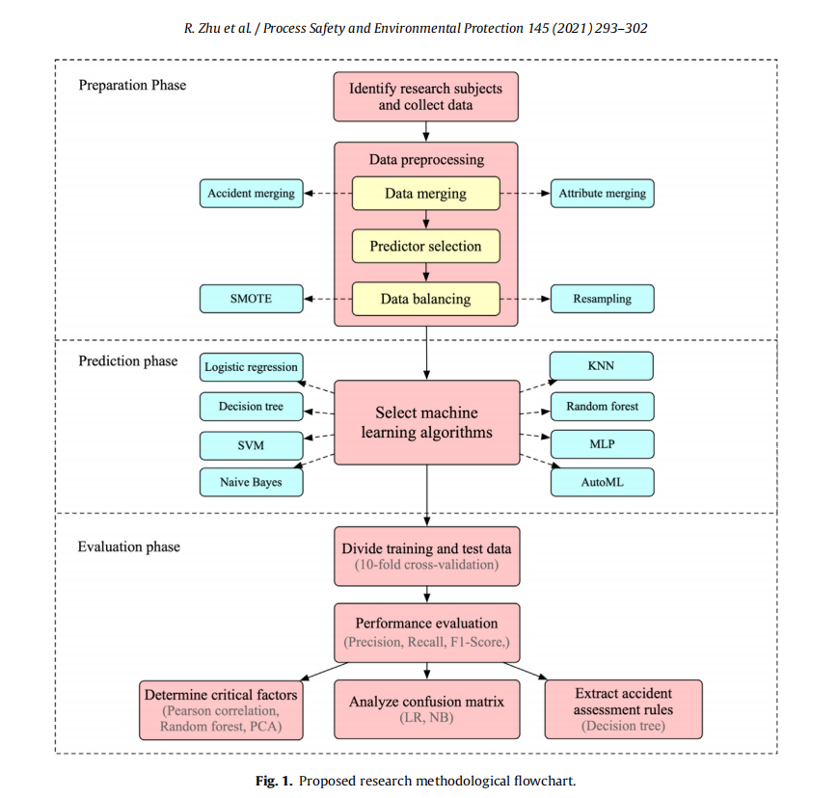
The AutoML method was used to find the best algorithm and to achieve the highest performance.We used the default parameters to compare the performance of the predictions.

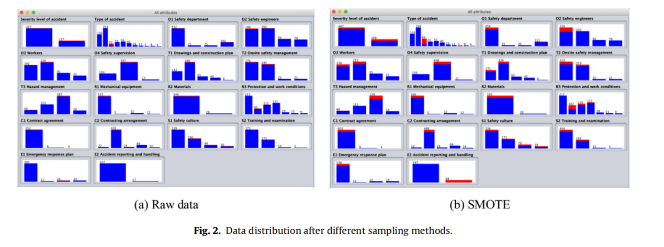
  - Data division and evaluation indicators
The model in this paper belongs to the classification model.We used precision, recall, and f1 score as indicators to assess the quality of the model.The confusion matrix, also known as the error matrix, was used to assess the quality of the classifier output on the test dataset.The confusion matrix is a matrix used to summarize the results of the classifier.Each column represents the predicted category, and the total number of each column is expressed as the number of data predicted for that category.Each row represents the correct attribute category of the data, and the total number of data in each row represents the number of data instances in that category.Based on the confusion matrix, the accuracy, the recall rate, and the F1 score can be further calculated.Precision is the ratio of the number of samples correctly classified to the total number of samples for a given dataset.approach:
Precision = TP/(TP + FP) (2)
Recall is used to explain the ratio of the positive example to the total positive example in the classifier:
Recall = TP/(TP + FN) (3)
The F1 score is used to more comprehensively evaluate the classifier, and can balance the impact of precision and recall.The f1 score is the harmonic average of the precision and recall.The F1 score =1 indicates the best overall performance of the model:
F1 − Score = 2 × Precision × Recall/(Precision + Recall) (4)
In the evaluation, (2) - (4): TP represents the number of correctly classified positive samples; FP represents the number of misclassified negative samples; and FN represents the number of misclassified positive samples.
- Research results
  - Predictive performance of the machine-learning algorithms
Raw data, asphyxia data method are used as input to machine learning.Then, eight prediction algorithms (LR, DT, SVM, NB, KNN, RF, MLP, and AutoML) were used to predict the severity of the accident.Finally, these three performance measures are obtained.
To prevent overfitting, we performed a 10-fold cross-validation.Furthermore, we verified the robustness of the algorithm with the strategy adopted by Sarkar et al.(2020) (2019b), percentage segmentation options using different random seeds.We used five different random seeds (1%, 2%, 3%, 5%, 10%) to divide the dataset.as shown in the figure.3. Except for the DT algorithm, all the algorithms have high stability.
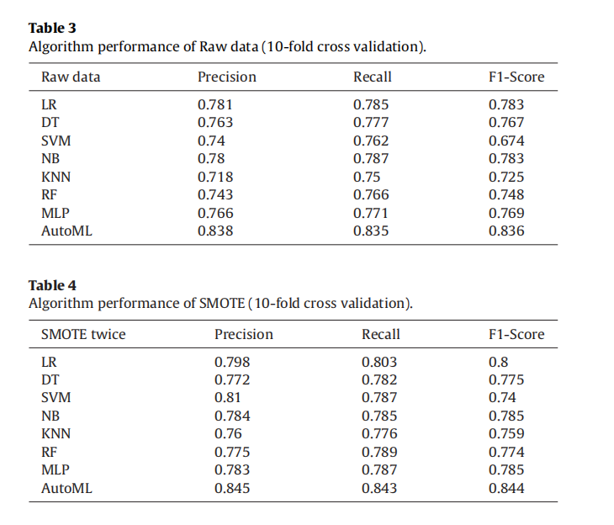
Tables 3,4 show the comparison results of all algorithms on two types of datasets.On the raw data, the three indicators of AutoML were the highest.After two sampling, all algorithms.In addition to automatic ML, SVM accuracy (0.81).LR has the best recall (0.803) and the highest F1 score (0.80).This phenomenon reflects that the use of oversampling techniques to eliminate category imbalance in data can improve classification performance (Sarkar et al., 2020).However, it is worth noting that the performance gain of the oversampling techniques is limited.The resampling technique is also used to handle the data imbalance, but the results show that the method is prone to overfitting, with nearly 95% scores in the training set, but poor performance in the new test set, only around 70%.
As shown in Figure 4.The f1 score were averaged across all algorithms on both datasets.AutoML had the highest F1 score, followed by LR, NB, and the lowest was SVM.In the original dataset, the AutoML achieved an F1 score (0.836), which reflects the potential of the AutoML method in finding the best prediction algorithm.However, the AutoML method takes a lot of time to find the best algorithms and parameters.The time required to build a model on MacBookPro (8GB of memory) is 833s, while other models have almost negligible running time.Since the severity of the accident is a simple binary classification problem, logistic regression and naive Bayes have good performance.If the severity of the accident is a problem of multiple classification, these two algorithms may not perform very well.Simple deep learning model (MLP) is used to compare the machine learning performance.We show that the model's performance of f1 points reaches the fourth place.However, the training time required for MLP is much longer than the other algorithms (except AutoML).Extracting data features as input to algorithms using deep belief networks may be a more feasible direction for machine learning algorithms.The DT also has a high performance profile.However, DT can easily overfit and ignore the correlations between properties.Random forest is an integrated algorithm.Its accuracy is usually higher than that of a single algorithm.However, when we tested on the dataset, we found that the method was easily overfit.The proposed algorithm performs well on the training and test sets, but poorly on the validation set.
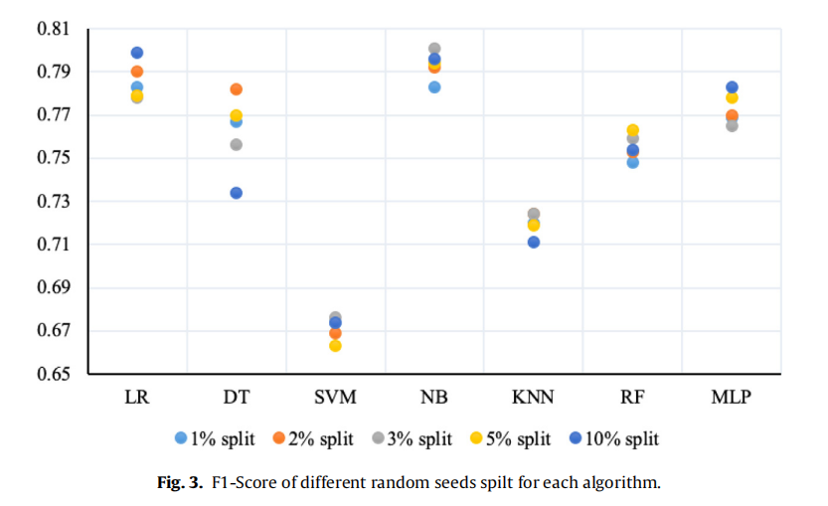
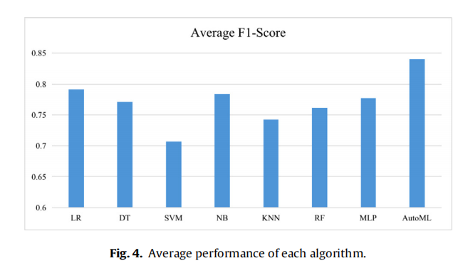
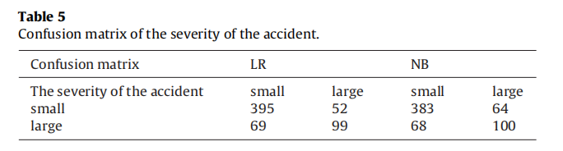
  - Analysis of the confusion matrix
Two of the most accurate machine learning algorithms (except AutoML) are applied to analyze the confusion matrix.The dataset is the data after the data ends.The algorithm has a score of 1 =0.8 and an F1 score of =0.785. The two fusion matrices are shown in Table 5. In the confusion matrix of the LR, 69 out of the 121 errors misclassified major accidents as minor accidents.This shows that the LR algorithm is not effective in classifying large accidents, and that the same problem appears in the SVM.In the confusion matrix of DT, the errors are more balanced.We further found that 59 large accident records were misclassified as minor accidents by two classifiers.Retrieving the raw data revealed that 47 out of the 59 records were present only once, reflecting the unique characteristics of these accidents leading to their misclassification.It is worth mentioning that the data used in this paper come from manual editing and sorting, and subjective problems may arise during the sorting process, which may be another reason for the classification errors.
  - To evaluate the importance of the various factors
This section uses Pearson correlation coefficients, machine learning algorithm, and principal component analysis to assess the influence of different factors on the severity of accident consequences.
The Pearson's correlation coefficient was used to measure the linear relationships between the distance variables.According to the calculation of Pearson's correlation coefficient, "accident reporting and handling" is the factor most related to the severity of accidents, followed by "accident type" and "safety culture".
It is used to evaluate the importance of various factors according on the characteristics of random forests."Accident type" is considered the most important factor, followed by "safety supervision" and "contractual agreement".
The purpose of PCA (main component analysis) is to transform multiple indicators into some comprehensive indicators by using the idea of dimension reduction.To simplify the PCA results, we only the most important principal component 1 was selected for the analysis."Training and inspection", "emergency plan" and "accident type" play an important role in the main component 1.What is unique is that "contingency planning" has a significant impact on accident severity in the PCA analysis, but this factor is not a key factor for other methods.
Summarizing the above three methods, the Pearson correlation coefficient yields the ratio of the covariance to the standard deviation of the two objects, which actually reflects the degree of linear correlation between the two groups.The RF was used to determine the contribution of the mutual features to each tree in the forest.The RF was averaged, and the contribution was finally compared between these features.Principal component analysis is a multivariate statistical method to testing correlation between multivariates.
Finally, the importance of each subsystem is obtained based on the weighted sum of the ranking factors.¨ Emergency Management ¨ 11, ¨ Safety Training ¨ 10, other subsystems less than 5.The results show that factories and relevant departments should improve the level of emergency management, such as conducting more emergency drills and developing more effective contingency plans.Secondly, the factory needs to conduct special safety training for employees to improve the level of accident prevention and reduce the accident risk.
- Research conclusion
The high performance of the proposed classification algorithm shows that the damage not only occurs in random situations, but also has potential patterns.This means that, in some cases, large accidents are more likely to occur.A large body of research focuses on historical accident data, often recording many detailed information.This paper uses the accident factors summarized by the experts as the training data.The method takes two steps on the raw data and yields abstract, more intelligent results.Since some types of data are relatively sparse, oversampling techniques are used to handle the imbalance problem.
In this study, eight machine learning techniques were evaluated with a maximum accuracy of 84.5%.Results prove that the proposed method can make useful predictions and help to make critical decisions.The most recent techniques of AutoML are compared with other machine learning methods.Although its performance is the strongest, it consumes too much resources.However, the model can be stored and reused when predicting similar accident outcomes.Users can enter any accident factor, using the model to judge the possible level of accident.In practice, different industries can use this method to retrain the model based on their risk factor characteristics.Furthermore, we can focus on the key factors presented in this paper.The rule extraction method used in Section 4.3 can be effectively applied to assess the risk level of other safe operations.Not only the decision tree, but also other machine learning methods.Support vector machines and random forest) can be used to extract more regular and concise safety rules.
Many studies have applied regression and classification models to the prediction of building damage consequences.This paper uses smoke techniques to deal with the problem of class imbalance.Eight machine learning algorithms, namely LR, DT, SVM, NB, KNN, RF, MLP, and AutoML, were used to predict accident consequences.We also used a 10-fold cross-validation and partitioned dataset to ensure that the model does not overfit and to verify the model robustness using a 10-fold crossover based to random seed overflow.The experimental results show that most algorithms perform better after adopting the smoke method compared with the original data.Among these, NB performed well in F1 score and robustness, followed by LR, DT and RF.The results show that machine learning models can accurately predict accident severity.The highest F1 score (LR) in the test data reached 80%, indicating that the injury severity is not random and that a powerful machine learning model can be used to reveal and discuss potential patterns and trends.The AutoML algorithm has achieved the best performance.But because it consumes a lot of resources, it's usually not the first choice for users.The cause of the classification error of the proposed algorithm is analyzed using the confusion matrix.It shows that the particularity of certain records cannot be correctly classified.We also used Pearson's correlation coefficient, random forest, and principal component analysis to identify the main factors influencing the consequences of accidents.In addition, we also weighted and summarized the factor ratings.Compared to previous rankings of scholars who derive factor importance from probability statistics, the method judges factors from a multidimensional perspective.According to methods such as main component analysis, class ¨ accident ¨ is the most important factor, followed by ¨ accident reporting and handling of ¨ and ¨ safety culture ¨.Through further factor-weighted sum calculation, ¨ Emergency Management ¨ and ¨ Safety Training ¨ are the most critical subsystems, providing the basis for factories and related departments to strengthen emergency response and safety training decisions.Safety practitioners can prioritize investment in existing resources to prevent accidents that are more likely to cause serious injuries.Finally, based on the decision tree algorithm.According to the rules, relevant departments can conduct dynamic evaluation of occupational risks and take effective measures to reduce the severity of harm caused by occupational emergencies.

- Liu Qixu, Chen Yanhui, Nijieshuo, Luo Cheng, Liu Caiyun, Cao Yaqin, Tan Ru, Feng Yun, Zhang Yue. Review of ITS based on Machine Learning [J / OL]. Computer Research and Development:1-21[2022-03-28].http://kns.cnki.net/kcms/detail/11.1777.tp.20220210.0905.004.html
- Cui Wei, Du Erling, Xu Qing, Li Haijun, Fan Yijun. Security issues and privacy protection of machine learning [J]. Science and Technology information,2022,20(04):10-12.DOI:10.16661/j.cnki.1672-3791.2112-5042-5724.
- Daniel. Research and Innovation of Emergency Management in Changsha[D]. Hunan Normal University,2021.
- Li Xuexin. Research on Emergency Decision Model of Dangerous Goods Accident Based on Bayesian Network[D]. JLU (Jilin University),2016.
- Qiu Yue, Xing Zhuo, Sun Xiaosong, He Yuteng. Application of machine learning in multi-omics data analysis[J].Technology and innovation,2021(24):170-171.DOI:10.15913/j.cnki.kjycx.2021.24.071.
- Gao Lingbao, Du Yinxue, Lu Jiangbo, Ma Yongjun, Du Haiping, Hu Xin. On machine learning[J].Casting equipment and process,2021(06):41-43.DOI:10.16666/j.cnki.issn1004-6178.2021.06.011.
- Tan Shunquan, Li Sili, Chen Baoying, Li Bin. Machine learning review for image and video forensics[J].signalprocessing ,2021,37(12):2235-2250.DOI:10.16798/j.issn.1003-0530.2021.12.001.
- Zhou Qihua. Design and performance analysis of distributed machine learning system for Data Center Network[D].Nanjing University of Posts and Telecommunications,2021.DOI:10.27251/d.cnki.gnjdc.2021.001532.
- Hu Changli, Shao Jianfei. Analysis of Machine learning Systems Based on a Distributed Computing framework[J]. Television Technology,2021,45(11):115-118+123.DOI:10.16280/j.videoe.2021.11.030.
- Zhang Saimale, Sun Biao. Review of network abnormality detection methods based on machine learning[J].Journal of Jilin University (Information Science Edition),2021,39(06):732-742.DOI:10.19292/j.cnki.jdxxp.2021.06.018.

APPLICATION FOR ETHICAL APPROVAL

In order for research to result in benefit and minimise risk of harm, it must be conducted ethically. A researcher may not be covered by the University’s insurance if ethical approval has not been obtained prior to commencement.

The University follows the OECD Frascati manual definition of research activity: “creative work undertaken on a systematic basis in order to increase the stock of knowledge, including knowledge of man, culture and society, and the use of this stock of knowledge to devise new applications”. As such this covers activities undertaken by members of staff, postgraduate research students, and both taught postgraduate and undergraduate students working on dissertations/projects.

The individual undertaking the research activity is known as the “principal researcher”.

Ethical approval is not required for routine audits, performance reviews, quality assurance studies, testing within normal educational requirements, and literary or artistic criticism.

Please read the notes for guidance before completing ALL sections of the form.

This form must be completed and approved prior to undertaking any research activity. Please see Checklist for details of process for different categories of application.

Delete the Guidance Notes at the end of the form BEFORE submitting your application

SECTION A: About You (Principal Researcher)
1 | Full Name: |  | Xu Yingjian
2 | Tick all boxes which apply: |  | Member of staff: | ☐ | Honorary research fellow: | ☐
3 | Undergraduate Student | ☐ | Taught Postgraduate Student | ☐ | Postgraduate Research Student | ☒

4 | Institute/Academic Discipline/Centre:
5 | Campus: | University of Wales Trinity Saint David
6 | E-mail address: | 2106319@student.uwtsd.ac.uk
7 | Contact Telephone Number: | 17631792217
 | For students:
8 | Student Number: | 2106319
9 | Programme of Study: | Research on the Application of machine learning technology in building emergency accident prediction in China
10 | Director of Studies/Supervisor: | Kapilan Radhakrishnan

SECTION B: Approval for Research Activity
1 | Has the research activity received approval in principle?  (please check the Guidance Notes as to the appropriate approval process for different levels of research by different categories of individual) |  | YES | ☒ | NO | ☐
 |  |  |  |  | Date
2 | If Yes, please indicate source of approval (and date where known): Approval in principle must be obtained from the relevant source prior to seeking ethical approval | Research Degrees Committee |  | ☒ | 2022.3.28
3 |  | Institute Research Committee |  | ☒ | 2022.3.28
4 |  | Other (write in) |  | ☒ | 2022.3.28

SECTION C: Internal and External Ethical Guidance Materials
 | Please list the core ethical guidance documents that have been referred to during the completion of this form (including any discipline-specific codes of research ethics, and also any specific ethical guidance relating to the proposed methodology). Please tick to confirm that your research proposal adheres to these codes and guidelines.
1 | UWTSD Research Ethics & Integrity Code of Practice | ☒
2 | UWTSD Research Data Management Policy | ☒
3 |  | ☐

SECTION D: External Collaborative Research Activity
1 | Does the research activity involve collaborators outside of the University? |  | YES | ☐ | NO | ☒
2 | If Yes, please provide the name of the external organisation and name and contact details for the main contact person and confirmation this person has consented to their personal data being shared.as part of this collaboration.
3 | Institution
4 | Contact person name
5 | Contact person e-mail address
6 | Has this individual consented to sharing their details on this form? |  | YES | ☐ | NO |  |  | ☐
7 | Are you in receipt of a KESS scholarship? |  | YES | ☐ | NO |  |  | ☐
8 | Is your research externally funded |  | YES | ☐ | NO |  |  | ☐
9 | Are you specifically employed to undertake this research in either a paid or voluntary capacity? | Voluntary | YES | ☐ | NO |  | ☐
10 |  | Employed | YES | ☐ | NO |  | ☐
11 | Is the research being undertaken within an existing UWTSD Athrofa Professional Learning Partnership (APLP) | If YES then the permission question below does not need to be answered. | YES | ☐ | NO |  |  | ☐
12 | Permission to undertake the research has been provided by the partner organisation | (If YES attach copy)  If NO the application cannot continue | YES | ☐ | NO |  |  | ☐

Where research activity is carried out in collaboration with an external organisation
13 | Does this organisation have its own ethics approval system? | YES | ☐ | NO | ☒
14 | If Yes, please attach a copy of any final approval (or interim approval) from the organisation

SECTION E: Details of Research Activity
1 | Indicative title: | Research on the Application of machine learning technology in building emergency accident prediction in China
2 | Proposed start date: | 2022.1.1 | Proposed end date: | 2022.3.28
3 | Introduction to the Research (maximum 300 words)  Ensure that you write for a Non-Specialist Audience when outlining your response to the three points below:  - Purpose of Research Activity  - Proposed Research Question  - Aims of Research Activity  - Objectives of Research Activity  Demonstrate, briefly, how Existing Research has informed the proposed activity and explain  - What the research activity will add to the body of knowledge  - How it addresses an area of importance.
4 | Purpose of Research Activity  (this box should expand as you type)
5 | Research Question  (this box should expand as you type)
6 | Aims of Research Activity  (this box should expand as you type)
7 | Objectives of Research Activity  (this box should expand as you type)
8 | Proposed methods (maximum 600 words)  Provide a brief summary of all the methods that may be used in the research activity, making it clear what specific techniques may be used. If methods other than those listed in this section are deemed appropriate later, additional ethical approval for those methods will be needed.
9 | (this box should expand as you type)

10 | Location of research activity  Identify all locations where research activity will take place.
11 | (this box should expand as you type)
12 | Research activity outside of the UK  If research activity will take place overseas, you are responsible for ensuring that local ethical considerations are complied with and that the relevant permissions are sought. Specify any local guidelines (e.g. from local professional associations/learned societies/universities) that exist and whether these involve any ethical stipulations beyond those usual in the UK (provide details of any licenses or permissions required). Also specify whether there are any specific ethical issues raised by the local context in which the research activity is taking place, for example, particular cultural and/or legal sensitivities or vulnerabilities of participants.
13 | (this box should expand as you type)

14 | Use of documentation not in the public domain: Are any documents NOT publicly available? | NO | ☐
14 |  | YES | ☒
15 | If Yes, please provide details here of how you will gain access to specific documentation that is not in the public domain and that this is in accordance with prevailing data protection law of the country in question and England and Wales.  (this box should expand as you type)

SECTION F: Scope of Research Activity
1 | Will the research activity include: | YES | NO
2 | Use of a questionnaire or similar research instrument? | ☐ | ☒
3 | Use of interviews? | ☐ | ☒
4 | Use of diaries? | ☐ | ☒
5 | Participant observation with their knowledge? | ☐ | ☒
6 | Participant observation without their knowledge? | ☐ | ☒
7 | Use of video or audio recording? | ☐ | ☒
8 | Access to personal or confidential information without the participants’ specific consent? | ☐ | ☒
9 | Administration of any questions, test stimuli, presentation that may be experienced as physically, mentally or emotionally harmful / offensive? | ☐ | ☒
10 | Performance of any acts which may cause embarrassment or affect self-esteem? | ☐ | ☒
11 | Investigation of participants involved in illegal activities? | ☐ | ☒
12 | Use of procedures that involve deception? | ☐ | ☒
13 | Administration of any substance, agent or placebo? | ☐ | ☒
14 | Working with live vertebrate animals? | ☐ | ☒
15 | Other primary data collection methods, please explain in this box  For example, ‘focus groups’. Please indicate the type of data collection method(s) in this box and tick the accompany box. | ☒ | ☐
16 | Details of any other primary data collection method:  (this box should expand as you type) | ☒ | ☐
If NO to every question, then the research activity is (ethically) low risk and may be exempt from some of the following sections (please refer to Guidance Notes).

If YES to any question, then no research activity should be undertaken until full ethical approval has been obtained.

SECTION G: Intended Participants
1 | Who are the intended participants: | YES | NO
2 | Students or staff at the University? | ☒ | ☐
3 | Adults (over the age of 18 and competent to give consent)? | ☒ | ☐
4 | Vulnerable adults? | ☒ | ☐
5 | Children and Young People under the age of 18? (Consent from Parent, Carer or Guardian will be required) | ☒ | ☐
6 | Prisoners? | ☒ | ☐
7 | Young offenders? | ☒ | ☐
8 | Those who could be considered to have a particularly dependent relationship with the investigator or a gatekeeper? | ☒ | ☐
9 | People engaged in illegal activities? | ☒ | ☐
10 | Others (please identify specifically any group who may be unable to give consent) please indicate here and tick the appropriate box. | ☐ | ☐
11 | Other – please indicate here:  (this box should expand as you type) | ☐ | ☐

12 | Participant numbers and source  Provide an estimate of the expected number of participants. How will you identify participants and how will they be recruited?
13 | How many participants are expected? | (this box should expand as you type)
14 | Who will the participants be? | (this box should expand as you type)
15 | How will you identify the participants? | (this box should expand as you type)

16 | Information for participants: | YES | NO | N/A
17 | Will you describe the main research procedures to participants in advance, so that they are informed about what to expect? | ☒ | ☐ | ☐
18 | Will you tell participants that their participation is voluntary? | ☒ | ☐ | ☐
19 | Will you obtain written consent for participation? | ☒ | ☐ | ☐
20 | Will you explain to participants that refusal to participate in the research will not affect their treatment or education (if relevant)? | ☒ | ☐ | ☐
21 | If the research is observational, will you ask participants for their consent to being observed? | ☒ | ☐ | ☐
22 | Will you tell participants that they may withdraw from the research at any time and for any reason? | ☒ | ☐ | ☐
23 | With questionnaires, will you give participants the option of omitting questions they do not want to answer? | ☒ | ☐ | ☐
24 | Will you tell participants that their data will be treated with full confidentiality and that, if published, it will not be identifiable as theirs? | ☒ | ☐ | ☐
25 | Will you debrief participants at the end of their participation, in a way appropriate to the type of research undertaken? | ☒ | ☐ | ☐
26 | If NO to any of above questions, please give an explanation
27 | (this box should expand as you type)

28 | Information for participants: | YES | NO | N/A
29 | Will participants be paid? | ☒ | ☐ | ☐
30 | Is specialist electrical or other equipment to be used with participants? | ☒ | ☐ | ☐
31 | Are there any financial or other interests to the investigator or University arising from this study? | ☒ | ☐ | ☐
32 | Will the research activity involve deliberately misleading participants in any way, or the partial or full concealment of the specific study aims? | ☒ | ☐ | ☐
33 | If YES to any question, please provide full details
34 | (this box should expand as you type)

SECTION H: Anticipated Risks
1 | Outline any anticipated risks that may adversely affect any of the participants, the researchers and/or the University, and the steps that will be taken to address them.  If you have completed a full risk assessment (for example as required by a laboratory, or external research collaborator) you may append that to this form.
2 | Full risk assessment completed and appended? |  | Yes | ☐
2 |  |  | No | ☒
3 | Risks to participants  For example: emotional distress, financial disclosure, physical harm, transfer of personal data, sensitive organisational information
4 | Risk to Participant:  (this box should expand as you type) | How will you mitigate the Risk to Participant  (this box should expand as you type)
5 | If research activity may include sensitive, embarrassing or upsetting topics (e.g. sexual activity, drug use) or issues likely to disclose information requiring further action (e.g. criminal activity), give details of the procedures to deal with these issues, including any support/advice (e.g. helpline numbers) to be offered to participants. Note that where applicable, consent procedures should make it clear that if something potentially or actually illegal is discovered in the course of a project, it may need to be disclosed to the proper authorities
 | (this box should expand as you type)
6 | Risks to investigator  For example: personal safety, physical harm, emotional distress, risk of accusation of harm/impropriety, conflict of interest
 | Risk to Investigator:  (this box should expand as you type) | How will you mitigate the Risk to Investigator:  (this box should expand as you type)
7 | University/institutional risks  For example: adverse publicity, financial loss, data protection
 | Risk to University:  (this box should expand as you type) | How will you mitigate the Risk to University:  (this box should expand as you type)

8 | Disclosure and Barring Service
9 | If the research activity involves children or vulnerable adults, a Disclosure and Barring Service (DBS) certificate must be obtained before any contact with such participants. | YES | NO | N/A
10 | Does your research require you to hold a current DBS Certificate? | ☐ | ☒ | ☐

SECTION I: Feedback, Consent and Confidentiality
1 | Feedback  What de-briefing and feedback will be provided to participants, how will this be done and when?
 | (this box should expand as you type)
2 | Informed consent  Describe the arrangements to inform potential participants, before providing consent, of what is involved in participating. Describe the arrangements for participants to provide full consent before data collection begins. If gaining consent in this way is inappropriate, explain how consent will be obtained and recorded in accordance with prevailing data protection legislation.
 | (this box should expand as you type)
3 | Confidentiality / Anonymity  Set out how anonymity of participants and confidentiality will be ensured in any outputs. If anonymity is not being offered, explain why this is the case.
 | (this box should expand as you type)

SECTION J: Data Protection and Storage
In completing this section refer to the University’s Research Data Management Policy and the extensive resources on the University’s Research Data Management web pages (http://uwtsd.ac.uk/library/research-data-management/).
1 | Does the research activity involve personal data (as defined by the General Data Protection Regulation 2016 “GDPR” and the Data Protection Act 2018 “DPA”)? | YES | NO
 | “Personal data” means any information relating to an identified or identifiable natural person (‘data subject’). An identifiable natural person is one who can be identified, directly or indirectly, in particular by reference to an identifier such as a name, an identification number, location data, an online identifier or to one or more factors specific to the physical, physiological, genetic, mental, economic, cultural or social identity of that natural person. | ☐ | ☐
2 | If YES, provide a description of the data and explain why this data needs to be collected:
 | (this box should expand as you type)
3 | Does it involve special category data (as defined by the GDPR)? | YES | NO
 | “Special category data” means sensitive personal data consisting of information as to the data subjects’ –  (a) racial or ethnic origin,  (b) political opinions,  (c ) religious beliefs or other beliefs of a similar nature,  (d) membership of a trade union (within the meaning of the Trade Union and Labour Relations (Consolidation) Act 1992),  (e) physical or mental health or condition,  (f) sexual life,  (g) genetics,  (h) biometric data (as used for ID purposes), | ☐ | ☐
4 | If YES, provide a description of the special category data and explain why this data needs to be collected:
 | (this box should expand as you type)

5 | Will the research activity involve storing personal data and/or special category data on one of the following: | YES | NO
6 | Manual files (i.e. in paper form)? | ☐ | ☒
7 | University computers? | ☒ | ☐
8 | Private company computers? | ☒ | ☐
9 | Home or other personal computers? | ☐ | ☒
10 | Laptop computers/ CDs/ Portable disk-drives/ memory sticks? | ☐ | ☒
11 | “Cloud” storage or websites? | ☐ | ☒
12 | Other – specify: | ☐ | ☒
13 | For all stored data, explain the measures in place to ensure the security of the data collected, data confidentiality, including details of password protection, encryption, anonymisation and pseudonymisation:
 | (this box should expand as you type)
14 | All Data Storage
15 | Will the research activity involve any of the following activities: | YES | NO
16 | Electronic transfer of data in any form? | ☐ | ☒
17 | Sharing of data with others at the University? | ☐ | ☒
18 | Sharing of data with other organisations? | ☐ | ☒
19 | Export of data outside the European Union or importing of data from outside the UK? | ☐ | ☒
20 | Use of personal addresses, postcodes, faxes, emails or telephone numbers? | ☐ | ☒
21 | Publication of data that might allow identification of individuals? | ☐ | ☒
22 | Use of data management system? | ☐ | ☒
23 | Data archiving? | ☐ | ☒
24 | If YES to any question, please provide full details, explaining how this will be conducted in accordance with the GDPR and DPA (and/or any international equivalent):
 | (this box should expand as you type)
25 | List all who will have access to the data generated by the research activity:
 | (this box should expand as you type)
26 | List who will have control of, and act as custodian(s) for, data generated by the research activity:
 | (this box should expand as you type)
27 | Give details of data storage arrangements, including security measures in place to protect the data, where data will be stored, how long for, and in what form. Will data be archived – if so how and if not why not.
 | (this box should expand as you type)
28 | Please indicate if your data will be stored in the UWTSD Research Data Repository (see https://researchdata.uwtsd.ac.uk/ ). If so please explain. (Most relevant to academic staff)
 | (this box should expand as you type)
29 | Confirm that you have read the UWTSD guidance on data management (see https://www.uwtsd.ac.uk/library/research-data-management/) | YES | ☒
29 |  | NO | ☐
30 | Confirm that you are aware that you need to keep all data until after your research has completed or the end of your funding | YES | ☒
30 |  | NO | ☐

SECTION K: Declaration
31 | The information which I have provided is correct and complete to the best of my knowledge. I have attempted to identify any risks and issues related to the research activity and acknowledge my obligations and the rights of the participants.  In submitting this application I hereby confirm that I undertake to ensure that the above named research activity will meet the University’s Research Ethics and Integrity Code of Practice which is published on the website: https://www.uwtsd.ac.uk/research/research-ethics/
 | Signature of applicant: |  | Date:

For STUDENT Submissions:
32 | Director of Studies/Supervisor: |  | Date:
33 | Signature: |  | Date:

For STAFF Submissions:
34 | Academic Director/ Assistant Dean: |  | Date:
35 | Signature: |  | Date:

Checklist: Please complete the checklist below to ensure that you have completed the form according to the guidelines and attached any required documentation:
☒ | I have read the guidance notes supplied before completing the form.
☒ | I have completed ALL RELEVANT sections of the form in full.
☒ | I confirm that the research activity has received approval in principle
☒ | I have attached a copy of final/interim approval from external organisation (where appropriate)
☒ | I have attached a full risk assessment (and have NOT completed Section H of this form) (where appropriate) ONLY TICK IF YOU HAVE ATTACHED A FULL RISK ASSESSMENT
☒ | I understand that it is my responsibility to ensure that the above named research activity will meet the University’s Research Ethics and Integrity Code of Practice.
☒ | I understand that before commencing data collection all documents aimed at respondents (including information sheets, consent forms, questionnaires, interview schedules etc.) must be confirmed by the DoS/Supervisor, module tutor or Academic Director.
☒ | I have deleted the guidance notes before submitting the PG2 for consideration

RESEARCH STUDENTS AND STAFF ONLY
All communications relating to this application during its processing must be in writing and emailed to pgresearch@uwtsd.ac.uk , with the title ‘Ethical Approval’ followed by your name.
You will be informed of the outcome of your claim by email; therefore it is important that you check your University and personal email accounts regularly.
STUDENTS ON UNDERGRADUATE OR TAUGHT MASTERS PROGRAMMES should submit this form (and receive the outcome) via systems explained to you by the supervisor/module leader.

