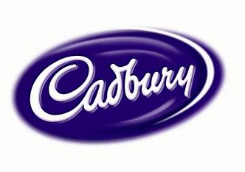

Cadbury
  - The organisational fucntion of cadbury
Kirsty Truslove | BMSP4013 | Contemporary Management Approaches
Contents………
Introduction
Overview of Cadbury
Background of Cadbury
Approaches to management –
- How they seek to motivate their employees
- How they view their employees
Perception and Communication
Conclusion
References

Introduction
In this report I aim to analyze the organizational functions and structure of Cadbury, with main focus being on their approaches to management, how they motivate their team and their work satisfaction, perception and communication within the organization.

Overview of Cadbury
Cadbury is a worldwide confectionery manufacturer based in Britain that was named after its founder, John Cadbury. Their headquarters are in London, and it is owned by Mondelez International. They are the second biggest confectionery company in the world. They are well known for popular chocolates such as Roses, Crème Egg and Dairy Milk chocolate. (Cadbury | Mondelēz International, Inc., n.d.) Cadbury operates in over 40 countries worldwide and employs more than 35,000 people, they also hold the title for being either number one or two in more than 20 of the world’s biggest confectionery markets. Cadbury World have more than $3billion in net revenues since 2016, and their biggest markets are the United Kingdom, Australia, India and China. The chocolate is manufactured in over 15 countries around the world. (Cadbury, 2017).

Background of Cadbury
Cadbury was opened in 1824, 200 years ago by a man named John Cadbury, in which the company gets its name from. The first shop was opened in Birmingham, which was a grocery store. He sold drinking chocolate (which he prepared himself), amongst many other things (Cadbury, 2017) . John Cadbury had two sons, with whom he bought a factory and started manufacturing in 1831 and from then on upgraded factories to larger premises. John retired in 1861 which is where his sons took over the company. What set Cadbury apart all them years ago was that the brothers concentrated on making unadulterated cocoa. They made their cocoa 100% pure which was then advertised as ‘Absolutely Pure, Therefore the best’ (Our story, n.d)
George Cadbury, son of John Cadbury exceeded on growing the company and in 1879, drew up plans for a factory and 16 houses for staff after buying land with a meadow, cottage and stream called the Bourn. He named the site Bournville which is now one of their most popular branded chocolate bars. He explained that he wanted to build a place with green spaces for his future employees to enjoy and have a better quality of life leaving city life behind. He built a small village where people could not only work, but live as well. In 1902, 30% of Cadburys capital expenditure was spent on their employees. Cadbury became one of the first organisations to introduce a Saturday half day off work. “People told us it would mean ruin, I do not think any men could be happier” said George Cadbury. (Our story, n.d, The history of Cadbury, 2024).
The company strengthened through out the wars, and continued to grow rapidly, emerging with other organisations to expand. They have partnered with many other family run companies such as Fry and Sons and Trebor Baset. (The History of Cadbury, 2024) Cadbury chocolate can now be found in more than 40 countries worldwide, and is manufactured in more than 15 countries. (Cadbury, 2017)
Approaches to management within Cadbury’s Organisation
From researching the three main management theorists Max Weber, Henri Fayol and Frederick Taylor, we can see that points from each theorist exists within most organisations as each is so different, but all have a common goal, and that is to be successful. Whilst Cadbury show many values from Henri Fayol’s Classical Management Approach through focusing on ranked job roles and approach to organising the chain of command within the company, they do also use Max Weber’s practical management theory as they seem to assign tasks to workers based on their skills and ability for efficiency.
From analysing Cadbury I can see that there is a clear chain of command from the Managing director to Clerical support assistants in Cadbury’s hierarchical organisational structure. Decisions are made at the top and passed down, and likewise information can be shared from the bottom, up. (As shown in figure 1 below). The company can achieve its goals through outlining duties effectively. Management decisions are made by several members involved in the company’s management team. There seems to be a democratic structure within Cadbury, where decisions require initiative, and everyone needs to know what they are doing. The organisation has implemented strategies to continually motivate staff to achieve their goals and lead a successful business. The company aim to educate their staff on their “vision, mission and strategy” for Cadbury. This would mean the employees feel that they are part of the organisation. (Teachers, n.d).
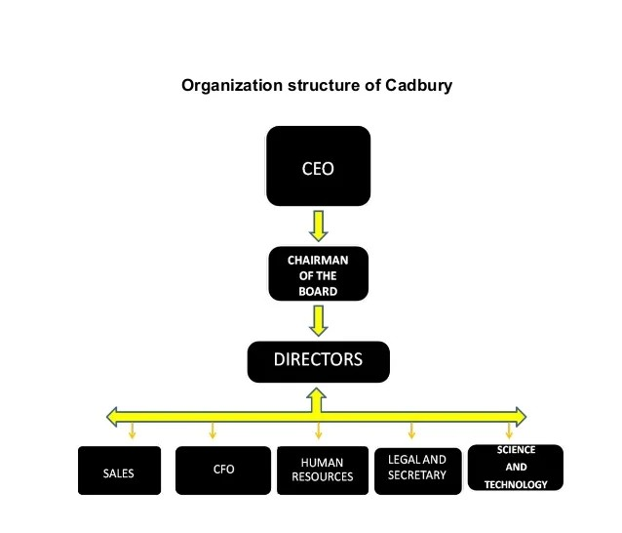
Figure 1. (Jain, 2017)
When John Cadbury opened his company, the leadership was democratic. He wanted his employees to feel equal. He believed in looking after the community, and their approach was ethical – looking out for stakeholders. However, the leadership has become more brutal, and profit driven since being taken over by Mondelez in 2010. Cadbury has many factories and one of these was Somerdale factory in Bristol. Mondelez closed this down after promising to keep it open which resulted in a job loss totalling over 200 employees. This was devastating for the company and employees were no longer feeling part of the organisation. Something like this causes low moral and can be highly disruptive. Internal issues need to be addressed quickly and efficiently by management before employees lose interest and productivity is affected. Cadburys excellent treatment of its employees is significant, maintaining a positive workplace. The fact that Cadbury has been a top brand for over 200 years is proof that their strategy works. (Business Bliss Consultants FZE, 2024).
The confectionary mogul went through an organisational restructure in October, reducing its business units from 13 to 7 and got rid of their four-region operating system. Even though this will have caused job losses worldwide, Cadbury insist it was for their business vision.“The restructure should result in people making decisions faster, removing unnecessary duplication. Hopefully staff will feel the organisation is working more efficiently.” Said the chief executive, Julia Freeman. One would assume that Cadbury has changed dramatically from when it was first opened and was more of a democratic organisation to now. (Peacock & Peacock, 2013)

How they seek to motivate their employees and how they view them
Cadbury have always been a progressive employer with employees at the heart of their company. They established works committee’s as early as 1905, for equal numbers of representatives and labour to attend, to discuss and make decisions on the workplace. Working conditions, health & safety, training and education were all under discussion at these meetings. Investing in their staff welfare resulted in a healthier workforce, additionally it fostered loyalty which helped them become a worldwide brand. This shows that treating people with respect, not only enables them to do the same for others it is beneficial for business. (Fcipd, 2020). The organisation are committed to employee training and development, encouraging them to be profit driven and result focused by offering two share schemes for anyone with a permanent contract. This scheme can be lucrative for employees, and they were said to understand the organisations’ purpose and values. The important factors for low staff turnover are dimensions, commitment and flexibility. This was brought in in 1977 with a programme called ‘Managing for change’. (Business Bliss Consultants FZE, 2024)
Perception and Communication
Within an organisation perception is important as it is the way in which people view their employees, managers and directors. Communication is also very important for voicing concerns, resolving conflicts and convey instructions clearly. Recent reviews I have found on indeed and Glassdoor show me that most people would recommend working at Cadburys and they enjoy it. 84% of employees would recommend to a friend, according to Glassdoor as there is a good business outlook and is an energetic environment to work in. Some of the benefits of working for Cadbury include growth opportunities, along with insurance benefits, pension benefits and a vacation policy. (Cadbury, 2017). Communication and perception were of high importance for John Cadbury when the company first opened, as he waned his employees to benefit from the company and held the committee meetings to understand what the employees needed and what the managers required back from this. Committee meetings can’t be held without a good level of communication and I think having being taken over from Mondelez, the true identity and values of Cadbury has been lost over the years as its grown. Cadbury have implemented a people management strategy, which can aid in accomplishing the objectives of their company. The strategy calls for creating a variety of strategic HR initiatives, such as empowerment and engagement. Interacting and empowerment is how Cadbury believes they can stimulate their team members. (Fcipd, 2020)

Conclusion
What I have found during my research is that Cadbury mainly shows that they have adopted traits from the classical management approach theory, and have a hierarchical approach to management with each section of the company broken down and assigned tasks to their trained skill level. Cadbury seems to be highly focused on keeping their employees happy, and knowing what they need to make this happen, which leads to higher productivity within the workforce and better quality of work and sustaining the number one confectionery mogul in the world.

Referencing

Business Bliss Consultants FZE. (2024, September 20). Organisational Behaviour and Influences Case Study: Cadburys. https://www.ukessays.com/essays/organisations/organisational-behaviour-and-influences-case-study-cadburys.php

Cadbury. (2017). 2017 Fact Sheet. https://www.cadburyworld.co.uk/media/i1pnh0in/cadbury_fact_sheet.pdf

Cadbury | Mondelēz International, Inc. (n.d.). Mondelēz International, Inc. https://www.mondelezinternational.com/our-brands/cadbury/

Fcipd, M. P. (2020, February 7). The Cadbury Approach to Engaging and Empowering People. https://www.linkedin.com/pulse/cadbury-approach-engaging-empowering-people-michelle-prescott-fcipd

Jain, R. (2017, March 3). Organisation behvaiour of Cadbury [Slide show]. SlideShare. https://www.slideshare.net/slideshow/organisation-behvaiour-of-cadbury/72773525

Our Story. (n.d.). https://www.cadbury.co.uk/about/history/our-story/

Peacock, L., & Peacock, L. (2013b, October 28). Cadbury committed to employee training and development. Personnel Today. https://www.personneltoday.com/hr/cadbury-committed-to-employee-training-and-development/

Teachers, M. B. (n.d.). Student essay on How management style, Culture and Organisational structure interrelate in Cadburys. https://www.markedbyteachers.com/gcse/business-studies/how-management-style-culture-and-organisational-structure-interrelate-in-cadburys.html

The History of Cadbury. (2024, November 18). Cadbury World UK. https://www.cadburyworld.co.uk/plan-your-visit/information/news/history-of-cadbury/

