1. Introduction.
Netflix makes a stop in India. Attracting 100 million subscribers in India made Netflix think about its long-term strategy all over again. Which parts of its strategy should it keep, and which would it be willing to change to grow in India? It might need to look at its promise not to show ads again. Let new things, like sports or videos made by people, come in. Or would it be better for the company to buy or merge with a company already in the area? If Netflix wants to stay on top of the competition, they need to pick a strategy for India that doesn't hurt its overall global strategy.

There's a lot more to Netflix than just shows you can't stop watching. There are a lot of other things you can do on Netflix, too. Netflix's marketing strategy is based on new ideas and cutting-edge technology, and it has worked well for them. When a business is successful, it must come up with modern marketing methods that are appealing to a wide range of people to grow. Netflix marketing is innovative because it uses cutting-edge technology, creative advertising, and real-time data analytics to build a strong brand and keep customers happy. This strategy works well in the digital age because it is flexible and can be changed quickly. Modern marketing, like that used by Netflix, changes with the market. This is different from traditional marketing, which tries to make a sale through one or two channels. As Netflix does, your brand can connect with customers across a wide range of mediums, devices, and touchpoints if you keep doing research and improving. Netflix's modern marketing tools are data-driven, customer-focused, tailored, and always there.

Here, we will finish a strategic study of how the company dealt with its main problems. We will use models and theories to show how they were used in the company's future strategies. To show how the company can get an advantage over its competitors, it should show how it chooses its strategic management. The use of conceptual frameworks and technical methods in the right way is important.

2. Netflix Background
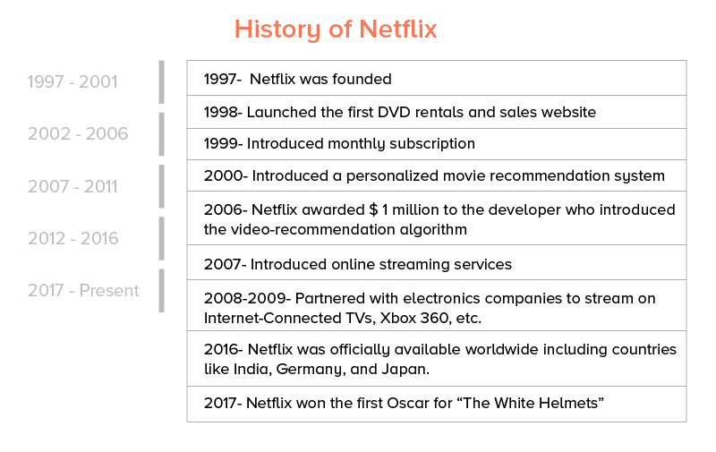Source: (Saxena, 2022)
Over 200 million people around the world used Netflix by the end of 2020. There were a lot of people who paid to be members outside of the United States and Canada, including two million people in India. At a faster rate than in any other country, Netflix had invested more money in India. It decided that India would be the source of its next 100 million subscribers. With a population of 1.3 billion people and better internet access through 4G smartphone connectivity, India had a lot of people who could sign up for the service. Netflix had already come up with its cheapest, mobile-only subscription plan to get into the market. However, competition from other SVOD providers, traditional broadcasters, and telecommunications companies was very strong. In addition, they needed to show a strong commitment to local content in the country's 22 regional languages to make them more appealing. Netflix had to figure out how to get the next 100 million Indian subscribers. (Don Sull, 2021)

3. Mission Statement:
“We promise our customers stellar service, our suppliers a valuable partner, our investors the prospects of sustained profitable growth, and our employees the allure of huge impact.” (RIVERA, 2019)
"Based on the number of people who use our service, the next 100 million subscribers for us are going to come from India." It is the best example anywhere in the world of low internet costs and the spread of 4G anywhere in the world.” Said by Reed Hastings, is a co-CEO of Netflix and a member of the board. (BHUSHAN, 2018)

4. Netflix Financial Situation:
Netflix's revenue in the first quarter of 2021 was $7.16 billion, an increase from around 5.8 billion in the same period of the previous year. Netflix revenue is expected to expand at a pace of 24.2 percent each quarter over the same period last year, according to projections. If Netflix can continue this kind of growth for a few more years, it will be tough for its competitors to catch up and eventually surpass the corporation. (Saxena, 2022)

5. Netflix Strategic Objective:
Netflix's general strategy objective is to make the most of the advantages of high operational efficiency and low cost of information technology. The company needs to do a lot of marketing to grow its streaming operations across the world. Based on Netflix's business model, these corporate strategies try to keep costs down and get into more markets. The online company's business model includes strategic management support for information technology to run more efficiently and expand globally. These strategic implications are put into practice by Netflix Inc.'s operations management. They make sure that all areas of operations work together to strengthen the business model and generic strategy for competitive advantage and to support the intensive growth strategies.
Walmart, Amazon, Google, Apple, HBO, Disney, and other big companies aren't able to hurt the company because of its business design and competitive position. Netflix's aggressive growth strategies help the company grow while these competitors are taken care of. These growth strategies must be aligned with the company's general strategy and business model to make the company's competitive advantages work in the real world. (MOORE, 2019)

6. Success Factors of Netflix:
1. Using technology to break things up
Netflix is always adding new people to its fan base. Netflix started by just mailing DVDs. Later, they dropped late fees, which caused Blockbuster to go out of business.
With time, they went from sending material to streaming high-quality movies and TV shows. This is how it worked: Netflix has grown so much that it is now making its original shows. This unique material is a big hit with everyone. (The Media Lab, 2020)
2. The ability to move quickly.
Netflix's main benefit to its customers is that they don't have to think about how to watch anything. These people can look at things whenever they want. Netflix makes sure that everyone has a great time with personalized preferences. (The Media Lab, 2020)
3. Options abound
Distribution partners give Netflix subscribers a wide range of movies, TV shows, and documentaries to choose from. This keeps bringing in a lot of people. (The Media Lab, 2020)
4. The content strategy.
Variety says Netflix will spend about $15 billion on programming in 2019. Around 85% of the extra money is going to original programming, which costs more than $12 billion. If you think about it, this is a lot more than Amazon, Hulu, and HBO Now, which are all competitors. This is why Netflix has the best customer service ratings. (The Media Lab, 2020)
5. Content that doesn't have any ads is the number
Ads that interrupt your favorite showtime are annoying. It's why ad-blocking software is becoming more popular. Netflix knows this and has ad-free movies and TV shows. This protects people from ads that they don't want or need, making sure everyone has an ad-free experience. (The Media Lab, 2020)
6. A better experience for users.
Netflix does a lot of research to make the customer experience better. The most important thing is the user-made preview videos. This picture shows a title card moving. It also lets people download and watch shows when they're not at home. There is also a 30-day free trial and the ability to share a Netflix account with other people. (The Media Lab, 2020)
7. Customize your Netflix experience
Every day, Netflix knows what we watch because we use it all the time. It knows when we watch certain shows and how many episodes we've watched. The way their AI works is like this:
Netflix is very good at using machine learning to help with its algorithms. It lets the platform make millions of decisions based on what people do.
If we didn't have our suggestion engine, people would spend a lot of time looking for movies and TV shows without it. So, the Netflix recommendation system is very important to the success of the service. (The Media Lab, 2020)

Netflix hasn't had much of an impact in India, and the company's lack of success in the country is "frustrating," according to Reed Hastings, co-founder, president, and co-CEO of the streaming behemoth. During an investor conference call, Hastings stated, "We've got the flywheel spinning in every other major market." We are disappointed that we have not yet achieved the same level of success in India. His comments come only a few weeks after Netflix announced a pricing reduction in India. (Business Today.IN, 2022)
A significant surge in paid subscribers in India and Japan helped Netflix win 2.58 million new paid customers in the Asia Pacific region in the fourth quarter of 2021, marking the company's largest subscriber gains in more than a year and the company's best quarter in over a year. India's price is "dramatically different" from the rest of the globe, according to CEO Charlie Hastings, who notes that the country costs around $3 (Rs 223) per month per family, which "influences customer expectations." (Business Today.IN, 2022)

7. PESTEL Analysis:
The PESTEL analysis is a way for marketers to figure out if macroeconomic factors are affecting their company. This is a very important step that helps businesses find threats and weaknesses that can be used in other frameworks like SWOT or to get a better sense of the overall marketing environment. (cuofano, 2022)
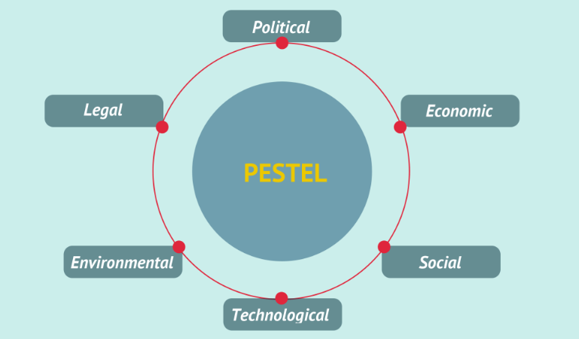
Source: (cuofano, 2022)
Political Factors:
There are a lot of political factors that play a big role in whether or not companies like Netflix and Svod invest in a new place. It costs more to run a business in a bad political environment, but it also makes it less likely to last for a long time. Some of the political factors are the governance system, democracy and institutions, military coup chances, the chance of armed conflict, the law and order in the market, and so on.
In India, the role of the judiciary in commercial and business decisions should be independent to a large extent. Civil society groups are influential not only in policymaking but also in building a society-wide narrative. The regulatory practices are streamlined with global norms which have helped the country to improve its "ease of doing business" ranking. Strengthening democratic institutions will foster greater transparency and reduce the level of corruption in the country. (EMBA Pro, 2019)
Economical Factor:
To make a market more appealing, the economics of a country and its surrounding area have an immediate effect on how appealing it might be to people. If Netflix Svod wants to enter a new market, it should think about things like inflation, GDP growth, disposable income, and so on. These are some of the things Netflix Svod should think about.
As mentioned in the political factors, the government of India is running a deficit budget. This can boost sales of its product in the short-run but also expose Netflix Svod to medium-term forex and currency depreciation risks. Inflation Rate – The inflation rate can impact the demand for Netflix Svod products. Higher inflation may require Netflix Svod to continuously increase prices in line with inflation. This could lead to lower levels of brand loyalty and constant endeavors to manage costs. Netflix Svod should be careful about the history of forex risk before entering a new market. The inflation rate can impact the demand for Netflix Svod products. Increasing consumption and stagnant household income in the U.S. had led to credit binge consumption. This has decimated the culture of savings as people don't have enough to save. (EMBA Pro, 2019)
Social Factor:
Many social factors have a big impact on the country's economy as well as the availability of workforce talent and the level of consumer demand. These factors include demographic trends, the power structure in society, women in the workforce, and more.
In Asia authority is respected while in the west it is something to rebel against. Netflix Svod should carefully analyze its attitude towards authority before launching a marketing campaign for its products and services. Gender composition of the labor market is a good indicator of disposable income of the household, priorities of the households, and related needs. The culture of saving in the US and China is different where the savings rate in China is around 30%, which is well below 15% in the United States. This culture of consumption and savings impact consumption and the magnitude of consumption.
In highly hierarchical societies the power of decision-making often resides at the top. - Societal Norms and Hierarchy – What sort of hierarchy and norms are acceptable in society also influence the types and level of consumption in a society. (EMBA Pro, 2019)
Technological Factors:
Technology is quickly changing business models in a wide range of industries. Some of the technology trends that are affecting the macro environment are the development of artificial intelligence, the use of machine learning and big data analytics to predict what people will do, and the rise of platforms over service providers.
Netflix Svod has to assess whether it can live with the fast pace of technology disruption in its industry. Netflix Svod should assess to what level the local market is prepared to roll out the 5G connectivity. It should evaluate the e-commerce infrastructure, technology infrastructure, etc before entering a new market. One of the areas where the US is lacking behind China is Mobile Payments. (EMBA Pro, 2019)
Environmental Factors:
Environmental factors are becoming more and more important not only to consumers but also to regulators and policymakers. Climate change and changes in the ecosystem are causing more than 20% of species on the planet to die out by the end of this century.
Corporate Social Responsibilities Culture – Are Netflix Svod present CSR efforts applicable in the new market or does it needs to have a new initiative to cater to the prospective market. The report includes an analysis of the per capita carbon emission and overall level of carbon emissions of the country. This can help Netflix Svod in numerous decisions such as plant location, product development, and pricing strategy. - Environmental Standards and Regulations both at National & Local Levels – Often the environment policy at the national and local levels can be different. (EMBA Pro, 2019)
Legal Factors:
Legal factors are often important when it comes to things like how to get into the market, how to run a business in the market, and how to solve problems with other people. If the legal system isn't strong, Netflix Svod can face a lot of problems, from people who want to make complaints to people who want to be punished by the government.
Netflix Svod needs to assess what are the data laws in the country and what it needs to do to comply with them. Netflix Svod should assess the level of protection that intellectual property rights get under the legal system of the country. Is the country following common law which is uniform for all parties – whether domestic or international? (EMBA Pro, 2019)

8. Industry Life Cycle:
There are 4 stage sin Industry Life cycle:
- Launch
- Growth
- Attract & Retain
- Scale
Launch
One way to make sure an SVOD platform is a success is to put all of your money into a content property with a large and enthusiastic fan base. As one example, CBS All Access recently announced that it would be expanding its service to more countries after the popularity of Star Trek Discovery soared when it premiered. People can start a platform with one good show, as shown below. (Parrot analytics, 2018)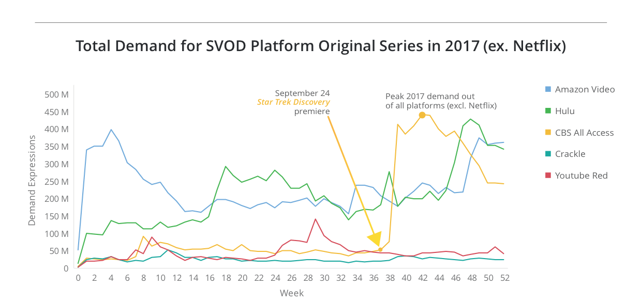
Source: (Parrot analytics, 2018)
Growth:
After the SVOD is launched, its original content must keep increasing the average number of people who want to watch it. Demand for originals on Hulu is rising, which means that more people will sign up for the service as the number of people who want to watch them grows. (Parrot analytics, 2018)
Attract and Retain
To keep people from leaving and to find new subscribers, an SVOD service has to manage its own original content assets. It's important for the service to focus on three types of shows: churn reducers, niche attractor, and subscription driver. (Parrot analytics, 2018)
Scale for Global Domination
After gaining a lot of popularity, Netflix goes on to dominate the world: (a) Increasing the number of shows that appeal to specific groups, like The Crown.
This is how Netflix has turned La Casa de Papel into a global hit by rebranding and marketing it as "Money Heist." (Parrot analytics, 2018)

Netflix currently leads in terms of SVOD revenue share with 29% of the market, followed by Disney+. Hotstar, which has a much lower subscription price, has the largest number of subscribers. Around $1bn has flowed into Indian-language content for OTT services over the past year. Netflix India vice president, content, Monika Shergill, agreed that Indian audiences are "ready for experimentation" and noted a 400% increase in Korean content viewing, a 100% increase in kids programming and a 250% increase in non-scripted formats from all over the world. Both Amazon and Disney+ Hotstar have premiered movies that were made for cinemas but not able to release during the pandemic, while Netflix has been more focused on its own slate of film productions, which were never intended for theatrical. (SHACKLETON, 2021)
Tata Sky Binge, a mobile app that aggregates content from 10 OTT streaming services, was also highlighted. Gandhi and Disney+ Hotstar president Sunil Rayan both said they welcomed the reopening of cinemas, and that India will continue to be a cinema-going nation, but that some movies would inevitably continue to premiere on digital platforms. While India is a mobile-first market, another trend highlighted by several speakers during APOS is the increase in consumers accessing OTT services via connected TVs, which again is a result of the pandemic as viewers were more willing to upgrade their hardware when forced to stay at home. (SHACKLETON, 2021)

9. Porter’s Five Forces Analysis

