

MODULE NAME: INTERNATIONAL FINANCIAL MANAGEMENT
MODULE CODE: LCBB6002
ASSIGNMENT TYPE: REPORT
STUDENT NAME: CERASELA LAVINIA STOICA
STUDENT ID: 2125057

Table of Contents
Introduction 3
Discussing the theoretical framework and models of IFM (International Financial Management) 3
Evaluating the impacts of frameworks and models of IFM 4
Explaining different methods and strategies related to financing of international business 5
Applying the different theoretical structures of corporate value and cost of capital internationally and financial framework 6
Conclusion 6
References 7

Introduction
Foreign finance management is the planned management actions all over the country borders. These needs managing the international finance functions such as financing, risk management and investing. This is essential as it provides international skills, enabling the company to shift all over the world with several economic centres (Finkler et al., 2022). The following report will discuss the theoretical framework and models of IFM (International Financial Management) and evaluate the models of IFM. Also, this study will elaborate different methods and strategies related to financing of international business including company examples. Along with this, the subject will mention the different theoretical structures of corporate value and cost of capital internationally and financial framework.

Discussing the theoretical framework and models of IFM (International Financial Management)
International Exchange Risk management
Currency Forecasting: Exchange rate predictions are evaluations that try to assume the exchange rates over any time. Currency predictions are executed by currency observers and economists’ evaluators performing for financial publications. Currency forecasting is important to estimate the international designated cash flows engaged in foreign transactions. This term is mainly related to money supply and this works at the time of increasing the exchange rate of a country from another country (Beckmann et al., 2020).
Economic Exposure: Economic exposure which is a part of international trade exposure caused by the impact of unpredicted currency variation on a future cash flow of an organisation, international investments, and incomes. Exposure analysis of the economy defines the wider effect of currency variations on an organisation's financial presentation. Along with this, this exposure analysis engages executing planning to reduce the entire threats associated with currency variations.
Foreign Investment Decisions
Capital Budgeting Methods: This is the analysis of financial methods that a company manages to control the approval or rejection or investment project. This has different types of techniques such as net present value, PB (Payback Period), IRR (Inner Rate of Return) and total present value. Capital budgeting depends on several fundamental applications where long-term budgets are risky, and uncertain. This is essential as this builds responsibility and is computable (Bedford et al., 2022).
Country Risk Analysis: This defines the unpredictability related to funding in a specific country. In case of foreign investment, this country's risk can lead to losses for capitalists. International investment decisions are defined as economic estimation criteria. Currently, organisations are becoming conscious about additional threats associated with international investment that occur as a direct challenge of selecting to operate in a separate environment. Country risk evaluation as an existing function in foreign business which reflects an increasing acknowledgement of the demand to involve an estimation of extra risks (Contractor et al., 2020).
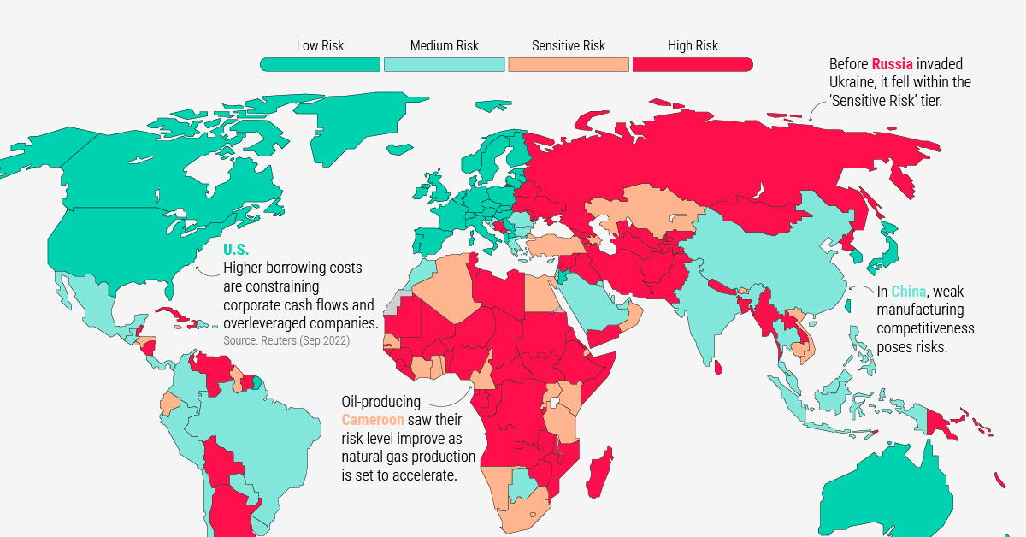
Figure 1: Global macro-economic risk
(Source: Chance and Brooks, 2021)
Foreign Financial Decisions
Cost of capital: Cost of capital defines the essential return on investment that an organisation forecasts when it creates an investment in an international country. This takes into explanation the threat related to the investment like geopolitical threat, exchange rate risk, and possible returns risks. The cost of capital is essential in international financial decision making as it estimates the cost that a trading suffers to finance its functions.
Capital Structure: Capital framework is the specific combination of equity and debt used by an organisation to finance its entire operations and development. The ratio of debt to equity is helpful in regulating the riskiness of an organisation’s negotiating practices. The capital of equity occurs from the shares of proprietary rights in an organisation and maintains to its cash flow and profit margins for future. Along with this, debt happens in terms of bond or loans, preferred stock, and incomes (Bateman and Mace, 2020).

Evaluating the impacts of frameworks and models of IFM
Market conditions: Foreign investment decisions can be the reason for negative impacts on domestic organisations, if international capitalists compress national investors from the market, and become sellers. This loss can be created in the payment balance of the hosting nation for their high number of outflows of profits of investors or large numbers of imports. Along with this, this defines that foreign investment decisions have impacts on the local economy which is beyond the increasing of direct investments in capital. This term offers a quick exit to the foreign market and a developed living standard. The decision-making of foreign investments is a prime improved element in the contemporary economy, and in partnership with the business, defines the most essential purchase of a business, organisation of manufacturing, supplying services and products on an international level (Lutfiani and Hidayah, 2022).
Data availability: International financial decisions provide the data availability by which the foreign financial decisions can observe and examine weather related risks to stability of financial sections. Threats to financial security from weather change vary in their quantity and nature from other threats to the financial system. IFM allows a better acknowledgement of the financial landscape, mapping the data availability and budget cycle from budget estimation. Along with this, risk management is important for foreign trading and this removes possible financial losses and security investments. The most vital aspect of global risk management is to make sure of the observation with agreements connected to international functions (Chance and Brooks, 2021).

Explaining different methods and strategies related to financing of international business
Letter of credit: This is an equipment presented by a bank based on the request of the importer, in which the bank assures to make the payment of the amount to the receiver introducing a particular document in the letter of credit. For instance, Zenith Bank Limited offers a letter of credit by providing surety of paying money to the exporter or importer a particular amount of capital on a particular date (zenith-bank.co.uk, 2024).
Factoring: This is another essential method of capitalising international business. In this method, the organisation or exporters sell their accounts invoice to the term Factor with a discount to increase the fluidity. By supplying a factor, an organisation can make sure that their terms and conditions are competitive and manageable as per the local application. Under this term Factoring, customers may be offered the option of payment on an open account. For instance, Lloyds Bank is a leading contributor of factoring and personal invoice discounting solutions including resources-based lending (realbusinessrescue.co.uk, 2024).
Forfaiting: This term is another specified factoring method used in terms of ultimate credit risk. In case of export financing, when the general ledger of a distributor is allowed whereby the distributor delivers the right to collect payment approving of transferring the transaction is known as Forfaiting. For instance, HSBC achieves credit terms for their buyer that an exporter can be unable to offer. In these terms, the bank gets their products and pays later for the products (business.hsbc.co.in, 2024).
Export Credit agencies: This term provides marketing finance and other services to make it possible for national organisation’s foreign exports. ECAs help the national economy and in creating job opportunities by assisting organisations find international product markets. The terms provide loans, insurance, and loan guarantees to assist national organisations limit the threat of selling products and services in international markets. Through these ECAs, international business can play a leading role in foreign project financing and transports. These factors help in filling the capitalising gap that private sector creditors make with their incapability to provide fundings. For instance, UK Export Finance (UKEF) helps distributors to access the insurance and investments where there is a lack of capacity (oecd.org, 2024).
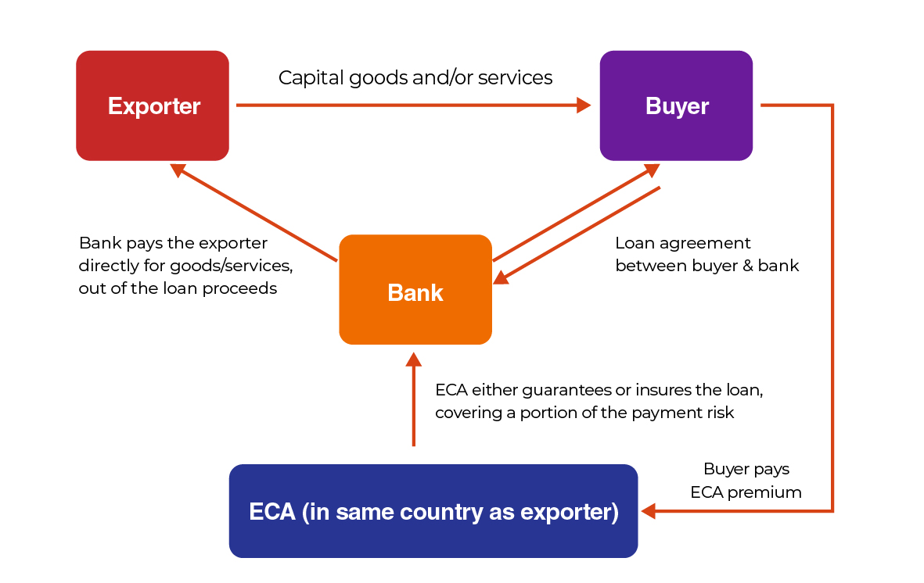
Figure 2: ECA working procedure
(Source: oecd.org, 2024)

Applying the different theoretical structures of corporate value and cost of capital internationally and financial framework
International Cost of capital: This defines the essential return on investment that an organisation predicts when it creates an expenditure in an international country. This considers an account of the threat related to the investment, like possible returns, exchange rate, and geopolitical threat. The approach of foreign cost of capital involves taking an international view of investment options of factors, funding opportunities and expected returns (Mayer,2021).
Capital structure: The approach of capital structure is to consider the value segment of the capital share to the entire cost of capital for an organisation to produce. This term is used in terms and conditions of a business. This is explained as the balance between the debt and an organisation’s equity (Vitolla et al., 2020).
Company Value: This is known as core values of a set of managing principles and basic beliefs that assist teams work toward common business targets. These values are connected to trade connections, customer relations and growth of the company. The motive of a company is the role of serving long-term values and various needs for all stakeholders.

Conclusion
The study has discussed that the role of international investment decisions for the economy of a country improves the major indicators of the economy. Along with this, the topic has highlighted the methods and strategies related to financing of international business. Commercial letter of credit that defines a letter which mitigates the threat of non-execution of the transaction. Forfaiting term is without option which is offering medium term export outstanding designated in complete exchangeable currencies such as Swiss, Pound, US Dollar, Franc and more.

References
Bateman, I.J. and Mace, G.M., (2020). The natural capital framework for sustainably efficient and equitable decision making. Nature Sustainability, 3(10), pp.776-783.
Beckmann, J., Czudaj, R.L. and Arora, V., (2020). The relationship between oil prices and exchange rates: Revisiting theory and evidence. Energy Economics, 88, p.104772.
Bedford, D.S., Speklé, R.F. and Widener, S.K., (2022). Budgeting and employee stress in times of crisis: Evidence from the Covid-19 pandemic. Accounting, Organizations and Society, 101, p.101346.
business.hsbc.co.in, (2024). Forfaiting. Available at: https://www.business.hsbc.co.in/en-gb/solutions/forfaiting [Accessed on: 18th March 2024].
Chance, D.M. and Brooks, R., (2021). An introduction to derivatives and risk management. South-Western, Cengage Learning.
Contractor, F.J., Dangol, R., Nuruzzaman, N. and Raghunath, S., (2020). How do country regulations and business environment impact foreign direct investment (FDI) inflows?. International Business Review, 29(2), p.101640.
Finkler, S.A., Calabrese, T.D. and Smith, D.L., (2022). Financial management for public, health, and not-for-profit organizations. CQ Press.
Lutfiani, A.P. and Hidayah, R., (2022). ESG Performance and Ownership Structure on Cost of Capital and Research & Development Investment. Fokus Bisnis Media Pengkajian Manajemen dan Akuntansi, 21(1), pp.25-42.
Mayer, C., (2021). The future of the corporation and the economics of purpose. Journal of Management Studies, 58(3), pp.887-901.
oecd.org, (2024). Export Credit Agencies. Available at: https://www.oecd.org/fr/sites/mena/competitivite/ismed-export-credit-agencies.htm [Accessed on: 18th March 2024].
realbusinessrescue.co.uk, (2024). Which Invoice Finance Companies Offer the Best Factoring Service? Available at: https://www.realbusinessrescue.co.uk/finance/invoice-finance/which-invoice-finance-companies-offer-the-best-factoring-service [Accessed on: 18th March 2024].
Vitolla, F., Salvi, A., Raimo, N., Petruzzella, F. and Rubino, M., (2020). The impact on the cost of equity capital in the effects of integrated reporting quality. Business Strategy and the Environment, 29(2), pp.519-529.
zenith-bank.co.uk, (2024). Letters of Credit. Available at: https://www.zenith-bank.co.uk/trade-services/letters-of-credit/ [Accessed on: 18th March 2024].

