Managing projects in the organization

Lecturer: Paul Jenkins
Cod: BMSW5104
Student: Ailene Tudor Alexandru
Student number: 1817993

Table of Contents
Introduction 3
Project sponsors, stakeholders, and scope 4
Tools and techniques of project management 5
Project communication methods 8
Benefits of project management 10
Characteristics of the project managers 10
Organizational structures to support projects 12
Types of project; the project life cycle, PRINCE2 15
Risk management techniques 17
Appreciation of soft skills 17
Stakeholder analysis 18
Conclusion 19
References 20

Introduction
Organizational project management is the systematic management of portfolios, programs, and projects in alignment with the achievement of the strategic goals. For the aim of case study, buskers aided to Tesco and got helped by the organization to overcome from the impact of COVID-19; this project will be taken and described. Project management is the application of techniques, tools, skills and knowledge to the project activities for meeting the project needs. The usefulness of the project management techniques and tools for managing a project within an organization will be critically assessed and described. Various kinds of communication methods of the project will be described along with the benefits of project management. Organizational structure for supporting the projects and characteristics of a project manager will be evaluated. Various types of risk management techniques associated with project management will be described.

Project sponsors, stakeholders, and scope
A project sponsor is in charge of driving the project towards the direction by which the project is brought to the successful realization of expected benefits. A project sponsor participates in processes of communication management, facilitates the development of project charter and initial scope, takes care of engagement processes, and finances the approved ideas and project initiatives (Aaltonen, 2011). The main role of the project sponsor covers organizational and financial activities and responsibilities, which are directed to decisive and quick governance of the project. The project sponsors are critical to the successful implementation of project objectives, high project sustainability and strategic planning (Njogu, 2016). Evaluation of the success of the project on completion, negotiation with the stakeholders for gaining consensus when differences of opinion take place, identification of project critical success factors, management of project benefits, qualification and identification of project benefits, and negotiation of funding for the project are some of the crucial responsibilities of project sponsors.
Stakeholders are people who are interested in the outcome of the project and also invested in the projects. Stakeholders are typically the members of users, customers, project sponsors, executives, project managers and also the members of the project team. The stakeholders project management will have affects at any point along with the way, and also the inputs of the stakeholders can affect the outcomes (Anantatmula, 2010). The stakeholders in a project can be an individual or the organization, which are affected by the outcome of a project and by the execution of the project. Resource managers, executives, steering committee, project sponsors, project team members, project managers, and customers are the main key stakeholders of the project.
Project scope can be crucial for the successful execution of the project, and also the main understanding of every key element of the project is involved in the scope of the project (Burke, 2013). Project scope is a detailed outline of all the aspects of a project, where the boundaries of the project, other related activities, deliverables, timelines, and resources are included. What is included, what is not, constraints, assumptions, processes, and stakeholders are outlined by the project scope.
Tesco aids buskers impacted by COVID-19. Busker play a huge role to create the environment and mood in the malls and stores of Tesco. Buskers are those who bought liveliness for Tesco’s malls, and were facing hardships because of losing the sources of income due to the closure of public gathering and malls in pandemic time. After knowing this scenario, Tesco planned a project of separating occasions reached out to the community of busker during movement control order. The main aim of the project was channelling RM10,000 in cash vouchers for the Malaysia Buskers Club members so that can fulfil their requirements by purchasing their necessity. At the end of May Tesco had donated over RM2,000 worth of foods to buskers.

Tools and techniques of project management
The project that required being accomplished needs some techniques for accomplishing effectively, where some crucial tools are necessary for successfully implementing the techniques. The tool that can be used as different work steps are described below:
Finance and Accounting – for the future planning and financial outcomes, understanding of financial outcomes of the project is essential for the business owners and project managers (Woodward et al., 2010). The finance and accounting tools differ as per the size of the projects, such as Freshbooks, Zoho, and QuickBooks are most used accounting tools for collecting the information, while other accounting solution tools are used for smaller team projects.
Time-management – the proper future estimation and planning are established by the provided valuable information through time management tool. For any period, the manager understands both results of the team and also individual time expenses by using time management tool such as antitime (Aaltonen, 2011). This project management tool had helped Tesco in managing the time because there were no such more time buskers had due to loss of income sources. Insights such as what can be optimized and how time is used, are provided by the notes to the logged time, and informative reports with time and cost summaries.
Scheduling – it is very vital to know who on the team is available for specific dates while planning for future and allocating resources. All the necessary details of the time off and leaves of team members, and also a clear visual chart of absences for upcoming dates are provided by scheduling software.
Communication – communication within a project team requires being meticulously organized for being the key point in many methodologies and techniques. By integrating various communication tools, the pain of having multiple messengers can be eliminated in the case of the use of various communication tools (Anantatmula, 2010). Having a corporate messenger, like Skype and Slake, is very essential for the project along with email, used for important messages and formal communication.
Organizing planning and workflow – how the quality of its outcome will be ensured and how the project will be performed is defined as this tool (Woodward et al., 2010). For both kinds of teams, such as for the large teams, MS Project is used as a comprehensive solution, while for the smaller one many alternatives are available. For visualizing future project progress, roadman and planning features are sufficient, while they do not provide the entire rich functionality typical expensive and complex tool.
Project management methods – there are lots of techniques available ranged from traditional to innovative that are selected by some crucial factors such as teams involved, the complexity of the project, and project specifics (Lianying et al., 2012). Traditional techniques are developed for certain field and also for certain areas of activity. Some of the crucial techniques that are used for project management are the following:
- Extreme project management - this technique emphasizes deterministic management, reduction of formalism, open approach and elasticity in planning. The main focus of this technique is on the human factor in project management instead of rigid phases and formal methods. Extreme project management technique is used for an uncertain, complex, and large project, where unpredictable factors and managing uncertain is required.
- Critical chain technique (CCT) - CCT emphasizes the optimization of time expenses, dependencies analysis and prioritization. This technique is derived from critical path methods and PERT methods (Stare, 2011). Critical Chain Technique gives more attention to how time is used and prescribes more flexibility in resource allocation while providing less focus on scheduling and rigid task order. This technique is used in complex projects and suites where resources are limited.
- Critical path technique - this technique is often used in conjunction with the PERT method and also this is like an algorithm for planning and scheduling works(Adan, 2012). Determination of the critical tasks and detection of the longest path from the beginning to the end of a project are involved in this technique. This technique is used for complex projects, where deadlines and delivery terms are critical.
- Program Evaluation and Review Technique (PERT) - visual tracking of work results on PERT Charts, and detailed and complex planning is involved in the PERT technique (Njogu, 2016). The analysis of task performed within the project is the core part of the PERT technique. This technique is used for long-term and larger projects with challenging needs.
- Agile Project Management - this technique fosters collaboration and self-organization of the team, which is targeted to producing maximum value, and also prescribes dividing project work into short sprints using continual and planning improvement. FDD, DSDM, Kanban, and Scrum are some of the techniques which are included in Agile frameworks. This technique is used in software development projects which are performed by highly and small collaborative teams.
- Waterfall technique - this technique can also be based on the sequential performance of tasks and takes the simple classic pro approach to a new level. Next steps of this technique never start until the last one accomplished (Stare, 2011). Gantt Charts are often used in this technique for monitoring performed steps and progress. Waterfall technique is used for complex projects, where successful delivery depends on rigid work structuring, and detailed phasing is required.
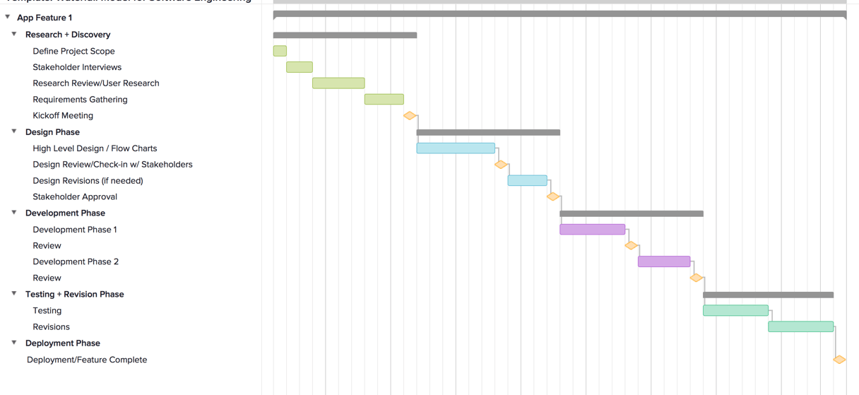
Figure 1. Waterfall Technique in Tesco Organization

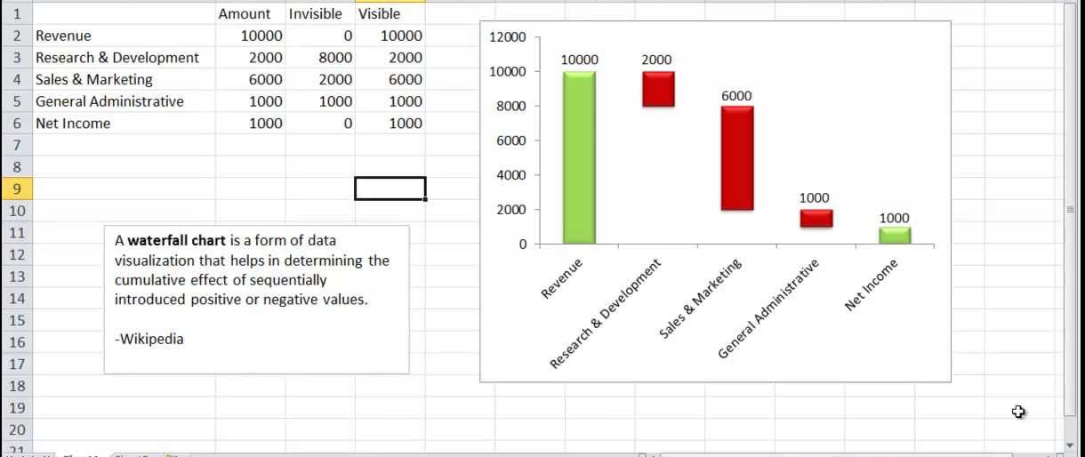

Figure 2.

Project communication methods
Communication methods are systematic procedures that are used for transferring various kinds of information among the stakeholders of the project. The main purpose of this tool is to ensure that all the information relayed and created is understood by the stakeholders involved in the project (Lianying et al., 2012). Pull, push and interactive communication are the main three kinds of methods used in project management. These methods allow the project leaders to extract a response from the stakeholders effectively along with this also allow to get the message across the organization. These three communication methods are categorized by Program Management Body Of Knowledge.
Pull communication method - pull communication method is most suitable for the large-scale audience (Whinnett et al., 2013). The information accessed by a large-scale audience is stored by the project manager in the data repository in a place where this information can be accessed by stakeholders and team members. The training session, study materials, and slide shows are some kind of information that are stored by the project manager.
Push communication method - this type of communication method is used by the project manager for sending meeting notes and other information. In push kind of communication method, the information is passed to the recipients, where immediate feedback is not required (Lienert et al., 2013). The project manager also uses this mechanism for passing the information to the stakeholders by a press release. One of the disadvantages of this method is that the project manager is not sure about the understanding of the information by the recipient. This method only acknowledges about sent off a message to the recipient. This method was very beneficial and useful for the organization because it has helped in communicating properly with the busker club and had planned the proper arrangements well so that Tesco could help the busker club.
Interactive communication method - in this kind of communication method all the stakeholders are allowed to interact live with every people involved in the project (Woodward et al., 2010). Phone calls live chatting and video conferencing are some of the great examples of interactive communication method. For the stakeholder located in a different region, the interactive communication method is more suitable. The project manager chooses the mode of communication for communicating with the stakeholders.
The project manager can select any of the communication methods from Pull, Push and Interactive method (Adan, 2012). The location of the stakeholders, the number of audiences and all the option must be checked by the project manager before selecting the type of communication method. These are a few crucial factors that must be cared for by the project manager before choosing the kind of communication method.

Benefits of project management
Project management is advantageous in resolving the problems quickly and also helps in managing the project effectively. This project has helped majorly to the busker club in the way of supporting them to overcome from the difficult situation and bought essentials. The aim of the project was the most beneficial for Tesco as it would increase the relationship bond with the busker club and would improve the market value of the organization in pandemic time. Project management helps in the following:
- Boosting the bottom line and gaining a competitive advantage
- Increasing customer satisfaction
- Mitigating risks of a project failing
- Satisfying the various requirements of the stakeholders of a project
- Encouraging consistent communication among clients, suppliers and staff
- Improving the quality of work and productivity
- Staying on schedule and keeping resources and costs to budget
- Setting budget, schedule, and scope accurately from the start
- Prioritizing the resources of the business and ensuring the efficient use of the resources
- Improving the chances of achieving the desired results (Anantatmula, 2010).

Characteristics of the project managers
A good project manager requires possessing certain skills such as management, business and technical skills for managing project with utmost efficiency and smooth delivery of various projects (Chouand Ngo, 2014). Some of the characteristics of a project manager are the following:
Problem-solving skills - the good project managers do not much concern with how others have performed problems solving skills, and they also have a fresh creative response for every opportunity. The leaders also share problem-solving responsibilities with the team.
Team building skills - the good leaders have the ability to the understanding of the styles of different team players and also of how to capitalize at the proper time for the problem in hand (Njogu, 2016). The leaders also have knowledge of the appropriate leadership style for using during each stage of team development. For the progress of the team from a group of strangers to a single cohesive unit, understanding of dynamics and processes required for the transformation is essential for the leaders.
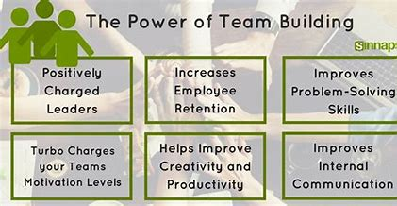
Figure 3: The Power of Team Building.
Cool under pressure - the leaders consider the problems as an opportunity and feel like they can influence the outcomes. In stride, the leaders with a hardy attitude will take these problems. Out of the chaos of changes and the uncertainty, the leaders articulate and raise a new image of the future that pulls the project together.
Ability to delegate tasks - a good leader has the quality of delegating the work and the delegation of the work depends upon the trust between the leaders and team (Lianying et al., 2012). A leader demonstrates the trust in others by the actions such as allowing people to participate, a delegation of the work, control over the work and checking process of the work. A person, who cannot believe in others, can never become a leader.
Competence - expertise in leadership skills is dimension incompetence. A competent leader can encourage, modelling, enabling, inspiring and challenging (Burke, 2013). Leadership competence does not refer to the technical abilities of the project leader in the core technology of the business.
Empathy - empathy presupposes the existence of the object as a separate individual, entitled for emotional history, ideas and feelings of the leader (Whinnett et al., 2013). This characteristic of the leaders is helpful for the team members, as the leaders acknowledge that every team member has a life outside of work.
Integrity - the demonstration of ethical practices is demanded by good leadership. The leaders in the process earn trust and walk the talk. The leadership based on integrity presents the dedication to honesty with team members, behaviour consistent with values and a set of values shared by the others.

Organizational structures to support projects
Organization requires defining the relationships to the projects and both the organization, degree of autonomy and authority, and the job of the project manager. Education and health are the areas counted in the development organization, which are usually organized around programmatic focus areas (Chouand Ngo, 2014). These areas are centred on a specific development field and also called as program units. There are three kinds of organizational structures are available, which are defined by the level of organizational authority handed to the project manager. These structures are as follows:
- Project-based structure
- Matrix-based structure
- Programmatic based
Project-based structure - the overall control of the project is in the hand of the project manager. The manager got the higher-level authority. The manager can acquire the required resources for accomplishing project objectives outside of the organization and also within the organization. The project manager is the main key to project-based organizational structure, where every assigned person report to the project manager. The main responsibility of the project manager in this structure is that the manager has to provide the opportunities for the career progression of the team members and also for the performance appraisal (Adan, 2012). The teams involved in the project develop a good understanding of the nature of goals, mission, and activities of the project, and also develops a strong sense of project ownership and identification. Among the complicated and large projects, pure project-based organizations are more common. Inefficient and costly use of a person is the biggest disadvantage of project-based organization. Limited opportunities exist for knowledge sharing between the projects, which are also a kind of lack of opportunity for professional growth. This project-based organizational structure was the beneficial and essential structure according to the aim of the project, as the project manager is responsible for the performance appraisal and progress of the project.
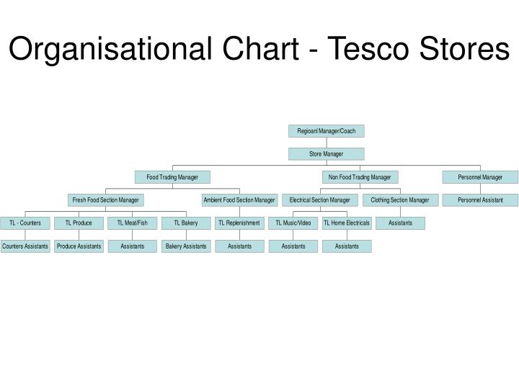
Figure 4 Project-based organizational structure.
Matrix-based structure - the organizations that follow matrix-based organizational structure allow the projects to be staffed with specialists from throughout the organization and also allow the program to focus on their specific technical competencies. The organizations that follow this kind of structure are the most flexible organizations when dealing with changing programmatic priorities and needs (Aaltonen, 2011). The organization allows career progression and professional development to be managed, allows for specialization that can increase the depth of knowledge, and also allows the team members to share the information readily across the unit boundaries. The efficient allocation of scarce speciality skills that cannot be fully utilized by only one project is the biggest advantage of matrix-based organizational structure. The relationships of reporting are very complex, and this is counted as the main disadvantage. Cooperation and communication between multiple project manager and programmatic unit managers since that all be competing for a time from the same resources.
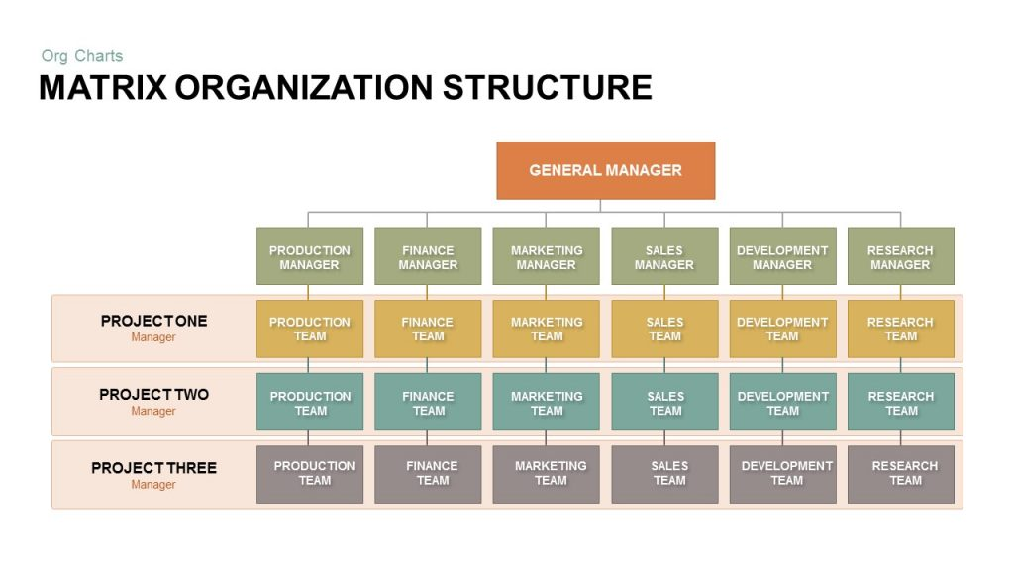
Figure 5 Matrix-based organization structure.
Programmatic based structure - it is a traditional structure, where over most of the resources, program sector managers have formal authority. This kind of structure is valuable only for one program sector. The resources required for the project team come from the same unit and also the overall project team is staffed with people from the same area. The team members within this kind of structure are usually familiar with each other (Lienert et al., 2013). For resources, no negotiation is required with the other program units. The clear line of authority is the biggest advantage of this structure. The entire specialist required to work on a project may not have in the project is the main disadvantage of this structure. Because of the other responsibilities along with the project work, the team members involved in the project are unable to give proper time to the main project work is another disadvantage of programmatic based structure.
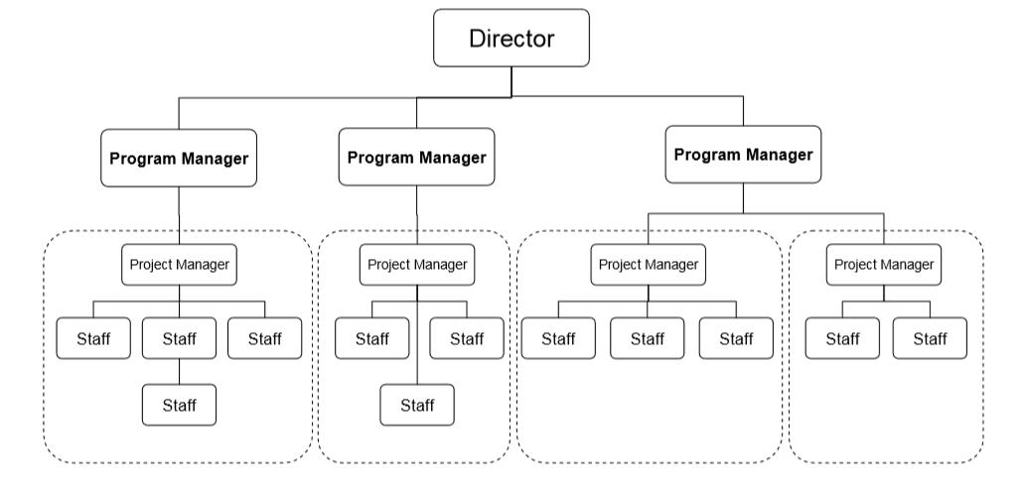
Figure 6: Programmatic based structure

Types of project; the project life cycle, PRINCE2
The sequences of phases through which the project passes are involved in a project life cycle, where the project initiated and end up with the closure of the project (Lianying et al., 2012). The areas of application, the nature of the project, requirements of the organization involved in the project and the management are some of the crucial factors which determine the sequence and number of cycles. The phases of the cycle are constrained by time and have control point along with definite start and endpoint. The basic foundations of the actions, which are required to be performed in the project, are provided by the life cycle (Burke, 2013). The project life cycle can be modified and defined according to the aspects and requirements of the organization. Project life cycle ranges from the change-driven approaches to the plan-driven approaches. The product is developed over multiple iterations in the changed-driven life cycle, and the detailed scope is defined for iteration only when iteration begins. However, the specifics are defined at the start of the project in plan-driven approaches, and also any kind of alterations is carefully addressed. The standard framework of the project consists of the same generic life cycle structure and also consists main four phases, namely initial, planning, execution and termination phases.
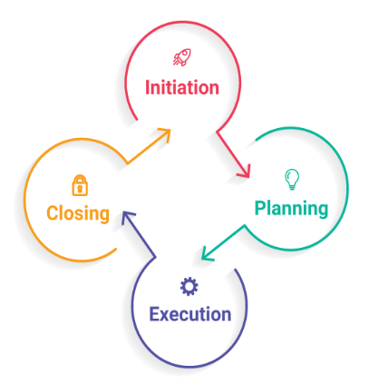
Figure 7: Characteristics of Project Life Cycle
PRINCE2 (Project IN Controlled Environment) is the most crucial project management standard in the present era, where it involves various processes, recommendations, and guidelines for the planning of the project. The main aim of this project management is achieving the project goals with optimum use of resources. For standards, the PRINCE2 manual defines the planning life cycle by the main three parts, which are principles, themes, and processes (Whinnett et al., 2013). The seven processes of PRINCE2 are start-up of the project, directing, initiating, controlling a stage, managing product delivery, managing stage boundaries, and closing a project. Seven themes of PRINCE2 are progress, change, risk, plans, quality, organization, and business case. The main seven principles of PRINCE2 are tailor to suit the project environment, focus on products, manage by expectations, manage by stages, defined responsibilities and roles, learn from experience, and continued business justification. The key features of PRINCE2 are the following:
- Flexibility, which can be applied at a level appropriate to the project
- Emphasis on dividing the project into controllable and manageable stages
- Product-based planning approach
- Defined organization structure for the project management team
- Focus on continued business justification

Risk management techniques
Project risk management is the process of determining, analysing and after that responding to any risk, which arises over the life cycle of a project for helping the project to meet the goals and remain on track. Risk management is the part of the planning process for figuring out the risk that might happen in the project. Risk management is very crucial for all sized organizations including smaller, start-up and larger organizations (Chouand Ngo, 2014). Identification, analysis, and planning are the main three risk management techniques involved in project management. Identification is the first technique in risk management, where the potential risks related to the project are recognized, determined, and described. Checklist analysis, SWOT analysis, risk survey, and brainstorming are some of the project management techniques used in the identification step. Another step is analysis; this technique is used after the identification of potential risk related to the project.
In the analysis step, the detailed description of how exactly the risks could impact the project is provided (Adan, 2012). The analysis of the project could be quantitative and qualitative. After the determination and analysis of all the potential risks related to the project risks, planning of the project is very crucial for determining the ways of mitigating the risks effectively (Anantatmula, 2010). Synapse project management software is a project planner which can be used for planning step of risk management technique. Risk management techniques are of two types, namely quantitative risk analysis and qualitative risk analysis. Quantitative risk analysis includes probability distribution, and quantitative risk analysis includes risk urgency, risk categorization, probability and impact assessment, and expert judgment.

Appreciation of soft skills
Leadership - effective leadership is defined by the results instead of attributes, it is about being liked or making speeches. For the project leader, leadership is an essential characteristic (Burke, 2013). Leadership is capable to enables the project manager to value the team members by the successful completion of the project and meantime accomplish a diversity amount of productivity too.
Team building - the goal of team-building exercises is to develop a project environment that people bond with each other. Team building helps the team members in trusting each other, collaborating and feeling safe.
Communication - lots of issues on the project are created by good communication, which also seems easier to achieve. Open communication practice builds mutual trust among the team members (Aaltonen, 2011). The project manager should communicate information regularly, keep cultural differences in perspective, and should identify efficient communication channels with each of the stakeholders.
Decision making - it is all about how the project manager handles the problems related to the project (Chouand Ngo, 2014). The decision-making of the project managers is based on consensus, consultants, and commands.
Negotiation - negotiation is the skills related to good conflict resolution. This enables the project managers in listening to both parties and making fair decisions. Negotiation could not always please to both parties. Articulation, stating, and listening to the problems might present the solutions.

Stakeholder analysis
Stakeholder analysis is the process of identification of people, such as team members involved in a team, internal people of project and people of the organization, before the beginning of the project. These people are called stakeholders, and these are grouped as per the level of influence, interest, and participation in the project. The stakeholder analysis is conducted by the product managers, program managers and project manager (Lienert et al., 2013). Helping in addressing the issues or conflicts early on, gaining early alignment among all stakeholders on plans and goals, and enlisting the help of key organizational players are the main aim of the stakeholder analysis. A stakeholder analysis is conducted by the project manager in three steps, where the first step is the determination of the stakeholders, the second step is prioritization and grouping of the determined stakeholders, while the third step is figuring the stakeholders for determining how to communicate with the stakeholders. Top five techniques used for stakeholder analysis are Salience model, `importance - influence grid, Power influence grid, Influence impact grid, and Power versus interest grid.

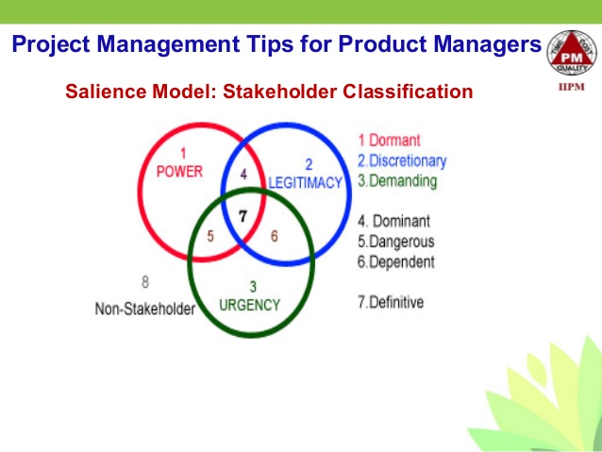
Figure 8: Salience model

Conclusion
It can be concluded that stakeholder analysis is very crucial for the project and the stakeholder analysis is conducted by the project manager and also the product manager. Leadership and team building are some of the crucial soft skill which is required for the project manager. It has observed that the identification, analysis, and planning are the main risk management techniques. For supporting the project, three kinds of organizational structures were determined; programmatic-based, project-based, and matrix-based structures. It has observed that some of the crucial characteristics are required for being a leader and managing the project. Quality of the work improved, and customer satisfaction is increased by the project management, which was counted as the benefits of the project management. Interactive, pull and push kinds of project communication methods were identified. Stakeholders are very crucial for running the project as well as the sponsors are also particularly important for initiating the project, as project sponsors provide the funding to the projects and ideas. It can be concluded that the Busker project of Tesco would increase the value of the organization and would also increase the relationship between the organization and busker club.

References
Aaltonen, K., 2011. Project stakeholder analysis as an environmental interpretation process. International journal of project management, 29(2), pp.165-183.
Adan, I.H., 2012. Influence of stakeholder’s role on performance of constituencies development fund projects a case of Isiolo North Constituency, Kenya (Doctoral dissertation, University of Nairobi, Kenya).
Anantatmula, V.S., 2010. Project manager leadership role in improving project performance. Engineering Management Journal, 22(1), pp.13-22.
Burke, R., 2013. Project management: planning and control techniques. New Jersey, USA, 26.
Chou, J.S. and Ngo, N.T., 2014, December. Identifying critical project management techniques and skills for construction professionals to achieving project success. In 2014 IEEE International Conference on Industrial Engineering and Engineering Management (pp. 1204-1208). IEEE.
Gomes, J. and Romão, M., 2016. Improving project success: A case study using benefits and project management. Procedia Computer Science, 100, pp.489-497.
Grimaldi, S., Rafele, C. and Cagliano, A.C., 2012. A framework to select techniques supporting project risk management. Risk Management, 3, pp.67-96.
Lianying, Z., Jing, H. and Xinxing, Z., 2012. The project management maturity model and application based on PRINCE2. Procedia Engineering, 29, pp.3691-3697.
Lienert, J., Schnetzer, F. and Ingold, K., 2013. Stakeholder analysis combined with social network analysis provides fine-grained insights into water infrastructure planning processes. Journal of environmental management, 125, pp.134-148.
Meredith, J.R., Shafer, S.M. and Mantel Jr, S.J., 2017. Project Management: A Strategic Managerial Approach. John Wiley & Sons.
Njogu, E.M., 2016. Influence of Stakeholders Involvement on Project Performance: A Case of Nema Automobile Emmission Control Project in Nairobi County, Kenya (Doctoral dissertation, University of Nairobi).
Stare, A., 2011. The impact of the organisational structure and project organisational culture on project performance in Slovenian enterprises. Management: journal of contemporary management issues, 16(2), pp.1-22.
Whinnett, N.W., Tong, F., Xiao, W. and Love, R.T., Motorola Mobility LLC, 2013. Use of the physical uplink control channel in a 3rd generation partnership project communication system. U.S. Patent 8,412,209.
Woodward, B.S., Sendall, P. and Ceccucci, W., 2010. Integrating Soft Skill Competencies through Project-Based Learning across the Information Systems Curriculum. Information Systems Education Journal, 8(8), p.n8.

(Meredith et al., 2017)

(Grimaldi et al., 2012)
(Gomesand Romão, 2016)

