

WHAT INFLUENCES DRIVERS TO CHANGE FROM
TRADITIONAL VEHICLES INTO MODERN SUSTAINABLE VEHICLES?

Author: Joaquim Anthony Fernandes
Student Number: 1805865
Module Code: (BMSP7005D)
Supervisor: Glenn Behenna
Submission Date: 20/09/2024

Signed Statement

DECLARATION
This work ensures that it has not previously been accepted in substance far any degree and is not being concurrently submitted in candidature for any degree.

Signed………………………………J.A.Fernndes……………………………….(candidate)
Date…………………………………19/09/2024………………………………………………

STATEMENT 1
This work is the outcome of my own investigations, except where otherwise stated.
Other sources are acknowledged by footnotes giving explicit references. A bibliography is appended.

Signed………………………………J.A.Fernndes……………………………….(candidate)
Date…………………………………19/09/2024………………………………………………

STATEMENT 2
I hereby give permission for my work, if accepted, to be available for photocopying and for interlibrary loan, and for the title and summary to be made available to outside organisations.

Signed………………………………J.A.Fernndes……………………………….(candidate)
Date…………………………………19/09/2024………………………………………………

Acknowledgements

First of all, I would like to thank my supervisor, Glenn Behenna for his help and support during the course of this dissertation. Glenn Behenna’s support and feedback has given me the encouragement and drive to keep progressing forward throughout this dissertation, as he has provided me with good insight and feedback to check if I was on the right track which I am extremely grateful for.

I would also like to thank my family and friends as they gave me the support, motivation and encouragement to do this dissertation.

I would also like to give a special thanks for the enthusiasm of the participants who took part in the interviews that were conducted and I would like to thank the participants that took time out of their day to answer the surveys.

Abstract

Sustainable leadership can be defined as people who are obliged to make a change, by way of becoming more aware of themselves in relation to the world around them. In doing so, people can embrace new ways of seeing, thinking and interacting, which can result to innovative and sustainable solutions (Visser, 2024). For example, people are deepening their awareness through cutting down, consuming less and becoming more aware of the materials that everybody uses in our day to day lives.

Therefore, the purpose of this research is to look more into sustainable vehicles as this is the most current movement towards sustainable leadership, as this current transition is not only changing the traditional internal combustion vehicle into a sustainable vehicle, but it is also looking at the sustainable challenges that can be tackled and resolved (Capgemini, 2022). This transition is also investigating the sustainable challenges that come with this current transition, how they are going to change their infrastructure to fit the needs to become more sustainable and to also look more into management practices and embedding sustainability into organisations, and to also look at peoples desire’s for this current transition (Lutsey, 2015).

This is going to be done by carrying out a literature review that consists of what types of sustainable vehicles are currently available and the advantages and disadvantages of the vehicles, are electric car batteries actually good for the environment, sustainable management practices and how are car manufacturers implementing sustainability into their vehicles to influence drivers to purchase them, and people’s desires for sustainable vehicles would also be looked at in the literature review as well.
Also the main theorists that will be drawn upon in the literature review will be the knowledgeable experts of the automobile companies, such as Renault, Volvo, Mazda, BMW and Tesla to show how they have implemented sustainability into their vehicles, either through the utilisation of the circular economy by using sustainable methods and materials or implementing sustainability through the utilisation of electric vehicles. The other main theorists that will be drawn upon in the literature review will be the inventor Thomas Edison to show how he brought about a better battery for electric vehicles and Shell Recharge will be drawn upon as well to show how the implementation of the charging infrastructure is being put into action, and to see how the user experience has gone through existing consumers.

Once the literature review has been carried out, the next step of this dissertation would be to carry out both quantitative and qualitative research which is going to be combined, through the use of the mixed methods approach which will uncover what people’s opinions and feelings are going to be and to also take into account the numerical data as well (Harvard Catalyst, 2024).

The benefits to using the mixed methods approach in this research, is that it will gain a better understanding of connections and contradictions amongst qualitative and quantitative data so that it can balance out each of their limitations, and this mixed methods approach will also offer opportunities for the participants to have a powerful voice, so that they can share their experiences and viewpoints across the research process, which will allow different avenues to be explored that will enhance the evidence and allow for the questions to be answered more deeply (Shorten, 2017).

The quantitative research is going to be carried out through developing and analysing questionnaires/surveys. The analysis of this research is going to be analysed through SPSS (Statistical Package for the Social Sciences), so that my results can be put into descriptive statistics and be displayed as a pie or bar chart.

Whereas the qualitative research is going to gather non numerical data through carrying out interviews from drivers to get their opinions on sustainable vehicles and what would or has influenced them to purchase a sustainable vehicle, in addition to those interviews, I am also going to carry out an interview for non-drivers too so I can get their viewpoint on sustainable vehicles. Once the interviews have been conducted, they will be transcribed and analysed so that they can be displayed as themes and interpretations ready for the outcome of my dissertation.

Table of Contents

Signed Statement………………………………………………………………………………2

Acknowledgements……………………………………………………………………………3

Abstract………………………………………………………………………………………..4

List of Figures…………………………………………………………………………………9

Chapter 1: Introduction………………………………………………………………………10

Chapter 2: Literature Review………………………………………………………………...16

Chapter 2.1: What are Sustainable Vehicles………………………………………………….17

Chapter 2.2: Circular Economy Implementation…………………………………………….24

Chapter 2.3: Environmental Impact of Sustainable Vehicles………………………………...25

Chapter 2.4: Technological Advancements in Sustainable Vehicles…………………………26

Chapter 2.5: Charging Infrastructure and Drivers Experience……………………………….28

Chapter 2.6: Energy Usage at Home…………………………………………………………30
Chapter 2.7: Sustainable Vehicle Regulatory Trends………………………………………...32

Chapter 3: Research Methodology…………………………………………………………...35

Chapter 3.1: Interview Process……………………………………………………………….38

Chapter 3.2: Interview Limitations…………………………………………………………..39

Chapter 3.3: Survey Design and Analysis……………………………………………………40

Chapter 3.4: Survey Limitations……………………………………………………………..42

Chapter 3.5: Ethical Considerations………………………………………………………….42

Chapter 4: Presentations and Interpretations of Results……………………………………...44

Chapter 5: Conclusion………………………………………………………………………..66

Chapter 6: Recommendations………………………………………………………………..68

References……………………………………………………………………………………70

Appendix……………………………………………………………………………………..79

List of Figures

Figure 1: Why electric cars will take over sooner than you think - BBC News…………………………………….
Figure 2: Why electric cars will take over sooner than you think - BBC News…………………………………….
Figure 3: Plug-in hybrid and other electric vehicles | BMW.com…………………………………………………….
Figure 4: A Guide to Hybrid Cars and How They Work - OVO Energy…………………………………………..
Figure 5: What is a mild hybrid car? (parkers.co.uk)………………………………………………………………….
Figure 6: Plug-in hybrid and other electric vehicles | BMW.com……………………………………………..
Figure 7: What is a Hybrid Vehicle and How it Works? Know More: - CarBikeTech…………………..
Figure 8: Plug-in hybrid and other electric vehicles | BMW.com……………………………………………..
Figure 9: EV charging statistics 2024 - Zapmap (zap-map.com)……………………………………………

Chapter 1: Introduction

Electric vehicles have been going on a lot longer than people would’ve expected, as they were here before the current Tesla and even before the General Motors EV1 of the late 1990s. If truth be told electric vehicles have been around a lot longer than the internal combustion engine vehicles, as dreamers have never stopped trying to make the electric vehicles work both on the road as well as a business proposition (Justin Rowlatt, 2021).

For example, the first electric car was first established in the 1830’s by a Scottish inventor Robert Anderson (Wilson, 2023), then in 1900’s Ferdinand Porche made the world’s first hybrid electric car called the Semper Vivus, which ran off of electricity, which was stored in a battery and a combustion engine to help extend the car’s driving range (Wienkotter, 2019), and in 1914 Henry Ford partnered with Thomas Edison to delve into options for a low cost electric car, but Ford’s popular Model T car was soon delt a massive blow to electric cars, as gasoline powered vehicles became more popular and more widely available and affordable (Strohl, 2018).

Even though, over the last hundred years electric vehicles have declined and that was due to them being phased out because of their short mileage, which can be shown with the world’s first electric car that could only do about 1.5 miles at 4 mph (Wilson, 2023), and this can be shown with the GM EV1 only going up to a range of 50 miles and the GM EV1 was certainly not commercially viable as it cost a billion dollars to develop (Justin Rowlatt, 2021), which goes to show how expensive electric vehicles are to make. Another reason for the fall of electric vehicles was also down to internal combustion engine vehicles winning the technology battle as they were more cheap and readily available, which practically made electric vehicles all but disappear by the year of 1935 (Energy.gov, 2014).

Whereas currently, in the 21st Century electric vehicles have become popular again and that is due to the improvement in the continuous advancements in technology, and that starts all the way from the materials that produce the cars to the infrastructure that allows the cars to be charged either publicly or at home (Swallow, 2023). Also the continuous development in technology is predicted to help the sales of electric vehicles as they are riding technology’s favourite curve the S Curve (Ashkenazi, 2022) (see Figure 1).

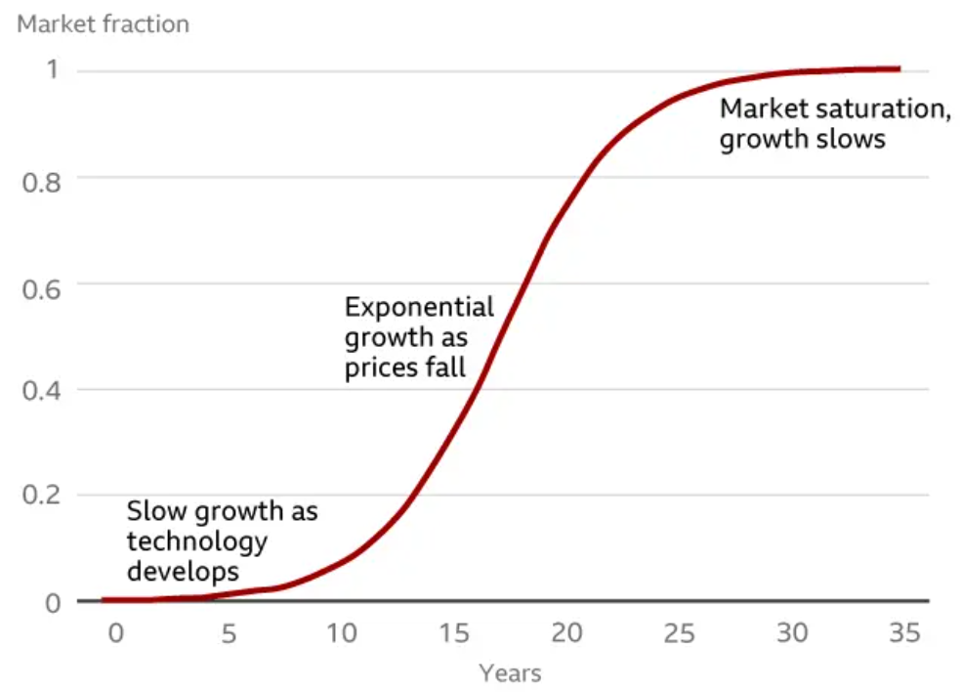
Figure 1

The internet S curve is showing how computers grew within the market, it started with the technology development which allowed for slow growth within the market, then around twenty years later the prices dropped allowing for exponential growth within the market and then around twenty to twenty five years later the market growth slowed as computers reached market saturation due to the fact that virtually anyone who wants to go online can now go online if they want to (Justin Rowlatt, 2021), and this is potentially the pattern in how the advancement in technology is going to help the rise of electric vehicles within the market by riding the internet’s S Curve (Subbaram, 2023) (see figure 2).

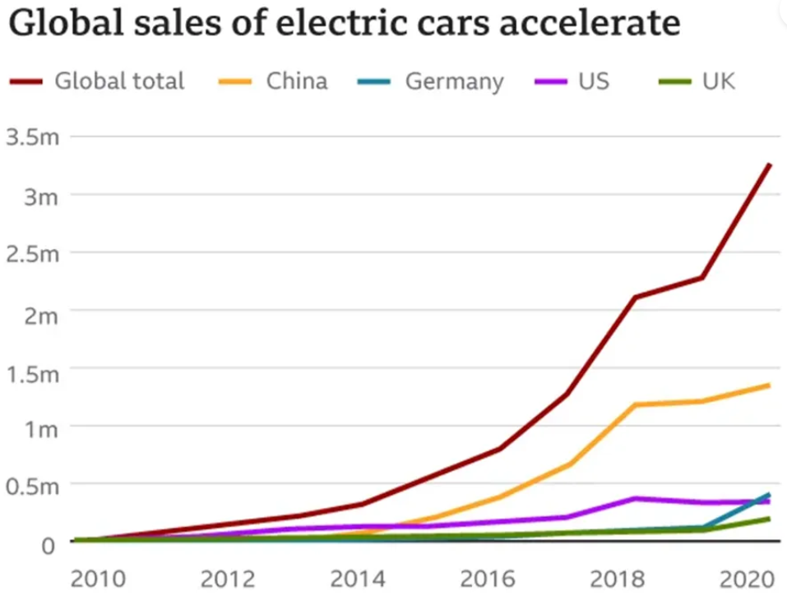
Figure 2

Another reason that electric vehicles have become popular is due to the negative impacts that internal combustion engine vehicles have towards the environment, which consists of the energy that is consumed throughout the production and destruction phase that leaves a giant footprint as materials such as steel, rubber, glass, plastics and paints need to be made before the vehicle is even road ready, and for the destruction phase the impacts do not stop once the car is at the end of its life cycle as the plastics, toxic battery acids might stay in the environment (National Geographic, 2019).

But it is not only the materials that are affecting the environment, it is also the tailpipe emissions that is having a negative impact towards our environment, which people are becoming more aware of now due to common knowledge about the amount of carbon dioxide being emitted into the atmosphere which is enhancing the greenhouse effect and causing climate change, and people are becoming more aware of the health concerns that comes from tailpipe emissions such as asthma and lung diseases (Climate Change Connection, 20117).

Even though electric vehicles are on the rise again, the downsides to the electric vehicles are that, drivers are concerned about their dependability whilst going on long distance journeys, which can also be known as range anxiety (Motabillity, 2024). Another downside to electric vehicles is that it takes a long time to charge an electric vehicle even on fast charge it still takes a couple of hours to charge, they have higher upfront costs and as electric vehicles is still a rather new transition, there is a limited availability of charging stations (Nair, 2023).

Therefore, the main aim of this research is to investigate what influences drivers to purchase sustainable vehicles. As sustainability within the automotive industry has gone from being an unimportant factor to a very important factor within the automotive industry, which is because of the increase of demand around driver purchase or interest in electric vehicles, which consist of car buyers and drivers want to help better the environment, by taking action to diminish environmental pollution which sees a reduction of greenhouse gas emissions as electric vehicles do not give out exhaust emissions (Ali, 2021).

Research Objectives

The objectives that would correspond with the main aim would be to carry out a literature investigation into sustainable vehicles, that would consist of the areas of sustainability challenges, management practices and embedding sustainability into organizations to see how these areas would influence drivers to change from the traditional petrol cars into electric vehicles. Also, another area that my dissertation is likely to draw upon would be the circular economy with the materials and methods in how the sustainable vehicles are built to solve the issue of resource depletion.

The second objective that would concur with the main aim is to incorporate primary research to discover what would entice drivers to purchase sustainable vehicles. The third objective is to produce evidence backed recommendations of what areas sustainable vehicles would work in practice.

To accomplish the main aim and the research objectives that are displayed above, there will be research questions that will be answered, and those research questions are:

- What types of sustainable vehicles are there?
- How are car manufacturers implementing sustainability within their cars to influence drivers to purchase them?
- How is the circular economy being implemented into cars?
- What are the environmental impacts of sustainable vehicles?
- What technological advancements have enhanced the influence of sustainable vehicles?
- Are electric vehicle batteries good for the environment?
- What is involved with the charging infrastructure of sustainable vehicles?
- What is involved with charging a sustainable vehicle at home?
- What are the regulatory trends and incentives to enhance sustainable vehicle adoption?
- What is to come in the future for sustainable vehicles?

Summary

To summarise my introduction, the main points that have been identified is the brief history of how electric vehicles were phased out due to the lack of technology that only allowed electric vehicles to run on a short mileage, and they were also phased out because the internal combustion engine vehicles were winning the technology battle and were more readily available for drivers to use. Also the brief history in how electric vehicles became on the rise again was also identified as it shows the negative impacts that the internal combustion engine vehicles was having on the environment and towards people’s health and wellbeing. Which then leads to the identification of electric vehicles potentially following the pattern in how the advancement in technology is helping the rise of electric vehicles, within the market by riding the internet’s S Curve.

However, even though electric vehicles have become on the rise again, their flaws were identified as well as it is to be believed that technology is not yet ready for the advancements of electric vehicles as drivers are concerned about their dependability whilst going on long distance journeys and are also concerned about the charging points, as they take too long to charge up an electric vehicle. Furthermore, the main aim of this research was identified along with the research objectives and the research questions.

Chapter 2: Literature Review

The two major problems that occur in today’s day and age, is the energy crisis and environmental pollution. Global energy consumption is growing faster than its generation, due to the automotive sector continuously increasing at a faster rate, which the reserves can’t handle because of the rapid technological development within the automotive industry. Also, vehicle pollution has become a serious concern all over the world for past couple of decades, as international combustion engine vehicles, are emitting too much carbon dioxide which will lead to global climate change (Taylor & Francis, 2011).

Therefore, the automotive industry is racing into a new world of mobility and sustainability, through continuing to strive towards more efficient and cleaner vehicles to make them more appealing. Which corresponds with the ambitions of governments and local administrations that are interested in creating strategies to accomplish long term emission targets (Cordera, 2018).

Another reason that is motivating the development of electric vehicles is that even though they are quite expensive with their upfront costs, they are more cost effective in the long run as it is cheaper to charge your electric vehicle rather than fuelling up an internal combustion engine vehicle. For example, it would normally cost around £14.00 to fill up an internal combustion engine vehicle up to 100 miles, whereas an electric vehicle it would cost around £04.00 to charge up to 100 miles (BBC, 2019).

Chapter 2.1 What are sustainable vehicles

The many sustainable vehicles of today that are leading the way towards a more sustainable future is the fully electric vehicles (EVs), the hybrid electric vehicles (HEV), plug in hybrid electric vehicles (PHEV) and fuel cell electric vehicles (FCEV) (Sanguesa, 2021).

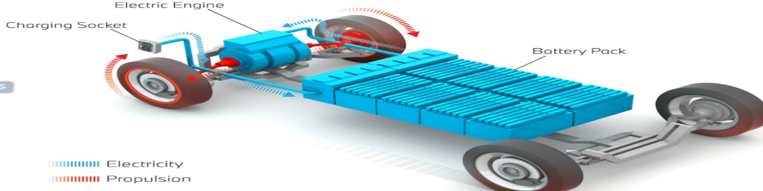
An all-electric vehicle (EV) or (BEV – a battery electric vehicle) is a vehicle that utilizes electricity as its main source of propulsion. Therefore, as an alternative to an engine and a fuel tank, the majority of electric vehicles consist of one or more electric motors to create propulsion, which will then be fed into the battery (see figure 3). Whereas, a battery electric vehicle (BEV) is simply an extension of the EV meaning. The term of battery electric vehicle is generally used to distinguish between the various types of electrified vehicles, which refers to those vehicles that have an electric component in the powertrain but are not fully electric themselves (Holding, 2023).
Figure 3
For example, Renault is bringing back the Renault 5, which is now fully electric with an innovative E-Tech engine, new battery which includes fast charging and it also has little nods within the car to the iconic Renault 5. The new Renault 5 E Tech has a driving range of up to 248 miles and it comes with a standard type 2 cable that can either be charged at home or at a public charging point, there are other optional cables such as a standard or reinforced socket or a fast charging cable which are additional extras. Once the car is fully charged the number 5 emblem will light up on the bonnet (Renault, 2024).

The benefits towards an all-electric vehicle, they are more cost effective than the conventional internal combustion engine vehicles, as they save the drivers money for a longer period of time, thanks to the cheaper prices to charge an all-electric car (Alanazi, 2023). Another benefit towards all electric cars is that they are quieter, and electric cars are potentially futureproof as they are becoming more widely available, so will the infrastructure around them (Larson, 2014).

The challenges of a fully electric vehicle is that drivers are anxious about their driving range, because the number of miles an electric vehicle can cover depending on the size of the battery, the weather, the age of the battery and where you go in the car as well (Motabillity, 2024).

Even though hybrid electric vehicles have been around since before 1900’s, the interest has now grown significantly over the past 15 to 20 years, due to the potential probability of these vehicles becoming a short term method to enhance fuel efficiency and to reduce the automobile’s toxic emissions that are being emitted into the atmosphere (Sciarretta, 2007). There are 4 main types of hybrid electric vehicles and they are mild hybrid electric vehicles, hybrid electric vehicles (HEVs), plug in hybrid electric vehicles (PHEVs) and there is range extended electric vehicles (REEVs) (Taylor & Francis, 2011).

A hybrid electric vehicle (HEV) or a self-charging hybrid vehicle has an electric motor that backs the combustion engine (see figure 4). The HEVs battery is solely charged through regenerative braking, which means that it takes the energy created by the friction of braking, then transforms that energy into electricity and stores it into the battery, therefore HEVs do not use charging stations (Lyati, 2021).

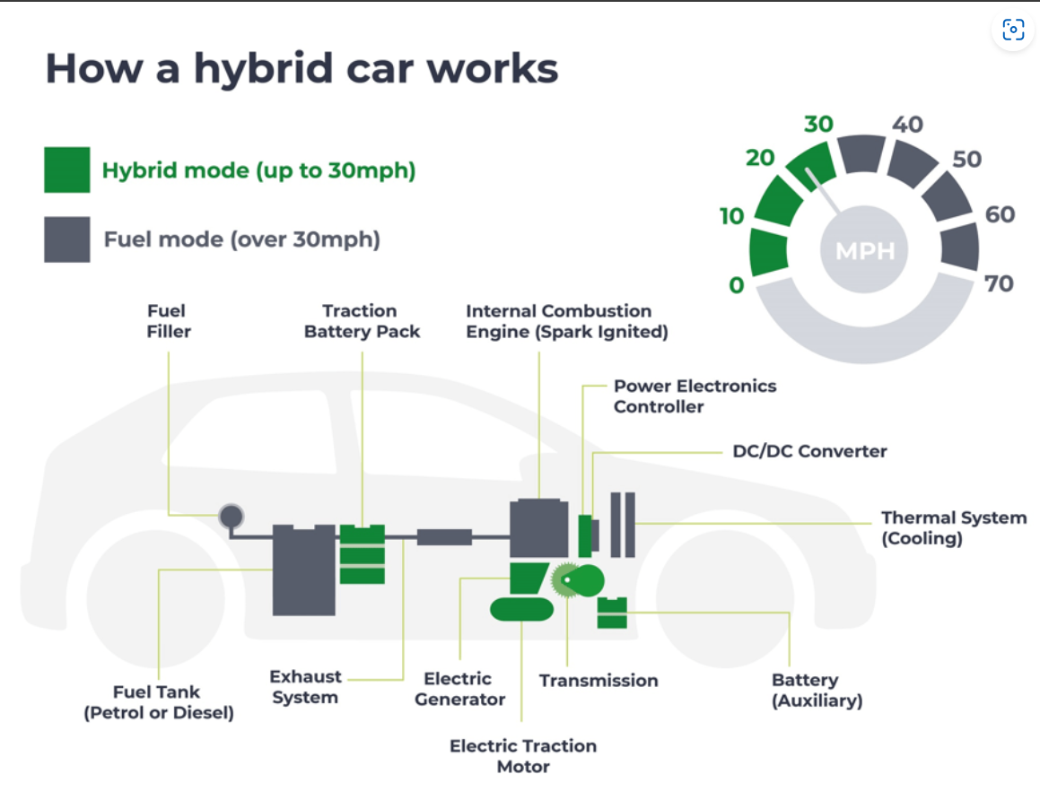
For example, Mazda have implemented a fully hybrid vehicle (HEV) by introducing the Mazda 2 Hybrid. As it has the state of the art 59KW electric motor that enables a swift acceleration, an improvement in the fuel economy and a reduction in emissions, which enables an environmentally friendly driving experience. Also, the Mazda 2 Hybrid uses kinetic energy that has been gained throughout driving, decelerating and braking, to recharge the on board battery repeatedly, therefore there is no need for a plug in charge (Mazda, 2024).
Figure 4

The benefits of a hybrid electric vehicle is there is no range anxiety with a HEV as they don’t solely rely on the electric motor, there is no worry about breaking down once the car battery runs out, so as long as the fuel tank is full the HEV should run smoothly (R.Graham, 2001). However, as the HEVs are not quite zero emission there would be no benefit towards an ultra-low emission zone (ULEZ) or a congestion charge which means that if a driver owned a HEV, then they would have to pay the congestion charge if it is a highly polluting vehicle, and if it is a high polluting vehicle within a ULEZ then they would have to pay a charge on a daily basis (motorway, 2024).

A mild hybrid vehicle which can also be known as 48 volt hybrids or MHEVs functions just like the full hybrid, as the mechanics function the same, as the battery can recharge with regenerative braking. However, the significant difference is they have a smaller battery so the driver would be using their combustion engine alongside the battery (see figure 5).

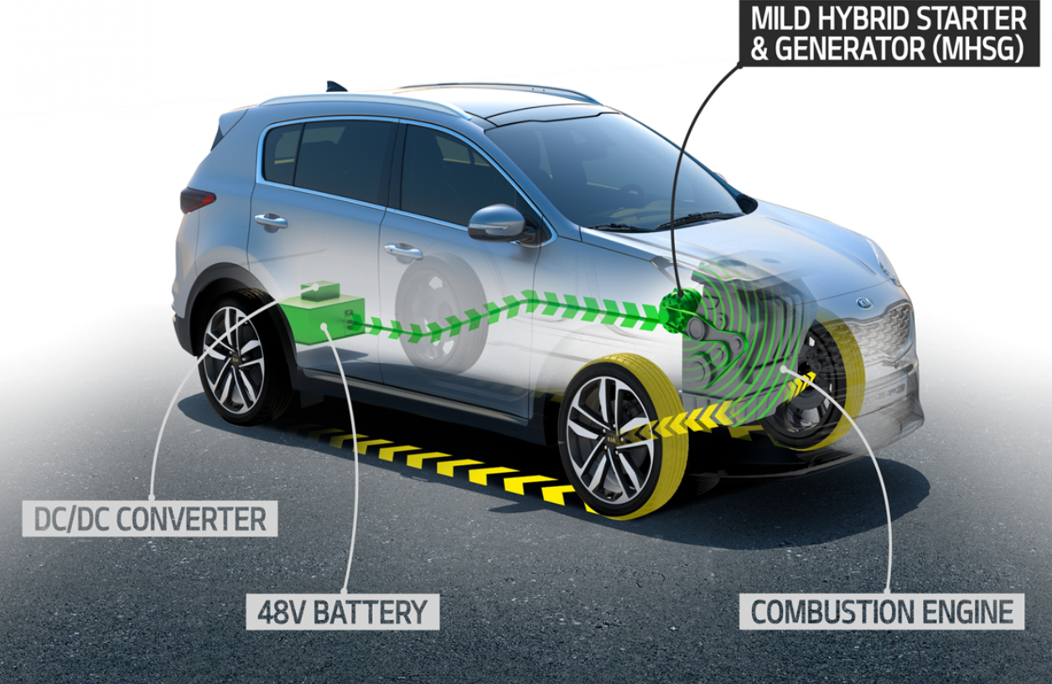
For example, Mazda have brought out a wide variety of mild hybrid vehicles as they ensure a safer, relaxed and enjoyable driving experience. Also, trying to help decrease emissions and improve fuel economy, through the utilisation of e-Skyactiv G which enables the engine technology to provide impressive fuel efficiency, whilst upholding high performance levels and an exceptional sense of control and clean combustion (Mazda, 2024).
Figure 5
A plug in hybrid electric vehicle (PHEVs) is basically a combination of an electric vehicle and conventional internal combustion engine vehicle, that contains a high capacity battery which can be charged externally (see figure 6). The PHEVs can accumulate enough electricity to considerably cut down the amount of petrol or diesel being used under the usual driving conditions (Singh, 2021).

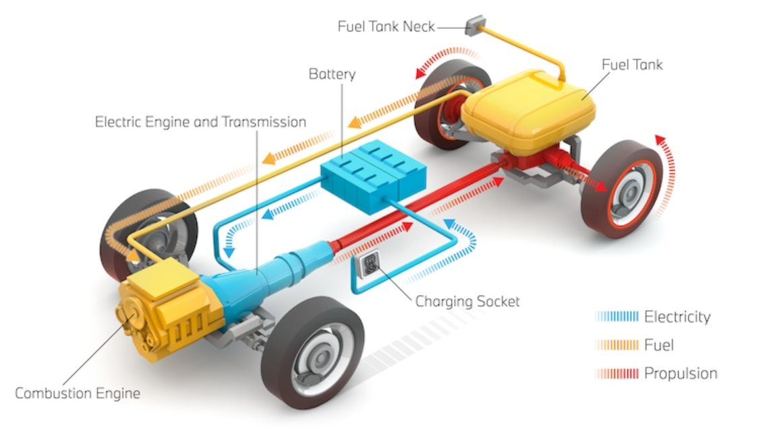
For example, Audi have implemented plug in hybrid vehicles into their company by having a wide range of the them, ranging from small hybrid family cars to hybrid SUVs and hybrid family saloons. They also call all their hybrid vehicles TFSI e’s. Audi’s TFSI e ranges give the best of both worlds as the driver can choose to drive purely electric (for up to round about 40 miles on electric drive only), purely combustion or an automatic mixture of both (Audi, 2024).
Figure 6

There are two types of PHEVs, a series plug in hybrid vehicle which can also be known as a range extended electric vehicles (REEVs), the way that this hybrid vehicle functions is by having the wheels driven directly through the use of electric motors (Prajapati, 2014).

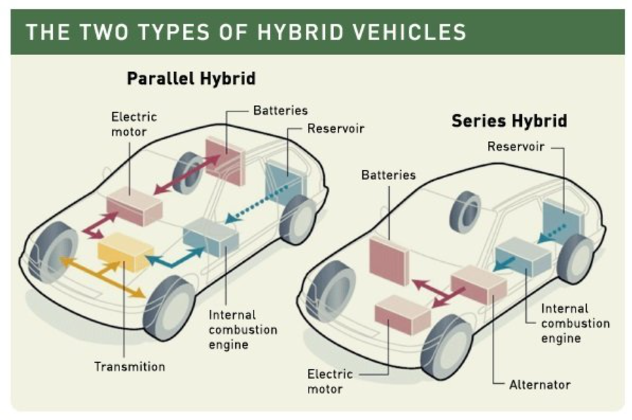
The second type of a plug in hybrid vehicle is a parallel plug in hybrid, also known as a blended plug in hybrid vehicle, in this type of system both the electric powertrain and the conventional internal combustion engine propel the vehicle in nearly all driving conditions. Usually, this type of vehicle can operate in all electric mode but only at slow speeds (acko drive, 2022) (see figure 7).

Figure 7

The benefits of a PHEV vehicles is they are more environmentally friendly than the standard hybrid vehicles, as the PHEVs have a larger battery than the standard HEVs, which allows the PHEVs to travel more miles with only using electric only and having the internal combustion engine to kick in only when necessary (Keogh, 2019).

However, having a larger battery can cause a challenge for the plug in hybrid vehicles, as the bigger battery, the more expensive they become, along with the fixable costs and the replacement of the battery which can also be fairly expensive as well (YoCharge, 2024).

A fuel cell electric vehicle (FCEV) generates their own electricity on board, as the FCEV is powered by hydrogen, through the use of hydrogen in the fuel cell reacting with the oxygen in the air, thereby generating electricity because when you mix hydrogen and oxygen together this creates electricity, which can then be used to power the electric motors and power the vehicles, which is similar to a BEV (Emadi, 2004) (see figure 8).

For example, Toyota have introduced the only fuel cell electric vehicle available in the UK, which is the Toyota Mirai that has a range of 400 miles, and takes no more than five minutes to fill up the fuel tank (Toyota, 2024).

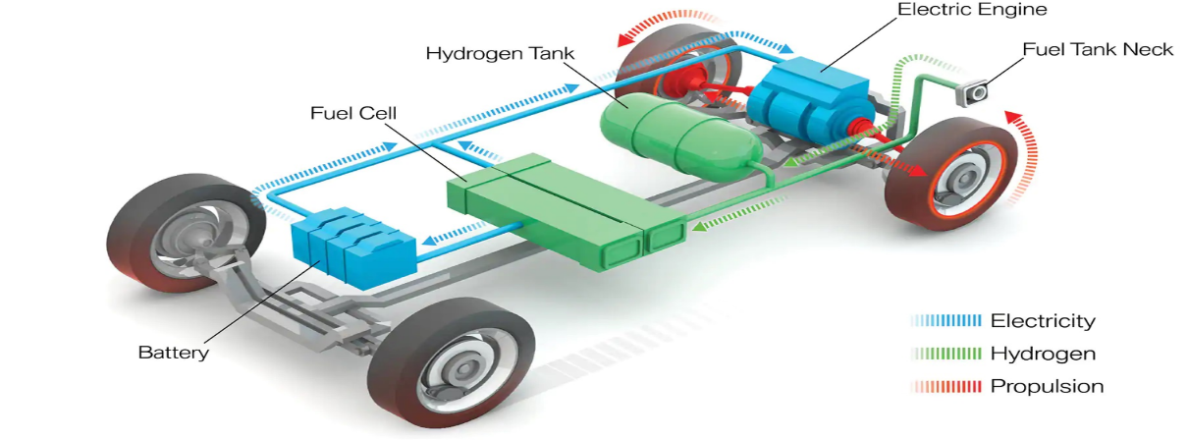

Figure 8

The benefits of a FCEV is they can reduce oil dependence because hydrogen can be obtained from domestic sources such as natural gas and coal and the hydrogen can not only be derived from domestic sources, it can also be obtained from renewable sources that consist of water, biogas and agricultural waste. Which would make the economy less dependent on other countries and would make it less vulnerable to oil price upsets from a progressively volatile oil market (U.S. Deparment of Energy, 2024).

A challenge that could occur with fuel cell electric vehicles is that due to them being rare, only a few manufacturers have invested in the technology therefore choice is very limited as there is only round about 20 hydrogen stations in UK (RAC, 2021).

Chapter 2.2: Circular Economy Implementation

Automobile manufacturers are looking at, the materials and processes to make a vehicle sustainable, by implementing sustainable recycled materials that consist of plant based interiors, bio based materials, recycled steel and plastics and advanced technology to produce vehicles that are more sustainable than they have ever been before (Nichols, 2023).

Therefore, as a result of looking at the materials and processes to recycle various raw materials to make a vehicle sustainable, this will result in a shift down the cost curve for the net material savings. As the global net material savings for steel could potentially add up to more than 100 million tonnes of iron ore in 2025, if it is applied to a sizeable part of the steel intensive automotive machining and other transport sectors which would account for 40% of the demand. Furthermore this shift, would deter away from the steep cost curve, which will likely decrease demand driven volatility (Ellen Macarthur Foundation, 2024).

For example, Mazda incorporates the use of bio based engineering for both interior and exterior parts, they use 100% plant based bio upholstery fabric for seat covers, an aqua tech paint system which allows for 78% lower emissions of unstable organic compounds and Mazda have also used recycled heritage cork interiors for their natural cork trims (Mazda, 2024). The utilisation of recycled heritage is not only given Mazda a unique look but it is also a nod to Mazda’s founding as the Toyoko Cork Kogyo. Ltd (Mazda Stories, 2022).

Chapter 2.3: Environmental Impact of Sustainable Vehicles

A key factor that the automobile sector is looking at is to contribute to a more sustainable environment, through electric vehicles combating climate change and reducing emissions (Oge, 2016). Due to the fact that the means of transport in countries that are similar to the UK and the USA, is now accountable for giving off more greenhouse gases than any other countries, including electricity production and agriculture. Altogether, the means of transport accounts for around a quarter of carbon emissions worldwide. For example, a typical petrol car on the road in the UK produces the equivalent of 180g of CO2 every kilometre, and in the USA the usual passenger vehicle on the road emits 650g of CO2/km. Generally, the bigger the car the higher the emissions will be (Timperley, 2020).

The main way that the sustainable/electric vehicles are reducing emissions and combatting climate change is through zero emission vehicles. For example, all the fully electric cars produce zero tailpipe emissions, which is better for the environment and people’s health because there is no toxic fumes to be breathed in or to be emitted into the atmosphere (Slowik, 2019).

Even though electric vehicles do not produce direct tailpipe emissions, they still are contributing to emissions being emitted into the atmosphere through their manufacturing phase, which is very energy intensive and some vehicles have made nearly double the impact on global warming compared to the manufacturing phase of internal combustion engine vehicles (Bomford, 2013). This is mainly due to the use of unsustainable materials and methods of extraction to retrieve the minerals used for the batteries such as cobalt, lithium, nickel and copper and also, the dismantling of the batteries, that have deteriorated over time is still giving off a strong amount of CO2 emissions (Schwanen, 2019).

Chapter 2.4: Technological Advancements in Sustainable Vehicles

Electric vehicle batteries have been around since 1859, as the first lead acid battery was invented by a French physicist Gaston Planté, and this battery opened up a viable way to store electricity on board a vehicle (energy saving trust, 2023). In 1901, due to high demand of electric cars, Thomas Edison brought about a better battery for electric vehicles, the nickel iron battery and more than a century later engineers would discover that his nickel iron battery was something of a diamond in the rough, as it is now being investigated as an answer to the ongoing challenge of renewable energy, as Edison’s battery has the unusual quirk of creating hydrogen just like the batteries in a FCEV (Hirschlag, 2021).

Whereas during current times, to enhance the electric vehicle appeal and to become more sustainable, the electric vehicle battery has improved through the use of the lithium ion battery, which was introduced in 1991 by Sony and Asahi Kasei, which allowed for the development of electric vehicles to accomplish traveling longer distances (energy saving trust, 2023). For example, the Renault Scenic E Tech can go up to a range of 375 miles, but certain factors could affect the range of the vehicle such as the outside temperature, the way the road is made, the persons driving style and the vehicles aerodynamics which can consist of the vehicle being overloaded by either too much luggage or too many passengers (Renault, 2024).

Although, electric vehicle batteries are contributing to sustainability by reducing emissions and combating climate change, they are contradicting themselves as lithium as an element is not a natural metal form, so it has to be found in brine salt and rocks which means mining for sources of the lithium element and then administering the mined extracts to produce the metal form. Throughout the mining process, it can cause many unwanted consequences such as depleting and contaminating local water sources, air pollution from the dust and emissions from the lithium mining operations, land degradation is a long term consequence as it degrades the quality of the land, biodiversity, productivity and the ecosystem services and the mining process can make numerous amounts of waste, which can be difficult to dispose of safely (Williams, 2024).

The way that an electric vehicle battery can further their EV appeal is through improving their charging technology through ensuring that the battery can be charged quickly. For example, a rapid charge can charge your battery up to 80% within 30 – 60 minutes rather than having a fast charge that can roughly take up to around 3 - 4 hours or having to charge it overnight which takes roughly around 8 - 10 hours, but with the rapid charge the vehicle has to have a rapid charging capability (Moses, 2020). Also another way the automobile sector has looked to enhance their EV appeal is through their autonomous features (Tesla, 2024).

Chapter 2.5: Charging Infrastructure and Driver’s Experience

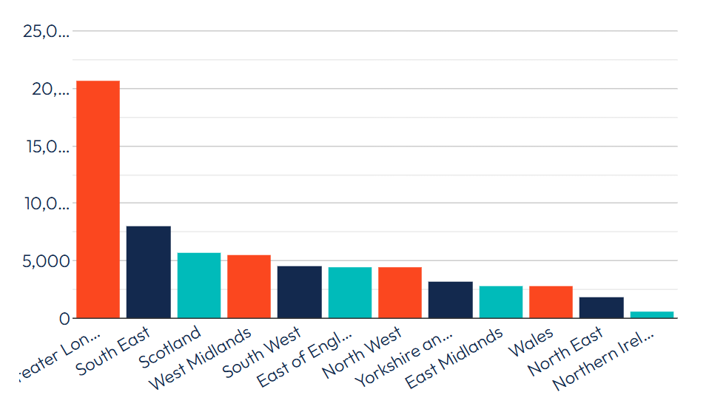
As the electric vehicle charging infrastructure is constantly developing and defining the needs of EV drivers, there are currently 64, 775 electric vehicle charging points across the UK, across 33,829 charging locations (see figure 9), which signifies a year on year increase of 46% for the number of public devices, with 20,367 charging devices being installed since June 2023. Also, at the end of June 2024 2,239 electric vehicle charging devices were put into action as well (Edwards, 2024).
Figure 9

The different types of chargers consist of:

- A slow charger connector has a UK three pin plug that has a power rating of 2.3KW AC, Single Phase (Standard Charge), which allows a charge of a mile range every 30 minutes.
- A fast charger has a Type 2 plug connector that has a power rating of 3-42KW AC, Single Phase or a Three Phase, which allows a charge of 24 miles every hour or allow a full charge within 3 to 4 hours.
- The rapid charger connector has a CHAdeMO plug which has a power rating of 50KW DC, Three Phase, which allows a charge of 85 miles every 30 minutes
- The ultra rapid charge has a Combined Charging System (CCS) plug, that has a power rating of 50-350KW DC and it allows a charge of 85-200 miles every 30 minutes (EDF Energy, 2024).

The driver’s point of view, they would want to have an appealing experience in driving sustainable vehicles, which is done through the utilisation of EV charging apps which makes the driver’s experience rather simple and easy, as the charging apps navigate nearby charging points or stations, verify what type of point or station is available (if it is a level 2 charger or a DC fast charger), identify how much the driver will be charged and how much the driver would have to pay for the use of the charging service. Another way that the EV charging apps are becoming appealing to driver’s is by having the app help alert them when the battery is low (Nova Charge, 2023).

Also, for the driver’s experience, they would have to pay the price per kilowatt hour (kWH), which is followed through by using the formula of the size of the battery (KWH) x electricity cost of the supplier (pence per kilowatt hour) = the total cost to charge an electric car (AA, 2024). Which are billed by electrical charging networks and the cost of charges will vary depending on the energy tariff, the location of the charging point or station, the battery size and it depends on the networks as well. (Pod Point, 2024).

For example, the top charging network and EV charging app in the UK is Shell Recharge (Edwards, 2024). Shell Recharge is mainly at the top due to ensuring that every charge from their branded Shell Recharge network comes from certified renewable electricity sources, and due to ubitricity rebranding as Shell Recharge they have started to put in a network of lamppost and bollard chargers with more to come for the future years ahead (Ubitricity, 2024). Shell’s Recharge network charges for an on street 5KW charge costs £0.51 per KWH, the AC 7-22KW fast charge costs £0.79 per KWH and their DC 50-175KW rapid and ultra rapid charge costs around £0.74 - £0.93 per KWH (Shell UK, 2024).

Even though the EV charging infrastructure, the EV charging network and EV charging apps all have their appeals, they also have their challenges as well, because the pace of the rollout for the different types of charge points is too slow to meet the governments predicted 2030 needs, especially public on street charging, as the business case for commercial implementation can be challenging in some areas due to EV adoption being in their early stages in some areas, as local on street charging can be remarkably commercially challenging for developers and investors (Patil, 2019).

In addition to those challenges, the public charging networks are letting people down, as some charge points can be difficult to find, hard to use and might turn out to be in use or broken once you arrive at the charge point, which is especially challenging for disabled drivers, and it can also cause multiple apps or smartcards needed if you use different EV charging networks (HM Government, 2021).

Chapter 2.6: Energy Usage at Home

An electric vehicle home charger is a charging station specifically designed to manage the high wattage that is essential to charge an electric vehicle. These electronic charging devices permits the driver to charge their electric vehicle from the comfort of their own home, plus using a home charger normally works out cheaper than a pay per use public charging station, because the driver would have full control over their energy tariff (Halfords, 2022).
As charging an electric vehicle in the UK from home usually depends on where your electric vehicle is parked and depends on the price per KWH. Therefore, the usual going rate to charge an electric vehicle at home usually costs around about £15.10 for a full charge and that is if it is based upon the regular domestic electricity rate of £0.28 per KWH and that is with a car battery the size of 54KWH (Pod Point, 2024), but there are ways to make the cost to charge the electric vehicle to become cheaper by charging the EV on off peak times (which has been made a default in EV home chargers due to the off peak charging regulation), and by taking advantage of the tariffs that the driver’s electrical company is offering (Paevere, 2013).

For example, to charge an electric vehicle at home the specific tariff that I would get is Eon’s Next Drive EV tariff, as this would give me a reduced price of electricity at 6.9p per KWH when I charge my EV between 12am and 7am, it comes included with 100% renewable electricity at no extra cost, fixed energy prices for a whole year and there would be no exit fees either (eon next , 2024).

Even though, it is good and cheaper to charge an EV at off peak times, it can however impact the national grid and local substations due to off peak charging becoming a default, so because everyone could well be putting their electric vehicles on charge all at the same time, then the grid and local substations could potentially experience an unexpected huge pull of electricity (Halfords, 2022).

Another way that charging an electric vehicle at home can help with the overall energy consumption is through the use of vehicle to grid charging (V2G) or can also be known as bi directional charging, which allows for a 2 way flow of electrical energy from the grid, that goes through a specific built charger into an electric vehicle and back again. Utilising V2G charging can enhance the EV appeal, as the driver can choose to charge up their electric vehicle from the grid or sell stored energy from their EV to reduce the driver’s energy bills (Topping, 2023).

For example, if I were to use vehicle to grid charging with Eon, once I have done my day to day errands and come back home, I can utilise the V2G charge by plugging in and taking the excess energy from the car battery to either be put into the house to power up my lights and other appliances and devices or sell it back to the grid when the grid is at high demand could potentially make me a profit of £700 - £1250 a year (Nissan Motor GB, 2019). Also if I take part in their trial, Eon would fund a support of up to 50% off of the cost towards V2G chargers, installation and maintenance (Eon, 2024).

Chapter 2.7: Sustainable Vehicle Regulatory Trends

One of the main government policies for driving EV adoption is the path to zero emission vehicles by 2035, which is known as the Zero Emission Vehicle (ZEV) mandate, and this mandate is being carried out by having 80% of new cars and 70% of new vans sold in Great Britain to be zero emission by 2030, and will then be increased to 100% zero emission cars and vans by 2035. This 2035 end of sale date ensures the UK to be matched up with other major global economies, such as France, Germany, Sweden and Canada (GOV.UK, 2023).

The other significant legislation and incentives to drive EV adoption further forwards are randomised delays, Vehicle Excise Duty (VED) Exemption, Congestion Charge and Ultra Low Emission Zones (ULEZ), LEVI FUND and the On Street Residential Charge Point Scheme (ORCS) (Connected Kerb, 2024).
The randomised delay legislation necessitates new EV charge points to have randomised delay function of up to 10 minutes at the start of each charging session, so that it ensures a balance to the national grid supply and ensures protection from any unexpected huge pulls of electricity to the national grid and local substations (Pod Point, 2024).

The Vehicle Excise Duty (VED) exemption incentive drives EV adoption as this allows for zero emission cars, vans and motorcycles to be exempt from paying the levy. However, from the 1st of April 2025, this all changes and all EV drivers will then have to pay their VED, but the good news for new electric vehicle drivers is that within their first year the only charge is the smallest fare of £10 so that the government can make sure that all drivers start to pay a fairer tax contribution, but after that then they would have to pay the standard rate of £180 per year (GOV.UK, 2022).

The congestion charge is a payment that drivers have to pay to pass through central London. This congestion charge was initiated in 2003 and London is still currently to this day the world’s largest congestion charge zone (CCZ). The way that the congestion charge zone becomes an incentive and drives EV adoption, is by having existing adopters of electric cars to not have to pay any congestion charges. Which is known as the cleaner vehicle discount, which is vehicles with CO2 emissions less than 75g/km and a minimum of 20 mile zero emission capable range will face zero payments with the CCZ. However, currently it is only authorised for zero emission vehicles such as fully electric vehicles and hydrogen vehicles and not hybrid vehicles, which was discussed earlier whilst talking about the benefits of hybrid vehicles (motorway, 2024).

As well as the CCZ, a driver would also have to keep in mind of the Ultra Low Emission Zone (ULEZ), as this stretches out further to Greater London up until the M25 but it does not include the M25. Just like the CCZ the ULEZ was put in place to cut down on pollution and improve air quality in London by initiating a charge for vehicles that do not meet the specific exhaust emission standards, therefore, if you do not meet the specific exhaust emission standards, then the standard ULEZ charge for all vehicles is £12.50 per day and if you do not pay the charge, you will be fined £180. So the way that the ULEZ has become an incentive towards EV adoption is by having all fully electric vehicles to be ULEZ compliant, but only if they can drive on electric power alone for at least 20 miles (Bailey, 2017).

The government has made an incentive towards EV infrastructure, through funding the Local EV Infrastructure Fund (LEVI Fund). This fund has permitted £450 million to enable local authorities that include councils to ensure a rollout on a grander scale of charge point infrastructure projects, which consist of local rapid hubs and larger on street schemes that are not supported by ORCS (HM Government, 2022).

The On Street Residential Chargepoint Scheme (ORCS) is what the government have implemented, so that it can provide local authorities with grant funding that can be operated to part fund the procurement and installation for on street EV chargepoint infrastructures to meet the needs of residents (GOV.UK, 2023). For example, this scheme has already implemented 2,308 chargepoints and is going to be supporting another 4,539 charging points (HM Government, 2022).

However, this ORC scheme does not cover non capital costs, the upgrade or the upkeep of existing charging points, the installation of passive charging infrastructure and this scheme does not cover the installation of the charging points for the main use of taxi fleets or other commercial undertakings, as this scheme is mainly focused on residential areas that have no off street parking, it also does not cover the installation of charging points that are linked to an individual’s domestic electricity supply (GOV.UK, 2023).

Summary

The main key findings that have been identified within my literature review, is what sustainable vehicles are already available and their benefits and challenges, how the circular economy is being implemented into automobile companies, how electric vehicles are contributing towards sustainability by reducing emissions and combating climate change. Also, how technological advancements have enhanced the influence of sustainable vehicles has been identified as well, through the use of improvements in battery efficiency, their charging times and too see if an EV battery is actually good for the environment.

Furthermore the other key findings that have been identified within my literature review is what is involved with the charging infrastructure and user experience, what is involved with charging an EV at home and how it impacts the energy usage at home. Also, the regulatory trends and incentives to enhance an EV appeal was identified as well.

Chapter 3: Research Methodology

The methods that have been utilised to gather information, so that the research questions can be met and fulfilled are primary and secondary research. A type of primary research that can be used is quantitative analysis, which came about in the year 1934 through the publication of the book Security Analysis which was written by Columbia Business School professors Benjamin Graham and David Dodd. With the upsurge of computers and spreadsheets and as technology became further advanced in the 21st century quantitative analysis was able to analyse data in a way that is countable, through the use of surveys and questionnaires, which allowed the statistics from the data that was gathered to be expressed into graphs or charts (Diongson, 2023).

The way that quantitative analysis can be beneficial for this research, is because it enables fast data collection, as it often consists of utilizing software programs to assist with the data analysis, and the software program can also enable for a large quantity of data to be analysed, which permits a broader study to take place, enabling better accuracy when analysing the collected data (Ahmad, 2019).

However, the drawbacks for quantitative analysis, is that the analysis does not show the bigger picture between broader themes and relationships because of this analysis only focuses on the numeric data. Therefore, this analysis does not perceive any of the recipients opinions or feelings towards the research that is being looked into (DeVault, 2024). Also, due to this type of analysis, analysing numeric data it needs to have a large number of respondents for the numeric data to be analysed which can also become time consuming (Chukwuemeka, 2021).

Also, another type of primary research that can be used is qualitative analysis, which came about at the start of the 20th century, due to the influence of psychoanalysis starting to go into the commercial world. By the year 1945 the founder of qualitative research Paul Felix Lazersfield, had demonstrated how psychology can provide a framework to understand human behaviour (Olive, 2018). This analysis is a form of social science that gathers and works with non-numerical data so that it can find out people’s views and feelings rather than using numerical data, which can be done by conducting interviews one on one, so that the results can be rich and detailed (Crossman, 2020).

Qualitative analysis can be beneficial for this research, as it enhances the understanding of the participant’s cultures, beliefs, values, human experiences and their experiences, as well as developing theories that their experiences towards this research topic (Kalu, 2017). Also another benefit is the flexibility and adaptability and the responsiveness of this research can also be a benefit as well, as it enables for a deeper exploration and makes sure that no valuable information is left unexamined (Discuss, 2024).

The drawbacks towards qualitative analysis, is that it is more difficult to prove that there is rigidity in what is collective, due to the foundation of the data that has been collected usually comes from the participant’s perspective. Also, the amount of data that is collected whilst performing the qualitative analysis, can be quite overwhelming due to sorting through all the data and pulling out all the key points and putting them into themes can become very time consuming (Gaille, 2017).

Furthermore, another type of primary research is the mixed methods approach, which came about in the early 1900’s and became widely adopted in the late 1980’s (Maxwell, 2016). This type of research method basically combines both quantitative and qualitative data in a single study or a series of studies in order to better understand the research questions and objectives that are to be met (Doyle, 2009). Whereas, the secondary research has been used by gathering existing information from the internet, paraphrasing the information into my own words and then reference them onto this dissertation (Gardiner, 2023).

Therefore, the method that is going to be used, to answer the research question of what influences drivers to change from traditional vehicles into modern sustainable vehicles is going to be the mixed methods approach, as this type of research method can be beneficial towards this research, as it will deliver stronger evidence and gain more confidence within the findings due to it combining the quantitative and qualitative approaches together so that it can balance out the limitations of each method (GOV.UK, 2020).

However, utilizing the mixed methods approach can be quite difficult as it is more expensive and more time consuming, due to having to learn about both research methods and how to mix them accordingly (Johnson, 2004).

Chapter 3.1: Interview Process

To collect the data for the qualitative method, interviews were conducted. The way that this was done was by identifying and looking through the data that had been collected throughout the literature review, which then lead to the questions to be formed, and once the questions had been formed I then looked to find the right participants to conduct interviews with, and then through email I sent them a participant agreement form (see appendix 1), which is basically an agreement form ensuring that they understand what the interview is about and why it is being conducted and the agreement form is to also ensure that the participant knows that their identity will remain anonymous throughout (McGrath, 2019).

Once the interviews had been arranged, the interview planning could start, by planning out the script which consists of the agreement form and the questions that I have created and planning out the location, which was difficult due to the recent global pandemic COVID 19, therefore it was decided that the interviews were to be held virtually from our households. During the planning of the interview preparation the most important things that need to be remembered is to have genuine care, concern and interest for the participant that is being interviewed (Jacob, 2012).

Additionally, the interviews will be recorded to reduce loss of information and allow the full attention of the interviewer. However, to record the interviews the participant must consent to being recorded within the participant agreement form and they will also be reminded that they are being recorded at the beginning of the interview to double check that they are ok with being recorded and to also avoid any awkwardness. Once all the interviews have been conducted and recorded, then the data can then be collected and analysed by transcribing the interviews onto a word document, and then the data can then be highlighted into a thematic approach to show what was the most recurring and linked data from the text from the transcript (Duke Initiative on Survey Methodology, 2020).

Chapter 3.2: Interview Limitations

The limitations that transpired throughout the interview process was that not all respondents got back to me with a reply to say that they were willing to do an interview with me, and due to only being able to do interviews virtually from our households, there were some connection and timing issues that occurred.

Chapter 3.3: Survey Design and Analysis

The procedure for carrying out the data collection of the quantitative research method, was to create survey onto a website called SurveyMonkey. Firstly, the questions were written down on paper, before they were typed up digitally onto my designed survey, which allowed me to give the recipients multiple choice questions to answer in my survey so that it could give me a broader spectrum of answers towards my main research question. After all that was done, I then shared my online survey through Facebook, which is how I got all of my collected data.

Once my survey was completed and the data had been collected, from the reasonable amount of recipients that answered my multiple choice questions, I was then able to analyse the collected data through SPSS. SPSS (Statistical Package for the Social Sciences) is a software package that prepares and analyses advanced statistical analysis, an immense library of machine learning algorithms, text analysis, open source flexibility, integration with big data and seamless deployment into applications without having to write any code (IBM, 2024).

First of all, to analyse my survey through SPSS, I would have to open up the variable view, which comprises of the description of the attributes of each variable in the data file and that consists of a place where you enter the variables, list all the variables and input the characteristics of all the variables. A variable consists of giving it a name and specifying its type. For example, there are two types of variables there are numeric variables (see appendix 2), which are made up of numbers and are quite fitting for numeric calculations such as addition and multiplication, and the second variable is called a string of variables which contains letters, numbers and other characters (SPSS TUTORIALS, 2020).

The next stage within the variable view that I did was to type up variable names and input the numeric or string variables, which then lead to typing in the description of the variable into the label, which was exactly the same as the variable name, after that I would then put in the values by using a coding frame (DeCoster, 2004). Once I had completely finished inputting the variables in the variable view, I could then start inputting the data that was collected from the survey that was created into the data view.

The data view is a place where the data can be entered. Many aspects of the data view are similar to the features that are found in spreadsheet applications. However, there are quite a few significant distinctions. For example, the rows are cases, which basically means that each row signifies a case or an observation which include each individuals response to the survey, the columns of the data view are the variables, which signifies a variable or a characteristic that is being measured and the cells contain values , which is where each cell contains a single value of a variable for a case and the cells is where the case and the variable intersect (IBM, 2023).

Once I completed inputting the data that was collected from my survey onto the data view, I then logged into SurveyMonkey so I could tally up the respondent’s answers and I did this by writing it down on paper first to double check that I have tallied up the data correctly, once I made sure the data was tallied up correctly I then inputted the tallied respondent’s answers onto the data view as well. To finish off my descriptive statistics, I displayed my tallied responses into pie and bar charts.

Chapter 3.4: Survey Limitations

The limitations that occurred throughout collecting data from my survey was the download of the SPSS software package as I did not have a code, I then had to pay for the software and register all my details, which I found time consuming and another limitation that occurred is that once I shared my survey through Facebook I was not getting responses to my survey quick enough, so I then had to send my survey to people individually through Facebook Messenger to ensure that I had enough responses, so that I could then be able to do the survey analysis, and this was also very time consuming as I had to wait for people to get back to me and wait for them to answer my survey.

Chapter 3.5: Ethical Considerations

The ethical considerations that are identified throughout the mixed method approach is that the participants understand what the aims and nature of the research is, who is undertaking the research, how long the interview and answering the survey going to take, why the research is being conducted, and to explain the likely consequences that could occur within this research and to show how the results are going to be distributed. Another, ethical issue that has occurred throughout is to ensure that the participants and recipients are not pressured into participating and to ensure that they are aware that they have the right to refuse to participate at any time (Fleming, 2018).

In line of adhering to the current data protection and privacy legislations (GDPR) the participants and recipients are going to be justified in how far the participants will be afforded anonymity and confidentiality. Which consists of the information that relates to the participants and recipients to be kept confidential and secure, the participants and recipients are given the option to refuse the use of data gathering devices such as video cameras, audio, and digital recording devices and the participants will also be made aware during the consent process (GOV.UK, 2024).

Summary

To summarise my methodology chapter, the main key findings that have been identified are the three different types of primary research methods which are quantitative and qualitative analysis and the mixed methods approach, along with identifying these approaches I have also identified their brief histories, their benefits and drawbacks. Once the methods had been identified, I then identified the secondary research method which was carried out by gathering existing information from the internet, paraphrasing the information into my own words and then reference them onto this dissertation, then it was decided that I would go for the mixed methods approach as it combined both quantitative and qualitative methods.

And then, the qualitative analysis was carried out through identifying the different components such as planning out the script which consisted of the agreement form and the questions that were formed and planning out the location, then the interviews were conducted. Once the interviews had taken place I then reflected upon my interview through identifying the limitations that had occurred during the interview process.

The key findings that were identified through the quantitative approach was, the survey design and analysis, which was done through designing a survey onto a website called SurveyMonkey, and once the survey was designed I then distributed it through Facebook Messenger, once the surveys were answered, I was then able to identify, collect and analyse the data through a software program called SPSS, and then once all the data had been analysed I was then able to reflect upon my survey design and analysis through identifying the limitations that occurred.

After I had carried out my primary research methods, the ethical considerations of the mixed methods approach were identified through ensuring that the participants understood what the aims and nature of the research was for, who is undertaking the research, how long the interview and answering the survey going to take, why the research is being conducted, and to explain the likely consequences that could occur within this research and to show how the results are going to be distributed. Along with ensuring that the participants know that they will remain anonymous which adheres to GDPR.

Chapter 4: Presentation and Interpretation of Results

From carrying out the qualitative research it became clear that there was some recurring themes linked to what the participants were saying in the interviews and what has been shown within the literature review, and these themes are displayed in the table below:

Themes | Quotes | Interpretations
Awareness of sustainable vehicles | I have driven, I think it was just an electric van in my previous employment, working for Royal Mail, where they have just upgraded to electric vehicles. I have also been on holiday recently to Poland and to London as well, most of their Uber’s and taxi cars are all electric and hybrid cars, they have to in London cause of the emission charges, it’s just too expensive to run on diesel cars (A)  I have seen a good few about, the police use them now as well, I think that they are alright I suppose. (B)  Um, there is a few about but I think that there is more about in like major cities than there is in rural areas, they’re more for town I think rather than long distance. (C) | My interpretation is that they are more aware of sustainable vehicles, due to electric cars being put into businesses now, and they also more aware of sustainable vehicles due to other places using electric or hybrid cars as taxi’s or Ubers.  Is aware that they are about.  They are aware that within major cities that they prefer to use electric vehicles for short journeys rather than long ones.
The transition to electric vehicles | I feel that it is way too early, it’s like way too expensive I wouldn’t dream of being able to afford one, even like having the charging points at home I know that you have to get like planning permission on your house just to be able to have a charging point, which costs thousands so absolutely not, not with the cost of the living crisis NO WAY. Yeah it’s just not that simple is it, get you electric car and get your electric plug in point, no there’s much more to it (A)  Um, yes I am happy with the transition in the sense of you know to the pollution side of it, you won’t be breathing in car fumes, you know that is one good point about it. (B)  Um yes it’s supposed to be better for the environment, but there’s an argument that there’s not really isn’t it, there’s lots of pros and cons really. It’s just that they’re so expensive to run isn’t it, running it off of electricity and with the electricity prices gone up with the cost of living crisis and I just think it’s the wrong time to do it I think. (C) | They feel that it is too early to transition to electric vehicles as they are just way too expensive and it’s way more complicated and not as straight forward as when you would buy a traditional petrol or diesel car.  The only reason that they are happy with the transition of electric vehicles is because it does not emit pollution into the atmosphere and will also help keep people healthy so they are not breathing in toxic fumes all the time.  They are happy with the transition to electric vehicles as it is supposed to be better for the environment. However, they are not sure if it is the right time to do the transition due to the running costs of an electric vehicle and due to the cost of the living crisis
Advantages of electric vehicles | They have got all the coins and whistles, like heated seats and they move by themselves, when you open the door to get in, it’s quite fancy.(A)  In the long run it could be a good thing but in another case it could be bad because of the amount of energy that has to go into them electric cars. (B)  I think maybe they are a bit more cheaper than they were when they first came out, but I still feel that they are still expensive for what they are. (C) | They like electric cars because it has got all the fancy modifications you need.  They think that it could be good for the long run. However, they are unsure about it because of the amount of energy that goes into electric cars.  They think it can benefit them if electric cars would be a bit more cheaper than they are now.
Disadvantages of electric vehicles | Umm not quite yet to be honest, just cause of like the financial cost of it, it’s just too expensive. (A)  I think that cost is the main problem you know none of these electric cars are cheap and uh, and the battery life to charge one these cars up, you know if you got an electric car and you got to recharge it, you got to spend 3 or 4 hours dong something so that the car can charge up. You know till battery technology gets to the point where you can charge your car in a matter of 10 to 15 minutes, you know it’s not as practical as you would like it to be. (B)  It’s expensive and not cost effective for me at the moment. I would like to try it at some point. (C) | They think electric cars are just too expensive.  They also think that electric cars are too expensive as well as it not having enough battery life for a journey, and would like the battery technology to advance so that electric vehicles can be charged quicker rather than having to wait around for like 3 to 4 hours for the car to charge up.  Again, they also think that electric cars are just too expensive and not cost effective enough.
Drivers and non-driver influence towards electric vehicles | Definitely, going to help save the environment, that’s like the only positive thing towards it. (A)  It would need to be cheaper and the charging times should be decreased as in a practical sense some people don’t have 3 or 4 hours in a day to wait for their vehicle to recharge, you know if they have a system where the vehicle could cover like 1,000 miles or 500 miles then you know the distance before the thing dies, then that would be a good thing. (B)  It’s expensive and not cost effective for me at the moment. I would like to try it at some point. (C) | Their influence towards getting an electric vehicle would be that it helps the environment.  Their influence towards looking into an electric vehicle would be that it would need to be cheaper and have better recharging times and better mileage on the battery so that it doesn’t run out too quickly.  Their influence towards looking into an electric vehicle is if it was cheaper and more cost effective for them.
Environmental factors of electric vehicles | Don’t like electric cars have like no exhaust emissions, but it’s like when you charge your car they are still using like coal and stuff to power the power stations for like to power the charging points and stations, which is like still kind of harming the environment, so like are we actually helping the environment or not, you know what I mean. Also the battery as well, mining for the materials that don’t help (A)  Um yes and no, there is no, you know its 50/50 on one hand replacing all the diesel and petrol is good in a sense that you know it’s not pumping out fumes, but on the other hand the energy that you got to put into this vehicle has to come from somewhere, Like you know some sort of power station, where it could be a nuclear power station. Umm I would say 50/50 with that one. (B)  Yes, cause then it would then obviously be less petrol cars about, that is what the um the end result was supposed to be I think, but it hasn’t gone that way cause of the cost of living crisis and everything that has gone on it hasn’t quite worked out that way I don’t think has it. I would also look into cars going into the circular economy or based on recyclable principles as I would like to do my part for the environment if I can. (C) | They believe that the only way the electric car is actually helping the environment is because it does not emit exhaust emissions. Other than that their point of view is that it contradicts itself really as the vehicle that is being made to help the environment is actually still causing harm to the environment due to the power still coming from non-renewable power stations, as well as mining for the material does not help the environment either.  Again, they fell like the electric vehicles are contradicting themselves as it is good on one hand, replacing petrol and diesel cars as no toxic fumes will be pumped into the atmosphere, but on the other hand they are also looking at where the energy is coming from to power up an electric vehicle.  They believe that it can help the environment but only if there was more people looking to replace their petrol cars. Also they would like to do their part for the environment if electric vehicles were based on circular economy or recyclable principles.
Technological factors of electric vehicles | O yeah, definitely, as I haven’t got time to wait around, and I don’t think I’d trust leaving it there plugged in someone would probably vandalize it. (A)  Umm well the stuff they use in batteries can run out as well which is not sustainable. (B)  Yeah, it depends on people’s lifestyles as well doesn’t it, whether you know if it is more handy for them, cause some people you know petrol stations are busy and stuff, you can’t always get into a petrol station sometimes cause they are too busy and you are waiting in a que, maybe it would be easier to just be at home where you could charge it and just go off, if you got a garage you can have the charger in the garage, or on your own private driveway maybe and if there was you know enough charging points about for journeys the that would help. A bit like the charging station in Crosshands. (C) | They like the idea the charging technology and charging their car but are worried about someone that could potentially vandalize their car as it is just sitting there waiting to be charged up.  They feel that the materials that make the batteries can potentially run out and therefore makes it not sustainable.  They actually like the idea of the charging technology but it does depend on a person’s lifestyle, and they would prefer to charge their car in either a garage or a private driveway or even an actual charging station not just a charging point unless they know that there would be enough charging points on route to their destination.
Public transport going electric | Yeah, like when I go to cities and stuff, I like use any public transport as possible, and I found like uber is so much cheaper to get like, so like when there’s a group of us, we would like rather pay like split it between the four of us, instead of like getting the tube when that costs like £5 each, so it worked out cheaper to get an Uber so yeah. Also, when I went to umm the Netherlands, they all had electric cars like umm Tesla’s as like their taxi’s. Yeah they were very nice and very fancy. (A)  Uh it’s good, it’s just that will it cost more and would they operate for longer times, that’s you know compared to London they run 24 hours compared to down here after 6 o clock they stop running and there is nothing you can do about it. (B)  I think it’s good, cause the public transport doesn’t really go as far does it, they have their certain journeys, so they know exactly how much they need to keep running. (C) | They like the modern way of public transport as it is cheaper than the usual public transport when they go away, and they also like public transport going electric as they tend to use Tesla’s so they got to feel luxurious as they are very nice and very fancy and they are also getting good quality for their money.  They like that public transport is looking into going electric but have more questions about it such as would it cost more and would they operate for longer times.  They think it’s good because the vehicles can keep their charge for a longer period of time as they do not go on long journeys.
Electric cars the next step towards sustainability | Umm, I think we are going to be like forced into it, but I think that it is definitely going to be leading that way, think that in the future that it is all going to be electric or hybrid cars.  Well I believe that it is only the next step towards sustainability as the government have the phasing out diesel and petrol cars, it’s going to get to the point where the government are going to do that and bring in I believe these grants or something, to basically encourage people to buy electric cars. In my opinion people should either use public transport or ride bikes so that there can be no cars on the road and less pollution in our atmosphere. (B)  Yeah, I thought they were going to be the future, but it seems to be in some areas it seems to be dying down isn’t it, people just think it is too expensive. However, I also think that if more people had them then yeah it would definitely be the future. (C) | They think that electric and hybrid cars is going to be the future only because we are being forced into it.  They believe that electric vehicles are the next step towards sustainability only because of the government wanting to phase out petrol and diesel cars and, they believe that the government are going to bring in grants to encourage people to buy electric cars. They believe for us to become sustainable and help better the environment people shouldn’t have cars and they should just use public transport or ride bikes.  They think that cars going electric is going to be the future but they have to be cheaper for it to actually become the future.

In the theme of awareness of sustainable vehicles, my interpretation is that Participant B and C have a brief awareness of sustainable vehicles as they have seen more electric vehicles appear more often than they used to which can link to my findings of EVs potentially becoming futureproof as they are becoming more widely available. Whereas Participant A has more knowledge and is more aware of sustainable vehicles as their previous employment has just started transitioning to electric vehicles, and they are more aware due to their recent travels.

As they say “ I have also been on holiday recently to Poland and London as well, most of their Uber’s and taxi cars are all electric and hybrid cars, they have to in London cause of the emission charges, it’s just too expensive to run on diesel cars”, and this statement can then link to the congestion charge and ultra-low emission zones as it shows that if people do not meet the specific exhaust emission standards, then the standard ULEZ charge for all vehicles is £12.50 per day and if people do not pay the charge, they will be fined at is £180 which is expensive.

With the transition to electric vehicles, it is perceived that Participant A believes that it is too early to transition to electric vehicles due to it being too expensive to afford an electric vehicle, which then links to my findings of some areas still being in their early stages of EV adoption. With Participant B, they are happy with the transition of electric vehicles but only because EV’s do not emit any tailpipe emissions into the atmosphere, which can then be linked to my zero emission vehicle findings within the literature review.

Again, another participant is happy with the transition of EV’s, as Participant C says “ Um yes it’s supposed to be better for the environment, which can also be linked to my zero emission vehicle findings as well. However, they are not content with the transition happening now as they have continued in saying “ It’s just that they’re so expensive to run isn’t it, running it off of electricity and with the prices gone up with the cost of the living crisis and I just think it’s the wrong time to do it I think”.

With the theme of advantages of electric vehicles, my findings of autonomous features enhancing EV appeal is one of the reasons that Participant A would look into getting an electric vehicle as they said “ they have got all the coins and whistles, like heated seats and they move by themselves when you open the door to get in, it’s quite fancy. Whereas, both Participant B and Participant C both link to my findings of EVs being cost effective in the long run as they have said “ In the long run it could be a good thing” (B) and “ I think maybe they are a bit more cheaper than they were when they first came out”(C).

For the theme of disadvantages of electric vehicles it has been well defined that all the participants feel that EVs are just still way too expensive. Also, Participant B feels that battery could be a disadvantage as they have said “ You know till battery technology gets to the point where you can charge your car in a matter of 10 to 15 minutes, you know it’s not as practical as you would like it to be”. Which can link to my findings of the advancements of rapid charging, as rapid charging charges the battery up to 80% within 30 to 60 minutes.

For the theme of drivers and non-driver influence towards electric vehicles, Participant A’s influence is to “help save the environment” which can then link to my findings of zero emission vehicles and my findings of the environmental impacts of sustainable vehicles.

Participant B’s influence on towards EVs is that “ the charging times should be decreased as in a practical sense some people don’t have 3 to 4 hours in a day to wait for the vehicle to recharge”, which can again link to my findings of the advancements of rapid charging capabilities, and this can also link to fuel cell electric vehicles as it takes no more than five minutes to fuel up the tank.

Also Participant B, would be influenced into looking into EVs if they “ you know if they can have a system where the vehicle could cover like 1000 miles or 500 miles then you know the distance before the thing dies, then that would be a good thing”, which can be linked to my findings of the hybrid electric vehicles that can be charges through regenerative braking and being boosted by the internal combustion engine on board the vehicle to allow the vehicle to go further, allowing for better mileage on the battery so that it doesn’t run out too quickly. Whereas Participant C does not feel like anything could influence them at the moment as they feel that EVs are just too expensive at the moment.

For the theme of environmental factors of electric vehicles, both Participant A and B both feel that electric vehicles are helping the environment by not producing any direct tailpipe emissions. However, they both also feel that electric vehicles are contradicting themselves as they have said “ don’t like electric cars have like no exhaust emissions, but it’s like when you charge your car they are still using like coal and stuff to power the power stations for like to power the charging points and stations, which is still kind of harming the environment, so are we actually helping the environment or not (A).

Participant B said something similar to that as well as they said “ Um yes and no, there is no, you know it’s 50/50 on one hand replacing all the diesel and petrol is good in a sense that you know it’s not pumping out fumes, but on the other hand the energy that you got to put into this vehicle has to come from somewhere. Through looking at both of their statements I can link them to my findings of environmental impacts of sustainable vehicles as I also found, that even though electric vehicles do not produce direct tailpipe emissions, they still are contributing to emissions being emitted into the atmosphere through their manufacturing phase and their use of unsustainable materials and methods of extracting the minerals that are used to make the batteries.

Whereas, Participant C would like to do their bit for the environment, as they “would also look into cars going into the circular economy or based on recyclable principles”, which can be linked to my findings of the circular economy implementations.

With the theme of technological factors of electric vehicles, both Participant A and C like the idea of charging technology but they do have some concerns, as they feel that someone could possibly vandalise their car whilst it is charging and they also feel that it depends on the person’s lifestyle as not everyone can get out an about so they would probably to prefer to charge their car from their private driveway or a garage. This could then link to my research findings of the different charging technologies that I have found for home charging and public charging.

With Participant B I feel like he believes that technology can do better through attaining all the materials they use to make cars as they say “ Umm well the stuff they use in batteries can run out as well which is not sustainable”.

With the theme of public transport going electric, all of my participants agree that is a good idea as they feel like it is cheaper to use electric public transport rather than driving an electric vehicle, which is shown by Participant A saying “ Yeah like when I go to cities and stuff, I like use any public transport as possible, and I found like uber is so much cheaper to get like”. However, with both Participant B and C they both have their concerns about the times that they would operate at.

For the theme of electric cars being the next step towards sustainability, both Participant A and B’s opinions can link to my findings of the ZEV mandate by 2030, as they have said “ Umm, I think we are going to be like forced into it”(A), “ well I believe that is only the next step towards sustainability as the government have the phasing out diesel and petrol cars, its going to get to the point where the government are going to do that and bring in I believe these grants or something to basically encourage people to buy electric cars”. Whereas Participant C believes that electric cars could be the next step for the future “if more people had them”.

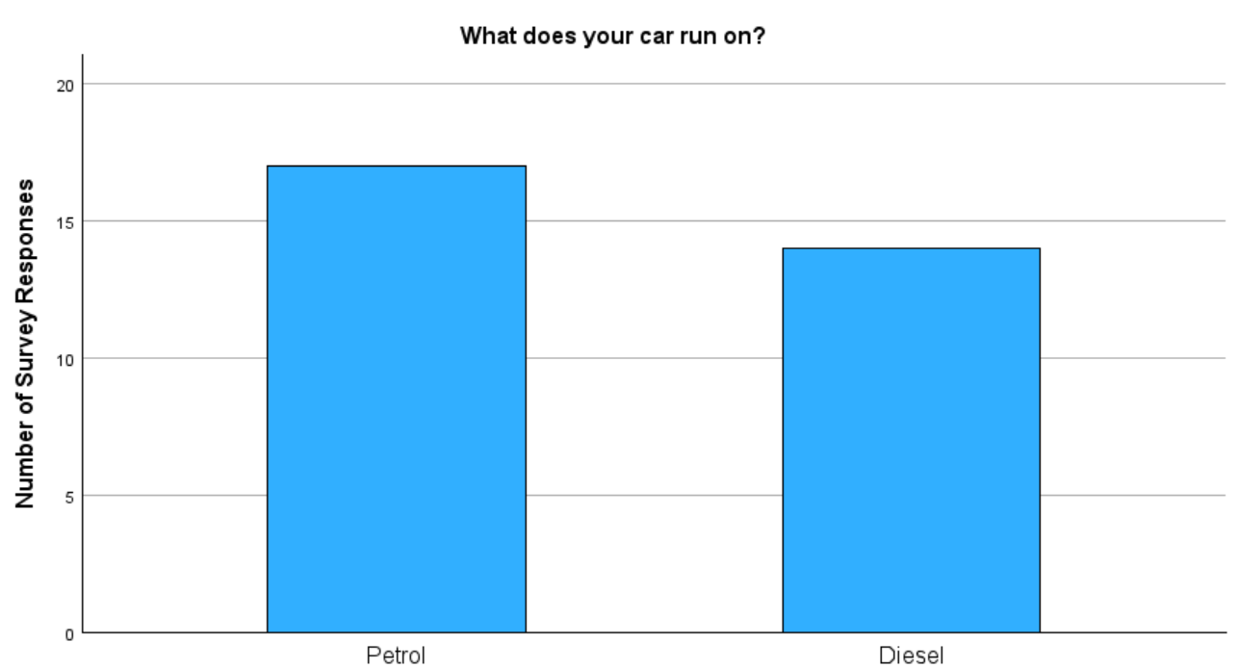
Shown below is my survey responses of my tallied pie and bar charts along with their descriptive tables:
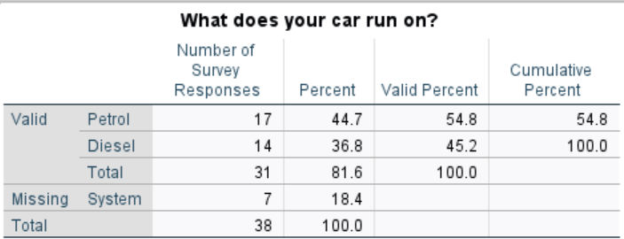

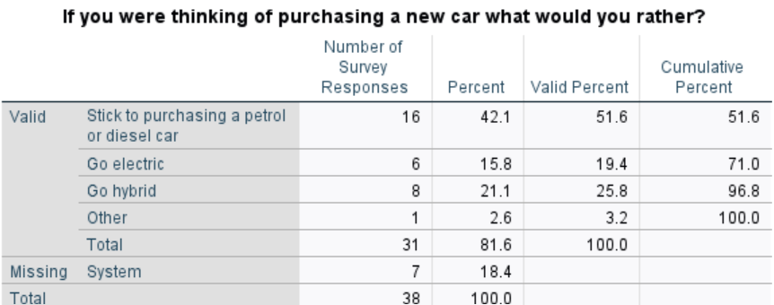
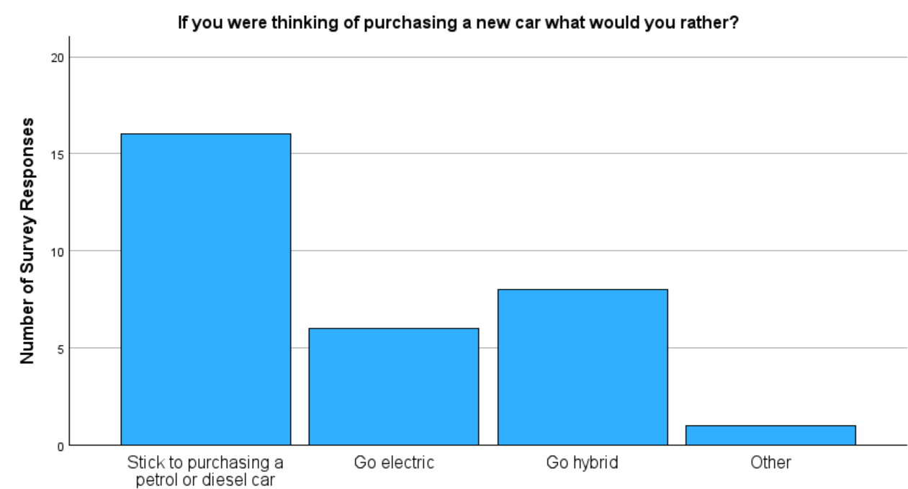

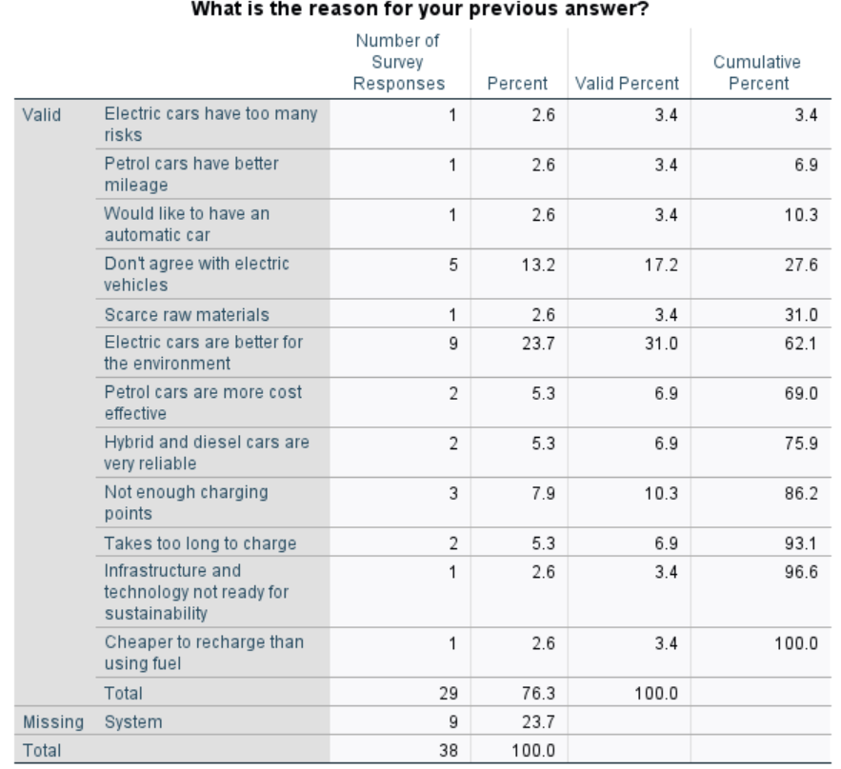
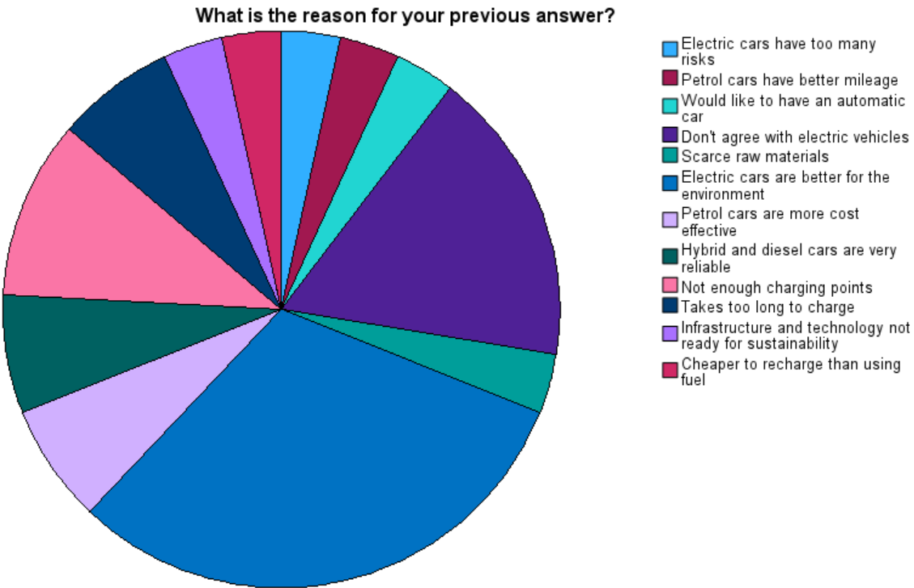
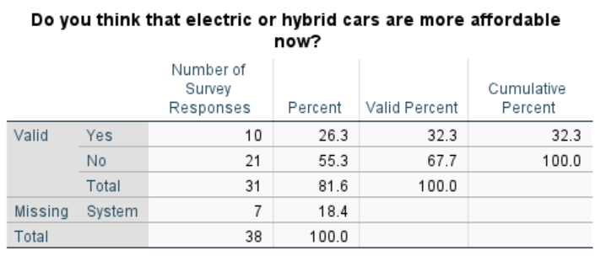
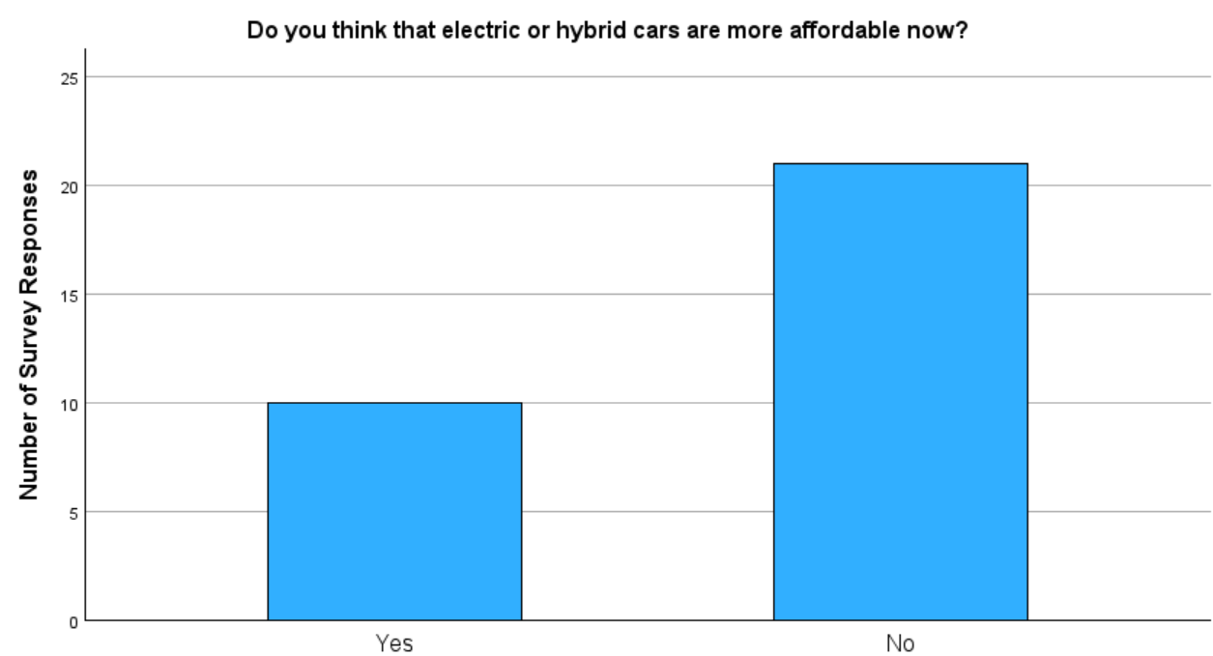

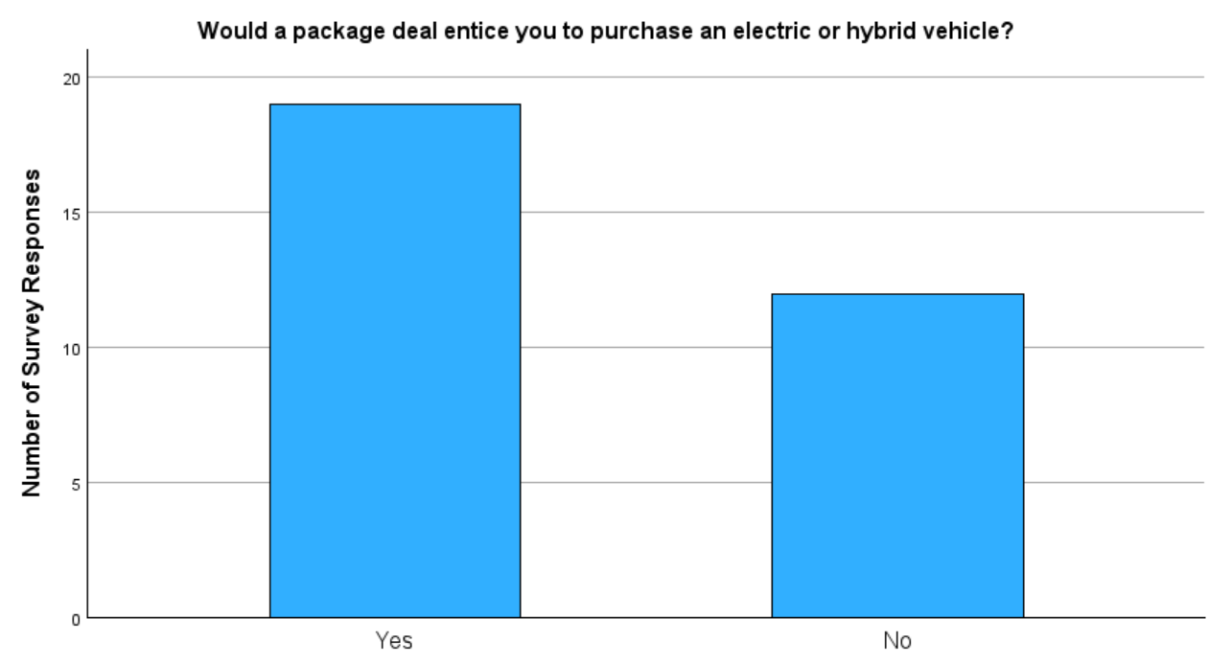

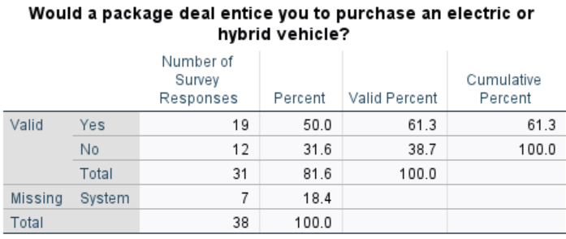

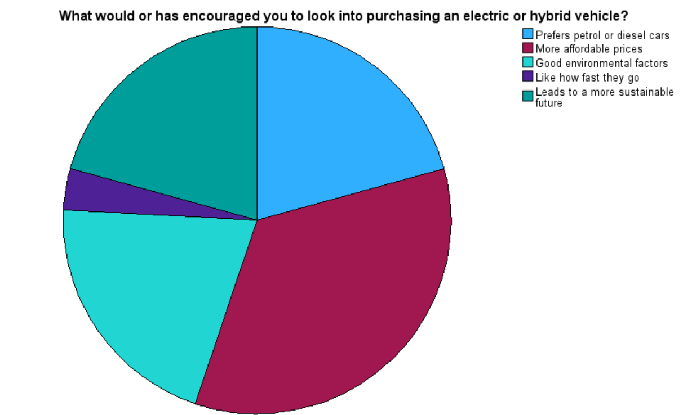

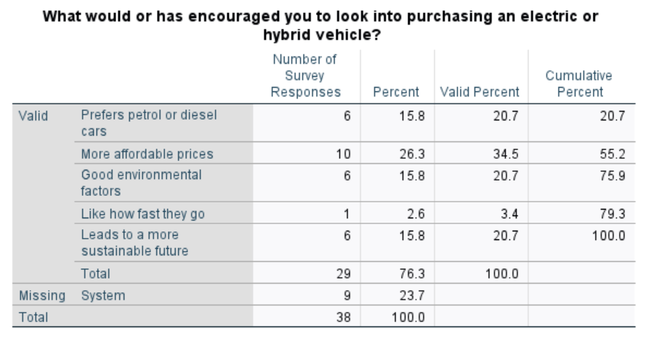
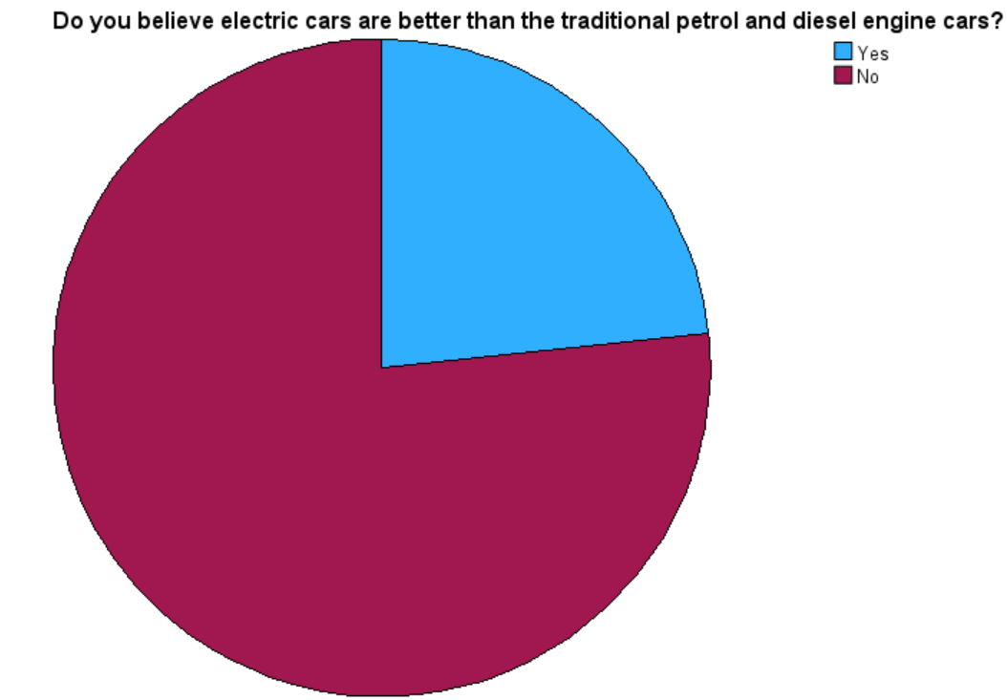

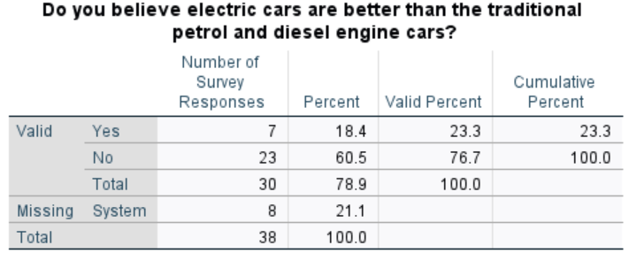
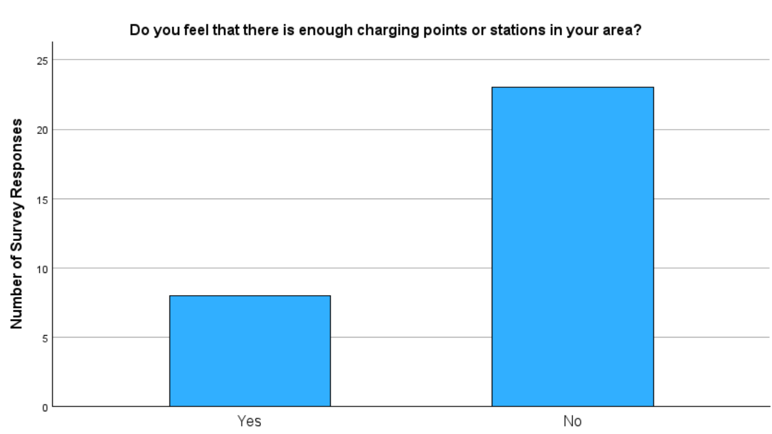

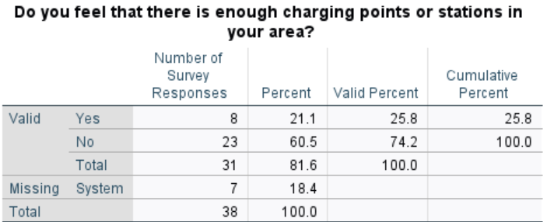

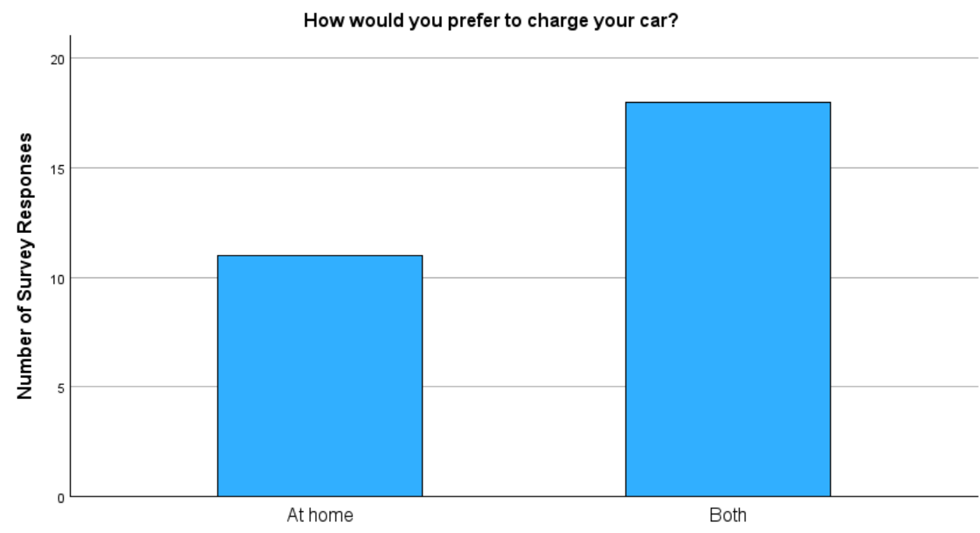

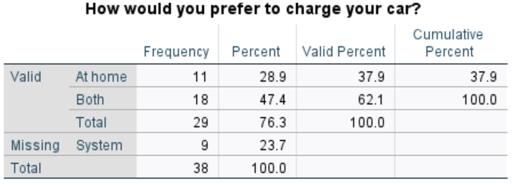

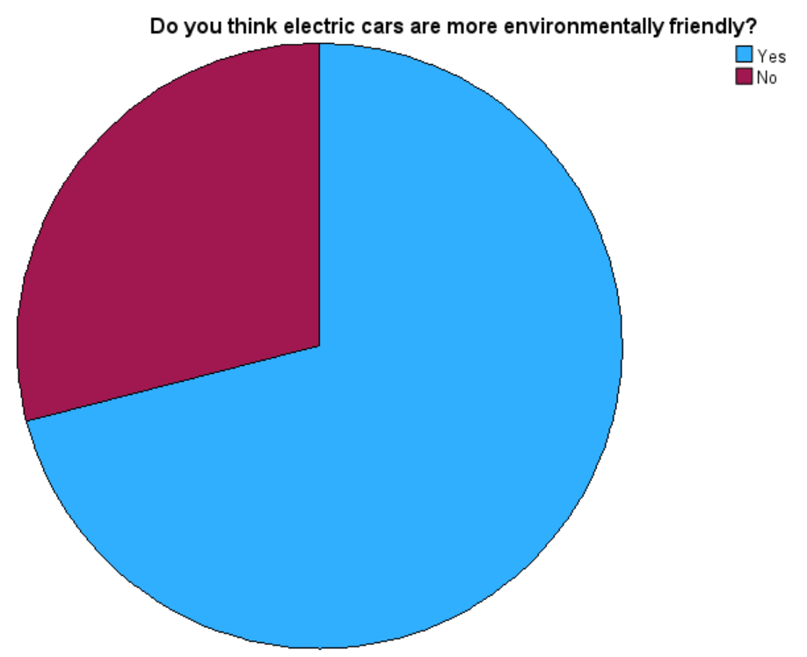

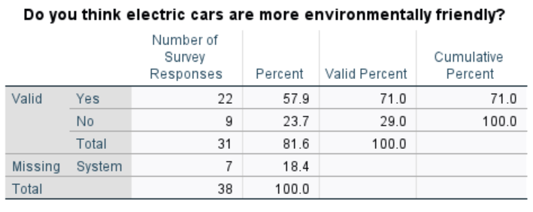

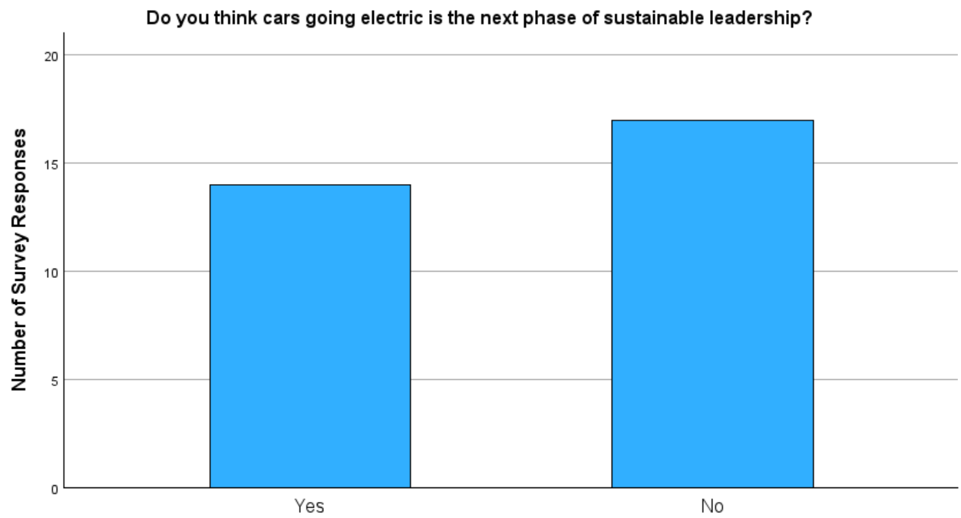

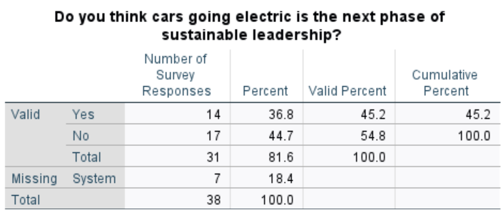

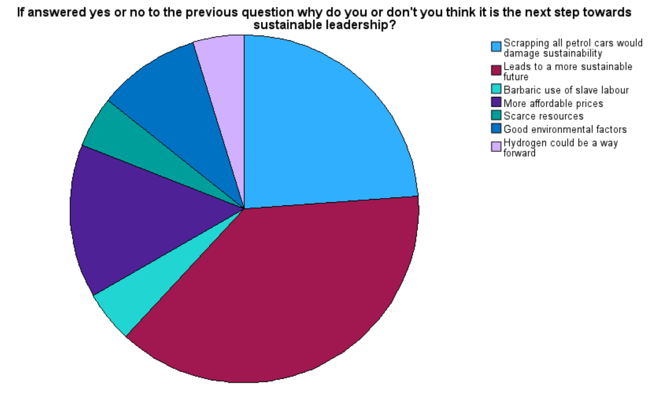

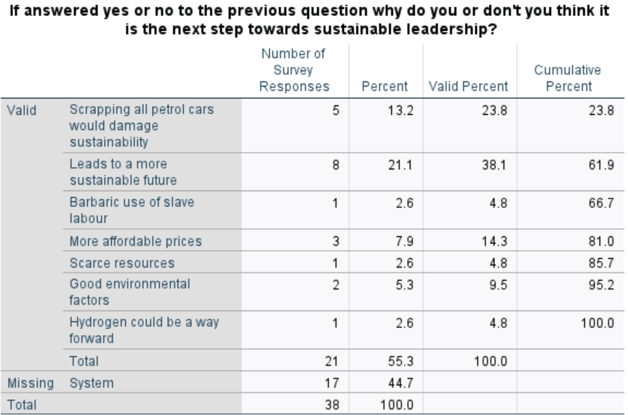

Summary

The main key findings that are identified within my presentation and interpretation of results chapter is the results of qualitative analysis through the utilization of my table of themes and the results were interpreted by interpreting each participants response, and linking it to my themes and what I have identified within my literature review.

The way that the results of my quantitative analysis has been interpreted, is by presenting the data that had been collected and analysed, to be displayed as pie and bar charts for each question that was most appropriate for this research. As the pie and bar charts, have identified that either people are not yet ready to transition to electric vehicle or they feel the opposite and feel that the transition to going electric or hybrid or another alternative is good for the environment, leads to a more sustainable future and feel that hydrogen could be the way forward.

Chapter 5: Conclusion

As a result of my findings throughout this dissertation, I have identified that the transition towards having all vehicles sustainable, is still in its early stages as automotive companies in the UK are only beginning to go into electric and hybrid vehicles as they do not have a broad spectrum of electric vehicles yet, and because of people that want to stick to their traditional internal combustion engine vehicles.

Which can be shown through my interviewee’s responses as Participant A and C have both feel that is too early to transition to electric vehicles, due to EVs being too expensive, the running costs of an EV and due to the cost of the living crisis. Whereas Participant B is happy with the EV transition but only due to them not emitting toxic fumes into the atmosphere.

This can also be shown in the above pie and bar charts, as the majority of my responses have said that they would still like to stick to purchasing a petrol or diesel cars, when they are thinking about purchasing a new car because they feel electric cars have too many risks, petrol cars have better mileage and are more cost effective, they just don’t agree with EVs, there is not enough charging points in their area and that it takes too long to charge up, and they also feel that the infrastructure and technology is not ready for sustainability. It has also been identified within that the respondents, also feel that EVs are not the next phase of sustainable leadership, because of the barbaric use of slave labour, scrapping all petrol cars would damage sustainability and they feel that they could make EVs more affordable.
However, the interviewee’s have said that they could be influenced in looking into EVs if they were definitely going to help save the environment, if EVs became cheaper and more cost effective, and if their charging times could be decreased and have better mileage on their clock. Also, it has been identified in the above pie and bar charts, that some of the respondents could be enticed to look into purchasing an EV through having a good package deal, and they would also be encouraged to look into EVs because of their good environmental factors and like how fast the electric vehicles accelerate.

Whereas, it has been identified that the rest of the respondents in my above pie and bar charts have said that they would look into going electric, going hybrid or another alternative, because they would like an automatic car, they feel that having EVs will help with the scarce raw materials, they feel that EVs are better for the environment, hybrid cars are very reliable and they feel it is cheaper to recharge than using fuel, as some of them feel they have enough charging points in their area. Also they have been encouraged to go electric or go hybrid or other because they feel that it is the next phase of sustainable leadership due to EVs leading to a more sustainable future, having good environmental factors, and someone also feels that hydrogen could be the way forward.

Therefore, electric and hybrid vehicles do have a potential to become futureproof as some of the respondents do believe that the EV transition is the way forward to a more sustainable future. Also, the automotive industry is always looking into ways that they can advance their technological features such as improving charging infrastructure to be implemented into homes to make it easier for people to charge their vehicles, to have infrastructure projects be implemented all over the UK, which is being funded by the Local EV Infrastructure (LEVI) Fund and by the On Street Residential Scheme (ORCS).
The automotive industry has also, advanced their technological features to enhance the EV appeal to influence drivers to look into or purchase sustainable vehicles, is through having the charging time to become quicker through rapid and ultra rapid charging capabilities, to guarantee that EV’s are going to be more cost effective in the long run, due to EVs being cheaper to charge than fuelling up an internal combustion engine vehicles, especially with off peak and vehicle to grid charging in homes.

Furthermore, the EV appeal is influencing drivers to look into or purchase sustainable vehicles, through ensuring that they are reducing carbon emissions that is leading to global climate change, which has been identified through my findings of zero emissions vehicles and the zero emission vehicle (ZEV) mandate and through improving how the vehicles are made through the circular economy implementation, which consists of implementing sustainable recycled materials such as of plant based interiors, bio based materials, recycled steel and plastics and advanced technology to produce vehicles that are more sustainable than they have ever been before.

Chapter 6: Recommendations

Based on my findings, I would recommend that the automotive industries would look into implementing more Fuel Cell Electric Vehicles as this would help enhance the EV appeal to become more influential for drivers to look into or purchase sustainable vehicles. As hydrogen can not only be obtained from domestic sources, but it can also be obtained from renewable sources that consist of water, biogas and agricultural waste. Also, it takes no longer than 5 minutes to fuel up the tank, rather than waiting for an electric vehicle to charge up.

Another way that the automotive industry could recommend, to enhance the EV appeal to become more influential for drivers to look into or purchase sustainable vehicles is by looking into alternative materials that make up the batteries as this would help reduce carbon emissions and potentially diminish the mining process, which can cause many unwanted consequences such as depleting and contaminating local water sources, air pollution from the dust and emissions from the lithium mining operations, land degradation is a long term consequence as it degrades the quality of the land, biodiversity, productivity and the ecosystem services and the mining process can make numerous amounts of waste, which can be difficult to dispose of safely.

References
AA, 2024. The ultimate beginner’s guide to electric and hybrid cars. [Online]
Available at: https://www.theaa.com/driving-advice/electric-vehicles/electric-hybrid-car-guide
[Accessed 11 June 2024].
acko drive, 2022. Plug-in Hybrid Electric Vehicles (PHEV): A complete guide. [Online]
Available at: https://ackodrive.com/ev-guide/plug-in-hybrid-electric-vehicles/
[Accessed 20 June 2024].
Ahmad, S., 2019. Qualitative v/s. Quantitative Research- A Summarized Review. Era University, p. 04.
Alanazi, F., 2023. Electric Vehicles: Benefits, Challenges, and Potential Solutions for Widesparead Adoption. applied sciences, p. 05.
Ali, S., 2021. AN OVERVIEW ON WHY ELECTRIC CARS ARE THE FUTURE OF TRANSPORTATION, San Bernardino: California State University.
Ashkenazi, R., 2022. Technology’s Favorite Curve: The S-Curve (and Why It Matters). Grove Ventures, p. 1.
Audi, 2024. Our Plug in Hybrid Cars. [Online]
Available at: https://www.audi.co.uk/uk/web/en/electric/hybrid.html
[Accessed 01 August 2024].
Auto Trader, 2020. Cars of The Future, Manchester: Auto Trader.
Baba, M. A., 2021. Fuel cell electric vehicles: A review of current power electronic converters Topologies and technical challenges. IOP Conference Series: Earth and Environmental Science, p. 03.
Bailey, S., 2017. Clearing the air, London: Greater London Authority Conservatives.
BBC, 2019. Electric vs fuel: why the government is encouraging more people to switch to electric cars. Newsround, p. 1.
BBC, 2024. Market research: qualitative and quantitative data. [Online]
Available at: https://www.bbc.co.uk/bitesize/guides/z6y9rj6/revision/5
[Accessed 13 August 2024].
BMW, 2019. Plug in hybrid and other electric vehicles. [Online]
Available at: https://www.bmw.com/en/innovation/Plug-in-hybrid-and-other-kinds-of-electric-cars.html
[Accessed 01 June 2024].
BMW, 2021. Sustainable materials in BMW interior design. [Online]
Available at: https://www.bmw.com/en/innovation/aquafil-sustainable-materials-in-bmw-interior-design.html
[Accessed 01 June 2024].
BMW, 2024. BMw sustainability in vehicles and materials. [Online]
Available at: https://www.bmw.co.uk/en/more-bmw/sustainability/sustainability-vehicles-materials-production.html
[Accessed 01 June 2024].
Bomford, A., 2013. How environmentally friendly are electric cars?. BBC NEWS MAGAZINE, p. 1.
Capgemini, 2022. LEADERSHIP IN THE ERA OF AUTOMOTIVE SUSTAINABILITY. [Online]
Available at: https://www.capgemini.com/insights/expert-perspectives/leadership-in-the-era-of-automotive-sustainability/
[Accessed 20 July 2024].
Charging At Home, 2023. Is It Cheaper To Charge An Electric Car At Home?. [Online]
Available at: https://chargingathome.co.uk/is-it-cheaper-to-charge-an-electric-car-at-home/
[Accessed 14 July 2024].
Chetty, P., 2015. Nominal, ordinal and scale in SPSS. [Online]
Available at: https://www.projectguru.in/nominal-ordinal-scale-spss/
Chukwuemeka, E. S., 2021. Limitations and Weaknesses of Quantitative Research. BSCHOLARLY, p. 01.
Clifford, J., 2022. Toyota GR Yaris Rally1: our new hybrid WRC car. Toyota UK Magazine, p. 1.
Climate Change Connection, 20117. Tailpipe Emissions. [Online]
Available at: https://climatechangeconnection.org/emissions/tailpipe-emissions/
[Accessed 20 March 2024].
Cockrell School of Engineering, 2020. New Cobalt-Free Lithium-Ion Battery Reduces Costs Without Sacrificing Performance. Cockrell School of Engineering, p. 01.
Connected Kerb, 2024. Electric Vehicle Incentives for 2024. [Online]
Available at: https://connectedkerb.com/stories-and-reports/electric-vehicle-incentives-for-2024/
[Accessed 15 July 2024].
Cordera, R., 2018. Demand for environmentally friendly vehicles: A review and new evidence. International Journal of Sustainable Transportation, p. 03.
Crossman, A., 2020. Qualitative Research. [Online]
Available at: https://www.thoughtco.com/qualitative-research-methods-3026555
[Accessed 13 August 2024].
DeCoster, J., 2004. Data Analysis in SPSS , Alabama: University of Alabama.
DeVault, G., 2024. Advantages and Disadvantages of Quantitative Research. [Online]
Available at: https://www.liveabout.com/quantitative-research-advantages-and-disadvantages-2296728
[Accessed 18 September 2024].
Diongson, D., 2023. What Is Quantitative Analysis? Definition & History. The Steet, p. 01.
Discuss, 2024. Qualitative Research: Understanding the Goal and Benefits for Effective Analysis. [Online]
Available at: https://www.discuss.io/blog/benefits-of-qualitative-research-analysis/
[Accessed 18 September 2024].
Dow, C., 2024. Self-driving cars could be on UK roads by 2026 after new law is signed. Top Gear, p. 01.
Doyle, L., 2009. An overview of mixed methods. Sage, p. 03.
Duke Initiative on Survey Methodology, 2020. TIPSHEET – QUALITATIVE INTERVIEWING. [Online]
Available at: https://dism.duke.edu/files/2020/05/Tipsheet-Qualitative_Interviews.pdf
[Accessed 31 August 2024].
EARTH.ORG, 2023. Why Electric Cars Are Better for the Environment. EARTH.ORG, p. 1.
EDF Energy, 2024. Electric Car Charging Points. [Online]
Available at: https://www.edfenergy.com/electric-cars/charging-points
[Accessed 11 July 2024].
Edwards, J., 2024. EV charging statistics 2024. [Online]
Available at: https://www.zap-map.com/ev-stats/how-many-charging-points/
[Accessed 11 July 2024].
Ellen Macarthur Foundation, 2024. Towards the Circular Economy: Economic and business rationale for an accelerated transistion, London: Ellen Macarthur Foundation.
Emadi, A., 2004. Fuel Cell Vehicles: Opportunities and Challenges. Illinois Institute of Technology, p. 01.
energy saving trust, 2023. A brief history of the electric car. [Online]
Available at: https://energysavingtrust.org.uk/a-brief-history-of-the-electric-car/
[Accessed 01 July 2024].
Energy.gov, 2014. The History of the Electric Car. [Online]
Available at: https://www.energy.gov/articles/history-electric-car
[Accessed 20 March 2024].
eon next , 2024. Get your home charger and tariff together. [Online]
Available at: https://www.eonnext.com/electric-vehicles/charger-and-tariff
[Accessed 14 July 2024].
Eon, 2024. V2G Charging. [Online]
Available at: https://www.eonenergy.com/business/commercial-ev-chargers/vehicle-to-grid-charging.html
[Accessed 02 August 2024].
European Environment Agency, 2024. Electric Vehicles. [Online]
Available at: https://www.eea.europa.eu/en/topics/in-depth/electric-vehicles?activeTab=07e50b68-8bf2-4641-ba6b-eda1afd544be
[Accessed -1 July 2024].
Fleming, J., 2018. Methodologies, methods and ethical considerations for conducting research in work-integrated learning. International Journal of Work-Integrated Learning, p. 06.
Gaille, L., 2017. 23 Advantages and Disadvantages of Qualitative Research. [Online]
Available at: https://vittana.org/23-advantages-and-disadvantages-of-qualitative-research
[Accessed 18 September 2024].
Gardiner, F., 2023. Secondary Research: an introduction. [Online]
Available at: https://www.universitylibrarian.com/blog/secondary-research-an-introduction
[Accessed 30 August 2024].
GOV.UK, 2013. Future of hydrogen powered cars mapped out. [Online]
Available at: https://www.gov.uk/government/news/future-of-hydrogen-powered-cars-mapped-out
[Accessed 05 August 2024].
GOV.UK, 2017. Innovative vehicle to grid technology to receive £20 million. [Online]
Available at: https://www.gov.uk/government/news/innovative-vehicle-to-grid-technology-to-receive-20-million
[Accessed 03 August 2024].
GOV.UK, 2020. Mixed methods study. [Online]
Available at: https://www.gov.uk/guidance/mixed-methods-study
[Accessed 30 August 2024].
GOV.UK, 2022. Introduction of Vehicle Excise Duty for zero emission cars, vans and motorcycles from 2025. [Online]
Available at: https://www.gov.uk/government/publications/introduction-of-vehicle-excise-duty-for-zero-emission-cars-vans-and-motorcycles-from-2025/introduction-of-vehicle-excise-duty-for-zero-emission-cars-vans-and-motorcycles-from-2025
[Accessed 16 July 2024].
GOV.UK, 2023. Government sets out path to zero emission vehicles by 2035. [Online]
Available at: https://www.gov.uk/government/news/government-sets-out-path-to-zero-emission-vehicles-by-2035
[Accessed 15 July 2024].
GOV.UK, 2023. On-Street Residential Chargepoint Scheme guidance for local authorities. [Online]
Available at: https://www.gov.uk/government/publications/grants-for-local-authorities-to-provide-residential-on-street-chargepoints/grants-to-provide-residential-on-street-chargepoints-for-plug-in-electric-vehicles-guidance-for-local-authorities#cost-eligible
[Accessed 03 August 2024].
GOV.UK, 2024. The Data Protection Act. [Online]
Available at: https://www.gov.uk/data-protection
[Accessed 01 September 2024].
Halfords, 2022. THE NEW EV HOME CHARGER REGULATIONS. [Online]
Available at: https://blog.halfords.com/the-new-ev-home-charger-regulations/
[Accessed 13 July 2024].
Harper, M., 2024. Self-driving vehicles set to be on roads by 2026 as Automated Vehicles Act becomes law. [Online]
Available at: https://www.gov.uk/government/news/self-driving-vehicles-set-to-be-on-roads-by-2026-as-automated-vehicles-act-becomes-law
[Accessed 06 august 2024].
Harvard Catalyst, 2024. Mixed Methods Research. [Online]
Available at: https://catalyst.harvard.edu/community-engagement/mmr/
[Accessed 24 July 2024].
Hirschlag, A., 2021. The battery invented 120 years before its time. BBC, p. 1.
HM Government, 2021. Taking charge: the electric vehicle infrastructure strategy, London: HM Government.
HM Government, 2022. Taking charge: the electric vehicle infrastucture strategy, London: HM Government.
Holding, J., 2023. What is an electric car? How do electric cars work?. Top Gear Magazine, p. 1.
IBM, 2020. Data View. [Online]
Available at: https://www.ibm.com/support/knowledgecenter/en/SSLVMB_23.0.0/spss/base/data_view.html
IBM, 2020. Variable View. [Online]
Available at: https://www.ibm.com/support/knowledgecenter/en/SSLVMB_23.0.0/spss/base/dataedit_auto_1.html
IBM, 2023. Data View. [Online]
Available at: https://www.ibm.com/docs/en/spss-statistics/saas?topic=editor-data-view
[Accessed 01 Septermber 2024].
IBM, 2024. SPSS Software. [Online]
Available at: https://www.ibm.com/analytics/spss-statistics-software
[Accessed 01 September 2024].
Igini, M., 2022. Why Electric Cars Are Better for the Environment. [Online]
Available at: https://earth.org/electric-cars-environment/
[Accessed 20 July 2024].
Jack Rix, 2024. The R5 has returned: meet the all-new, all-electric £25k Renault 5 E-Tech. Top Gear Magazine, p. 1.
Jacob, S. A., 2012. Writing Interview Protocols and Conducting Interviews: Tips for Students New to the Field of Qualitative Research , Pennsylvania: Slippery Rock University.
Jain, N., 2022. What are the advantages and disadvantages of electric cars?. [Online]
Available at: https://www.autotrader.co.uk/content/advice/benefits-and-downsides-of-owning-an-electric-or-hybrid-car
[Accessed 11 June 2024].
Johnson, R. B., 2004. Mixed Methods Research: A Research Paradigm Whose Time Has Come. American Educational Research Association, 33(07), p. 10.
Justin Rowlatt, 2021. Why electric cars will take over sooner than you think. BBC News, p. 01.
Kalu, F. A., 2017. What Makes Qualitative Research Good Research? An Exploratory Analysis of Critical Elements. Macrothink Institute, 05(02), p. 03.
Keogh, N., 2019. The Benefits of Plug-in Hybrid Cars. [Online]
Available at: https://nofuelneeded.com/the-benefits-of-plug-in-hybrid-cars/
[Accessed 23 June 2024].
Kia, 2024. Sustainability/Kia UK. [Online]
Available at: https://www.kia.com/uk/about/sustainability/?gclid=3cdff5df08931f9ab78693714776d1a7&gclsrc=3p.ds&msclkid=3cdff5df08931f9ab78693714776d1a7&utm_source=bing&utm_medium=cpc&utm_campaign=Kia_GBR_GNC_CQR_PHR_STD_Sustainability_KML_Bing&utm_term=sustainable%20ve
[Accessed 04 August 2024].
Larson, P. D., 2014. Consumer attitudes about electric cars: Pricing analysis and policy implications. ELSEVIER, p. 02.
Logan, K. G., 2021. Phasing in electric vehicles: Does policy focusing on operating emission achieve net zero emissions reduction objectives. Elsevier BV, p. 4.
Lutsey, N., 2015. Global climate change mitigation potential from a transition to electric veehicles, California: The International Council on Clean Transportation.
Lyati, M. M., 2021. Hybrid Electric Vehicles (HEV): classification, configuration and vehicle control. SA Electronics, 01(01), p. 02.
Maxwell, J. A., 2016. Expanding the History and Range of Mixed Methods Research. SAGE, 10(01), p. 01.
Mazda Stories, 2022. INTERIOR DESIGN: THE SUSTAINABLE MATERIALS IN MAZDA’S MX-30. [Online]
Available at: https://mazdastories.com/en_us/innovate/interior-design-the-sustainable-materials-in-mazdas-mx-30/#:~:text=The%20material%20that%20lines%20the,used%20in%20a%20car%27s%20cabin.
[Accessed 01 June 2024].
Mazda, 2024. 2024 Mazda 2 Hybrid. [Online]
Available at: https://www.mazda.co.uk/cars/mazda2-hybrid/
[Accessed 01 August 2024].
Mazda, 2024. Mazda 2 Hatchback Car. [Online]
Available at: https://www.mazda.co.uk/cars/mazda2/
[Accessed 01 August 2024].
Mazda, 2024. Mazda Sustainability. [Online]
Available at: https://www.mazda.co.uk/why-mazda/sustainability/
[Accessed 01 June 2024].
McGrath, C., 2019. Twelve tips for conducting qualitative research interviews. Taylor & Francis, 41(09), p. 02.
Moses, M., 2020. How do electric cars work?. [Online]
Available at: https://www.edfenergy.com/energywise/how-do-electric-cars-work
[Accessed 04 July 2024].
Motabillity, 2024. Electrification. Lifestyle, Issue 122, p. 75.
motorway, 2024. Do electric cars pay congestion charge?. [Online]
Available at: https://motorway.co.uk/sell-my-car/guides/do-electric-cars-pay-congestion-charge
[Accessed 16 July 2024].
motorway, 2024. London’s ULEZ – the ultimate guide. [Online]
Available at: https://motorway.co.uk/sell-my-car/guides/ulez-ultimate-guide
[Accessed 16 July 2024].
motorway, 2024. What is a mild hybrid car?- the ultimate guide. [Online]
Available at: https://motorway.co.uk/sell-my-car/guides/mild-hybrid-cars
[Accessed 18 June 2024].
motorway, 2024. What is the London ULEZ?. [Online]
Available at: https://motorway.co.uk/sell-my-car/guides/ulez-ultimate-guide
[Accessed 17 June 2024].
Nair, B. S., 2023. 10 Downsides To Owning An Electric Vehicle. [Online]
Available at: https://www.topspeed.com/downsides-to-owning-an-electric-vehicle/
[Accessed 25 April 2024].
National Geographic, 2019. The environmental impacts of cars, explained. National Geographic, p. 1.
Nichols, D., 2023. The Future of EV Batteries. [Online]
Available at: https://www.greencars.com/greencars-101/the-future-of-ev-batteries
[Accessed 06 August 2024].
Nichols, D., 2023. The Most Eco-Friendly Cars. [Online]
Available at: https://www.greencars.com/expert-insights/the-most-eco-friendly-cars
[Accessed 01 June 2024].
Nissan Motor GB, 2019. The drive towards a low carbon grid, London: Eon Drive.
Nova Charge, 2023. EV Charging Basics: What You Need to Know about EV Charging Networks. [Online]
Available at: https://www.novacharge.net/blog/ev-charging-basics-ev-charging-networks
[Accessed 13 July 2024].
Odum, S. M., 2023. Breaking Barriers. Motability Lifestyle, Issue 121, p. 9.
Oge, M. T., 2016. Driving the Future: Combatting Climate Change with Cleaner, Smarter Cars. First Edition ed. New York: Arcade.
Olive, 2018. The History of Qualitative Research. Medium, p. 01.
Paevere, P., 2013. Spatio-temporal modelling of electric vehicle charging demand and impacts on peak household electrical load. Springer, p. 08.
Patil, P., 2019. Electric Vehicle Charging Infrastructure: Current Status, Challenges and Future Devlopments. International Journal of Intelligent Automation and Computing, pp. 5-6.
Peugeot, 2024. Peugeot's Insight on Benefit of Electric Cars. [Online]
Available at: https://www.peugeot.co.uk/about-us/brand/news-articles/benefits-of-electric-cars.html#:~:text=This%20is%20because%20of%20the%20many%20benefits%20that,vehicle%203%20Extremely%20quiet%204%20Outperform%20petrol-powered%20cars
[Accessed 10 June 2024].
Pod Point, 2024. Complete Guide on EV Charging. [Online]
Available at: https://pod-point.com/guides/complete-guide-on-ev-charging?_gl=1*p7v7gg*_up*MQ..&gclid=9eb67c6198f31680142a1af254149527&gclsrc=3p.ds
[Accessed 14 July 2024].
Pod Point, 2024. Home Charging Solutions and Installation. [Online]
Available at: https://pod-point.com/solutions/driver/home-charging?_gl=1*114w2ry*_up*MQ..&gclid=9eb67c6198f31680142a1af254149527&gclsrc=3p.ds
[Accessed 14 July 2024].
Pod Point, 2024. Rapid Charging. [Online]
Available at: https://pod-point.com/solutions/driver/network/rapid-charging
[Accessed 13 July 2024].
Pod Point, 2024. Tesco Vauxhall EV Charging | UK National Rollout. [Online]
Available at: https://pod-point.com/rollout/tesco-ev-charging
[Accessed 13 July 2024].
Pod Point, 2024. The Electric Vehicles (Smart Charge Points) Regulations and what they mean. [Online]
Available at: https://pod-point.com/guides/smart-charge-point-regulations
[Accessed 26 August 2024].
Prajapati, K. C., 2014. Hybrid Vehicle: A Study on Technology. International Journal of Engineering Research & Technology, 03(12), p. 02.
R.Graham, 2001. Comparing the Benefits and Impacts of Hybrid Electric Vehicle Options, Southern California Edison: Electric Power Research Institute.
RAC, 2021. Types of electric vehicles – EVs explained. [Online]
Available at: https://www.rac.co.uk/drive/electric-cars/choosing/types-of-electric-vehicles-evs-explained/
[Accessed 23 June 2024].
RAC, 2021. What is a hybrid car and should I buy one?. [Online]
Available at: https://www.rac.co.uk/drive/electric-cars/choosing/what-is-a-hybrid/
[Accessed 17 June 2024].
RAC, 2024. What is a hybrid car and should I buy one?. [Online]
Available at: https://www.rac.co.uk/drive/electric-cars/choosing/what-is-a-hybrid/
[Accessed 18 June 2024].
Renault, 2024. electric driving range, savings and charging time. [Online]
Available at: https://www.renault.co.uk/electric-vehicles/scenic/ev-simulator.html#autonomy
[Accessed 13 July 2024].
Renault, 2024. Meet Renault Scenic E Tech 100% Electric. [Online]
Available at: https://www.renault.co.uk/electric-vehicles/scenic/ev-simulator.html#autonomy
[Accessed 04 July 2024].
Renault, 2024. Renault 5- Fully electric city car by Renault. [Online]
Available at: https://www.renault.co.uk/electric-vehicles/r5-e-tech-electric.html
[Accessed 05 June 2024].
Sanguesa, J. A., 2021. A Review on Electric Vehicles: Technologies and Challenges. MDPI Smart Cities, p. 06.
Schwanen, T., 2019. The five major challenges facing electric vehicles. BBC NEWS, p. 1.
Sciarretta, A., 2007. Control of Hybrid Electrified Vehicles. IEEE Control Systems Magazine, p. 60.
Shell UK, 2024. Public Charging with Shell Recharge. [Online]
Available at: https://www.shell.co.uk/electric-vehicle-charging/public-charging-with-shell-recharge.html
[Accessed 13 July 2024].
Shorten, A., 2017. Mixed methods research: expanding the evidence base. BMJ Journals, 20(3), p. 2.
Singh, H., 2021. Plug In Hybrid Electric vehicles. Springer Nature Singapore Pte Ltd, p. 53.
Slowik, P., 2019. Funding the Transition to All Zero Emission Vehicles, Berlin: The International Council on Clean Transportation.
SPSS TUTORIALS, 2020. SPSS Variable Types and Formats. [Online]
Available at: https://www.spss-tutorials.com/spss-variable-types-and-formats/
Strohl, D., 2018. Ford, Edison and the Cheap EV That Almost Was. [Online]
Available at: https://www.wired.com/2010/06/henry-ford-thomas-edison-ev/
[Accessed 14 March 2024].
Subbaram, S., 2023. Are EV’s breaking the “S-Curve” dynamics ?. Medium, p. 1.
Swallow, T., 2023. Top 10 technologies driving the shift to electric vehicles. [Online]
Available at: https://evmagazine.com/top10/top-10-technologies-driving-the-shift-to-electric-vehicles
[Accessed 20 March 2024].
Tartaro, C., 2021. Research Methods for Criminal Justice and Criminology. London: Taylor & Francis Group.
Taylor & Francis, 2011. Alternative Fuels For Transportation, London: CRC Press.
Tesla, 2024. Tesla Model 3. [Online]
Available at: https://www.tesla.com/en_GB/model3
[Accessed 07 July 2024].
The University of Sydney, 2021. University spin-out Gelion to make next-gen batteries in Sydney. The University of Sydney, p. 01.
Timperley, J., 2020. How our daily travel harms the planet. BBC, p. 1.
Top Gear, 2021. Toyota Mirai Review 2024. Top Gear, p. 01.
Topping, C., 2023. Vehicle-to-Grid (V2G) explained: What it is and how it works. [Online]
Available at: https://www.ovoenergy.com/guides/electric-cars/vehicle-to-grid-technology
[Accessed 02 August 2024].
Toyota Media Team, 2023. Toyota sets out advanced battery technology roadmap. Toyota, p. 01.
Toyota, 2024. Hydrogen Cars. [Online]
Available at: https://www.toyota.co.uk/hydrogen?_gl=1*19hdxnc*_up*MQ..&gclid=5806c4cb6f1f18d2fabfa260ce4fb1b9&gclsrc=3p.ds
[Accessed 01 August 2024].
U.S. Deparment of Energy, 2024. Fuel Cell Vehicles - Benefits and Challenges. [Online]
Available at: https://www.fueleconomy.gov/feg/fcv_benefits.shtml
[Accessed 23 June 2024].
Ubitricity, 2024. Lamppost and bollard charge. [Online]
Available at: https://ubitricity.com/en/charging-solutions/ac-lamppost/
[Accessed 13 July 2024].
Visser, D. W., 2024. Sustainability Leadership: Linking Theory and Practice, Cambridge: University of Cambridge.
Volvo, 2024. Volvo electric cars. [Online]
Available at: https://www.volvocars.com/uk/cars/electric-cars/?gclid=eff01396da15149d400975f5f22196ea&gclsrc=3p.ds&msclkid=eff01396da15149d400975f5f22196ea&utm_source=bing&utm_medium=cpc&utm_campaign=uk_masterbrand_range_consideration-action_alwayson_gen_alon_mxd_eng_g
[Accessed 08 June 2024].
Wienkotter, M., 2019. The history of Porsche begins electrically. Porche Newsroom, p. 1.
Williams, A., 2024. Is Lithium Mining Bad for the Environment? 6 Crucial Facts. [Online]
Available at: https://citizensustainable.com/lithium-mining/#:~:text=6%20Ways%20Lithium%20Mining%20Affects%20the%20Environment%201,on%20Biodiversity%20...%206%206.%20Waste%20Disposal%20
[Accessed 04 July 2024].
Wilson, K. A., 2023. First Electric Car. A Brief History of the EV, 1830 to Present. [Online]
Available at: https://www.caranddriver.com/features/g43480930/history-of-electric-cars/
[Accessed 14 March 2024].
YoCharge, 2024. The Different Types of Electric Vehicles. [Online]
Available at: https://yocharge.com/faq/the-different-types-of-electric-vehicles/
[Accessed 23 June 2024].
Zauaghi, Y., 2021. Two-Thirds of Consumers are “Sustainability-Minded Drivers,” Accenture Report Finds. [Online]
Available at: https://newsroom.accenture.com/news/2021/two-thirds-of-consumers-are-sustainability-minded-drivers-accenture-report-finds#:~:text=A%20key%20finding%3A%20Sustainability%20is%20no%20longer%20a,hybrid%20electric%2C%20flexible%20fuel%20or%20fuel%20cell%20elec
[Accessed 13 January 2024].

Appendix

Appendix 1



Participant Name __________________________________
Interviewer Name ___________Joaquim Anthony Fernandes____________
Interviewer Programme of Study _______MBA Sustainable Leadership__________
Research Learning Tutor _____________Glenn Behenna__________

Participation Agreement to be interviewed:

I agree to participate in the research concerning “What influences drivers to change from traditional vehicles into modern sustainable vehicles?”. I understand that the purpose of this study is to examine my experiences of “what influences drivers to purchase sustainable vehicles and what sustainable vehicles are already currently available, are sustainable vehicles actually good for the environment and why and in what areas would sustainable vehicles work in practices”. I understand that this will involve me in a short 20 minute interview.

I understand that this interview will be recorded and transcribed for use only in Joaquim Anthony Fernandes’s dissertation at the University of Wales Trinity Saint David.

I understand that my name or any reference to my identity will be kept anonymous in this study and for any subsequent publications I will be asked again for my consent. I understand that use storage of the recordings and transcriptions relating to this interview will be anonymous; not be used for any other purpose than this study and will be subsequently destroyed after the use intended here.

I understand that I may withdraw from the study at any point with all records of my contribution removed without having to provide a reason.

Interviewee Signature:

Interviewer Signature:

Joaquim Anthony Fernandes

Date of Interview:

A copy of this agreement should be retained by both interviewer and interviewee.

Appendix 2


