REFLECTIVE JOURNAL
Name of the student: Marius Hurmuzache
Nme of the university: University of Wales
Student’s ID: 2125248
Tutor name: Jessica Newtown
Module: Managing Guest Service Operations
Module code: BMIH6003

Executive summary
The reflective journal has outlined the understanding of the services provided by Delta Hotels Tudor Park by Marriott. Additionally, the study will include the reflections of the entire understanding with the help of Gibbs' Reflective Model. The exposure obtained from the professional hospitality environment has helped individuals to learn lots of new things. It has further helped to identify the strengths and weaknesses of the individuals. Improving communication can help individuals to improve the productivity and efficiency. The reflective journal has further analysed the different work-based skills and technical kowledge that are applicable within the hospitality industry. The study has also identified organisational issues in the Delta Hotels Tudor Park and provided some solutions to address them. The study has provided an action plan to understand which skills need to be developed for a better future.

Contents
Introduction 4
Section 1: Reflection on Experience and Personal Development 5
Section 2: Critical Analysis of Work-Based Skills and Technical Knowledge 6
Section 3: Reflection on Organisational Issues 7
Conclusion and Action Plan 8
Weekly journal 9
References 10
Appendices 12

Introduction
Delta Hotels Tudor Park by Marriott is a company that provides multiple facilities to the guests and the consumers. The main service of the company is to clean the cutlery and prepare for the next guests. It also cleans the tables and prepares for the next booking depending on the customer's requirements. They sort the dining rooms, serve at the bars and other services (Marriott Bonvoy, 2024). Delta Hotels also sometimes shows the consumers and makes them understand the process of booking hotels and general questions that can be asked. The hotel is used for spa, golf, courtesy and wedding purposes. The study will use Gibbs' Reflective Model in order to reflect on the experiences and personal development. This specific theoretical framework of individual reflection comprises six steps, which can be termed as “Discussion”, “Feeling”, “Evaluation”, “Analysis”, “Conclusion” and “Action Plan” (Pieper et al., 2021). The study will also highlight the critical analysis of work-based skills and technical knowledge. Lastly, the study will provide a reflection on the organisational issues that can be encountered while providing services to the guests.
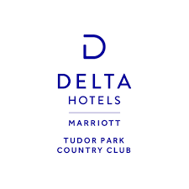
Figure 1: Logo of Delta Hotels Tudor Park
(Source: Marriott Bonvoy, 2024)

Section 1: Reflection on Experience and Personal Development
Description
I worked in Delta Hotels Tudor Park Marriott for a long period of time. I was working in entry entry-level position as a result my job role included the basic things. I was tasked with cleaning the cutlery, preparing for the next customers, cleaning the table and setting new ones, sorting the dining, changing the table and preparing them for the next booking. I am also tasked to serve in bars and make coffee for customers whenever they need it.
Feeling
Initially, I was feeling very nervous but after a certain time period I became habituated to the job and I was feeling quite good as I was able to maintain my work-life balance while working on the job.
Evaluation
The worst thing about the job was that there was too much work pressure and I barely had any time to rest but the best thing was that I got exposure to a professional work environment and got to learn a lot of new things. Customer reservation rates and profits are the cornerstone elements of a successful hospitality business (Dominioni, 2023). The skills I learn would significantly contribute to my career growth.
Analysis
While working there I was able to identify my strengths and weaknesses in that field. Psychological capital is the strongest predictor of self-reported job performance (Huang et al., 2021). I was able to know myself better and get to know about my mistakes. Presently travellers desire an overall immersive hotel experience which is provided by a skilled staff (Sands, 2023). I learned that I need to work on my time management and communication skills.
Conclusion
Working In Delta Hotels Tudor Park Marriott helps me in denying my knowledge and skills and helps to get live-on job experience.

Section 2: Critical Analysis of Work-Based Skills and Technical Knowledge
The staff members of a hotel need to have proper knowledge about the different kinds of skills that are required to meet the expectations of the guests. These skills need to be thoroughly developed by the hotel authorities so that the customers can have the optimal experience while staying in the hotel. As per the evaluation stage, the experience of the individuals can be assessed (Roedema et al., 2022). I was able to gain proper management skills when I worked on cleaning the available cutlery, clearing the tables and setting new ones. I have improved my multi-tasking ability by serving at the bar, pouring beers and making coffee. However, I believe that this skill can be further improved in the future. We learned to work together as a team, which enhanced my teamwork skills. However, I need to create a proper plan to further improve my teamwork skills. In addition, our communication skills were improved when we were provided lessons on how to ask general questions to the customers according to their needs and preferences. Furthermore, I have substantially developed my decision-making skills while understanding the needs of the customers. However, my problem-solving skills can be further improved with careful consideration. In terms of technical skills, we have been provided with proper training on understanding the booking process in the Delta Hotels Tudor Park. Overall, I had a positive experience working at the Delta Hotels Tudor Park by Marriott. In addition to this, the skills can be analysed using the fourth stage of Gibbs' Reflective Cycle. Management skills can help in individual to become more agile in their daily work (Santos et al., 2021). The improvement of decision-making skills can be really helpful for making the right decisions at critical moments. These skills can be used for professional as well as personal well-being. Although, I feel like I can develop my multi-tasking, teamwork and problem-solving skills with a proper plan.
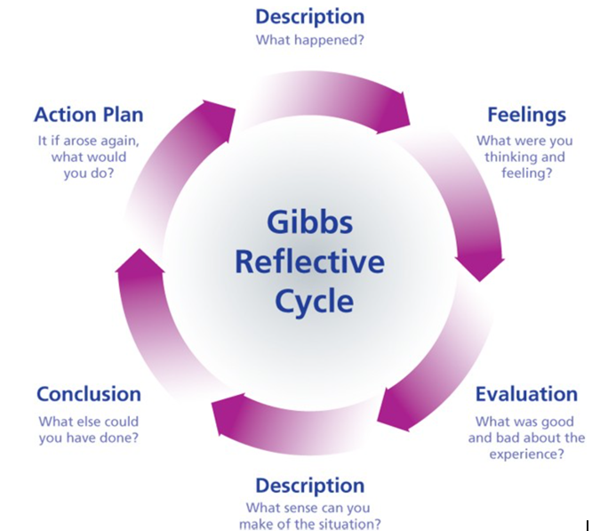
Figure 2: Gibbs’ Reflective Cycle
(Source: Roedema et al., 2022)

Section 3: Reflection on Organisational Issues
During my work, I expand the range of operational issues regarding staff shortages and digital skill gaps. The hotel was experiencing a high rate of employee turnover due to low pay which negatively affected the operational efficiency. As a result, the remaining employees are under high work pressure and they are not able to maintain the quality of their services (Wen et al., 2020). During the evaluation of the work, I remember that once there was an emergency due to a high influx of visitors as a result I was tasked with extra work beyond my allocation. It negatively affected the quality of my work as there was limited time and my tasks were beyond the set limit.
Since I have identified the operational follies due to a shortage of staff along with a lack of digital skills, it can be further reflected using the fifth stage of Gibbs' Reflective Cycle. I believe that the hotel management authorities of Delta Hotels Tudor Park need to create proper initiatives to train the employees on digital abilities. Furthermore, they need to hire skilled individuals to fill the scarcity of employees within the hotel premises (Marneros et al., 2020). I believe that if these strategies are properly executed by the hotel executives, then they can improve employee satisfaction. The improved skills of the employees can further help to provoke better services to the customers. In this manner, Delta Hotels Tudor Park can establish itself in the hospitality industry of the UK.

Conclusion and Action Plan
Conclusion
The study has outlined the understanding of the services provided by Delta Hotel Tudor Park by Marriott. It has provided the understanding of experience and personal development with the help of Gibbs' Cycle. The study has also incorporated the understanding of work-based skills and technical knowledge by critically analysing the factors. It can be stated that the study has also included reflection on the organisational issues and an action plan has been provided in terms of understanding how the company will grow within a short period of time. In addition to this, it can be stated that the study will provide a reflective understanding of the entire services provided by Delta Hotel Tudor Park by Marriott.
Action Plan
Skills to be developed | Required resources | Required actions | Time-frame | Success criteria
Multi-tasking | Delegation, organisation, group similar tasks and prioritising tasks. | To work with multiple things without facing any challenges. | 1-2 months | I will be able to work efficiently and provide better outcomes.
Team-work | Active listening and communication | To work within a team and several people | 2-3 months | It will become easier for me to understand the co-workers and work together.
Problem-solving skills | Develop potential solutions and measure the results. | To define problems and select the best opinions. | 3-3.5 months | I will help the company mitigate multiple challenges.
Table 1: Action plan for personal development after working experiences
(Source: As created by the author)

Weekly journal
Refer to the appendices.

References
Dominioni, F., (2023). 4 Strategies For Leaders Seeking To Elevate The Hotel Experience. Forbes. [online] 19 May. Available at: https://www.forbes.com/councils/forbesbusinessdevelopmentcouncil/2023/05/19/4-strategies-for-leaders-seeking-to-elevate-the-hotel-experience/ [Accessed: 11 Nov. 2024].
Huang, S., Yu, Z., Shao, Y., Yu, M. and Li, Z., (2021). Relative effects of human capital, social capital and psychological capital on hotel employees’ job performance. International journal of contemporary hospitality management, 33(2), pp.490-512.
Marneros, S., Papageorgiou, G. and Efstathiades, A., (2020). Identifying key success competencies for the hospitality industry: The perspectives of professionals. Journal of Teaching in Travel & Tourism, 20(4), pp.237-261.
Marriott Bonvoy, (2024). Delta Hotels Tudor Park Country Club. [online] Marriott Bonvoy. Available at: https://www.marriott.com/en-us/hotels/lontp-delta-hotels-tudor-park-country-club/overview/ [Accessed: 11 Nov. 2024].
Pieper, M., Roelle, J., vom Hofe, R., Salle, A. and Berthold, K., (2021). Feedback in reflective journals fosters reflection skills of student teachers. Psychology Learning & Teaching, 20(1), pp.107-127.
Roedema, T., Rerimassie, V., Broerse, J.E.W. and Kupper, J.F.H., (2022). Towards the reflective science communication practitioner. Journal of Science Communication, 21(4), pp.1-20.
Sands, R., (2023). These Unique Hotel Jobs Ensure An Immersive Travel Experience. Forbes. [online] 6 Oct. Available at: https://www.forbes.com/sites/rogersands/2023/10/06/these-unique-hotel-jobs-ensure-an-immersive-travel-experience/ [Accessed: 11 Nov. 2024].
Santos, G., Sá, J.C., Félix, M.J., Barreto, L., Carvalho, F., Doiro, M., Zgodavová, K. and Stefanović, M., (2021). New needed quality management skills for quality managers 4.0. Sustainability, 13(11), p.6149.
Wen, B., Zhou, X., Hu, Y. and Zhang, X., (2020). Role stress and turnover intention of front-line hotel employees: the roles of burnout and service climate. Frontiers in psychology, 11, p.36.

