Electrical and Electronic Systems Report



Tegan Ingram-2317699

University of Wales Trinity Saint David
Ordinance, Munitions and Explosives Engineering

Fundamentals of Electrical and Electronic Systems

Supervisor: Stalin Jacobs
June 2024

Table of Contents
List of Figures 3
1. Introduction 4
2. Circuit Parameters 4
3. Relation to OME 5
4. Proteus (Simulation) 6
5. Breadboard (Physical) 8
6. Comparison 11
7. Conclusion 11
8. Bibliography 12

List of Figures
Figure 1 – Astable 555 Circuit Diagram 7
Figure 2- 555 Timer Internal Block Diagram [1] 7
Figure 3 – Circuit in Proteus 9
Figure 5- Breadboard circuitFigure 6 – Breadboard circuit, top view 11
Figure 7 – Power supply 12
Figure 8- oscilloscope connection points 12

Introduction
  - To optimise the performance of a circuit, precise readings must be taken and the values must be calculated. This can be a tedious task, as well as an inefficient use of time and money when working with physical circuits. As a solution to this, the software “Proteus” allows an engineer to simulate the exact circuit that is being tested and thus provides all of the measurements required in a much more efficient manner.
  - This report investigates and relates a physical breadboard circuit to a simulated circuit produced within the computer program “Proteus”. This is done by physically creating and testing an astable 555 timer circuit using a breadboard while comparing it to an identical circuit simulated within “Proteus”. The results of both methods are then calculated and compared.
  - The aim of this report is to display the benefits and differences between physical, theoretical data and data comprised from simulation. As well as proving the validity of either method.

Circuit Parameters
The circuit used for this experiment was an astable 555 timer circuit assembled as shown in figure 1.
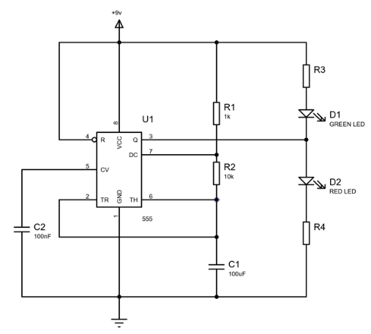 Figure 1 – Astable 555 Circuit Diagram
2.1 Below is a block diagram showing the internal circuitry of a 555 timer.
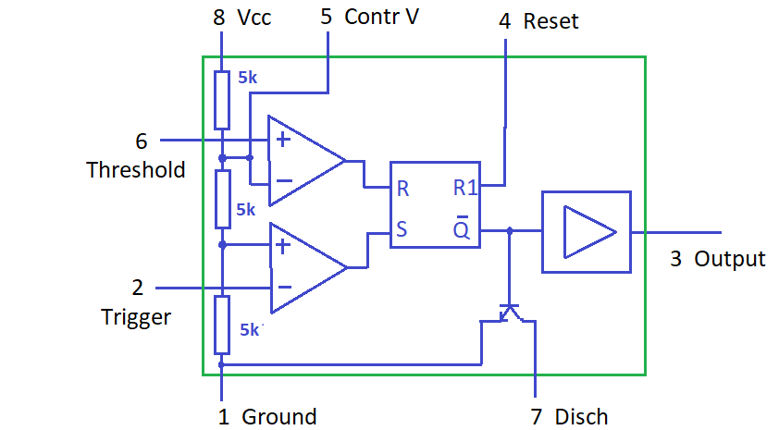 Figure 2- 555 Timer Internal Block Diagram [1]
2.1.1 The name of the 555 timer stems “from the fact that there are three internally connected 5kΩ resistors which it uses to generate the two comparators reference voltages” [2]. This means that the 555 timer can act as a simple timer generating pulses, singularly or with long delays, as well as being able to act as a relaxation oscillator hence producing strings of stabilised waveforms [2].
2.1.2 The 555 timer will be used in a pulse generating mode in which it will power two LED bulbs accordingly. This will be seen as the two bulbs flashing on and off in sequence, with the red LED flashing when the green LED goes dim and then and vice versa.
2.2 As seen in figure 1, the circuit is made up of just one active opponent (the 555 timer). The circuit does also include multiple resistors and capacitors included within the circuit design.
2.2.1 The network of resistors are included within the design as a way to limit and control the voltage traveling to the LEDs. “A resistor is a passive two-terminal electrical component that limits the current flowing in electrical or electronic circuits” [3]. The resistors used were fixed resistors which mean that the resistance cannot be changed.
2.2.2 Capacitors have the capability to store electrical energy. They are used within this circuit to manage the timings of the flashes by stabilising the flow of power.

Relation to OME
3.1 Within the field of ordinance, munitions and explosives, circuits are widely used. The capability and performance of the circuits must be reliable and to do this testing must be done. This is where Proteus may become the most efficient form of testing for a manufacturer.
3.2.1 Engineers are currently moving away from original fuze designs and developing “e-fuzes”. These fuzes contain a circuit within them. The primary purpose of a fuze is to trigger the projectile at the moment or in the place that it is needed. This could be creating an explosion among enemy forces or lighting up the battle field with an illumination round. This is why it is so essential that the fuze acts in its intended way.
3.2.2 Proteus can be used by engineers to validate fuze designs at a lower cost than physically making and testing. This means a much more efficient way of manufacturing.
3.3 A two tone alarm is used to alert people of danger within the industry. Like the simultaneous flashing lights created within the circuit, the different tones have to play at the correct time so that people can recognise and act on the alert. Resistors and capacitors would be used within the alarm system like in the circuit produced in this report.

Proteus (Simulation)
4.1 Schematics were provided regarding the design intended for this assignment (see figure 1). This has then been reproduced within Proteus.
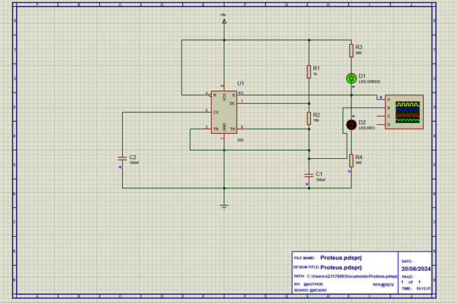 Figure 3 – Circuit in Proteus
4.2 The values of R3 and R4 were not provided were not provided within the schematics so this is what is being calculated. The voltage must be controlled in order to prevent damage to the bulbs by managing the voltage supplied to the LEDs. The on and off time, frequency and period are all also in need of calculation as they can be used to ensure that the circuit is performing the way that it was designed to.
4.2.1 The equations used for the calculation of resistance are as follows:
R3 = (Vcc – Vf) / If
R4 = (Vcc – Vf) / If
In which, Vcc = Input voltage
Vf = Forward voltage of LEDs
If = The forward current.
4.2.2 The input voltage of the circuit (Vcc) is 9v, the forward voltage of the LEDs (Vf) is 2.2v and the forward current (If) is 20Ma. When these numbers are substituted into the above equations the results are as follows:
R3 = (9 - 2.2) / 0.2 = 340
R4 = (9 - 2.2) / 0.2 = 340
Meaning that both resistors have the value of 340ohms.
4.2.3 The equations used to calculate, frequency, on and off time and period are as follows.
F = 1.44 / (R1 + 2 x R2) C
This gives us a frequency of 685.7 Hertz.
Period = 1/F
Providing a result of 1.458μs.
On time = 0.694 (R1 + R2) C
Off time = 0.694 x R2 x C
So on time is equal to 0.7634ms.
And off time is equal to 0.6940ms.
4.3 Proteus has an oscilloscope feature within it and the readings can be seen in figure 4.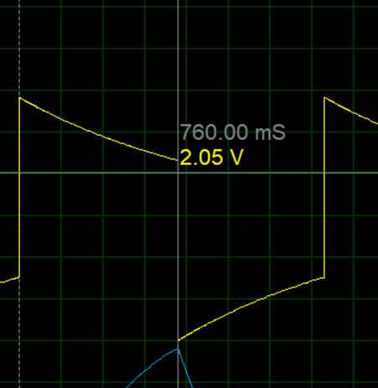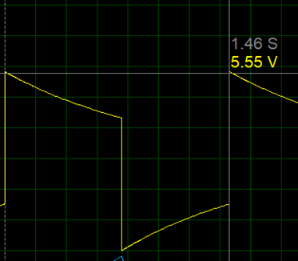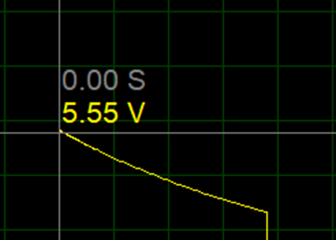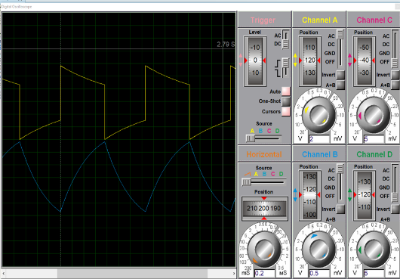Figure 4 – oscilloscope readings, simulation

Breadboard (Physical)
5.1 Physical testing is always required when making a circuit. This ensures that that the circuit is reliable and works exactly as expected. In order to do this a breadboard was created using all of the physical parts included in the schematics. The breadboard can be observed in figure 5 and 6.
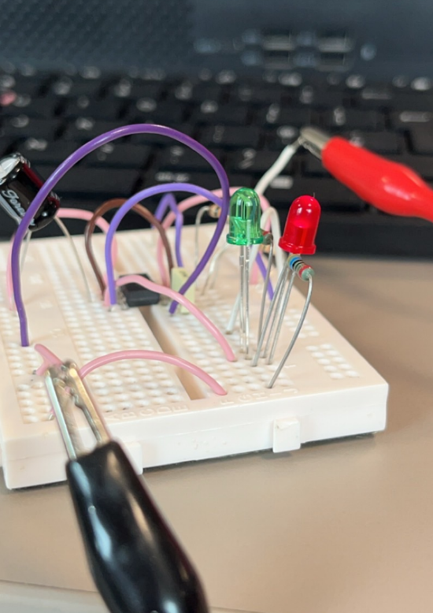 Figure 5- Breadboard circuit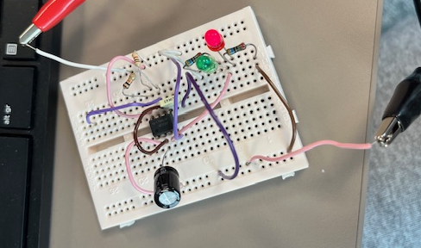Figure 6 – Breadboard circuit, top view
5.2 When the circuit has been fully assembled it must then be connected to the power supply. The power supply used must be set at specific parametres, this is to prevent damage if something is wired incorrectly. Once power is supplied to the breadboard the circuit should function as intened. The power supply used can be seen in figure 7.
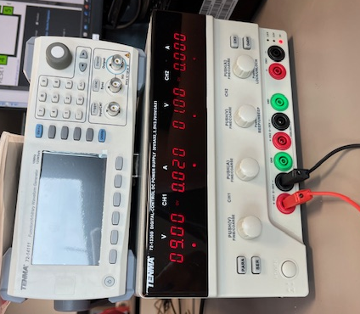 Figure 7 – Power supply
5.3 The circuit must be tested once the circuit is up and running. To do this, like in Proteus, an oscilloscope is used. The oscilloscope was connected at the points seen in figure 8. The ground of the oscilloscope is grounded at the same point as the circuit, this is essential to do as it ensures accurate measurements as well as being necessary for safety. The probe is connected to the input channel of the oscilloscope as well as the signal that is being tested.

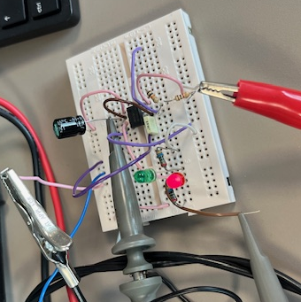 Figure 8- oscilloscope connection points
5.4 The results for the oscilloscope can be seen in figure 9. Horizontally the time divisions can be measured, vertically voltage can be measured (yellow lines).
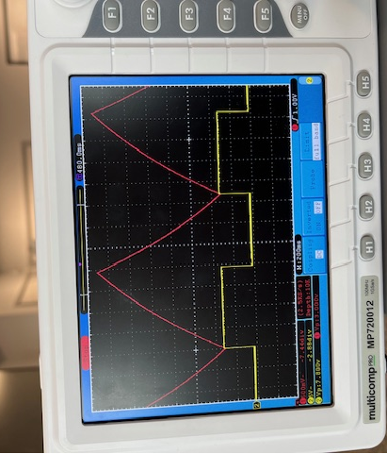 Figure 9- Oscilloscope readings, physical

Comparison
6.1 The timing of the wave speed for the physical bread board is 1.48 seconds. The timing for the wave speed for the simulated circuit is 1.46s. This is very similar. The timing for half the wave is identical in both the simulated and physical breadboard with them both equalling 760ms.
6.2 This proves that the simulated version is nearly as reliable as the physical version. Not only does this show the reliability of the Proteus software, it also ensures that all of the physical parts used for this circuit are working as expected.

Conclusion
7.1 From this report it can be concluded that Proteus is a reliable software that should be considered for use by engineers needing circuit testing.
7.2 Proteus provides many eases of use for the user, with it being quicker to assemble than a physical circuit and having all parts and equipment readily available within the software it means that it can be used in the very early stages of manufacture without having to invest any money.
7.3 Real life testing must be conducted when a circuit is being produced so it could be argued that using Proteus us not worth it. It would be up to a company as to whether they believed that investing in the software would be a worthwhile investment for their company.

Bibliography
[1] G. Lambert. (2021, Mar. 22.) Introduction to the 555 Timer [Online]. Available: Introduction to the 555 Timer - Circuit Basics
[2] Electronic Tutorials. (2018, Apr. 29.) 555 Timer Tutorial - The Monostable Multivibrator [Online]. Available: 555 Timer Tutorial - The Monostable Multivibrator (electronics-tutorials.ws)
[3] J. Braza. (2020, May. 13.) How Resistors Work [Online]. Available: How Resistors Work - Circuit Basics

