PHP worksheet for 8th November 2018
1. Write a PHP page to show all the fields in your people table (joining with horoscope and/or job fields if required – as we did last week in class). If you missed last week's class don't worry, just print out the people table.
It will look something like this:


2. Once the above is working, add a field called userlink to your database. (This will hold a URL). Call up the structure of the people table and use the "Add column" section.
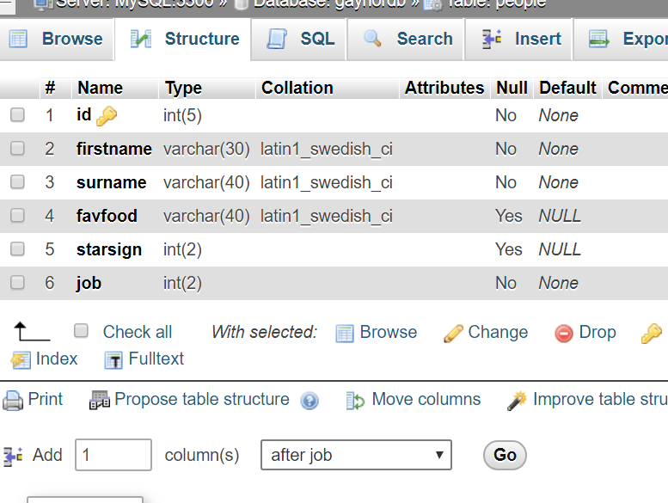
Use varchar type, and choose a length suitable for storing a web URL in.
3. Once the field is created, edit a link in each record:
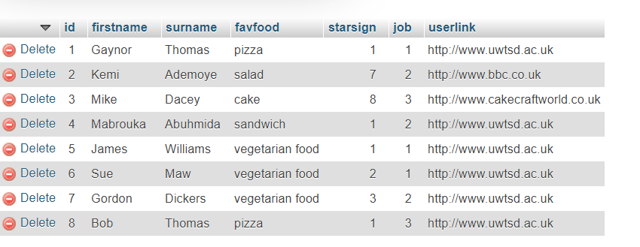

4. Return to the PHP code and add the link to your code:
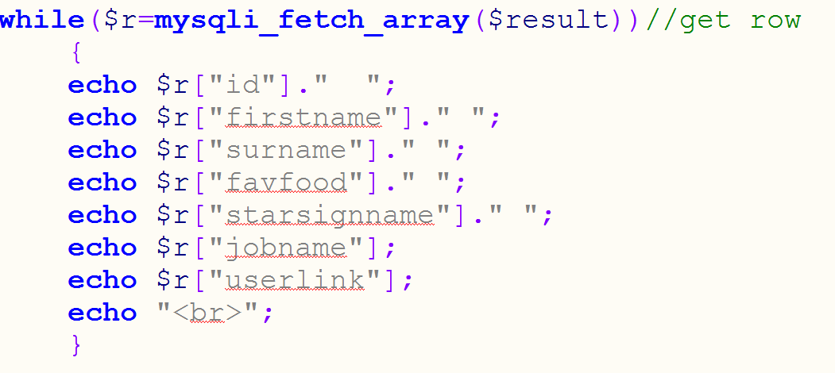

5. Run the page again, and you'll see something like this:

The links are not clickable – essentially, they're just text at this point.
6. Make the links clickable. We will mix HTML with PHP. We already know that an HTML link is formed as follows:
<a href=" "> </a>
Echo the PHP directly into a link as follows:
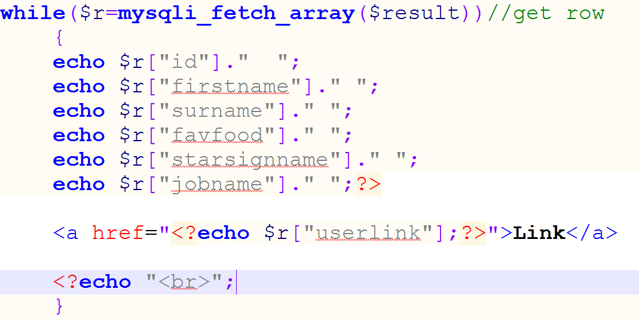
This should give this result:
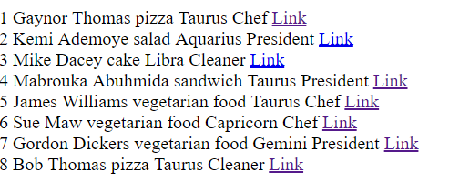

To show the full URL, rather than just "Link", echo the userlink field a second time:
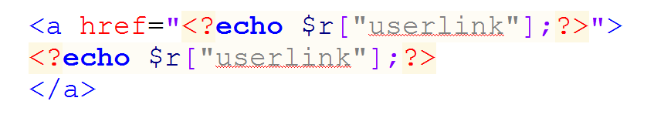


7. Repeat the above process with images. Add a field to the database called userpic. This should be a varchar of suitable length to hold a filename (we are going to store the filename in the database, not the image itself)
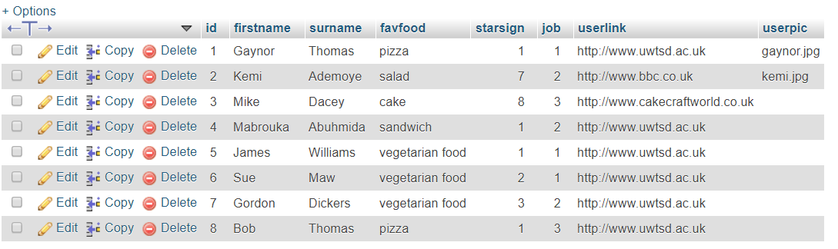

8. Put images in your www folder which have the same filename as the images listed in the database.

9. Use the HTML tag <img src=""> in a similar way to previously to make the image appear correctly:
You should see something like this:


