Effective Teamworking for team success.

Module title: Effective Team Working and Communication
Module code: BMSW4002
Tutor name:
Student name: Cristina Anton
Student ID: 2110293

Abstract
Must organisations enhance success due to effective team working. Creating effective teams is vital for them to deliver tasks on time and accurate. Sometimes, due to different reason people do not have success to deliver tasks and they fail to accomplish their project properly because they are not working effective as team. For develop an effective team can be used theoretical model such as creating Effective Teams and Shannon and Weaver's Model of Communication. Models of team development are Tuckman’s Model of Team Development, Wheelan’s Model of Team Development. Also, for team role can be used Belbin’s Team roles. A team well developed with a good delegation of task will eliminate barriers on team working and will lead to the success.

Table of content
Introduction………………………………………………..……………………………………….3
Team working……………………………………………….……………………..………………3
Models of team development……………………….…………………………………….……..4
Team Roles ………………………………………….………………………………..…………..5
Advantage of effective teamworking…………………………………………………………….6
Impact of effective teamworking on team success…………………………………………….6
Impact be of ineffective or poor teamworking…………………………………………..………6
Barriers of effective team working on Abdul case………………………………………..……..7
Effective team working barriers…………………………………………………………….……..7
Conclusion……………………………………………………………………………………….….7
References…………………………………………………………………………………….……8

Introduction
Abdul has a team of 18 employees and together they have assigned a new project for Vodafone UK where they must deliver a community event with local stakeholders, commercial businesses, and voluntary organisations. Their project is not yet accomplished due to their bad organisation as a team. The aim of this report is to evaluate how Abdul can develop an effective team by using theoretical model and what types of roles are needed to create an effective team. Will be analysed what impact can effective teamworking have on team success and what were the barriers that had Abdul with his team. At the end will be provided some recommendation regarding how to improve team working and why effective teamworking is important.
Team working
According to Morgan (2017, pg. 204) “A team is a number of individuals working as one to achieve a particular goal to which they are mutually committed”
For a team to be successful each member should have a collaborative work environment. Then each member should know its role and responsibly as a team making agreement with what will be done and by who. A team must have a specific goal with deadline. Communication between members of the team is a very important condition for an effective team, members should share ideas and solutions (Rebel Monkey, 2020).
Not always team are working effectively. Sometimes people afford different problems to work with other people. The most common issue faced by team for work effectively together are Lack of commitment, bad productivity, low communication, personal conflicts, and poor leadership (Griffith & Dunham, 2015, p7)
Based on scenario presented by the School, Abdul fails to successfully manage his team. Their project was not ready on time because they did not work effectively as a team. Covid- 19 is not their main problem. Their principal problem was communication. Abdul received complains about poor communication. Communication is a factor very important for can deliver their project. Abdul did not communicate enough with the team and people do not respond between them. They do not help each other’s. Abdul was not a good leader for its team. He only deliver task and did not involved them in nothing.
Models of team development
It is necessary to develop a strong and effective team for successfully performing. Team are people who work together, and they will easily deliver their task if are motivated and well treated. Saari and Judge (2004, p396) defined motivation as “"a pleasurable or
positive emotional state resulting from the appraisal of one's job experiences". People motivation is a key for enhance job satisfaction. According to Jehanzeb, Rasheed, Rasheed and Aamir (2012, p.274) job satisfaction is "a sensation employees have about their work
environment and their expectations toward work".
Motivation and job satisfaction are properly missing for Abdul team. He delivered team members roles and attribution, but he did not motivate his team and he do not have any job satisfaction. Now Abdul must find solution to develop his team in order to finish the project for Vodafone UK.
Tuckman and Wheelan are both models of team development and both of them are describing relationship of people in group development stages.
According to Maund A. et al (2017) Tuckman’s Model helps to clarify the roles and responsibilities of the team member. It is a model which describe 5 steps for develop a team which are forming, storming, norming, performing and adjourning. Team leader responsibilities on these 5 steps are:
Forming refer to make each member comfortable and stabilise clear objectives and team accountability expectation. Remove obstacle that can occur in accomplishing goals. Provide feedback on team progress.
Storming refers to each member role and position in the team. Division of the tasks. Ensure good relationship between members and resolve conflicts. Offer support to individuals which struggle to accomplish their task. Remove obstacle if there are and provide feedback on team progress.
Norming stage allow team to work independently. Provide resources, training to develop necessary skills, and teambuilding events. Remove obstacle if there are and provide feedback on team progress.
Performing refer to structure, trust, and collaboration. Leader must delegate to do so, allow them autonomy, remove obstacle if they have and provide feedback on progression.
Adjourning team conducts assessment and implement plan for transitioning roles and recognising members contribution.
Wheelan model of team Development focus on stages that groups must afford for become a team.
Stage 1 – Dependency and inclusion. Focus on members feelings and safety. Members wait for team leader to tell them what to do, and they are more concern about to be accepted then what have to do. (Wheelan, 2016, p 25)
Stage 2 – Counter dependency and fighting. People at this stage want dependency and are created task conflict which are inevitable at this stage but also useful for establish trust and climate to disagree between them. Some groups cannot pass this stage due to interpersonal conflict.
Stage 3 – Trust and structure. At this stage means that people pass stage two and interpersonal conflict and their productivity increase. Now members have good communication. Now leader is more consultative.
Stage 4 – Work. At this stage members of team are highly performing and also the quality of work increased.
Analysing the two models of team development, I think Abdul should abord Tuckman’s Model for develop his team.
Forming- He has to form his team, making them to feel better and to know clearly their objectives. Look if they have any problem and provide feedback.
Storming- Then Abdul must ensure good relationship between them and divide task. He ensures that there is not task conflict.
Norming- Than Abdul must provide training and resources in order to prepare they for their job
Performing- Abdul delegate their tasks, leave them to work autonomy but ask if they need help and give feedback
Adjourning- Abdul must recognise member contribution and implement plan for transitioning roles.
Wheelan model is the model that Abdul already adopted but his team did not pass from second stage.
Team Roles
For create a cohesive and effective team each member role is another important key. It is essential to understand people strong points for can give them appropriate roles.
“Belbin and others argued that the combination of personalities in a team or the combination of individual team member roles could significantly improve or diminish the ability of a team to complete a particular task” (Morgan, 2017, p207).
Belbin suggested that if you understand your role, you can develop your strong points and manage defects. The roles to combine with personalities for be successful are 9 roles divided into 3 categories.
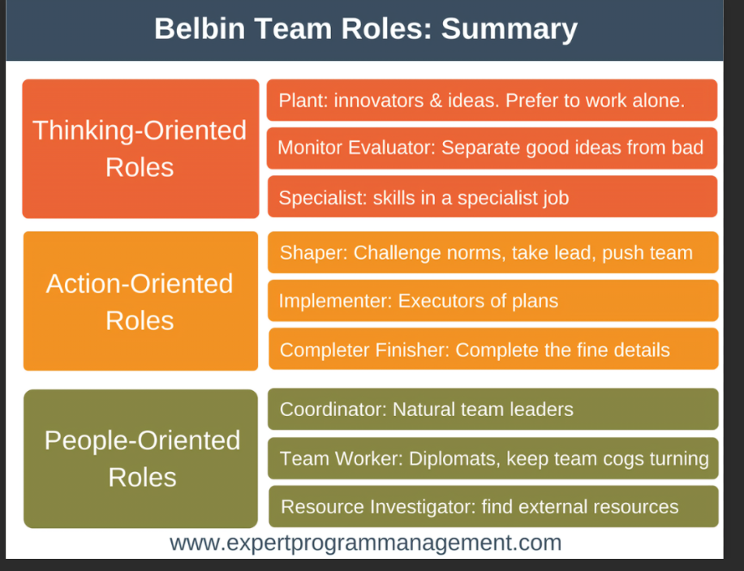Abdul must leave choose people which role is more appropriate for them. Abdul must ensure that each member is enough prepared for his task for can accomplish it. They must communicate more for understand which are their straightness and weaknesses for can balance around action-orientated, people-orientated and thinking people and what this means for their performance. Then, they can decide their roles in function of skills they have.
Advantage of effective teamworking
If the team is effective, they have many advantages for deliver their project such as:
- Increase productivity (Nibusiness info, 2022), people feel valued when their contribution help their team. This will lead to increase productivity because members feel motivated and happy.
- Delivery on time if team work effectively, they will be productive and ready on time with no facing issues
- Problem solving communicating between them many problems can be resolved. Someone else can have solution for a other person problem. Different opinion can be helpful to resolv problems.
- Strong relationship. People learn from other people. Working and communication help to build strong relationship.
- Flexibility Working as a team help people to give idea to other time making information flexible.
Coyle (2018) identify the secret of successful groups and discuss how this can turn into effective team In the Culture Cod. The Culture Code is divided in 3 different skills by Build safety, share vulnerability and establish purpose.
Impact of effective teamworking on team success
Good communication has a strong impact on team success. Good communication helps team members become more confident with what they have to do and helps them to be more motivated to accomplish their tasks. Communication gives people access to more opinion which can be solutions for their tasks.
Create good relationship. Effective teamworking create good relationship between members.
Good delegation of tasks lead to accurate execution of the project. Abdul can involve his team to choose which task is more appropriate for each member and for avoid conflict between them they must establish clear from beginning who and what can do for an accurate execution of the project.
Deliver on time project. Effective team working lead also to have ready project on time. Providing feedback means that he is checking what other are doing. In this way Abdul can see if people have trouble on doing work and then can take action to solve these problems.
Impact be of ineffective or poor teamworking
According to Maggie Baska (2019) A poor teamworking can bring serious consequences in organisations. If the team is not effective, they cannot be successful. They will not perform and then will fail.
If the teamwork is poor their can be more impact such as:
- Not meeting deadlines
- Failure to accomplish tasks
- Losses of projects
- Conflict between members
Barriers of effective team working on Abdul case
Abdul and his team afford more barriers on working on their project. Some of these barriers are:
- Covid19 restrictions. Abdul and his team never met even if they are working on project for the last two months. Because of Covid restriction and this was a barrier for them to accomplish their tasks.
- Ineffective Communication. They do not communicate between them. Some people sent emails, but no one answer.
- Poor leadership. Abdul was not a good leadership. He did not checked how people are performing. He should call them weekly for see how they are dealing with tasks.
Conclusion
In conclusion effective team working is essential for the success. If the team is not working effectively than will not be successful. Abdul has failed to manage his team to be successful. Now, if he wants to save the project, which is focuses on executing a community event project with local stakeholders, commercial businesses, and voluntary organizations he must rebuild his team. The better way to develop his team, Abdul must adopt Tuckman’s Model because for deliver the project mean that he needs a strong team. Abdul already tried with Wheelan model, but he fails. His team fail to accomplish task.
Recommendation
- Abdul should adopt Tuckman’s model for develop a strong and effective team, even he failed first time, now he can be successful if is following Tuckman’s model of team development.
- Improve and encourage communication between members of his team. Also, Abdul could encourage them the share ideas and solutions. There were people complaining that if they asked for help, they did not received answer
- Abdul should clearly stabilise objectives. People clearly should know what their objective is.
- Abdul must delegate task to his team but at the same time must check if they are ok and if they need help.
References
Baska, M. (2019), Poor teamwork can have serious consequences, People Management, Available at: https://www.peoplemanagement.co.uk/experts/research/poor-teamwork-serious-consequences (Accessed: 27 February 2022)
Belbin, M., (2010), Team Roles at Work, eBook Collection (EBSCOhost), Routledge
Coyle, D. (2018), The Culture Code, London, Random House Business.
Griffith, Brian A., and Ethan B. Dunham (2015) Working in Teams: Moving From High Potential to High Performance, SAGE Publications,
Jehanzeb, K., Raseed, M.F., Rasheed, A., & Aamir (2012) A. Impact of rewards and motivation on job satisfaction in banking sector of Saudi Arabia International Journal of Business and Social Science, pg 271-278
Maund, A. et al. (2017) Certificate in higher education: skills for the workplace student yearbook. London: Sage.
Monkey, R. (2020), 5 Tips For Effective Teamwork, Available at: https://www.youtube.com/watch?v=n_UhsBZNADM (Accessed: 25 February 2022)
Morgan, P. (2017) The Business Student’s Guide to Study and Employability London: Sage Publications Ltd.
Nibusiness info (2022), How to build and manage an effective team, Available at: https://www.nibusinessinfo.co.uk/content/advantages-effective-teamwork#:~:text=%20Advantages%20of%20effective%20teamwork%20in%20the%20workplace,which%20can%20lead%20to%20the%20development...%20More%20 (Accessed: 25 February, 2022)
Saari, L.M. & Judge(2004), T.A. Employee attitudes and job satisfaction. Human Resource
Management, pg. 395-407.
Wheelan, S.A., (2016), Creating Effective Teams, 5th Ed, London, SAGE.

