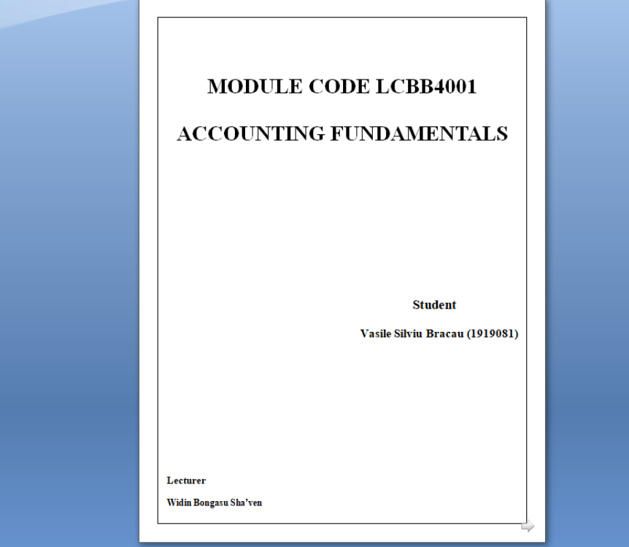

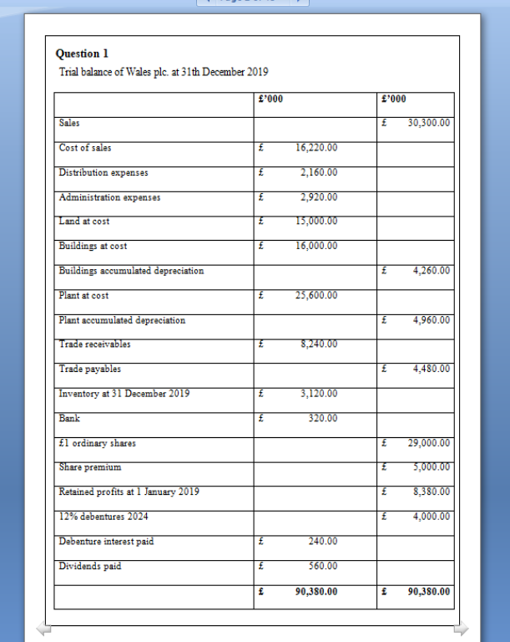

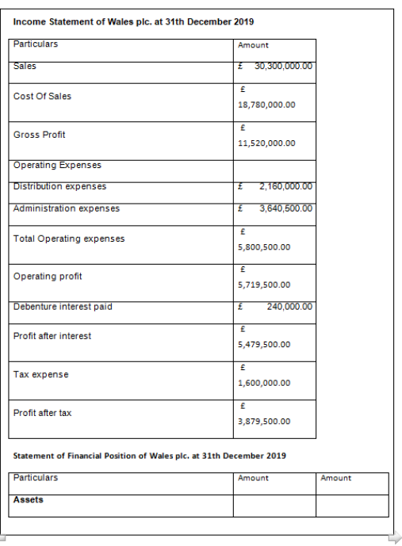

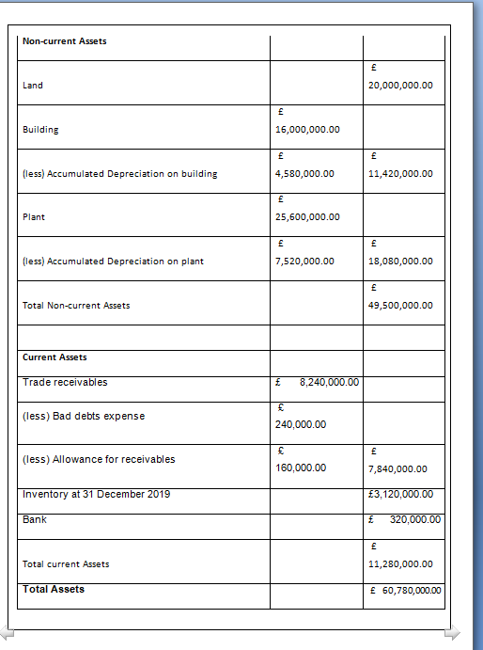
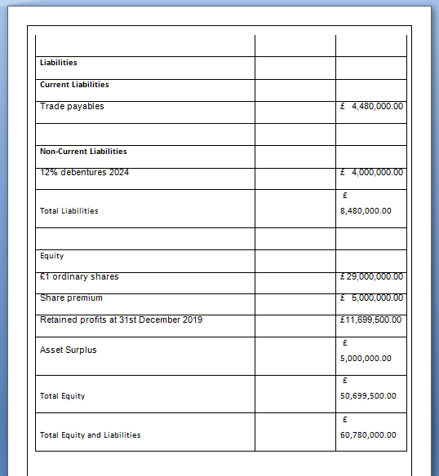

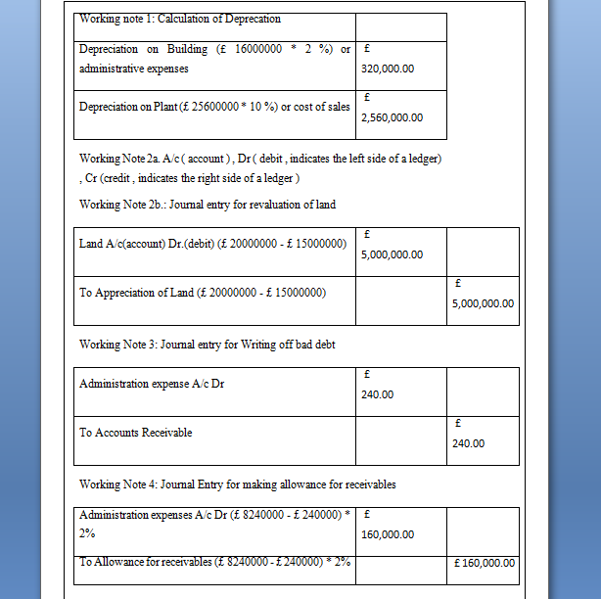

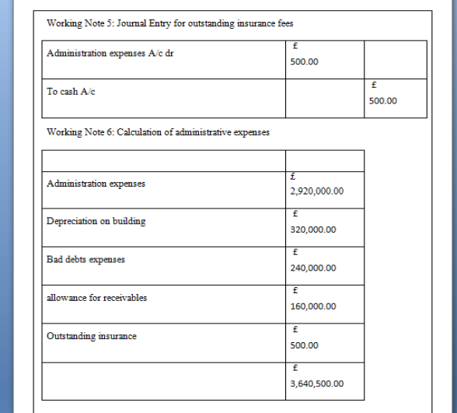

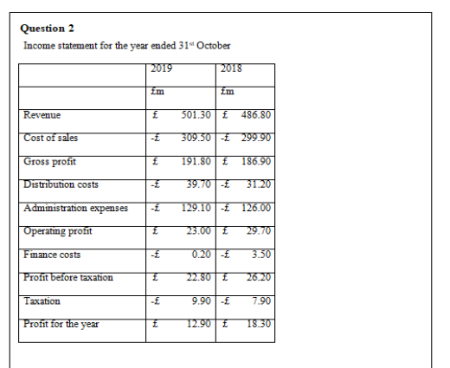

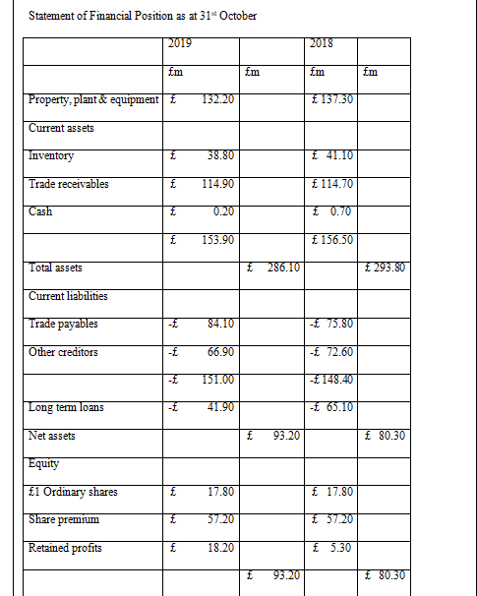

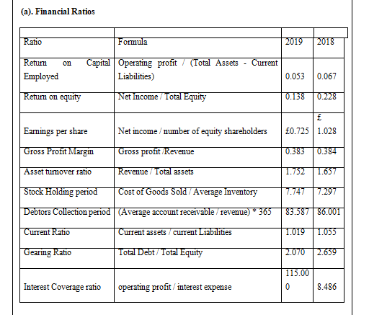

(b)
Return on capital employed ratio(ROCE) expresses the relation between operating profit acquired in a period and the average long term capital invested in a business being an essential measure of business performance (Atrill and McLaney, 2017). For the year 2018 return on capital employed, ROCE was 6.7% meaning that the company acquired 6.7% profit on capital in 2018, however in 2019 ROCE dropped to 5.3%, the company making less profit in 2019 than 2018.
Return on equity(ROE) is used to measure the company’s ability in generating return on its equity capital (Bilal2020). Equity capital includes share capital, reserve and surplus, share premium and retained profits. Company’s ROE for the year 2018 was 0.228 or 22.8 %, this means company generated 6.7 % profit on its capital in 2018 and in 2019 ROCE decreased to 0.138 or 13.8 %, the reason behind this decline was that company made lower profit in 2019 as compared to 2018. This shows that in 2019 company provided lower return to its shareholders.
According to Weetman(2013), earning per share(EPS) is one of the most used ratio for measuring a company performance and progress and it helps investors who buy shares in a company to compare the returnings day received with the amount they have paid for they’re shares. Company’s EPS in 2018 was higher being at £ 1.028 while in 2019 was at £ 0.725 , that indicates that company provided better returns for investors in 2018 compared to 2019.
Gross profit margin ratio is used identify the margin that has left with the company after deducting the cost of goods sold from revenue (Andarsari2019). It represents company’s ability in managing cost of production such as labour cost, material cost and other variable costs. Gross profit margin ratio of company for 2018 was 0.384 or 38.4 % and in 2019 it was 0.383 or 38.3 %, company’s Gross profit ratio has been stable in last 2 years. This shows out of total revenue 62.6 % was Cost of sales.
Asset turnover shows us how efficiently assets are used in order to generate profit before tax and interest(Weetman, 2013). In this case for 2018 asset turnover was lower than 2019, indicating a bigger revenue in 2019.
Debtorcollection period is used to identify the number of days required by company to collect from its debtors (Ondiek2019). It is calculated by using the credit sales and average accounts receivables. Company’s debtors collection period for year 2018 was 86, this means company required 86 days forrecovering from its debtors, it was 83.58 days in 2019, company’s debtor collection period was lower in 2019 because company had lower accounts receivables in 2019.
Current ratio is used to measure the company’s ability in paying back its short term liabilities or current liabilities (Agustina2018). It represents company’s liquid assets such as cash, debtors, and short term marketable assets. Company’s current ratio for the year 2018 was 1.055 and in2019 it was 1.019, for both years it was higher than 1 this means company is able to pay its short term liability through its current assets, but is need to be improved.
Interest coverage ratio is used to identify the company’s ability in raising funds from interest bearing liabilities (Choi 2018). Company’s interest coverage ratio for year 2018 was 115 and it decreased to 8.48 in 2019, this shows company raised funds from interest bearing liabilities in 2019.

Question 3
a.)
There are many people who are interested in company’s financial statements e.g lenders, investors, internal management, all this different users will use the financial statements and ratio analysis which is of vital concern to them.(Wood and Sangster,2011)
Investors assess the financial performance of the company in terms of profits or loss facing. Investors make the decision of whether to invest in company or not.
Lenders are the entities which lend the founds to company, lenders include banking organizations, investement banks etc ., they use the company financial statement to assess the company ability of paying back the loan amount.
Management -another user of financial statements is internal management. Financial statements are assessed by financial managers for taking managerial decisions. Management set up financial key performance indicators with the help of financial statement.
b.)
Financial report
According to (Weetman,2013) external users of accounting have restricted day to day access to a company’s records, based on that, they rely on managerial judgement and integrity to reveal high quality information. Over the years it has been discovered that regulation is needed for an accurate financial reporting.
One of the main advantages of having highly regulated report regime in finance is that it helps in certifying that financial statements are prepared by following appropriate accounting standards and it also helps in reducing errors and frauds, the risk related to manipulation of financial accounts it’s minimized .
Disadvantages of highly regulated report regime
Having highly regulated reporting regime in finance as we refer in the previous paragraph, helps certifying that financial statements are prepared by following appropriate accounting standards and it also helps in reducing errors and frauds but in some instances for a person who has less knowledge of finance it becomes difficult to understand reports and financial statements because of financial statements complexity.

c.)
Limitation of Financial Statement
According to Atrill and McLane(2016), financial accounting statements reveal a picture of the performance and financial position of a business. For all users, financial statements dependency is on historical costs and data. The data that is recorded in financial statement is of historical nature, based on this result, financial statements are unable to provide the current present value of assets and liabilities which might be affected by changes in market factors.
Financial Statements can be largely informative and usefully applied to the needs of the users thanks to ratios which are useful if they are used and read appropriately, otherwise all the information can be misleading.( Wood and Sangster,2011)
Reffering to Wood and Sangster(2011), financial statements should reveal information about the financial position, business achievement , data knowledge that is useful for a wide range of users in order to make decisions. To achieve this, financial statements are prepared on the basis of personal judgements of the company who is preparing the financial statements. Using different methods for calculating depreciation and amortization based on their personal decisions, financial statements can be misleading.
As discussed in previous point the financial statements are prepared on basis of personal judgement, fact that creates comparability issues based of the different standards followed by different companies.

References
Atrill, P. and McLaney, E. 2016 2017. Accountig and Finance for Non-Specialists. 10th Ed. Harlow, England: Pearson, pp.204.
Raza, W., Hayat, K., Farooq, N. and Bilal, H., 2020. Corporate Governance and Return on Equity Evidence from Pakistan Stock Exchange. Journal of Accounting and Finance in Emerging Economies, 6(1), pp.63-72.
Weetman, P., 2013. Financial Accounting. 6th Ed. Harlow: Pearson Education, pp:347
Andarsari, P.R., 2019. The Effect Of Firm Size, Gross Profit Margin And Institutional Ownership On Disclosure Of Corporate Social Responsibility (CSR). JurnalApresiasiEkonomi, 7(3), pp.301-308.
Weetman, P., 2013. Financial Accounting. 6th Ed. Harlow: Pearson Education, pp:350
Wafula, W.M., Tibbs, C.Y. and Ondiek, A.B., 2019. Average Collection Period and Financial Performance of Nzoia Water Services Company.Int. J. of Multidisciplinary and Current research, 7.
Restianti, T. and Agustina, L., 2018. The effect of financial ratios on financial distress conditions in sub industrial sector company. Accounting Analysis Journal, 7(1), pp.25-33.
Choi, Y.J., 2018. The Effect of the Fast-Track Corporate Rehabilitation Program on the Interest Coverage Ratio of the Companies Under Court Receivership. Journal of Governance and Regulation, 7(1).
Wood, F. and Sangster, A., 2011. Frank Wood’s Business Accounting 1. 12th Ed. Financial Times Pretince Hall/Pearson
Weetman, P., 2013. Financial Accounting. 6th Ed. Harlow: Pearson Education, pp:85 94 95.
Atrill, P. and McLaney, E. 2016 2017. Accountig and Finance for Non-Specialists. 10th Ed. Harlow, England: Pearson, pp.12 29.
Wood, F. and Sangster, A., 2011. Frank Wood’s Business Accounting 1. 12th Ed. Financial Times Pretince Hall/Pearson pp.113 643 644.

