

PROGRAMME: MASTER OF BUSINESS ADMINISTRATION

MODULE: MARKETING MANAGEMENT
MODULE CODE: LCMB7024

ASSIGNMENT TITLE: ASSESSMENT COMPONENT 1

Marketing Environment Analysis for Amazon and Walmart

Lecturer:
Laila Maazouz
Dian Mayasari

Student Name: Hani Gaurangbhai Patel
Student ID: 2532566

Table of Contents
Task 1: Macro Marketing Environment Analysis 3
Introduction 3
Overview of Industry Context (E-commerce & Retail) 3
Macro Factor 1: Technological Environment 4
Macro Factor 2: Economic Environment 5
Comparative Impact on Competitive Position 6
Conclusion 7
Task 2: Strategic Response & Evaluation 8
Introduction 8
Amazon’s Strategic Response 8
Walmart’s Strategic Response 11
Comparative Strategic Evaluation 12
Conclusion 13
References 14

Task 1: Macro Marketing Environment Analysis

Introduction
Amazon is well-known as a leader in the market, transforming the world of e-commerce with the help of developed digital ecosystems and constant innovations. Walmart, on the other hand, is an example of a follower that has changed its ancient retailing approach to adapt to changing digital trends. Strategic decisions and competitiveness are determined by the macro marketing environment, which is determined by the PESTLE factors. In this analysis, focus will be on technological and economic aspects to analyse how each company competitiveness is made by these external factors in the global retail business.

Overview of Industry Context (E-commerce & Retail)
Digital transformation and shift in consumer behaviour have seen the global e-commerce and retail industry grow tremendously.
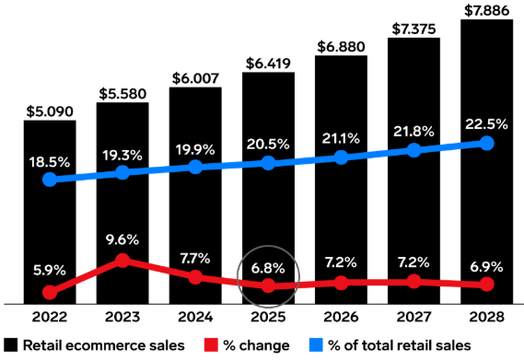
Figure 1: Global e-commerce sales
(Source: EMarketer, 2025)
EMarketer (2025) estimated that in 2026, equivalent to more than 20 per cent of overall retail activity, global online retail sales will have hit about 6.88 trillion. This trend indicates a change toward the traditional brick-and-mortar retailing and omnichannel scenarios, in which consumers can interact seamlessly in both online and brick-and-mortar environments. Narayan and Ahmed (2025) note that the use of AI, improved logistics, and online payment systems are improving efficiency and customer experience. In this landscape, Amazon is the leader in terms of innovation and digital ecosystems, whereas Walmart is the leader in terms of scale and cost leadership as it adjusts to the digital transformation.

Macro Factor 1: Technological Environment
Competition in the retail sector has been greatly altered by the technological environment due to the development of artificial intelligence (AI), automation, and cloud computing. In the case of Amazon, technology is a significant opportunity to strengthen the company's position as a leader in the market. Sivasankari et al. (2025) found that the recommendation systems powered by AI have enabled the company to personalise customer experience, which has been used to increase engagement and sales conversion. In addition, Reuters (2025) reported that Amazon Web Services has become a crucial growth driver, with an annual growth rate of about 20% to support the high demand for AI-based cloud services. It is also supported by automation technologies, such as warehouse robotics and drones in deliveries, which further increase operational efficiency, and Amazon is targeting the accomplishment of one million drone deliveries by 2026. The innovations create customer experience strength and ecosystem dominance. However, Widder and Kim (2025) note that this leadership demands a significant amount of capital investment - Amazon has spent billions of dollars in AI infrastructure - as well as heightened vulnerability to regulatory review on the issue of data utilisation and market concentration.
Conversely, Walmart, being a follower, has been using technology to enhance operational efficiency as opposed to being an innovator.
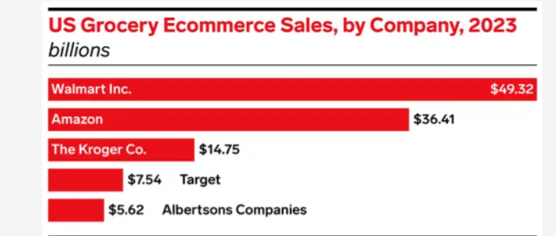
Figure 2: Grocery e-commerce sales
(Source: EMarketer, 2023)
EMarketer (2023) state that Walmart recorded online sales of groceries amounting to 58.92 billion by end of 2024 compared to 40.50 billion in Amazon. It will make the online grocery market share of Walmart to grow to 26.9% against the depleting 18.5% market share of Amazon. Also, Walmart invests in automation, such as drone delivery partnerships, which target over 40 million customers in 150 locations and so on. Despite these developments, Walmart has a technological wide gap since it has embraced digital capabilities later. Hossain (2024) argues that its approach to strategic response is very much based on partnerships and incremental innovation, which reflects a reactive as opposed to a proactive strategy. Thus, although technology is also making Walmart more competitive, it is the first-mover advantage that has sustained and created a strong competitive advantage in the digital retail industry at Amazon.

Macro Factor 2: Economic Environment
The economic environment, especially the inflationary pressures and changing consumer buying powers, has had opposite effects on Amazon and Walmart and influenced their competitive positioning differently. In the case of Amazon, the escalating fuel, labour, and fulfilment costs have raised operational expenses, showing how it is straining to maintain its fast-delivery system (Islam, 2026). Also, in economic uncertainties, consumers are likely to cut discretionary spending, which impacts high-margin products of Amazon, like electronics and lifestyle products. Nonetheless, Amazon mitigates these risks with its diversified sources of revenue. Its Prime subscription model, which has more than 200 million members worldwide as of 2023 (Statista, 2024), guarantees recurrent revenue and retention of customers. In addition, AWS offers a predictable revenue stream that is not as vulnerable to the recessions of consumers, allowing Amazon to stay relatively stable in response to changes in the economy.
On the contrary, Walmart is a stronger beneficiary when economic downturns occur because of its cost leadership positioning. Rezaei and Rezaei (2025) found that with the increasing inflation, the buyers are turning to value-based stores, and this reinforces the marketability of Walmart. To illustrate, the U.S. sales of Walmart increased more than 6 per cent in 2023, mainly due to a rise in the demand of primary products and groceries during the period of rising inflation. This illustrates the financial constraints as a possibility for Walmart as a chance to get price-sensitive consumers. This has its benefits, though, coupled with the issue of profitability, as it has a low-price strategy that causes thin margins and minimal price flexibility. In comparative terms, Rajagopal (2025) notes that though Amazon uses diversification and less price-sensitive segments to counter economic shocks, Volpe and Boland (2022) argue that Walmart uses economic downturns to enhance its value proposition. This comparison shows the role of the same macroeconomic force in generating threats and opportunities, which solidifies the leadership in prices in Walmart's and Amazon's ability to endure.

Comparative Impact on Competitive Position
The relative influence of macro-environmental factors emphasises the ability of Amazon and Walmart to maintain different competitive positions in the retail sector. Bagnoli et al. (2022) highlight that Amazon also uses the differentiation strategy, which is motivated by unceasing innovation, high technologies and a highly interconnected digital environment. Its pioneering nature towards AI, automation, and cloud computing enhances its customer-level experience and upholds dominance in the market. Nag and Tran (2020) argue that Walmart, on the contrary, is based on cost leadership, leveraging its size, effective supply chain, and pricing model to appeal to value-sensitive customers, slowly moving towards digital transformation. One of the main comparisons to make is that technological innovations are the major source of competitive advantage that allows Amazon to become the leader in digital innovation. On the other hand, Rezaei and Rezaei (2025) highlight that economic strains like inflation also make Walmart more resilient as more consumers are more concerned with being cheap. More importantly, these external forces do not equally affect both firms, but rather they dynamically alter competitive advantages, enabling both organisations to dominate over each other in varying market environments.

Conclusion
The macro-environmental factors create opportunities as well as threats, which affect the way organisations compete and maintain growth. Technology has helped Amazon to enhance its innovation-based leadership approach, and financial constraints have also helped Walmart to tighten its cost leadership position. The most important lesson is that Amazon is still ahead of the pack due to its differentiation and technological advances in the digital realm, and Walmart is not behind because of its efficiency, low prices, and responsiveness strategies. After all, the competitive advantage in the retail industry is constantly being reformed by the dynamic nature of external forces.

Task 2: Strategic Response & Evaluation

Introduction
Building on Task 1, the impact of technological innovation and financial demands has had a great effect on strategic decision-making in the retail business. It is these external forces that make organisations change and remain in growth using effective strategies. This part analyses the reaction of Amazon and Walmart to such issues. The analysis uses Porter's Generic Strategies and Ansoff's Growth Matrix to evaluate the way of each company as to how it stays competitive and uses its strategic direction to match the market conditions.

Amazon’s Strategic Response
Porter’s Generic Strategies
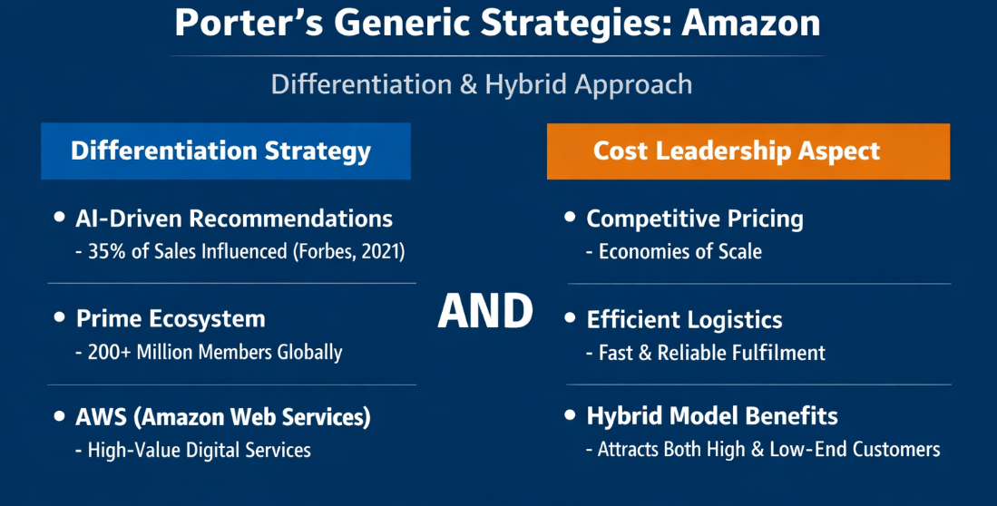
Figure 3: Porter’s Generic Strategies: Amazon
(Source: Self-developed)
Amazon follows a differentiation strategy mainly by making use of high-level personalisation, seamless Prime ecosystem, and its cloud platform AWS to develop high-value customers. Recommendations made by AIs help to increase the rates of conversion, and it has been demonstrated that more than 35% of Amazon sales are affected by its recommendation system as reported by Forbes (2021). Furthermore, Amazon Prime surpassed 200 million members around the world, which strengthened customer loyalty and streams of revenue.
Nevertheless, Amazon also incorporates aspects of cost leadership, with competitive prices in terms of economies of scale and effective logistics. Bagnoli et al. (2022) investigated that the hybrid business model of Amazon strikes a balance between innovation and affordability, which can be used to attract both high-end and low-end clients in comparison with other competitors such as Walmart. This is unlike Walmart, which is more strategic in its cost leadership, and this shows the wider strategic flexibility of Amazon.
Ansoff Matrix
The development plan of Amazon is well in line with the Ansoff Matrix, especially in market penetration, product development, and diversification.
Market Penetration: Geradin and Smith (2023) found that Amazon is ever-growing its Prime ecosystem, through faster delivery, and exclusive content, more customers are retained and buy more often.
Product Development: The company pours a significant amount of money into innovations like Alexa-enabled and AI-powered services, which reinforce its smart ecosystem.
Diversification: The venturing into cloud computing and entertainment is something that Amazon has been able to accomplish successfully.
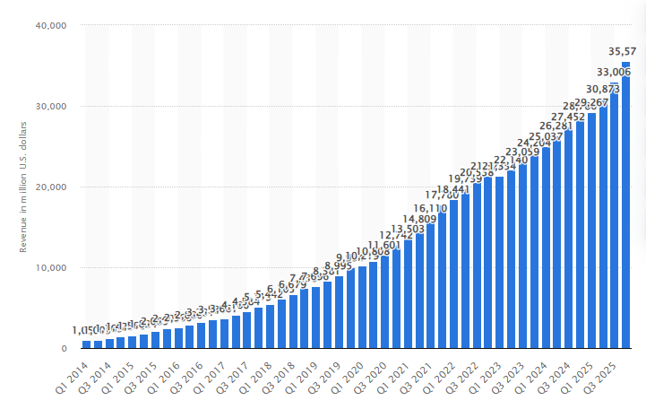
Figure 4: Amazon Web Services revenue quarterly 2014-2025
(Source: Statista, 2025)
Indicatively, during the fourth quarter of 2025, AWS was able to generate 35.58 billion U.S. dollars in cloud computing and hosting revenues. This was 24% higher than it was in the same quarter of the previous year (Statista, 2025). Likewise, Prime Video will be competing with such platforms as Netflix and will further entrench users into the Amazon ecosystem.
Diversification of Amazon is more intensive and technology-based compared to Walmart which offers the business several sources of revenue and hence is less reliant on retail as the sole source of income.
The advantages of the strategy of Amazon are high, such as leading in innovation and the high switching costs generated by the ecosystem. Davidson and Rajeswari (2025) illustrate that the services like Prime, AWS, and Alexa are locked in and increase long-term loyalty. However, there are also expensive operational and capital cost implicates in these strategies, especially in the area of logistics and technology infrastructure. Besides, Amazon is under growing regulatory pressure concerning market control and the use of data. Compared to the cost-effective model of Walmart, the one that Amazon applies grants the company a greater level of differentiation but puts the company at a higher risk in terms of finances and regulations.

Walmart’s Strategic Response
Porter's Generic Strategies
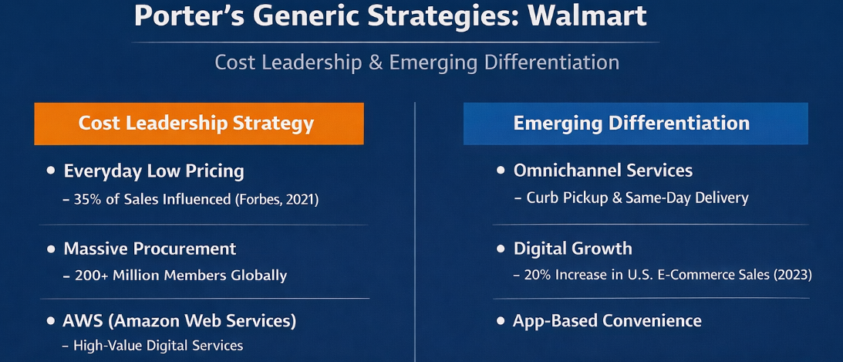
Figure 5: Porter’s Generic Strategies: Walmart
(Source: Self-developed)
Walmart operates mostly via a cost leadership strategy, with a concentration on the Everyday Low Pricing strategy to attract low-end consumers. A massive procurement process and effective supply chain allow Walmart to offer lower prices in comparison to most of its competitors. This is expressed in its financial results, whereby Walmart is projected to earn more than 648 billion dollars in revenues worldwide in 2024, and this expression of power through size has cemented its leadership (Walmart, 2025). However, contrary to the heavy emphasis on differentiation at Amazon, Walmart is slowly integrating the aspect of differentiation, especially in omnichannel retail. Weinstein et al. (2021) illustrate that curb pickup, same-day delivery, and shopping via an app are some of the services that increase convenience. In 2023, Walmart increased sales in the U.S. e-commerce by more than 20%, which shows an improvement in its digital integration. The strategy of Walmart is more cost-based than Amazon's, yet the new digital opportunities allow narrowing the competitive gap.
Ansoff Matrix
The strategic expansion of Walmart is in line with the Ansoff Matrix and in market penetration, product development, and market development strategies.
Market penetration: Walmart is reinforcing its market base by blending its physical stores with digital mediums where customers can be able to conduct their shopping across the channels (Gou, 2025). This omnichannel model helps to make it more convenient and leverages on its large network of stores.
Product Development: The company develops its own-label brands and web-based grocery offers, which have become the source of growth. The grocery division remains the market leader of the U.S. Walmart, reliant on online ordering and delivery.
Market Development: Walmart has increased its online digital footprint through investments in other markets, such as India, through Flipkart.
Compared to the diversification-intensive strategy of Amazon, Durand and Baud (2023) argue that Walmart puts more emphasis on the reinforcement of its current retail concept and broadens its digital presence in a slow manner.
This operational efficiency and price competitiveness is evidenced in the strategy of Walmart, in which it has one of the most advanced supply chains in the world. This helps the company to function well in economic slowdowns. However, in comparison with Amazon, Walmart is slow in innovation and partially relies on its physical retail history (Durand and Baud, 2023). Its digital transformation is getting better, but the company remains technologically less sophisticated than Amazon, though it cannot fully equal the competitive edge of an innovatively driven company such as Amazon.

Comparative Strategic Evaluation
The relative strategic analysis shows that there are marked disparities in the way Amazon and Walmart maintain momentum in the changing world of retailing. Zhang (2023) found that Amazon aligns with an innovation-based growth strategy, which is facilitated by solid diversification in cloud computing, digital services, and smart technologies. Such a proactive strategy will help Amazon to foresee the tendencies in the market and, at the same time, influence the industry standards. Negi et al. (2025) argue that Walmart, in its turn, adheres to the efficiency-focused model, prioritising operational excellence, cost management, and slow digitalisation. It is also more reactive in its strategy as it follows the changes in technology instead of becoming a leader.
The point is that the active form of innovation that Amazon has developed will provide it with a long-term competitive edge, and Walmart has better built-in defences and stability through its adaptive approach. Importantly, both organisations are attaining long-term growth, albeit using radically different strategic templates- one being innovation and diversification, the other efficiency and gradual change.

Conclusion
Overall, Amazon maintains its competitive edge by means of a high degree of differentiation strategy that is backed by unceasing innovation and diversification. Conversely, Walmart holds itself by cost leadership and is slowing down the pace of embracing changes in the digital world. Although these two organisations have different strategies, they are both able to respond positively to external forces. The lesson here is that the flexible performance of the retailing industry over the long term is the ability to balance innovation growth and operational efficiency to keep the firms competitive in the dynamic environment.

References
Bagnoli, C., Albarelli, A., Biazzo, S., Biotto, G., Marseglia, G.R., Massaro, M., Messina, M., Muraro, A. and Troiano, L., (2022). The integration of digital business models: The Amazon case study. In Digital Business Models for Industry 4.0: How Innovation and Technology Shape the Future of Companies (pp. 211-239). Cham: Springer International Publishing. https://link.springer.com/chapter/10.1007/978-3-030-97284-4_4
Davidson, J.D. and Rajeswari, P.S. (2025). A Case Study on How Amazon Uses Personalization to Win Back Prime Subscription Lapsers. Journal of Information Technology Teaching Cases, 1(1). doi: https://doi.org/10.1177/20438869251325244.
Durand, C. and Baud, C. (2023). Profit-making, costs, and investments in the digitalization of retailing—The uneven trajectories of Carrefour, Amazon and Walmart (1995–2019). Competition and Change, 28(2), pp.318–339. doi: https://doi.org/10.1177/10245294231204973.
EMarketer (2023). Online Grocery Wars: Walmart Gains Share While Amazon Drops. [online] EMARKETER. Available at: https://www.emarketer.com/press-releases/online-grocery-wars-walmart-gains-share-while-amazon-drops/ [Accessed 19 Mar. 2026].
EMarketer (2025). Ecommerce to account for more than 20% of worldwide retail sales despite slowdown. [online] EMarketer. Available at: https://www.emarketer.com/content/ecommerce-account-more-than-20--of-worldwide-retail-sales-despite-slowdown [Accessed 19 Mar. 2026].
Forbes (2021). How Amazon Has Reorganized Around Artificial Intelligence And Machine Learning. [online] Forbes. Available at: https://www.forbes.com/sites/blakemorgan/2018/07/16/how-amazon-has-re-organized-around-artificial-intelligence-and-machine-learning/ [Accessed 19 Mar. 2026].
Geradin, D. and Smith, T., (2023). Spinning Amazon’s Flywheel: How Amazon's Business Model Harms Competition--A View from Europe. Available at SSRN 4398725. https://papers.ssrn.com/sol3/papers.cfm?abstract_id=4398725
Gou, Y. (2025). A Study of Digital Transformation Success: The Wal-Mart Case. Advances in Economics, Business and Management Research, pp.734–741. doi: https://doi.org/10.2991/978-94-6463-748-9_81.
Hossain, M.M. (2024). Profiting from IT-Driven Innovation: The Impact of Information Technology Investment on Business Strategy and Performance. Pacific Journal of Business Innovation and Strategy, [online] 1(1), pp.60–69. doi: https://doi.org/10.70818/pjbis.v01i01.0113.
Islam, M.S. (2026). Enhancing Last Mile Delivery Efficiency: A Strategic Analysis and Recommendations for Quick Delivery E-commerce Companies. SSRN Electronic Journal. [online] doi: https://doi.org/10.2139/ssrn.5811762.
Nag, B.N. and Tran, J., (2020). Blue Ocean Strategy and Operations Management. American Journal of Management, 20(2). https://www.academia.edu/download/113450246/2848.pdf
Narayan, L. and Ahmed, M. (2025). The Role of AI in Enhancing Customer Convenience and Ease in Digital Payment System. The Role of AI in Enhancing Customer Convenience and Ease in Digital Payment Systems. [online] doi: https://doi.org/10.69968/ijisem.2024v3si282-86.
Negi, S., Ansari, M., Karyamsetty, H. and Trivedi, S., (2025). Leveraging Digital Transformation for Operational Excellence and Sustainable Supply Chains in Modern Organizations. In AI and IoT: Driving Business Success and Sustainability in the Digital Age: Volume 2 (pp. 107-117). Cham: Springer Nature Switzerland. https://link.springer.com/chapter/10.1007/978-3-031-88874-8_9
Rajagopal, (2025). Understanding the Market Environment. In Contemporary Marketing Strategy: Analyzing Consumer Behavior to Drive Managerial Decision Making (pp. 113-168). Cham: Springer Nature Switzerland. https://link.springer.com/chapter/10.1007/978-3-031-95921-9_3
Reuters (2025). Amazon shares soar as cloud growth beats expectations. Reuters. [online] 31 Oct. Available at: https://www.reuters.com/business/retail-consumer/amazon-forecasts-quarterly-revenue-largely-below-estimates-2025-10-30/ [Accessed 15 Mar. 2026].
Rezaei, A. and Rezaei, A., (2025). Resilience Model: A Strategic Framework for Business Adaptation in Inflation, Recession, and Stagflation. Recession, and Stagflation (July 10, 2025). https://papers.ssrn.com/sol3/papers.cfm?abstract_id=5347127
Sivasankari, M., Kasireddy, L.C., Shrivastava, A., Patra, P.K. and Patil, J., (2025). Artificial intelligence in retail marketing: Optimizing product recommendations and customer engagement. Journal of Informatics Education and Research, 5(1). doi: https://doi.org/10.52783/jier.v5i1.2105.
Statista (2024). Topic: Amazon Prime. [online] Statista. Available at: https://www.statista.com/topics/4076/amazon-prime/?srsltid=AfmBOopEX3Kyxo-gJ9kV6W665iPlCd6SbIRF-CENUNbLfNHFAHYuk5IS#editorsPicks [Accessed 19 Mar. 2026].
Statista (2025). Quarterly net sales of Amazon Web Services (AWS) from 1st quarter 2014 to 4th quarter 2025. [online] Statista. Available at: https://www.statista.com/statistics/250520/forecast-of-amazon-web-services-revenue/?srsltid=AfmBOopWc3SXd7NBvUNFHrbj5PAbmF_Af-QcLOxexJ64d7RsNJdM8HHn [Accessed 18 Mar. 2026].
Volpe, R. and Boland, M.A. (2022). The economic impacts of Walmart Supercenters. Annual Review of Resource Economics, 14(1), pp.43–62. doi: https://doi.org/10.1146/annurev-resource-111820-032827.
Walmart (2025). Walmart Reports Third Quarter Results. doi: https://corporate.walmart.com/content/dam/corporate/documents/newsroom/2024/11/19/walmart-releases-q3-fy25-earnings/q3-fy25-earnings-release.pdf [Accessed 19 Mar. 2026].
Weinstein, A.T., Anti, K. and Ochoa, E. (2021). World’s biggest retailer launches Walmart Plus and customers have their say. Journal of Business Strategy, [online] 43(6). doi: https://doi.org/10.1108/jbs-07-2021-0133.
Widder, D.G. and Kim, N., (2025). How Big Cloud becomes Bigger: Scrutinizing Google, Microsoft, and Amazon's investments. Microsoft, and Amazon's investments (July 31, 2025). https://papers.ssrn.com/sol3/papers.cfm?abstract_id=5377426
Zhang, Y., (2023). Control of Technological Innovation: Analysis from The Perspective of Scale. International Journal of Operations and Quantitative Management, 29(4), pp.13-35. https://submissions.ijoqm.org/index.php/ijoqm/article/view/275

