Material science and Building services Assessment- 2
Lighting, Layout and sound index calculations

Created by: Ieuan Vokes

Created for: Alan nantel

Completion date:
31/03/2023

Word Count:
603

Task 1
A) The room index
To calculate the room index I need to use the calculation:
RI = (L X W)/ (H (L + W)
In this situation L = Length of room, W = Width of the room and H = Height of the luminaire measured.
RI = (20X6)/ (2 (20+6)
RI = 120/52
RI= 2.3

B) The utilisation factors
The utilisation factor can be calculated by using the table that is shown at the bottom of this section.
I was able to calculate the utilisation factor by using the values:
RI = 2.3
DLOR = 70%
Room reflectance = 0,5
To calculate the utilisation factor, I needed to look at the table and the type of lamp that has been requested. (65W Aluminium Industrial reflector lamps). I then used the values to determine where they all intersected within the table. Which then gave me my Utilisation Factor.
The utilisation factor = 0.65

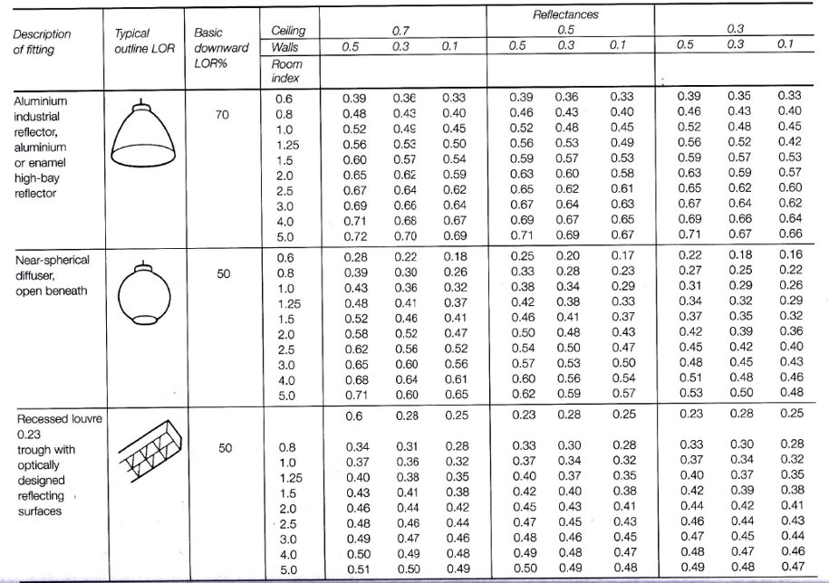

C) The number of lamps for the building

Now that I have calculated the utilisation factor. I now can calculate the number of lamps that are needed within the building.
To be able to calculate the number of lamps that are needed I will use the calculation:
N= E X A/ F X UF X LLF
In this situation E = Luminance, A = Area, F = Fluorescent lamp/luminous efficiency, UF = Utilisation factor and LLF = Light loss factor.

N = 600 x 120 / 4550 X 0.65 X 0.7
N = 72,000 / 2.047
N = 35.17 Lamps
N = 36 Lamps

D) A suitable layout (value of Smax) For the lamp fittings
To allow me to calculate the Smax I need to use the calculation:
Smax = 1.5 X H
In this situation H = The mounting hight of the lamp.

Smax = 1.5 X 2
Smax = 3 meters apart
As we require the use of 36 lamps. The best layout for this room is going to be 3 rows of 12 Lamps.
For this layout to work. There will be a hight of 2 meters between each row with a width of 1.5 meters between each row. Doing this will allow for ever lamp to be fitted into the layout of 3 rows of 12.
I have created a drawing of the layout which can be shown below.

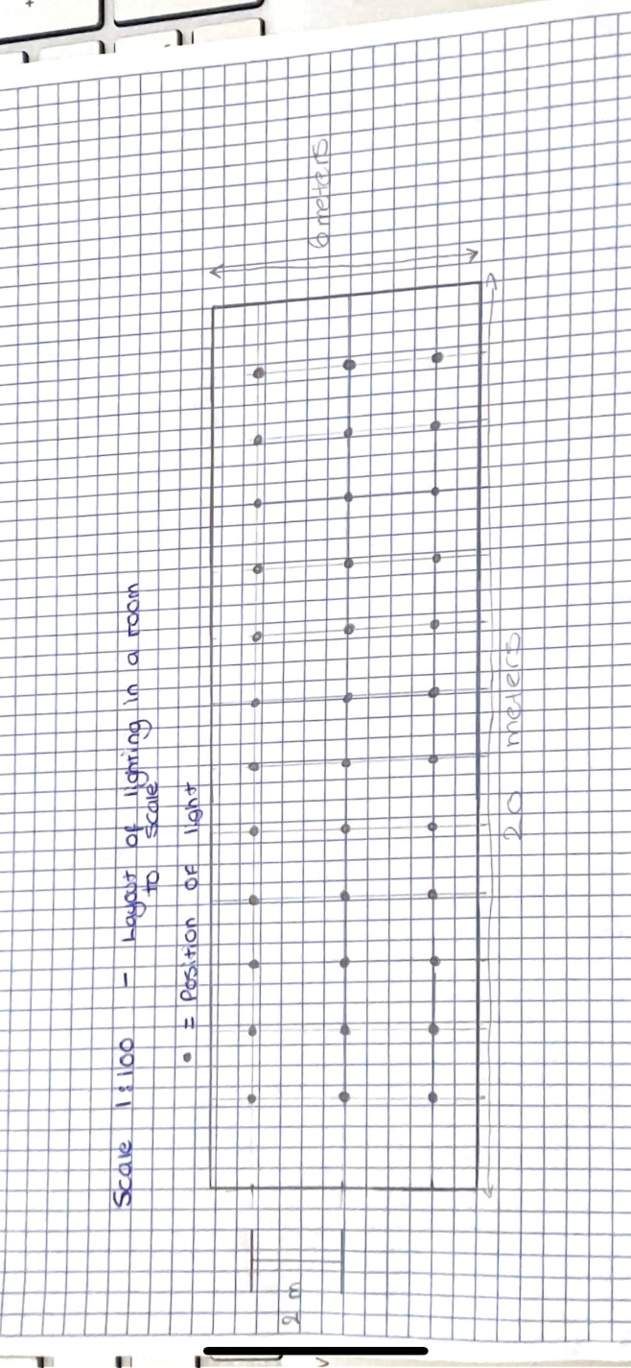

Task 2
A) The first section of this task asks for me to calculate the sound reduction index for the entire wall.
Before calculating this, I need to collect some data to be able to complete the equation.
I need to calculate the transmission of the coefficient for both the brick as well as the window.
For the first two equations shown below, when it comes to flipping an equation with log10 in it. It can be done as shown:
X = log A X Y
Then Y = A^X
Brick
SRI = 10(log10(1/T)
50 = 10(log10(1/T1)
5 = log10 X (1/T1)
1/T1 = 10^5
T1 = 10^-5
= 0.000010 – Transmission for the coefficient for brick

Window
SRI = 10(log10(1/T)
10 =10(log10(1/T2)
1 = log10 X (1/T2)
1/T2 = 10^1
T2 = 10^-1
= 0.10 – Transmission for the coefficient for the window

Now that I have calculated the coefficient for each part of the wall. I now need to calculate the average coefficient of both parts of the wall which will then allow me to calculate the composite partition.
The calculation that I need to use to complete this is shown below:
T1 – Transmission of the coefficient for the bricks
T2 – Transmission of the coefficient for the window
A1 – Area of the Bricks
A2 – Area of the window
T= (T1 X A1) + (T2 X A2) / A1 + A2
T = (10^-5 X 20) + (10^-1 X 4) / 20 + 4
T = 0.0002 + 0.4 / 24
T =0.016675
Now that I have all the information that I need, I now can calculate the SRI for the complete wall.
SRI = 10 X (log10(1/T)
SRI = 10 X (log10(1/0.016675)
SRI = 10 X (log10(59.970015)
SRI = 10 X 1.77
SRI = 17.7
SRI for the composite partition = 18 dB
B) I now need to define frequency and the wavelength of a sound, and discuss the implication of dealing with these two parameters in:
(a) A building’s internal design and services support
(b) A Partition wall’s construction technique
(c) The choice of Insulation types available.

Frequency is a number of repeated movements in a period of time. Most of the time frequency is measured by the second. This is measured in hertz(Hz). An example for how frequency is measured is that if a sound wave was to vibrate 200times per second this would mean that the frequency of the wave is 200Hz.The human ear will then here the vibrations at a certain pitch which all depends on the frequency of the sound. The best way to give an example of this is by looking at it through a musical view. For example, a low-pitched note such as the bass would give off a low frequency. Whilst in turn a high-pitched note such as a treble would be given off through a high frequency of sound waves. Whilst wavelength is a property of waves. It is the distance between wave crest to crest.
Within construction, There can be many implications when it comes to working with sound. This can be found quite commonly when it comes to the internal design of the building. For example the types of materials that you look to use in the internal design of the building can. For example, low frequency sounds can be harder to be absorbed by most materials which can lead to the soundwaves bouncing around the room which would cause an echo. And this is not what you would be looking for within a house. When it comes to designing a property. The designer will first look into how nosy the building already is. This will be done as it means the designer can understand what type of materials will be the best fit for the building as it would the building become better by making it louder or would it become better by making it quieter.
When construction a partition wall. It can be very vital in a common home to make sure that these walls have the ability to absorb as much sound as possible. This is because these walls will allow for the most privacy for example between two bedrooms. Because of this these rooms are going to need to be as sound proof as possible. To make these walls as soundproof as possible different methods can be put into place. One method that can be used is to add mass to the wall. By doing this it means that the sound will reflect from the wall and convert into heat energy, therefore stopping the sound breaching the wall. Another way that you can prevent sound breaking through a partition wall is by sound absorption. This is where you add a material into the wall such as rock wall which can absorb the sound.
My next point links well into my final sentence, Choosing the right type of insulation is best for the building can play a vital role in sound absorption. For example the material I mentioned above “Rockwool” is an insulation type commonly found in many council properties throughout Wales. This insulation is used because it is very good at absorbing sound. Rockwool is good at absorbing sound because it is high density. Rockwool can make even the nosiest infrastructures quieter. This type of insulation is called acoustic mineral wool. And it is made up from a combination of volcanic mineral rock and slag. The rock is melted down into a wool and this is why it is such a dense material and why it is considered to be so good at absorbing sound. Its main function is to be an insulator. But because it is a brilliant sound absorber, it has become very popular.

References
Fsorb.com(2022) Acoustics in architecture. Available at: https://www.f-sorb.com/post/acoustics-in-architecture-fundamental-principles-architects-designers-and-contractors-need-to-know (Accessed: March 30,2022)
iKoustics .co.uk(2023) Science of Soundproofing. Available at: https://www.ikoustic.co.uk/science-soundproofing/ (Accessed: March 30,2022)
www.rockwool.com(No date shown) Acoustic capabillities. Available at: https://www.rockwool.com/north-america/advice-and-inspiration/why-stone-wool/acoustic/#:~:text=ROCKWOOL%20products%20are%20high%2Ddensity,the%20nosiest%20infrastructure%20sounds%20quieter. (Accessed: March 31,2022)
The soundproofing Store (No date available) What is the best sound proofing acoustic insulation. Available at: https://www.soundproofingstore.co.uk/soundproofing-insulation#:~:text=Acoustic%20mineral%20wool%20delivers%20a,acoustic%20insulation%20within%20cavity%20partitions. (Accessed: March 31,2022)

