The History and Culture of Late Antiquity (HPAH7010)
Session 2 workshop: Art in Late Antiquity

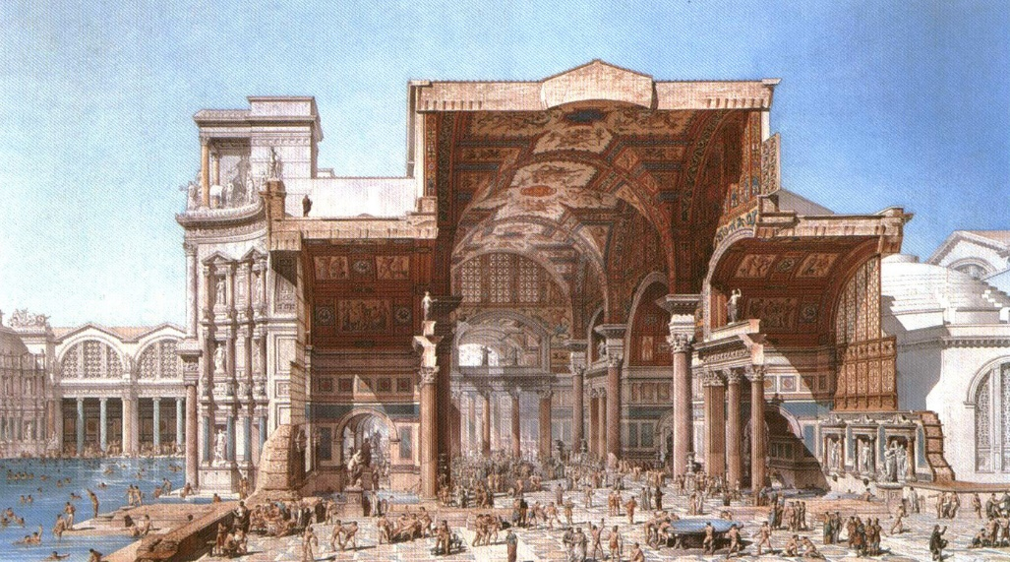
Baths of Diocletian (hypothetical reconstruction)

For the task for unit 2, I have provided a range of “artistic” (iconographic) imagery, including reliefs, statues, wall-paintings, carved ivories, mosaics and tapestries from the Severan period to the fifth century. Among the themes explored are religion and commemoration of the dead. You should the images incorporated into this document (see below) and keep the following broad questions in mind:
- Can we assume anything about the identity of those commissioning the objects / reliefs / tapestries, etc.?
- What do you make of the adaptation of forms and imagery in Christian and polytheist settings? Are there any interesting overlaps?
- What importance might allegory and symbolism play?

You do not need to write direct responses to all the questions posed in this booklet, rather you can select out some themes or representations that are of interest to you. Collate your general thoughts and post a few hundred words reflection (be selective) onto the Unit 2 forum.

If you want to explore these areas in greater depth, have a look at:
Francis, J. A. (2009). “Visual and Verbal Representation: Image, Text, Person, and Power”, in P. Rousseau and J. Raithel (eds.), A Companion to Late Antiquity. Wiley-Blackwell, pp. 285-305.
Harley, F. (2009). “Christianity and the Transformation of Classical Art”, in P. Rousseau and J. Raithel (eds.), A Companion to Late Antiquity. Wiley-Blackwell, pp. 306-326.

Images

Theme of religion
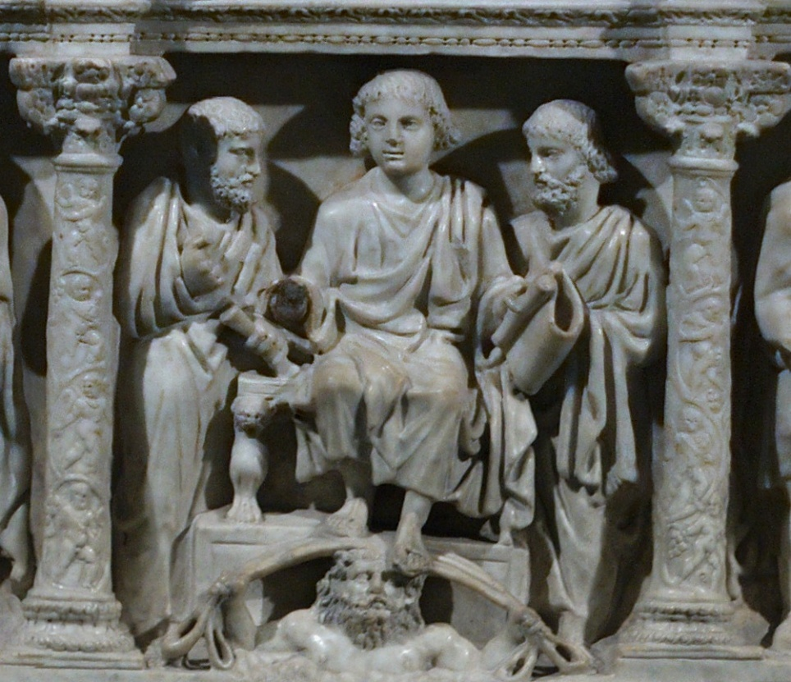
Sarcophagus of Junius Bassus, AD 359 (Vatican City), the traditio legis (“giving of the law”) scene
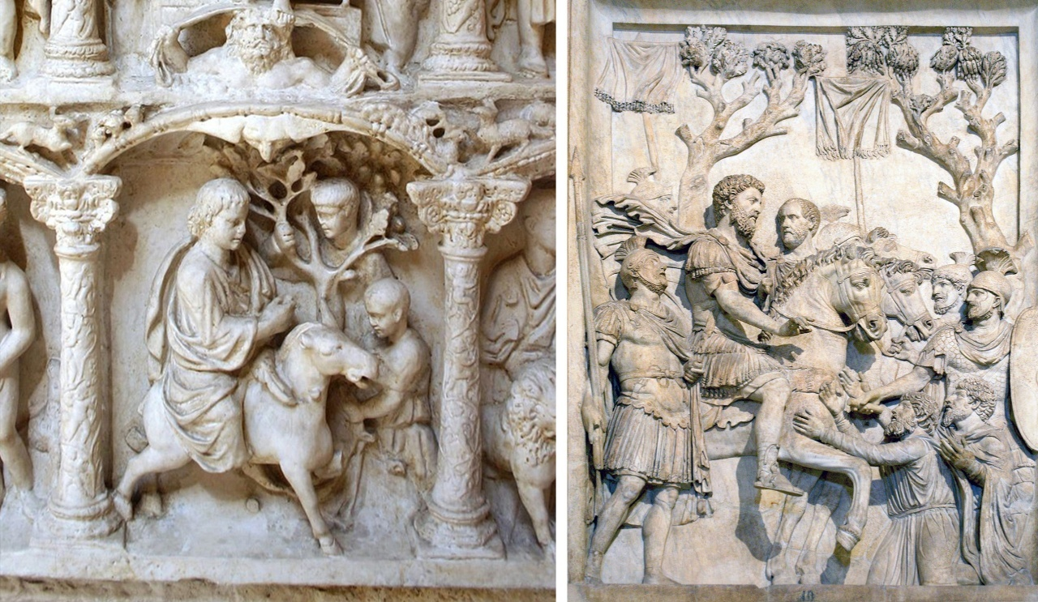
Christ’s entry into Jerusalem (plaster copy of Sarcophagus of Junius Bassus, AD 359); right: Adventus of Marcus Aurelius, AD 176–180 (Palazzo dei Conservatori, Rome).

What Classical styles and themes seem to be being adopted in this Christian sarcophagus?

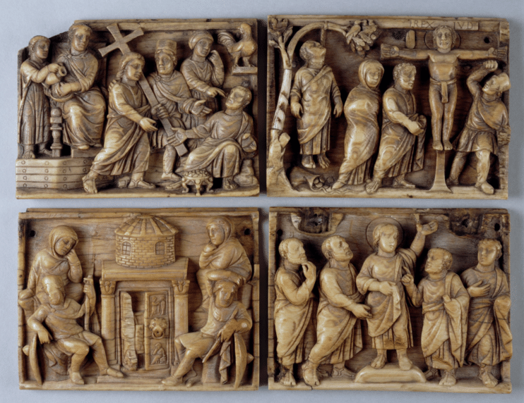

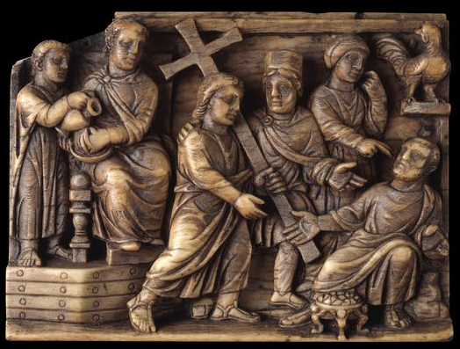
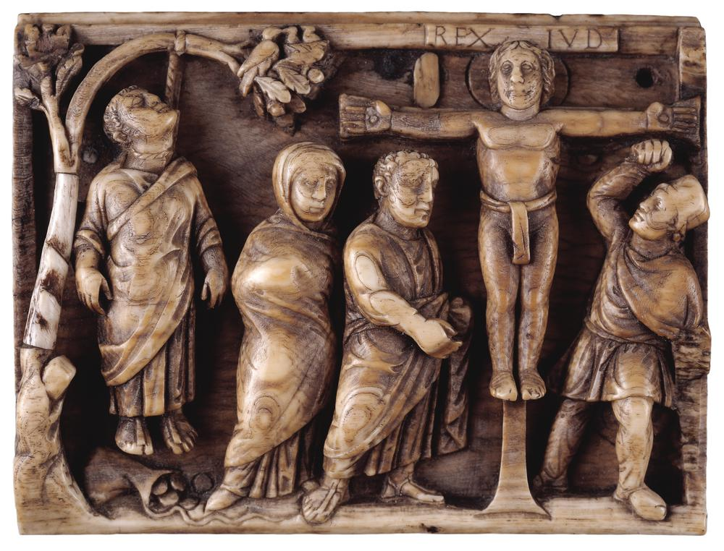
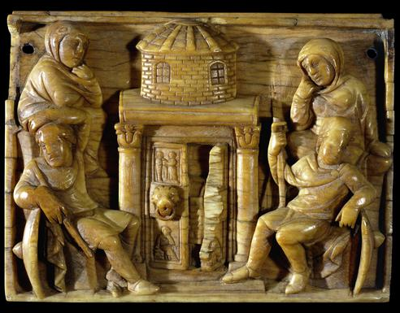
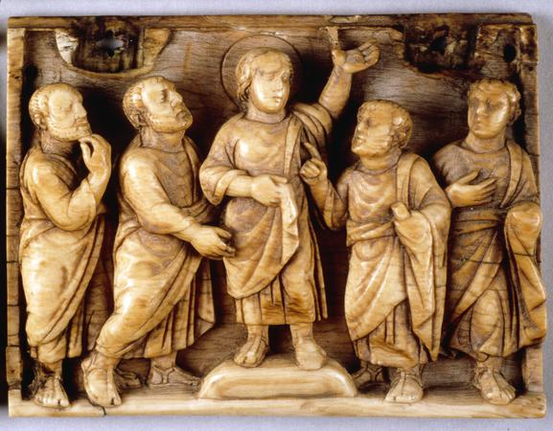
Maskell Passion Ivories, c. AD 420-430, British Museum

Do these scenes seem to emphasise suffering or triumphalism? Do any of the ivory panels share points of comparison with the Sarcophagus of Junius Bassus?

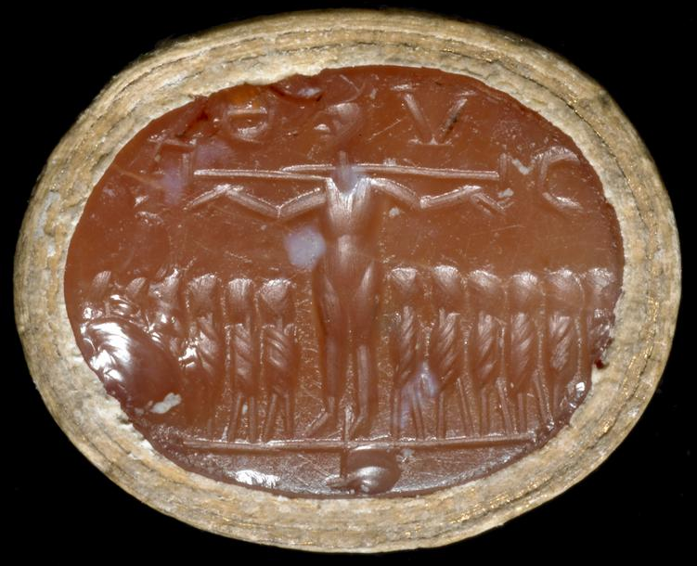
Carnelian intaglio, from 4th century Syria (British Museum); above Christ’s head ἸΧΘΥϹ (ichthys), which as an acrostic signifies: "Ἰησοῦς Χρῑστός Θεοῦ Υἱός Σωτήρ" (Jesus Christ, God’s son and savoir).

How does this intaglio depict of the crucifixion compare to that above?

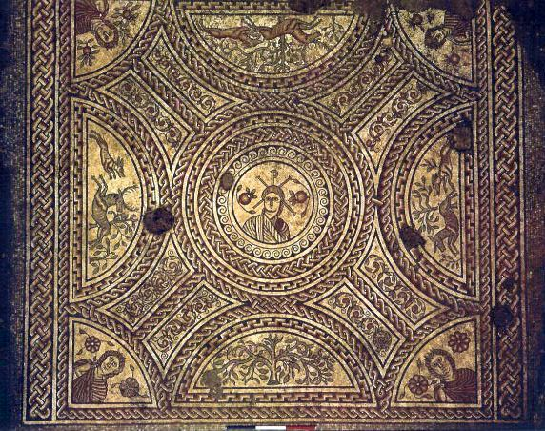
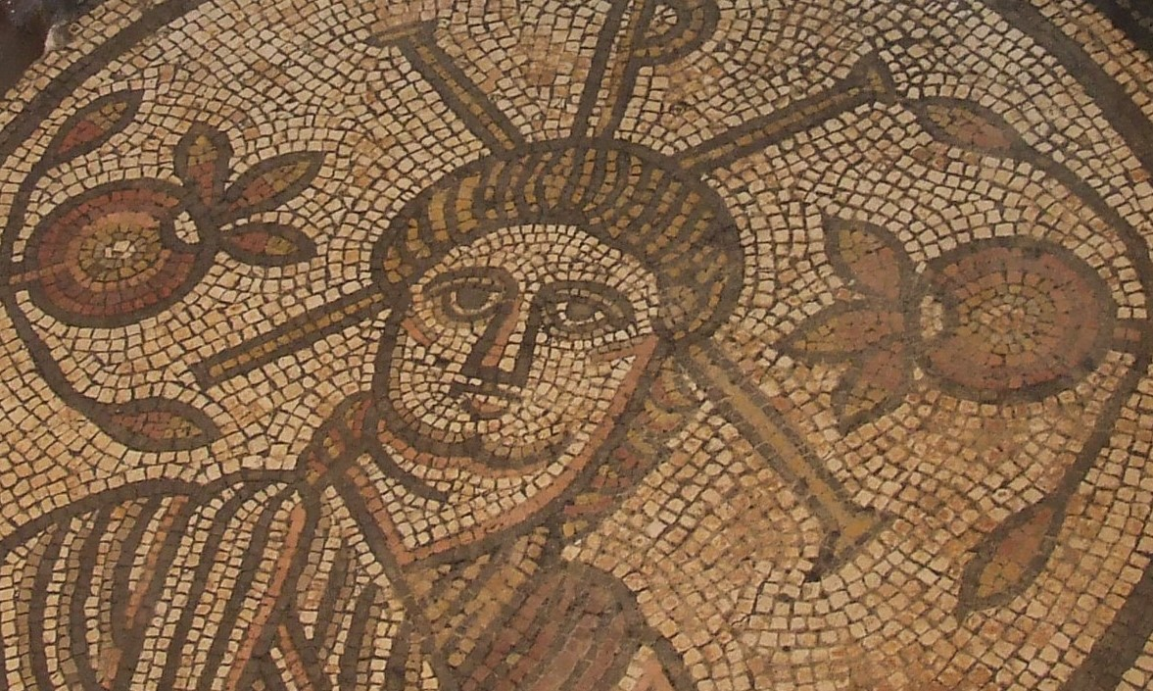
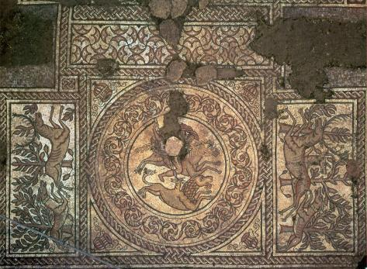
These mosaic images come from Hinton St Mary Roman villa, Dorset (fourth century AD). Who do you think the central figure is on the top and middle image? How can you tell who it is? What scene in being represented in the bottom (third) image? Does anything strike you as interesting about the juxtaposition of this imagery?

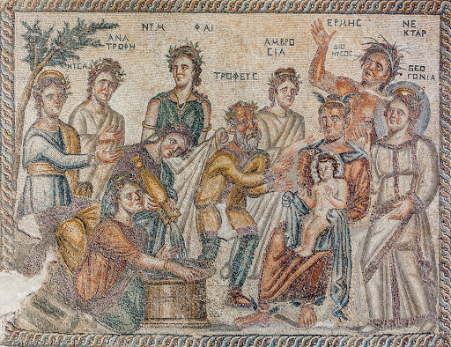
This is a floor mosaic from Nea Paphos in Cyprus, ca. first half of the fourth century AD. Who do you think is the child being represented on the man’s lap on the right? Who do you think the man holding the child is? What resonance does this imagery have with another belief system?

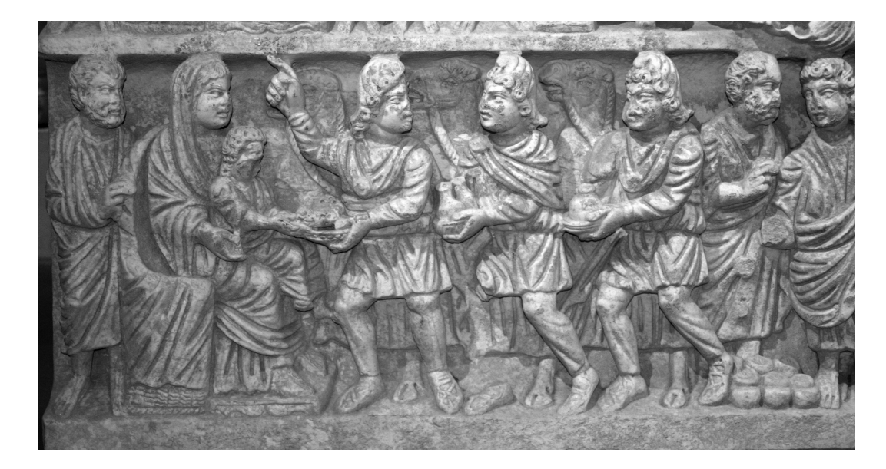
Sarcophagus from Arles, ca. AD 320-335 [Musée de l’Arles et de la Provence Antiques]
What do you think is being represented here? Does the image have any resonances with the one above?

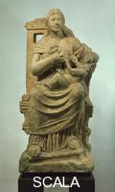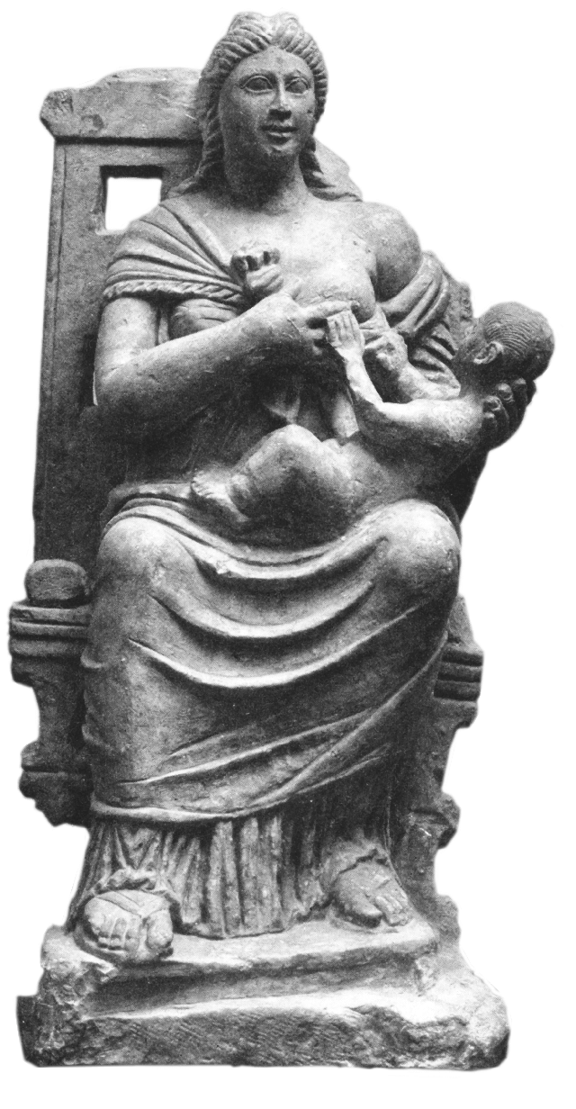
A colour and black and white imager from Antinoe, Egypt, ca. fourth century AD. Who do you think is being represented here?
Theme of Death and the afterlife

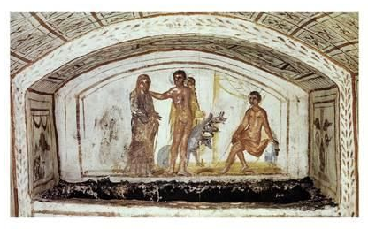
This image is from the Via Latina catacomb in Rome, ca. third quarter of the fourth century AD. The scene represents Hercules leading Alcestis back to Admetus. It sits within a complex that has many frescos with Christian art. What do you think the significance and symbolism is of this image?

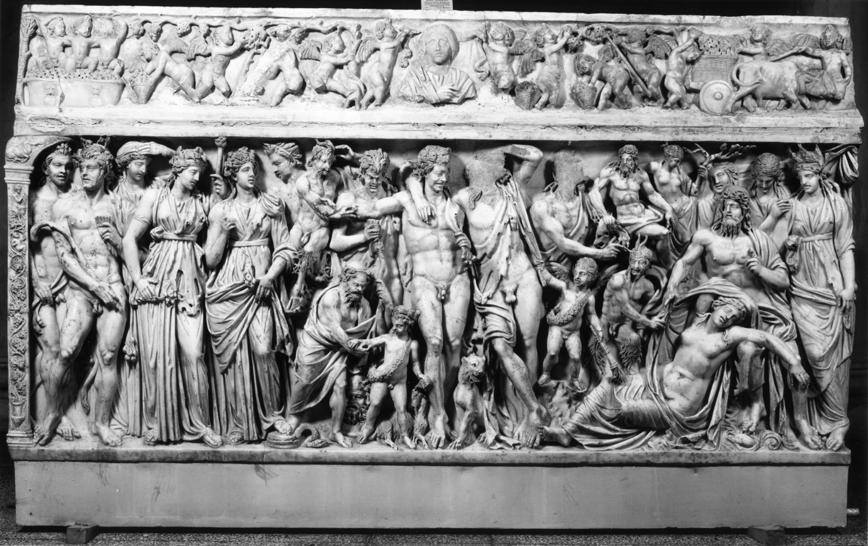
Marble sarcophagus, Rome, ca. second century AD. Scene represents Dionysus (his head since heavily damaged) with his entourage of Maenads and Satyrs, approaching a sleeping Ariadne on Naxos. We cannot know precisely what this imagery meant to the deceased and their family, but what possibilities are there?
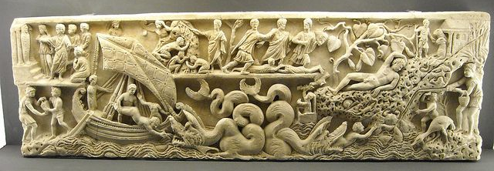
Marble “frieze” sarcophagus from Rome, ca. last quarter of the third century AD. What do you think is being represented here? What religious analogy may it have?

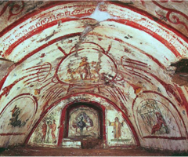
Vault of arcosolium of Cubiculum C, Via Latina Catacomb, Rome, ca. AD 320.
Peacock in the niche; temptation of Adam just to the left; orant in prayer just to the right; further left, Jonah and the whale; further right, Jonah under the gourd; tondo, Good Shepherd represented as a child.

Decorative tapestries

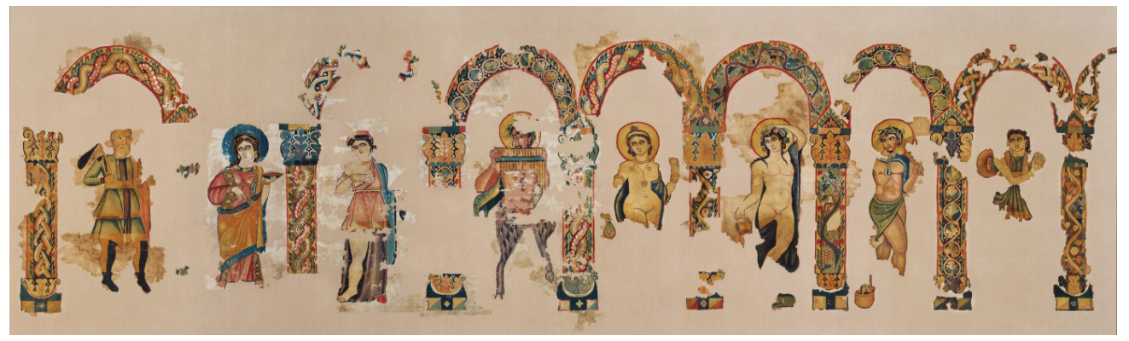
Linen and wool tapestry from Egypt, fourth century AD. Dionysus and Ariadne (centre right), with various personifications and deities under arcades. Fragments of something perhaps originally 10 metres long. Likely either a wall-hanging or for a couch.
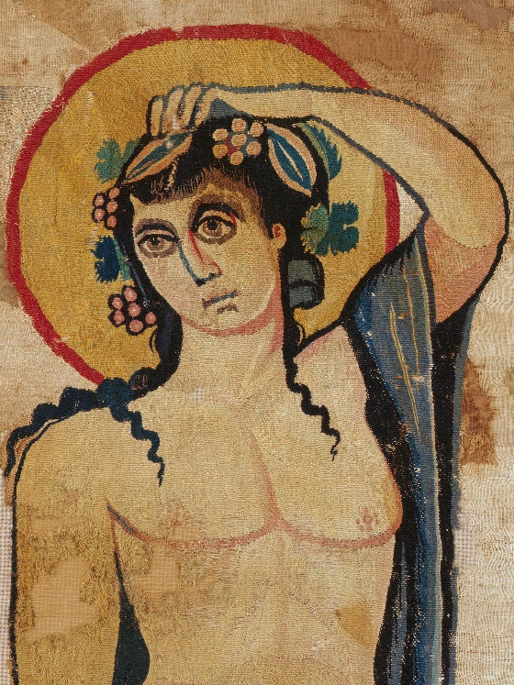
Close up image of Dionysus.

Consider how might we understand this textile object and the imagery on it. Might it reflect cult activity and Dionysiac rites? Or is it an example of paideia [cultural education]? Or might it purely have reflected personal tastes? Can we make any assumptions at all about who might have owned it?

