Principles of Analytics PowerPoint & Presenter Notes
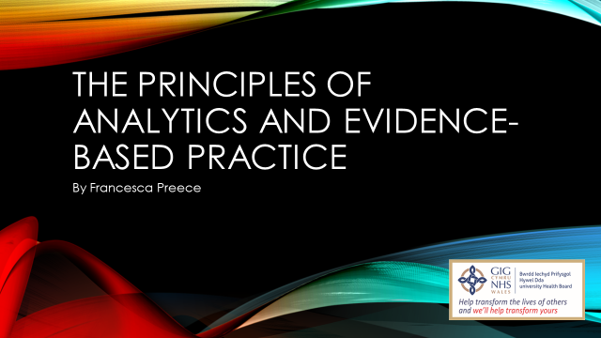
Welcome to today’s presentation on “The Principles of Analytics and Evidence-Based Practice”. At the end of the presentation there will be an opportunity to ask any questions and also all reading or links can be found on the final slide.
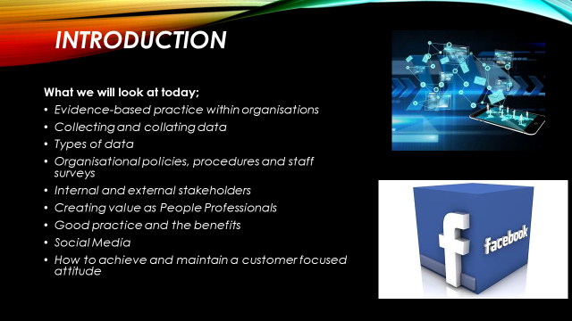
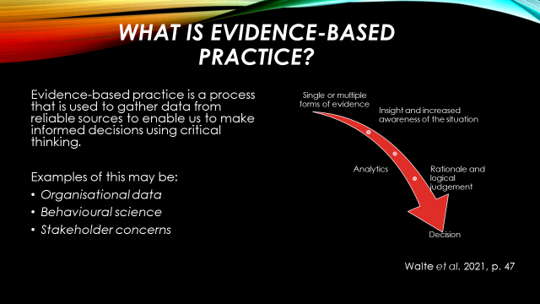
Evidence based-practice can be defined as a decision making process which is supported by multiple reliable sources.

Young (2022a) states that at the heart of evidence-based practice is the idea that good decision-making is achieved through critical thinking and drawing on best available evidence.

The CIPD professions map sets the international benchmark for People Professionals to make principle led judgements for the organisation. Young (2022b) also states that the Profession Map defines the knowledge, behaviours and values which underpin today’s people profession.

On the slide you can see 3 examples of evidence-based practice that is used.

Organisational data such as staff surveys can be used to get to know the Workforce. It can also help to identify any skill gaps or areas of expertise. It can also give us an insight into employee well-being and engagement as can exit interviews (HDUHB 2022a) and we have recently promoted a new exit interview strategy;

Behavioural science such as Kotters 8 step change model is a tool to help implement change successfully. Kotter (1995) suggests that for change to be successful, 75% of a company's management needs to "buy into" the change.

Stakeholder concerns help People Professionals to establish where bias is arising from and if it is causing a negative impact on an Organisation. It is also critical as Professionals we observe our organisational culture to enable us to understand it.

A great example of this is the current plans for a new hospital site, which is, yet to be determined. An appraisal group has therefore been setup for members of the public to be a part of to have their say with regards to the new Urgent and Planned Care Hospital somewhere between and including the zone of St Clears to Narberth (HDUHB 2022b).

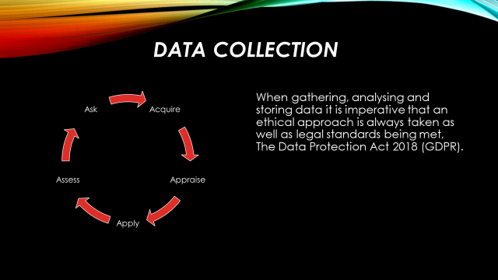

Collecting data, whether that be quantitative or qualitative, can help assist in organisation improvements to ensure we form a strategic decision based on reliable, sound evidence. It is important to use up-to-date data to ensure that we not only follow new legal regulations (if any) but to also ensure we make the best decision possible using valid information.

We should always follow the 5 steps of evidence based practice as seen in the diagram – ask, acquire, appraise, apply and assess. This will help to ensure our data is valid, ethical and accurate.

According to CIPD research (2022) HR functions lack credibility with regards to statistical and numerical skills and capabilities. Only 36% of finance professional agree that HR has demonstrable numerical and statistical skills, and only 37% believe their HR function demonstrates expertise in people data. This could be damaging to an organisation when collecting data as if it has not been done correctly the wrong decision could be made resulting in damaging an organisations reputation or profit.

We naturally create our own bias but this can deterrent from progress when we automatically inherent behaviours this is why it is important to gather reliable data from multiple sources before planning and implementing change in an organisation to ensure any similarities can be investigated.

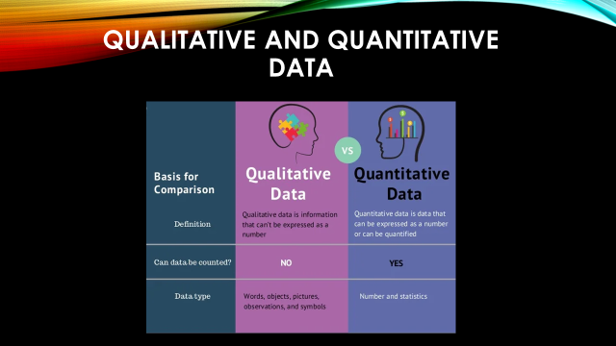
There are two types of data measurements regularly used when collecting information. These are quantitative and qualitative.

Quantitative data is statistical or numerical variables where as qualitative data is qualities or characteristics, which can be collected via surveys, interviews, case studies etc., appears in a narrative form, and captures the views of the individuals participating.

An example of quantitative data collected within the Health Board which we use on a regular basis would be sickness reports and staff turnover reports. This can identify any hot spot areas that may require help from HR.

Qualitative data would be collected through exit interviews (previously discussed) which are held when a staff member leaves a Department or the Health Board all together. This can be used in conjunction with the turnover reports to identify any hotspot areas and elaborate in further detail why we have a high number of turnover of staff. This could then lead onto further training and learning and Development in areas to help overcome this problem.

As stated by Streefkerk (2022) when collecting and analysing data, quantitative research deals with numbers and statistics, while qualitative research deals with words and meanings. Both are important for gaining different kinds of knowledge.

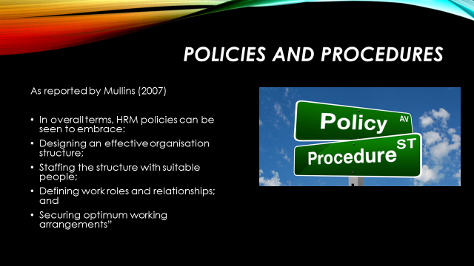

Policies are put in place to protect the workforce and stakeholders. In order for polices to be effective they not only have to be embedded into a Team but also understood as this adds value. It is the Line Managers responsibility to ensure all their team members understand the polices.

For a policy to be approved and implemented by HDUHB it must first be presented to the PODCC (People, Organisational Development and Culture Committee) The full Terms of Reference of the PODCC (HDUHB 2021c).

One policy that is used on a regular basis is the Managing Attendance at Work All Wales Policy (HDUHB 2022d). This is to ensure that appropriate choices are being made in supporting staff while off sick and what procedures need to be followed ensuring all members of staff are treated fairly and equally.

Evidence based practice should also be used when following procedures; i.e. changing terms & conditions of employment or staff reward benefits to ensure that the best decision has been made by collecting and collating relevant data.

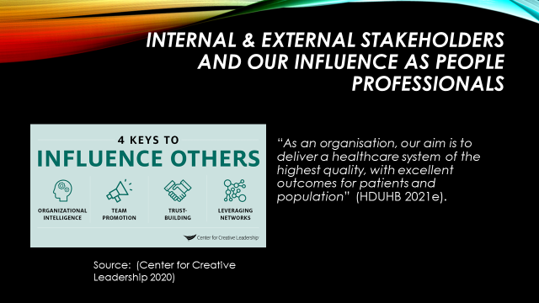

HR and People Professionals assist in ensuring the Workforce are treated equally and fairly. While they have a big influence on stakeholder fulfilment it is also vital that the this is embedded to the Team as a whole so a positive culture flows through an organisation.

Due to COVID affecting staffing levels and service demands a Recovery in Nature: Eco therapy Retreats for Hywel Dda Staff was developed to help support staff at risk of burnout and who are already on sick leave for these reasons. This was produced by the Staff Wellbeing Service and it was stated that the retreats would be evaluated. Each participant will be asked to take part in the evaluation as this enables us to assess how effective the Retreats are and make changes as we move forwards (HDUHB 2022f).

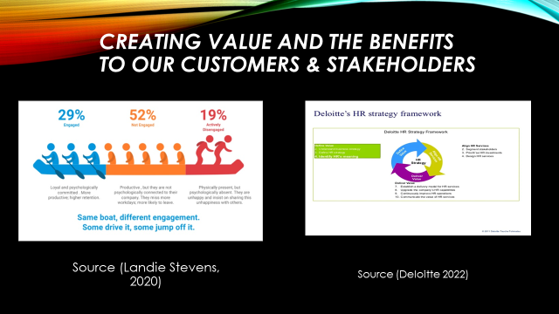

The aim of an organisation is to create value, this is often assisted by the People Professional body. Creating value for the stakeholders enhance in the hiring of employees and ensure we keep our staff engaged. By keeping staff engaged it could improve our retention rates and lower staff turnover. A positive culture creates relationships that are more impactful and keeping staff engaged is key to keeping productivity high.

Creating value to our customers (patients and service users) is also imperative to our organisation. HDUHB (2020f) is committed to openness and transparency, and therefore conducts as much of its business as possible in a session that members of the public are welcome to attend and observe. All Board Meeting dates can be found on our Website.

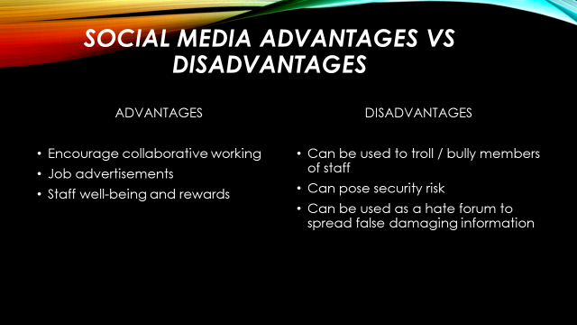

The Social Medial Policy used by the Health Board is an “All Wales” policy. This means that Health Boards across Wales adhere to the same policy and it applies to all NHS staff, locum staff, students, trainees, secondees, volunteers, contracted third parties and others (permanent or temporary). All Wales policies are devised by the All Wales Workforce and OD Committee (HDUHB 2022g).
As you can see, social media, if used within the right context, can be a great tool to help with staff engagement, job advertisement and making the workforce aware of the staff well-being and rewards available to them. It does however also come with its disadvantages if not used correctly and it can be profoundly damaging to a business or organisation.

As reported by Robinson (2020) The 2013 Boston Marathon went down in history due to the terrorist offence that happened during the race. Two homemade bombs detonated and killed 3 persons. Dozens more suffered injuries, and 16 of those victims lost limbs. Adidas seemed to have forgotten about all of that because they sent an insensitive email to runners after the event. The email’s subject title read: “Congrats, you survived the Boston Marathon.”

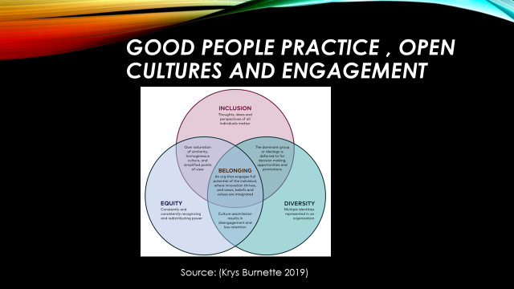

When good people practice is performed in an organisation supporting diversity and inclusion this can benefit the businesses talent and corporate reputation not only enhancing job appeal but also enhancing engagement amongst staff.

As reported by Ali and Green (2021) While UK legislation – covering age, disability, race, religion, sex and sexual orientation among others – sets minimum standards, an effective inclusion and diversity strategy goes beyond legal compliance and seeks to add value to an organisation, contributing to employee wellbeing and engagement.

Although good people practice is essentially produced by the People Profession it is up to us as champions to embed the knowledge throughout the workforce providing managers with the knowledge and capability of how to treat staff members. We do this by following our Health Boards Standards of Behaviour Policy (HDUHB 2020h).
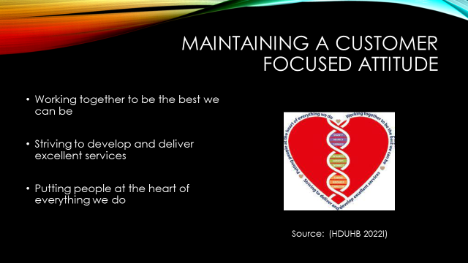

To ensure we continue to provide a customer focused attitude we, as a Health Board, have developed a “Values and Behaviours Framework Staff Information Booklet”. The link to this can be found at the end of the presentation on the “further reading” slide. (HDUHB no datei)

You will see on the slide HDUHB logo demonstrating the organisation values that we are committed to.

Our organisational values help to shape our organisation and offer guidance to our employees. When staff feel valued at work this has a positive impact on our patients leading to a better service being provided.

We also offer a Patient Support Service which provides patients with the appropriate support should they wish to make a complaint about an issue that has arisen for them. They also offer regular surveys which patients can take part in to help gather and collate data and improve services where required. There is also an opportunity for patients to give recognition to a staff member or service if they were pleased with the treatment received (HDUHB 2022j).



