

Network Operating Systems and Services - CW01
Build, and deploy, a Type 2 Hypervisor platform based Virtualised network

February 23, 2024

Mohammed Ansari - 2024571

Table of Contents
List of Figures / Tables 2
Tasks 1 3
1 - Hypervisor Research 3
2 – Selection of Hypervisor Oracle VirtualBox 6
3 - Download the chosen Hypervisor and Server, Client Operating Systems. 7
4 - Network setup as per the given topology. 7
5 - Research on IP Addressing: 8
6 - IP addresses and network configuration. 10
7 - Network testing 12
Reference list: 17

List of Figures / Tables
Figure 1: Hypervisor Types ……………………..…………………………………………. 4
Figure 2: Network Topology..………………………………………………………………. 8
Figure 3: Screen shot = SW-DC……………………………………………………………. 12
Figure 4: Screen shot = LD-DC………………………..…………………………………….12
Figure 5: Screen shot = Ethernet Troubleshooting.…………………………………………. 14
Figure 6: Screen shot = SW-PC Ping...……………………………………………………….15
Figure 7: Screen shot = SW-DC Ping.………………………………………………………. 16
Figure 8: Screen shot = LD-DC Ping.………………………………………………………. 16
Figure 9: Screen shot = LD-DC Ping.………………………………………………………. 17

Tasks 1

1 - Hypervisor Research
The hardware or software components known as hypervisors allow several operating systems to run on the same physical hardware. They build virtual machines (VMs) that offer resource allocation and isolation for each VM, enabling them to operate independently of the host operating system. Hypervisors come in two primary varieties: Type 1 (bare-metal) and Type 2 (hosted). Type 1 and Type 2 hypervisors differ primarily in that Type 1 operates on bare metal whereas Type 2 operates on top of an operating system. [1]
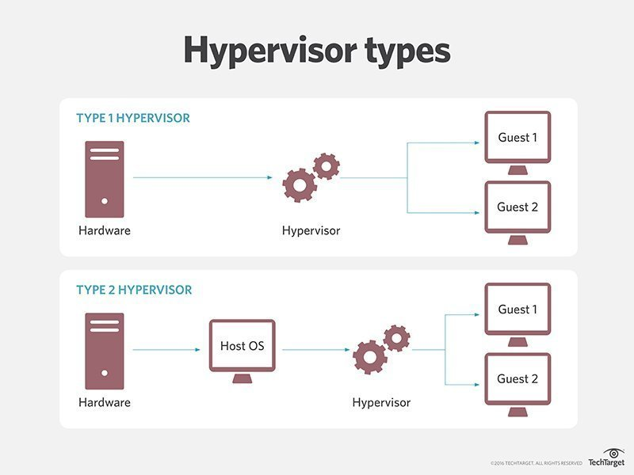
Hypervisor Types - Figure 1 - [1]
Type 1 Hypervisors
Type 1 hypervisors, sometimes referred to as bare-metal hypervisors, operate directly on the hardware of the host computer and act as a direct conduit between the virtual and physical worlds. Better speed and less overhead are possible in comparison to Type 2 hypervisors.

Type 1 hypervisors include: [2]

VMware ESXi A bare-metal hypervisor called VMware ESXi is intended for usage in enterprise and data center settings. In addition to offering advanced capabilities like distributed resource scheduling, high availability, and vMotion—a function that allows virtual machines to migrate live—it supports a broad variety of hardware platforms. [2]
Microsoft Hyper-V One native hypervisor that comes with Windows Server and select Windows 10 editions is Microsoft Hyper-V. Together with capabilities like live migration, failover clustering, and virtual machine replication, it supports guest operating systems including Linux and Windows.
Citrix Hypervisor (formerly XenServer) A free, open-source bare-metal hypervisor that supports Windows, Linux, and Solaris guest operating systems is called Citrix Hypervisor (previously known as XenServer). It provides capabilities including high availability, centralized control via the Citrix Hypervisor control Console, and live migration. [2]

Type 2 Hypervisors
Type 2 hypervisors operate as an application on top of the host operating system and are also referred to as hosted hypervisors. Compared to Type 1 hypervisors, they are simpler to install and configure, but they could perform worse and have more overhead. Some popular Type 2 hypervisors include:

VMware Workstation
A desktop hypervisor called VMware Workstation enables users to run several operating systems on a single computer. A vast array of guest operating systems are supported, and capabilities like shared folders, cloning, and snapshots are available. [2]

VirtualBox
Oracle created VirtualBox, a free and open-source hypervisor. It provides capabilities including snapshots, remote display, and virtual networking and supports guest operating systems including Windows, Linux, Mac OS X, and Solaris.

Parallels Desktop
A commercial hypervisor made specifically for macOS hosts is called Parallels Desktop. With its smooth interaction with the host operating system and support for DirectX and OpenGL graphics acceleration, it enables users to run Windows and Linux alongside macOS.

Hardware Requirements
The quantity of virtual machines, their resource needs, and the type of hypervisor being utilized all affect the hardware requirements for hypervisors. Typically, for hypervisors to effectively support numerous virtual machines, they need a multi-core processor, enough RAM, and a quick storage subsystem. [2]

Hypervisors provide a number of benefits, including:
- Resource optimization: By dynamically distributing hardware resources among virtual computers, hypervisors enable effective utilization of available resources.
- Isolation: By separating virtual machines, hypervisors guarantee that the instability or poor performance of one VM won't impact the others.
- Flexibility: Hypervisors provide flexibility in software selection and deployment by enabling the simultaneous use of multiple operating systems and applications on the same hardware.
- Disaster recovery: Features that help with disaster recovery and business continuity, like live migration, high availability, and replication, are supported by hypervisors. [2]

Security
One of the main concerns with virtualization is security. Virtual machines should be isolated from the host computer and from one another, and hypervisors should be set up with the proper security configurations. To further secure the virtual environment, security measures like firewalls, antivirus programs, and encryption should be used. [3]

Hypervisors are used in several contexts, such as:
- Development and testing: With the help of virtualization, developers and testers can set up separate environments to test apps and software without interfering with the host system.
- Desktop virtualization: With the help of virtualizers, users can run several operating systems conveniently and adaptably on a single computer.
- Server consolidation: By allowing several server workloads to be combined onto a single physical machine, hypervisors lower hardware costs and streamline administration.
- Disaster recovery: Live migration, high availability, and replication are characteristics that are supported by hypervisors that help with business continuity and disaster recovery. [3]

2 – Selection of Hypervisor Oracle VirtualBox
Oracle Corporation created the potent open-source hypervisor VirtualBox. On a single physical machine, it enables users to run numerous operating systems simultaneously. VirtualBox is a flexible option for virtualization needs because it supports a large variety of guest operating systems. [4]
Factors Affecting the VirtualBox Hypervisor Selection:
Open-Source Nature:
The fact that VirtualBox is open-source is one of the main aspects influencing the decision. Because VirtualBox is open-source, it can be altered to meet unique needs and is always free to use. This lowers expenses while also giving users the freedom to alter the program as needed.
Cross-Platform Interoperability:
VirtualBox has a stellar reputation for cross-platform interoperability. It is compatible with several hosts operating systems, including Linux, Solaris, macOS, and Windows. Because of its adaptability, VirtualBox is the go-to option for consumers that require a hypervisor that can easily fit with their current configuration and operate on multiple systems.
User-Friendly Interface:
VirtualBox makes the process of setting up and maintaining virtual machines easier with its user-friendly interface. Both novice and expert users can quickly and easily set up virtual environments thanks to the user-friendly GUI (Graphical User Interface). [4]
Extensive Feature Set:
VirtualBox has a plethora of functionality to meet a variety of virtualization requirements. With features like seamless mode, shared folders, and support for USB devices, VirtualBox provides an extensive toolkit to improve the virtualized experience in general.
Community Support:
Users can access a multitude of resources, like as forums, tutorials, and documentation, thanks to the lively and engaged VirtualBox community. Users may readily find solutions to any problems they may run into when using VirtualBox because to the robust community assistance.
Performance and Stability:
VirtualBox has a reputation for providing good performance and stability, especially when running several virtual machines or resource-intensive apps at once. The hypervisor is a dependable option for virtualization jobs since it is designed to provide great performance without sacrificing stability.
The aforementioned elements demonstrate why VirtualBox is a well-liked option for those searching for a stable and feature-rich hypervisor solution. For people and companies looking for effective virtualization solutions, its open-source design, cross-platform compatibility, user-friendly interface, rich feature set, community support, performance, and stability make it an attractive choice. [4]

3 - Download the chosen Hypervisor and Server, Client Operating Systems.
Hypervisor Oracle VirtualBox was already installed and configured on the System.
For server OS, downloaded the Windows Server 2019 from Microsoft Evaluation Center, installed and configured. [5]
For client OS, downloaded the Windows 10 2022 from Microsoft software download Center, installed, and configured. [6]

4 - Network setup as per the given topology.
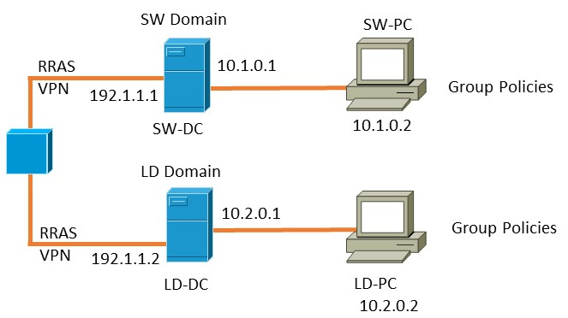
Network Topology - Figure 2 - [7]

To configure a network according to a certain topology (Figure 2), one must comprehend the connections and structure shown in the supplied diagram. The network's device connectivity is determined by the topology..

One PC is served by each of the two Domain Control Servers in the provided topology network.

Topology-based network configuration:

Connect Devices: Using Ethernet connections, directly connect each PC on the network to the Domain Control Server. Make that every device is connected to the Domain Control Server using a separate cable.

Configuration: Set up the Domain Control Server to effectively handle network traffic. Each device must have its IP address, subnet mask, and other network settings configured.

Testing: To make sure that data can go between devices without interruption, test the network connectivity after all devices have been linked.

Set up a network successfully using topology by following these procedures, as shown in the provided diagram (Figure 2). [8]

5 - Research on IP Addressing:
Data is communicated from one computer to another via the use of internet protocols (IP) and networking, which create communication rulings between any devices and applications connected to the internet. For example, when sending and receiving a text message, the sender (person sending the message) will create the message and send this via a mobile signal from a telephone number, to which the recipient (person receiving the message) will receive the message via their telephone number.

This is like how computers communicate, whereby a message is sent detailing the source and destination IP addresses via data packets, which contain the details of the message. This is sent to the internet via routers, to which the router sends the message to the correct destination, finds the recipient, and concludes with the message being delivered.
Internet Protocol (IP)
by Steve Protheroe-Hewitt - Sunday, 11 February 2024, 10:54 AM

There are two types of IP addresses.

IPv4 addresses - 32-bit addresses created using binary and octal systems, identifying hosts within networks and have ‘two to the power of 32’ addresses available, though have no blocks left

IPv6 addresses – 128-bit addresses created using hexadecimal systems which can be assigned to every single device without worrying about running out of IPv6 addresses.

Re: Internet Protocol (IP)
by Steve Protheroe-Hewitt - Sunday, 11 February 2024, 10:56 AM

A key component of computer networking that permits device communication over the internet is Internet Protocol (IP) addressing. Every device connected to a network is given an IP address, which is a unique numerical label, thanks to IP addressing. Device identities on a network are represented by these addresses, which are also necessary for data packet forwarding and routing between devices. The structure, format, and representation of IPv4 and IPv6 addressing, the idea of subnetting, and the effective use of IP addresses will all be covered in this essay as we examine how IP addressing enhances the functionality and efficacy of networks.

IPv4 Addressing: The fourth iteration of the Internet Protocol, or IPv4, is the most extensively utilized addressing scheme globally. In dot-decimal notation, which is made up of four octets separated by periods, IPv4 addresses are 32-bit values. A value between 0 and 255 can be assigned to each octet. The format for an IPv4 address is x.x.x.x, where x is a decimal value between 0 and 255.
IPv4 Addressing: The most recent version of the Internet Protocol, known as IPv6, was released in response to the IPv4 address space running out. Hexadecimal representations of 128 bits are used for IPv6 addresses. Eight sets of four digits each are separated by colons and compose the address. The format for an IPv6 address is x:x:x:x:x:x:x:x, where x is a hexadecimal value between 0 and f.

Structure and Format of IP Addresses: A network portion plus a host portion make up an IP address. While the host portion identifies a particular device within that network, the network portion identifies the network to which a device belongs. The subnet mask, a 32-bit value with the network portion set to 1 and the host portion set to 0, defines the border between the network and host portions.
Subnetting: The practice of subnetting involves splitting a network into smaller subnetworks, or subnets, in order to increase network productivity and better manage network resources. By assigning a piece of the network address to the subnet and keeping the remaining portion for the host address, subnetting is accomplished. This makes it possible to create several subnetworks, each with a unique set of IP addresses.

IP addressing principles are necessary for many real-world uses, including:

Network Design and Configuration: Creating and setting up computer networks requires a thorough understanding of IP addressing. Network administrators can use it to set up communication channels between networks, configure routers, and assign IP addresses to devices.

Traffic Management and Routing: Network managers can control network traffic and route data packets between networks thanks to IP addressing. Administrators can set up switches and routers to efficiently direct traffic by knowing the format and structure of IP addresses.

Security and Access Control: Security and access control are two more uses for IP addressing. IP addresses can be used by network administrators to monitor network activity, impose access restrictions on resources or services, and identify any security risks.

6 - IP addresses and network configuration.
A logical element made up of numbers that is assigned to a host's network interface to identify it in a computer network is known as an IP address, or Internet Protocol address.
The router uses the network address to locate a way across the entire network. The American Registry for Internet Numbers (ARIN) (or an ISP) is responsible for assigning this number.
The network administrator assigns a host address based on an internetworking address plan. It is possible to allocate host addresses dynamically.
The network number of every host on the same network will be the same, but each host is uniquely recognized by its own host number. [9]

Please find below the IP address connection details in attached screenshots.
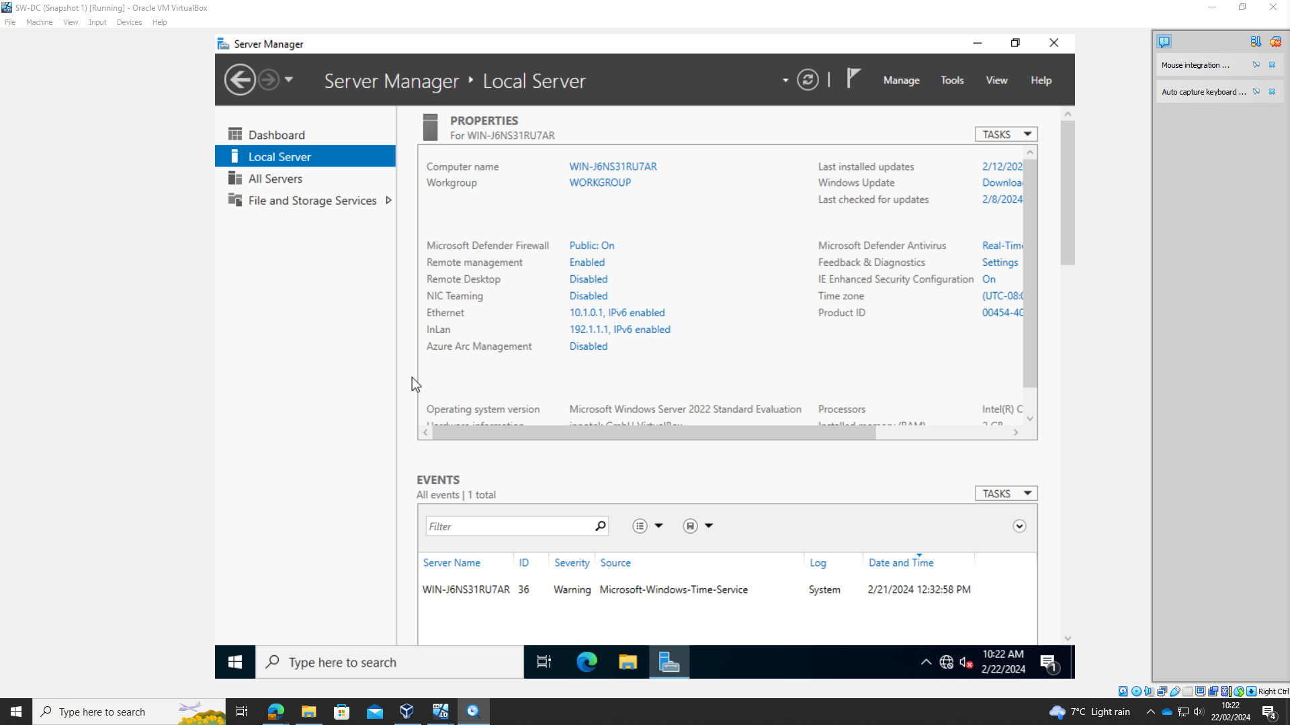
Screen shot = SW-DC
Figure 3

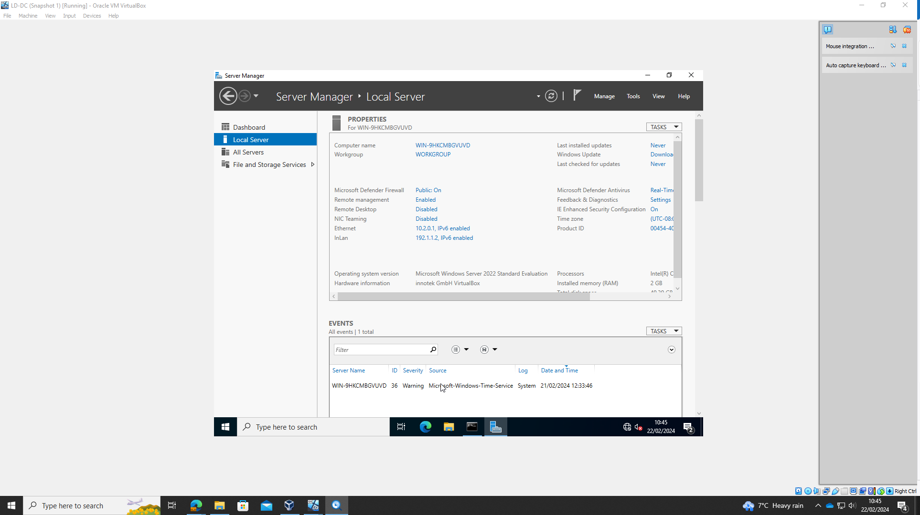
Screen shot = LD-DC
Figure 4

7 - Network testing
7.1. Network Testing and Troubleshooting Techniques
To guarantee that networks run smoothly, troubleshooting and testing are crucial procedures. Tests for connectivity are essential for locating and fixing problems with networks. Maintaining network performance also requires other testing criteria, such as bandwidth, packet loss, and security testing, in addition to connectivity tests.
Connectivity Tests:
Ping Test: The ping test is among the simplest ways to check for connectivity. It facilitates figuring out whether a device on the network can speak with another device. Administrators can confirm device connectivity by sending ICMP echo requests and receiving ICMP echo replies.
Traceroute Test: Traceroute is a tool for tracking packets from their source to their destination. It assists in locating any network hops that contribute to packet loss or delays.
Telnet Test: This utility checks whether a remote device is connected to a given port. It assists in confirming whether a service is responsive and reachable.
Bandwidth Test:
Speed Test: Measure the speed at which data is transferred between devices or over the internet with a bandwidth test. Speed testing make sure that the available bandwidth satisfies user needs and assist in locating network bottlenecks.
Packet Losses Test:
Packet Capture Analysis: To find packet loss problems, packets can be captured and analyzed using programs like Wireshark. Degradation of network performance and user experience can result from packet loss.
Security Testing:
Port Scanning: To find potential security flaws, security testing entails looking for open ports on devices. Nmap and other port scanning programs can be used to find open ports that might be dangerous for security.

Typical Problems with Connectivity:
IP Address Conflicts: Conflicts and connectivity problems arise when two devices connected to the same network have the same IP address. Finding the infringing devices and allocating distinct IP addresses are the first steps in resolving IP address conflicts.

DNS Resolutions: When domain names cannot be resolved to IP addresses, DNS resolution errors may result in connectivity issues. Using other DNS servers, deleting DNS cache, or examining DNS server settings are all part of DNS troubleshooting.

Firewall Configurations: Improper firewall configurations might obstruct network communication and result in problems with connectivity. Verifying rules, permitting required traffic, and guaranteeing correct configuration are all part of troubleshooting firewall settings.

Methodically Identifying and Resolving Network Problems:
Determine the Issue: Begin by compiling data regarding the problem as reported by users or monitoring systems.
Isolate the Cause: To identify the source of the issue, use diagnostic tools such as packet capture, traceroute, and ping.
Implement Solutions: Resolve issues by modifying firewall rules, changing IP addresses, or optimizing network setups in accordance with the diagnosis.
Verify Resolution: Retest connectivity and performance to ensure that the problem has been fixed after applying fixes.
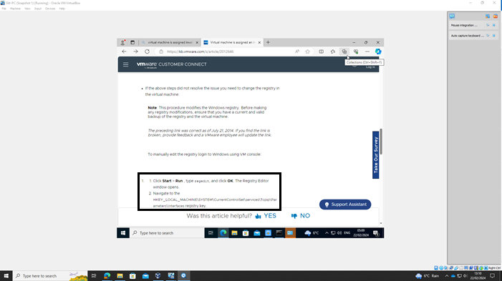
Screen shot = Ethernet Troubleshooting
Figure 5

7.2. Network Test Screenshots are attached, proving successful pinging.
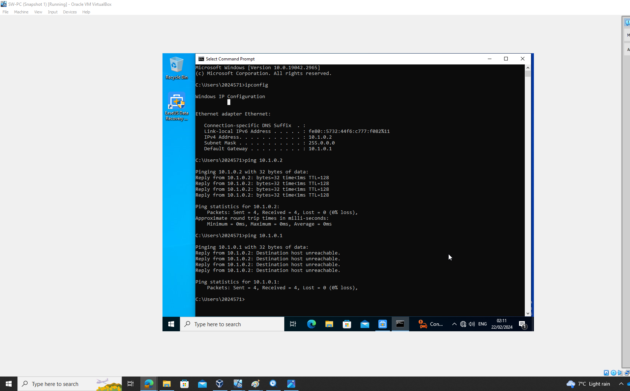
Screen shot = SW-PC Ping
Figure 6

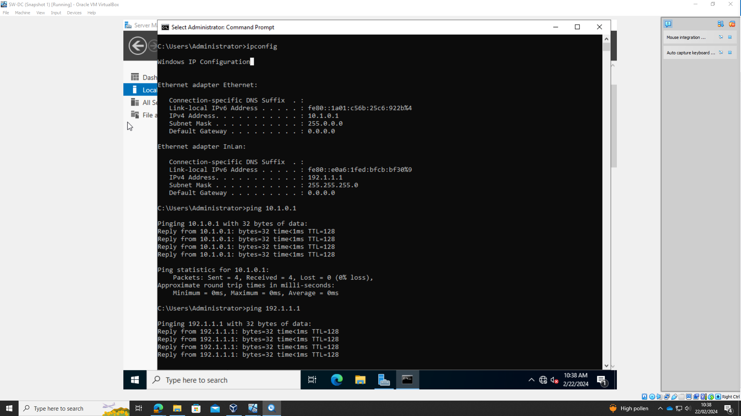
Screen shot = SW-DC Ping
Figure 7

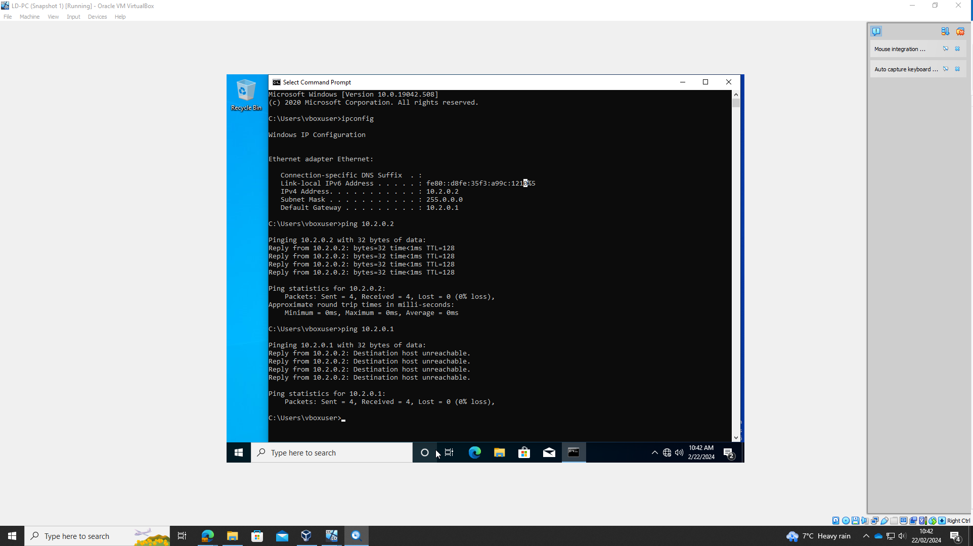
Screen shot = LD-DC Ping
Figure 8

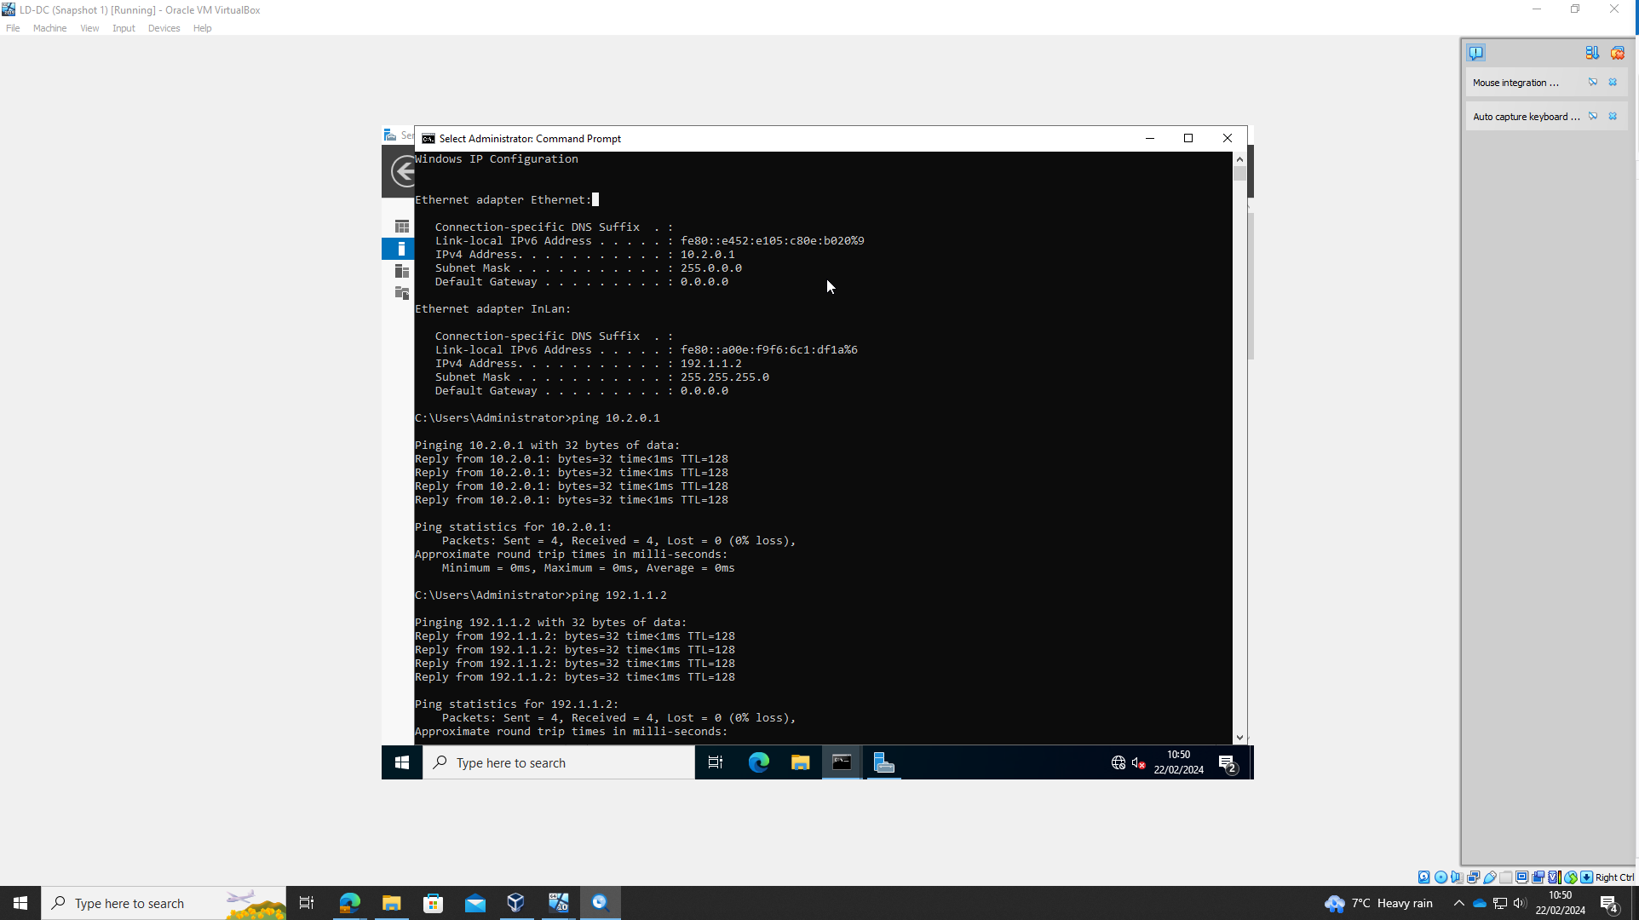
Screen shot = LD-DC Ping
Figure 9

Reference list:

[1] Difference between Type 1 vs. Type 2 hypervisor [Online Available] at:
https://www.techtarget.com/searchitoperations/tip/Whats-the-difference-between-Type-1-vs-Type-2-hypervisor at: [Accessed: 22 Feb 2024]

[2] Types of Hypervisors 1 & 2 [Online Available] at: https://phoenixnap.com/kb/what-is-hypervisor-type-1-2 [Accessed: 22 Feb 2024]

[3] What is a hypervisor [Online Available] at: https://www.vmware.com/topics/glossary/content/hypervisor.html at: [Accessed: 22 Feb 2024]

[4] Exploring the World of Virtualization [Online Available] at: https://www.acecloudhosting.com/blog/hyper-v-vs-virtualbox/ [Accessed: 22 Feb 2024]

[5] Windows Server 2019 OS [Online Available] at: https://www.microsoft.com/en-us/evalcenter/download-windows-server-2019 [Accessed: 22 Feb 2024]

[6] Windows Server 10 OS [Online Available] at: https://www.microsoft.com/en-gb/software-download/windows10 [Accessed: 22 Feb 2024]

[7] Network Topology, NOS_ACCA5023_Component_1_CW_Final_24_v2.docx [Online Available] at: https://moodle.uwtsd.ac.uk/course/view.php?id=8759 [Accessed: 23 Feb 2024]
[8] Network topology [Online Available] at: https://www.techtarget.com/searchnetworking/definition/network-topology[Accessed: 22 Feb 2024]

[9]Lecture 1 Introduction.pptx Course: L5 - Network Operating Systems and Services (ACCA5023) (uwtsd.ac.uk) [Online Available] at: https://moodle.uwtsd.ac.uk/course/view.php?id=8759 [Accessed: 23 Feb 2024]

