
HRM Assignment 2
Amazon company

Student name: Lucia Preguza
Student ID: 2111861

Module name: Human Resource Management
Module code: LCMB7000
Lecturer name: Gladius Kulothungan
Submission date: 18.01.2022
Table of Contents
Introduction…………………………………………………….3
Company background………………………………………….3
What is change management model…………………………...4
Amazon change management model………………………....5
Compensation……………………………………………….…6
Compensation strategy…………………………………………7
Compensation in Amazon company…………………………...8
Leadership development……………………………………….9
Leadership development in Amazon company…………….…10
Conclusion………………………………………………….…10
Recommendations…………………………………………......11
References……………………………………………………..13

Introduction
Human Resource Management prepare the employees for essential develop skills, to help the company to have a progress in the market place (Marchingtom, et al., 2021). As well Human Resource Management are training people and motivated for a better understanding for progressing at their work place. Human Resource Management prepare and help, how to manage all the problems can be between the employees in an organization (TL, 2021). Another essential point is that HRM are hiring the right people for right job, and that makes life easier for both sides.
Function of Human Resource Management is to represent some techniques and tools, that the organization can implement for company success (Collings & Wood, 2009). Then again for every people individual works, and that is the main roll for Human Resource to work with people and support them.
This Assignment In quality of Human Resource Director of an International Technology Amazon company, will present the following point of view and discuss about the change management and which kind of models the company is using and how changing management can affect the Amazon.
Then again will see what is compensation and how the compensation works for Amazon company, after examining all these two strategies we carry on with Leadership development in Amazon company, and why is important for Amazon company. In summary by researching these three strategies, we will understand how the employees are appreciating in Amazon company.
Company background
Amazon is the biggest internet company in the world, founded by Jeff Bezos in 1994 USA, started only to sell books but Jeff Bezos with a great idea ‘’to grow big and fast’’ had an amazing success and today the company sells everything (InterstingEngineering, 2021). Amazon started in a garage but in years the company has progress into almost on of the best type of product, service and media.
Equally important is a great idea to start to build a company and Jeff Bezos had the right one, he chose the name Amazon because is exotic and different, like the biggest river in the world.
The Amazon slogan is ‘’Hork Hard. Have Fun. Make History’’ (TheSun, 2018). These words made history for sure in the marketplace, compere to their competitors. As well Jeff Bezos is one of the richest people in the world, because is no doubt that is a strong personality and motivated one and this is the key for the success.
Amazon introduced in 2005 prime loyalty program, is mixture of loyalty programs and offering services (Loyalty Programs, 2021), all about this prime loyalty program is to encourage customers to bay from Amazon and make easier to delivery their online shopping.
According to (2003), from the moment the customer by something from Amazon and till is finished the purchase, Amazon is collecting the information to individualize the experience. This it builds customer loyalty and a good experience for the customer, as well good reviews and reputation for Amazon company.
Amazon company is famous because of:
- Innovation
- Customer service
- Diversification
- Execution

In summary it can be said that Amazon is one of the biggest in the world and have customers in all around the word, here for sure is power of building the right business with a right idea that make Jeff Bezos a huge success.
What is change management model
Change management models is to correctly help employees to become conscious of the change, and as well to develop the new skills for better understanding the business needs (Gallagher, 2019). Change is focuses on the future, taking the right moment and the right decisions because is very important factor for the business.
Perhaps change management models shows the company benefits and limitations for each model in part that the organization use, as well change management model can be use through:
- Planning
- Thinking. (Hayes, 2018)
Change management can signify different things to different people, but all go about with individual changing in the way the company work:
- Procedures
- Culture
- Location
- Personnel
- Leadership
- Tools, (AGS, 2021)
And all the organizations adopt different model that works better for their company success and employees understanding.

Figure 1.1 Change Management model
(Strategy, 2021)
In this figure 1.1 we can see which are the tools for understand better the change management model.
Amazon change management model
Change management is necessary for the Amazon company, without a change management model is no business that can exist for a long time. Main change is generally very hard to apply without employees help (Kotter, 2012), and for that’s why Amazon company value each employee separately. Application of ADKAR model for Amazon’s company will help to set some goals and objectives for performance of employees, and the word ADKAR is an abbreviation for the five points of people needs to make a change to be successful in a company (Hiatt, 2006).
The ADKAR change management model was introduced by the founder Jeff Hiatt in 2003, all five elements of the model is for achieving successful change management.

The ADKAR Model
Awareness- of the necessity of change
Desire- to support the change
Knowledge- how to change
Ability- about the skills
Reinforcement- to encourage the change
(Hiatt, 2006)

Figure 1.2 The ADKAR Model elements
(2006)
In this figure 1.2 we can see the elements of the ADKAR model and how they can be managed in the Amazon company.
Awareness - involves all the changes required in Amazon company, as well if they need to implement. Activities for building awareness are:
- Manager’s conversation
- Employee communications
- Sharing the messages. (Goddard, 2012)
Desire - the change is very important for the growth and better profits in Amazon company, and as well for the development of employees.
Knowledge – includes the information about the education, obligatory to know how to change (Hiatt, 2006), Amazon leadership needs to have all necessary tools for a change in the company.
Ability – is changing knowledge into action (2006) , Amazon needs to find the new resources to implement for change.
Reinforcement – the last element is the most important in this model because reinforcement, supports all the changes that happen in the company.

There are many benefits connected with using the ADKAR model:
- The ADKAR model provides a simple approach to change management
- ADKAR model is introduced a long time ago and has been massively tested
- ADKAR model comes with a lot support and training
- ADKAR model is a best solution for a company that want change (Hiatt, 2006).

Compensation
The Compensation is a modern model of Human Resource management that goes after employee remuneration, that helps organization to motivate people to work harder and better at the work place (Gupta, 2020). As well compensation has a very important factor in human resource management because helps to upgrade organizational productiveness, and is like an exchange for employees for their work.
Objectives of benefits are:
- To keep pace with competition
- To captive and keep good employees
- To encourage good morale at work place, etc. (Deb, 2006)
To choose the right Benefits plan for a company, is very important to recognize business needs and beliefs including:
- Need for pliability
- Need for tax
- Need for development of benefits
- Need for stable number of employees and future plans. (2006)

Figure 1.3 Compensation and Benefits meaning
(AIHR Academy, 2021)
In figure 1.2 is represented a guide to compensation and benefits
Compensation strategy
Compensation strategy transmit to employees the meaning of the company’s attitude with regard to pay and remunerate people (Edge, et al., 2004). Compensation strategies can be used as well for hiring and retaining the best people for an organization, to expand satisfaction of employees. When in Human Resources makes notable changes to the HR Strategy, the compensation strategy must be renovated, as well a strong compensation strategy is necessary to retain employees that has special skills to get the right job. (Mortocchio, 2016)
Types of Compensation:
- Bonus
- Salary
- Commission
- Overtime wages
- Benefits, etc (2004)
Objectives of compensation:
- To keep the best employees
- Attract the right employees
- Retain employees through compensation
- Motivate employees (2020).
Human Resource leaders play a vital role in structure of compensation, and which are the needs and wants of the employees. To sustain a good employee compensation, it can conduct to a growth in:
- Retention
- Productivity
- Engagement (Hiatt, 2006).
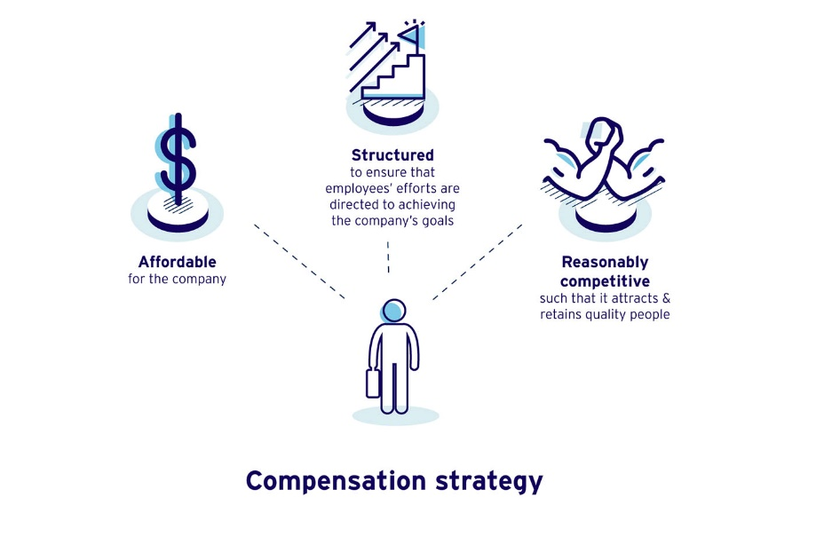
Figure 1.4 Compensation strategy
(MaRs, 2021)
In figure 1.2 we can see what the compensation strategy means for the organization and how this works.
Compensation in Amazon company
Amazon provide a set of considerable benefits that support employees and their family, a payment starts 18$ per hour (Balsam, 2002). Amazon company helps their employees through compensation and benefits, for a successful future. Employee health and wellness is first concern for the organization, they also offer 24/7 Amazon Care that provides medical prescription for all types of needs (2021).
Amazon encourages employees at all stages of their life and of the most important for them like parental leave, through a variety of benefits. The company offers six weeks for parents who adopt and as well 20 weeks of leave to births mother, because Amazon take care after their employees (Amazon, 2021).
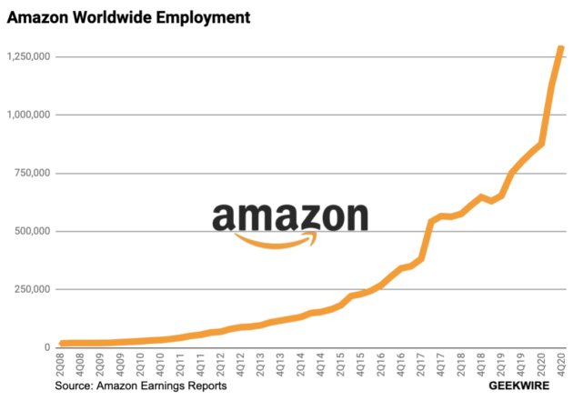
Figure 1.5
(GeekWire, 2021)
In figure 1.5 we can see how employment in Amazon company is growing, and that means how successful the company it is.
Leadership development
Leadership development is the operation which helps to improve the success of the company, with their employees, as well a good leader will always help and encourage their colleagues for a company success. (Gallagher, 2019)
Leadership development is an action that prepare leaders to execute successfully in their responsibilities, as well to improve their skills in:
- Strategy
- Project management
- Adept decisions
- Innovation
- Team management (Atwater & Bolea, 2016).

Leadership development is important because:
- Retain and attract good employees
- Improve financial performance
- Increase success of the company
- Developing and promoting people (Gallagher, 2019).
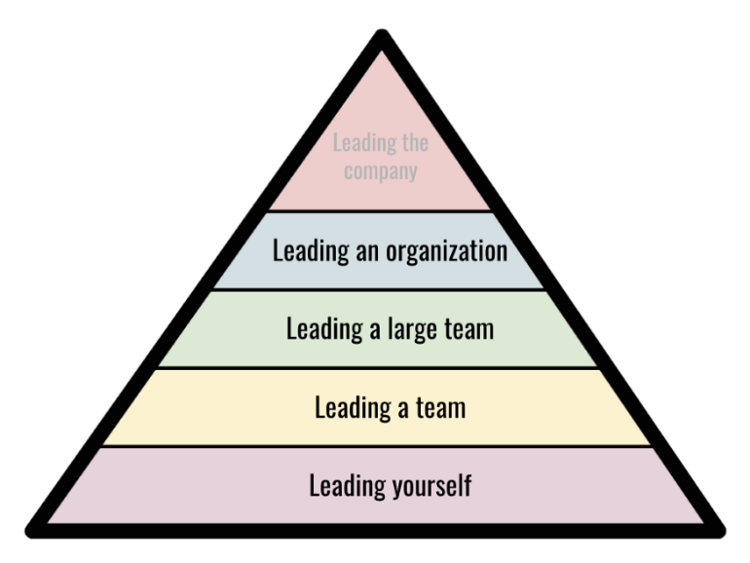
Figure 1.6 Leadership Development thorough scale
(Start it up, 2019)
In this Figure 1.6 we can see the levels of the Leadership Development in an organization
Leadership development in Amazon company
Amazon believes that everyone can be a leader and they always have things to learn, in the Leadership Development they include special programmes that help to become better leaders. As well Amazon company has its individual culture to hiring people, that we can see in figure 1.6. Leadership Development positions in Amazon are:
- IT Trainer
- Sales Trainer
- Instructional Designer
- Learning & Development Manager
- Technical Curriculum Developer. (Amazonjobs, 2021)
In Amazon company Leadership Principles are used every day like:
- Discussing ideas
- Implement new projects
- Solving problems. (2021)

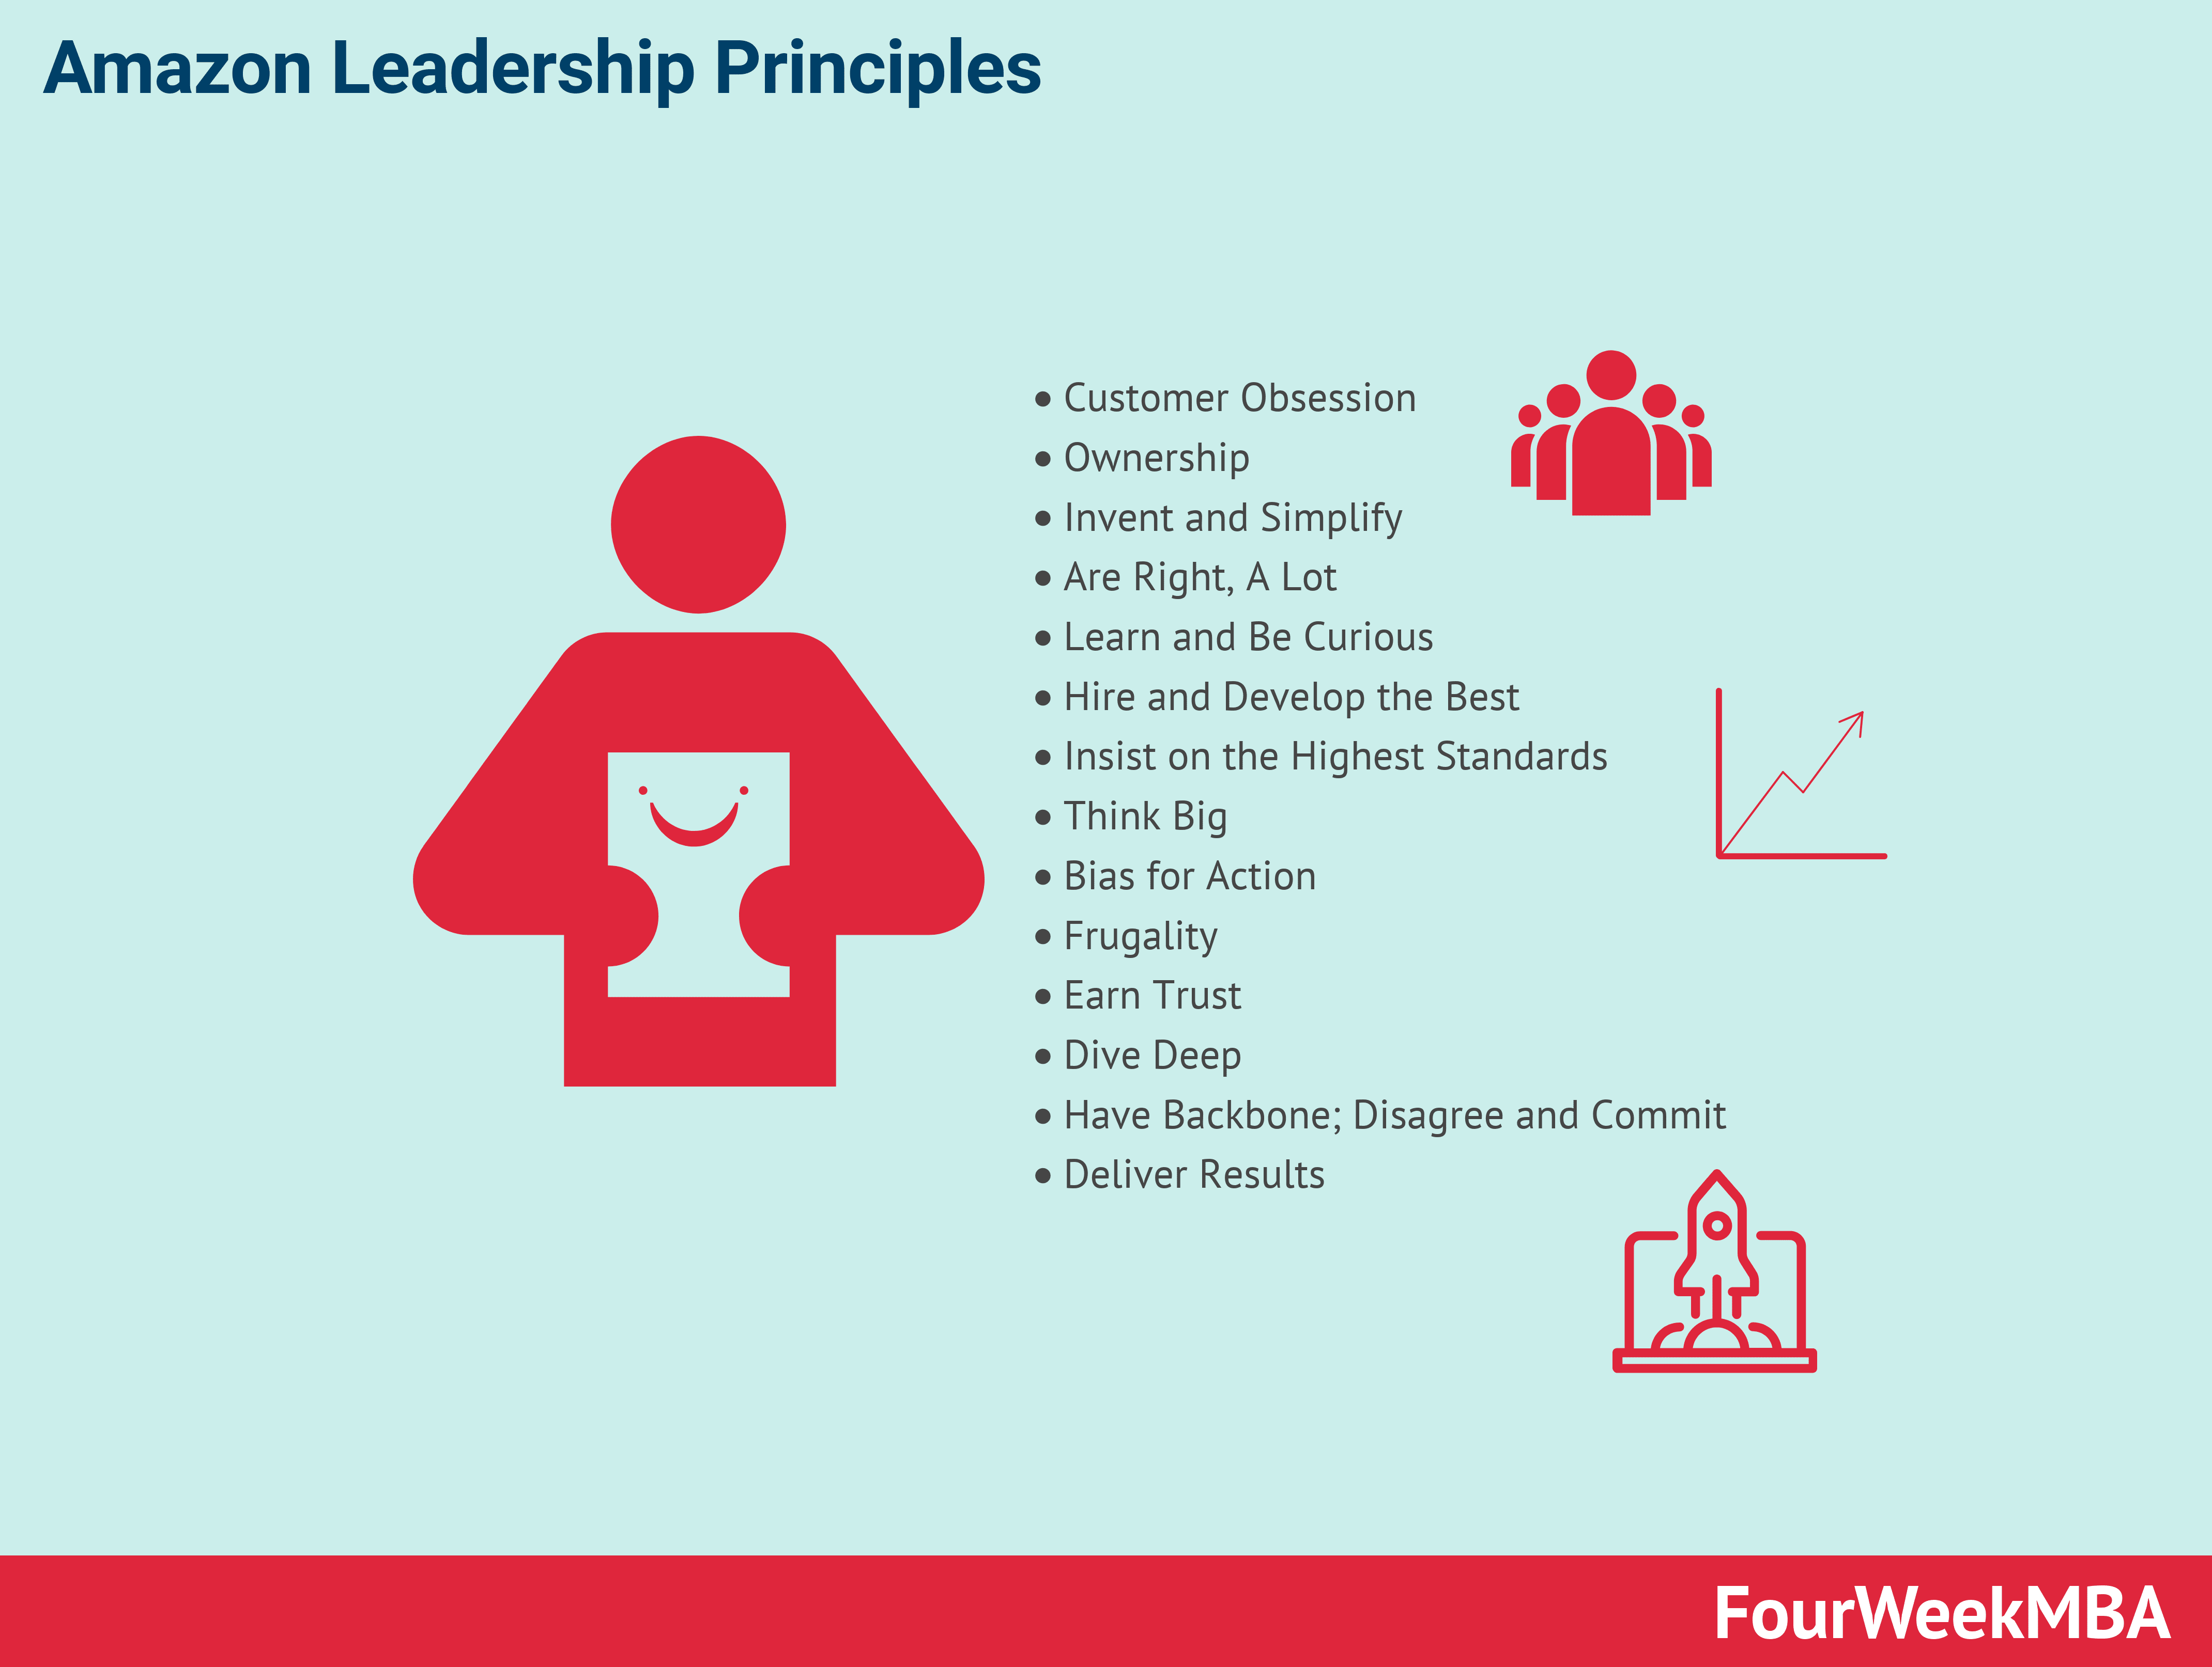
Figure 1.6 Amazon Leadership Principles created by the owner Jeff Bezos
In figure 1.6 we can see the most important leadership principles that are for Amazon company that makes the company strong and powerful compare with their competitors in the marketplace.
(2021)
Conclusion
It has been shown that human resource management are very important in the development of a company, big companies that operate their business mainly depend on their employees, that is the reason why the Amazon slogan is ‘’Work hard. Have fun. Make history’’ because is it only about employees and their willingness for work, and without people the Amazon company can’t exist.
Also studying these three factors:
- Change management
- Compensation
- Leadership development
It can be said that Amazon company works hard to motivate and encourage employees at the work place, and leadership in the company are doing all the best to support them actions.
To conclude, it can be said that without the help of human resource management, it would be harder for the company to carry on its business for a long time, because employees are important for Amazon, because people make history for the company success.
Recommendations
Like Human Resource Management Director of Amazon, it can be said that all the implementations for the development of the company are correct and right, but I will add some changes for a better appreciation for Amazon’s employees at work place.
The employees pay must be double paid for motivation and prosperity at work place, because Amazon people works hard and they need to be more appreciated. As well to give them some awards for good result at the work place, and this is the one of the changes that the Amazon can implement.
Depending on the success of the employees, everyone must to try to be a Human Resource Director in order to understand how Human Resource Department works. And this will be a challenge for each employee for a better communication and equality for all. And only like that each employee can feel how is to be a Human Resource Director and all the responsibility he has, and with these future recommendations for the Amazon company can have more success and prosperity.

References
AGS, 2021. Change Management Definition | 2021 | What You Need to Know. [Online]
Available at: https://www.airiodion.com/change-management-definition/
[Accessed 16 December 2021].
AIHR Academy, 2021. A Full Guide to Compensation and Benefits. [Online]
Available at: https://www.aihr.com/blog/compensation-and-benefits/
[Accessed 20 December 2021].
Amazon, 2021. Employee Benefits. [Online]
Available at: https://www.aboutamazon.com/workplace/employee-benefits
[Accessed 20 December 2021].
Amazonjobs, 2021. Leadership Development & Training. [Online]
Available at: https://www.amazon.jobs/en/job_categories/leadership-development-training
[Accessed 20 December 2021].
Atwater, L. & Bolea, A., 2016. Applied Leadership Development: Nine Elements of Leadership Mastery. 1nd ed. New York: Taylor&Francis.
Balsam, S., 2002. An Introduction to Executive Compensation. California: Academic Press.
Bausch, P., 2003. Amazon Hacks: 100 Industrial-Strengths Tips&Tools. 1nd ed. Sebastopol: O'Reilly&Associates, Inc.
Collings, D. & Wood, G., 2009. Human Resource Management: A critical approch. Oxon: Taylor&Francis e-Library.
Deb, T., 2006. Strategic Approach to Human Resource Management: Concept, Tools&Aplication. Delhi: Atantic Publisher&Distribuitors.
Edge, J., Edge, J. T. & Davis, M., 2004. Executive Compensation: The Professional's Guide to Current Issues and Practices. 1nd ed. San Diego: Windsfor Proffesional Information.
Gallagher, P. F., 2019. The Leadership of Change. 3nd ed. London: PFB Publishing.
GeekWire, 2021. Amazon now employs nearly 1.3 million people worldwide after adding 500,000 workers in 2020. [Online]
Available at: https://www.geekwire.com/2021/amazon-now-employs-nearly-1-3-million-people-worldwide-adding-500000-workers-2020/
[Accessed 20 December 2021].
Goddard, N., 2012. The Power of Awareness. 1nd ed. New York: Tribeca Books.
Gupta, I., 2020. Compensation and Benefits Manual - User Guide: For HR and C&B Professionals. 1nd ed. Mumbai: Independently Published .
Hiatt, J. M., 2006. ADKAR A Model for Change in Business, Government, and Our Community. 1nd ed. Colorado: Prosci Learning Center Publications.
InterstingEngineering, 2021. A Very Brief History of Amazon: The Everything Store. [Online]
Available at: https://interestingengineering.com/a-very-brief-history-of-amazon-the-everything-store
[Accessed 16 December 2021].
Loyalty Programs, 2021. Amazon Prime Loyalty program. [Online]
Available at: https://loyalty-programs.com/amazon-prime-loyalty-program
[Accessed 16 December 2021].
Marchingtom, M., Wilkinson, A., Donnely, R. & Kinighou, A., 2021. Human Resource Management at Work. 7nd ed. London: Kogan Page Limited.
MaRs, 2021. Employee compensation: Salary, wages, incentives and commissions. [Online]
Available at: https://learn.marsdd.com/article/employee-compensation-salary-wages-incentives-and-commissions/
[Accessed 20 December 2021].
Mortocchio, J. J., 2016. Strategic Compensation: A Human Resource Management Approach. 8nd ed. Ilinois: Pearsons Education.
Start it up, 2019. A Guide for Leadership Development through Scale. [Online]
Available at: https://medium.com/swlh/a-hierarchy-model-for-leadership-development-cee911071e4a
[Accessed 20 December 2021].
Strategy, 2021. Change Management Model. [Online]
Available at: https://strategyassociates.cc/change-management-model/
[Accessed 16 December 2021].
TheSun, 2018. Who founded Amazon, what’s the corporate slogan and where is the headquarters?. [Online]
Available at: https://www.thesun.co.uk/fabulous/5364575/who-founded-amazon-corporate-slogan-where-headquarters/
[Accessed 16 December 2021].
TL, P., 2021. Human Resource Management: The strategic approach to the effective and efficient management of people in a company or organization. Mumbai: Nestfame Creation Pvt. Ltd..

