

Managing People

Assessment Component 2

BA Business Management

LCBB5004

Student: Radu-Daniel Catrina 2123271
Lecturer: Abdi Rahman

Table of Contents

Introduction 2
Benefits of Implementing Flexible Working Strategies 2
The Advantages of a More Modular Work Schedule 2
Considerations for Implementing Flexible Working 3
Planned Flexibility in the Workplace 3
Guidelines and Feedback for Maintaining Productivity 4
Strategies to Promote Employee Engagement 4
Methods for Increasing Participation by Workers 4
Promoting Employee Engagement in Flexible Working Hours 5
Evaluating the Employee Value Proposition 6
Assessment of the EVP in the Workplace 6
Conclusion 6
References 7

Introduction
The COVID-19 pandemic has had a profound effect on how people work. As a result, there has been an increase in requests for flexible working hours from employees. This report will offer a critical analysis and evaluation of the advantages of implementing flexible working strategies into the organisation, what the company should take into account when implementing flexible working to the employee workforce, strategies to promote employee engagement while implementing flexible working, and how the firm can assess the employee value proposition in order to implement a pay structure.
According to App et al. (2012), it will also provide recommendations for the new human resource manager of the company. Also, the study will examine potential implementation-related difficulties and offer suggestions for overcoming them. It will also examine how flexible working affects productivity, job satisfaction, and turnover rates.

Benefits of Implementing Flexible Working Strategies

The Advantages of a More Modular Work Schedule
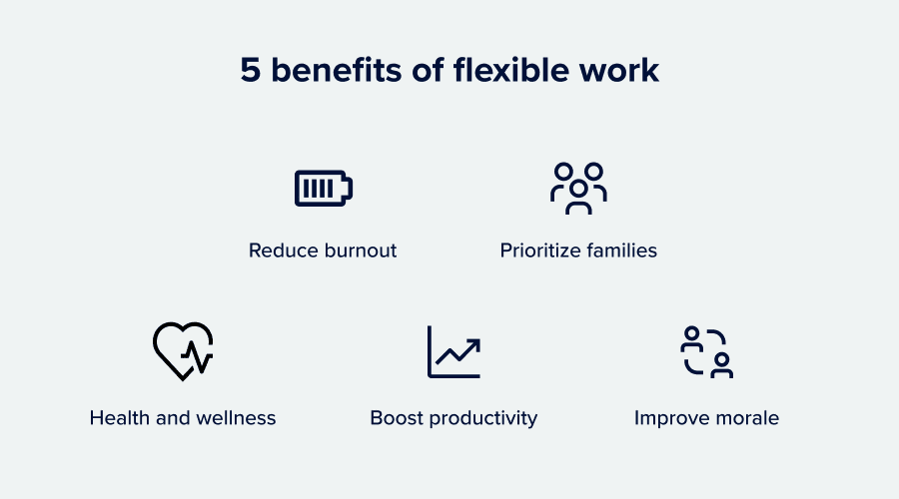
Figure 1: Benefits of Flexible Work (Dabirian et al., 2017)
Implementing flexible working strategies can bring a number of benefits to the organisation. These benefits include increased employee satisfaction and productivity, reduced absenteeism, and improved work-life balance. Furthermore, flexible working strategies can also help organisations attract and retain top talent by offering a more appealing work environment. It can also lead to cost savings for the organisation by reducing the need for office space and other resources. Additionally, flexible working can help attract and retain top talent, as it is becoming an increasingly important factor for job seekers.
Furthermore, offering flexible working options can also save companies money on overhead costs such as office space and utilities. Frow et al. (2011) concluded, it can also reduce traffic congestion and improve the environment by reducing carbon emissions from working. Moreover, providing employees with flexible working options can increase job satisfaction and employee retention rates. This can lead to a more productive and loyal workforce, ultimately benefiting the company's bottom line.
For starters, flexible working can help employees improve their satisfaction and work-life balance. This is because flexible working arrangements can give employees more control over their work schedules, allowing them to better balance their personal and professional commitments. Secondly, flexible working can help to attract and retain talent. In fact, studies have shown that offering flexible working arrangements can improve employee satisfaction and productivity. Additionally, it can also lead to cost savings for employers by reducing office space and other overhead expenses. This is especially relevant in today's world, where many employees are seeking a better work-life balance and remote work options. Also, because individuals can work when they are most productive and are not constrained by commute times, remote work has the potential to boost productivity (Frow et al., 2014). However, it is important for employers to establish clear communication channels to ensure effective collaboration and teamwork. By offering flexible arrangements, employers can attract and retain top talent while also benefiting from increased efficiency and reduced costs. By offering flexible working arrangements, the organisation can differentiate itself from competitors and appeal to job seekers who value work-life balance. Thirdly, flexible working can lead to increased productivity. Studies have shown that employees who have more control over their work schedules are more engaged and productive.

Considerations for Implementing Flexible Working

Planned Flexibility in the Workplace
When implementing flexible working, there are a number of factors that the firm should consider. These include the needs and preferences of employees, the effect on productivity and communication, the availability of technology to support remote work, and the possible legal and regulatory effects. Additionally, the firm should also consider the potential impact on company culture and the need for clear policies and guidelines to ensure consistent implementation and management of flexible working arrangements.
Gilani et al. (2017) argued, it is important to strike a balance between meeting employee needs and maintaining organisational effectiveness. It is also important for the firm to establish clear guidelines and expectations for flexible working arrangements, as well as to provide training and support for managers and employees. Also, regular evaluation and feedback can help make sure that the flexible working policy is meeting the needs of both the company and its employees. It's also important to set clear rules and policies so that flexible work arrangements are fair and the same for everyone. This can help prevent any misunderstandings or conflicts that may arise. Additionally, offering training and support for managers and employees can ensure that everyone is equipped to effectively navigate the flexible work environment. First, it's important to make sure that the flexible work arrangements fit with the culture and values of the organisation. Secondly, it is important to ensure that the flexible working arrangements are fair and equitable across the organisation. This can be achieved by establishing clear guidelines and policies for flexible working arrangements and ensuring that all employees have access to these opportunities.
Regular communication and feedback from employees can help identify any issues or concerns with the implementation of flexible working arrangements. This means that all employees should have access to flexible working arrangements, and there should be clear guidelines and policies in place to ensure that flexible working is managed fairly. Thirdly, it is important to ensure that there is clear communication and training in place to support the implementation of flexible working arrangements (Grilo et al., 2010). This can help to ensure that employees understand how to use the arrangements and that managers are equipped to manage flexible working effectively.

Guidelines and Feedback for Maintaining Productivity
Providing regular feedback and support to employees who work flexibly can also help to maintain productivity and engagement. It is important for organisations to establish clear guidelines and policies regarding flexible working arrangements to avoid confusion and misunderstandings. Additionally, training programs can be implemented to educate both employees and managers on the benefits and challenges of flexible work. This can foster an environment of trust and accountability where workers feel free to work in a way that meets their needs while still advancing the objectives of the company. Mandhanya et al. (2010) said, by doing so, organisations can attract and retain top talent, improve employee satisfaction and productivity, and ultimately achieve greater success. Also, establishing clear guidelines and policies around flexible working can promote consistency and fairness in the workplace.
According to Graffigna (2017), regular feedback and evaluation of the flexible working arrangements can also help to identify any issues or areas for improvement, allowing for adjustments to be made and ensuring that the arrangements continue to benefit both employees and the organisation as a whole.

Strategies to Promote Employee Engagement

Methods for Increasing Participation by Workers
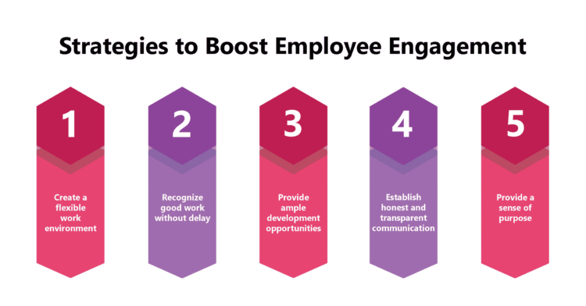
Figure 2: Strategies to Boost Employee Engagement (Patala et al., 2016)
Implementing flexible working arrangements can have a significant impact on employee engagement. It is important to communicate the benefits of flexible working and encourage open communication between employees and managers to ensure that everyone is on the same page. In addition, providing opportunities for professional development and growth can also increase employee engagement. This can include offering training programs, mentorship opportunities, and career advancement paths within the company. Payne et al. (2017) concluded, providing training and support for managers can also help them effectively manage their teams in a flexible working environment.
No matter where employees work, firms can boost employee engagement and productivity by putting these methods into practice. They can also improve communication between staff members and management to make sure that everyone is on the same page. In addition, providing opportunities for professional development and growth can also increase employee engagement. This can include offering training programs, mentorship opportunities, and career advancement paths within the company. Providing training and support for managers can also help them effectively manage their teams in a flexible working environment. By implementing these strategies, companies can create a culture of trust and collaboration that fosters employee engagement and productivity, regardless of where employees work. Additionally, offering flexible work arrangements can help companies attract and retain top talent who value work-life balance (Priyadarshi, and P., 2011).

Promoting Employee Engagement in Flexible Working Hours
In order to promote employee engagement while implementing flexible working, there are a number of strategies that the firm can consider. These strategies may include regular communication with remote workers, setting clear expectations and goals, offering flexible scheduling options, and providing access to necessary technology and resources. Furthermore, creating a culture of trust and accountability can also be beneficial in promoting successful flexible working arrangements. Setting clear objectives, developing communication protocols, and routinely checking in with staff members to make sure they have the tools and support they need to succeed are a few of these techniques.
Providing flexible work options can increase employee satisfaction and productivity while also assisting in luring and keeping top talent. First and foremost, it's crucial to guarantee that staff members have access to the technology and resources they need to work remotely. This can include providing employees with laptops, mobile phones, and access to collaboration software. Secondly, it is important to ensure that employees have access to regular communication and feedback.
This can help to maintain productivity and a sense of connection with the company, even when working remotely. Additionally, providing training and support for remote work can help employees feel more confident and capable in their roles (Shuck & Rocco, 2013). This can include regular check-ins with managers and opportunities for team meetings and social events.
It is important to ensure that employees have access to learning and development opportunities. Providing training programs and mentoring opportunities can help employees grow in their roles and feel valued, leading to increased job satisfaction and retention rates. The ability to work remotely or on a flexible schedule is another flexible work option that can boost employee morale and work-life balance. This might help to make sure that workers keep improving their abilities and feel appreciated by the company. By giving employees the chance to learn and grow, employers can boost retention rates and boost general job satisfaction as employees feel encouraged to further their careers. Also, it may result in a staff that is more qualified and skilled, which would ultimately be advantageous to the organisation.

Evaluating the Employee Value Proposition

Assessment of the EVP in the Workplace
The employee value proposition (EVP) refers to the benefits and rewards that an organisation offers to employees in exchange for their skills and expertise. Evaluating the EVP is crucial for organisations to attract and retain top talent. Srivastava et al. (2010) stated, a strong EVP can also enhance employee engagement and productivity, as it communicates the company's commitment to supporting and valuing its workforce. Therefore, organisations must regularly review and update their EVP to ensure it remains competitive and aligned with employees' evolving needs and expectations. It helps to ensure that the benefits and rewards offered are aligned with employees' needs and expectations, ultimately leading to increased job satisfaction and productivity. In addition, a strong EVP can also improve an organisation's employer brand and reputation, making it more attractive to potential candidates and enhancing its competitive advantage in the job market. Therefore, companies should regularly review and update their EVP to keep up with changing employee needs and market trends (Sirisetti, 2012). This can involve conducting surveys, focus groups, and other forms of feedback to gather insights and make necessary adjustments.

As such, regularly assessing and updating the EVP is essential for organisations to stay relevant and appealing to current and future employees. When evaluating the EVP in order to implement a pay structure, there are a number of factors that the firm should consider. Firstly, it is important to ensure that the EVP is aligned with the organisation's culture and values. This means that the benefits and rewards offered should reflect the organisation's commitment to its employees and its broader goals and objectives. Secondly, it is important to ensure that the EVP is competitive in the market. This means that the benefits and rewards offered should be comparable to those offered by other organisations in the industry (Tursunbayeva et al., 2018).
Finally, it is important to ensure that the EVP is tailored to the needs and preferences of the organisation's employees. By doing so, the organisation can attract and retain top talent, increase employee engagement and productivity, and ultimately achieve its business objectives.

Conclusion
Implementing flexible working arrangements can bring a number of benefits to the organisation, including improved job satisfaction, the attraction and retention of talent, and increased productivity. However, it is important for employers to carefully consider the potential challenges and drawbacks of flexible working, such as maintaining communication and collaboration among team members, ensuring fair workload distribution, and addressing any issues related to data security and confidentiality. By doing so, organisations can successfully leverage the advantages of flexible working while mitigating its potential risks.

References
App, S., Merk, J. and Büttgen, M., 2012. Employer branding: Sustainable HRM as a competitive advantage in the market for high-quality employees. Management revue, pp.262-278.
Dabirian, A., Kietzmann, J. and Diba, H., 2017. A great place to work!? Understanding crowdsourced employer branding. Business horizons, 60(2), pp.197-205.
Frow, P. and Payne, A., 2011. A stakeholder perspective of the value proposition concept. European journal of marketing, 45(1/2), pp.223-240.
Frow, P., McColl-Kennedy, J.R., Hilton, T., Davidson, A., Payne, A. and Brozovic, D., 2014. Value propositions: A service ecosystems perspective. Marketing theory, 14(3), pp.327-351.
Gilani, H. and Cunningham, L., 2017. Employer branding and its influence on employee retention: A literature review. The marketing review, 17(2), pp.239-256.
Graffigna, G., 2017. Is a transdisciplinary theory of engagement in organized settings possible? A concept analysis of the literature on employee engagement, consumer engagement and patient engagement. Frontiers in psychology, 8, p.872.
Grilo, A. and Jardim-Goncalves, R., 2010. Value proposition on interoperability of BIM and collaborative working environments. Automation in construction, 19(5), pp.522-530.
Mandhanya, Y. and Shah, M., 2010. EMPLOYER BRANDING-A TOOL FOR TALENT MANAGEMENT. Global Management Review, 4(2).
Patala, S., Jalkala, A., Keränen, J., Väisänen, S., Tuominen, V. and Soukka, R., 2016. Sustainable value propositions: Framework and implications for technology suppliers. Industrial Marketing Management, 59, pp.144-156.
Payne, A., Frow, P. and Eggert, A., 2017. The customer value proposition: evolution, development, and application in marketing. Journal of the Academy of Marketing Science, 45, pp.467-489.
Priyadarshi, P., 2011. Employer brand image as predictor of employee satisfaction, affective commitment & turnover. Indian Journal of Industrial Relations, pp.510-522.
Shuck, B. and Rocco, T.S., 2013. Human resource development and employee engagement. In Employee engagement in theory and practice (pp. 130-144). Routledge.
Sirisetti, S., 2012. Employee engagement culture. Journal of Commerce (22206043), 4(1).
Srivastava, P. and Bhatnagar, J., 2010. Employer brand for talent acquisition: An exploration towards its measurement. Vision, 14(1-2), pp.25-34.
Tursunbayeva, A., Di Lauro, S. and Pagliari, C., 2018. People analytics—A scoping review of conceptual boundaries and value propositions. International Journal of Information Management, 43, pp.224-247.

