Pel Fordham
20.10.21

Augustan Love Elegy
Propertius 1.5.1-10 translation

You madman, what do you want - to feel my rages?
You ill-fated man, hurrying to know the worst of evils,
And to walk wretched through fires of which you have no knowledge,
And to drink the poisons from all of Thessaly.

She is incomparable, she is not similar to inconstant girls:
She knows not to be mildly angry with you.
Because if by chance she is not opposed to your wishes
She will instead give you as much as a thousand problems!
For there will be no sleep for you, she will not forsake your eyes:
That cruel one fetters the courage of men. [this is probably too idiomatic as I know that viros is not genitive but I couldn’t get the sense out of it otherwise..]

Commentary on Tibullus 1.1.1-32

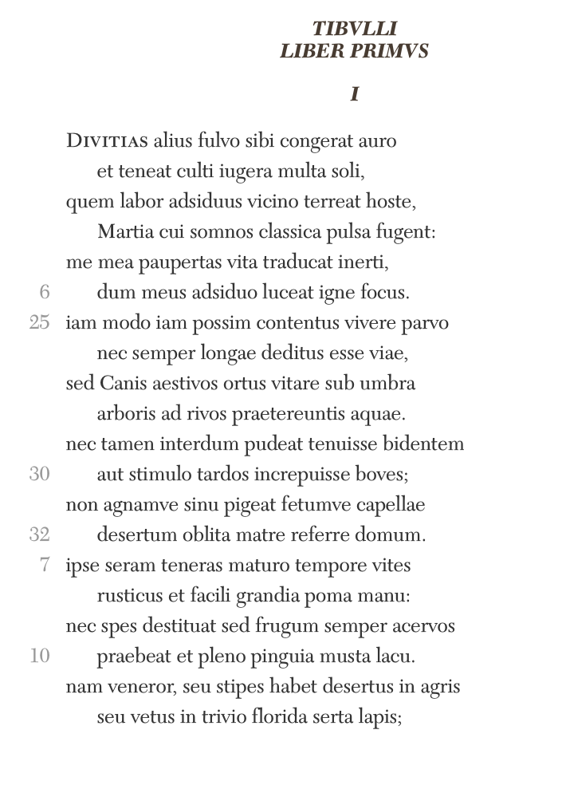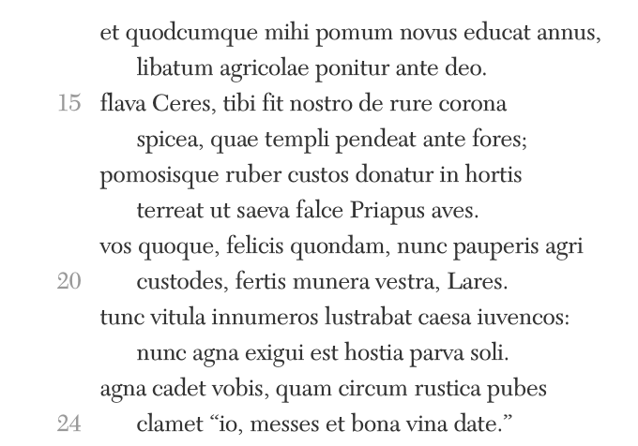

Key Points for a commentary

Pseudo-autobiographical information
l.1 ‘alius’ Tibullus’s emphatic opening line teasing the reader to question who is ‘alius’. Putnam [1980, p.133] believes that Tibullus is referring to Messala and Tibullus’s ‘own past acquisitive self.’

l.5 ‘mea paupertas’: ‘a man of moderate means’ although evidence to the contrary suggests that this is relative: Tibullus was not poor.

l.26 ‘nec semper longae deditus esse viae’: indicates former military experience. Lyne [1980, p.157] interprets this as Tibullus being a victim of events, i.e., not choosing a military life and therefore revealing his passivity.

Augustan values
1.Piety expressed in lines 11-22; to Ceres, Priapus and Lares (Lares are the spirits of dead ancestors who keep watch on household). Tibullus addresses Ceres (goddess of corn, agriculture) four times throughout his Elegies whereas he is not mentioned by Propertius. Priapus, a god associated with sexuality, fertility, gardens and herds, son of Dionysus and Aphrodite, in statues he was depicted ‘as a grotesque deformed creature with a phallic symbol’ [Harvey 1984, p.345] not mentioned by Propertius while Tibullus addresses 1.4 to him – a poem in which Priapus is invited to give advice on how to win a male lover. Allusions to Priapus were common in Hellenistic literature.

Lyne [1980, p.156] suggests that the use of present indicative tenses in lines 11-22 is Tibullus affirming his continuing attention to ‘protecting the deities on the farm.’

2.Simplicity. Critics disagree on whether or not Tibullus is describing a pastoral e.g., ‘Tibullus really does want to live on his farm in rustic simplicity – it’s not an idyll that he’s dreaming of escaping to’ [Lyne 1980, p.155] whereas Veyne [1988, p.143] infers that, ‘Tibullus’s elegy is a dreamlike pastoral… Elegy becomes a pastiche of bucolic in the first person …’ Veyne [1988, p.143] argues persuasively that Tibullus’s use of the subjunctive in 1.1 gives his writing ‘a half-reality, an absence of decisive features as its model, so that subjunctives and future tenses fall naturally from his pen…’

Pastoral theme & Intertexts
Putnam [2005, p.135], ‘Tibullus is .. reimagining.. a georgic world’
Veyne [1988, p.143], ‘The rural theme here has the same semiotic role as mythology does in Propertius.’

Numerous Intertexts with Vergils’s Eclogues and Georgics, both with Hellenistic influences.

Militia Amores
Military language introduced in the first eight lines, ‘hoste’, ‘classica pulsa’, ‘longae viae’. Cairns [1979, p.17], also suggests that ‘adsiduus.. had a special association in etymological contexts with soldiers… Tibullus exploits these etymologies to enhance the contrast between the adsiduus labor of the soldier and his own hearth with its adsiduo igne.’ Conflict in love evoked by military language.

Conflict
Ruth Parkes seminar, ‘inconsistency is a key feature of elegy.’

Roman farming life as a ‘symbol of a good, moral life’ vs Tibullus’s representation of it as being one of ‘careless otium.’ [Lyne 1980, p.155]

While extolling the charms of simple life Tibullus suggests that it is actually beneath him, ‘nec.. pudeat.. nec pigeat’ (l.29-31)

l.26 viae – vias l.52
Beginning of 1.1. Tibullus implies that he is relinquishing long journeys to lead a simple rural life; towards the end of 1.1 he reveals that his desire for stillness is to protect his mistress from being lovesick

l.5 inerti – inersque l.58
The implied respectability of ‘vita inerti’ [a life of ease] in l.5 develops into an insult in l.58 [indolent] as it is coupled with ‘segnis’, but, an insult that Tibullus welcomes ‘quaeso vocer’.

l.8 facili manu – facili luto l.40
‘with nimble hand’ suggests the writer’s skill and links himself to the antiquus agrestis in l.40 who makes earthenware pots ‘from pliant clay’ – perhaps hinting at his roots in Hellenistic [as in ‘antiquus’] poetry

l.4 classica pulsi – signa tubaeque l.75
the trumpet signals frame the opening and closing lines of 1.1: begins with a rejection of military life in favour of rural retirement but ends with a rejection of them in favour of the pursuit of love

l.9 acervos – acervo l.79
Tibullus maintains the theme of ‘heaped corn’ with the uncertainty (use of subjunctive) of l.9 ‘nec Spes destituat’ finally banished by l.79 ‘ego .. securus’. Tibullus confident that Spes is on the side of Amor.

Bibliography

Cairns, F. (1979) Tibullus: A Hellenistic Poet at Rome. Cambridge: Cambridge University Press.
Harvey, P. (1984) The Oxford Companion to Classical Literature. Oxford: Oxford University Press.
Lyne, R. (1980) The Latin Love Poets. Oxford: The Clarendon Press.
Putnam, M.C.J. (2005) ‘Virgil and Tibullus 1.1’, Classical Philology, 100, pp.123-41.
Veyne, P. (1988) Roman Erotic Elegy. Chicago and London: The University of Chicago Press.

