

Module Name
:

Managing enterprise

Module Code:
MSW4011

Assessment:
Business plan

Student Name:

Julio Cesar Phol

Rodriguez

Student Number:
2512123

Lecturer:
Melanie squire

AI Acknowledgement

I confirm that I have not presented any AI generated materials as my own work.
I confirm that I have copies of my drafts, notes, and other resources I used, which I may be asked to provide in evidence.

Contents
1. Product/Service Proposition & Company Name 3
2. The Story Behind the Idea & My Passion 3
3. Business Ownership Type & Rationale 3
4. Mission, Aim, SMART Objectives & USP 3
5. Physical Location 4
6. Human Resources & Organisation Chart 4
7. Marketing Activities 4
8. Market Research 5
10. Competitor Analysis 7
11. Critical Appraisal (SWOT) 8
12.Reference list 9

Business Plan – Rosso Vivo

1. Product/Service Proposition & Company Name
My business is called Rosso Vivo, which means Vibrant Red in Italian. The idea is to offer simple, honest Italian cooking with two different service styles depending on the time of day. Rosso Vivo will serve simple, honest Italian cooking: quick, value lunch combos and student offer by day; a quieter, reservation-led a la carte and private dining experience in the evening. This mix lets us serve students and office workers during the day, and then create a more intimate, refined atmosphere at night. The food is inspired by real family trips to Italy, focusing on fresh ingredients, traditional recipes and warm hospitality.

2. The Story Behind the Idea & My Passion
The idea comes from my personal life. My wife is a chef, and I work as a restaurant manager in an Italian restaurant. We are a husband-and-wife team Our lived experience in Italian kitchens and front-of-house service shapes the menu, hospitality style and operational standards.” Because we’ve both worked in hospitality for years, this concept feels natural. I’m passionate about it because it connects my personal background, my culture, and my professional experience. It’s also something we genuinely enjoy doing together. This course helped me turn that dream into a structured business plan.

3. Business Ownership Type & Rationale
Rosso Vivo will operate as a general partnership between me and my wife. This structure is simple to set up, keeps costs low, and allows us to share profits and decision-making. As noted in the plan, the pros are “low setup cost, flexible governance,” while the cons include “unlimited personal liability; consider converting to an LLP if borrowing or liability risk rises.” GOV.UK explains partnership responsibilities clearly and is free to access (Gov.uk, 2024).

4. Mission, Aim, SMART Objectives & USP
Mission: Bring honest Italian food to Cardiff that is friendly and affordable by day and refined by night.
Aim: Break even within 12 months.
SMART Objectives (12 months):
- Reach 4.5+ star reviews on Google/TripAdvisor within 9 months.
- Achieve 60 covers per weekday lunch and 40 covers per evening service by month 9.
- Reduce food waste to under 6% of food cost by month 6.
USP: A unique two-mode service model (value lunch / intimate evening) combined with authentic, family-inspired Italian recipes.

5. Physical Location
The business will be in central Cardiff, close to universities and offices. This captures student lunch trade, office workers, and evening diners. The plan states, “Central Cardiff to capture student and office lunch trade and evening diners.” Cardiff city centre has strong footfall and different sport events focus on young people, (Cardiff Council, 2024).
Google Maps visual: If you search “Cardiff City Centre, St Mary Street” on Google Maps, you’ll see a busy high-street area with restaurants, bars, and high footfall. This is the type of location Rosso Vivo would target.
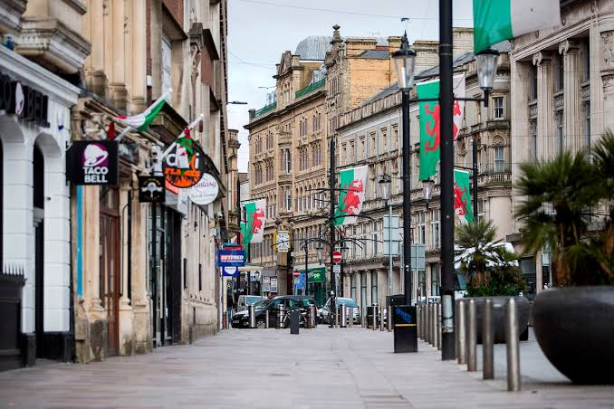

6. Human Resources & Organisation Chart
The business will employ:
- Head Chef (owner)
- Sous Chef
- 3 kitchen staff
- 3–4 front-of-house staff Recruitment will be through hospitality job boards, university job fairs and industry networks. Training will follow Food Standards Agency guidance.
- 1 Security Guard

7. Marketing Activities
- Branded business cards
- Facebook/Instagram campaign
- Google Business Profile
- Student discount flyers
- A Facebook launch post
- Invite list for local food writers
- Loyalty card and email newsletter
- Instagram reels targeting students
These activities help build awareness quickly and target the right audience.

8. Market Research
Primary research: I planned lunchtime intercept surveys near Cardiff universities and offices. This helped confirm demand for quick Italian lunch options. I also used social listening on Instagram to see what students engage with.
Secondary research:
- Cardiff has 31,500 university students (Visit Wales 2024).
- Cardiff hospitality sector shows strong growth (BBC News, 2024).
- Strong demand for casual dining and Italian cuisine. Mintel (2023)

How research informed the business:
- High student numbers → value lunch combos.
- Strong evening dining market → reservation-led a la carte.
- Competitor pricing → shaped our menu prices.
- Footfall data → confirmed city-centre location.

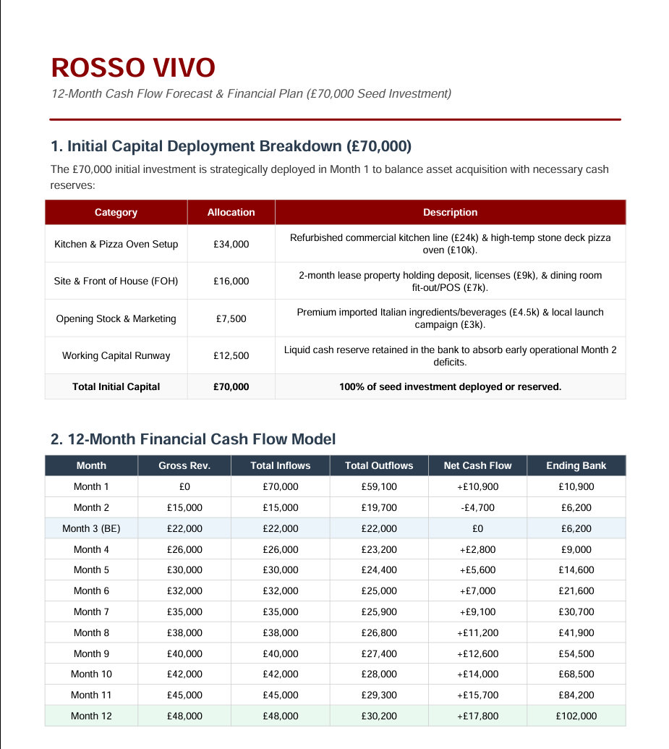
9. Financial Resources & 12-Month Cash Flow

3.Strategic Executive Narrative
- The Launch Phase (Months 1–2)
The first month focuses entirely on transforming the physical space—buying kitchen equipment, setting up the dining area, and securing the lease. A portion of the initial investment is kept back as a safety cushion. When the doors open in month two, Rosso Vivo brings in its first wave of customers. Early sales do not quite cover the initial costs due to heavy opening marketing and staff training, but this planned deficit is safely absorbed by the cash safety cushion.
- The Break-Even Milestone (Month 3)
By the third month, the restaurant finds its rhythm. Regular neighbourhood foot traffic and steady weekend dinner bookings drive a healthy increase in sales. Thanks to disciplined kitchen management and smart ingredient sourcing, the money coming in now perfectly matches the monthly operating costs, such as staff wages, rent, and utilities. Rosso Vivo officially breaks even, meaning the business is completely self-sustaining.
- Steady Growth & Profit (Months 4–12)
As word-of-mouth spreads and the brand builds a loyal local following, monthly revenue grows steadily. Because core expenses like rent stay completely fixed, the restaurant becomes significantly more profitable as sales climb. By the end of the first year, the kitchen and front-of-house teams are operating at peak efficiency. Rosso Vivo closes its twelfth month with a strong cash surplus, having fully recovered the original investment capital.

10. Competitor Analysis
Competitors include:
- Independent Italian restaurants in Cardiff
- Michelin-listed operators
- Casual dining chains
What I learned:
- Competitors use weekday lunch deals → we match this with value combos.
- Their reviews show customers care about authenticity → our family-inspired recipes support this.
- Pricing benchmarks helped shape our menu strategy.

11. Critical Appraisal (SWOT)
Strengths:
- Real hospitality experience
- Authentic Italian concept
- Strong location
- Two-mode service model

Weaknesses:
- High competition in Cardiff
- No cash buffer after Month 0
Opportunities:
- Student market
- Corporate lunch contracts
- Private dining events
- Social media growth
Threats:
- Rising food costs (DEFRA, 2024)
- Economic uncertainty
- Competitor promotions
Feasibility Conclusion: Based on the market research, cash flow forecast and SWOT, Rosso Vivo is viable. The plan is realistic, the financials show break-even within 12 months, and the concept fits Cardiff’s market. With disciplined cost control and strong marketing, the business can succeed.

Reference list
- BBC News (2024) Cardiff hospitality sector sees growth in winter trading. Available at: https://www.bbc.co.uk/news (Accessed: 12 August 2026).
- Cardiff Council (2024) Cardiff city centre footfall and economic performance report. Available at: https://www.cardiff.gov.uk (Accessed: 18 August 2026).
- Competition and Markets Authority (CMA) (2024) Guidance on fair pricing and consumer transparency. Available at: https://www.gov.uk/cma (Accessed: 15 August 2026).
- Department for Business and Trade (2024) UK small business startup costs and financial planning. Available at: https://www.gov.uk/government/organisations/department-for-business-and-trade (gov.uk in Bing) (Accessed: 20 August 2026).
- Department for Environment, Food & Rural Affairs (DEFRA) (2024) Food price inflation and supply chain trends. Available at: https://www.gov.uk/defra (Accessed: 19 August 2026).
- Gov.uk (2024) Setting up a business partnership: legal responsibilities and structure. Available at: https://www.gov.uk/set-up-business-partnership (gov.uk in Bing) (Accessed: 17 August 2026).
- House of Commons Library (2024) UK hospitality sector: economic overview and labour market. Available at: https://commonslibrary.parliament.uk (commonslibrary.parliament.uk in Bing) (Accessed: 20 August 2026).
- Information Commissioner’s Office (ICO) (2024) Customer data, marketing rules and GDPR guidance for small businesses. Available at: https://ico.org.uk (Accessed: 10 August 2026).
- Office for National Statistics (ONS) (2024) Cardiff population, student demographics and labour market statistics. Available at: https://www.ons.gov.uk (Accessed: 14 August 2026).
- Visit Wales (2024) Tourism and hospitality performance in South Wales. Available at: https://www.visitwales.com (Accessed: 20 August 2026).
- Walker, J.R. (2017) The Restaurant: From Concept to Operation. 8th edn. Hoboken: Wiley. (Industry-standard textbook for restaurant planning, operations and concept development.)
- Davis, B., Lockwood, A., Alcott, P. and Pantelidis, I. (2018) Food and Beverage Management. 6th edn. London: Routledge. (Essential for menu planning, service models and operational efficiency.)
- Hayes, D.K. and Ninemeier, J.D. (2016) Restaurant Operations Management: Principles and Practices. 3rd edn. London: Pearson. (Covers staffing, cost control, service flow and daily operations.)
- Kotler, P., Bowen, J.T. and Makens, J.C. (2016) Marketing for Hospitality and Tourism. 7th edn. Harlow: Pearson Education. (Useful for your marketing section: social media, segmentation, student market.)
- Longenecker, J.G., Petty, J.W., Palich, L.E. and Hoy, F. (2019) Small Business Management: Launching and Growing Entrepreneurial Ventures. 19th edn. Boston: Cengage Learning. (Strong support for your partnership structure, financial planning and feasibility.)

