
Module Name
Organisational Consultancy (M6X01422)
Name: Wei He
Student Number: 1900504
Research on Transportation Management Strategies of United Parcel Service
08/05/2020
Table of Contents

1.0 Executive Summary 1
2.0 Introduction 2
2.1Research background 2
2.2 Research significance 3
2.3 Ideas and methods 3
3.0 Findings 4
3.1 Transportation Strategy of United Parcel Service 4
3.2 Information Technology of Freight Management 7
3.3 Marketing strategy of UPS 8
4. 0 Analysis of Marketing Strategy of UPS Company 9
4.1 SWOT Analysis 10
5.0 Discussion 11
6.0 Conclusion 16
7.0 References 17

1.0 Executive Summary
United Parcel Service (UPS) is the world's largest parcel delivery service, founded in 1907. UPS is a famous provider of global supply chain management solutions. The United Parcel Service (UPS) took the 132nd place in the 2019 Fortune Global 500 lists and was ranked no. 1 among the top 10 global logistics companies in 2019(Vernon,2019). Hence it is good to be selected as research object to see its operating strategy and how transportation strategy makes the success as one of the biggest logistics company in USA.
In this thesis, I will study the freight strategy of United Parcel Service in the United States, focusing on the three aspects of freight management, which are demonstrating UPS’s history and development, Transportation Strategy of United Parcel Service and SWOT analysis based on this enterprise to figure out its opportunities and challenges in its marketing environments. Besides, the advantages and disadvantage of the UPS transportation management will be also illustrated and based on the organization consultancy, I will give some operational recommendations for this logistics company and experience for other companies in the same industry.

2.0 Introduction

2.1Research background
United Parcel Service (UPS) is one of the four international giants in the logistics industry, the world's largest courier agency, and a professional transportation and logistics service provider(Armstrong, 2016). UPS has a wealth of experience in marketing, and has unique methods in terms of products, prices, channels, promotions, public relations, and personnel sales. As UPS CEO Scott Davis said in an exclusive interview with Wharton Business School, he pointed out that whenever the company faces a new technical challenge, they will transform their business again and it is constant changing that makes us success today(Manzini, 2018). Powerful network support, advanced IT system, well-trained staff, clear and simplified processes, smart transportation strategy and continuous innovation of customer solutions are precisely these factors that lead to UPS today's success. So it is necessary to analyze and learn many effective and successful strategies and patterns from UPS company.

We will be focusing on the operating pattern and logistics of UPS in the worldwide and the domestic market. UPS company has high quality and diverse services and a wide range of services, making it a common choice for consumers in their daily logistics needs. The United Parcel Service is the number one global logistics enterprise in which the company has a set of systems for freight management strategy. Whether it be a transit point set, line planning, or transportation equipment configuration, provide consumers with better service, ready to the final step in logistics services, is also the most crucial step. Nowadays, many of the existing logistics companies do not pay much attention to the last stage of consumer contact, that is, freight transportation, resulting in a constant stream of bad reviews and no return business(Susan, 2017). This study, by understanding the current situation of freight management and sorting out the superior freight strategy of united parcel service, can effectively improve the level and performance of logistics enterprises and promote the sales to some extents.

2.2 Research significance
The success of the United Parcel Service comes from a mature operating model, and transportation management is one of the essential links. Therefore, this topic is selected to study the freight transportation strategy of the United Parcel Service of the United States. Recognizing the excellence of the United Parcel Service and analyzing its advantages and characteristics can better compare and find out its own shortcomings, seek new opportunities and then improve the system, regain the market and finally achieve business goals.

2.3 Ideas and methods
Here I first use literature research method which will access plenty of primary data and secondary data to understand what other authors can collect and draw upon. Then, I use both qualitative and quantitative method. Qualitative method is used to describe how UPS integrates its resources and distribute the system to make sure all the sections working together and guarantee the efficiency and correction. While the quantitative method is used to demonstrate the change and trend of numbers of the freight management system, clarify the development status of the United Parcel Service, combing qualitative method to fully explain related theoretical knowledge of freight management. The structure of this research is shown as Figure 1.

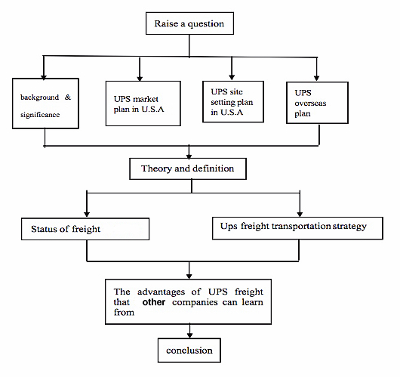
Figure 1 The structure of this research

3.0 Findings

3.1 Transportation Strategy of United Parcel Service
UPS company's worldwide business is basically divided into express business, global supply chain solutions and freight business and among them, the most core business is express delivery. As Figure 2 below shown, the revenues of UPS in 2014 is $58.2 billion and after that, it clearly shows a constant increase in the next years, estimated up to $78.4 billion in 2020, then keep increasing. Among them, and the turnover of express delivery business was 48.8 billion U.S. dollars, accounting for 84% of the total turnover(Bram,2018). UPS’s experienced staff can use an extensive network of transportation models to design practical solutions for consumers including air transport and a full range of global ocean freight and transportation services(Pearce, 2015).
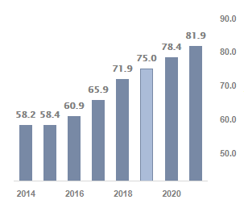
Figure 2 UPS’s Total Revenue in recent years
Source:https://www.forbes.com/sites/greatspeculations/2019/10/18/ups-revenues-strong-last-few-years-but-slower-growth-ahead/#385d5edc68e4
One of the most important reasons why the revenues of UPS can keep increasing is its global logistics network is linked together to provide customers with safe and secure international and domestic express delivery services. In order to highlight the efficient operation mode of UPS Express, the following will take the actual operation process of its transshipment center as an example. Everyday at around 11pm, there are flights from Paris International Airport, and flights from the Asia Pacific region land at Guangzhou Airport(Mohan, 2016). UPS Express has a dedicated control tower, which can manage the take-off and arrival time of the aircraft and manage the cargo loading and unloading time, so as to transfer the package from one aircraft to another aircraft faster(Kumar, 2017). In the unloading process, the container is transported to the cargo input area, and the parcel passes through the AS automatic sorting line. The laser beam is used to measure the weight of the parcel and scan the size while the parcel is moving. According to statistics, the maximum speed of its sorting system can reach more than 9,000 packages per hour(Nwokah, 2009). The cargo loading and unloading work was completed at 2:40 in the morning, the aircraft left the airport one after another, and the night sorting work was finally completed. In the meanwhile, the company's daily import and export express tickets at Shenzhen Port reached about 10,000, accounting for more than one-half of Shenzhen's total express delivery, but the company's port operators only accounted for the sum of other companies about a quarter(Razzaque, 2014). It can be seen that the advanced technical equipment and efficient sorting operation process of UPS have saved a lot of manpower costs and reduced production costs, thereby increasing corporate profits. In the cargo tracking system, the company launched the industry's most advanced portable computer-the third-generation express data collector. The machine can collect and transmit real-time delivery messages for express shipments, and customers can quickly find the shipment location of express shipments by using the tracking system on the company's official website. For international express transportation, UPS Express uses EDI electronic fast customs clearance systems in Beijing, Shanghai, and Shenzhen(Gerhardt,2012). The system uses EDI technology to connect with the customs, which can complete the customs sorting work before the goods reach the express processing center, thereby reducing the customs clearance and transshipment time of the goods and improving the efficiency of goods customs clearance.
In the international express delivery market, the UPS electronic customs clearance system can efficiently complete the customs clearance of goods, save customers transportation time and improve work efficiency. In order to provide better services, a lot of human, material and financial resources should be invested in the customs clearance of goods to improve the efficiency of customs clearance. Comparing the advantages of the operating modes of the two express delivery companies, in addition to analyzing the existing technical equipment, the product speed provided by the express delivery company is the best measure.

3.2 Information Technology of Freight Management
By investing US $ 1 billion in IT field, UPS has successfully carried out global synchronization of service product information and capital services(Rahman, 2011). The new technologies such as wireless positioning systems, GIS systems and cloud-based technology to microcomputers in office automation systems , Internet, various terminal equipment and other hardware and computer software are developing rapidly, which greatly improves the efficiency of express logistics operation, allowing enterprises and users to understand the dynamics of express shipments in real time, reducing the cost of human resources and improving Operation efficiency and operation accuracy(Nina, 2019). As Figure 3 shows that UPS supplier management is remarkably enhanced with cloud-based technology. More specifically, with this cloud-based logistics management system, it will provide great support and optimization for logistics transportation, which can effectively reduce unnecessary flow and waste, and complete the entire process more logically and reasonably. Apart from this, all the users including front-end users and back-end officer, even transporter as well as suppliers can all share the information like order details, which undoubtedly accelerate the whole process. Also, this cloud platform can keep user information and data much safe than manual operation like taking order by phone call and record. In this way, it can effectively improve the efficiency of logistics, reduce errors at every stage of the system, make it more complete, and make information more transparent, making logistics services more accurate and providing customers with effective information to obtain better customer feedback. Except for the management system, in terms of transportation technology, more and more advanced transportation equipment such as ultra-high-speed aircraft, EMUs, and high-speed railways are being put into express transportation, which effectively speeds up the operation(Shapiro, 2015).
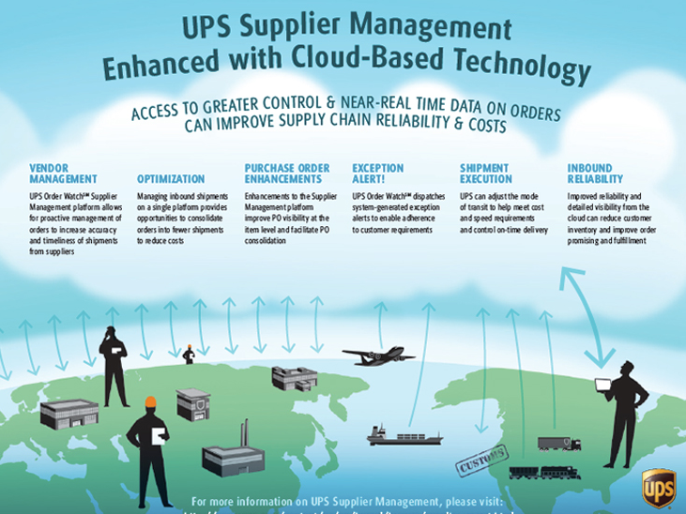
Figure 3 Cloud Computing used in Lining for Logistics
Source:https://www.supplychain247.com/article/ups_logistics_a_masterpiece_of_streamlined_supply_chain_management/green

3.3 Marketing strategy of UPS
In the early days, UPS did a lot of work in advertising and promotion in order to establish its good corporate reputation, increase corporate visibility, establish corporate reputation, and increase public trust. The first is TV advertising, and the second is the promotion method of bundling business, which covered a wide variety of business types, including newspapers, stamps and other diversified businesses. This allows couriers to bundle express services with other services when promoting business. For example, through postal delivery and express delivery, discounts such as subscribing to newspapers or giving stamps can be given accordingly, which can play a certain attractive role for some collection lovers, so as to achieve their promotional purposes.
At the same time, UPS has established a new marketing method that promotes product awareness and promotes product sales for a consumer-focused and acceptable marketing platform. By engaging in some public welfare activities, the company can greatly enhance its social image, increase the brand's influence and visibility, and bring incalculable potential benefits to the company(Salih, 2017). As an international company, UPS has the courage to shoulder social responsibilities and has made many outstanding achievements in public welfare. For example, UPS puts sustainable development at an important position in the company's strategy, and took the lead in proposing emission reduction targets in response to global warming. UPS purchased carbon offsets from the Garcia River Forest Climate Action Project and paid $ 1 million to launch the Carbon Neutrual delivery service in the Asia-Pacific region(Reisch, 2018). Customers can use this product to pay a small fee to calculate their goods in Carbon emissions during transportation, and this cost is used as compensation for the environment.This behavior brings good reputation to UPS and win more loyal customers.

4. 0 Analysis of Marketing Strategy of UPS Company
Due to the different products and market positioning of each company, each company will have different ways of formulating marketing strategies. Common methods include differentiated product strategies, price competition strategies, channel strategies, and various promotional strategies such as placing advertisements on TV and other media, asking celebrities to make endorsements, and promoting through promotional activities. UPS has rich and diverse methods in marketing, and has a unique way different from other companies(Kilcarr, 2006). All its marketing activities are carried out around a purpose to provide customers with the best quality services. In order to gain a deeper understanding of the company's marketing strategy, we must first have a general grasp of the company's external and internal environment.

4.1 SWOT Analysis
Strength:
- Brand equity: Over time, UPS can build ultra-high levels of brand equity. It is world-renowned due to its high quality products and services
- Global business: More than 220 countries around the world and has the largest market for freight services(Shankar, 2018). At the same time, it maintains a broad and essential position in all major economies in the world, making it easy for customers to make global deliveries.
- Extensive distribution network: UPS has one of the most extensive distribution networks in the world and the company is continuously upgrading its hardware and software system(Franklin,2012).
- Pay attention to technology and innovation: UPS has been very focused on technology and innovation to achieve growth and better customer service. It invests heavily in technologies such as information technology, aircraft, vehicles, and factory equipment every year.

Weaknesses:
- Reliance on the US market: The United States is the largest market, which means it makes the brand over rely on domestic market, changing with this nation.
- Operating cost keep rising: The operation expenses have continued to increase over the years including repairing plant equipment and aircraft, the brand's labor costs have also increased.
- FedEx Competitor (FedEx): FedEx is one of the biggest strong competitor. Currently, FedEx takes up to approximately 49% of the express market, while UPS accounts for just 36% of the market(Walliman, 2012).

Opportunities:
- Digital Marketing Opportunities: Digital technologies have created significant and it is a future trend for our company(Storbacka, 2011). Logistics outsourcing and 3D printing these high-tech could be contributing to the development of company and occupying more customer group.
- Employee Engagement: Company is hiring more well-experience employee to join this big family. Although brands invest much money in their employee salaries, it is essential to engage them digitally.Particularly, UPS is going to expand its overseas, it is inevitable to hire more employee in the local country.

Threats:
- Economic fluctuations is not stable, such as financial crisis, tariff barriers will all make a negative influence on importing or exporting, badly impacting on the.logistics company.
- Competitive threats: DHL, FedEx will pose a huge threat to our company. Today, UPS has been struggling to think out the solutions to win this battle by changing the organization structure or adjusting marketing strategies. Organization has been stuck in the bottleneck.
- Regulatory threats: The regulatory environment around the world is becoming increasingly severe, which will be more stressful on international companies.

5.0 Discussion
Based on SWOT analysis, it is easily found that UPS by providing differentiated products can bring many benefits to the company, first of all, it can bring direct sales revenue, and at the same time provide the possibility for consumers to purchase again and higher loyalty. When a customer is faced with a uniform product, a distinctive differentiated product can immediately attract customer attention and put the company in a favorable position in market competition. At present, with the increasingly fierce competition in the express delivery industry, if companies want to be invincible, it is imperative to develop products and provide differentiated services. Therefore, when formulating product and service strategies, express delivery companies should fully consider the differentiation factors to make own products or services unique.
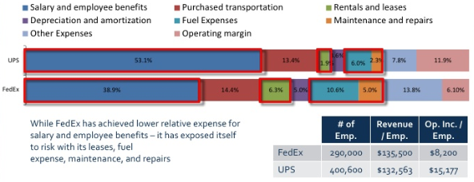
Figure 4 Cost breakdown structure (UPS VS FedEx)
Source: https://www.slideshare.net/AlinDev/fedex-vs-ups
We can clearly see from Figure 4 Cost breakdown structure, UPS has more expenses on salary and employee benefits, 53.1%, much more than FedEx only 38.9%, which is an advantage as well as a burden since it means UPS has a better employee wage and attract more people to join UPS but at the same, the cost is too much, over half of the whole cost, which may reduce the net profit. Then, the purchased transportation is similar and according to the rentals and leases, UPS cost is much less than FedEx, occupying 1.9% than 6.3%. Similarly, the fuel expenses and maintenance and repairs expenses are both less than FedEx, which means the transportation quantities and cargo throughput of UPS may be less than its competitor. However, the rate of operating margin of UPS, 11.9% is higher than FedEx 6.3%, which is a good signal to demonstrate that cost structure of UPS is more suitable for its development as the final aim of enterprise is to gain profits.

From above discussion, we can find brand image is quite essential, including freight capacity, service attitude so no matter what company has to take care of it. For example, in terms of the freight process, other logistics companies often experience delays, inexplicable returns often occur during the transportation process, and consumers calling and asking for customer service have also failed. The freight process reflects the professional level of the logistics company. The twists and turns have undoubtedly affected the company's image, giving consumers a lousy experience, and will no longer choose the company when they next choose(Lewis, 2015). In terms of service attitude, consumers' preference for other logistics companies is partly due to the comparison of service attitudes of various companies. With the optimization and development of various service industries, the status of consumers has skyrocketed, and people can choose companies with excellent service attitudes to fulfill logistics needs.

There are several key aspects that logistics company should learn from UPS:
(1) Differentiation of delivery time
The level of difference in customer demand in modern society is quite different, and there are also different pursuits for the delivery time of express services. Therefore, according to different customer needs, we can set up different express delivery products, as the city arrives on the same day, the next day, the working day and so on(Berman, 2019). Through the difference in product timeliness to attract customer groups with specific needs, to avoid existing low-price competition and seek new growth points.
(2) Differentiated service response
Service response time is an important factor that affects customers' choice of express companies. When customers have any needs to contact the company, they hope that the company can give a reply or solution in the fastest time. Therefore, courier companies should make full use of various forms such as phone calls, text messages, web pages, and customer service systems to deal with customer needs in a timely manner. According to the types of products and services of different packages, priority delivery of emergency packages and timely feedback to customers, so that customers truly feel the difference in service response.
(3) Differentiation of service quality
The products of express delivery enterprises are different from ordinary products. It sells not tangible products but intangible services(Wong, 2018). This requires courier companies to fully consider customer needs from the perspective of customers throughout the operation. In the service process, ensure the high efficiency and high quality of transportation and maintain a high working efficiency. Adjust the content of products and services in a timely manner according to market needs and competitors, and accelerate the speed of product replacement.

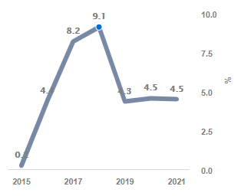
Figure 5 The Growth Rate Could Slow In The Near Term.
Source: https://dashboards.trefis.com/no-login-required/hCGopKcy/UPS-Revenues-How-Does-UPS-Make-Money-?fromforbesandarticle=ups191018
The sparse population and slow economic development have led to a small demand for logistics services. From Figure 5, we could easily see that the growth rate is keeping increasing from 2015 to 2018 then sharply going down since 2018 until 2020. The reason why growth rate decreases is UPS company has abandoned the market because of the small number of orders in remote areas, or have only received a small number of orders. They have even explicitly restricted the responsible cities and put the transportation cities are excluded. What most companies showed is not the attitude of a company that provides services. The service industry should focus on consumers and try to meet consumer needs. The subjective choice of the market is very unprofessional behavior, which seriously affects the brand image, finally leading to the decrease of growth rate. Once company fixes this problem, the growth rate will go back to show a positive trend.

6.0 Conclusion
To sum up, based on our analysis of UPS transportation and marketing strategies, we can point out that UPS separates its products through industry differentiation and currently achieves a good performance though it is facing some threat. One one hand, UPS is not only focused on price but is also committed to providing the high-level service in the industry. UPS is committed to providing excellent customer service and timely delivery. UPS's prices have risen in recent years, but its quality and service have not, still keeping high-level standard. With new technology, UPS can deliver products to customers faster and more efficiently and also simplified and optimized the process of operation, keeping the user data secure. On the other hand, due to the fact that UPS is located in more than 220 countries and regions and UPS has a broad market segment across the industry, not limited in USA, it has advantage of expanding overseas market to compete with its strong competitors like FedEx as well as seek new opportunities. As UPS growing business goes globally, it now makes it easier for its customers to do business with foreign markets. Overall, UPS provides tremendous value in the logistics industry and helps connect people to products through advanced logistics.

7.0 References
Armstrong, G. (2016). Analyzed the competition strategy of United Parcel Service around e-business. The Research of UPS Company Competition Strategy Based on E-Business, 9(6), pp. 20-27.
Berman, J. (2019). Marketing to existing customers, in marketing service: competing trough quality.The Free Press, New York.
Bram,Kin.(2018). Towards more efficient and sustainable urban freight transport. Marketing intelligence & Planning, 22(1), pp. 84-94.
Franklin,Z. (2012). UPS ground freight through strategies in Jones v. UPS Ground Freight.
Gerhardt, L. (2012). A paper presented in partial fulfillment of the requirements of OM 814 marketing strategy and practice. Journal of Service Marketing, 20(8), pp. 150-160.
Kilcarr, S. (2006). A paper presented in partial fulfillment of the requirements of OM 814 marketing strategy and practice. Journal of Service Marketing, 8(2), pp. 150-160.
Kumar, P. (2017). Selection of potential 3PL services providers using TOPSIS with interval data, IEEE, New York.
Larry, B. (2010). The development of UPS in Evolving the UPS brand. John Wiley & Sons, Inc. CourierWestford, United States of America.
Lewis, K. (2015). Research project-a step guide for the first time researcher.
Manzini, A. (2018). The effects of UPS and Apple's two industry giants cooperating and integrating. International Journal of Logistics Systems and Management, 3(2), pp. 125-157.
Mohan, S. (2016). UPS’s business model in UPS supply chain business company business model analysis. International Journal of Logistics Management, 36(9), pp. 666 – 689.
Nina, C. (2019). The freight strategy in U-Freight Group launches logistics service for e-commerce startups.Journal of Services Marketing, 18(7), pp. 514-523.
Nwokah,G.(2009).Customer-focus, competitor-focus and marketing performance, Measuring business excellence, 13(3), pp. 20-28.
Pearce, D. (2015). UPS worldwide service in Largest in history UPS expands global express service range, Sage Publications Ltd.
Rahman, S., (2011). An exploratory study of outsourcing 3PL services: an American perspective. An International Journal, 18(3), pp. 342 – 358.
Razzaque, M. (2014). Outsourcing of logistics function: a literature survey. International Journal of Physical Distribution & Logistics Management, 28(2), pp.89-107.
Reisch, A. (2018). Time and wealth: the role of time and temporalities for sustainable
patterns of consumpetion. Time & Society, 10(1), pp. 367-385.
Salih, T. (2017). Sustainable Economic Development and the Environment. International. Journal of social economics, 30(2), pp. 153-162.
Shapiro, C. (2015). Customer information, products quality and seller reputation. Journal of Economics, the RAND Corporation.
Shankar, R. (2018). Selection of Third-Party Logistics (3PL): A Hybrid Approach Using Interpretive Structural Modeling (ISM) and Analytic Network Process (ANP). International Journal of supply chain forum, 6 (1),pp. 32-46.
Storbacka, K. (2011). Customer Relationship Management: Creating Competitive Advantage through Win-win Relationship Strategies, McGraw-Hill, Singapore.
Susan, M. (2017). Air freight network with the United States in Comparison of major air freight network hubs in the U.S. 40(7), pp. 524 - 533.
Vernon,B. (2019). The UPS Freight and Time in Transit Calculator for Fey Industries. Services Marketing – People, Technology, Strategy. 7th ed.,Upper Saddle River, New Jersey: Prentice Hall.
Walliman, N. (2012). Global development of UPS in Research on the Internationalization Development Strategy of Express Delivery Industry, 2nd ed. SAGA Publication.
Wright, S. (2012). Competitive intelligence in UK firms; a typology. Marketing intelligence & Planning, 20 (6), pp.349-360.
Wong, V. (2018). Marketing and competitive performance: an empirical study. European Journal of Marketing, 32 (5), pp. 514-535.

