

Module name: Problem Solving and Decision Making

Module code - (BMSW4004_LON)
Task 2 – Individual Report

Module leader – Hossein Shokri
Student - Joanna Zaleska
Student ID - 2030291

CONTENTS

Introduction 3
Company Overview 4
Problems of the company 4
PESTLE FRAMEWORK 4
Effective Solution 6
Application of Theory 7
Application of Strategies 7
Decision-making Process 8
FISHBONE DIAGRAM 9

Introduction
This report is a reflection of my work at McDonald's for the last ten years. Working as a manager I need to make sure that customers can come into the restaurant and enjoy the quality food and service they have come to expect from Mcdonald's. This takes in everything from the welfare of staff through to the performance of the restaurant itself This study aims to reveal the problem solving and decision-making situation of a known workplace over its issue, which is customer dissatisfaction. As the overall view is based on the general mode of crisis that can be held in any business sector or workplace, the focused problem and the approaches to solutions can be used in any sector or organisation. This study is an individual report, which includes a particular company as an example and focuses on a specific complex problem. Side by side, the project also has an elaborative explanation with every possible way to represent the appropriate solution to the problem.

Company Overview
McDonald's is fast food, limited-service restaurant with over 35,000 restaurants in over 100 countries. It employs more than four million people. McDonald's serves 70 million customers per day, which is greater than the population of France.
McDonald's offers a uniform menu that includes fries, the Big Mac, chicken sandwiches, chicken nuggets, hamburgers, the quarter pounder with cheese, salads, wraps, desserts, soft drinks, and other beverages. However, to ensure that it connects with the international markets, McDonald's offers locally relevant food menus as well. For example, it serves gazpacho in Spain, the black and white burger in China, and the Veg Pizza McPuff in India.

Problems of the company
As it is a time of rapid changes in businesses, having a lot of critical problems in the business sectors or companies is usual (Klein and Crandall, 2018). Based on that situation, McDonald's also has faced some challenging issues, and one of them is customer service, which impacted the company in a major way. As we live in a world of instant satisfaction, these days, customers demand immediate customer service in any sector, especially in the food sector. Even they have the right and position to make their dissatisfaction or any displeasure with the customer service revealed thoroughly through the social networking and make the particular company suffers for it. As though McDonald's has a reputation for its customer service and working environment, it is the worst impact on the company by poor customer service lately. This major problem reduces the customers' interest in McDonald's restaurants. Even after the covid-19 pandemic, the situation has worsened (Klein and Crandall, 2018). The only profitable way McDonald's could have invested in is its development of customer service. Only this drastic change can bring back the old form of reputation and interest of the company.
The company is using the PESTLE framework to examine the company's macro (external) forces.

PESTLE FRAMEWORK

POLITICAL FACTORS IMPACTING MCDONALD'S
Health and Hygiene regulations. Government regulations and political laws of different countries influence the policies of McDonald's. For instance, the brand and its employees have to follow other countries' health and hygiene standards. If the company doesn't follow the norm, the health & safety department will shut down McDonald's franchises.
ECONOMICAL FACTORS AFFECTING MCDONALD'S
Tarif. The import and export tariff plays a significant role because the company has to move raw materials from one country to another.
The management should take a smart decision about whether to buy the ingredient and raw materials locally or from other countries. The import and export taxes would increase the basic cost, impacting the sale and customer satisfaction.
Higher turnover rate. The employees don't join the brand permanently because of the lower wages and long working hours. They leave the company as soon as they get another opportunity.
McDonald's can't provide quality service because of the inconsistent workforce. The poor service quality results in the form of loss of business to the company.
SOCIAL FACTORS AFFECTING MCDONALD'S
Health-conscious customers. The customers are becoming health conscious. They want a healthy diet and food that doesn't jeopardise their health. The food menu of McDonald's doesn't follow the standard protocol of diet. Such trends aren't good for the business of the brand.
Local menu. The western burgers and French fries are good occasionally for the international market. They won't always choose the same product. McDonald's should offer a local food menu to the different geographically located audience.
TECHNOLOGICAL FACTORS IMPACTING MCDONALD'S
Use of technology. McDonald's is one of the first in the food industry to adapt to the latest technology. It includes a digital payment system, mobile ordering, and self-servicing kiosks. The use latest would help the brand to perform two important functions. First, it would improve the customers' experience, and secondly, it would save time by offering them quick service. It's because starving customers don't like waiting in lines.
Digital marketing. The young generation is very much active on digital and social media platforms like Facebook, Google, Twitter, and Instagram. McDonald's should exploit the current trends and launch marketing and promotional campaigns to increase customers' engagements. Many businesses have increased their sales and growth by using social media platforms.

ENVIRONMENTAL FACTORS IMPACTING MCDONALD'S
Recycling units. McDonald's has installed approximately more than 1000 recycling units at different location points in the UK. It's a great step for the company to address environmental issues. The recycling units would allow customers to separate plastic cups for recycling.
Paper packaging. According to an estimate, approximately more than 69 million customers visit restaurants of McDonald's across the world. Plastic packaging creates an astronomical amount of waste daily.
That's why many environmental activists protested against the company to avoid using plastic straws and plastic packaging. The recycling units and paper packaging are great steps towards the protection of the environment and satisfying the customers.

LEGAL FACTORS AFFECTING MCDONALD'S
Following the laws. McDonald's is a multinational brand and operating its business in different countries. Therefore, the brand must follow the health and safety standards of different countries. The management should also follow the labor laws and improve the working conditions for its employees.
After an in-depth study of the PESTLE analysis of McDonald's, we have realised that McDonald's has a great market position. The health and hygiene regulations, employee turnover, and environmental pollution issues pose serious threats to the company. McDonald's should utilise digital marketing and the latest technology to avoid these threats.

Effective Solution

Effective solutions are needed to conduct as soon as possible to make McDonald's work like its golden days. Change is needed immediately in critical and complex situations like customer service development. Customers are the main variables in doing business, and the best way to keep them continue ordering the food is to provide the best customer service as the loyalty of customers holds the future of a company. Several methods have been found to approach effective solutions for this stage.

Application of Theory
There are various theories to apply in the development of customer services (Lee, and Lee, 2020). In this case, the applicable theory is the Expectancy-value theory, which indicates the value of a product based on customers' judgment, perspective, using benefits, and desirable expectations. Even the product delivery services are also included here. By using this theory, the company can understand the desires, values, and priorities of products and service management from individual customers and act accordingly to develop their customer service program. The purpose of this theory mainly involved customers' satisfaction and their advantages, and this is the best process to include in any company's development and evaluation feature to make them shine again.

Application of Strategies
There are also exists some strategies to make improvements in customer service and satisfaction. Such as,
Strengthening Customer Service Team
As the customer service team is the main focus here, various approaches are included in that strategy to improve the customer service team in every aspect. Such as hiring and training professional employees with appropriate skills the company needs based on their strategic plan (Lee, and Chow, 2020). Good communication skills provide an instant connection and positive impact on the customers, which leads them to order food repeatedly with that particular restaurant. As in customer service, the team has to deal with different kinds of people and their behaviours. So, being empathetic and patient enough to blend with every situation and customer is highly needed in that phase. Side-by-side monitoring of the performances of the team members of customer services is also required here. As the employees are the key source to interact with customers directly, it is also essential to make them happy with appraisals and provide development skills.
Seeking Customers' Feedback
Here comes the most important and valuable point of strategy to develop customer service. As the customers are the priority here, it is important to take feedback from them to know and understand their expectations, needs, and desires appropriately. By doing so, customers can reveal their experiences with the company and their services and product quality. Even the additional feedback from the different customers varies the vital factor of development needed in the company. The company should conduct offline or online surveys at the end of every year or a little gap of between 2 or 3 months to get their customers' feedback (Lee, and Lee, 2020).

Decision-making Process

The Decision-making process has a significant impact on making solutions for complex problems in any situation or association along with working places and companies. As this process makes decisions by containing a proper judgment, information, strategical viewpoint, combination of available data, factors, and the type of situation the workplace or association needs to overcome. In this certain scenario and the problem, the recognition-prime decision-making process has been applied, as it has the appropriate potential to overcome this complex problem. The recognition-prime-decision-making process works in some steps, which include the recognition of a design in the available information. After that, the decision-maker chooses a course of action plan and performs accordingly to the action script (Sahu, Padhy, and Dhir, 2020). Then, if any possibilities are shown up on behalf of the taken action plan, the system decides to go further with it. If the program does not work, there will be changes in techniques according to the situation. There the new strategies came to alive. By using this strong process, the above-mentioned strategies can be applied well to develop the company's customer service system. Side by side, the expertise and experienced members of the company can lead the strategic plan based on the recognition-prime-decision-making process a long way. Thus, the technique of using the effective solution under the guidance has been implanted, which can avoid this mentioned complex issue.

FISHBONE DIAGRAM

The fishbone diagram will help to visualise many possible causes and factors that cause customer dissatisfaction.

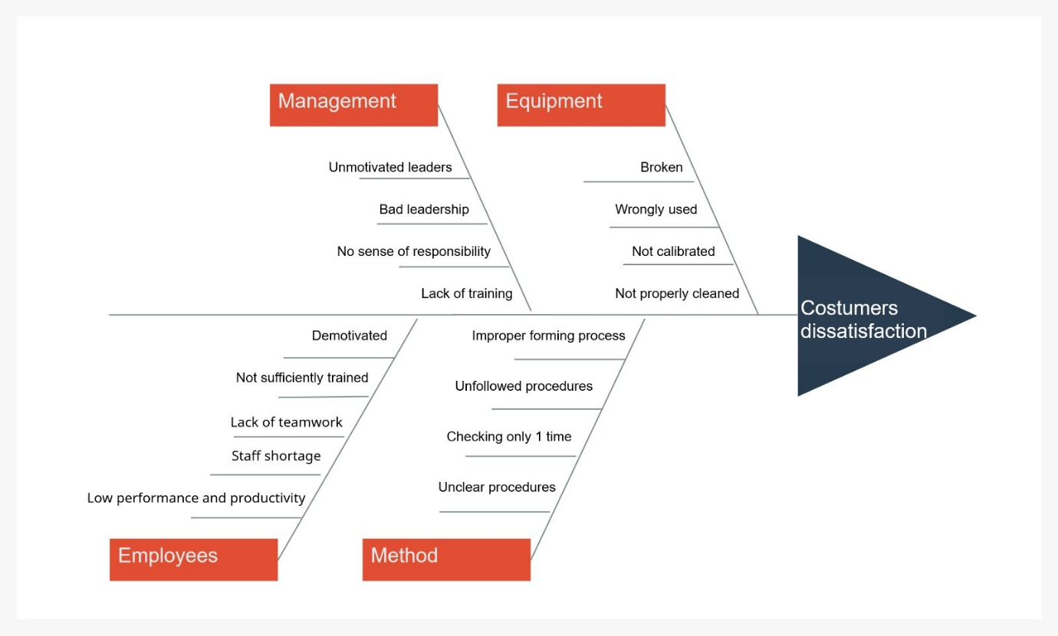

Conclusion
Throughout the reflective report, I have analysed and solved organisational problems using the knowledge gained during my Management Acceleration Programme at McDonald's, which are part of strategic management, governance policy, organisational behavior and organisational development, and the knowledge I earned while studying Problem Solving and Decision Making module. (James, Ziegenfuss, 2001). it is clearly stated that each problem has its own approaches to end with effective solutions, as well as the mentioned context of this project. Although customer service is a common and critical issue in any workplace, it can be reduced with appropriate analysis and strategic applications.

Reference

Klein, G. and Crandall, B.W. (2018) The role of mental simulation in problem solving and decision making. In Local applications of the ecological approach to human-machine systems (pp. 324-358). CRC Press. https://www.taylorfrancis.com/chapters/edit/10.1201/9780203748749-11/role-mental-simulation-problem-solving-decision-making-gary-klein-beth-crandall
Lee, S.H. and Chow, P.S. (2020) Investigating consumer attitudes and intentions toward online fashion renting retailing. Journal of Retailing and Consumer Services, 52, p.101892. https://www.sciencedirect.com/science/article/pii/S0969698918309561
Lee, S.M. and Lee, D.,(2020) "Untact": a new customer service strategy in the digital age. Service Business, 14(1), pp.1-22. https://link.springer.com/article/10.1007/s11628-019-00408-2
Sahu, A.K., Padhy, R.K. and Dhir, A. (2020) Envisioning the future of behavioral decision-making: A systematic literature review of behavioral reasoning theory. Australasian Marketing Journal (AMJ), 28(4), pp.145-159. https://www.sciencedirect.com/science/article/pii/S1441358220300367
Ziegenfuss, James T. (2001) Organization and Management Problem Solving : A Systems and Consulting Approach, SAGE Publications,. ProQuest Ebook Central, http://ebookcentral.proquest.com/lib/trinity/detail.action?docID=996813.
Created from trinity on 2022-04-15 21:57:12.

