Research Methods & Data Analysis
DVLA UWTSD | 1809712
Assignment 1: Data Analysis
Kadmin Van Vuuren
2019

Table of Contents

Table of Contents 1
Table of Figures 2
Introduction 3
Hypothesis 3
Assumptions 3
Chapter One: Summarising of Data 4
1.1 Part One: Organisation of Data 5
1.2 Part Two: Graphing our Data 5
1.3 Part Three: Frequency Distribution Line Graph 6
1.3.1 Part Four: Outliers 7
1.3.2 Part Five: Outliers | Grubbs Test 8
1.4 Part Six: Normal Distribution & Skewness 9
1.5 Part Seven: Measures of Central Tendency 10
Chapter Two: Steps Towards t Test 12
2. Part One: Calculating the Variance 12
2.1 Part Two: Calculating the Standard Deviation 13
2.2 Part Two: Finding the t Stat and Degrees of Freedom 13
Chapter Three: Analysing our t Test & Concluding 16
3. Part One: Analysing our t Test 16
Conclusion 16
Reference List 17
Reading List 17

Table of Figures
Figure 1: Dataset 4
Figure 2: Frequency Distribution 5
Figure 3: Sorted Graph Data 5
Figure 4: Frequency Distribution Line Graph | Mature Students 6
Figure 5: Frequency Distribution Line Graph | Young Students 6
Figure 6: Outliers | Mature 7
Figure 7: Outliers | Young 7
Figure 8: Grubbs Test 8
Figure 9: Skewed Distribution | Mature 9
Figure 10: Skewed Distribution | Young 9
Figure 11: Mean | Median | Mode | Mature 10
Figure 12: Mean | Median | Mode | Young 10
Figure 13: Excel | Variance 12
Figure 14: Excel | SD 13
Figure 15: Excel Data Analysis Tools t Test 13
Figure 16: Significance Level 0.01 14
Figure 17: Significance Level 0.02 14
Figure 18: Significance Level 0.10 14

Introduction

There are a wide range of techniques one can use to accurately analyse and predict the outcome of the concerned datasets. As such one can hypothesis such outcomes whilst using the correct techniques to either prove or disprove any given hypothesis.
This paper will look to apply mathematical techniques to determine whether young or mature students enjoyed their University experiences. In order to achieve this, two datasets have been provided with scores to rank satisfaction. Furthermore, when two materials are to be compared according to some property, the most usual comparison is between the mean values of that property [7].

Hypothesis

In order to produce a $t$ Test to show if the datasets statistically differ to a significant level, our null hypothesis or $H_{0}$ suggests that both data sets are the same. This should allow for the rejecting of the null hypothesis and further allow for us to assume that there is a difference between the two datasets.
As such, after reviewing the initial dataset, a $H_{1}$ hypothesis will be put forward that the satisfaction scores between the mature and younger students are different.
Furthermore, this has also been suggested as: If our dataset is small enough, we might feel justified in rejecting that null hypothesis, favouring instead the alternative hypothesis that there was indeed a difference.
Finally, these hypotheses were presented as we need to concern ourselves with questions such as: Is there sufficient evidence to infer that the mean values of the underlying populations (𝜇1 and 𝜇2) differ [7]? This is true as if there is, say not enough evidence, we can’t simply dispute the argument that the populations mean are the same.

Assumptions

It is assumed that the given dataset may be negatively or positively skewed due to its size of less than 30 entries: As such, our data should still be considered as Normally Distributed. Furthermore, an assumption has been made towards the randomness of the data points and is considered to be sufficient.

1

Chapter One: Summarising of Data

The first step of data analysis is to summarize the data by drawing plots and charts as well as by computing some descriptive statistics [2].
The overall arching question presented by this research paper is to identify if there is a significant difference between the two presented data sets, as seen below:
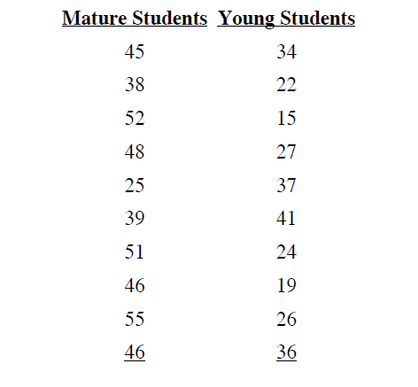
Figure 1: Dataset
In order to achieve an understand of a “Significant Difference” between datasets, we need to ultimately conduct a ‘t Test’. This test will determine whether there is a significant difference between the means of two groups [1].
Additionally, before we can begin to analyse anything we need to know what we’re analysing. As such we will need to consider Frequency Distribution, The Normal Curve, Skewed Distributions and even the Mean, Median and Mode of our data.
Furthermore, considerations should be made towards any potential outliers and their impact upon the results.

Part One: Organisation of Data

It is suggested that, when data is first gathered and is in the form of an unordered set of scores, the first thing to do, is organise and display it using a frequency distribution.
As such, using Figure 1, the following frequency distributions have been created:
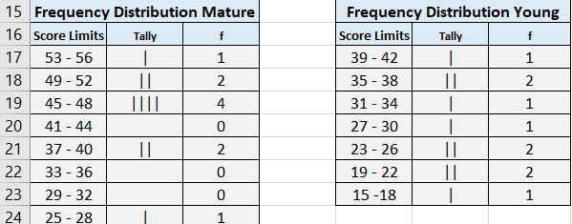
Figure 2: Frequency Distribution
The above begins to help us with draw meaningful inferences between our two data sets, as by simply looking at the above, we can see that there is at least, a difference in the score’s weightings.
Now that our data has been grouped and presented through frequency distribution, we can begin to graph our data, so to provide a better understanding.

Part Two: Graphing our Data

Figure 3: Sorted Graph Data
After having sorted our dataset, we can see already that it seems to be presenting a much more detailed view than that of its raw form, as seen in Figure 1. This further supports the hypothesis presented and further suggests both sets of data are statistically different to one another.

Part Three: Frequency Distribution Line Graph

For the purposes of this test, an interval width of 3 and starting point of 25 was used to produce a Grouped Frequency Distribution Table for both the mature and younger students.

Figure 4: Frequency Distribution Line Graph | Mature Students
We can see from the above that most scores are within the 45 – 56 range, indicative of high satisfaction. However, the younger students seem to have far lower scores.

Figure 5: Frequency Distribution Line Graph | Young Students

Part Four: Outliers

At this point we can denote potential outliers within our dataset. These outliers can be noted from Figures 4 ~ 5, however let’s produce graphs to better illustrate this.

Figure 6: Outliers | Mature

Figure 7: Outliers | Young
The above illustrates two potential outliers within our dataset. At the moment we can’t really say what impact these outliers will have on the outcome, although one would imagine that due to such a small dataset, such outliers may not have much of an impact, if any at all.

Part Five: Outliers | Grubbs Test

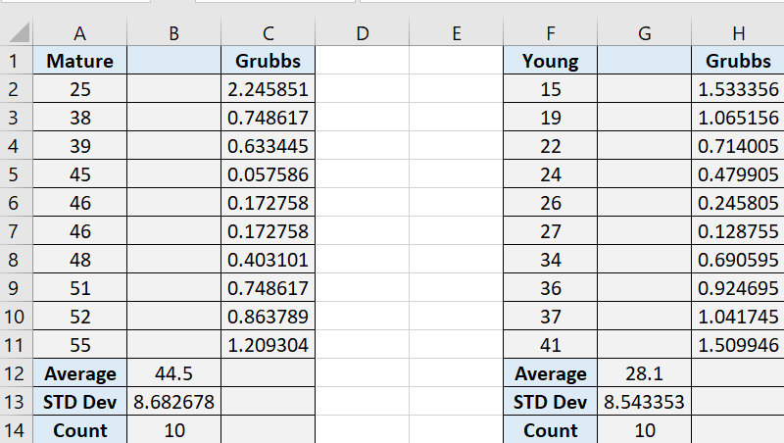
Figure 8: Grubbs Test
Above outlines a Grubbs Test performed on our data, we can see that: Grubbs’ test can be used to test the presence of one outlier and can be used with data that is normally distributed [8]. Furthermore, we have already outlined that we assume data to be of normal distribution.

Part Six: Normal Distribution & Skewness

As suggests previously, when looking to perform a t Test on data, we are looking to ensure that our data has a normal distribution. As such, although our data may be presenting signs of skewness, we should assume that this is due to the size of the dataset.
One other simple summary statistic, important because it often indicates when common statistical methods may be unreliable, is skewness. The skewness of a distribution of values is a measure of asymmetry [3].
As such, using Figure 8 & 9, we can produce a best fit skewed distribution to identify a negatively skewed distribution among the mature students and a positively skewed distribution among young students. Importantly at this point we can decide to use a one-tailed distribution.
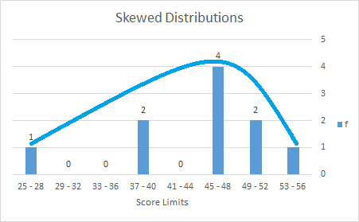
Figure 9: Skewed Distribution | Mature
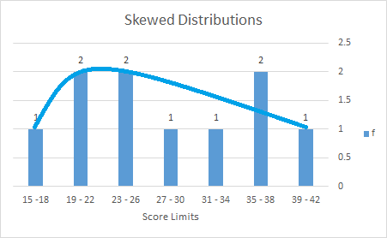
Figure 10: Skewed Distribution | Young

Part Seven: Measures of Central Tendency

Now that our data has been sorted, graphed and having identified potential outliers as well as the skewness of our data, we can begin to look at how our scores vary within the dataset. To do this we can use a Measure of Central Tendency such as the Mean, Median and Mode: This will also allow us to obtain scores that are critical when looking to produce a t Test.

Figure 11: Mean | Median | Mode | Mature

Figure 12: Mean | Median | Mode | Young
Above illustrates a way of representing a measure of Central Tendency. Furthermore, it is suggested that if a dataset is skewed then it is better to report the median than the mean. As such both median values should be considered. Importantly, we can directly see how both Median values are pulling our datasets to one side and the other in our skewed distribution diagrams. Furthermore, the more skewed the distribution, the greater the difference between the median and mean, and the greater emphasis should be placed on using the median as opposed to the mean [6].

This Page Left Intentionally Blank

2

Chapter Two: Steps Towards t Test

Chapter One allowed us to sort and present our data in such a way that we were able to ascertain that mature students at this stage appear to have a higher satisfaction rating. Chapter Two will look to perform the necessary steps required to perform a t Test.

Part One: Calculating the Variance

One of the most common forms of representing Variability within our dataset is to use and determine the Variance. The variance of the sample is the average (in the sense of mean) size of the squared differences between the sample values and their mean [4]. So, using this, we can calculate what the variance for our dataset may be, such that, by subtracting the Mean from each data point and squaring the result: We then finally take the average of these scores to find out Variance:

$${SD}^{2}= \frac{\sum{{\left(X-\overline{X}\right)}^{2}}}{N-1}$$

Using this we can determine Variance scores for our groups of:
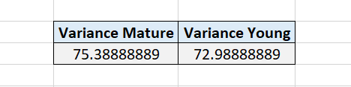
Figure 13: Excel | Variance
We have now determined the variance scores of both sets of students, and here we see that there is not much difference between the two scores.

Part Two: Calculating the Standard Deviation

The proper measure of dispersion about the mean of a set of observations is expressed as positive square root of the variance and is called standard deviation [5]. As such, we have calculated the variance first and now present the SD:

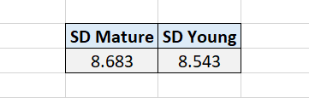
Figure 14: Excel | SD

Part Two: Finding the t Stat and Degrees of Freedom

Throughout this Chapter findings from performing t Tests for both Data Sets using Significance Levels of p = 0.01, 0.02 and 0.10 will be used. The DoF is easy as it is simply calculated as 10 + 10 -2 = 18. Where 10 + 10 is the number of data points in our set, and N-2 to give us 18.
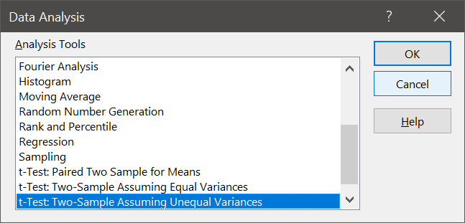
Figure 15: Excel Data Analysis Tools t Test
So, using Excel, we can perform a t test using the inbuilt Two-Sample Assuming Unequal Equal Variances. This tool will help us perform the following calculations:

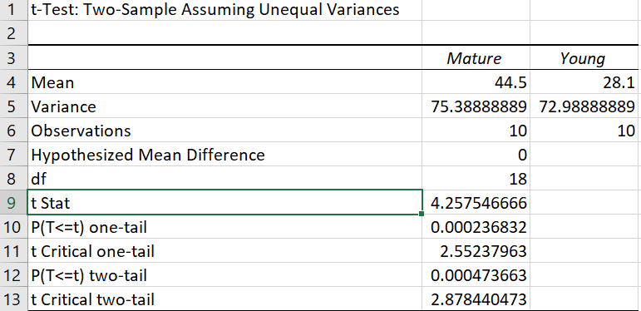
Figure 16: Significance Level 0.01

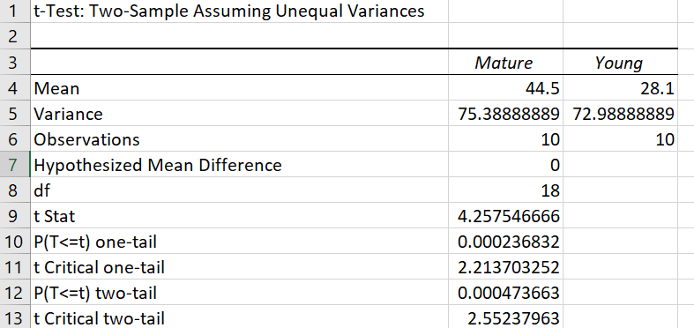
Figure 17: Significance Level 0.02

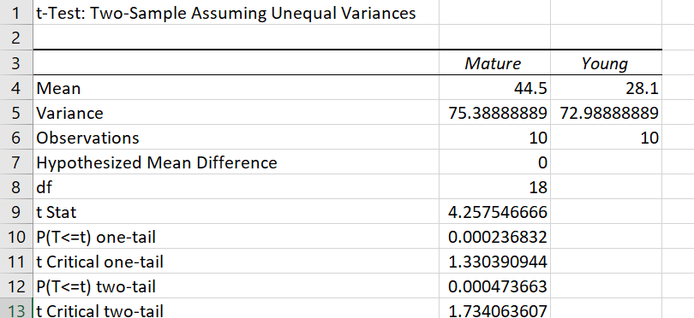
Figure 18: Significance Level 0.10

This Page Left Intentionally Blank

3

Chapter Three: Analysing our t Test & Concluding

In Chapter Two we completed the steps necessary to perform our t Test, however, what does it all mean, and can we justify hypotheses and assumptions put forward throughout this report.

Part One: Analysing our t Test

We can determine if there is a significant difference by comparing our t Stat to that of the $t_{crit}$. Using the above figures 16 ~ 18, we can denote that all calculated t values exceed that of the critical value, and our t values can be seen to be in the tail: As such we can say with high confidence that there is a significant difference between the two groups.
Importantly, we can see that this significant difference is true regardless of the p significance level used.
It is however, important to note that as this is only a small sample out of a potentially much larger data pool, one can’t completely reject the null hypothesis and as such we can reject the null hypothesis although it may be true, producing a Type I Error.
Finally, with reference to our outliers, we can see that there are actually no outliers present, all of which fall within the t Critical range.

Conclusion

Often whilst trying to understand data within statistics, one can misunderstand what is being presented to them. This paper looked to present ways in which one can make sense of the information that is being presented to them, using many tools and techniques.
By doing so we can make reasonable conclusions on our data, all of which suggest that our alternative hypothesis, such as hypothesising that there is a difference between the sets, is true.

Reference List

[1] University of Connecticut, “Educational Research Basics by Del Siegle” UCONN 2018. [Online] Available: https://researchbasics.education.uconn.edu/t-test/#. [Accessed Nov. 24, 2018].
[2] A, S. Noorzad, Q. Mohammadi, Introduction to Statistics, Karwan, 2018. pp 14.
[3] T. Greenfield, S. Greener, Research Methods for Postgraduates, New Delhi: Wiley, 2016, ch. 28, pp. 313.
[4] T. Greenfield, S. Greener, Research Methods for Postgraduates, New Delhi: Wiley, 2016, ch. 28, pp. 313.
[5] A, S. Noorzad, Q. Mohammadi, Introduction to Statistics, Karwan, 2018. pp 123.
[6] Statistics, “Measures Central Tendency Mean Mode Median” Statistics 2018. [Online] Available: https://statistics.laerd.com/statistical-guides/measures-central-tendency-mean-mode-median.php [Accessed: Dec. 31, 2018].
[7] T. Greenfield, S. Greener, Research Methods for Postgraduates, New Delhi: Wiley, 2016, ch. 28, pp. 313.
[8] Real Statistics, “Grubbs Test” Realstatistics 2018. [Online] Available: http://www.real-statistics.com/students-t-distribution/identifying-outliers-using-t-distribution/grubbs-test/ [Accessed: Dec. 04, 2018].

Reading List

A, S. Noorzad, Q. Mohammadi, Introduction to Statistics, Karwan, 2018.
T. Greenfield, S. Greener, Research Methods for Postgraduates, New Delhi: Wiley, 2016.
Dr M. Abuhmida, ‘Research Methods & Data Analysis’, University of Wales Trinity Saint David, 2018.

