
Digital Learning and Digital Literacy
Embracing the New Digital World through Competent Choice

April 3, 2019
BA Business and Management – Learning for Collaboration for Global Citizenship -
BMSP4003 - Dr Alex Bell - Contribution to Sustainability – Alexander Apps – 1806320
(Pictured Above Michelangelo’s Sistine Chapel Painting Picturing a new creation through choice (Italianrenaissance, 2015))
Digital Learning and Literacy: Embracing the new digital world through Competent Choice
Introduction

What is Digital Learning to me? Simply put it’s a choice to embrace a new world that is easier swifter richer and personally more rewarding than previous mechanical style of learning. A collocal definition for digital learning is "learning facilitated by technology that gives students some element of control over time, place, path and/or pace” (Achievement, 2019). A new world, a new vista, a new vision. A determined choice to learn, can change the future and having the cerebral will, may accelerate positive self-change and can become a muse of astronomic positivity for the escutcheon that is called learning.
The digital interaction improves your time, allows you to create your own learning environment, directly allow you to affect your rate of learning and can specifically direct your auto-didactic sense of learning (Microlearning, 2019). Digital “Learning is no longer restricted to the pedagogy used by the teacher” (Achievement, 2019).These reasons, our why it is so useful (Microlearning, 2019). Sir Tim Berners-Lee the father of the Internet, effectively gave genesis to a completely digital environment. Affecting banking, finance, the economy, medicine and education to name but a few, changes. Using the now palpable vison of this new world, we need to embrace it through sculptured choice.
Yet the digital revolution is not a sickly, sardonic, shibboleth used by the few (Turoff, 2005). Educating are choices for our own digital learning has never been a more puissant reality. Now, we all have the swift power, to engender our own education and create our own intellectual reality. The navigation of these digital environments needs a coruscating sense of cartography, especially when the liberation of education is at stake.

Cutting the Gordian Knot: An analysis of my personal learning approach to Digital Learning

Without the Internet I would be lost. My intellectual direction would be scuppered. For me using the UWTSD library or the refractive paradigm of Google scholar, allows an increase in the alacritous attainment of good intellectual texts.
Digital learning allows me to remain in my personal learning environment unmolested by travel to the library. This digital revolution has been powered by social media (Newberry, 2019). Digital education is now catching up with this.
The UWTSD Business School has their own twitter feed (Twitter, 2019) dedicated specifically to the nourishing soup of the changing business world. Twitter is fast and easily connectable.
Knowing a good website like the digital financial times or the oxford union online is something that can easily be used due to the possession of a deep-seated credibility.
Digital Peer Reviewed texts are something that burnish my pride and usually spark a greater sense of curiosity within me. When looking at the citations of the peer reviewed texts this gives me further direction as to the attainment of better academic sources. Usually the best trajectory just starts with a simple sense of, what good essences can be derived from these sources, what polarity will it satisfy within my sense of persuasion and how will this benefit the paper. The more quality sources the better the argument and when coupled with opposing views it leads the eventually reader to a space that the I’ve carefully chosen.
I need intellectual companions on this journey. Yes, I have Aristotle, Milton, Baku and Dante. I have used their intellectual blood, bone and marrow and have carefully observed the oft contrapuntal resonances within the still beating hearts of their intellectual agency. But I would be rudderless without the community of students and lecturers. Fellow class mates ward off my scholastic malnourishment, inverting the oft times perceived malediction of perdition. Something all of us can feel but without a community. Collectively we thrive. That’s an easy supposition but is it true. The class learning environment works well for me.
Personally, my class is a second family and I feel we would all be mutually adrift without this collective. It’s an inviting intellectual ecosystem that has a palpable character and, in my sense, extends a helping warmth to all who desire to participate. Dr Alex Bell is a superb intellectual and a great scholastic alchemist for the students he guides in the nebulous umbra of initial learning. He has given us a deep intellectual sight both digitally and tangible. Without this direction we’d be easy prey to our corrosive emotions, which would flood our rationale. He’s a muse of the highest quality. The cross-pollination of ideas with him drives me to become a better student, by placing a simply cut across that gordian knot of learning, breaking the internal aporia of poisonous self-doubt.

A critical reflection of your use and understanding of digital technology:

The choice for using digital technology is an easy prospect for me. It is something that I have been using for several years, thanks mainly to the ubiquitous confluences of social media platforms. It has been an effortless transition to the choice of digital learning within education. Positively it has a cloying sensibility and has changed the daily direction of my existence. Effectively the learner, is driving this digital solubility and sublimating its existence further in to our lives.
Social Media itself is the golden platform for communication, from the now mostly first gear e-mail to immediate updates and live time responses to anyone globally with an internet solution. Facebook, Twitter, Instagram, Linked-In and What’s Ap are large and necessary mile stones in digital communication. I use Facebook mostly and our class at UWTSD has a Facebook group with which we can share information pertinent to this course. Choosing a direction for a sustainable digital learning is a must for me and my fellow students. Social media is an angelic sentinel in the war against ignorance and in the finality, it is the choice for august change that paves a way for informed discussion and fixed understanding. There are still so many undiscovered counties in the digital world and the internet is so vast and ever expanding. That some of its primary uses communication, business and education will be greatly enhanced by the very nature of its essence and a multiplicity of new uses will become apparent soon.
Is this digital learning age of the Internet self-sustaining? I would say yes. The Internet’s growth through use of social media and business digitality, is now offering an unending choice of digital literacy for digital learning power. This new digital world has many benefits but is replete with maledictions and curses that can plague our allegiance to this essential digital forum.

Strengths and weaknesses of my digital literacy

This invasive digital world does offer many benefits both for the individual and global community. Now it’s the agency of communication for business, education and socialisation. Which are now a daily benefit to us.
Convenience (Jiang, 2013) is a great seller for the understanding and sale of this digital world, we have all willingly embraced a new world like, disregarding the old world for the new. Convenient learning is a powerful persuader for potential online users.
Rate, personal learning environment, direction and good use of time online are all conceptually linked for me with digital learning. In fact, digital learning has given me more free time within the physical world and has led to a better sense of digital literacy because I am totally immersed in this electronic environment through choice and need. I need less time online because of this digital fluency.
My sense of Digital Literacy the use of social media platforms like Facebook and Google Scholar has greatly increased and the ability to discover needed texts quickly is becoming easier with each new assignment. The rate and use of these platforms are now a very easy task and tweaking the search parameters is a fundamental tool for discovering necessary texts for the persuasive argument.
But with every invention there are copious flaws some of which I have experienced personally.
Isolation (Rainie, 2009), is a concerning aspect of this epoch. Being isolated online is an ever-evolving element of digital interaction. You can be involved in discussion but at the same time still embrace a palpable sense of self-nihilism (Ali and Smith, 2015). Paradoxically isolation online can increase online isolation when learning. It’s our choice to use the internet and accept this burden but we must be aware of it and tackle its manifestation.
Internet fatigue or information fatigue syndrome (Miller, 2013) (IFS) is a leprous truism. Many people are overloaded with too much online activity, creating despair and extreme tiredness. Our minds embrace this new age, but we are still not justified in the emotional prepared at times for this digital transition. Online fatigue is a developing problem and has affected me sometimes. Future levels of online fatigue and conditions will endure. Tackling this requires more than a choice this would fall to the digital community for a for a further understanding of this entrapment. We have a choice to leave, but our jobs and ventures may apply a crushing pressure for forced online presence.
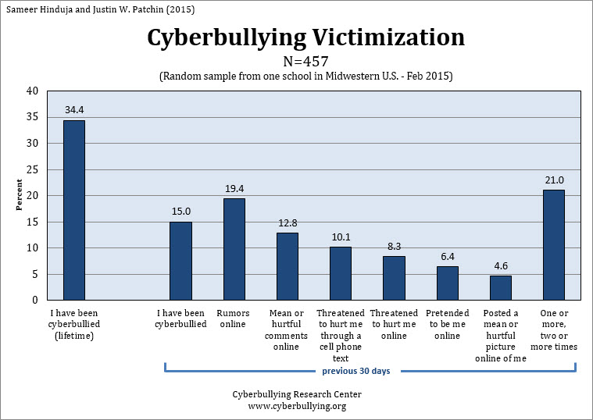
Online bullying is much easier online than it has ever been in the non-digital world (Patchin, 2015). Mostly being more viscous which in turn adds to more isolation and a distinct lack of further wishful participation. It’s a painful sting the first time it happens speaking from experience. This is something that platforms like Facebook and Twitter are tackling. Domestic governments are implementing interventions, but a global conscience is needed here. Hodgson and Ferreday surmise that “darker sides of collaborative participation which in its extreme manifestations can be experienced as normative and, we suggest, as a form of tyranny of the dominant and which instead of having a liberating effect, reinforces a form of oppression and control” (Hodgson, 2008). So far it can be problematically aporetic and no real solution is forthcoming.
Above some Online Bullying figures (Patchin, 2015)
But these are still early days the benefits of an online pressence for learning in my opinion is an essential valediction and choice that we can easily make due to the many benefits.

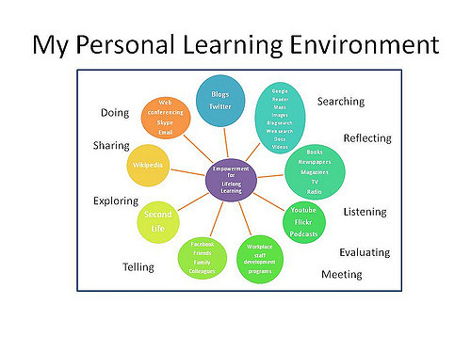
My Personal learning environment against current trends
Above a visual understanding of elements of my Personal Learning Environment (Dixon, 2011)

As a non-smart user my personal learning environment is bucking the current trend. I use a PC exclusively for digital learning. This is something that appeals to me, for the simple reason of chosen solitude. I work purposely from home it’s an environment that I’ve developed over the years and one that suits me through choice. Adding my Tutor Alex Bell and the class environment to my learning schedule has become a crucial learning ally, I’ve learned more in this BA through this collaborative type of learning experience than I would have perceived possible. I look forward to the classroom forum for discussion and the necessary unmasking’s of perceptual ignorance. This in turn offers me a purer direction for learning and when coupled with the digital learning environment it is an essential and fundamental catch net for the apogee of intellectual thrust.

The position of advice that I would give new undergraduates preparing for learning in the 21Century

Stay with the trend for digital learning, it’s a prescient choice, one that we are all finding our allegiance with. Digital learning either through self-sustained learning or refracted by the class and tutor is an invaluable new world, for your benefit. Online platforms like MOOCS and Futurelearn.com allow you to experience the academic environment starting with the choice of your preferred digital learning environment and type of digital course. This type of world was not possible even 15 years ago but now is becoming more prevalent and has gained significant credibility. For those who want to learn, it is a vast and unending digital ecosystem that only needs the spark of choice for the discharge of a guiding scholastic illuminance.
Choice is the axiom here what do we do with all these digital learning assets, that is strictly up to the pioneer. But some of these online environments will not be for the un-gregarious, those who like the discussion forum will be forlorned by this possible encagement; the strict lack of classroom and perceptual peers.
Look, learn, listen, question and resource constantly. We are not in this alone, if your choice is the tangible university environment then you will the gain the structured help of the class and lecturers; there isn’t necessarily a digital prosthetic for that.
Lastly, empowerment is what you will gain from this tertiary learning experience having produced a well-researched paper will flood you with an otherwise ineffable and ostentatiously warm sense of emotion, something that for me the choice of education provides.

Conclusion

“But I surrender all this magic now [and] throw my book of magic spells deeper into the sea than any anchor ever sank” (Shakespeare, 2019), like Prospero, we are all leaving the old world and are choosing this new digital world of science. This is a completely new world this digital manifestation of learning. Some may call it true liberation; after all the word liberation has its genus in the Latin for book, being liber. The digital learning environment is greater than the invention and use of the printing press in my opinion. This New World can be embraced by all who choose it. New worlds, new vistas and undiscovered Countries all for our future learning, discoveries. This is an exciting time for all potential learners, and we are only, our own limitation in this new world. Business and social media are powering it, and we have the productive choice to benefit from it. Like Christopher Columbus (History.com, 2019) may have mused, I say to all new digital learners…
“Welcome to the New World”

A representation of easy choice (Italianrenaissance, 2015)

Bibliography
Achievement, T. G. (2019). What is Digital Learning? Retrieved from Georgia Government: https://gosa.georgia.gov/what-digital-learning
Ali, A., & Smith, D. T. (2015). Comparing Social Isolation Effects on Students Attrition in Online Versus Face-to-Face Courses in Computer Literacy. Issues in Informing Science and Information Technology, 11-20.
Dixon, J. E. (2011). Information and Communication Technologies for Teaching and Learning. Retrieved from jessicaellendixonblog.wordpress.com: https://jessicaellendixonblog.wordpress.com/elearning/
History.com. (2019, August 28th). christopher-columbus. Retrieved from History.com: https://www.history.com/topics/exploration/christopher-columbus
Hodgson, D. F. (2008). The Tyranny of Participation and Collaboration in Networked Learning. Proceedings of the 6th International Conference on Networked Learning, 640-647.
Italianrenaissance. (2015). Michelangelo’s Creation of Adam. Retrieved from Italianrenaissance: http://www.italianrenaissance.org/michelangelo-creation-of-adam
Jiang, L. (. (2013). Measuring consumer perceptions of online shopping convenience. Retrieved from emeraldinsight.com: https://www.emeraldinsight.com/doi/abs/10.1108/09564231311323962
Microlearning. (2019). Microlearning Blog. Retrieved from edapp.com: https://www.edapp.com/blog/what-is-digital-learning/
Miller, Z. C. (2013, July 3rd). Information Fatigue Syndrome (IFS): What it is and how it affects you. Retrieved from naturalnews.com: https://www.naturalnews.com/041057_internet_fatigue_information_overload_news.html
Newberry, C. (2019, March 5th). 130+ Social Media Statistics that Matter to Marketers in 2019. Retrieved from hootsuite: https://blog.hootsuite.com/social-media-statistics-for-social-media-managers/
Patchin, J. W. (2015, May 1st). 2015 Cyberbullying Data. Retrieved from cyberbullying.org: https://cyberbullying.org/2015-data
Rainie, L. (2009, November 4th). Social Isolation and New Technology. Retrieved from Pewinternet: https://www.pewinternet.org/2009/11/04/social-isolation-and-new-technology/
Shakespeare, W. (2019). The Tempest Translation. Retrieved from sparknotes: https://www.sparknotes.com/nofear/shakespeare/tempest/page_176/
Turoff, S. R. (2005). The Evolution of Online Learning: Online Learning and the Revolution in Higher Education. New Jersey: ACM.
Twitter, M. A. (2019, March 29th). Carmarthen Business School. Retrieved from Twitter: https://twitter.com/UWTSDCarmsBus

