CertHE Computing Skills for Workplace
Analysing and Solving Problems

Name: Lucas Adouko
Student ID: 2424749
Course Name: Computing Skills for The Workplace
Module Name: Analysing and Solving Problems
Module Code: ACCA4019

Table of Contents
Introduction 2
1.0 Task 1: Deconstruct the Problem 2
1.1 Order Allocation 2
1.2 Route Optimisation 2
1.3 Time Management 3
1.4 Fuel Efficiency 3
1.5 MoSCoW Technique 3
1.5.1 Must-have 3
1.5.2 Should-have 4
1.5.3 Could-have 4
1.5.4 Won’t-have 4
1.6 Key Variables 5
1.7 Summary 5
2.0 Task 2: Propose a solution (Flowchart and Pseudocode) 6
2.1 Flowchart 6
Part 1: Order Processing & Zone Assignment 6
Part 2: Delivery & Route Optimisation 7
Explanation of the Flowchart 8
2.2 Pseudocode 9
Explanation of the Pseudocode 11
Conclusion 11
Task 3: Reflect and Justify 12
Conclusion 13
References 14

Introduction
In this assignment, I will analyse a real-world problem faced by GrocerQuick, an online grocery delivery company that struggles to manage its delivery routes efficiently. The aim of this task is to use problem-solving and abstract thinking to design a clear and structured solution. Through this work, I will learn how to identify the main requirements and constraints of a system, break down a complex problem into smaller parts, and create a logical solution that could be applied in different situations. By the end of the assignment, I will demonstrate my ability to think critically, plan effectively, and design a solution that helps GrocerQuick optimise its deliveries, reduce fuel use, and improve delivery times.

1.0 Task 1: Deconstruct the Problem
To create an effective solution for GrocerQuick, it is important to first understand and break down the main problem into smaller and clearer parts. The company is facing difficulties in managing its delivery routes, which causes delays, wasted fuel, and unhappy customers. By dividing the problem into smaller parts, it becomes easier to focus on each part, identify what needs to be improved, and find suitable solutions.

1.1 Order Allocation
This means deciding which driver should deliver which orders based on location, distance, and time. If orders are not well distributed, some drivers may have too many deliveries in one area, while others may have less. This can lead to long delivery times and inefficient use of vehicles. A fair and logical allocation of orders helps balance the workload and ensures that all deliveries can be completed within the required time.

1.2 Route Optimisation
This focuses on finding the best and shortest route for each driver. If drivers follow longer or complicated routes, it increases fuel consumption and delays deliveries. An optimised route means the system can calculate the best path that reduces travel distance while still covering all delivery points. This can be achieved using algorithms or mapping tools that consider distance and traffic conditions.[1]

1.3 Time Management
GrocerQuick wants to make sure that no delivery arrives more than 30 minutes late. This means the solution must include a way to plan delivery schedules carefully. The system should calculate estimated delivery times and adjust routes when necessary to avoid delays. Time is a key factor in customer satisfaction and maintaining the company’s reputation.

1.4 Fuel Efficiency
Fuel is one of the biggest costs for delivery companies. If routes are not well planned, drivers will travel longer distances and use more fuel. This not only increases costs but also affects the environment due to higher emissions. By reducing total travel distance and avoiding unnecessary trips, the company can save money and work in an eco-friendlier way.

1.5 MoSCoW Technique
The MoSCoW technique can be used to organise and prioritise these requirements, this method helps to decide what is essential and what can be added later. The solution must have efficient route planning and on-time deliveries, as these are the main goals of the assessment. It should also include fair order allocation, so all drivers have a balanced workload. It could have real-time traffic updates to improve accuracy [2].

1.5.1 Must-have
- Order Input System: The user must be able to enter delivery details (name, address, items). Without this, no delivery can be created.
- City Divided into Zones: The system must divide the city into delivery zones (North, South, etc.). This is needed for route planning and assigning drivers.
- Driver Assignment: The system must assign each order to a driver based on the zone. Without a driver, the delivery cannot happen.
- Basic Route Calculation: The system must find a basic route for the driver to reach each stop. Drivers need directions to complete deliveries.
- Delivery Confirmation: The driver must confirm when an order is delivered. The system needs to track which deliveries are finished.

1.5.2 Should-have
- Time Estimation: The system should estimate delivery time for customers. It improves the customer experience but is not required for the system to function.
- Order Priority Level: The system should mark urgent orders, so they are delivered first. This helps efficiency but is not essential for basic operations.
- Automatic Updates for Drivers: Drivers should receive updated routes if new orders appear in the same zone. It improves speed and reduces wasted time.

1.5.3 Could-have
- Map Visualisation: A small map showing the route could be included. It makes the interface better, but drivers can work without it.
- Customer Live Tracking: Customers could see where their driver is in real time. This improves visibility but requires more technology.
- Weather or Traffic Alerts: The system could warn drivers about traffic jams or bad weather. Helpful, but not required for basic delivery operations.

1.5.4 Won’t-have
- Full AI Route Optimisation: The system will not include complex AI route optimisation. Too advanced for the current scope.
- Multi-City Delivery Support: The system will not support deliveries in more than one city. The project only focuses on one city for now.
- Automatic Vehicle Management: The system will not track fuel, car condition, or maintenance. Not needed for delivery planning.

1.6 Key Variables
There are also several key variables involved in this problem. These include the number of orders, the number of drivers, the delivery locations, the distance between each delivery, the estimated travel time, and the amount of fuel used. Each of these variables affects how efficient the delivery system can be. For example, if the number of orders increases, the system must still find the best routes without affecting delivery times.
Variables | Type | Description
orderID | Integer | A unique number that identifies each order.
customerName | String | The name of the person receiving the delivery.
customerAddress | String | The full address where the order must be delivered.
customerZone | String / Enum | The zone (North, South, East, West) based on the address.
orderItems | Array | The list of products inside the order.
orderPriority | Enum | Shows if the order is normal or urgent.
driverID | Integer | A unique number that identifies each driver.
assignedDriver | Integer | The driver chosen to deliver the order.
driverZone | String | The zone where the driver works.
routeList | Array | The list of all stops the driver must visit.
currentStop | String | The stop where the driver is right now.
deliveryStatus | Enum | Shows if the order is “Pending”, “In Progress”, or “Delivered”.
estimatedTime | Float | The estimated time to deliver the order.
deliveryTime | Float | The actual time when the order was delivered.
trafficLevel | Enum | Shows road traffic conditions (low, medium, high).
weatherCondition | Enum | Simple weather info (sunny, rainy, etc.).
newOrdersAvailable | Boolean | True/False value that checks if new orders appear.
updateNeeded | Boolean | True/False indicating if the route needs to be recalculated.

1.7 Summary
Breaking down the problem into smaller parts, it becomes clearer what GrocerQuick needs to improve. Focusing on order allocation, route optimisation, time management, and fuel efficiency will make it possible to design a strong and effective solution. Using the MoSCoW method and analysing key variables ensures that the result meets the company’s main goals and can be developed further in the future.

2.0 Task 2: Propose a solution (Flowchart and Pseudocode)

2.1 Flowchart
The flowchart below shows the main steps of the solution to improve GrocerQuick’s delivery system. It explains how orders are divided into zones, how drivers get their routes, and how deliveries are made on time. The flow also includes checks to make sure each delivery is done within 30 minutes and helps reduce fuel use by choosing the shortest routes. The flowchart is divided into two connected parts to improve readability. A single start and end point are used to show one complete process. A connector symbol links Part 1 and Part 2 to indicate the continuation of the system flow.

Part 1: Order Processing & Zone Assignment
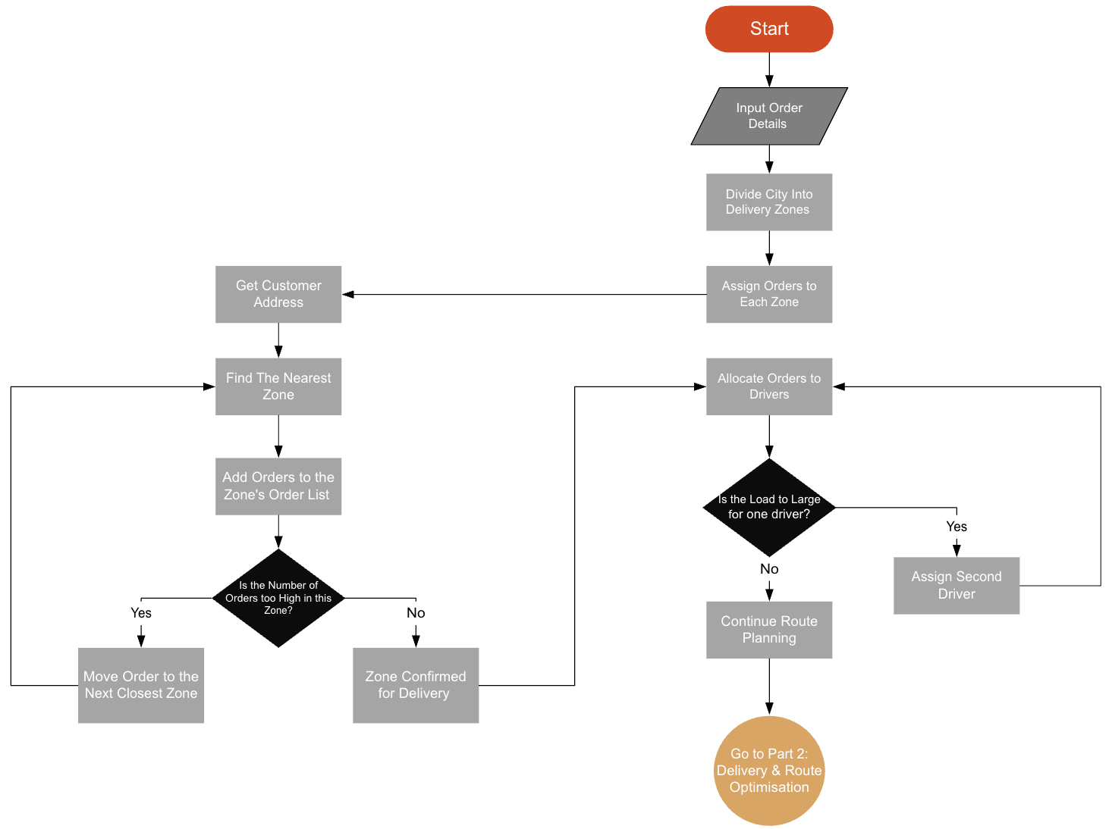
Part 1 Image (Flowchart)

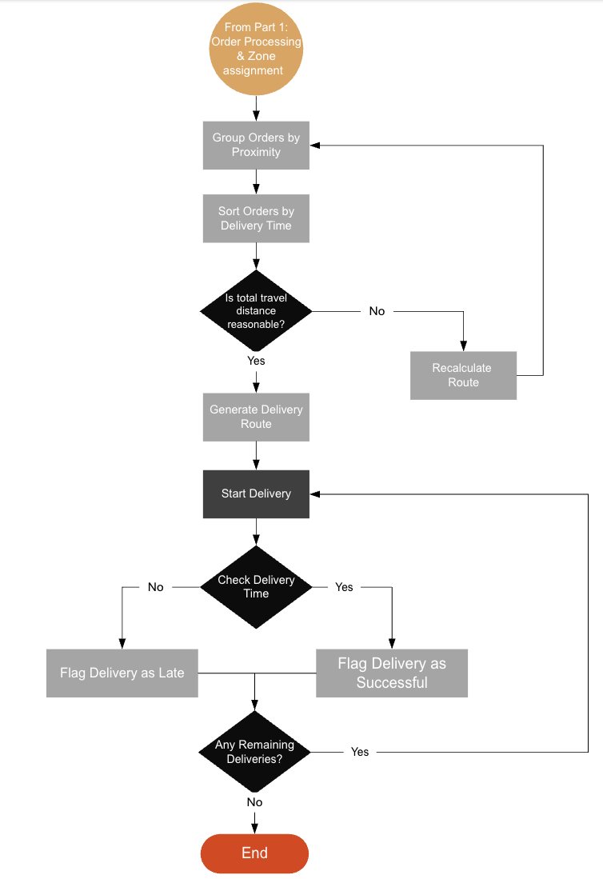
Part 2: Delivery & Route Optimisation
Part 2 Image (Flowchart)

Explanation of the Flowchart
The solution starts when all customer orders are entered into the system. Each order includes details such as the customer’s address, delivery time, and order size. Once all orders are recorded, the system divides the city into fixed delivery zones. This helps to organise deliveries better and makes it easier to manage drivers.[3]
After that, each order is assigned to the correct zone based on the delivery address. Every driver is then given one zone to manage. This method helps reduce confusion and saves time, as each driver only focuses on one area they know well.[4]
Next, inside each zone, the system groups orders that are close to each other. This step is called route clustering. By doing this, the driver does not need to travel long distances between deliveries, which helps save fuel and time.
Once the orders are grouped, the system sorts them by delivery time. This means the driver will deliver the orders that are due first before moving on to the next ones. Sorting by delivery time helps make sure that no order is delivered more than 30 minutes late.
After that, the system creates an optimised route for each driver. The route shows the best path to follow to complete all deliveries in that zone with the shortest travel distance. The driver then starts the delivery following the planned route.
During the delivery, the system checks if each order is delivered within the 30-minute time limit. If the delivery is on time, it is marked as successful. If it is late, it is flagged as delayed, and the reason (such as traffic or technical issues) can be recorded for future improvements.
The system then checks if there are any remaining deliveries for that driver. If there are more deliveries left, the driver continues with the next one. If all deliveries are completed, the process ends.
This solution helps GrocerQuick work more efficiently in several ways. Dividing the city into zones and giving one driver per zone makes the system organised and easier to control. Grouping orders by location and sorting them by delivery time helps reduce fuel use and ensures deliveries are made quickly. By following this logical process, GrocerQuick can save time, lower costs, and improve customer satisfaction.

2.2 Pseudocode

START

Initialize OrdersList
Input all orders with address, delivery time, size, and ID
Add each order to OrdersList

Load city map
Divide city into fixed delivery zones
Initialize Zones dictionary with empty lists for each zone

For each Order in OrdersList
ZoneFound ← FindZone(Order.Address)
Add Order to Zones[ZoneFound]
End For

DriversList ← GetAvailableDrivers()
For each Zone in Zones
Assign one available driver to Zone
Zone.Driver ← AssignedDriver
End For

For each Zone in Zones
Apply clustering to Zone.Orders to create delivery groups (routes)
For each Route in Zone.Routes
Sort Route.Orders by delivery time
End For
End For

For each Zone in Zones
Driver ← Zone.Driver
For each Route in Zone.Routes
OptimizedRoute ← GenerateOptimizedRoute(Route.Orders)
Driver.StartRoute(OptimizedRoute)

For each Delivery in OptimizedRoute
If CurrentTime ≤ Delivery.ScheduledTime + 30 minutes Then
Mark Delivery as Successful
Else
Mark Delivery as Late
Record reason
End If
End For
End For
End For

END

Explanation of the Pseudocode
The pseudocode below describes the logical steps of the proposed solution for optimising GrocerQuick’s delivery process. It shows how orders are collected, divided into delivery zones, and assigned to drivers. The goal is to reduce fuel use, improve route planning, and make sure all orders are delivered on time. The explanation that follows describes each step in detail and explains how the system makes decisions to achieve these objectives.
This solution starts by collecting all the customer orders, including their delivery address, order size, and the required delivery time. These inputs are important because they help the system decide how to organise and prioritise the deliveries. The city is then divided into fixed delivery zones to make planning easier and to avoid unnecessary long trips that waste fuel. After that, each order is checked and placed into the correct zone based on its address, allowing all nearby deliveries to be grouped together.[4]
Next, a driver is assigned to each zone, so deliveries are well controlled and more efficient. The orders inside every zone are sorted by their delivery deadlines so that the most urgent deliveries happen first. Then, the system optimises the driver’s route by choosing the next nearest delivery location each time. This simple optimisation helps reduce total travel distance and improves fuel efficiency. During this planning step, the system checks if any delivery would be more than 30 minutes late. If that happens, the route order is adjusted to reduce delays.
Once the best routes are found, the final plan is confirmed and ready for the drivers to follow. This method achieves the three main objectives of the problem: it assigns orders efficiently, reduces fuel consumption, and helps ensure all deliveries arrive on time. The approach is logical, easy to apply, and suitable for real-world delivery services like GrocerQuick.

Conclusion
The proposed solution provides a structured and efficient way to improve GrocerQuick’s delivery operations. By dividing the city into fixed delivery zones and assigning a driver to each area, the system reduces long travel distances and helps control fuel usage. The flowchart and pseudocode show a clear process where orders are sorted by location and delivery time, making sure that urgent deliveries are handled first. The nearest-location routing method helps create an optimised route that saves time and avoids unnecessary travel, also includes a time check to ensure that no order is delivered more than 30 minutes late. If delays are detected, the route can be adjusted to improve delivery performance. This logical and organised approach can be applied in real-life situations to help GrocerQuick improve its delivery system and customer satisfaction.

Task 3: Reflect and Justify
During this assignment, I used several problem-solving techniques to create an effective solution for GrocerQuick’s delivery issues. One of the main techniques I used was abstract thinking. Instead of focusing on real maps or exact distances, I worked with a simplified version of the problem. For example, I divided the city into delivery zones without worrying about the exact layout of every street. This helped me focus on the general idea of reducing travel distance and improving delivery time. Abstract thinking allowed me to design a solution that can work in many different situations, not only for this one company.[5]
I also used subdividing, which means breaking down a big problem into smaller parts. The original problem had many goals, reduce fuel, be on time, and allocate orders correctly. Trying to solve everything at once would be confusing and complicated. So, I separated the problem into tasks such as sorting orders, assigning drivers, planning routes, and checking delivery times. This made the problem much easier to understand and solve step by step. Subdividing is a key skill in computing because large systems are always built from smaller, manageable parts.
Another important technique was decision-making through logical rules. In the pseudocode and flowchart, I added decision points like checking if the driver will be more than 30 minutes late. If the answer is yes, then the route needs to change. This helps the system make smart choices instead of just following a route blindly. It shows how logical thinking helps improve real-world results.
The approach I chose is appropriate because it directly supports the three main goals in the scenario. Dividing the city into zones and assigning a driver reduces long-distance travel, which helps save fuel. Sorting by delivery time and checking for delays helps ensure customers receive their orders on time. Choosing the nearest next stop is a quick optimisation technique that improves the delivery route without using complicated algorithms. This makes the system realistic for a business that wants results fast without spending too much on technology.[4]
However, I recognise that my solution does have some limitations. For example, the “nearest next stop” method does not always create the perfect route. A more advanced technique could give a better result, but it would also be much harder to implement. Another limitation is that the solution assumes one driver per zone is always enough. In real life, order numbers can change each day, so some zones might need more drivers, which the system would need to handle. Also, traffic conditions, weather problems or road closures are not considered in this simplified model. These real-world factors could affect delivery time and fuel usage.
There are also a few assumptions in this solution. I assumed every order has a clear delivery time and every address can be easily placed in a zone. I also assumed drivers can follow the route exactly as planned without delays. Even with these assumptions, the solution still gives a strong base system that can be upgraded later.
In conclusion, the problem-solving methods I used helped create a solution that is logical, simple to understand, and relevant to the company’s goals. Even if the model is not perfect, it gives a strong foundation that GrocerQuick could realistically use and improve over time.

Conclusion
To conclude this assignment, I analysed a real-world problem faced by GrocerQuick and developed a structured solution using problem-solving and abstract thinking techniques. I first examined the key requirements of the delivery system and identified the main goals to reduce fuel consumption, to make sure every order arrives on time, and to allocate deliveries efficiently. Breaking the problem into smaller parts made it easier to understand what the system needed to do.
I created a flowchart and pseudocode to show the logical steps of the solution. These tools helped me clearly explain how the system can group orders into zones, assign drivers, sort deliveries by time, and plan the shortest route inside each zone. This approach improves delivery speed and reduces unnecessary travel distance. The solution also includes a time check to make sure none of the deliveries are more than 30 minutes late, which improves customer satisfaction.
I reflected on the problem-solving methods used and justified why my approach was appropriate. While I recognised that there are limitations and assumptions in my simplified model, the solution still provides a strong foundation that could be used and improved in a real business situation.
Overall, this assignment helped me understand how computing techniques can be applied to real-world issues and why structured thinking is important when designing solutions.

References

[1] L. Daniells, "The Travelling Salesman Problem – Libby Daniells", https://www.lancaster.ac.uk/stor-i-student-sites/libby-daniells/2020/04/21/the-travelling-salesman-problem/ (accessed Nov 1, 2025).
[2] Kate Brush. "What is the MoSCoW Method?" https://www.techtarget.com/searchsoftwarequality/definition/MoSCoW-method (accessed Nov 1).
[3] M. Goodman, "Systems Thinking: What, Why, When, Where, and How?", The Systems Thinker, https://thesystemsthinker.com/systems-thinking-what-why-when-where-and-how/ (accessed Nov 1, 2025).
[4] Caroline Hassett. "Maximize Deliveries with Zones." https://smartroutes.io/blogs/maximize-deliveries-with-zones/#:~:text=Scheduled%20Delivery:%20By%20organizing%20zones,varying%20demands%20throughout%20the%20week.
[5] Erin E. Rupp. "What is abstract thinking? 10 ideas to improve your skills." https://able.ac/blog/what-is-abstract-thinking/ (accessed Nov 1).

