

Postgraduate Certificate in Teaching in Higher Education (Advanced HE accredited)

UNHE7007

Effective Teaching & Assessment in Higher Education

Portfolio

Lecturer: Mark Flagg
Student: Ka Po Chong
Student Number: 2317651
Submission Date: 15th July 2024
Table of Contents

1 Teaching Statement 2
2 Micro-teaching Reflection 7
3 Teaching Intervention Report 16
4.1 Teaching Observation 1 by Ka Po Chong (Scott James’s lesson) 27
4.2 Teaching Observation 2 by Scott James 36
4.3 Teaching Observation 3 by Robin Griffith (Practice Advisor) 45
5.1 CPD Reflective Report 1 - How to use the Hyflex learning space, Whiteboard integration and Moodle 55
5.2 CPD Reflective Report 2 - Mark Assessment 57
5.3 CPD Reflective Report 3 - Assessment Based Interviewing 59
6 List of Reference 61
Appendix 2.1 Micro Teaching Slide 71
Appendix 2.2 Screen Shot of Kahoot Quiz (Micro Teaching) 73
Appendix 2.3 Micro Teaching Video 74

1 Teaching Statement

As a professional, hospitality is my passion and profession. Being a hotelier, I aspire to cultivate new hoteliers for the industry. I believe both academic and practical experience are essential. I am a lecturer who is teaching hospitality and gastronomy management at UWTSD. Teaching philosophy is the main role of a lecturer in the classroom and the roles can be good listening or reflection (Muthanna, 2022). Different lectures have different style of teaching and my teaching philosophy encourages active learning and creates an environment for critical and creative thinking. I believe my role is not only lecturing them but also engage them to be critical and apply what they have learnt in the lecture, which means student are encouraged apply theories in class activities and ask questions actively. For example, apply theories into board games and explain the actions and decision making according to theory. It promotes practical application but not listening to lecturing only. If they have placement experience, they can reflect what they have experience in class activity, such as role play and group discussion (A2, A4). The activites promotes practical application, decision-making, and lifelong learning (Shulman, 2021; Haggis, 2004).

Motivation and curiosity to learn are crucial for students to succeed (Malone and Lepper, 1987). It determine how much energy learners expend on each assigned task (Urdan & Schoenfelder, 2006). Therefore, I used different techniques to encourage students to learn and experience more, which include visual images, videos, case studies and games-based learning. As a lecturer, I design activities and use different materials in teaching to engaged students.

Teaching is half learning and half teaching (A5). It is because knowledge continuously expands each day, necessitating our commitment to lifelong learning. We have to read latest scholarly articles, then, deliver the knowledge. Beside subject knowledge, pedagogy is crucial as a HE lecturer. McGuire and McGuire (2015) suggested that lecturers learn how to teach in different approaches. Especially in higher education, most of the lecturers are experts in their industry; however, we are new or need more experience in the education industry. We must learn different teaching and learning theories to be professionals in the education industry. For example, digital technology is playing an important role at higher education which is affecting all aspects of the student experience and engagement (Bond et al., 2020). There are various teaching tools and technologies for us to improve student experience, such as Kahoot, quizlet and stimulation. I play Kahoot quiz with students after every chapters to check their understanding (K2,K5). They are more active in game-based learning and I apply it in every modules.

The world is changing and the hospitality industry is changing so fast. There are new trends and new technologies every year. For example (K1), cultured meat is a trend in hospitality industry (Statista, 2024), however, which I had not learnt when I was student. It is essential to keep our latest knowledge related to the industry trend. Scholarly activities effectively deliver the latest information in the lesson, such as reading academic articles and research and joining conferences and seminars. I have recently joined a consumer behaviors conference, and one of the presentation is related to customer perspective to human chef and robot chef. The authors argued that customers have higher preference in health of robot chef and tasty of human chef. It is interesting and can be discussed further with students in class.

Hospitality employer require students to have better employability skills (Mesa, 2023). Prime Minister Rishi Sunak considers all UK students to study Math and English until 18 to ensure they have better employability skills in the future (Gov. uk, 2023). It has shown the importance to embed employability skills in student’s study. When I design the learning activities and assessments, I always consider the elements of literature, math and ICT skills, the core skills in employability. I emphasize the importance of report structure to embed the literature, math and ICT skills. For example, I teach students how to use MS Office to create a good business plan in the module of entrepreneurship (K1). Although young people are often referred to as 'digital natives', there is research suggesting that 'digital natives' are not equal to good ability in learning through technology (Corrin, Bennett and Lockyer, 2010). Indeed, in my teaching experience, many students have limited ICT skills such as MS Office, using search engines and so on.

Although psychologists argued that human brain can only take up to 15-45 minutes of information before it starts decreasing its capacity to absorb anything, especially in the modern society, too many distractions prevent us focus on studying (Gazzaley and Rosen, 2016). However, there is research show that it depends on the lecture teaching style and the methods to deliver lesson (Bradbury, 2016). I have clear learning objectives in every lesson to break down the lesson to provide a better learning flow (A4). On the beginning of the lesson, I will present the table of content of today agenda to make sure student know at the learning outcomes of the lesson. The learning pyramid Edgar Dale created gave me good insights into designing my lecture and tutorial. I use different materials and activities to engage in learning. In Dale's Cone of Experience (Dale, 1969), we remember 10% of what we read, 20% of what we hear, 30% of what we see, 50% of what we see and hear, 70% of what we discuss with others, 80% of what we experience, 95% or what we teach others (Lee and Reeves, 2007). Different approaches can ensure that students are well-prepared for future learning and careers. In my lesson, lecturing play minor parts only and I use a lot of questions and activities to engage students to achieve better learning outcome. I assigned group work in every tutorial to encourage students discuss with others. I assigned different theories to groups and request them to present the theories in tutorial to teach their classmates.

The case study method, as employed by Harvard Business School and popular in management education, holds significant relevance to teaching practice, particularly in fields such as hotel management. Harvard Business School has used case study methods in teaching since 1921 (Nohria, 2021). Most of the case studies provide accurate data with a real story. By utilizing real-world cases with accurate data and compelling narratives, educators can engage students in active learning and facilitate deeper understanding of complex concepts. In the context of teaching business culture in hotel management, the use of case studies, such as those from The Ritz Carlton, offers a powerful pedagogical tool. These cases provide vivid examples of organizational culture, empowerment, and excellence in hospitality, which resonate strongly with students. The 'WOW Stories motto' and the '$2000 rules' exemplify key principles of service excellence and customer-centricity, making the material more relatable and memorable for students.

Furthermore, the use of case studies allows educators to impart not only theoretical knowledge but also their own values and professionalism as experienced practitioners. Through the sharing of personal insights and reflections, instructors can enrich the learning experience and inspire students to aspire to high standards of professionalism and service (A4). Overall, the case study approach enhances teaching effectiveness by fostering student engagement, promoting critical thinking, and imparting practical wisdom through real-world examples. By leveraging the power of storytelling and real-life scenarios, educators can create a dynamic learning environment that motivates students to actively participate and apply their learning to real-world challenges in the hospitality industry (Bury, 2019).

Inclusive learning is a global agenda in the education industry (Ainscow, Booth & Dyson, 2006). When I have the job interview, almost all university employers will ask us how can we promote inclusive learning and fairness (V1). During the induction training, inclusive learning is one of the topic. We are informed as a lecturer at university, one of our responsibilities is creating an inclusive teaching and learning environment. Inclusive learning may have different definitions and approaches in different levels of education.

Most of the university has commitment and guidance to staffs about inclusive learning. An example from Imperial College London (2023), "Inclusive learning and teaching recognizes all student's entitlement to a learning experience that respects diversity, enables participation, removes barriers and anticipates and considers a variety of learning needs and preferences" An inclusive environment creates a supportive and responsive environment for all learners from different backgrounds and cultures, including learners with different learning difficulties/ disabilities. Besides cultural diversity, I take backgrounds as one of the concerns when designing the activities and field trips; Hurtado et al. (2014) stated that many disadvantaged background students did not participate in social and academic activities because they needed to afford the fees for the trips, clothes or technology (e.g. laptop) required for the course (V2, K4, A2).

2 Micro-teaching Reflection


Details of the Observation
Observee | Ka Po Chong
Practice Advisor / Expert peer observer | Jaliya de Silva
Date of the Observation | 9/11/2023
Campus / Location | Swansea Business Campus
Date, Time, Duration | 9/11/2023 – 10 minutes
Subject Speciality | Coffee Brewery
Type of activity | Lecturing

Teaching/Support preparation [A1: Design and plan learning activities]
i.e. Preparation, selection and organisation of content. Choice of teaching/learning methods.

Comments

The well-structured topic was one of the micro teaching session's major strengths. The presenter began with a brief history of coffee brewing, setting the stage for the upcoming conversation. The text flowed well from one point to the next, producing a logical development that held the audience's attention.

The use of visual aids, such as slides depicting various coffee brewing methods and equipment, brought a dynamic element to the presentation. This not only improved comprehension, but also responded to the audience's diverse learning preferences. The inclusion of a live demonstration of a pour-over brewing technique was extremely helpful, allowing attendees to see the practical application of the theoretical knowledge offered.

.

Teaching [A2: Teach and/or support learning.]
i.e. Beginning class, introduction, continuity with other sessions, students’ prior knowledge. Clarity of presentation. Pace. Attitude to the subject matter. Use of appropriate reinforcement. Ending the session – summary, future work etc. Technique and Aids: General apparatus – board, data projector, use of handouts. Was effective communication achieved? Was there good student–teacher rapport? Were the aims/outcomes achieved? Appropriateness of teaching/learning methods.
Comments
The introduction successfully drew the audience's attention, offered a clear summary of the session, and ensured a consistent learning experience.
The presentation by Ka po Chong was clear and succinct, demonstrating a great mastery of the subject matter. Complex subjects were thoroughly taught, and questions were answered clearly.

While the general pace was sufficient, time management might be improved. Some sections felt rushed, and distributing time more evenly could improve the depth of coverage for each topic.

Ka Po Chong demonstrated excitement and passion for the subject, which contributed to a great learning environment. The engaging delivery piqued participants' curiosity.

Effective Learning Environments [A4:Develop effective learning environments and approaches to student support and guidance.]
i.e General class atmosphere, level of participation, attention, and interest. Student attitude and ability to carry out classwork. Were learning problems identified and overcome? Awareness of individual needs. Attitude to students.
Comments

A combination of verbal presentation, visual aid, and participatory activities resulted in overall effective communication. The learning objectives established at the start of the session were met, and participants indicated comprehension through active involvement.

Assessment [A3: Assess and give learners feedback]
i.e Formative/summative assessment examples , Question and answer technique. Other evaluation procedures, class management, instructions to students005C.
Comments
Ka Po Chong effectively used the question-and-answer technique, promoting interaction and engagement.

Core Knowledge
• Subject knowledge
• Teaching methods
• Student learning
• Learning technologies
• Evaluation
• Teaching effectiveness
• Quality assurance
Comments
Subject knowledge: Ka Po Chong demonstrated a thorough understanding of the subject, "Coffee Brewery."

Teaching methods: The use of varied instructional methods showcased effective teaching strategies.

Student learning: The session positively impacted student learning through engagement and clear communication.

Learning technologies: The use of visual aids indicated an incorporation of learning technologies.

Teaching effectiveness: Overall, Ka Po's teaching effectiveness was notable, but improvements in time management and individual needs consideration could enhance effectiveness.

Professional values
• Respect for learners
• Promote participation
• Evidence informed approaches
• Wider context of HE
Comments

Respect for learners: Ka Po Chong demonstrated respect for learners, contributing to a positive learning environment.

Promote participation: Active participation was promoted through varied instructional methods.

Evidence-informed approaches: While the session demonstrated evidence-informed approaches, explicit references to scholarly sources could further strengthen this aspect.

Examples of good practice:

Clearly articulated the objectives of the micro-teaching session, outlining what participants should learn or achieve by the end. Incorporated interactive elements such as discussions, Q&A sessions, and activities to promote active participation.

Action points:

Efficiently manage your time to cover all planned content and activities within the allotted timeframe.

Observer …….Jaliya de Silva.... ................... Date: 9/11/2023

Observee ...........Ka Po Chong..................... Date: 9/11/2023

PGCert PARTICIPANTS
On completion of the peer observation reports for each module, compose a short reflective paragraph on your observation experiences for inclusion in your portfolio along with the observation sheets.

Reflection:
Microteaching is a teaching technique wherein lecturer deliver short, focused lessons to a small group of peers or students. It typically involves the presentation of a specific topic or skill within a limited time frame, followed by feedback and reflection. Microteaching provides an opportunity for educators to practice and develop their teaching skills (Donnelly and Fitzmaurice, 2011). After the micro teach, my confidence in lesson delivering has been increased by peer-reviewed and constructive feedback (V5).

I have a micro teach about introduction to coffee session to two of my colleagues, Jaliya de Silva and Lisa-Marie Bassler, and Jaliya finished the observation form for me. I choose coffee as the topic because of engagement. I want to deliver something interesting to my colleagues, and after consideration, I consider coffee a good choice as we drink coffee every day.

According to Jaliaya's observation, my main weakness is time management. I have shown good subject knowledge but not quite meet the 10 minutes rule. I have prepared demonstration of coffee brewing and Kahoot quiz (K4, A1). It is because they can learn more and get better memory if they can experience, according to Dale's Cone of Experience (Dale, 1969).

Although I have a passion to share coffee knowledge but I should follow the rules and regulations. I have prepared coffee brewing tools and asked if they want to see the demonstration of Coffee. However, because of time limitation, they believed the demonstration of coffee brewing was not necessary. If I have 10 minutes only, I should deliver 10 minutes of content only. Lisa and Jaliya expected 10 minutes teaching only and they would not like to have lesson more than 10 minutes. Same as our students, when they expect 1.5 to 2 hour lesson, they would not have willingness to take a lesson longer than 1.5 to 2 hour.

When I prepare lesson, less is better. I should not deliver too many contents in one lesson as it may overwhelmed. If I do it again, I will have five minutes teaching and 4 minutes for demonstration, and one minute for Q&A. Lesson planning should prioritize brevity to avoid overwhelming students with excessive content delivery. A balanced approach involves allocating five minutes for teaching, four minutes for demonstration, and one minute for Q&A. Effective time management is crucial in ensuring that lessons remain engaging and focused. While lecturers may have a propensity to speak at length, it is essential to consider students' willingness to absorb extensive information (K3, A2).

3 Teaching Intervention Report

Pedagogy encompasses the methods and practices of teaching, including the strategies, techniques, and approaches educators use to facilitate learning. These practices are grounded in instructional theories and contextual factors that influence both teaching and learning processes (Dennis et al., 2020). Effective pedagogy is essential for developing robust instructional practices that promote significant learning outcomes

Intervention strategies are crucial in higher education for students’ retention and building long-term relationship (Fazal-e-Hasan et al., 2019). Studies have shown that with higher expectations from the lecturer, the students can receive higher challenges, leading to a more significant learning process (Weinstein, 2002; Babad et al., 1989). Students should not stay in the classroom and listen to the lecturing only but also be apply theories and knowledge in the learning process. For example, students should able to use the tools such as PESTEL and SWOT in environmental analysis with real-life examples. Lecturers design the curriculum based on their expectations of the students (Rubie-Davies, 2008). I expect students should be ready to work in the hospitality industry after study. The curriculum design in higher education is institutionalized by profession and disciplines (Ashwin, 2020). As a lecturer in higher education, I have to consider my expectations and the requirement from the institutes. I design the curriculum and identify the gaps to help students achieve their academic and personal goals. Hattie (2003) propose expert teachers should ‘identify essential representation of their subjects’. Many students think they can study theories only to be graduated and become manager but this is not the case. They have to learn the practical (employability) skills, and that also the expectation from the program learning outcome. I have to ensure students understand being a professional should start from the entry level stuffs, knowing and be able to apply standard procedures in work environment. I have to change their mind to be grounded. Students did not understand the reason to learn housekeeping, for example, and they claim that they are here to learn management. However, same as other professionals like medical doctor and nurse, they have to learn a lot of health and safety rules as part of the study, in order to be professional and chartered.

Intervention strategies
Teaching interventions in higher education include a wide range of tactics and practices designed to improve student learning outcomes and engagement (Carini, Kuh and Klein, 2006), and promote academic achievement (Elliot and Murayama, 2008; Turner and Hodis, 2023). These interventions can address numerous parts of the teaching and learning process. An intervention strategy aims to produce desired outcomes and is often based on research, best practices, and evidence-based methods. The students are diverse and we need different methods to help students to be succeed, for example, more learning activities to help passive / nonacademic students to achieve learning outcomes (Biggs, Tang and Kennedy, 2022). I design different activities to motivate different types of students for discussion and apply theory in the activities. There are no best practices, as different students respond to different teaching tools. I change my teaching tools according to student reaction and performance.

In response to the evolving landscape of education and the diverse needs of students, I have to increasingly adopting new teaching methods aimed at enhancing student engagement and promoting effective learning outcomes. The teaching intervention cycle is a methodical approach employed by teachers to systematically identify, design, execute, observe, assess, and reflect on teaching strategies with the goal of enhancing student learning outcomes (Hattie, 2009). This section evaluates the general intervention strategy implemented to improve student engagement across all levels of academic learning. I will identify the current issue from my experience in teaching and explain how I design the curriculum to enhance student learning outcomes.

The crisis of COVID-19 has had a significant impact on the education industry. There is no doubt that COVID-19 has severely affected the psychological and socio-emotional aspects of the students as all the activities are conducted online (Srivastava, Maheshwari and Dwivedi, 2022). According to an article from the World Economic Forum, it is “only just starting to emerge” from the impact of the COVID-19 pandemic (Broom, 2022). Research showed that 147 million students missed more than half of their in-person schooling during the pandemic, which amounts to 2 trillion hours of lost in-person learning globally (UNICEF, 2022). My current students have difficulties in communication and presentation. They tell me they have never done presentation because of online learning.

Students have huge skills gaps compared to students who have not suffered from the pandemic. As a hospitality industry professional, I am highly concerned about their sense of punctuality, interpersonal and communication skills, which are fundamental in the industry. Student discipline is a critical issue, especially in online learning. Self-discipline significantly impacts academic performance (Duckworth and Seligman, 2006). In my working experience in both college and university, recent students have relatively negative discipline and behaviours. They are always late and show no interest in studying. Students do not have a sense of punctuality, and it's because they get used to it. Especially in online learning, lecturers have lower classroom control than in face-to-face teaching. Online learning has more flexibility for the students, but self-discipline can make organising the input of information challenging, resulting in lower levels of knowledge construction (Schellens & Valcke, 2005). Punctuality is essential, not only limited to academic achievement but their future career as well. In the hospitality industry, punctuality is one of the crucial professional values, and no one can be late. As a future professional in the hospitality industry, students have to be embedded in punctuality and self-discipline.

In any learning environment, whether traditional classrooms or online settings, establishing clear ground rules is fundamental to fostering a positive and productive atmosphere conducive to learning. Ground rules serve as a framework for behavior, interactions, and expectations, ensuring that all participants feel respected, valued, and supported throughout their educational journey (Lambirth, 2006). In order to improve student’s discipline, I developed ground rules for the first lesson with the students. I can create and show the rules to the students or create them together. If the students can participate in the process, they have more willingness to follow the rules. Agreeing ground rules can increase the level of trust with the students (Whatley, 2009).

Meanwhile, I have a template from the hospitality department about engagement policy in online learning (see appendix 1). I encourage students to open cameras all the time; if not they may be marked absent. I should find out what are the students' feelings and feedback. The Thinking Together Program (Dawes, Mercer, and Wegerif, 2000), which can take everyone into account, all people are listened to and noticed in designing ground rules. It can be committed with the students because the ground rules are designed and agreed with them. This is a tool to manage behavior and build up professional conduct. When it become a habit, student will perform the same professional attitude and behavior as a long term goal attainment in the future studies and work (Fiorella, 2020).

The rules examples are as follows:
- To prepare every lesson
- Be on time for class, and send an email to inform your lecturer if you are late or absent
- No food or drinks in the classroom, only water or coffee
- Maintain the tidiness and good condition of the classroom
- Respect the deadline and submit your work on time
- We share ideas and listen to each other

The ground rule can create a better environment and engage students to behave more professionally. Many students are absent from the class without notice, which is ‘no show’. Indeed, in my own experience, many students have the same habit in part-time/full-time work. It is because they get used to that at university or college. Therefore, to help students have better academic performance and embed professional value as a lifelong attitude, it is critical to let them know the importance of punctuality and self-discipline when we set up the ground rules. It is one of the interaction strategies I adopt in curriculum design. After I keep reminding them the ground rules, students show better discipline and punctuality. They come to class on time, and if they late, I will mark them absent. Also, they will send email to inform me if they cannot come to the class. If they do not follow the rules, I will ask them when I see them in the next lesson, and remind them the ground rules. Students realized that I will apply the rules, and they follow the rules. They have improved discipline and behave better at the end of the semester compared to the beginning.

Communication skills and interpersonal skills are other identified challenges. The COVID-19 pandemic has decreased students' ability of communication and language skills (Charney, Camarata and Chern, 2021). In my recent experience, a number of students tell me they have no experience in any presentation for either classroom activities or assignments. Major students are hesitant to express their opinions in front of the class. They may even refuse to do any presentation and try to convince me it is unnecessary to do a presentation as it is “useless”, according to their words. I consider the pandemic is one of the primary reasons for this. Communication is an essential skill for students, especially in the hospitality industry. An article from EHL suggested that communication is one of the top ten skills in hospitality (K3). No day is the same in the hospitality industry; students will interact with different backgrounds. Thus, communication skills in the business can ensure at the same time speaking to customers in a way that they can understand and relate to (Giannotti, 2023).

Educators suggested different approach in teaching and learning strategies in appropriate cognitive processing (Fiorella and Mayer, 2016). When I design teaching strategies, one of my key concerns is how to improve their communication skills and interpersonal skills. Research has shown that the dialogic process in classroom interactions impacts the success of students in academic performance (Mercer and Howe, 2012). There are different ways to engage students to speak and participate in the lesson. Questioning and answering is the most popular way to interact with students. I love asking questions in class. I ask questions, and students will start to think about the answer. They know I will ask them questions; therefore, when I ask questions, most students will start brainstorming and be ready for my questions. I ensured every student had opportunities to answer questions and interact with me and other students. They know I will call their name randomly; therefore, they pay more attention in the lesson. Also, I will link the questions to the final assessment. Turner and Hodis (2023) stated student will more value the task with higher expectations of success. I give hence for the final assessment, therefore, students tend to value the tasks as they know it is helpful for the assessment and final grade. If student keep silent, I will wait for their response. I encourage them to ask for help if they do not know the answer. If they cannot answer the question, I will ask them another question. After few lesson, students understand that no one can escape from Q&A session, therefore, the passive students will also try their best to participate.

In addition to facilitating question and answer sessions, I advocate for the implementation of group discussions as a means for students to engage in dialogue and exchange perspectives. Group discussions in higher education provide a platform for students to explore specific topics in depth, fostering an environment where they can share insights and knowledge with their peers. Students construct more coherent and well-reasoned responses through peer interaction enhances their understanding and retention of course material (Janssen et al., 2010). However, it is important to acknowledge the potential for conflicts to arise within group dynamics. The dynamics of group learning and identifies the factors that can hinder the effectiveness (Barron, 2003). As observed, varying levels of assertiveness may lead to tensions, particularly when multiple individuals vie for leadership roles within the discussion. Instances may occur where some students prefer to abstain from active participation, thereby deferring responsibility to their peers. In my experience overseeing group discussions, I encountered instances where student concerns regarding perceived lack of engagement and participation among their peers were raised. Such grievances often stem from feelings of disrespect and may prompt requests for redress. Furthermore, the absence of effective leadership within the group can result in disjointed discussions devoid of logical coherence or ‘free riding’ issues (Davies, 2009). Instances may arise wherein students abstain from assuming leadership roles, leading to periods of silence and diminished discourse within the group setting.

Indeed, it is a good experience for students to solve the problem. By grappling with real-world problems, students develop the ability to think critically and creatively, skills that are essential for success both in academic settings and in their future careers (Bridges and Imafuku, 2020). Communication is not only speaking and talking but also caring about other people's opinions and ensuring everyone feels involved. “The smaller the group, the greater is the likelihood of close relationship, full participation, and consonance of aims (Bligh and Jaques, 1985). They have to learn what they should do to create an inclusive group discussion environment and the solution if conflict happens during communication. Also, if no one wants to share opinions, will they keep silent or try to lead the discussion because of peer review? Students have a higher willingness to finish the assigned work under peer pressure. It can develop students' communication, interpersonal skills and teamwork. When I see students in group discussion are silent, I will appoint a group leader to lead the talk. When student is assigned a role, he/she will perform better and behave as a group leader.

Besides the general practices, e.g. Q&A and group discussion, presentation is another effective way to develop students' communication and professional skills. Instructional strategies refer to more specific kinds of activities through which teachers expect students to develop and engage in critical thinking practices such as synthesizing information, making inferences, assessment techniques like peer-review, teacher evaluation, and self-evaluation (Andreucci-Annunziata et al., 2023). The presentation is a good critical thinking practice. Students can receive peer-review and evaluation from teacher (K5). Setting up the ground rules with them in the beginning and telling them that the presentation is designed in the tutorial class and everyone has the chance to present in front of the class is an effective way for teaching intervention. They can understand my expectations and what they can expect from the tutorial class in the first lesson. Involving students in decision-making can make them feel better and be part of the class. I understand most of the students dislike presentations because of peer review. I will allow students to have opinions on the frequency and format of the presentation. I believe it is an application of student-centered learning to reduce teacher input and enhance student engagement in tutorials (Bryan, 2015). Indeed, students have higher willingness when they are involved in the decision making. Usually, I provide two – three options for student to choose, and they will choose the option or try to bargaining. They become more active in the discussion/ bargaining.

In hospitality study, students have assignments with presentations. It is helpful for them to practice during the tutorial so they will not be too nervous in the final presentation for the assignment. Practice makes perfect. Many students had no chance to do any presentations in the previous study. They have no clue what a good presentation is. Students who lack experience in presentation may even think presentation is reading the notes or PowerPoint. Repeat the exact wording from the PowerPoint slides without intonation and body language. Design presentation activities can help students achieve better academic achievement and future careers. This is a basic skill in higher education for both students and professors (Aranda, Mena-Rodríguez and Rubio, 2022). Students have many opportunities to present in their future career, including but not limited to presentation in interviews, presenting data or reports to supervisors, presenting an idea to customers, etc.

Through my professional encounters, it has become evident that communication and presentation competencies rank among the most sought-after skills by employers. My personal experiences encompass various instances wherein presentation skills have been pivotal, spanning from recruitment evaluations to on-the-job training scenarios. When I worked for The Ritz-Carlton, we had to do a presentation in front of the executive team of the hotel as a graduation presentation. I have done different presentations in the recruitment process, such as management training, recruitment consultant and lecturer, etc. My previous experience allowed me to understand the importance of communication, interpersonal and presentation skills. If you have outstanding communication, interpersonal and presentation skills in the hospitality industry, you have the ticket to a successful hotelier. With more practice at school, better performing students may be in the future. It is a lifelong learning process.

In addition to fostering the development of soft skills, encouraging students to engage in active learning practices offers valuable pedagogical benefits. Edgar Dale's Cone of Experience, posits that individuals retain a significantly greater proportion of information—95%—when they teach others, in contrast to the 5% retained from passive lecture-based instruction (Dale, 1969). Encouraging students to independently research, synthesize information, and subsequently deliver presentations to their peers can enrich the learning process and yield higher academic attainment. Reflecting on personal experience as a former student, initial skepticism regarding the efficacy of this approach was prevalent despite theoretical knowledge of the learning pyramid acquired during university studies. Commonly construed as a pretext for the absence of tutorial activities, the practice of peer teaching was often dismissed as a consequence of perceived faculty negligence. However, personal recollection reveals a more enduring retention of knowledge acquired through peer presentations as opposed to traditional lecture delivery.

These intervention strategies comprehensively evaluate students' comprehension from varied perspectives. Employing question and answer sessions allows for the assessment of pre-existing knowledge prior to lesson delivery, as well as gauging understanding of the lesson's content. Additionally, through observation and subsequent feedback during discussions and presentations, educators can gain insight into students' proficiency levels and adapt curriculum plans accordingly.

As previously delineated, distinct interaction strategies are employed to accommodate the diverse needs of both typical students and those with varying learning challenges. It falls within the purview and obligation of university educators to cultivate an inclusive learning environment conducive to the needs of all learners. Such an inclusive milieu fosters a nurturing and adaptive atmosphere that accommodates individuals from diverse cultural and experiential backgrounds, encompassing those with learning difficulties or disabilities (Unlu, 2017). The realm of higher education underscores a pronounced emphasis on inclusivity and diversity. Ashwin (2020) explained manage different students’ need is one of the key mission of educators in 21st century. The World Higher Education Conference convened by UNESCO (2022) underscores this imperative, emphasizing the necessity for higher education institutions to address the requirements of an increasingly heterogeneous populace, encompassing working professionals, elderly individuals, non-traditional students, aspiring scholars pursuing further academic pursuits, refugees, and migrants. Thus, it is incumbent upon educators to conscientiously attend to the multifaceted needs emanating from diverse backgrounds, transcending the conventional demographic of traditional, youthful learners.

In order to uphold principles of equity and impartiality, it is imperative that students with diverse backgrounds and learning challenges are treated with parity. However, a commitment to fostering mutual respect, engagement, and support remains steadfast in both online and face-to-face instructional settings. Notably, within the student cohort, there exists a subgroup comprising mothers who bear familial responsibilities. During online lectures, some of these mothers are accompanied by young children, and in certain instances, infants, necessitating their attendance to familial duties such as meal preparation during the class period, which spans from 09:00 to 13:00. On one hand, it is incumbent upon these individuals to fulfill their academic obligations, including active participation in class activities, group discussions, and responding to queries, notwithstanding familial commitments. It is incumbent upon students to exercise effective time management skills to reconcile familial duties with academic responsibilities, given their familiarity with class schedules and term dates. Conversely, commendation is extended to these individuals for their diligent pursuit of academic endeavors despite the formidable challenge of balancing familial obligations with scholarly pursuits.
Consequently, efforts are made to encourage their engagement in class discussions, even if their children are visible on camera, recognizing children's inherent desire for parental attention. Though the presence of children may occasionally disrupt class proceedings, such disruptions are deemed tolerable and manageable. Distinct interaction strategies are employed for non-traditional students compared to their conventional counterparts, acknowledging the nuanced needs of diverse learners. Balancing the support provided to students encountering difficulties with the requirements of those who may not necessitate additional assistance poses a formidable challenge, yet endeavors are undertaken to foster a culture of lifelong learning and inclusivity guided by professional discernment and respect for individual worth.

Conclusion & Recommendation
This reflection addressed the intervention strategies in curriculum design. Creating a learning environment for the learners and motivating them to prepare for their future is crucial. The comprehensive teaching interventions I implemented have significantly impacted student engagement, discipline, and professional skills. Soft and hard skills can increase the student's competitiveness in the service economy. I have mainly focused on designing and planning learning activities and/or programs of study (A1). The variety of learning activities can meet different students’ need. I help passive students to be active and active students to respect other students’ opinion. I use different tools in teach and/or supporting learning (A2). By establishing clear ground rules and creating structured learning environments, students have shown marked improvements in punctuality and self-discipline, critical traits for their future careers in the hospitality industry It is a powerful tool to improve students’ discipline and class participation. The strategies can develop an engaging environment for students’ self-discipline for active learning (A4). The introduction of practical skill-building activities, such as PESTEL and SWOT analyses, and the inclusion of presentation and group discussion exercises (K2) have enhanced students' ability to apply theoretical knowledge in real-world scenarios, fostering critical thinking and effective communication. I believe communication and presentation skills are the foundation for them to learn and practice. I should encourage students to have a vision to open their hearts to discover the unlimited possibilities in the future. These employability skills are transferable and instrumental to achieving better academic performance and benefit their future career, especially as a hotelier (K3).

In the subsequent portfolio (UNHE7008) on teaching intervention, I will further develop the advantages of presentation as an activity design. The peer review from students is a good assessment tool to assess and give feedback to the students (A3) and develop effective learning environments and approaches to student support and guidance (A4). I will discuss more how I can do better quality assurance (K6) and develop methods for evaluating effective teaching (K5). In the following section, the CPD report 1, I have mentioned the CPD activity related to Hyflex learning. I will discuss how I can use the teaching technologies to embed ICT skills in the curriculum design (K4).

4.1 Teaching Observation 1 by Ka Po Chong (Scott James’s lesson)

Details of the Observation
Observee | Scott James
Practice Advisor / Expert peer observer | Ka Po Chong
Date of the Observation | 13th Oct 2023
Campus / Location | Online
Date, Time, Duration | 31st May, 2023 09:00 to 11:00, 2 hours
Subject Speciality | Marketing
Type of activity | Lecturing, group discussion
This observation will contribute to the participant’s portfolio of evidence to satisfy the assessment of the PGCert tHE and should be undertaken by an experienced academic colleague or professional colleague. Observation by a fellow participant on the programme is not permissible as a means of authenticating practice.

Teaching/Support preparation [A1: Design and plan learning activities]
i.e. Preparation, selection and organisation of content. Choice of teaching/learning methods.

Comments

Scott has very good preparation in subject contents. He has a recap session before the lecture. The table of contents is not specific enough. It will be better to have a clear agenda for the lectures and activities. Scott has used videos to explain the key theory. It can engage students to participate in learning. He has explained the market research step by step. It is a clear presentation for the audience. A lot of visual images and comics in the slides. Very engage and increased my interest in the topic.

Teaching [A2: Teach and/or support learning.]
i.e. Beginning class, introduction, continuity with other sessions, students’ prior knowledge. Clarity of presentation. Pace. Attitude to the subject matter. Use of appropriate reinforcement. Ending the session – summary, future work etc. Technique and Aids: General apparatus – board, data projector, use of handouts. Was effective communication achieved? Was there good student–teacher rapport? Were the aims/outcomes achieved? Appropriateness of teaching/learning methods.
Comments
Scott has checked the prior knowledge of the students. He has done a recap at the beginning of the lesson. He has an introduction to the day's presentation. A smooth tone to present and explain the theories. He has shown a positive attitude in lesson delivery. He emphasizes the importance of the key theories and makes sure students understand before moving to the next slide.

Effective Learning Environments [A4:Develop effective learning environments and approaches to student support and guidance.]
i.e General class atmosphere, level of participation, attention, and interest. Student attitude and ability to carry out classwork. Were learning problems identified and overcome? Awareness of individual needs. Attitude to students.
Comments

Scott had a slide of break time. He ensures there is a break in the lesson. He breaks students into breakout rooms for group discussion. He asked students to put ideas on the white board. It can ensure a level of participation of the students. It is quite often that students have no output in the break out room because of lower level of classroom control.

Assessment [A3: Assess and give learners feedback]
i.e Formative/summative assessment examples , Question and answer technique. Other evaluation procedures, class management, instructions to students005C.
Comments

Scott has provided feedback and comments of students’ ideas. He has summarized the ideas from the white board and provided general feedback. However, he may consider providing specific real life examples to give learner feedback. It is easier to understand with the support of real life examples.
Core Knowledge
• Subject knowledge
• Teaching methods
• Student learning
• Learning technologies
• Evaluation
• Teaching effectiveness
• Quality assurance
Comments

Scott has evidence of outstanding subject knowledge in Marketing. He has used Team's technology to deliver the lesson and create activities. Using a whiteboard is a smart idea to ensure students' participation.

Professional values
• Respect for learners
• Promote participation
• Evidence informed approaches
• Wider context of HE
Comments

Scoot has treated every student with the same attitude. He has promoted participation by group work.

Examples of good practice:

He has explained the coherence of today's lesson to assignment two. Sometimes, students may not understand what is the coherence between the lesson and the assignments.

Action points:

He opened the module handbook and explained step by step how the learner works on the assignments.

Observer ............Ka Po Chong................... Date: 13th Oct 2023

Observee .............Scott James................... Date: 13th Oct 2023
PGCert PARTICIPANTS
On completion of the peer observation reports for each module, compose a short reflective paragraph on your observation experiences for inclusion in your portfolio along with the observation sheets.
Reflection:

I have finished an observation from Scott James' lesson in Marketing. He took attendance even though this was an online lesson. I may need to do that next time as well. It can make sure the students are participating in the lesson. I used to take attendance according to the list of people in teams. After the attendance, he started with a recap of what they had done last week. It was a good warm-up practice for the students. He explained the general objectives of the following weeks. However, it was not specified enough in the table of contents (A1). I did not know what I could expect from the lecturer. My lecturers at university always emphasize the importance of the table of contents. Therefore, that is one of the points Scott can consider improving.

Scott has used videos to explain the theory. I used the videos for teaching as well. However, I could summarize the contents after playing the videos. He summarized the video contents in paragraphs by bolding the keywords. I always summarized the videos' contents verbally. It will be more clear if I highlight the key points.

Regarding the engagement, he used a lot of images as materials, especially images of comics as support. In my lectures, I use images and photos which are real-life examples. However, cartoons and comics may engage students better. Scoot has applied comics to explain sample selection in marketing research. I actually read the comics on the PowerPoint slide. It can increase the engagement of the lesson (A4, V2).

Scott had a slide of break time to inform student it was a break time (A1). Quite often, students were not notified that this was a break time. He had planned the break-in curriculum design. I should consider planning the break-in curriculum design as well. I usually give a break to my students according to the time, for example, every 45-60 minutes with 15-20 minutes break time. According to Harvard Health Publishing (2020), some studies suggested that humans at work and classroom performance can focus from 10 minutes to 52 minutes on average. Consider a coffee break in curriculum design for better flow in lesson delivery.

Scott also put photos of the famous and key authors for the critical theories (A2). I told the students who the important authors of the theories as well. I consider showing their photos for better engagement. It is a better presentation to introduce the author with photos. He put the recommended books on the slide with the author. I only recommend
my students get information from my reading list, but I seldom go through the reading list with them. I should talk about the reading list step by step to encourage them to do the mandatory reading.

4.2 Teaching Observation 2 by Scott James

Details of the Observation
Observee | Ka Po Chong
Practice Advisor / Expert peer observer | Scott James
Date of the Observation | 16th Oct 2023
Campus / Location | Online
Date, Time, Duration | 05th Oct 2023 09:00-13:00 4hr
Subject Speciality | F&B Operation
Type of activity | Lecturing
This observation will contribute to the participant’s portfolio of evidence to satisfy the assessment of the PGCert tHE and should be undertaken by an experienced academic colleague or professional colleague. Observation by a fellow participant on the programme is not permissible as a means of authenticating practice.

Teaching/Support preparation [A1: Design and plan learning activities]
i.e. Preparation, selection and organisation of content. Choice of teaching/learning methods.

Comments
A way in which you promoted engagement throughout the session was to stick students in breakout rooms. The activities that you had for the students was relevant to what you had discussed, and enabled them to think about what the lesson material. By dividing the students into sub-groups allows for communication with other peers that they may not communicate with a lot of the time. This will have facilitated relevant and healthy discussion over the lesson material, sharing ideas amongst each other and really aiding their learning and development by hearing alternative viewpoints.

Teaching [A2: Teach and/or support learning.]
i.e. Beginning class, introduction, continuity with other sessions, students’ prior knowledge. Clarity of presentation. Pace. Attitude to the subject matter. Use of appropriate reinforcement. Ending the session – summary, future work etc. Technique and Aids: General apparatus – board, data projector, use of handouts. Was effective communication achieved? Was there good student–teacher rapport? Were the aims/outcomes achieved? Appropriateness of teaching/learning methods.
Comments
In terms of your delivery, you displayed the quality where you can really delve into a slide with in-depth knowledge and understanding, as well as providing context to the Hospitality sector. Some slides did not contain a huge amount of information, but you engaged the class by asking them questions, gathering inputs from students who were willing to speak, as well as getting them to expand on their responses. From there, you also added your own knowledge and understanding. Students were never just sat there listening to you for a continuous period, you got them thinking consistently about the lecture material, and getting them to develop their own ideas.

Effective Learning Environments [A4:Develop effective learning environments and approaches to student support and guidance.]
i.e General class atmosphere, level of participation, attention, and interest. Student attitude and ability to carry out classwork. Were learning problems identified and overcome? Awareness of individual needs. Attitude to students.
Comments
Throughout your session, the one aspect that shone through was your calmness in delivering your message. You never came across that you were flustered or that you did not know what you were talking about. Your tranquillity you displayed throughout your session also relaxed the students, and this invited them to contribute in a positive manner. With being relaxed, it can often make the students feel like you are their friend, and not their lecturer. As aspect that would be beneficial to work on would be to be more clear and authoritative with your message, however, that is something that will come with more experience.

Assessment [A3: Assess and give learners feedback]
i.e Formative/summative assessment examples , Question and answer technique. Other evaluation procedures, class management, instructions to students005C.
Comments

While it was good that you engaged the class continuously throughout the session, there were a few dominant characters who were always willing to provide their own insights and opinions. These types of students are great as they never allow for silence when you do pose a question to everyone, however, there were many students who were not engaging throughout in the main session. The difficulty of online sessions is that a lot of students do go missing, as they may feel that they do not need to contribute as they are online and not in a physical, face to face environment.

Core Knowledge
• Subject knowledge
• Teaching methods
• Student learning
• Learning technologies
• Evaluation
• Teaching effectiveness
• Quality assurance
Comments
Very good subject knowledge
Different activities
Students are engaged in learning

Professional values
• Respect for learners
• Promote participation
• Evidence informed approaches
• Wider context of HE
Comments
You have respected all learners
Good participation
Examples of good practice:
Good Engagement
Keep asking questions

Action points:

I think one element that can certainly be improved on would be the communication and delivery of your messages. This is an aspect that is difficult as English is not your first language, and the more you speak in front of people, and the more experience you gather, the more prominent your ability to effectively deliver your message will become. An aspect that could be implemented would be to slow your pace of your lectures (which you did a lot of the time), as well as incorporate more activities/ team work so it gets students to think about the material more individually and collectively.

Observer ...........Scott James................... Date: 16thOct 2023

Observee .............Ka Po Chong.................. Date: 16th Oct 2023
PGCert PARTICIPANTS
On completion of the peer observation reports for each module, compose a short reflective paragraph on your observation experiences for inclusion in your portfolio along with the observation sheets.
Reflection:
According to Scott's observation, There are good and bad practices in my lesson. I am calm enough to deliver my message to the students. I always invited them to contribute to the class discussion positively (V2). Students feel relaxed and happy in my lesson. There was clear evidence to build an effective learning environment to engage students. Although I may not be authoritative enough to deliver my class, it is not a negative issue. I tried not to be too severe and have a poker face in my lesson. Taking things less seriously can increase engagement and effectiveness in learning. Students would not like a poker face with a monotonous tone teaching from a lecturer. However, I can consider being more serious when discussing academic quality and conduct policies. The changing tone will be helpful to emphasize the importance of rules and regulations at the university, as I tried to use a conversational tone instead of an authoritative tone. According to an article from Harvard Business Review Anderson (2023), some speakers may want to come across as an authoritative tone in the presentation. However, it is much more natural to sound conversational in the presentation.

Scott mentioned my slide was lacked information, although I positively engaged students to understand and develop ideas from class materials (A1, K4). This is my presentation strategy in both lecturing and presentation. I have learnt from my lecturer at university that the PowerPoint slide is only a support tool for your presentation. It would help if you got audience focus but not on the slides. Anderson (2023) suggested three ways to present: you can read the script, use the bullet points or memorize the talk, and many of the best and most popular TED Talks have been memorized word for word. This is why I tried to minimize the words in the PowerPoint slide, as they must pay attention to my speech. However, I understand Scott’s concern about the students catching up with me if there are only bullet points on the slides, as he put a lot of information on his slides in the lecture. In that case, I will put more information on some fundamental theories to ensure students have a better understanding and complete picture of the lesson.
Scott mentioned that a few students could have been more engaging throughout the main lesson, and I should be careful if the students went missing during the online lesson. Indeed, it is not easy to ensure that all students are engaged in the online lesson as some refuse to turn on the cameras with many excuses. Although we have a clear engagement policy regarding cameras in online teaching, they will open for a few seconds and then turn off with different excuses. In that circumstance, I will call their name next time to ensure that all students participate in the lesson and encourage them to answer the questions. If I call their name and ask them to answer questions, they will know I pay attention to them.

One key concern from Soctt was my communication and delivery of my message. I understand that English is not my first language, and some students' first languages are neither. Therefore, I always ask questions to check understanding and ensure students are engaged. He has mentioned that more activities/teamwork can be incorporated into the lesson. I will consider more activities for the following curriculum design with ideas, for example, game-based learning, case-study learning, etc. As we are doing online teaching, designing activities for online students takes work. I should attend a CPD session related to online learning to get some insights about activity design in the future.

4.3 Teaching Observation 3 by Robin Griffith (Practice Advisor)

Details of the Observation
Observee | Ka Po Chong
Practice Advisor / Expert peer observer | Robyn Griffiths
Date of the Observation | 17/11/2023
Campus / Location | Online
Date, Time, Duration | 05/10/2023 / 9am / 4hrs
Subject Speciality | Food & Beverage Operation
Type of activity | Lecture
This observation will contribute to the participant’s portfolio of evidence to satisfy the assessment of the PGCert tHE and should be undertaken by an experienced academic colleague or professional colleague. Observation by a fellow participant on the programme is not permissible as a means of authenticating practice.

Teaching/Support preparation [A1: Design and plan learning activities]
i.e. Preparation, selection and organisation of content. Choice of teaching/learning methods.

Comments
Good use of methods and approaches to underpinning some of the core knowledge required for this particular subject. I myself have never taken this module as part of any of my academic studies, and I found it to be interesting how much of what I had already learned in terms of models and approaches the business were relevant to this subject, and were used to good effect in terms of allow me to understand the content/subject matter with use of effective learning methods.

Teaching [A2: Teach and/or support learning.]
i.e. Beginning class, introduction, continuity with other sessions, students’ prior knowledge. Clarity of presentation. Pace. Attitude to the subject matter. Use of appropriate reinforcement. Ending the session – summary, future work etc. Technique and Aids: General apparatus – board, data projector, use of handouts. Was effective communication achieved? Was there good student–teacher rapport? Were the aims/outcomes achieved? Appropriateness of teaching/learning methods.
Comments
Ensured recapping of previous sessions as a basis/foundation of learning for the session at the very beginning.

Online delivery is difficult but Ka Po made it a comfortable learning environment – there is always the bonus of sessions being recorded as well for recap purposes and as a form of resource.
Good use of videos is a technique to create a broader sense of delivery.
Whilst hard to say – in terms of trying many things to ensure/encourage participation… Perhaps initial engagement would have been more forthcoming from the students, if Ka Po did a little more of a welcome and informal introduction prior to sharing screen and discussing the content to be covered.

Effective Learning Environments [A4:Develop effective learning environments and approaches to student support and guidance.]
i.e General class atmosphere, level of participation, attention, and interest. Student attitude and ability to carry out classwork. Were learning problems identified and overcome? Awareness of individual needs. Attitude to students.
Comments

Ka Po does well to create a fun atmosphere conducive to learning… Under the circumstances (online) this is not always easy.
Looks to ensure he leaves enough space and time for students that feel willing to respond to questions asked - as well as encouraging that desire to want to participate due to pauses within the delivery of content, not too much such that the atmosphere becomes awkward, but enough that it encourages the students to engage When looking at the recap of previous weeks, it’s nice to see students volunteering responses based on things they clearly learnt in previous sessions.
Where there are occasions where Ka Po is working on separate screens (not being shared) in order to get some content to share) or where trying to deal with tech issues, due to the nature of the classroom environment, needs to be more vocal in explaining to students what is going on. There was a moment where there was a YouTube video being looked for and I thought my screen has paused.
When teaching in this way/looking for content mid session - I look to notify students that I am looking for some content and explain why I am about to show it and what I am hoping they will get from it
.

Assessment [A3: Assess and give learners feedback]
i.e Formative/summative assessment examples , Question and answer technique. Other evaluation procedures, class management, instructions to students005C.
Comments
Again – leaves enough space for students to answer and appears to challenge their thinking should he believe that there is more they can give in relation to an answer they share.
Encouragement of wider participation may be the next step in order to ensure ability to offer feedback in real time which also encourages discussion around the ‘draft’ elements of a students assessments. In the past, when I have not been proactive within this when delivering online, it often means the only time a student gets ‘feedback’ is in a formal capacity at the point of assignment/assessment review.

Core Knowledge
• Subject knowledge
• Teaching methods
• Student learning
• Learning technologies
• Evaluation
• Teaching effectiveness
• Quality assurance
Comments
I feel Ka Po displayed a good level of core knowledge and professionalism with regard to the subject ad models used.
Online teaching is always going to be difficult from the perspective of student engagement. There will be a few students who are happy to talk and then others who despite being very competent and confident in other environments, are less inclined to want to speak up.

This is a rolling concern for all practitioners in the field of remote delivery education especially where there is a necessity to have an over reliance on technology. I feel based on his ability to encourage engagement, Ka Po would be good at contributing to devise a best practice to deal with this – and should be mindful to reflect on his current approach in order to see how he may be able to increase participation from students.

Professional values
• Respect for learners
• Promote participation
• Evidence informed approaches
• Wider context of HE
Comments
• Respected his learners well – could enhance this with a little more of a rolling narrative.

• Promoted participation by virtue of leaving pauses – I would in future call on people by name.

• Good evidence informed approaches with use of strong models

• Wider context of HE addressed by virtue of being mindful that a lot of the students are mature students who themselves have had relevant experiences with in the industry being discussed.

Examples of good practice:
• Pauses allowing for encouragement of discussion.

• Group work encouraging collaboration and wider participation

• Humour as a tool to reinforce learner interaction

• Models of learning used were good.

Action points:

• Provide more of a narrative element to students when doing thing which result in long periods of silence.

• Try to apply more practises which encourage students to be confident in their ability to contribute, regardless of how ‘good’ what they say (often very self critical).

• Perhaps get in the habit of calling on people by name more, in order to answer questions you pose – especially where cameras are off (despite them being told numerous times)

• Remember to mute mic during breakout rooms to avoid recordings containing unintended elements.

Observer .................... Date: 17/11/2023

Observee .............Ka Po Chong..... Date: 17/11/2023
PGCert PARTICIPANTS
On completion of the peer observation reports for each module, compose a short reflective paragraph on your observation experiences for inclusion in your portfolio along with the observation sheets.

Reflection:
Robyn has identified one of my weaknesses, which is engaging all students. I encouraged students to participate in the lesson, but I should have paid more attention to the silent students—online teaching is very different from face-to-face teaching. In face-to-face teaching, it is easy to identify who is not engaged in the learning, and I can invite them to answer questions or participate in discussions very quickly. However, it is difficult to identify students who are not participating as my screen is not large enough to show 30 students. Next time, consider calling them one by one according to the name list to make sure everyone has been involved in the learning process and encourage all of them to participate. No one should hide behind the camera.

Also, I should provide more feedback to students' answers. I need more than a good try, but I should provide constructive feedback to them. Constructive feedback allow students to improve with clear guidance (Toit, 2012). Usually, I provide constructive feedback in assessment only, I should apply constructive feedback in lecturing as well. It can increase their confidence and encourage them to say more as they know I listen to them. Listening is vital in conversation, and it can make students feel respected (V1).

Robyn has noticed that I did not mute during the breakout room, and some noise may be recorded in the video (V4). It seems like it could be more professional, and I should be careful about that. If I was discussing the students' performance with other lectures, it may have serious consequences. GDPR policy is essential, and we should be careful of the recording.

5.1 CPD Reflective Report 1 - How to use the Hyflex learning space, Whiteboard integration and Moodle

Digital learning and technologies are playing a key part in modern higher education. The demand of online learning is increasing, and students have higher expectations of quality remote course options (V3). According to research by McKinsey & Company, the US education venture-capital funding has increased from $1.3 billion to $8.3 billion from 2017 to 2021, and the number of learners increased from 300,000 to 220 million between 2011 to 2021 (Diaz-Infante, et al., 2022). Research from Statista also showed that digital learning has played a significant role in the UK education industry. Between 2007 and 2019, for example, the percentage of people who said they had taken an online course grew from four per cent to 17 percent (Clark, 2023).

Advance HE has suggested that enhanced learning is essential for flexible learning in higher education to empower students for greater success (Advance HE, 2019). Indeed, technology is helpful in enhancing the quality of teaching and student’s experiences.
I have joined a CPD section presented by the digital creativity and learning team about using the HyFlex learning space at IQ building. It is an impressive experience as a new lecturer to know and learn how to use technology to enhance teaching quality. Although hybrid methods are familiar, this was the first time I knew this term before joining the CPD. According to the Cambridge Dictionary (2023), HyFlex is a type of teaching in which some students are physically present in class. Others join the same class simultaneously from a distance, using the internet, and HyFlex is short for hybrid flexible.

In this section, the team introduced different technologies in the HyFlex learning room. An application which is called Alpha Victor Room can control and monitor the cameras and facilities. There are dual displays and cameras which can zoom in and zoom out. The presenter can switch the cameras for a different focus. There are 4-5 cameras in the classroom, and the presenter can change the cameras for the whiteboard, computer display or to the presenters. When I deliver the lesson, I can walk around and present with body language (A2, A4). I do not need to sit in front of the computer because of the limitation of the camera. Delivering a lesson when I sit down or stand up is different. The presentation is more natural, with body language and better intonation.

The tech whiteboard has been introduced to us as well. In the past, I considered IPAD with drawing and typing as one of the best tools for online teaching. However, the tech whiteboard is even more useful for a hybrid environment. The whiteboard integration allowed me to draw attention from both online and face-to-face teaching students. I can have visual communication with my students. There are different functions not limited to highlighting but documentation, graphic design, etc. I can use different tools to ink and create notes whilst engaging with reactions. Engaging and communicating with the students is easier and increases the teaching quality outcome (K4, K5, V2).

However, there are limited classrooms with a Hyflex design environment. There is a distance for universities to upgrade the facilities for future education trends. As a new lecturer, I am happy to see technology embedded in classroom and curriculum design as I believe it is essential for students’ and lecturers’ experience. Lecturers can deliver the lesson more easily with the help of technology, and students have better engagement with the ‘cool’ technology.

While studying at university, my school was an ‘Apple Distinguished School’. Indeed, I have had positive experiences with the use of Apple technology, and it has increased my motivation to study. I believe the Hyflex learning space will be the same for future students. I am looking forward to delivering lessons with Hyflex technology in the future. I will request Hyflex teaching room in future teaching if possible and apply it in my teaching. The learners can be engaged with the technology. They can experience it when they do the presentation in class. As mentioned before, I assigned students in group to present theories in tutorial. They can experience teaching technology and get fun experience in learning (K3).

5.2 CPD Reflective Report 2 - Mark Assessment

I have joined a CPD session presented by one of the program managers in the hospitality department. She has explained the marking process and the module lead's role in marking assessment.

She has explained the importance of constructive feedback to the students. For example, students get general comments only with 5 out of 10 in one of the criteria. Then, students would need to learn how to improve the assignments and achieve higher grades next time. I agree with the importance of constructive feedback. As a student, I was frustrated when I received general comments with low grades, which disappointed me. I would not know the problem with my essay and apply the same practice next time. Constructive feedback provide student opportunity to improve their work and assessment (Toit, 2012).

Students often receive comments like ‘good essay’ and ‘well done’ with only a pass (40-59) grade. On Chinese social media platforms, it is not difficult to see posts from students from the Western world (UK/US/Australia/Canada) asking about the meaning of the feedback. It is pretty often that lecturers only give general feedback. I should be more specific in providing constructive feedback to help students achieve a higher level of assessment success (A3, K2, V1). I will provide them feedback specific feedback in what are the good and bad practices with examples.

She has shared the tools in Turnitin about the rubric and grading form. This is a function to help us standardize the grading criteria and format in Turnitin, as we may have more than one lecturer in the same module. It is easier to show the students the same grading format and standards in case of misunderstanding and unfair marking practices. Ragupathi, K. and Lee, A. (2020) explained rubric is essential for monitoring fairness and consistency. When I was a student, different lecturers had different styles of grading and feedback. Some lecturers may attach a form at the end of the assignments, some lecturers may use summary comments only, and some lecturers may even use voice comments. The variety can increase the flexibility of marking. However, students need clarification. I will create rubric and share it to my colleague for better consistency to ensure fairness. It is a good practice for us to standardize the grading methods in Turnitin within the department.

She has demonstrated the function of quick marks, inline comment, and comment. I have learnt how to create new quick marks or download quick marks from the database. It is useful to increase efficiency if I create quick marks before I start the marking.

Beside the constructive feedback in the marking, I have learnt how to be more effective in assignment submission. Most lecturers would request students to upload videos to YouTube and send private links to them or submit it in USB. However, the CPD session show us how to create submission link for students to submit video in turnitin. It can protect both side as they have to submit everything in turnitin ,and prevent situation like lecture loss their work (V4).

5.3 CPD Reflective Report 3 - Assessment Based Interviewing

I have joined a CPD session regarding assessment based interviewing presented by the admission team at the university. The idea of assessment based interviewing is to enhance the engagement and have a better selection process of the suitable students. The department had its first trial in August and the outcome was quite good. Compared to the online interviewing which they used the last few years, the assessment based interviewing apparently attracts better quality students to the courses. We can observe their behaviors and interaction in different activities and discussions but not limited to one to one interviews. Hospitality requires different kinds of skill sets such as teamwork, collaborative skills, communications and problem solving skills. It can measure their skills with a better full picture to analyze if the students are suitable for the course or not. Some students may have good performance in online interviewing but actually not good at teamwork, and some students may have outstanding interpersonal skills but not perform well in front of the camera as the atmosphere in online interviewing is quite different to the face to face interviewing. It is definitely a good practice for us in the student selection process.

I am assigned to be one of the assessors in the following recruitment days to observe the students' performance and make the decision together if we offer the students or not. I believe it is good for both students and lecturers. Students can have better engagement in the courses as they come to the campus and have the opportunities to talk to the staff to know more about what they can expect and get from the courses. They can get much more information but not only from the internet and the agencies. Also, we can give them advice in the course choices as we have three different courses in the discipline (A3, K2, V1).

The assessment based interview also allows students to experience a professional interview in the early stage. I had assessment based interview experience when I was looking for a management training job in the hospitality industry. Chamorro-Premuzic (2015) stated that recent research showed that 76% organizations with more than 100 employees relied on assessment tools such as attitude and personality tests and expected more organizations will use the assessments based interview in the future. The experience is transferable to both academic course work in human resource management and future work interview preparation. In my future lectures in human resources management, I will apply assessment based interviewing in lesson design. My colleagues have shared that one of the activities is using marshmallows, wooden sticks and straw to think about how to use these materials in the hospitality industry. It inspired me to have similar activities in game based learning in the future tutorial design (A1, K2, V2).

6 List of Reference

Advance HE. (2019) Essential Framework for Enhancing Students Success. [Online]. Available at: https://www.advance-he.ac.uk/sites/default/files/2020-05/Flexible%20Learning%20in%20Higher%20Education%20Framework.pdf (Accessed: 16 Oct 2023).

Anderson, C. (2013) How to give a killer presentation, Harvard business review. Boston: Harvard Business School Press, pp. 121 -125.

Andreucci-Annunziata, P., Riedemann, A., Cortés, S., Mellado, A., Rio, M.T. del and Vega-Muñoz, A. (2023). Conceptualizations and instructional strategies on critical thinking in higher education: A systematic review of systematic reviews. Frontiers in Education, 8, pp.1–18.
Ainscow, M., Booth T. & Dyson, A. (2006) Inclusion and the standards agenda: Negotiating policy pressures in England, International Journal of Inclusive Education, 10(4-5), pp. 295-308.

Aranda, L., Mena-Rodríguez, E. and Rubio, L. (2022). Basic Skills in Higher Education: An Analysis of Attributed Importance. Frontiers in Psychology, 13, pp.1–18.

Ashwin, P. (2020). Reflective Teaching In Higher Education. 2nd ed. S.L.: Bloomsbury Academic.

Babad, E., Bernieri, F., and Rosenthal, R. (1989) Nonverbal communication and leakage in the behavior of biased and unbiased teachers, Journal of personality and social psychology, 56 (1), pp.89–94.

Barron, B. (2003). When Smart Groups Fail. Journal of the Learning Sciences, 12(3), pp.307–359.
Biggs, J., Tang, C. and Kennedy, G. (2022). Teaching for Quality Learning at University. 5th ed. UK: Open University Press.
Bradbury, N. (2016). Attention span during lectures: 8 seconds, 10 minutes, or more? Advances in Physiology Education, 40(4), pp.509–513.
Bridges, S.M. and Imafuku, R. (2020). Interactional research into problem-based learning. West Lafayette, Indiana: Purdue University Press.
Bryan, C. (2015). Enhancing learning and teaching in higher education : engaging with the dimensions of practice. In: Enhancing learning and teaching in higher education : engaging with the dimensions of practice. Maidenhead: Open University Press, pp.21–53.
Bligh, D.A. and Jaques, D. (1986) Evaluation by Teachers. In D, Bligh. (Eds.), Teach Thinking by Discussion. (pp. 192 - 203). Guildford: Society for Research into Higher Education & NFER-Nelson.

Bond, M., Buntins, K., Bedenlier, S., Zawacki-Richter, O. and Kerres, M. (2020). Mapping research in student engagement and educational technology in higher education: a systematic evidence map. International Journal of Educational Technology in Higher Education, 17(2), pp. 1-30.

Broom, D. (2022) Here's how COVID-19 affected education – and how we can get children’s learning back on track. [Online]. World Economic Forum. Available at: https://www.weforum.org/agenda/2022/11/covid19-education-impact-legacy/ (Accessed: 22 Oct 2023).

Bury, J. (2019). Introducing storytelling into tourism and hospitality courses: students’ perceptions. Journal of Teaching in Travel & Tourism, 20(2), pp.135–155.

Carini, R.M., Kuh, G.D. and Klein, S.P. (2006). Student Engagement and Student Learning: Testing the Linkages*. Research in Higher Education, 47(1), pp.1–32.

Chamorro-Premuzic, T. (2015) Ace the Assessment, Harvard business review. Boston: Harvard Business Review, pp. 118 - 121.

Charney, S.A., Camarata, S.M. and Chern, A. (2021) Potential Impact of the COVID-19 Pandemic on Communication and Language Skills in Children, Otolaryngology–Head and Neck Surgery. 165(1) pp.1-2.

Clark, D. (2023) Digital learning in the UK - Statistics & Facts. [Online]. Statista. Available at: https://www.statista.com/topics/8518/digital-learning-in-the-uk/#topicOverview (Accessed: 16 Oct 2023).

Corrin, L., Bennett, S. and Lockyer, L. (2010) Digital natives: Everyday life versus academic study. Proceedings of the Seventh International Conference on Networked Learning 2010 (pp. 643-650). Lancaster: Lancaster University.

Dale, E. (1969). Audio-visual methods in teaching. New York: Holt, Rinehart And Winston.
Dawes, L., Mercer, N., & Wegerif, R. (2000). Thinking together: A programme of activities for developing thinking skills at KS2. Birmingham, UK: The Questions Publishing.

Dale, E. (1969). Audiovisual methods in teaching. Third edition. New York, Etc.: Dryden Press; Holt, Rinehart & Winston.
Davies, W.M. (2009). Groupwork as a form of assessment: common problems and recommended solutions. Higher Education, 58(4), pp.563–584.
Dennis, C., Abbott, S., Matheson, R. and Tangney, S. (2020). Flexibility and pedagogy in higher education : delivering flexibility in learning through online learning communities. Leiden: Brill Sense.
Diaz-Infante, N., Lazar, M, Ram, S. and Ray, A. (2022) Demand for online education is growing. Are providers ready? [Online]. McKinsey. Available at: https://www.mckinsey.com/industries/education/our-insights/demand-for-online-education-is-growing-are-providers-ready (Accessed: 16 Oct 2023).

Donnelly, R. and Fitzmaurice, M. (2011). Towards productive reflective practice in microteaching. Innovations in Education and Teaching International, 48(3), pp.335–346.

Duckworth, A. L., & Seligman, M. E. P. (2006) Self-discipline gives girls the edge:
Gender in self-discipline, grades, and achievement test scores. Journal of Educational
Psychology, 98(1), pp.198-208.

Elliot, A.J. and Murayama, K. (2008). On the measurement of achievement goals: Critique, illustration, and application. Journal of Educational Psychology, 100(3), pp.613–628.
Fiorella, L. and Mayer, R.E. (2016). Eight Learning Strategies that Promote Understanding. Educational Psychology Review, 28(4), pp.717–741.
Fazal-e-Hasan, S.M., Mortimer, G., Lings, I., Sekhon, H. and Howell, K. (2019). Managing Relationships: Insights from a Student Gratitude Model. Research in Higher Education, 62(1), pp.98–119.

Fiorella, L. (2020). The science of habit and its implications for student learning and well-being. Educational Psychology Review, 32, pp.603–625.

Gazzaley, A. and Rosen, L.D. (2016). The Distracted Mind : Ancient Brains in a High-Tech World. US: MIT Press.
Gov.uk. (2023) Studying maths to 18 – what you need to know. [Online]. UK GOV. Available at: https://educationhub.blog.gov.uk/2023/01/04/studying-maths-to-18-what-you-need-to-know/ (Accessed: 15 Oct 2023).

Hattie, J. (2003). Teachers Make a Difference What is the research evidence? In: Building Teacher Quality: What does the research tell us? Australian Council for E Australian Council for Educational Research (ACER).

Hattie, J. (2009). Visible learning: A synthesis of over 800 meta-analyses relating to achievement. London: Routledge.

Harvard Health Publishing (2022) Focus on concentration. [Online]. Harvard Health Publishing. Available at: https://www.health.harvard.edu/mind-and-mood/focus-on-concentration (Accessed: 18 Oct 2023).

Haggis *, T. (2004). Meaning, identity and ‘motivation’: expanding what matters in understanding learning in higher education?. Studies in Higher Education, 29(3), pp.335–352.
Hubackova, S. and Semradova, I. (2014) Research Study on Motivation in Adult Education, Procedia, Social and Behavioral Sciences, 159, pp. 396-400

Imperial College London. (2023) What is inclusive learning and teaching and why is it important?. [Online]. Available at: https://www.imperial.ac.uk/staff/educational-development/teaching-toolkit/inclusive-learning-and-teaching/what-is-inclusive-learning-and-teaching-and-why-is-it-important/ (Accessed: 15 Oct 2023).

Janssen, J., Kirschner, F., Erkens, G., Kirschner, P.A. and Paas, F. (2010). Making the Black Box of Collaborative Learning Transparent: Combining Process-Oriented and Cognitive Load Approaches. Educational Psychology Review, 22(2), pp.139–154.

Lambirth, A. (2006). Challenging the laws of talk: ground rules, social reproduction and the curriculum. The Curriculum Journal, 17(1), pp.59–71.

Lee, S.J. and Reeves, T.C. (2007) ‘A Significant Contributor to the Field of Educational Technology’, Educational technology, 47(6), pp. 56–59.

Malone, T.W. and Lepper, M.R. (1987) Making learning fun: A taxonomy of intrinsic motivations of learning. In R.E. Snow & M.J Farr (Eds.), Aptitude, learning, and instruction volume 3: Conative and affective process analyses (pp. 223-253). Hillsdale, NJ: Lawrence Erlbaum Associates, Publishers.

McGuire, S. Y., & McGuire, S. (2015) Teach students how to learn: Strategies you can incorporate into any course to improve student metacognition, study skills, and motivation. Sterling, VA: Stylus Publishing, LLC.

Mesa, M.P. (2023) Employability skills among hospitality management students in the province of Albay towards designing enrichment competency, International Journal of Education, Business and Economics Research, 3(3), pp. 148-167.

Muthanna, A. (2022) Higher Teacher Education: Raising Awareness toward Constructing Teaching Philosophy Statements. ATHENS JOURNAL OF EDUCATION, 9(2), pp.225–236.

Mercer, N., & Howe, C. (2012) Explaining the dialogic processes of teaching and learning: The value and potential of sociocultural theory. Learning, Culture and Social Interaction, 1, pp.12–21.

Nohria, N. (2021) What the Case Study Method Really Teaches. [Online]. Harvard Business Review. Available at: https://hbr.org/2021/12/what-the-case-study-method-really-teaches (Accessed: 15 Oct 2023).

Oxford Learner's Dictionaries. (2023) ground rule. [Online]. Oxford Learner's Dictionaries Available at: https://www.oxfordlearnersdictionaries.com/definition/english/ground-rule?q=ground+rules (Accessed: 25 Oct 2023).

Ragupathi, K. and Lee, A. (2020) ‘Beyond Fairness and Consistency in Grading: The Role of Rubrics in Higher Education’, in C. Sanger and N. Gleason (eds.) Diversity and inclusion in Global Higher Education: Lessons from across Asia. Singapore: Palgrave Macmillan.
Rubie-Davies, C.M. (2008) Teacher expectations. In: TL, Good (eds.) 21st century education: a reference handbook. Thousand Oaks, CA: Sage, pp. 254–262.

Srivastava, A., Maheshwari, D., and Dwivedi, A. (2022) Psychological and Socio-Emotional Impacts of the COVID-19 Pandemic on School Children. In P. Bull & G. Patterson (Eds.), Redefining Teacher Education and Teacher Preparation Programs in the Post-COVID-19 Era (pp. 117-131). Hershey, Pennsylvania: Information Science Reference.

Tammy, S. and Martin, V. (2005) Collaborative learning in asynchronous discussion groups: What about the impact on cognitive processing?, Computers in Human Behavior, 21(6), pp. 957-975.

TOIT, E.D. (2012). Constructive feedback as a learning tool to enhance students' self-regulation and performance in higher education. Perspectives in Education, 30(2), pp. 32-40.

Turner, M. and Hodis, F.A. (2023). A Systematic Review of Interventions to Reduce Academic Procrastination and Implications for Instructor-based Classroom Interventions. Educational Psychology Review, 35(4), p.118.

UNICEF. (2022) Are Children Really Learning? Exploring foundational skills in the midst of a learning crisis. [Online]. UNICEF. Available at: https://data.unicef.org/resources/are-children-really-learning-foundational-skills-report/ (Accessed: 22 Oct 2023).

Unlu, V. (2017) What does ‘inclusive practises’ mean and how can we ensure that all our classrooms and work environments are truly inclusive? Varinder Unlu explores in this third instalment from her series on supporting specific learning differences. [Online]. Cambridge. Available at: https://www.cambridge.org/elt/blog/2017/11/15/create-inclusive-classroom-environment/ (Accessed: 26 Oct 2023).

Urdan, T. and Schoenfelder, E. (2006). Classroom effects on student motivation: Goal structures, social relationships, and competence beliefs. Journal of School Psychology, 44(5), pp.331–349.
Weinstein, R. S. (2002) Reaching Higher: The Power of Expectations in Schooling. Cambridge, MA:University Press.

Whatley, J. (2009) Ground Rules in Team Projects: Findings from a Prototype System to Support Students, Journal of Information Technology Education: Research, 8, pp.161-176.
Appendix 1. Template of Engagement Policy

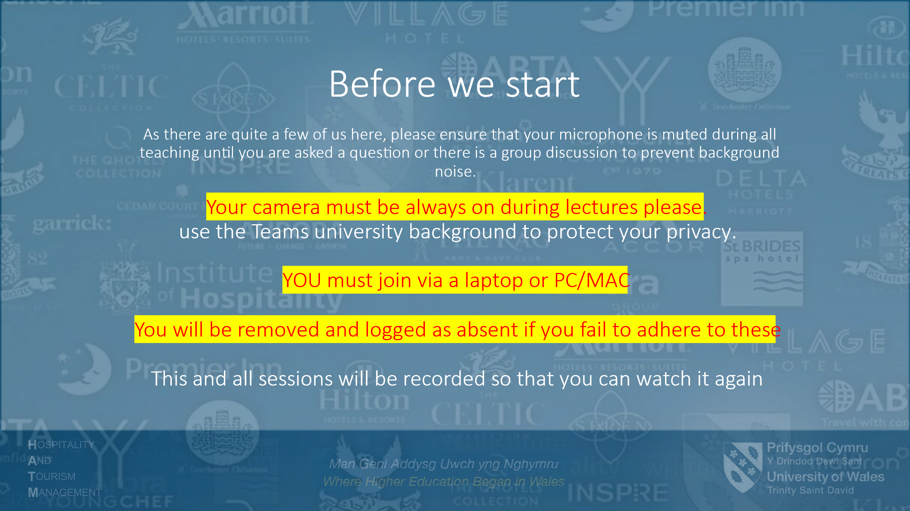
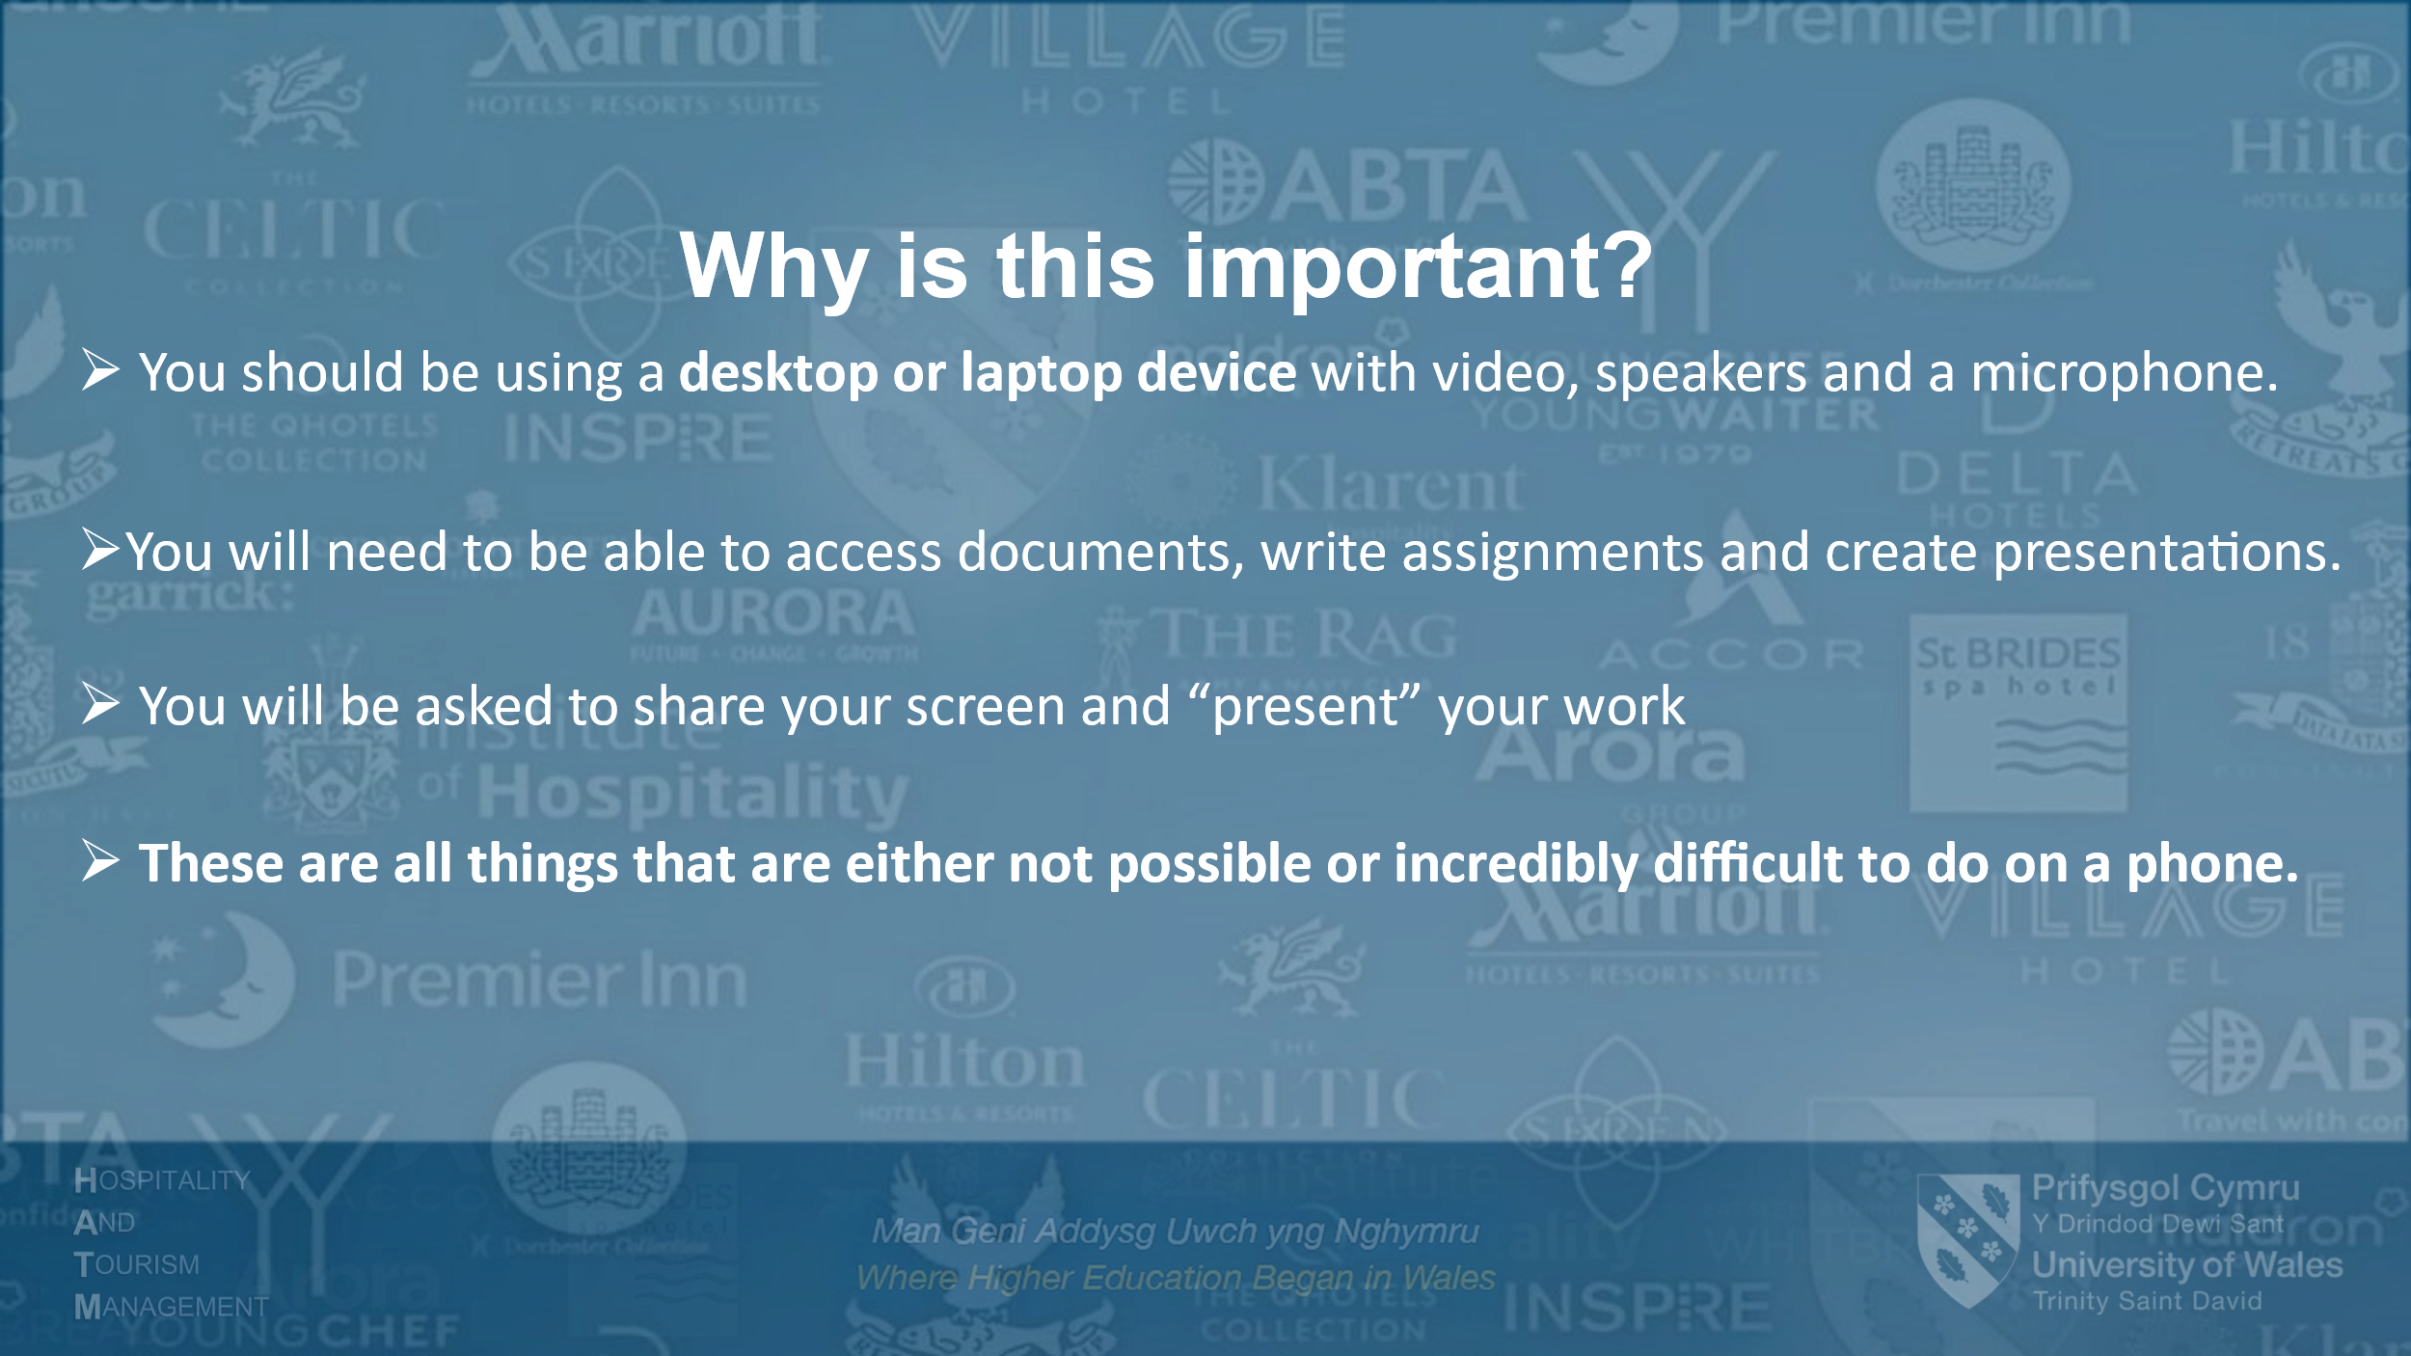
Appendix 2. Teaching Log
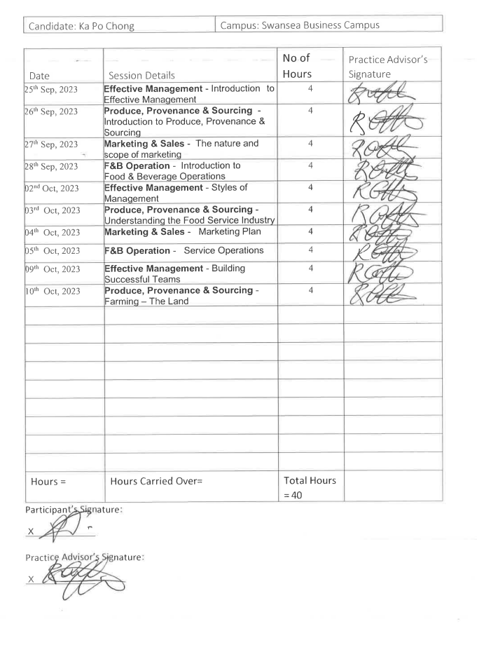

Appendix 3.1 Micro Teaching Slide

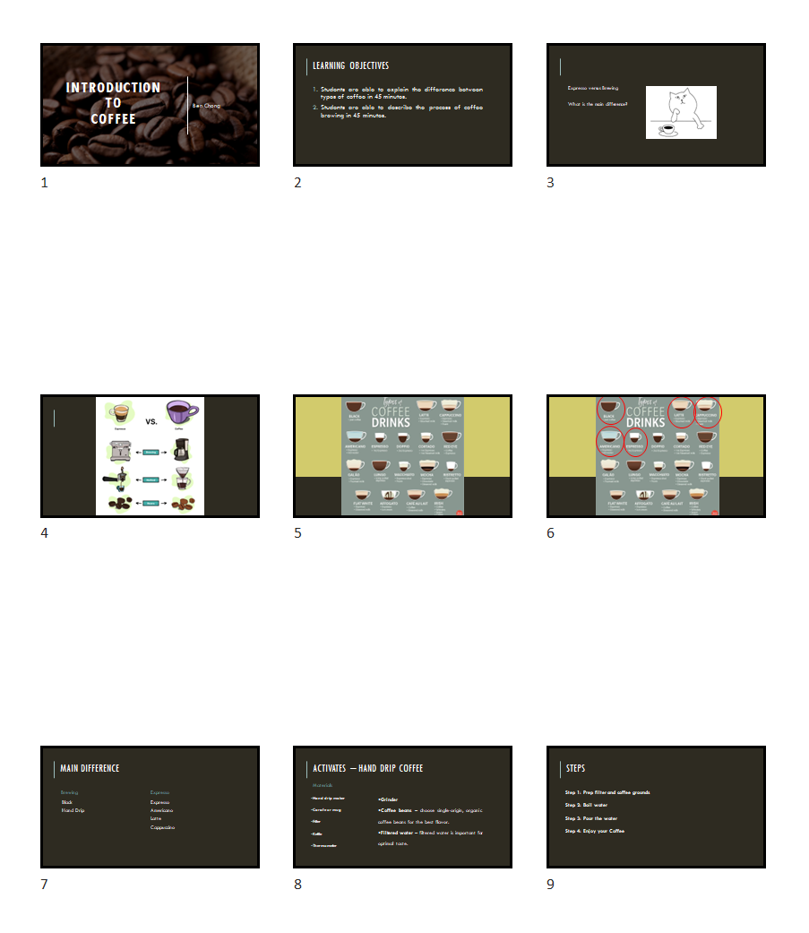
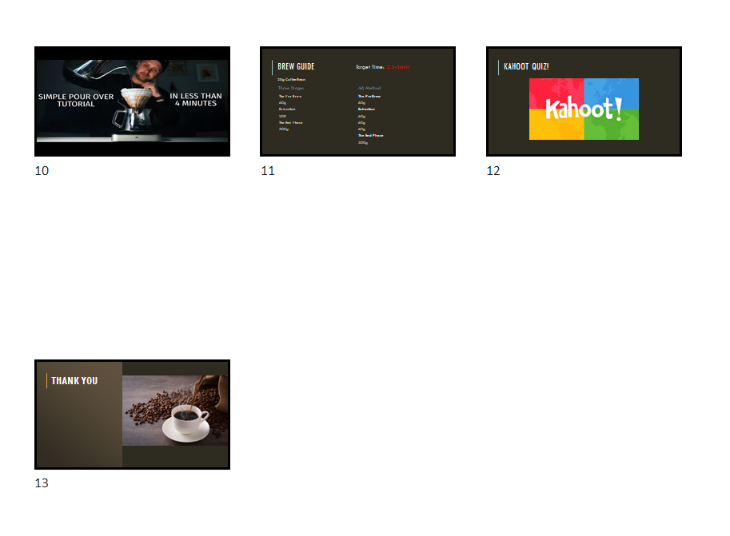

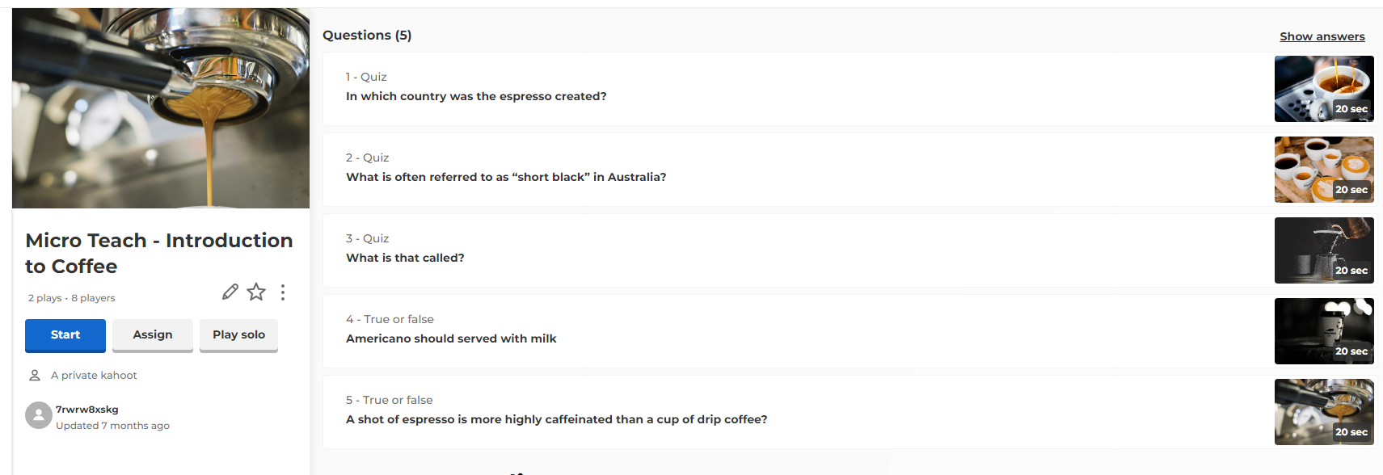
Appendix 3.2 Screen Shot of Kahoot Quiz (Micro Teaching)

Appendix 3.3 Micro Teaching Video

The file is too large and uploaded in a separate Turnitin link.

