MICHAELA BADZOVA

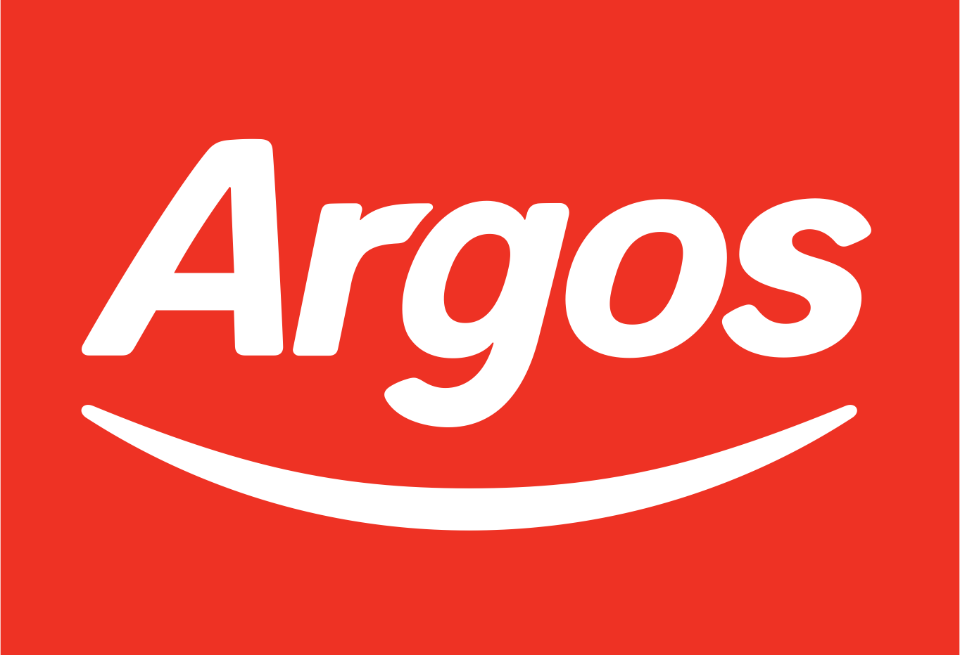
Introduction:

Argos, established in 1973 is a leading and prominent retailer based in the United Kingdom, operating primarily in the private sector. The company's goal is to provide a broad range of products so that customers may buy with “Outstanding convenience, choice and value”. Argos is well-known for offering an extensive selection of goods (over 60,000 products based on their website), such as toys, furniture, electronics, as well as home and garden supplies.

The brand is well respected in the field of e-commerce thanks to its powerful online presence and ability to let customers order things for in-store pickup or home delivery. In the digital age, Argos wants to continue providing high-quality products and a flawless shopping experience while keeping up with evolving retail trends and customer demands. A staggering 70% of their sales are brought in online, which clearly evidences the achievement of their excellent digital customer journey.

Functions of a Business:

Accounting and Finance:

Obtaining, planning, and overseeing the financial assets of a business are all part of the finance function. Finance managers assess the effects of borrowing on the business's financial health and make plans for both short and long-term capital requirements. The finance department is an operation that responds to inquiries regarding the best way to raise capital (loans vs. stocks or assets vs. liabilities), the long-term cost of borrowing money, and how financing choices will affect the long-term viability of the company.

An essential part of the Finance functional area is accounting. Accountants provide management of financial data, (Profit/Loss accounts, cash flow, revenue, operational costs etc.) which they need in order to decide how best to utilise and allocate the companies resources. Overall, this department oversees and provides data that is accurately reflecting all company's financial activities to stakeholders, investors, and internal and external parties. Financial accountants are largely in charge of creating financial statements, which are used by organisations' internal and external stakeholders to evaluate the company's financial health. Managerial accountants supply data to management for internal use in making decisions about costs, budgets, asset allocation, and performance evaluation.

Marketing and Sales:

Everything a business does to determine the needs of its customers and provide goods and services to satisfy those needs is referred to as marketing. Similarly, advertising products and services, deciding on a delivery method, and creating a price plan to gain market share while maintaining competition are all included in the marketing role. Marketing is in charge of creating and managing the company's online presence in today's tech-driven business world (e.g., the company website, blogs, social media campaigns, etc.). One of the areas of the marketing function that is expanding the fastest right now is social media marketing.

Closing the revenue that the company needs to function financially is the aim of sales, particularly in B2B enterprises. Once again, the structure and methodology of the Sales functional areas might differ based on the market's characteristics and the size of the company: inside/outside representation, vertical/horizontal focus, direct, etc. Sales pushes to take advantage of the leads that Marketing generates as well as the activities that the sales force itself produces.

Human Resource Management:

Human Resources Management processes are designed to manage employees in order to accomplish the mission of the company and uphold the corporate culture. HR managers who implement outstanding people management can assist in hiring new workers who possess the abilities to help achieve the objectives of the business. In order to achieve the objectives of the company, HR specialists also support staff development and training.

Since an organisation is only as good as its employees, human resource management (HRM) is essential to preserving or enhancing the company's success. Additionally, HR managers monitor the trends of the job market to ensure the organization stays competitive and retains the right talent. This could include the pay and benefits are competitive. Events and other out of business activities are planned to keep employees from burning out, improving staff morale and retention as well as engagement across the company.

Culture in a Business:

Employee behaviour within an organisation is shaped and influenced by the values, beliefs, attitudes, systems, and regulations that make up its organisational culture. The perceptions that stakeholders, customers, suppliers, and employees have of the company and its brand are reflected in the culture.

Although they can both aid in defining it, business objectives and a mission statement should not be confused with culture. Press releases or policy statements do not establish culture; genuine, consistent behaviour does. When you observe how a manager corrects an employee who makes an error, how a team adjusts to new customer demands, or how a CEO handles a crisis, you can witness business culture in action.

How does Culture Influence Key Functions in a Business:

The key business functions are greatly impacted by culture, which has an effect on how an organisation runs, how employees interact, and how the business is perceived in competition.

The culture defines the leadership perspectives. Leadership in a culture that prioritises hierarchy and tradition may be more authoritarian. On the other hand, a culture that values creativity and diversity could produce more empowering and collaborative forms of leadership.

Within an organisation, ways of communicating are influenced by culture. There may be an open-door policy that promotes transparency in some cultures. There may be more formal, hierarchical channels of communication in others.

The culture is the backbone of any business function, the values you endorse, will ultimately reflect in all operational aspects and measures the potential of success.

Conclusion:

The fundamental operations of the business and its culture are closely related, and both influence its overall effectiveness. Motivated and engaged workers can result from effective leadership, human resources (HR) practises, communication, and decision-making that are in line with a supportive and inclusive culture. Better business outcomes are then produced as a result, increasing productivity and creativity.

Trust and loyalty are fostered by a culture that places a high value on moral behaviour and customer-centricity, which improves the brand's reputation and customer relations. A culture of flexibility and openness to change also aids in the organization's ability to stay agile in a fast-paced business environment.

Overall, an organisation is better able to overcome obstacles, take advantage of opportunities, and accomplish its objectives when key functions are in harmony with a strong, values-driven culture.

REFERENCES:

Argos – Sainsbury’s - About Argos. Available at: https://about.sainsburys.co.uk/brands-that-deliver/argos (Accessed: 29 October 2023).
Learning, L. Introduction to business, Lumen. Available at: https://courses.lumenlearning.com/wm-introductiontobusiness/chapter/reading-functional-areas-of-business/ (Accessed: 29 October 2023).
Barney, N., Chai, W. and Sutner, S. (2023) What is Human Resource Management (HRM)?: Definition from TechTarget, HR Software. Available at: https://www.techtarget.com/searchhrsoftware/definition/human-resource-management-HRM (Accessed: 29 October 2023).
Wong, K. (2023) Organizational culture: Definition, importance, and development, Achievers. Available at: https://www.achievers.com/blog/organizational-culture-definition/#:~:text=Organizational%20culture%20is%20the%20set,the%20organization%20and%20its%20brand. (Accessed: 29 October 2023).
Saner, N. (2023) Why is culture so important in business?, Chorus. Available at: https://www.chorus.co.uk/resources/why-is-culture-so-important-in-business/#:~:text=It%20helps%20employees%20understand%20the,influence%20an%20organisation%27s%20brand%20perception. (Accessed: 29 October 2023).

