

Postgraduate/Distance Learning
Assignment coversheet & feedback form

THIS SHEET MUST BE THE FIRST PAGE OF THE ASSIGNMENT YOU ARE SUBMITTING (DO NOT SEND AS A SEPARATE FILE)

For completion by the student:
Student Name: Luke Collin

Student University Email: 2307915@student.uwtsd.ac.uk
Module code: HPCA7014  Module title: Sacred Geography | Student ID number:  2307915 |  |  | Educational support needs:  No
Assignment title: Essay based on a supervised research project.

Assignment due date: 5th Jan 2026
This assignment is for the 1st 2nd 3rd 4th x 5th 6th module of the degree
Plagiarism declaration
I confirm that this is my original work and that I have adhered to the University policy on plagiarism.

Artificial Intelligence (AI) declaration
For this assessment, you can use Generative AI to check your own text/creation for grammatical and syntactical mistakes, including rephrasing of your own work within specific standards.*

*See separate guidance in the MA Writing Guidelines

I confirm that I have not used any AI tools in the research and creation of this assignment, except as permitted above. I confirm that I have not presented any AI generated materials as my own work. I confirm I have copies of my drafts, notes, and other resources I used, which I may be asked to provide in evidence.

Signed: L.Collin

Assignment Mark
1st Marker’s Provisional mark
2nd Marker’s/Moderator’s provisional mark
External Examiner’s mark (if relevant)
Final Mark

NB. All marks are provisional until confirmed by the Final Examination Board.

For completion by Marker 1 :
Comments:

Marker’s signature: |  |  | Date:
For completion by Marker 2/Moderator:

Comments:

Marker’s Signature: |  | Date:
External Examiner’s comments (if relevant)

External Examiner’s Signature: |  | Date:

HPCA7014: Essay Two

Luke Collin

Is sacred space a human construct or a natural phenomenon?
The Stones that were left behind: Investigating the sacredness of a stone circle

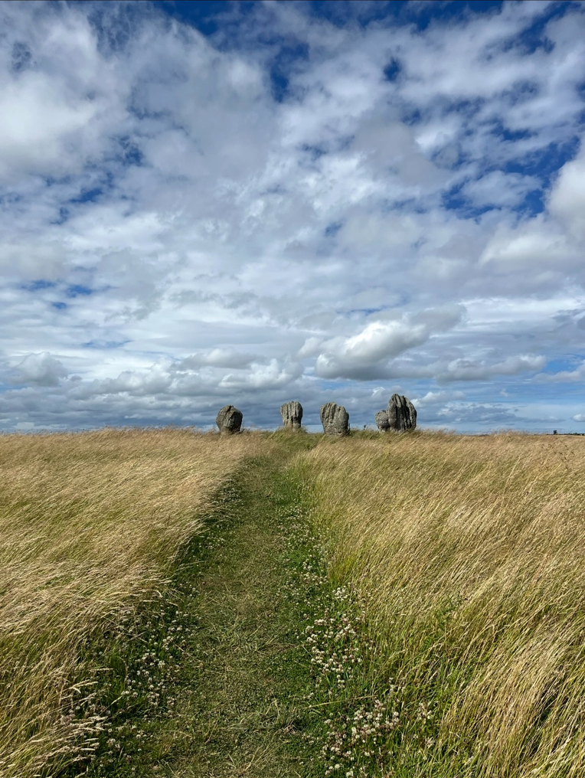

Figure 1: Duddo Five Stone, Northumberland. Taken by Luke Collin (2025).

Introduction

The aim of this research is to investigate public opinions on whether an ancient stone circle can be considered a sacred space, thus answering an overarching question ‘is sacred space a social construct or a natural phenomenon?’ The topic in question, sacredness, and what are sacred spaces and how are they established are questions that have been debated by scholars for some time and there is no clear agreement. A report published in 2008 by Anthony Thorley and Celia Gunn provided a definition of what a sacred place is, stating that it is located “in the landscape, occasionally over or under water, which is especially revered by a people, culture or cultural group as a focus for spiritual belief and practice or likely religious observance”. There is a type of place in the landscape that was once revered by a people or cultural group, and they are stone circles.

Most stone circles can be dated back from the Late Neolithic to the Early Bronze Age periods, around 4,500 years ago, and were likely used for ceremonial and astronomical purposes such as the stones of Ballochroy and Stonehenge. However, these sites are no longer attached to the original cultural group who used them for astronomical or religious observance. This raises the question of whether they are still considered sacred and functional. There are some individuals who view and use stone circles as religious sites or for astronomical observance today and it’s those that tend to identify with neo-paganism. This is an umbrella term for those who practice religious and spiritual beliefs and rituals belonging to groups that pre-date Christianity in Europe and are not part of the predominant religions today. At the time of writing, neo-pagans have been present at Stonehenge to witness the arrival of the winter solstice. Do those individuals believe that stone circles are sacred, if so, then why and do non-neo-pagans have a different opinion. There are many questions that must be asked and it is those questions like these that will form the premise for this essay. A secondary research component was to adopt a phenomenological approach and visit a nearby stone circle and record my experience. The data found from this research, alongside the analysis of supporting academic literature on sacredness, will be used in order to formulate the body of this work. Therefore, the purpose of this research project is to add to the work on stone circles and how they operate in the modern day in relation to beliefs of sacred spaces.

Literature Review

As previously highlighted, there is extensive academic discussion over sacredness, and it being experienced in certain locations. The earliest academic reference to ‘sacredness’ comes from the German philosopher, Rudolf Otto. In his book The Idea of the Holy published in 1917, Otto wrote that the sacred was a mysterious awe-inspiring experience, which he termed “numinous”, referring to ‘divine will’. For Otto, the ‘numinous’ consisted of three components, the first being mysterium tremendum et fascinans which creates a reaction of silence, mysterium tremendum that incites terror, and lastly, fascinans which refers to grace and merciful.

According to Bernadette Brady, writing in 2024, there are two dominants approaches in academia that attempt to understand sacredness: a sociological and an ontological perspective. The sociological perspective was advocated by Emile Durkheim (1858-1917), an influential sociologist from France. In 1912, he published his book The Elementary forms of Religious Life which was concerned with religion and the sacred. Durkheim’s view suggests that nothing is inherently sacred and sacredness is a human construct, being created solely within the mind of an individual or a group. Durkheim wrote “society in general…undoubtedly has all that is required to arouse the sensation of the divine” and that “Society is the soul of religion”. These quotes suggest that sacredness is established by a group when they set apart certain spaces or objects from the everyday commonplace. It was hypothesized by Durkheim that this dichotomy can be found in religion. He coined the ordinary or commonplace as the ‘profane’, a phrase that will be echoed in the ontological approach. Lastly, Durkheim believed that sacredness could be maintained in a space through repetitive acts such as rituals.

The ontological approach was promoted by Mircea Eliade (1907-1986), a scholar in religious studies from Romania. His book The Sacred and the Profane published in 1957 is one that is concerned with this topic. Eliade’s perspective suggests that the divine is responsible for the creation of a sacred place. He believed that a sacred space is established due to a ‘hierophany’ which he described as being an irruption of the sacred or divine, revealing itself to an individual or group. Therefore, this specific location becomes detached from everything else around it, the profane. This term is the same as used by Durkheim, although there is no evidence to suggest that Eliade acknowledged the works of Emile Durkheim. However, it is apparent that there are great similarities between Eliade’s ‘hierophany’ and Otto’s ‘numinous’, suggesting that Eliade may have developed his theories based on Otto’s ideas.

To Eliade, the profane was homogenous which made the hierophany stand out, and in order for an hierophany to occur, the earth had to be involved in some form of communication with the heavens above, or the underworld below. Eliade also offered a different approach to understanding sacred space which would be based on a personal level and how space may play a role within a person’s life. He named this ‘crypto-religious behaviour’ where he suggested that events such as a man's birthplace or his first love creates a sense of sacredness. These events stand out, being separate from the ordinary or the profane.

The academic Belden C. Lane has a perspective that is similar to both Durkheim and Eliade, however, Lane considers his to be phenomenological. In his book Landscapes of the Sacred published in 2001, Lane proposes that there are four rules or ‘axioms’ in which the character of sacred space can operate. His first axiom ‘a sacred space is not chosen, it chooses’, suggests that the divine chooses a specific place to reveal itself and humans maintain that location. The second axiom is that a ‘Sacred place is an ordinary place, ritually made extraordinary’. From these two axioms alone, one can see both Eliade and Durkheim’s approaches combined. The third axiom is that a ‘sacred place may be trod upon without being entered’. This implies that a sacred space may be considered as sacred to an individual or group, but not to another. Lastly, Lane’s fourth axiom is ‘the impulse of sacred space is both centripetal and centrifugal, local and universal’, suggesting that the divine cannot be confined to a single location but people are driven to a physical site such as a shrine for example. This somewhat relates to Lane’s second axiom.

Similar to Lane, archaeologist Christopher Tilley takes a phenomenological approach, writing on the subjectivity of experiencing certain locations such as mountains. He states that ‘mountains will always be different according to how we approach them’. This suggests that each individual will experience a place very differently. Tilley shares the opinion of Lane in that a location can be considered a sacred space depending on the number of stories there are about the place.

Methodology

The aims of this research project were to establish whether a 4,500-year-old stone circle can be considered as a sacred space. In order to reach a conclusion, a questionnaire featuring eight specifically formulated questions was deployed in a public setting. This task was spread over the course of two days, each day having a specific target audience/group. The intended group on the first day were those attending a pagan craft market and the other group were people passing through a busy high-street. This method was specifically chosen to find out if different groups of people would provide different answers. I felt that this would create a varied outcome as well as coving a wide scope of viewpoints and opinions on the subject. Going into this research, I had some initial hypotheses. The first was that those attending the pagan craft market would identify as pagan and believe that a stone circle is a sacred space. The second was that those walking on the Newcastle high-street would be less likely to believe that a stone circle would be sacred. I was also interested in whether there would be a correlation between belief in sacredness and sex and age. Some of the questions featured on the questionnaire include, “Do you believe that stone circles are sacred?” and “Is sacredness a social construct or is it created by the divine?” (see appendix A). These questions were chosen as they are topic specific and less generalised, aiming to seek a specific answer.

A secondary component to this research was to personally adopt a phenomenological approach and visit the nearby stone circle of Duddo Five Stones (see fig.1). This stone circle was not chosen specifically, but out of convenience to my location and distance. This visit took place on the afternoon of the 30th November and it must be noted that the photograph provided above of the stones was taken some years ago. This is because my recent photos do not do the stones justice as it was an overcast day making the photos appear dark. The intended result of doing this was to report my experiences of the site and the landscape that it dwells in, whilst considering the opinions of the individuals discussed in the literature review above. The experiences of this visit were written in my journal, and they are incorporated into the discussion below.

Prior to this project, it was important to conduct research on the theorists and approaches that focus on the subject of a sacred space and sacredness in general. This was done in order to establish an understanding of different perspectives and to determine the scope of available literature. Most of the dominant theorists and their approaches are explained in detail within the literature review section of this work.

Following the universities ethical guidelines for conducting research, this questionnaire was deployed on November 21st and 22nd, 2025. The first day of questionnaires took place at a local late evening pagan craft market just outside of Middlesbrough City Centre at 6pm when the market begun and the second day took place on Newcastle’s busy high-street, Northumberland Street at 12 pm. The time of 12pm on the 22nd was specifically chosen to carry out the questionnaire on the high street because students and workers are more likely to be on their lunch breaks and it is also a peak time for shoppers. These two locations were chosen to see if I could capture a larger number of individuals and diverse results. The Newcastle high street tends to be always busy, and the pagan craft market is one of the biggest in the North-East. These locations were perfect for offering a sample pool that I required. The questionnaire itself was directed towards consenting adults between the ages of 18 and 60 years old. Following the example of Jenny Rowley, participants were solely identified based on their willingness to participate. The aim was to receive between 40 to 50 completed questionaries on both days.

Ethical considerations
Proposing a questionnaire based on an individual’s personal beliefs raised some ethical considerations, especially at the pagan craft market. The likelihood of certain questions causing offense to some members of the public was rather high due to it involving sensitive information such as religion, for example. To lower the risk of offense, prior to conducting a questionnaire, all participants were briefed about what the questionnaire entailed and how their information would be used and stored. Following the university guidelines, participants were also given the option to opt-out at any time and if they wished, and their data would be disposed of immediately. During this research, no offense or harm were caused, and no issues were faced throughout.
Limitations
Upon the completion of this research, there were a few limitations that arose. The first limitation what that only 32 questionnaires were completed at the craft market and 28 in the high street, rather than the intended 40 to 50 goal which was initially set out. There were two primary reasons for this. Firstly, the majority of the public were unwilling to stop what they were doing to talk. Secondly, when people did stop, there was a large disinterest in the subject when the premise of the research was explained which discouraged people from taking part.
Another limitation is likely the research method itself, where it was deployed and when. It may have been useful to have placed this questionnaire online and had it shared across social media. This would therefore ensure a larger reception than what was received in public, especially due to my focus being only within the North-East. The issue with an online questionnaire is that most internet users are under the age of 24 and it would take slightly longer to gain the desired results. That said, there was no issue with gaining younger recipients as on the second day of the questionnaire in Newcastle, students were on their lunch breaks and made up a significant portion of completed questionnaires. This naturally effects the balance of age groups, but also younger generations tend to be drawn to neo-pagan beliefs than older generations.
A third limitation is based on the initial premise that people out on the high-street would provide a specific result in comparison to those at the pagan crafts market. Naturally, this was indeed the case as seen in the discussion below. However, it was rather surprising to see how many individuals on the high street shared the same views and opinions as those from the market. Newcastle contains a large pagan and wiccan community, however there is a limitation when it comes to looking at census data of religions. According to the Pagan Federation, pagans and wiccans tend to be categorised under ‘other’, being put together with other groups such as Zoroastrianism and Jainism (see appendix C).
Going into this research project I had some personal biases regarding the potential outcomes of the questionnaires. As stated previously, I was under the preconceived notion that those attending the pagan crafts market would identify as pagans themselves and therefore believe that a stone circle is a sacred space. Another notion was that individuals walking on the Newcastle high street would be less likely to believe that a stone circle would be sacred. These preconceived notions alone are a limitation to this project.

Discussion and Findings

The results of the questionnaire were interesting and proved two initial hypotheses that I had going into this research project. The first was that the majority of those attending the pagan craft market would believe that a stone circle, like Duddo five stones, is a sacred site. This was generally the case as 86% of those asked, said that they are sacred. However, what was surprising was that 11% said that stone circles were not, and it was these individuals who did not identify as pagan. The second proven hypothesis was that individuals on the high street stated that a stone circle is not sacred with 77% attesting this. Again, it was surprising to see that 20% of people on the street said that stone circles are sacred. However, of this 20% who agreed upon the sacredness of stone circles, all of them identified as pagan, whereas many individuals that disagreed, highlighted that they were atheist.

I speculated that those from the high street who did not believe that a stone circle was a sacred space, were more likely to believe that sacredness was a social construct, sharing Durkheim’s opinion. This was proven as 68% attested to this, whereas at the craft market, 86% of those asked believed that sacredness can only be created by the divine in some way. The remaining 32% on the high street believed that the sacred is created by the divine and this may be reflective of the small percentage of pagans and Christians who completed these questionnaires. The general question was asked ‘can a location or space be sacred?’, and it was found that 96% of those at the crafts market said yes and 84% of individuals on the high street said no. I found it quite interesting that 54% of people who completed the questionnaires on the high street had not actually been to a stone circle before, especially as most of the individuals stated that sacredness is a social construct and that a stone circle cannot be sacred. How can someone be certain of this without even visiting a stone circle? This is what I did, I had to be there physically instead of intellectualising an experience through literature. That said, the 46% of those that had visited a stone circle, around 34% of those individuals believe that stone circle is a sacred space. A question that should have been asked from that point would be ‘Did you believe that a stone circle is sacred before or after your visit?’. This may have clarified whether belief in sacredness is a direct result of an in-person experience.

For those that did visit a stone circle, one of my questions asked, ‘How did you feel when you visited a stone circle?’. One answer taken from the craft market states, “It felt amazing, I was shocked in a good way”. Another stated “I felt immediately connected to nature and the ancestors”. In comparison, an answer taken from the high street states “I felt nothing other than an appreciation of the past”. Another answer states “I don’t believe that it creates a spiritual sentiment inside of me, but I have always loved the stone ages”.

There is a clear difference and similarity between the two. The similarity is that one can enjoy the physical exploration of a stone circle and appreciate it mainly because of its historic relevance. The difference is whether an individual feels or believes that this site can be sacred based on their own belief system. The person that stated that they felt connected to nature and the ancestors is an interesting statement. When looking at this questionnaire, this individual ascribes to pagan beliefs, and it could be argued that this belief system itself has influenced opinions and views regarding the importance of stone circles and other ancient landmarks and sites in a religious context. I would have liked to know if this person connected more to nature inside of the stone circle rather than being in the outdoors in general, but how much of that can be psychological or related to being a social construct.

Lastly, the results found that there was a correlation of belief and disbelief regarding sacredness between sex and age. I noticed that on the high street, more women than men were more likely to believe that a stone circle can be sacred, noticeably, young women within the millennial and generation-z groups. Naturally, it was these women who identified as pagans too, so this adds slight bias into the equation. The same bias could also be applied to the pagan crafts market as over 90% of customers were women of mixed ages who also mostly identified as pagan. A study from 2014 found that 70.8% of women out of an 8000-group sample, were more likely to identify as a pagan than men. This same study also found that those identifying as pagan had significantly increased from 2001 to 2011 by 21%, specifically in Canada alone, with a similar percentage from Europe.

What now follows is my journal entry and it has been merged into this discussion to maintain linearity. I arrived at a convenient parking spot next to the roadside around 1:30pm on the 23rd of November. Using my iPhone map application, this allowed me to understand which direction I needed to walk. I visited this site many years prior and had a rough idea where the site was in relation to my position. After walking through fields, avoiding a broken ankle due to the number of holes, I made it to the field in which the stones stood on the hill directly in the centre. I found that my eyes naturally gravitated towards the stones regardless of the environment. When I walked up to the stones, they grew larger and larger as I became closer, and I noticed surrounding fields that I couldn’t previously see from the base of the hill. As I reached the top the hill and walked into the centre of the stones, I felt a sense of achievement, that my journey through the landscape was complete. I could see more of the surrounding area than I could previously, and it made me think about how this site would have been an important landmark for our ancient ancestors. I could imagine that it would have been great to visit on a clear night.

When I began to take a closer look at the stones, I noticed that there were Selenite crystals placed in their crevasses (Appendix D). I can only imagine that these have been used previously by those that are associated with neo-pagan circles in some kind of ritual or offering. According to many online articles about crystals and their properties, Selenite can be used for various things such as protection, healing and warding off negative energy. According to The Gemmological Association of Great Britain, Selenite is named after Selene, the Greek goddess of the Moon. It is interesting to note that the New Moon only occurred a few days prior to my visit to the Duddo stones and the use of Selenite may have been intentional during a New Moon festivity or ritual.

After completing my look around the site, I was in awe of it, as well as the surrounding landscape that you can see from standing within the stones. It is how it stood within the landscape, acting as a focal point, that made me feel in astonishment. In his work The Materiality of Stone, Christopher Tilley not only focusses on a site being a visual marker but looks at the material presence and physical qualities. For example, Tilley would look at how the stones are weathered, how they feel and their colour. Tilley believes that these factors also contribute to how ‘sacredness’ can be experienced at a site. There is also the mental/emotional side to experiencing a site too. The geographer Yi-Fu Tuan suggests that individuals or groups can have affectionate ties with the material environment. These are rooted in deeper responses of belonging and emotional reactions. This would essentially describe my attachment to this stone circle, although I have no personal connection to it, it does relate to my own romanticism with the past as an archaeologist.

I am unable to say that Duddo Five Stones felt sacred or that its special place within the landscape made it sacred. I visited the elaborate Nativity of Christ Russian orthodox Cathedral in Riga, Latvia, many years ago and the feeling of entering this space felt very similar to entering the stone circle. This may have been something to do with the environments such as the vast surrounding landscape of the stones or the bright coloured artwork of Christ, saints and the high domes within the Cathedral. I felt an awe and a reaction of silence. These are both components of Otto’s numinous, but I do not think I experienced the divine revealing itself like Eliade would say. It could be argued that what I am experiencing is something of a social construct in both locations like Durkheim would assert, or that Lane was correct in stating that a ‘sacred place may be tread upon without being entered’. This is because it is not directly sacred to me but that doesn’t mean it is not sacred to another person or group.

The stone circle may be considered sacred to those who placed Selenite crystals within the stones. However, that makes me think about whether this individual or group has been influenced by the beliefs and opinions of others who regard stone circles to be sacred such as neo-paganism, therefore coming back to Durkheim’s perspective of sacredness being social construct, yet again. Durkheim’s opinions can be offered when looking at the idea that these neo-pagan groups may have been doing some form of a ritual, as Durkheim believed that rituals reinforce the idea of sacredness.

Something that was noticeable through this research was how much personal experience can affect views on sacredness. Rudolf Otto was brought up within the Lutheran church and has an innate belief in the divine. Mircea Eliade grew up within the Eastern Orthodox Church and the influence that his religion had upon his work was something that was discussed in 2010 by Rennie. Eliade was a firm believer in heaven and hell and he became more interested in eastern religions during his travels throughout India in the late 1920’s and early 1930’s. As for Emile Durkheim, he was to follow in his father's footsteps and become a rabbi, therefore it could be argued whether the pressure he faced to become what his family wanted may have made Durkheim a sceptic of religion. Durkheim’s scepticism of religion was a topic that was discussed in 2012 by Stephen Lukes. The academic Belden C. Lane is a Presbyterian theologian who currently teaches religion and theology on a Jesuit faculty at St Louis University. He states that he is a Christian, raised in the Reformed tradition. When looking at other sources, Christopher Tilley’s appreciation with materiality and how they influence the experience of sacredness likely originates in his specialism of archaeology, a career that requires you to look at objects critically and be outdoors. Tilley’s background is similar to my own as an archaeologist, there is an innate admiration with materiality and the landscape and attempting to find how the two can interact.

Reflexivity and Further Implications

An important consideration within this research is the role of reflexivity and how my own background may have influenced both the research process and interpretation of findings. As an archaeologist, I approach ancient sites with an inherent appreciation for landscape, materiality, and the human past. This disciplinary background likely heightened my attentiveness to the physical presence of the stones, their placement within the landscape, and their visual dominance as a landmark. While this may have shaped my phenomenological experience at Duddo Five Stones, acknowledging this subjectivity strengthens rather than weakens the research, particularly within phenomenological inquiry, where personal perception is considered a valuable source of data rather than a bias to be disregarded.

Beyond the immediate findings presented above, this research has broader implications for how ancient sites are understood and managed in the modern world. Stone circles are primarily treated as archaeological or heritage assets, however, this study demonstrates that they continue to hold spiritual and emotional significance for certain groups today. This raises important questions regarding site access, management, and preservation, particularly were contemporary ritual practices cross with heritage conservation.

Conclusion

This research project set out to investigate whether an ancient stone circle can be considered a sacred space and, more generally, whether sacred space should be understood as a social construct or something that is divinely created. This was achieved through a combination of research methods including a questionnaire, phenomenological fieldwork, and engagement with key academic theories, this research has demonstrated that sacredness is neither fixed nor universal, but instead highly dependent on belief, experience, and social context.

The results of my questionnaire revealed that there was a clear divide between belief groups as I initially suspected. Those identifying as pagan were more likely to consider stone circles as sacred and to attribute their sacredness to divine or spiritual origins, aligning closely with the ontological approaches of Eliade and Otto. On the other hand, the majority of participants on the high street, many of whom identified as atheist, viewed sacredness as a social construct, which echoed Durkheim’s sociological theories. However, the presence of pagans within the high-street sample, particularly among younger women in a university city with a large neo-pagan community, complicates my initial aim of gaining a diverse sample but did highlight how belief systems continue to evolve and circulate with modern society.

My phenomenological visit to Duddo Five Stones further reinforced the idea that sacredness is experienced subjectively. While the site evoked personal feelings of awe and achievement, these sensations that I had did not necessarily translate into a perception of divine presence. Instead, the experience aligned more closely with Otto’s concept of the numinous without fully following Eliade’s criteria for a hierophany. This supports Lane’s assertion of his third axiom that a sacred space may be “tread upon without being entered” and Tilley’s view that landscapes are encountered differently depending on the individual. The presence of potential ritualistic objects such as the Selenite crystals amongst the stones demonstrates how contemporary groups actively re-sacralise ancient sites, suggesting that sacredness can be maintained or recreated through social practices and ritual behaviour, as Durkheim proposed.

Overall, this research suggests that ancient stone circles can be considered sacred spaces, but only if they are made sacred by individuals or groups who provide meaning to them. Sacred space, therefore, is best understood as a social construct. This is because it can be reinforced through belief, ritual, personal experience, and cultural memory, rather than an inherent or widely recognisable attribute of the landscape. While natural features and material qualities undoubtedly contribute to emotional responses, it is human interpretation that ultimately defines sacredness. In this sense, stone circles remain active and meaningful sites not because they are intrinsically sacred, but because people continue to make them so.

Bibliography

Andrews, C.R., The pagan boom: why young people are turning to non-traditional religions (2019) https://www.dazeddigital.com/life-culture/article/43242/1/the-pagan-boom-young-people-non-traditional-religions-druids-witchcraft [accessed 20th December 2025].

BBC News, In Pictures: Druids descend on Stonehenge to mark winter solstice (2025) https://www.bbc.co.uk/news/articles/cn7k55jg2n3o#:~:text=Thousands%20of%20revellers%20gathered%20at,dancers%20also%20welcomed%20the%20sunrise [accessed 21st December 2025].

Britannica, Modern Paganism (2025) https://www.britannica.com/topic/modern-Paganism [accessed 17th November 2025].

Burl, A. Prehistoric Stone Circles (Buckinghamshire: Shire Publications Limited, 1997).

Burl, A. Prehistoric Astronomy and Ritual (Aylesbury: Shire Publications Limited, 1983).

Durkheim, E. The Elementary Forms of Religious Life, trans. Karen Fields (New York: The Free Press, 1995).

Eliade, M. The Sacred and the Profane (New York: Harcourt, 1987).

Evans, M. T. ‘The Sacred: Differentiating, Clarifying and Extending Concepts’, in Review of Religious Research vol.45 (1), (London: Sage Publications Ltd, 2003).

Fay, W. ‘The Gnome, The Rock and The Pool – Sacredness in a Domestic Garden’, in Sacred Geography: Conversations with Place, eds. Brady, B. and Hunter, J. (Wales: Sophia Centre Press, 2024).

Hunter, J. ‘Introduction Part 2’ in Sacred Geography: Conversations with Place, eds. Brady, B and Hunter, J. (Wales: Sophia Centre Press, 2024).

Krupp, E. C. ‘The Stonehenge Chronicles’ in In Search of Ancient Astronomies eds. Edwin C. Krupp (London: Penguin Book, 1984).

Lane, B. C. ‘Fierce Landscapes and the Indifference of God’ in Christian Century, vol.115 (Chicago: Christian Century Foundation, 1998).

Lane, B. C. Landscapes of the Sacred: Geography and Narrative in American Spirituality (London: John Hopkins University Press, 2001).

Larkin, B. Selenite Crystals & Gemstones: Names, Meanings & Benefits (2025) https://tinyrituals.co/blogs/tiny-rituals/selenite-meaning-healing-properties-uses?srsltid=AfmBOoo2NKCQNtFPiROvuH0NMLpj7XDOOZfifxA9Qtm9x15CN-w0E_N8 [accessed 15th December 2025].

Lukes, S. ‘Is Durkheim’s understanding of religion compatible with believing?’ in Religion vol.42 (1), (Oxford: Routledge, 2012).

Minney, R. The work of Rudolf Otto and its relevance to religious education in Britain at the present time (Durham thesis: Durham University, 1993).

McNiven, H. ‘An Unexpected Pilgrimage to Seoul’s Namsan Mountain’, in Sacred Geography: Conversations with Place, eds. Brady, B. and Hunter, J. (Wales: Sophia Centre Press, 2024).

Otto, R. The Idea of the Holy: An Inquiry into the Non-Rational Factor in the Idea of the Divine and Its Relation to the Rational (London: Oxford University Press, 1970 [1917]).

Petrosyan, A. Global age distribution of internet users 2024, by region (2024) https://www.statista.com/statistics/209101/age-distribution-internet-users-worldwide-by-region/ [accessed 20th December 2025].

Rennie, B. ‘The Influence of Eastern Orthodox Christian Theology on Mircea Eliade’s Understanding of Religion’ in Hermeneutics, Politics, and the History of Religions: The Contested Legacies of Joachim Wach and Mircea Eliade, eds. Christian Wedemeyer and Wendy Doniger (Oxford: Oxford University Press, 2010).

Rowley, J. ‘Designing and using research questionnaires’, in Management Research Review, vol.37 (3), (Leeds: Emerald Group Publishing, 2014).

Spencer, A. ‘The Hiroshima Peace Park; Is It Possible For A Nuclear Weapon To Create A Sacred Space?’ in in Sacred Geography: Conversations with Place, eds. Brady, B. and Hunter, J. (Wales: Sophia Centre Press, 2024).

Thorley, A. and Celia M. Gunn, C. M. Sacred Sites: An Overview (Abridged) (London: The Gaia Foundation,2008).

Tilley, C. ‘Foreward’, in Space, Place and Religious Landscapes: Living Mountains, eds. Gunzburg, D. and Brady, B. (London: Bloomsbury Academic, 2020).

Tilley, C. A Phenomenology of Landscape: Places, Paths and Monuments (London: Bloomsbury Publishing, 1997).

Tilley, C. The Materiality of Stone: Explorations in Landscape Phenomenology (London: Routledge, 2004).

The Gemmological Association of Great Britain, Gem – A Gemstone & Mineral Collection: Understanding Selenite (2019) https://gem-a.com/gem-hub/understanding-selenite/ [Accessed 15th December 2025].

The Pagan Federation, Census 2021 – Results (2022) https://www.paganfed.org/census-2021-results/ [accessed 20th December 2025].

Tollefsen, I. B. and Lewis, J. ‘Gender and Paganism in Census and Survey Data’ in Pomegranate vol.15 (1-2), (Sheffield: Equinox Publishing Limited, 2014).

Tuan, Y. F. Topophilia: A Study of Environmental Perceptions, Attitudes and Values (New York: Columbia University Press, 1990).

University of Wales Trinity Saint David, Research Ethics & Integrity Code of Practice (2022) https://www.uwtsd.ac.uk/research/research-integrity-and-ethics [accessed 17th December 2025].

White, D. G. ‘Introduction’ in Yoga: Immortality and Freedom (New Jersey: Princeton University Press, 2009).

Appendix A


Astrological Questionnaire
By Luke Collin
Faculty of Humanities and the Performing Arts
University of Wales Trinity Saint David, Ceredigion, Wales, SA48 7ED, UK.

Please circle and complete all applicable:

Sex: Male / Female / Other

Ethnicity:

Generation: Boomer (1946-64)/ Gen X (1965-80)/ Millennial (1981-96)/ Gen Z (1997-2012)
- What is your religion?

- Do you attend your place of worship? Yes / No (if so, how often do you attend: Often / Rarely)

- Would you say that you are spiritual? Yes / No

- Do you believe that stone circles are sacred?

- Can a location or space be sacred?

- Have you ever visited a stone circle?

- How did you feel when you visited a stone circle?...................

- Is sacredness a social construct or is it created by the divine?

Consent:
Please note that this data will be used anonymously for academic research purposes and your name will not be used. Do you consent to this Yes / No.

Appendix B

Results of the Questionnaire

Sex: (market)
Male 4%
Female 96%
Sex: (high street)
Male 35%
Female 65%

Ethnicity: (market)
White British 96%
Irish 4%
Ethnicity: (high street)
White British 81%
Mixed 18%

Generation: (market)
Gen X 71%
Millennial 10%
Gen Z 17%
Generation: (high street)
Gen X 18%
Millennial 56%
Gen Z 25%

What is your religion? (market)
Pagan 96%
Christian 4%
What is your religion? (street)
Atheist 68%
Pagan 18%
Christian 12%

Do you attend your place of worship? (market)
Yes 58%
No 42%
Do you attend your place of worship? (street)
Yes 22%
No 78%

Would you say that you are spiritual? (market)
Yes 98%
No 2%
Would you say that you are spiritual? (street)
Yes 21%
No 79%

Do you believe that stone circles are sacred? (market)
Yes 86%
Maybe 2%
No 11%
Do you believe that stone circles are sacred? (street)
Yes 20%
Maybe 3%
No 77%

Can a location or space be sacred? (market)
Yes 96%
No 4%
Can a location or space be sacred? (street)
Yes 14%
Don’t know 4%
No 82%

Have you ever visited a stone circle? (market)
Yes 92%
No 8%
Have you ever visited a stone circle? (street)
Yes 46%
No 54%

(Question 7 is not included as it does not include a percentage)

Is sacredness a social construct or is it created by the divine? (market)
Divine 86%
Social 14%
Is sacredness a social construct or is it created by the divine? (street)
Divine 32%
Social 68%

Appendix C

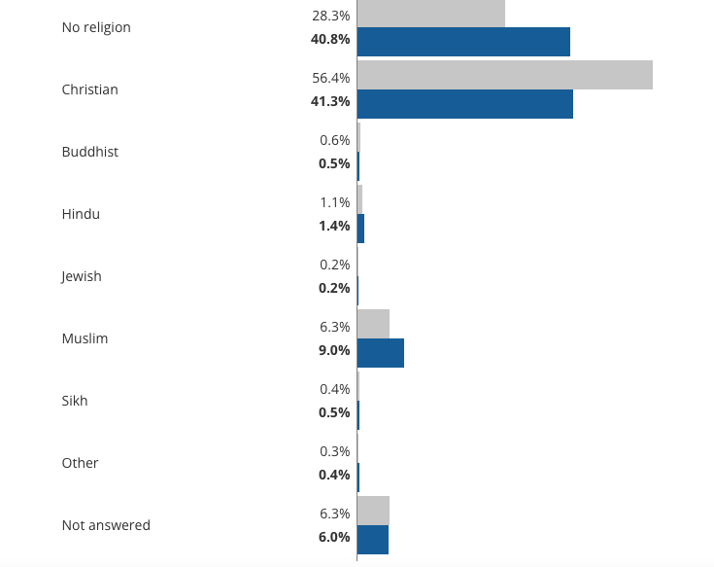

Appendix C: Census data from Newcastle regarding religion percentages (2021). Taken from the Office of National Statistics.

Appendix D

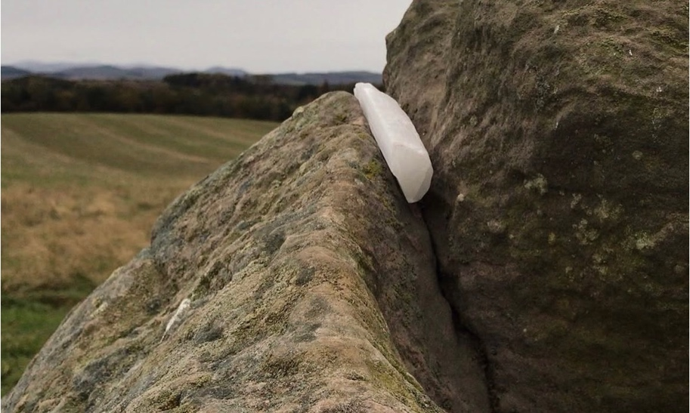

Appendix D: Photo showing a selenite crystal placed within the stones of Duddo Five Stones (2025). Taken by Luke Collin.

Matthew T. Evans, ‘The Sacred: Differentiating, Clarifying and Extending Concepts’, in Review of Religious Research vol.45 (1), (London: Sage Publications Ltd, 2003). p.32.
Anthony Thorley and Celia M. Gunn, Sacred Sites: An Overview (Abridged) (London: The Gaia Foundation,2008). p.12.
Aubrey Burl, Prehistoric Stone Circles (Buckinghamshire: Shire Publications Limited, 1997) p.9.
Ibid, pp.9-10.
Aubrey Burl, Prehistoric Astronomy and Ritual (Aylesbury: Shire Publications Limited, 1983) Pp.30-34.
Ibid, p.7
Edwin C. Krupp, ‘The Stonehenge Chronicles’ in In Search of Ancient Astronomies eds. Edwin C. Krupp (London: Penguin Book, 1984) pp.77-126.
Britannica, Modern Paganism (2025) https://www.britannica.com/topic/modern-Paganism [accessed 17th November 2025].
BBC News, In Pictures: Druids descend on Stonehenge to mark winter solstice (2025) https://www.bbc.co.uk/news/articles/cn7k55jg2n3o#:~:text=Thousands%20of%20revellers%20gathered%20at,dancers%20also%20welcomed%20the%20sunrise [accessed 21st December 2025].
Matthew T. Evans, ‘The Sacred: Differentiating, Clarifying and Extending Concepts’, in Review of Religious Research vol.45 (1), (London: Sage Publications Ltd, 2003). p.32.
Wendy Fay, ‘The Gnome, The Rock and The Pool – Sacredness in a Domestic Garden’, in Sacred Geography: Conversations with Place, eds. Bernadette Brady and Jack Hunter (Wales: Sophia Centre Press, 2024) p.144.
Rudolf Otto, The Idea of the Holy: An Inquiry into the Non-Rational Factor in the Idea of the Divine and Its Relation to the Rational (London: Oxford University Press, 1970 [1917]) p.7.
Ibid, pp.14-17.
Jack Hunter, ‘Introduction Part 2’ in Sacred Geography: Conversations with Place, eds. Bernadette Brady and Jack Hunter (Wales: Sophia Centre Press, 2024) p.11.
Emile Durkheim, The Elementary Forms of Religious Life, trans. Karen Fields (New York: The Free Press, 1995) p.208.
Ibid, p.314.
Wendy Fay, ‘The Gnome, The Rock and The Pool – Sacredness in a Domestic Garden’, in Sacred Geography: Conversations with Place, eds. Bernadette Brady and Jack Hunter (Wales: Sophia Centre Press, 2024) p.144.
Emile Durkheim, The Elementary Forms of Religious Life, trans. Karen Fields (New York: The Free Press, 1995) p.34.
Jack Hunter, ‘Introduction Part 2’ in Sacred Geography: Conversations with Place, eds. Bernadette Brady and Jack Hunter (Wales: Sophia Centre Press, 2024) p.11.
Mircea Eliade, The Sacred and the Profane (New York: Harcourt, 1987). P.11.
Ibid, p.26.
Holly McNiven, ‘An Unexpected Pilgrimage to Seoul’s Namsan Mountain’, in Sacred Geography: Conversations with Place, eds. Bernadette Brady and Jack Hunter (Wales: Sophia Centre Press, 2024) p.74.
Mircea Eliade, The Sacred and the Profane (New York: Harcourt, 1987). p.22-23.
Ibid, p.36.
Ibid, p.24.
Andrew Spencer, ‘The Hiroshima Peace Park; Is It Possible For A Nuclear Weapon To Create A Sacred Space?’ in in Sacred Geography: Conversations with Place, eds. Bernadette Brady and Jack Hunter (Wales: Sophia Centre Press, 2024) p.176.
Ibid, p.176.
Belden C. Lane, Landscapes of the Sacred: Geography and Narrative in American Spirituality (London: John Hopkins University Press, 2001) p.20.
Ibid, p.19.
Ibid, p.19.
Ibid, p.19.
Ibid, p.19.
Holly McNiven, ‘An Unexpected Pilgrimage to Seoul’s Namsan Mountain’, in Sacred Geography: Conversations with Place, eds. Bernadette Brady and Jack Hunter (Wales: Sophia Centre Press, 2024) p.74.
Christopher Tilley, ‘Foreward’, in Space, Place and Religious Landscapes: Living Mountains, eds. Darrelyn Gunzburg and Bernadette Brady (London: Bloomsbury Academic, 2020). p.xv
Christopher Tilley, A Phenomenology of Landscape: Places, Paths and Monuments (London: Bloomsbury Publishing, 1997) p.24.
University of Wales Trinity Saint David, Research Ethics & Integrity Code of Practice (2022) https://www.uwtsd.ac.uk/research/research-integrity-and-ethics [accessed 17th December 2025].
Jenny Rowley, ‘Designing and using research questionnaires’, in Management Research Review, vol.37 (3), (Leeds: Emerald Group Publishing, 2014) p.310.
University of Wales Trinity Saint David, Research Ethics & Integrity Code of Practice (2022) https://www.uwtsd.ac.uk/research/research-integrity-and-ethics [accessed 17th December 2025].
Ani Petrosyan, Global age distribution of internet users 2024, by region (2024) https://www.statista.com/statistics/209101/age-distribution-internet-users-worldwide-by-region/ [accessed 20th December 2025].
Charlotte-Richardson Andrews, The pagan boom: why young people are turning to non-traditional religions (2019) https://www.dazeddigital.com/life-culture/article/43242/1/the-pagan-boom-young-people-non-traditional-religions-druids-witchcraft [accessed 20th December 2025].
The Pagan Federation, Census 2021 – Results (2022) https://www.paganfed.org/census-2021-results/ [accessed 20th December 2025].
Inga B. Tollefsen and James Lewis, ‘Gender and Paganism in Census and Survey Data’ in Pomegranate vol.15 (1-2), (Sheffield: Equinox Publishing Limited, 2014). Pp.61-78.
Ibid, pp.77-78.
Brett Larkin, Selenite Crystals & Gemstones: Names, Meanings & Benefits (2025) https://tinyrituals.co/blogs/tiny-rituals/selenite-meaning-healing-properties-uses?srsltid=AfmBOoo2NKCQNtFPiROvuH0NMLpj7XDOOZfifxA9Qtm9x15CN-w0E_N8 [accessed 15th December 2025].
The Gemmological Association of Great Britain, Gem – A Gemstone & Mineral Collection: Understanding Selenite (2019) https://gem-a.com/gem-hub/understanding-selenite/ [Accessed 15th December 2025].
Christopher Tilley, The Materiality of Stone: Explorations in Landscape Phenomenology (London: Routledge, 2004).
Ibid, pp.85-144.
Yi Fu Tuan, Topophilia: A Study of Environmental Perceptions, Attitudes and Values (New York: Columbia University Press, 1990) p.214.
Ibid, p.19.
Emile Durkheim, The Elementary Forms of Religious Life, trans. Karen Fields (New York: The Free Press, 1995) p.34.
Robin Minney, The work of Rudolf Otto and its relevance to religious education in Britain at the present time (Durham thesis: Durham University, 1993) p.8.
Bryan Rennie, ‘The Influence of Eastern Orthodox Christian Theology on Mircea Eliade’s Understanding of Religion’ in Hermeneutics, Politics, and the History of Religions: The Contested Legacies of Joachim Wach and Mircea Eliade, eds. Christian Wedemeyer and Wendy Doniger (Oxford: Oxford University Press, 2010) pp.197-214.
Mircea Eliade, The Sacred and the Profane (New York: Harcourt, 1987). P.36.
David Gordon White, ‘Introduction’ in Yoga: Immortality and Freedom (New Jersey: Princeton University Press, 2009) p.xiii.
Stephen Lukes, ‘Is Durkheim’s understanding of religion compatible with believing?’ in Religion vol.42 (1), (Oxford: Routledge, 2012) p.51.
Belden C. Lane, ‘Fierce Landscapes and the Indifference of God’ in Christian Century, vol.115 (Chicago: Christian Century Foundation, 1998) p.907.

