

Cover Page

STUDENT NAME: | MERCY NYARKOA QUIST ANANE
STUDENT NUMBER: | 2323101
PROGRAMME: | BSC HEALTH AND SOCIAL CARE
MODULE: | CHANGEMAKERS: BUILDING YOUR PERSONAL BRAND FOR SUSTAINABLE EMPLOYMENT
MODULE CODE: | BMHP5015
LECTURER: | TSIWANI KHUMALO
ASSIGNMENT TITLE: | COMPONENT 1: ONLINE PORTFOLIO OF SET EXERCISES
SUBMISSION DEADLINE: | WEDNESDAY 25TH March 2026  14:00 (2 PM) – (WEEK 11)

Contents
My Personal Brand Statement 3
The Rationale 3
My Social Capital Network 4
Embracing Digital Inclusion in Social Care 4
Task 4: The NHS Equality, Diversity, and Inclusion Quiz 5
Task 5 – A Letter to My Younger Self 7
Revised Counselling Education Plan (5-7) 8
Task 6- GANTT Chart (12- Month Plan) 8
Task 6: Gantt Chart Narrative & Rationale 8
Task 7- Making Changes- Report 9
Task 8- Self-Reflection 10

My Personal Brand Statement

My personal brand is to serve as a consultant or counsellor who bridges structured clinical
practices and genuine human connection. I believe that meaningful health and social care
can only be achieved through this deep-rooted connection; therefore, I ground my
professional identity in empathy, active listening, and a dedicated commitment to advocacy.
Rather than viewing my role as a simple professional label, I see myself as a facilitator of
change who prioritises the dignity of the individual within often rigid institutional frameworks.
By bringing clinical structures together with the nuanced emotional and psychological needs
of service users, I intend not only to support individuals on a one-to-one basis but also to
humanise care systems more broadly. I am committed to ensuring that compassion and
person-centred values remain at the absolute core of service delivery, regardless of the
complexity of the clinical setting. As I progress in my career, I aim to lead by example,
demonstrating that professional excellence and profound human kindness are not mutually
exclusive. Ultimately, my brand represents a promise to be a voice for the vulnerable, a
steady hand in clinical navigation, and a relentless advocate for a compassionate and
equitable healthcare future.

The Rationale

My network map illustrates a diverse array of connections supporting both professional
development and personal resilience. In the professional domain, relationships with senior
practitioners provide the bridging social capital essential for my progression towards
Becoming a counsellor. As Granovetter (1973) notes, weak ties, such as acquaintances
made through professional forums, are often more beneficial for career advancement than
strong ties, as they offer access to new information and job opportunities.

Critically assessing my map, the support and community aspects are most developed, while
the emotional buffer against health and social care stressors. However, the social
dimension remains comparatively underdeveloped. As Field (2017)9
emphasises that social capital plays a vital role in preventing burnout. Therefore, it is
important to expand my social network beyond the workplace by engaging with local interest
groups to ensure lo. long-term sustainability and diversity. My community links strengthen
bonding social capital, fostering a sense of identity and belonging. I reciprocate this by
offering peer support. My network map depicts a diverse range of connections supporting
both professional development and personal resilience. In the professional realm,
relationships with senior to others. To further improve my network, I should intentionally
develop “linking social capital” by connecting with health consultants and policymakers.
This will deepen my understanding of the strategic aspects of the UK health system
Balancing bridging, bonding, and linking capital will support my professional growth and
wellbeing, ensuring a sustainable counselling career.

My Social Capital Network
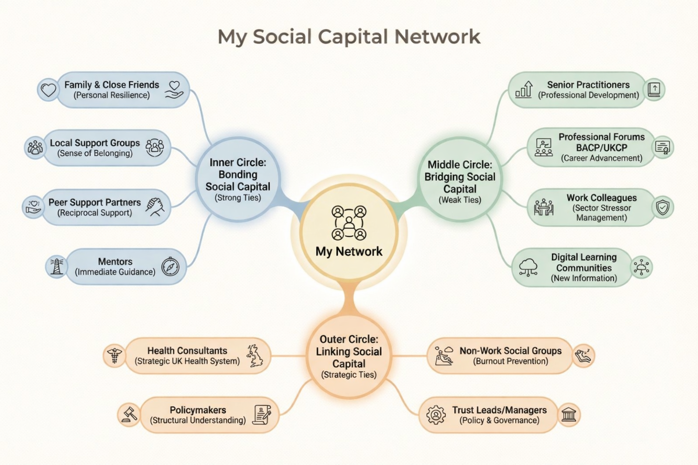

Embracing Digital Inclusion in Social Care

In the fast-paced world of UK health and social care, we often regard person-centred care as
the gold standard. As the sector advances further into the 2020s, another obstacle to
reaching this benchmark has become evident. The digital divide.
For many residents in care homes, the shift to digital-first services (such as GP video
consultations and staying connected with family through tablets) can be both challenging
and rewarding. The role of staff now goes beyond supporting physical health to include
digital advocacy. Using tablets for resident activities is not just about entertainment; they are
a valuable tool for mental stimulation and can help lessen the deep sense of isolation that
often comes with ageing or disability.
Current pressures in the sector, including the staffing crisis and rising demand, make the
shift to digital documentation (e-notes) increasingly crucial. Some individuals have
expressed worry that screen use might lessen resident interaction. In reality, the opposite is
often seen. Digital systems enable real-time information sharing and reduce the time needed
for manual filing. This directly increases the availability of care staff and allows more time to
be spent supporting residents.
At the same time, the human aspect of this transition must always be taken into account.
Staff training remains vital. A workforce already under stress cannot be expected to
embrace new technology without proper support and a clear understanding of how it benefits
residents.
For colleagues involved in management, it is valuable to see tablets and digital tools not just
as costly devices but as essential equipment supporting modern care. By embracing digital
inclusion, organisations not only improve documentation systems but also create new
opportunities for residents while preparing staff for the future of healthcare. Effective
collaboration can help bridge this gap. This message is intended for fellow care
professionals.

Task 4: The NHS Equality, Diversity, and Inclusion Quiz

- Primary Goal:
The NHS EDI improvement plan aims to tackle systemic inequality and foster a sense of
belonging among staff. By ensuring a diverse workforce thrives, it ultimately enhances
patient care NHS England, 2023.
- Gender Pay Gap:
The NHS EDI Improvement Plan 2023 mandates that all NHS organisations develop specific
plans to eliminate gender pay gaps. It focuses on inclusive recruitment and on implementing
Mend the Gap recommendations, NHS England, 2023.
- Intersectionality:
It emphasises that discrimination cannot be fully addressed by looking at a single
characteristic, such as race or disability, in isolation North London NHS, 2025

- Psychologically Safe Work Environment:
Psychological safety in the NHS is vital for patient safety and innovation, allowing staff to
voice concerns without fear. This improves well-being, retention, and workforce resilience
Edmonson, 2018.
- Internationally Recruited Staff:
The plan recommends offering comprehensive induction programmes that include clinical
and cultural integration, along with peer support and mentorship. It also requires that
international staff have equal access to career development opportunities and are protected
against discriminatory practices NHS England, 2023.
- Role of Leadership:
Leaders must be personally accountable for EDI outcomes and inclusive behaviours.
Leaders are to embed EDI into the core strategy rather than treating it as a peripheral HR
task NHS, 2023.
- Reducing Health Inequalities in the Workforce:
The NHS EDI Improvement Plan reduces health inequalities by mandating leaders to embed
Inclusive practices should be incorporated into the core strategy, and be personally
accountable for workforce outcomes NHS England, 2023.
- Collecting and analysing Data:
Data collection is essential for identifying hotspots of inequality and for measuring the impact
of EDI interventions over time. Without robust data, the NHS cannot hold organisations
accountable or make evidence-based decisions to close experience gaps NHS, 2023.
- Flexible Working Policies:
Flexible working supports diverse staff with caring responsibilities and disabilities to remain
engaged. This retains talent that might otherwise leave due to inflexible scheduling NHS
England, 2023.
- Combatting Bullying and Harassment:
One key strategy is to implement civility and respect programmes that train staff to recognise
and challenge microaggressions and unprofessional behaviour, NHS,2023.

Task 5 – A Letter to My Younger Self

14 Willow Bank Road
Flat 2B
Bristol
BS5 7LT

Dear Younger Me,

I’m writing to you from a place of calm, something that probably feels impossible to
picture right now. I remember the weight you’re carrying: your son’s behaviour at school
has triggered a review that could affect your DBS check, and the fear that your dream of
working in health and social care might slip away feels overwhelming. You’re questioning
everything – your worth, your ability to protect your family, and even your future career.
I want you to know that this feeling is temporary.
You need to realise how essential emotional intelligence and resilience will become.
Resilience doesn’t mean the absence of stress or fear; it is the quiet strength that allows
you to move forward, even when things feel impossible. If you could see this through the
lens of emotional intelligence now, you would realise that self-regulation is your greatest
ally. By managing your immediate emotional reactions to this crisis, you can think more
clearly and act with professionalism that defines you.
Developing these areas earlier would have shown you that your character and
Professional integrity matters far more than a single period of difficulty.
This trial is a practical lesson in social awareness and empathy.
As a future counsellor, you will draw on this lived experience to support others who feel
just as lost and uncertain as you do now. You aren’t just surviving a crisis; you are
building the foundation of relatability and resilience that will make you an exceptional
practitioner

Hold on. Your journey is only beginning, and every challenge is building the foundation
for the meaningful work and difference you will have in the lives of others.

With love and hope,
Your future self

Revised Counselling Education Plan (5-7)

Task 6- GANTT Chart (12- Month Plan)

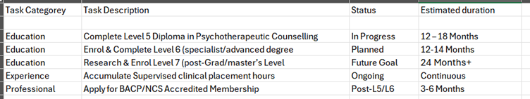

Task 6: Gantt Chart Narrative & Rationale
This 12-month Gantt chart outlines a strategic progression from my current Level 5
studies
toward advanced clinical practice. The primary focus in the first year is on completing
the Level
5 Diploma in Psychotherapeutic Counselling. This provides the foundational practitioner
status
required to work ethically with clients. Simultaneously, I have categorised Supervised
Clinical
Placement as "Continuous." This is critical because BACP/NCS accreditation requires a
specific number of logged hours; maintaining a steady placement ensures these hours
accumulate alongside my academic studies.
Transitioning into the second half of the plan, I have scheduled the enrolment for Level
6. This step is designed to deepen my specialism and bridge the gap between diploma-
level work and the Level 7 master’s research phase.
The timeline for Professional Membership (BACP/NCS) is strategically placed after
Level 5/6 to ensure I meet the eligibility criteria for accredited status, thereby enhancing
my employability and professional standing.
The "Future Goal" of Level 7 represents a long-term commitment to evidence-based
practice and advanced clinical theory.
By spreading these tasks across a tiered timeline, I ensure the academic workload
remains manageable while meeting the professional requirements for
clinical hours and ethical oversight, ultimately leading to full accreditation.

Task 7- Making Changes- Report

Making changes to the report subject, digital documentation, and enhanced resident activity
programmes.
I propose a dual initiative transitioning from paper-based documentation to digital tablets for
all resident records and expanding our range of tailored resident activity programmes. This
change aims to improve the efficiency of care coordination while enriching the quality of life
for those we support.
Paper-based systems often lead to delays in accessing critical information, and potential for
errors and challenges, and sharing updates across care teams. By moving to digital tablets,
We can ensure a real-time, accurate record-keeping that puts the resident's needs at the
centre of every interaction, additionally expanding activity programmes will address diverse
interests and abilities from creative workshops and gentle fitness sessions to
intergenerational connections and hobby groups fostering greater engagement and well-
being.
Implementation strategy
To guide this transition, I will apply Lewin's change management model, structured in three
phases:
1. Unfreeze we will engage staff residents and families to build awareness of the limitations
of current processes and the benefits of change this includes sharing data of efficiency gains
from digital systems and gathering feedback on desired activities to ensure buy in.

2. Change: We will roll out digital tablets gradually, paired with comprehensive training for
activities. We will pilot new programmes in small groups before full implementation, adapting
based on participant input.
3. Refreeze: We will embed new practices through regular check-ins, updated policies, and
recognition of successful adoption, ensuring changes become sustainable.
To support staff motivation, I will use Herzberg's two-factor theory (1966). While digital tools can act as a motivator by simplifying workflows, we will prioritise reliable hardware and
technical support to prevent technology from becoming a hygiene factor that causes
dissatisfaction.
Finally, social learning Theory (Bandura, 1977) will be used to accelerate adoption. We will
identify and empower digital champions among staff who will model best practises share tips
and provide peer support of activities we will encourage residents and staff to Co design and
lead sessions fostering a culture of learning and collaboration.

Task 8- Self-Reflection
Using Gibbs Reflective Cycle (Gibbs,1988), I've engaged in a critical reflection on my
approach to leading the integrated Digital-Centric Care and Engagement Model initiative,

As I prepare to lead this dual initiative, my initial focus is heavily on the process efficiency of
digital transformation. I started drafting the plan from a technical standpoint and identified
areas for growth – critical to ensuring I can effectively guide staff, residents, and families
through change.
First, I felt that enthusiasm for digital transformation could lead me to overlook the needs of
those less comfortable with technology. I need to actively listen rather than assume that
solutions will be universally welcomed. When I initially drafted the plan, I focused heavily on
process efficiency, but speaking with a few staff members reminded me that change can feel
overwhelming. This has shifted my focus to prioritising empathy alongside implementation
timelines.
I also reflected on my leadership style. I tend to take on too much detail work, which could
slow progress and limit team ownership. Identifying digital champions isn’t just about driving
adaptation; its an opportunity to empower colleagues and build capacity across the
organisation. I need to trust the expertise and step back to provide strategic support rather
than micromanage.
This experience brought to light that while I value efficiency, successful change leadership
requires a deeper engagement with the human element. My initial focus was on the what
and how of the change, but not sufficiently on the who and their experience. The
Feedback from staff, and my reflection on it, made me realise the importance of balancing
implementation timelines with empathy. My tendency to micromanage could also limit team
ownership and hinder the empowerment of colleagues through initiatives like digital
champions. Similarly, regarding resident activities, my assumptions about preferences could
inadvertently undermine genuine engagement, stressing the need for co-design.
Conclusion: I have learned that genuine leadership in change management demands active
listening, empathy, and a willingness to adapt. My enthusiasm must be tempered with
consideration for diverse comfort levels with technology. I also recognise the critical need to
trust the expertise of my team and delegate more effectively, fostering empowerment rather
than micromanagement.
Action Plan: Moving forward, I will actively practice listening rather than assuming solutions
and prioritise empathy alongside implementation. I will strategically step back to provide
support, entrusting colleagues with ownership, particularly through the digital champions
program, which empowers them to build capacity. I will ensure more spaces for residents to
co-design programs, acknowledging that their perspectives are essential. Finally, I commit to
being flexible and open to adapting the plan based on continuous feedback, recognising
that this iterative approach is key to sustained success and informing my future practice as a
more empathetic and adaptive leader.
Reference List
1. Amina, A., Kassem, A. and Sleem, W. (2025) 'Applying Lewin’s change management theory to improve patient’s discharge plan', Mansoura Nursing Journal, 9(2), pp. 335–348.
2. Bandura, A. (2021) Social cognitive theory: an agentic perspective on human nature. 2nd edn. New York: Wiley. (Note: Modern reprint/updated edition of the 1977 core theory).
3. Buja, A. and Akhtar, S. (2025) 'The association between social capital and quality of life in old adults: a systematic review and meta-analysis', Frontiers in Public Health, 13, 1668696.
4. Dlamini, S., Cummings, G. and Sampathkumar, A. (2024) 'Innovations in oncology: change management for AI-based diagnostic tools', Journal of Current Health Sciences, 4(1), pp. 45–58.
5. Edmondson, A. C. (2023) Right kind of wrong: the science of failing well. London: Penguin. (Updated research on psychological safety).
6. Field, J. (2025) Social capital: new directions for the 2020s. 4th edn. Abingdon: Routledge.
7. Good Things Foundation (2024) The digital divide in UK health and social care: annual report 2024. Sheffield: Good Things Foundation.
8. Harrison, R., Walton, M. and Mowll, J. (2023) 'Ineffective change processes and nurse burnout in specialized clinical settings', International Journal of Nursing Studies, 138, 104412.
9. Laurence, J. (2025) 'Did social capital protect mental health during the COVID-19 pandemic? A longitudinal analysis', Understanding Society, 5 October. Available at: https://www.understandingsociety.ac.uk/ (Accessed: 21 March 2026).
10. Lee, S. (2025) 'Mastering reflective practice for better outcomes: mental health social work through continuous learning', Number Analytics Blog, 24 May.
11. Lloyds Bank (2024) UK consumer digital index 2024. London: Lloyds Banking Group.
12. NHS England (2023) Equality, diversity, and inclusion improvement plan. Available at: https://www.england.nhs.uk/ (Accessed: 21 March 2026).
13. NHS England (2024) NHS workforce race equality standard (WRES) 2023 report. London: NHS England.
14. NHS England (2025) NHS workforce disability equality standard (WDES) 2024 report. London: NHS England.
15. North London NHS (2025) Addressing intersectionality in healthcare: EDI strategy 2025-2030. London: North London NHS Trust.
16. Robinson, G. (2025) '“Artful doing”: a case for bounded reflective practice with mental health professionals', Practice: Social Work in Action, 37(1), pp. 12–28.
17. SCVO and Scottish Government (2025) Pillars paper: embedding skills and confidence in health and social care. Edinburgh: SCVO.
18. Social Care Wales (2025) The digital potential tool: an insight into digital maturity and literacy in social care. Cardiff: Social Care Wales.
19. Thompson, N. and Perry, J. (2024) The reflective life: becoming a more thoughtful practitioner. 2nd edn. London: Palgrave Macmillan. (Modern application of Gibbs/Schön).
20. Tsatsou, I. (2025) 'Change management in oncology nursing practice: applying Lewin and Kotter', Journal of Current Health Sciences, 5(2), pp. 109–116.
21. Virgin Money (2025) Tackling the barriers to financial and digital inclusion. London: Virgin Money Research.

