November 2012
WCF Metadata Exchange
Distributed Enterprise Applications
Stephen Hole
Tim Bashford

Creating a Basic WCF Distributed Application

A WCF (Windows Communication Foundation) Application consists of a Service and Client.
This tutorial will show you how to create a simple WCF-to-WCF distributed application using two Windows Forms applications. One will host the service, while the other will consume it - the client. Two projects will be created (you may wish to do this in different instances of Visual Studio):

- Windows Forms Service Host titled WCFHelloWorldService.
- Windows Forms Client titled WCFHelloWorldClient.

Creating a basic WCF Service Host
1. Create a Windows Forms Application project titled WCFHelloWorldService under .net framework 4.0.
2. Add to the project a Reference to the assembly System.ServiceModel.
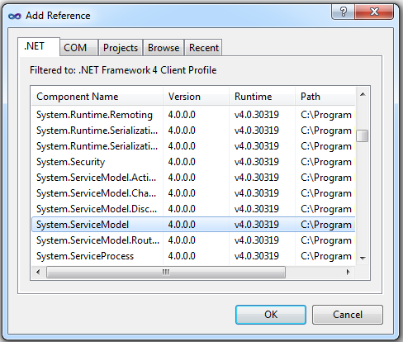
3. Add a Class file to the project and name it SimpleService.cs.
4. The SimpleService.cs class file should contain the following code:

using System;
using System.Collections.Generic;
using System.Linq;
using System.Text;
using System.ServiceModel;

namespace WCFHelloWorldService
{
[ServiceContract()]
public interface IHelloWorldServiceContract
{
[OperationContract()]
string HelloWorld();
}

class SimpleService : IHelloWorldServiceContract
{
public string HelloWorld()
{
return "Hello World";
}
}
}

5. Via the Form's Visual Designer, add two Buttons and a Label.
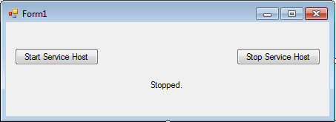

6. The Form1.cs file should contain the following code:
using System;
using System.Collections.Generic;
using System.ComponentModel;
using System.Data;
using System.Drawing;
using System.Linq;
using System.Text;
using System.Windows.Forms;
using System.ServiceModel;

namespace WCFHelloWorldService
{
public partial class Form1 : Form
{

public ServiceHost sh;

public Form1()
{
InitializeComponent();
buttonStopHost.Enabled = false;
}

private void buttonStartHost_Click(object sender, EventArgs e)
{
labelStatus.Text = "Starting...";
buttonStopHost.Enabled = true;
buttonStartHost.Enabled = false;

sh = new ServiceHost(typeof(SimpleService));

sh.Open();
labelStatus.Text = "Started.";
}

private void buttonStopHost_Click(object sender, EventArgs e)
{
labelStatus.Text = "Stopping...";
buttonStopHost.Enabled = false;
buttonStartHost.Enabled = true;

sh.Close();
labelStatus.Text = "Stopped.";
}
}
}

7. Add an app.config XML application configuration file to the project.
8. The app.config file should look like this:
<?xml version="1.0" encoding="utf-8" ?>
<configuration>
<system.serviceModel>
<services>
<service name="WCFHelloWorldService.SimpleService" behaviorConfiguration="HTTPGET">

<host>
<baseAddresses>
<add baseAddress="http://localhost:8001/SimpleService" />
</baseAddresses>
</host>

<endpoint
name="SimpleServiceEndPoint"
address=""
binding="wsHttpBinding"
bindingConfiguration="SimpleServiceBinding"
contract="WCFHelloWorldService.IHelloWorldServiceContract" />
</service>
</services>

<bindings>
<wsHttpBinding>
<binding name="SimpleServiceBinding"
closeTimeout="00:10:00"
openTimeout="00:10:00"
receiveTimeout="00:10:00"
sendTimeout="00:10:00"
>
<security mode="None" />
</binding>
</wsHttpBinding>
</bindings>

<behaviors>
<serviceBehaviors>
<behavior name="HTTPGET">
<serviceMetadata httpGetEnabled="True"/>
</behavior>
</serviceBehaviors>
</behaviors>

</system.serviceModel>
</configuration>

Creating a Basic WCF Service Client
1. Create a Windows Forms Application project titled WCFHelloWorldClient under .net framework 4.0.
2. Add to the project a Reference to the assembly System.ServiceModel.
3. Open a Visual Studio 2010 Command Prompt.
4. Make a note of the directory you wish to output in, as this is from the point you will be adding a client proxy to the project. It is a good idea to change the working directory of the command prompt to the WCFHelloWorldClient directory of the project. The default output location is C:\Program Files (x86)\Microsoft Visual Studio 10.0\VC should you forget to change this.
cd "path-to-project"
(e.g.)
cd "F:\DEA\11\Tutorial\Code\Client\WCFHelloWorldClient\WCFHelloWorldClient"

5. Generate a client proxy class by entering the following command:
svcutil /language:C# /config:app.config "http://localhost:8001/SimpleService"

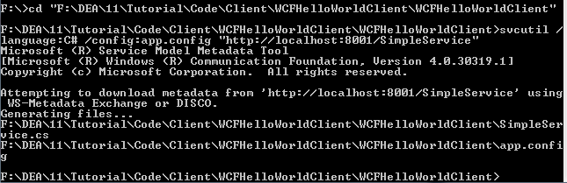
6. Add the two generated files to the project (Remember to change the File type filter to "All Files(*.*)").
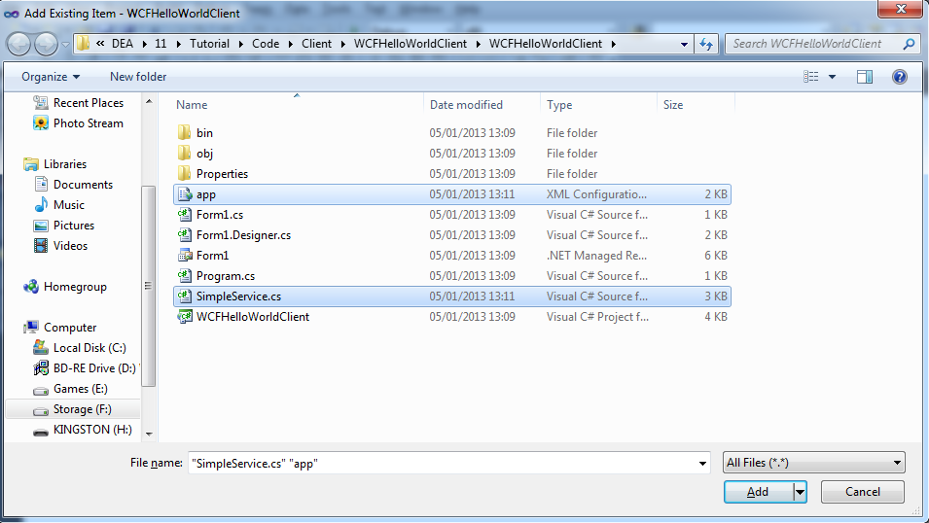
7. Add a button and label to the form.
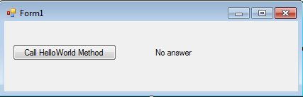

8. Add the following code to Form1.cs:
using System;
using System.Collections.Generic;
using System.ComponentModel;
using System.Data;
using System.Drawing;
using System.Linq;
using System.Text;
using System.Windows.Forms;
using System.ServiceModel;

namespace WCFHelloWorldClient
{
public partial class Form1 : Form
{
public Form1()
{
InitializeComponent();
}

private void buttonHelloWorld_Click(object sender, EventArgs e)
{
HelloWorldServiceContractClient proxy = new HelloWorldServiceContractClient();
labelResult.Text = proxy.HelloWorld();
}
}
}

9. Test this code.

Exercise
Create a new WCF Service Host which has two functions:
[OperationContract()]
string SayHello(string name);

[OperationContract()]
string GetTime();

SayHello should take in a name and return “Hello name”, i.e. if “Dave” is input into the function, it will return “Hello, Dave”.
GetTime should return the current time. You can use the following code fragment to obtain the current date and time as a string:
DateTime.Now.ToString("HH:mm:ss tt")

This should be encapsulated in a WCF application, including a configuration file which can be downloaded to the client. The client should be set out in such a way to be able to access these two functions. Select an appropriate address and endpoint.

WCF Service with Multiple Bindings
Create a C# Console Application named MultipleBindingsConversionService. Add to the project a class named ConversionImplementation.cs and a Configuration file named App.config. Add a .NET reference to the System.ServiceModel namespace.
To the ConversionImplementation.cs class add the following code:
using System;
using System.Collections.Generic;
using System.Linq;
using System.Text;
using System.ServiceModel;

namespace MultipleBindingsConversionService
{
[ServiceContract]
interface ISimpleConversion
{
[OperationContract]
double FeetToInches(double feet);

[OperationContract]
double InchesToFeet(double inches);

[OperationContract]
double PoundsToOunces(double pounds);

[OperationContract]
double OuncesToPounds(double ounces);
}

class ConversionImplementation : ISimpleConversion
{
private const double FTP = 12.0;
private const double PTO = 16.0;

public double FeetToInches(double feet)
{
return feet * FTP;
}

public double InchesToFeet(double inches)
{
return inches / FTP;
}

public double PoundsToOunces(double pounds)
{
return pounds * FTP;
}

public double OuncesToPounds(double ounces)
{
return ounces / FTP;
}
}
}

To the App.config file add the following definitions:
<?xml version="1.0" encoding="utf-8" ?>
<configuration>
<system.serviceModel>
<services>
<service name="MultipleBindingsConversionService.ConversionImplementation" behaviorConfiguration="conversionBehaviour">
<endpoint name="Basic"
address="http://localhost:8000/ConversionImplementation"
binding="basicHttpBinding"
contract="MultipleBindingsConversionService.ISimpleConversion"/>

<endpoint name="Secure"
address="http://localhost:8000/ConversionImplementation/Secure"
binding="wsHttpBinding"
contract="MultipleBindingsConversionService.ISimpleConversion"/>

<endpoint name="tcp"
address="net.tcp://localhost:8001/ConversionImplementation"
binding="netTcpBinding"
contract="MultipleBindingsConversionService.ISimpleConversion"/>

<endpoint name="mex"
address="http://localhost:8000/ConversionImplementation/mex"
binding="mexHttpBinding"
contract="IMetadataExchange"/>
</service>
</services>

<behaviors>
<serviceBehaviors>
<behavior name="conversionBehaviour">
<serviceMetadata httpGetEnabled="True" httpGetUrl="http://localhost:8000/ConversionImplementation/Secure"/>
</behavior>
</serviceBehaviors>
</behaviors>
</system.serviceModel>
</configuration>

To host the application add the following code to program.cs:
using System;
using System.Collections.Generic;
using System.Linq;
using System.Text;
using System.ServiceModel;

namespace MultipleBindingsConversionService
{
class Program
{
static void Main(string[] args)
{
ServiceHost convService = new ServiceHost(typeof(ConversionImplementation));
convService.Open();

Console.WriteLine("Press Enter to terminate");
Console.ReadLine();

convService.Close();
}
}
}

WCF Client to Service with Multiple Bindings
Create a Windows Forms Application project named BindingConversionServiceClient. Add a .net reference to the System.ServiceModel namespace.
Use the Form Designer to create an interface as follows:
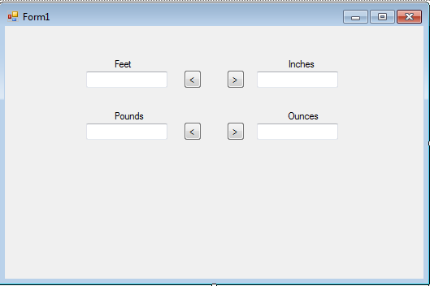
Perform metadata exchange:
svcutil.exe /language:c# /config:app.config http://localhost:8000/ConversionImplementation

Add the two generated files to the project (Remember to change the File type filter to "All Files(*.*)").

7. Add a button and label to the form.

Add the following code to Form1.cs:
using System;
using System.Collections.Generic;
using System.ComponentModel;
using System.Data;
using System.Drawing;
using System.Linq;
using System.Text;
using System.Windows.Forms;
using System.ServiceModel;

namespace MultipleBindingsConversionServiceClient
{
public partial class Form1 : Form
{

public Form1()
{
InitializeComponent();
}

private void buttonToInches_Click(object sender, EventArgs e)
{
SimpleConversionClient client = new SimpleConversionClient("Secure");

textBoxInches.Text = client.FeetToInches(double.Parse(textBoxFeet.Text)).ToString();
}

private void buttonToFeet_Click(object sender, EventArgs e)
{
SimpleConversionClient client = new SimpleConversionClient("Secure");

textBoxFeet.Text = client.InchesToFeet(double.Parse(textBoxInches.Text)).ToString();
}

private void buttonToPounds_Click(object sender, EventArgs e)
{
SimpleConversionClient client = new SimpleConversionClient("Basic");

textBoxPounds.Text = client.OuncesToPounds(double.Parse(textBoxOunces.Text)).ToString();
}

private void buttonToOunces_Click(object sender, EventArgs e)
{
SimpleConversionClient client = new SimpleConversionClient("tcp");

textBoxOunces.Text = client.PoundsToOunces(double.Parse(textBoxPounds.Text)).ToString();

}
}
}

Build and test this code.

Exercise
Modify the client so that the user may select their protocol of choice as they run the application:
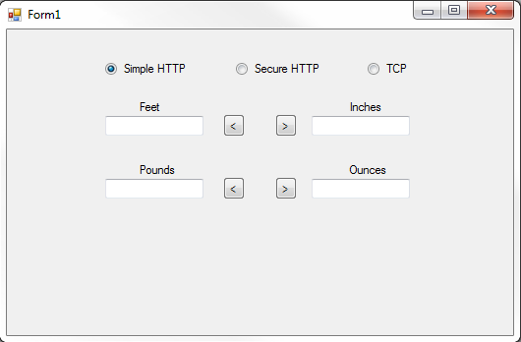

Remember that the instantiation of the client defines the protocol by the name it was assigned in the service host.

