

ANA DZHIPOVA

Student Number: 2013882

MARKETING MANAGEMENT
LCMB7001
Assignment 2

Module Lecturer:
Tushara Balendran

Table of content

- Introduction …………………………………………………………………………….…………3

- Zara …………………………………………………………………………………………………….3

- Analysis of the environmental factors in relation of building of marketing strategies …………………………………………………………………………….3
3.1 PESTEL Analysis……………………………………………………………………………………………………………….4
3.2 Porter’s five forces Model……………………………………………………………………………………………...6
3.3 SWOT Analysis………………………………………………………………………………………………………………..8
3.4 Segmentation, Targeting, Positioning……………………………………………………………………………..9
3.5 Marketing mix model…………………………………………………………………………………………………….10
3.6 Other models and strategies………………………………………………………………………………………….12

- Recommendations ……………………………………………………………………………..14

- Conclusion…………………………………………………………………………………..………15

References

- Introduction

Management is a complicated process and composing a smart management strategy require considering of many components – external and internal. Fundamental element of this process is excellent knowing of the environment and its factors. Strategies present new ideas and forms new views for future development based on benefit from changes in the environment. That is what explains the importance of understanding and evaluating the outside forces and to presume these environmental changes when build management strategies.
This study is focused on critical analysis of macro and microenvironment and its factors. Based on these analyses will explain how environmental key drivers are influencing the marketing strategy of Zara in relation of general purpose – growth of the brand.

- Zara

Zara is a fast fashion brand founded in in 1975, La Coruna Spain, by Amancio Ortega. In 1985 he created a parent company Inditex, and very soon after that he started global expansion. Product range includes clothing, accessories, shoes, swimwear, beauty products, and perfumes. It is the largest and most profitable company in the Inditex group and largest clothing retailer in the world. Before the Covid-19 pandemic Zara had 2259 stores on 202 markets in 96 countries.
The retailer’s customers enjoy fast fashion models based on newest trends but inexpensive. Customers of the brand are offered limited number of fast changing models lady’s ( Zara women), men’s (Zara men), and children's clothing (Zara Kids), Zara Home as well, in European stores.

3. Analysis of the environmental factors in relation of building of marketing strategies

Every business operates in an environment which is divided to macro – and microenvironment. Main characteristic of the macro environment is that it is out of control of the organisations, so they must adapt to the macro factors or forces. Also, these factors impact the microenvironment. Microenvironment consists of factors or forces immediate to the company and more or less, they can be controllable by the companies. These factors affect the routine business straight away.
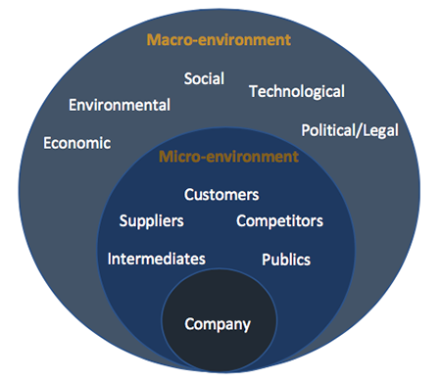

Figure 1, Source: http://solutia.ir/2019/05/what-are-micro-and-macro-environment-consideration-in-marketing/

Both – macro and microenvironments are dynamic which means that monitoring and analysing the outside forces is continuous process.
As a part of overall business, for the success of marketing management it is fundamental to understand the outside forces and the way they affect the business. In order of this, detailed analysis of the environment will enable adequate management response ensuring performance of the company at the market.

3.1 PESTEL analysis
One of the most popular ways for analysing macroenvironment is PESTLE analysis which defines six main group of macro factors impacting company’s performance. It is useful especially for global retailers like Zara when they entry foreign markets.

Figure 2, Source: https://www.business-to-you.com/scanning-the-environment-pestel-analysis/
- Political factors – this group includes factors like tax policies, government stability, import/export regulations. These factors impact all the business existing in the county. They have high importance while entering new markets but not only. Example is Brexit – from beginning of 2021 the UK, which is a large market, will be foreign market for the company. Zara is Spanish brand and this a big advantage because of EU trade agreements which allow the companies to trade within very advantageable conditions, so it is favourable factor. (Bush,2019).
- Economic forces are about economic growth, inflation, exchange rates. These factors can be directly or indirectly impacting all businesses and can affect the product price, consumers demand and supply to the economy (Boddy,2017). For Zara, the main economical factor is income level, respectively consumers purchasing power. Hot point in the current economic environment is Covid-19 pandemic. From June 2020 Zara started closing some of its shops. Marketing activities are focused on online platforms and the economic results of the brand started recovering. The online sales soar, also Zara has opened online shops in 12 countries last year. (Dean, 2020). Other fact about Zara is that company uses low labour cost and this help improving its profit. All these determinates economic factor as a favourable for Zara.
- Social factors are demographic characteristics and customs and values of the population. According to Kotler and Armstrong (2016) “The demographic environment is of major interest to marketers because it involves people, and people make up markets”. Zara is global fast fashion retailer and social factors are extremely important for its performance. As it is mentioned above, Zara operates at 202 markets and 96 of them are markets with shops. To achieve high performance at the different markets Zara must comply demographic structure and average incomes of the population, population size and growth rate, ethnical concern, lifestyle characteristics, cultural norms and religion and beliefs in relation to the clothing and shopping behaviour, attitudes toward product quality and customer services. These aspects are degeminating factors for choosing new markets as well.
Social factor is one more favourable factor for the brand. “Overall, this strong, positive brand presence allows Zara to collect healthy profit margins for its shareholders, while buyers still feel like they’re getting a great deal” (Bush, 2019).
- Technological factors cause many changes in the marketing. Development of the new technologies is a good opportunity for Zara to develop digital marketing. It is very suitable for the brand because it gives more options to reach the consumers, increase brand awareness and optimising the sales process from one side which in combination with decreasing the costs from the other side. Internet infrastructure is essential for Zara’s marketing. “Zara is the leader , thanks to a pioneering technological strategy. By adapting to new tools—including big data—the Spanish clothing retailer has managed to outpace its direct competitors. Despite being of the last fashion companies to take up e-commerce, Zara has achieved a universal shopping experience that encompasses both its brick-and-mortar locations and its online stores.” (Sudhakaran(2020)). Development of internet structure and technologies are favourable factor for Zara because it gives an opportunity for analysing of large data amount and many options to reach consumers.
- Environmental factors are climate change, weather, pollution, emission control and is oriented to Ecology. Companies responsibility is to use environment friendly materials. (Boddy,2017). Zara is the biggest retailer involved in the Detox Campaign of Greenpeace and switched to a fully toxic-free production and has overall eco-friendly manufacture and stores, environmental factor is favourable for Zara as well.
- Legal factors are concerned to all the specific laws, protecting both consumers and businesses and setting legal framework that is related to the nature of the business. Organisations must be kept aware of law changes regularly. Zara has been involved in many situations related to author rights. It is almost inevitably to not face similar difficulties in the future because brand designs rapidly model according to new fashion trends, so it is unfavourable factor.

3.2 Porter’s 5 Forces Model
Porter’s five forces model is oriented to “analysing the level of competition within the industry and its purpose is “effectively to ascertain the competitive landscape and potential profitability” (Kingsnorth, 2019). The five forces identified and used for analysis are as follows:
  - Threat of entry.
  - Industry rivalry.
  - Threat of substitutes.
  - Bargaining power of suppliers.
  - Bargaining power of buyers.

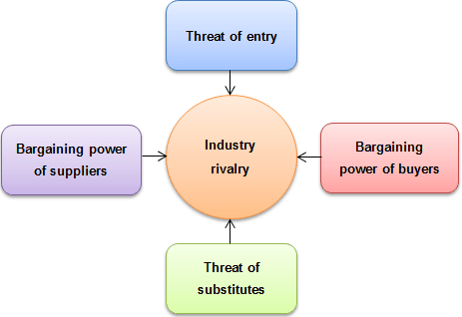
Figure 3, Source: https://strategicmanagementinsight.com/tools/porters-five-forces.html

- Threat of entry – it is obvious that new entering competitors can be threat for every business. Fast fashion retail functions in one of the strongest competitions. The industry is very attractive for many new enterers from one side but from the other side exactly this strong competition is a reason for many players to leave the industry. Zara is a giant. It is extremely difficult for potential new entrants to cause serious threats for the brand because this require not only investing of capital and good designs but also the image of the brand and customer loyalty cannot be overcome by them. One of the factors that can reduce the appearing of new entrants is barriers to entry. In the industry there are government requirements for licencing. Therefore, threat of entry creates a medium risk for Zara.
- Industry rivalry: It is a medium force for Zara because from one side it is one of most competitive industries but from the other side, there are not many large fast fashion retailers which can be strong rivals of the brand. Zara holds big advantage in many points comparing with its competitors but still needs to monitor the biggest clothing chains like H&M and GAP.
- Threat of substitute: Basically, it is about existing substitutes available that could attract the customers. Zara’s products are cheaper comparing with the same quality products of the competitors and provide higher quality products on a similar price of the competitors, so there are not many alternatives available. Also, Zara does not meet just a primary need of clothes but is a brand that helps its customers to demonstrate personal identity for moderate price. All this determinates threat of substitute as a low force for Zara.
- Bargaining power of suppliers: It has direct affect to the business profit because strong suppliers can control product qualities and prices. (Kingsnorth, 2019) Zara’s strategy aims producing high quality at affordable prices. It orients the management to reduce the costs of resources and the outside force of suppliers. Zara controls its suppliers by licensed contracts, and this reduce their power, so it is a low force.
- Bargaining of buyer’s power – It refers to “buyers’ ability to put pressure on companies’ lower prices, change their products or improve customers service” (Kingsnorth, 2019). Consumers are not so powerful in this context as Zara’s products are competitive. Also, Zara produces small quantities of each product which limitates buyer’s power as well. Therefore, it is a low force for the brand.
Porter’s five forces analysis shows that Zara is a powerful competitor in the industry it operates. The method gives good view about where is the retailer compared with the competitors and can be used for evaluating opportunities of the company to move further. There are some disadvantages of the model. Andrew Beattie (2019) identifies drawbacks like: “backward-looking, making its findings mostly relevant only in the short term; company is placed in one industry group when some companies straddle several” and globalization as a “blind point”.

3.3 SWOT analysis
SWOT (strengths, weaknesses, opportunities, and threats) is “an attempt to translate company specific factors from the company audit into company strengths and weaknesses plus external environmental factors (from the PEST analysis) into external opportunities, and threats” (Lancaster & Reynolds, 2004).
According Kotler and Armstrong, (2016), “The goals of SWOT analysis is to match the company’s strengths to attractive opportunities in the environment, while eliminating or overcoming the weaknesses and minimising the threats”.
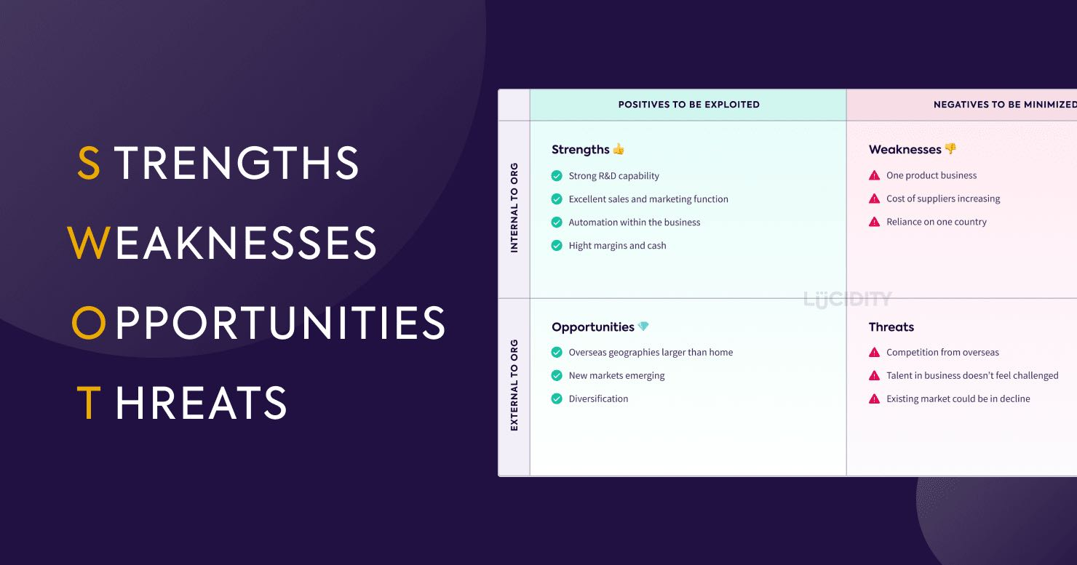
Figure 4, Source: https://getlucidity.com/strategy-resources/ultimate-guide-to-swot-analysis/

Some of the strengths of Zara are: Strong brand name and good reputation, good relationship with suppliers and distributors, workforce, innovations. An online survey shows some facts: Inditex, parent company, has 700 designers and Zara creates new collection twice weekly. It takes 3 to 5 weeks to the new product to get from the design to be delivered to the market. Zara has 10 logistic centres and deliver at any location on the globe in 48 hours. Brand has the biggest number of stores in the world and invest huge amount in increasing online sales (aim is to get 25% of its revenue by 2022). (Sudhakaran, 2020).
Each of the strength in case it fails can be easily transformed into weakness. To support this the same survey highlighted that: “the trend that helped propel Zara to the top is the cause of its most pressing weakness. With the focus on sustainability increasing among customers and policymakers Zara’s weakness is balancing sustainability with fast-fashion”.
Main opportunity of Zara is the company’s investing in innovations, research, and development. Good example is the amount Inditex will spend for developing and improving the online sales. Zara has already started to work with AI and Big Data companies in relation to create system to predict the customers behaviour and the expectation is this system to be implemented very soon – one more step further.
In relation to threats Zara is not in high risk but still needs to monitor existing competitors and new enterers; and to improve its relationships with the suppliers and consumers.

In conclusion, every business is different, so to obtain full picture of environmental drivers, organisations could choose one or more methods depending on their orientation for development. PESTEL analysis is flexible and understanding of external factors is essential but it is important understanding of the advantages and disadvantages of the method as well. Main advantages are: simple framework; low costs; provides strategic view; enables assessment of many aspects of entering new markets; helps for detecting of the threats and opportunities. (Frue, 2016). Main disadvantages are needs regular conducting; sometimes is difficult because of too large amount of information, the results are not complete as only covers the external factors (Frue, 2018).

3.4 Segmentation, targeting, positioning.

Segmentation
It is a “process of breaking down the total market for a product or service into distinct subgroups or segments where each segment may conceivably represent separate target market top be reached with a distinctive marketing mix”. (Lancaster & Reynolds, 2004).
Zara uses a mix of segmentation strategies (demographic, geographic, psychographic, and socio economical) but the most important component is demographic and psychographic – age structure, culture, ethnicity, lifestyle, beliefs, social status.

Targeting
It is an identifying of the market segments that are most likely buyers of the brand product. (Lancaster & Reynolds, 2004). It includes evaluation of the segments.

Positioning
It is ensuring that the brand will occur selected segment the way that will create regarding the brand relate to the competitors. To evaluate the success of position companies, they should consider following key components: clarify, consistency, credibility and competitive. Zara’s methods for positioning are product and price/quality. Brand is known as provider of high-quality fashion at inexpensive price.

3.5 Marketing mix model
It is a strategy based on the consideration of 4 main components: product, price, place, and promotions,

Product

Zara is the brand delivering one of the most loved fashion products and this is caused by the product features. Products are quick replay of the latest fashion trends meeting customer needs. Very successful strategies that Zara implements are branding strategies like wide range fashion clothing, shoes, backs, accessories and beauty products. Zara’s products are prestigious and meet the requirements for style, vision, quality, price.

Price
Very typical for Zara is deferential pricing. Brand customers get latest fashion designs and pay affordable price which is a big advantage. On a different market, Zara specify different prices for the different markets. Sales promotions provide very low prices which is an effective practice for attracting customers and increasing the brand awareness.

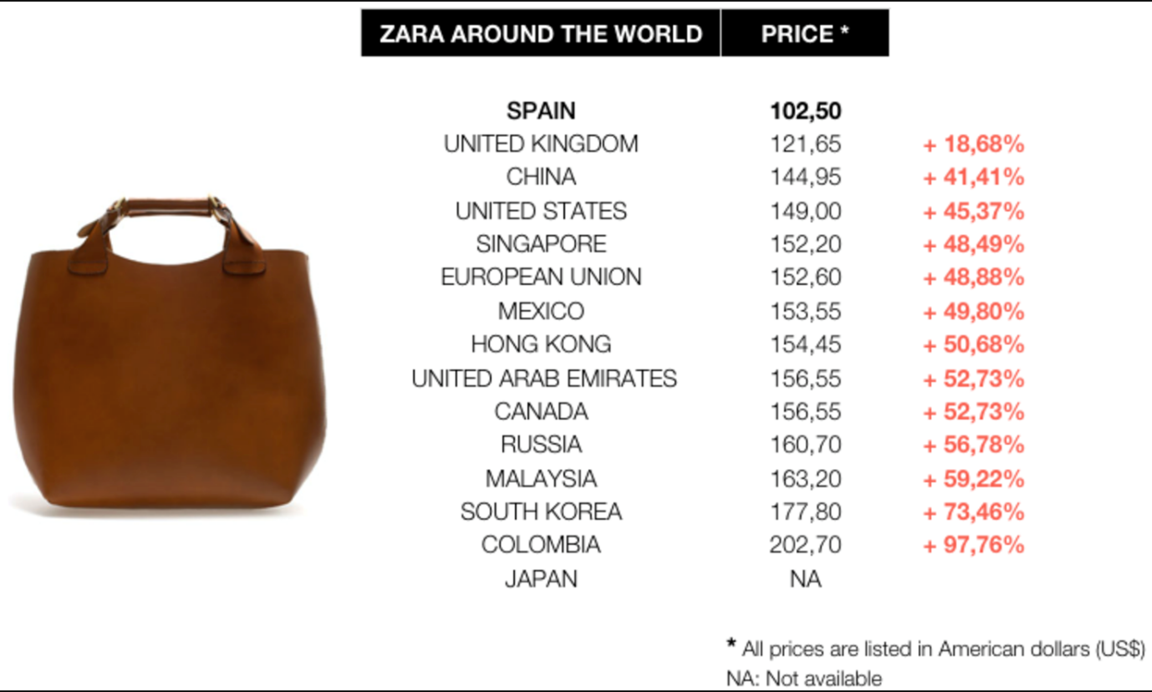
Figure 5, Source:http://peacockplume.fr/fashion/zara-has-pricing-and-sizing-problem#:~:text=As%20the%20Zara%20brand%20goes,differs%20from%20country%20to%20country.&text=Zara's%20success%20is%20based%20on,new%20designs%20twice%20a%20week.
Other very powerful method is the psychological pricing which Zara practices as well – example is that they set the price finishing with 9.99 (29.99 but not 30).

Place

Via the excellent optimised distribution process Zara guarantees fast delivery at all the sales points. Zara has well designed website and social media profiles on You tube, Facebook, Twitter, Instagram, LinkedIn and Pinterest. Location and vision of the stores and in-store atmosphere are highly beneficially for Zara.

Promotions

Zara implements a combination of promotions. Its marketing is unique with its “zero investment in marketing” (Bhasin,2019) which is a strategy with proved effectiveness. Zara utilises combination of promotions like sales promotions, including NHS discounts, pull strategy, direct and digital marketing, location, public relation, influencing marketing. Focus is on promotional campaign; brand does not use flashy advertisements. This is the element of uniqueness of Zara’s marketing strategy.

Marketing mix model is expanded with three more components:
People
Anyone who communicate with the customers can impact customer’s satisfaction. Importance of this evaluation increases for Zara because brand aims more online sales and it require intensive direct contact of customer service team with the customers.

Process
it is considering of customer experience from first contact to after- sales process. Zara accentuates on satisfaction of its customers and all the processes are strongly oriented to increase the quality of customer service at any time of their communication with the company. In relation of tending to emphasize the online sales and increasingly need of after purchase customer care, Zara continuously improves complain process and ex-change and return procedure, which is easy, fast, optimised and customer is treated as king.

Physical evidence
Everything that customer “sees” – shops, websites, social media, blogs, products, staff. It is one more factor with increasing importance because very often first impression creates long lasting opinions. Zara’s presence is always on high level – style, vision, design, in-store atmosphere and sales and customer service team performance.

3.6 Other models and strategies

- Ansoff model:

“This model is essential for strategic marketing planning where it can be applied to look at opportunities to grow revenue for a business through developing new products and services or “tapping into” new markets”, (Hanlon, A. 2020).
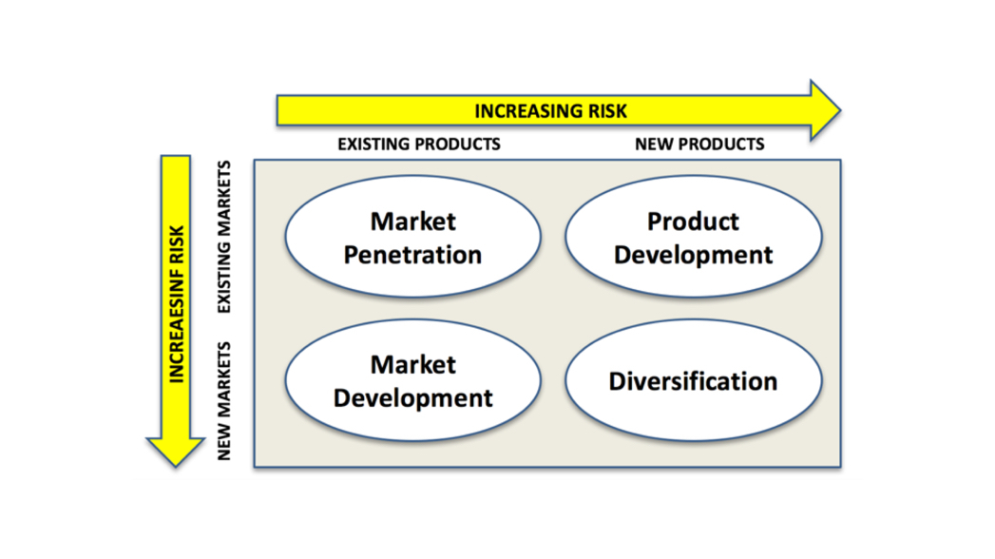
Figure 6, Source: https://www.tutor2u.net/business/reference/ansoffs-matrix
Market penetration is a “company growth by increasing sales of current product to current market segments without changing the products”. (Kotler, Armstrong, 2016). It is a strategy that made Zara global retailer and leader.
Product development refers to selling a new product to existing market or to develop a product and it is a strategy used by Zara for developing its product line continuously. Leading characteristic of the business is the short time needed for creating and presenting on the market – Zara is fastest comparing with the competitors.
Market development – focused on priority to develop existing markets instead to entry new. It is fundamental tool for Zara’s stability.
Diversification – most risky strategy which refers to entry new market with new product. Zara Home is an example for application of this method.

- Product Life Cycle
“The term product life cycle refers to the length of time a product is introduced to consumers into the market until it's removed from the shelves”. (Kopp, 2020). The diagram shows 4 stages – Birth, Growth, Maturity, and Decline but the life cycle for Zara’s products is only few weeks.

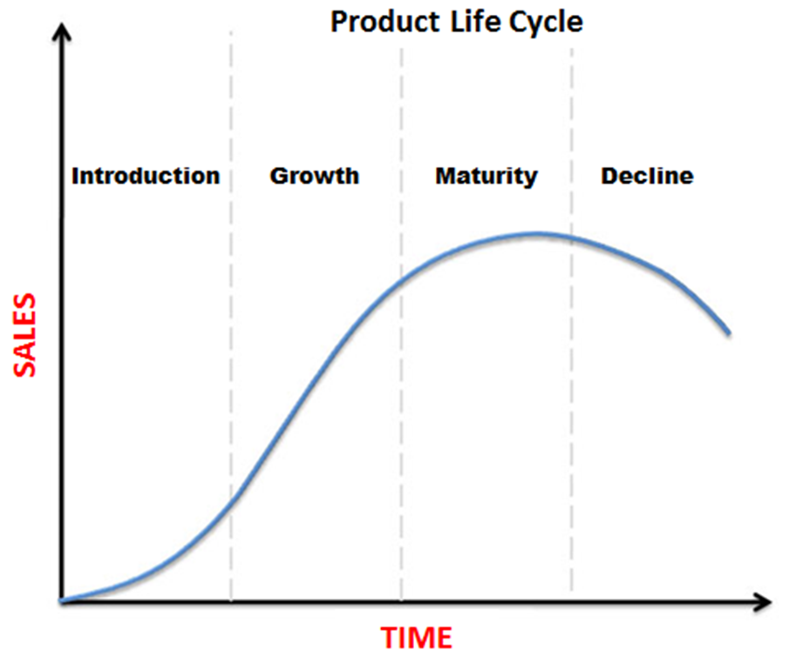
Figure 7, Source: https://www.economicshelp.org/blog/140934/business/product-life-cycle/

- Fortress or position defence strategy

Zara stands on a leading position in the fashion retailing – position which requires protection. In order of this, company applies Fortress or position defence strategy. Example is contracting of the suppliers. Also, marketer continuously increases awareness of the brand and maintains relationships with the existing customers via variable techniques and this is one more appropriate technique to keep them far from the competitors.

4.Recommendation for strategies
Zara is a giant. The company proved its marketing politic, but nevertheless, development of the strategies is a key for future success. Focus of Zara is on customers and its main point of view is the ratio product/price.
Pricing, product development, market entering, and development of markets are most efficient methods that made Zara distinctive brand and they should be used in future. Zara Homes is developed in 44 countries until now but experience, history, reputation, brand awareness, and customers loyalty achieved are good fundament for overbuilding the product range and expanding the market.
Zara provides wide product range, but it will be still profitable to expand it with very small extra costs /one skirt can be offered in 3 lengths/.
In relation to improve the customer service, Zara must accent to live chat. According to McDonald, (2020) “more than 41% of customers expect live chat”. It is increasingly preferred way to contact an adviser.
Loyalty program for the customers can be good tool to say “thank you” for the loyalty and to improve the customer engagement.
For stronger brand can be developed strategy of named collections or most successful models.
Influencing marketing is an innovative strategy that Zara has adopted. It is quite powerful tool for the main group of Zara’s customers and Zara can use the advantage of first and fastest brand and to develop this strategy.
On the level of relationship with the customers that Zara has already achieved, public relations is extremely efficient strategy and can have a key role in improving the positive image of the company, which itself is one of the main factors for customer loyalty. Zara involves its customers in designing the product through their feedback and this is one more tool with positive effect of sales (increase revenues and in parallel, increases customer engagement). To develop both methods Zara can start organising competitions for designers /or designs at the different locations. This kind of activity can expand the product lines on the different markets with designs combining modern styles with local tastes.
Innovation strategy in many aspects is very appropriate strategy for leaders. It applies to all stages of communication process with the customers, customer service, stores look and design, product range, marketing research methods and collecting and usage of data, using new technology as well. Keeping investing in new technologies, Zara must train its workforce in using them.

5.Conclusion

Marketing decisions are dependent on the influence of the environment factors. It is real challenge to detect and seize the best opportunities in parallel with avoiding or reducing the power of the threats. This study included overview and detailed analysis of the factors of macro and microenvironment influencing Zara’s business. Based on this critical analysis there were made recommendations about future marketing strategies. The key role of marketing for the business success was also discussed. Modern marketing faces fast changing needs and high expectation of the consumers together with dynamic environment and this require professional and well considered marketing decision. Leading position of global brands like Zara need extremely developed and innovative marketing strategy because this position in the industry is a big advantage but is also huge responsibility for the brand and its customers.

References:

Beattie, A. (2019) The Pitfalls of Porter's Five Forces, online, available at: https://www.investopedia.com/articles/investing/103116/pitfalls-porters-5-forces.asp, accessed:28/12/2020.

Bhasin, H. 2019 Marketing mix of Zara, online, available at: https://www.marketing91.com/marketing-mix-zara/, accessed on 27.12.2020.

Boddy,(2017), Management an introduction, 7th Edition, UK, Pearson Education Limited

Bush(2019), PESTLE Analysis of Zara, (online), available at: https://pestleanalysis.com/pestle-analysis-of-zara/, accessed: 23/12/2020

Dawar, (2020) Marketing Mix of Zara: The 4Ps Strategy, online, available at: https://www.advergize.com/marketing/marketing-mix-of-zara-the-4ps-strategy/, accessed on 27/12/2020.

Dean(2020), Zara owner Intidex says it has bounced back from its pandemic woes, reporting a $254 million second-quarter profit, (online), available at: https://www.businessinsider.com/zara-owner-inditex-reports-rising-profits-online-sales-up-74-2020-9?r=US&IR=T, accessed: 28/12/2020

Frue(2016) The Advantages of PESTLE Analysis, (online), available at: https://pestleanalysis.com/advantages-of-pestle-analysis/, accessed: 27/12/2020

Fruel(2018), 6 Frustrating Disadvantages of PESTLE Analysis, (online), available at: https://pestleanalysis.com/disadvantages-of-pestle-analysis/, accessed: 27/12/2020

Hanlon, A.2020https://www.smartinsights.com/marketing-planning/create-a-marketing-plan/ansoff-model/ The Ansoff Model,

Kingsnorth, S., Digital marketing strategy, 2nd edition, 2019, London, Kogan Page Limited

Kotler and Armstrong, (2016), Principles of Marketing, 16th Edition, UK, Pearson Education Limited

Kopp, C. (2020) online, Product Life Cycle, online, available at: www.investopedia.com/terms/p/product-life-cycle, accessed on 28/12/2020.

Lancaster, G. & Reynolds, P., (2004), Marketing, Palgrave Macmillan

McDonald, S. 2020, “25 reasons live chat can help you grow your business”, online, available at: ttps://www.superoffice.com/blog/live-chat-statistics/, accessed on 28/12/2020.

Sudhakaran(2020), Zara SWOT Analysis 2020: Ultimate Guide, (online), pestleanalysis.com/zara-swot-analysis/#What_is_the_biggest_threat_to_Zara, accessed: 29/12/2020

https://www.ie.edu/insights/articles/zara-technology-and-user-experience-as-drivers-of-business/ DECEMBER 15, 2017 Zara: Technology and User Experience as Drivers of Business

https://www.business-to-you.com/scanning-the-environment-pestel-analysis/, Scanning the Environment: PESTEL Analysis, 18 September 2016, Accessed on 27/12/2020

Inditex Annual Report 2019
https://www.economicshelp.org/blog/140934/business/product-life-cycle/
www.inditex.com
https://www.inditex.com/investors/investor-relations/results-and-presentations
www.zara.com
https://getlucidity.com/strategy-resources/ultimate-guide-to-swot-analysis/
http://peacockplume.fr/fashion/zara-has-pricing-and-sizing-problem#:~:text=As%20the%20Zara%20brand%20goes,differs%20from%20country%20to%20country.&text=Zara's%20success%20is%20based%20on,new%20designs%20twice%20a%20week
thtps://www.skillsyouneed.com/lead/7-marketing-ps.html
http://solutia.ir/2019/05/what-are-micro-and-macro-environment-consideration-in-marketing/
https://www.tutor2u.net/business/reference/ansoffs-matrix

