
Student Name: Kevin Gosai
Student ID: 2531973
Module Name: International Business Concepts
Module Code: LCMB7034
Lecturer’s Name: Akshay Narayanan
Word count : 6261

s

Section 1 3
1. Introduction 3
2. Organisational Classification and Global Strategy 4
2.1 Strategic Categorisation 4
2.2 Global Configuration 5
3. Macro-Environmental Appraisal and Market Attractiveness 6
3.1 Host Country Analysis 6
3.2 Market Entry Analysis Through OLI 12
4. Entry Mode Strategy and Strategic Synthesis 16
4.1 Historical Pattern Recognition 16
4.2 Strategic Fit and Justification 17
4.3 Conclusion and Recommendations 19
Section 2: Reflective Account 20
References 24
Appendices 28
Appendix 1: Performance Summary of Currys PLC 28
Appendix 2:Unboxing how Australians shopped in 2025 28
Appendix 3: Acquisition of Norwegian-listed Elkjøp Group in 1999 29

Section 1

1.Introduction
This report is a critical assessment of Currys plc as a chosen multinational company and Australia as a potential country for entry. According to their performance graph, Currys likely saw 12% like-for-like revenue growth in the Nordics, demonstrating overseas growth and not showing evidence of Australian transferability (Currys plc, 2026). However, overseas performance cannot establish Australian suitability because local institutions, consumer behaviour, competition, and market conditions may differ significantly. Therefore, the report addresses the international strategy of Currys, attractiveness of the Australian market, Dunning's OLI framework, and ultimately entry mode suitability.
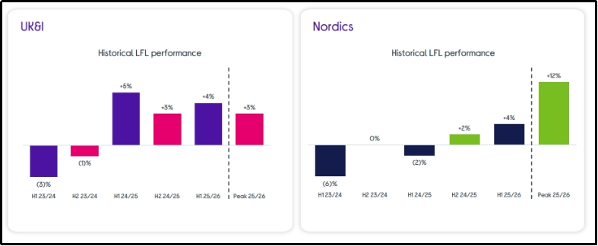
Figure 1: Group Peak like-for-like revenue
(Source: Currys plc, 2026)

2. Organisational Classification and Global Strategy

2.1 Strategic Categorisation
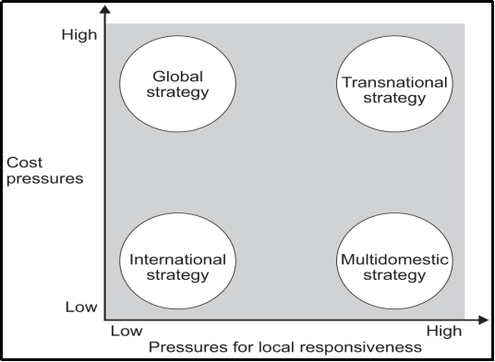
Figure 2: Bartlett and Ghoshal’s model
(Source: Bartlett and Ghoshal, 2003)
The international strategy of Currys is of vital importance and should be classified critically since it constitutes a cross-border model with a high level of adaptation to the various consumer markets in Europe. Bartlett and Ghoshal (2003) differentiate between International strategy, Global strategy, Multidomestic strategy and Transnational strategy on both dimensions as Integration pressures and Responsiveness pressures. A Global strategy has been an effective fit because the head office directs the procurement, digital, services, and operational capabilities across geographically dispersed national businesses. However, diverse Curry and Elkjøp brands undermine complete standardisation around the globe, as customers are offered offers based on the national market situation. International strategy also explains capability transfer, yet it understates reciprocal learning because Nordic innovations have subsequently influenced British operations materially. For instance, the implementation of electronic shelf-edge labelling, which was successful in the Nordics, has been replicated across UK&I stores, showcasing cross-border knowledge transfer (Currys plc, 2025). Multidomestic strategy is still not effective, as regional brands and local execution coexist with shared systems, procurement, services, as well as strategic priorities at group level. Thus, transnational strategy has the best fit, with the characteristics of integration, local responsiveness, international coordination and knowledge transfer, but not standardisation. Batsakis et al. (2023) demonstrate that digitalisation can assist retailer internationalisation, as foreign-market unfamiliarity may initially drive up the costs of internationalisation significantly. Overall, the nature of Currys can be viewed best as a regionally concentrated transnational retailer, although this geographical benefit depends on good local adaptation.

2.2 Global Configuration
The geographic structure of Currys requires consideration in the context of the critical assessment of its scale, which presents operational benefits but also regional concentration risks to the group. The company has stores, websites, services and distribution in Britain and Ireland, as well as in Norway, Sweden, Denmark and Finland. Its results for 2024/25 show that it is heavily concentrated geographically, with £5.286 billion revenue in its UK&I and £3.420 billion in its Nordics business (Currys plc, 2025) [Refer to Appendix 1]. This concentration supports scale economies and shared sourcing, but at the cost of lesser diversification from region-specific demand, currency, regulatory requirements, and competitive shocks. With established international markets, Currys' worldwide sourcing distribution network enables a convenient and consistent availability of the products, as well as procurement leverage and co-ordinated procurement. The value around its physical-digital structure also lies in the customer being able to seamlessly integrate online investigation, online stores, fulfilment, online credit, online repair, and after-sales services. In the interim 2025/26, these figures indicated a 4% increase in both regions against a backdrop of 12% year-over-year growth across the UK&I, highlighting a balanced performance in terms of regional growth (Currys plc, 2025a). However, the same growth rates do not necessarily indicate Australian transferability, as the logistics, supplier coordination, costs, and responsiveness would change depending on the location. Although learning can be cross-border, strengthening the competitive advantage, there is a need for redesigning supply chains and local propositions before transferring the European abilities into Australia. Thus, the structure adopted by Currys is good for Australia's expansionism, whereas value creation would require disciplined localisation, as opposed to copying the European business model.

3. Macro-Environmental Appraisal and Market Attractiveness

3.1 Host Country Analysis
Political Factors Affecting Australian Market Entry
The policy environment for the firm Currys in Australia can be predicted, yet entry feasibility and control decisions are affected by foreign-investment screening and trade regulations. In October to December 2025, Australia approved 355 commercial projects totalling A$68.2 billion, which was a significant level of openness towards foreign investment (Australian Government, 2026). The same report highlighted the UK as the biggest source, at A$20.2 billion, thus lowering nationality-related concern for Currys (Australian Government, 2026). Nevertheless, proposals would take a median of 35 days to be approved, leaving potential for timing uncertainty, administrative expenses, and possibly conditions with regard to acquisition-based entry. Sensitive assets or data retain governmental discretion in a national-security screening, which is not eliminated by political predictability, but makes the regulation intervene. This has implications for the Currys as acquisitions may involve customer records, digital assets, real estate interests and store outlets that need to be evaluated. Australia and the United Kingdom signed an agreement that will improve policy coordination and end tariffs on 98% of qualifying imports from the United Kingdom (DFAT, 2026). This may reduce the selected import costs and facilitate commercial relationships, which in turn provides a better institutional environment for a British retailer entering Australia. However, the benefits of preferential treatment are dependent on rules of origin, so when Currys purchases televisions, computers, appliances or components from manufacturers, it would not have preferential treatment. Therefore, the deal provides political support to market access, but cannot mitigate the risks of supply disruptions or import conditions demands for Currys outside of the UK.
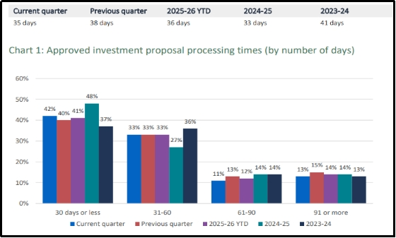
Figure 3: Median processing times for approved commercial investment proposals
(Source: Australian Government, 2026)
The clear screening mechanism in Australia can safeguard the integrity of the market against arbitrary regulatory interference and enhance confidence in long-term capital investment decisions. However, such requirements can negatively impact strategic flexibility if Currys requires mergers and acquisitions, restructurings, property transactions, and/or technology transfers to establish the market. Competing effects will likely tend to make staged investment more desirable as Currys can then nail certain regulatory relationships before investing in stores and distribution infrastructure. Political attractiveness is thus strong but conditional, with political screening and origin restrictions, credible commercial ties between the UK and Australia, and government surveillance risks. Overall, Australia offers a political platform for Currys, but without taking for granted that foreign expansion will occur, entry design must be flexible and compliant.
Economic Factors Affecting Australian Market Entry
Australia presents meaningful consumer demand for Currys, but weakening discretionary spending, persistent inflation, and labour costs reduce near-term market attractiveness. According to the ABS spending graphs, expenditure decreased by 1.1% in April 2026 but is still 4.9% higher than the amount recorded the same month last year (ABS, 2026). This annual increase signifies market capacity, but the monthly decrease signals that this headline growth is not necessarily associated with a steady electronics demand. An expenditure category also brought into question the assumptions of any immediate appliance and technology growth was furnishings and household equipment, which decreased 0.1% monthly (ABS, 2026). Accordingly, the Currys had the opportunity to begin a consumer economy, but aggressive expansion of stores might reveal the fixed costs prior to demand strengthening.
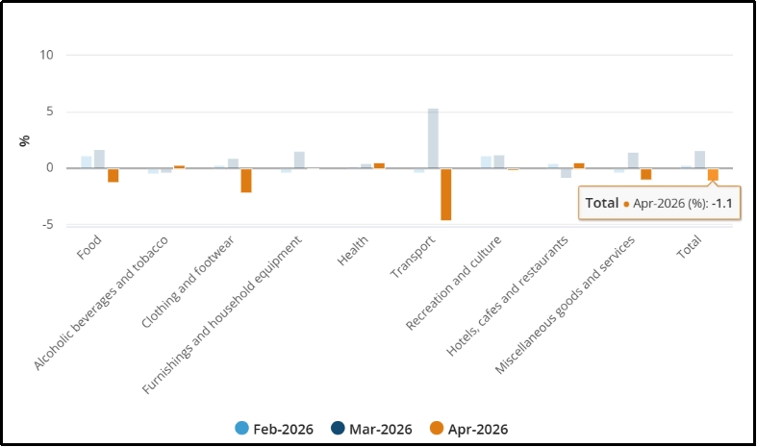
Figure 4: Household spending, percentage change
(Source: ABS, 2026)
The RBA reported weakening consumer sentiment and expected spending to slow as higher fuel prices and interest rates constrain households. Its May decision raised the cash rate to 4.35%, increasing borrowing costs and weakening demand for electronics (RBA, 2026). Higher rates also increase the investment barrier for Currys as making commitments in property, stock and distribution becomes more difficult without good expected margins. On the other hand, resilient employment and previous periods of household income growth offer some support for consumption, decreasing the chances of severe demand contraction. There are mixed cost conditions as retail wages rose by 2.9% over the year to March 2026 (ABS, 2026a). Such wage increases help improve employees purchasing power but also add to the cost of the service and sales model of Currys' company, which is built on staffing. Slower quarterly retail wage growth of 0.1% offers partial relief, but labour costs still pressure margins against established competitors. (ABS, 2026a). Therefore, when looking at the growth of revenues that the Currys are seeing, they need to consider the financing-based situation as well as the risk of labour and the demand side of the business rather than just relying on the growth of spending annually. A phased rollout could minimize the risk of fixed costs and provide an opportunity to assess demand for aftersales services, response, strength of prices, and delivery economics. Overall, Australia offers an attractive economic environment for Currys, but there are unsettled volumes, and financing costs are high for them. It means that a cautious view should be taken of investing in Australia rather than catch-up investment on a national scale.
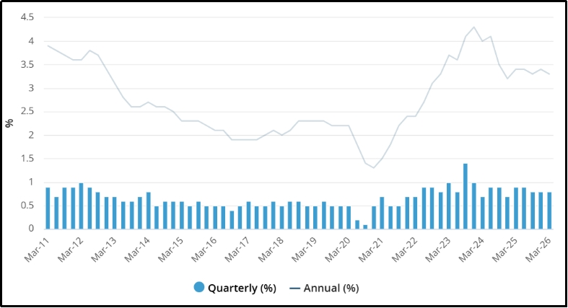
Figure 5: Slower quarterly retail wage growth in March
(Source: ABS, 2026a)
Legal Factors Affecting Australian Market Entry
Australia's legal landscape can boost consumer confidence; however, demanding retail responsibilities could make it harder for Currys to operate, leading to greater compliance costs and liability. ACCC data revealed over 38,000 consumer-guarantee reports for the year ending 2025, reflecting a 20 per cent increase and high levels of consumer-enforcement sensitivity (ACCC, 2026). Approximately 70% of electronics and whitegoods respondents referenced guarantees, reflecting that guarantees are particularly relevant to Currys' key products and services (ACCC, 2026). They build confidence in the customers, but if products turn bad, refunds, replacement, repairs and compensation can be a huge cost after the sale. This requires strong service systems in place locally and well-trained store staff at each of these retailers, and they cannot simply shift customers to the manufacturers. Product-safety responsibilities also risk putting Currys on the recall list, but the company might always distinguish itself through consistent service and responsible retailing. Promotional options are also limited by competition and advertising regulations, as it would be easy to damage the reputation and margins with misleading discounts or warranty claims.
These responsibilities would not go away with online transactions, as product information, complaint handling, pricing, and service quality would still have to be guaranteed across channels. The fact that there are also privacy risks associated with this is also noteworthy, with Australia reporting 1,205 notifiable data breaches in 2025, an 8% increase on 2024 (OAIC, 2026). An omnichannel model with data, which Currys uses, thus has the potential, materially over time, to increase the investment in cybersecurity, reputational risks and the costs associated with breaches while creating value for customers. Personalisation services might conflict with complex obligations for stronger privacy governance, which might lower service speed and operational flexibility. Foreign-investment, employment and electronic-waste obligations also must be carefully considered before Currys stores, warehouses, staff or acquisition capital. A complete acquisition would maintain service oversight and place compliance costs and responsibilities squarely on the acquiring entity and require a more mature internal compliance program. There might be local legal knowledge or flexibility, but weaker controls may be associated with entry as a partnership, resulting in inconsistent standards of service or compliance. Overall, there is credible legal protection that Currys should ensure they make use of as a strategic capability, not as a necessary administrative burden.
Cultural Factors Affecting Australian Market Entry
Australia’s consumer culture appears compatible with Currys’ omnichannel model, but digital maturity alone cannot guarantee a successful transfer from European markets. According to Australia Post’s (2026) report on trends and behaviours in online retailing, 82% of Australian households purchased goods online in 2025, indicating a high level of acceptance of online shopping in the country. Online spending grew to $82.6 billion, growing by 14 per cent every year, further cementing the commercial arguments for a purpose-built, designed digital entry (Australia Post, 2026) [Refer to Appendix 2]. However, the response of 45% of shoppers who waited until something was put on sale demonstrates that price is a pressure on Currys' margins and position (Australia Post, 2026). Delivery expectations are crucial, with 69% wanting checkout choices, whilst the quality of fulfilment is important for satisfaction, there and purchasing (Australia Post, 2026). These trends clearly support Currys' ‘out-of-store and online', but they expect local pricing, delivery, returns, and service standards not in Britain. However, cultural distance is diminished by familiar language and digital behaviours, but it does not eliminate the competition, lack of trust, or value-perception issues altogether.
ACMA data reveals that 99.7% of adults have access to the internet and 97 per cent have mobile internet access in 2025 (ACMA, 2026). This significant technology investment facilitates the discovery, comparison, and servicing of customers digitally via apps, reinforcing Currys capacity for efficient integrated customer relationships. However, these national averages are masking key socioeconomic disparities, and adequate technology access is not always sufficient to ensure the participation or engagement of every group of consumers. According to the Digital Inclusion Index, 20.6 per cent are still excluded or highly excluded, which hinders an exclusively digital solution (ADII, 2025). Older, regional, disadvantaged and First Nations consumers are faced with additional barriers and need accessible stores, regional support, communication and alternative means of fulfilment. So the acceptance of foreign brands is not only related to familiarity in Britain, but also to the credibility of its service, price and delivery. Existing strong local recognition, convenience, promotions and loyalty programmes can also mean that strong rivals can match Currys in its ability to transfer advantage. Overall, there is a level of cultural fit in Australia, but Currys needs to localise its offer, as similarity cannot replace proven customer relevance in the local market.
Integrated Market Attractiveness Judgement
The market in Australia is an attractive opportunity, but considerations of demand, regulation, operating costs and culture contribute to a weakening of the opportunity for Currys. Political stability and other forms of uncertainties associated with trade relations between the United Kingdom and Australia offer benefit; however, investment screening and origin rules limit UK material strategic flexibility. Economic conditions allow for a more optimistic entry as household spending is still positive, but increases in the interest rate adversely affect discretionary demand and investment returns. The ABS evidence reveals that the spending by households was still 4.9 per cent higher than in April 2025 despite a fall of 1.1 per cent (ABS, 2026). This contradiction results from the fact that market size is a condition for rapid expansion, but volatile demand may leave stores, inventory, and logistics underutilised. While legal safeguards help build trust, they also add greater service burden and exposure to refunds, cybersecurity expenses and management complexities for electrical retailers. Consumer-guarantee complaints are still largely restricted to electronics and white goods, and after-sales capability is significant for Currys (ACCC, 2026). Price sensitivity drives comparison shopping and competitors' promotional reactions, while digital experience seems to favour cultural conditions among Australians.
Whilst omnichannel access helps ease convenience expectations, 82% of households revealed the habit in 2025 of shopping online via Australia Post (2026). Hence, digital maturity can become an opportunity if Currys gets a combination of competitive pricing, reliable fulfilment, easy-to-access stores, and great local service. Strict regulation and high operating costs are generally less desirable features for Currys, while political stability facilitates long-term commitment. Similarly, online demand can enhance customer acquisition, and price sensitivity and incumbent competition can reduce margin before the recognition of the customers' brand. These interactions lend towards conditionally attractive Australia, as the benign institutional and digital demand factors co-exist with the regulatory, financial and execution risks. A phased omnichannel entry would then take into account market opportunity, regulatory risk, capital volume, as well as how much local consumers need to learn. Overall, Australia can provide a potential market for Currys, but effective localisation is necessary and not easy to duplicate the European assets.

3.2 Market Entry Analysis Through OLI
Ownership Advantages
Currys has several ownership advantages, but they are dependent on capabilities being unique in markets outside Europe. Its technology retail expertise extends to procurement, supplier management, digital systems, stores, customer information, services, repair and financing, and operations. According to business figures released by the company on the occasion of a store opening, customers who purchased solutions were generating baskets that were 4 times larger and margins at 8 times higher compared to customers who only purchased products (Currys plc, 2026). The findings suggest that advice and after-sales service is more than just the normal retail offering of a competitor and add value. ESLs save 138,000 colleague hours a year, and Action AI contributes to incremental sales of £20-40 million (Currys plc, 2026). While this technology has the potential to enhance the productivity and responsiveness to prices of Australian food producers, potential transferability may be limited by implementation costs and operating conditions different from those previously studied. However, supplier size and supply experiences may provide the means to support assortment and bargaining power, yet will need to be reevaluated, given logistical goods flow and vendor relationships, given the distance. As noted by Surana et al. (2024), information, knowledge, networks and open resources can enhance internationalisation benefits in digitally empowered firms. Their evidence on the digital platform does not, however, necessarily transfer to Currys, as the chain still has the critical value of physical stores, inventory, repairs and local service. Therefore, Currys possesses transferable benefits, but what that means is they only represent Australian competitive benefits when locally adapted offers more gain than current retailers.
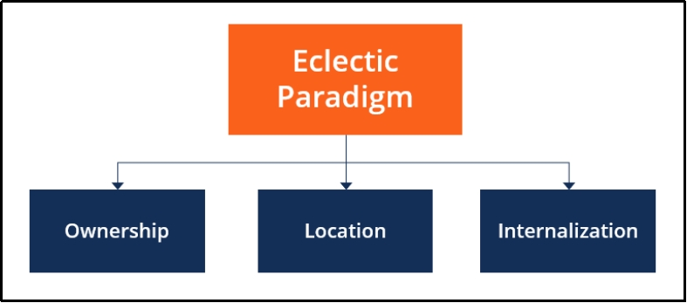
Figure 6: Eclectic paradigm or OLI framework
(Source: Self-Developed)
Location Advantages
Australia possesses significant location advantages for Currys, but geographic distance, operating costs, regulation, and competition can not outweigh market demand. Online retail sales increased seven-point-three per cent year on year to reach a seasonally adjusted value of A$4.537 billion in April 2025 (ABS, 2025). This digital scale complements Currys' omnichannel approach, as customers are already engaging in a mix of online comparison, home delivery and a growing number of technology-enabled purchase journeys. However, when online demand is high, it also brings the efficient incumbents, and with them come high customer acquisition costs, which affect the margins for an unknown British retailer. Investment predictability is bolstered by Australia's institutional stability and purchasing power, and by its developed retail infrastructure, which enables retail outlets, fulfilment, payments and customer services. But the further away from Currys' distribution centres in Europe, the more complicated the logistics of shipping goods, the more inventory needed, the longer the lead time to delivery, and the more vulnerable a supply chain is to disruption in Europe. Labour costs, consumer protections, privacy obligations and e-waste responsibilities further erode the location benefits, causing the fixed and variable costs of operating the location to rise. According to Donnelly et al. (2024), the institutional distance inhibits foreign entry, and financial and managerial slack can decrease the gap. Thus, there is room for uncertainty to be absorbed by Currys, but costs in connection with the acquisition and information deficits that exist locally may prove to be a drag on expected returns. Overall, Australia provides genuine location advantages, but its value supports phased entry rather than immediate nationwide investment under competitive uncertainty.
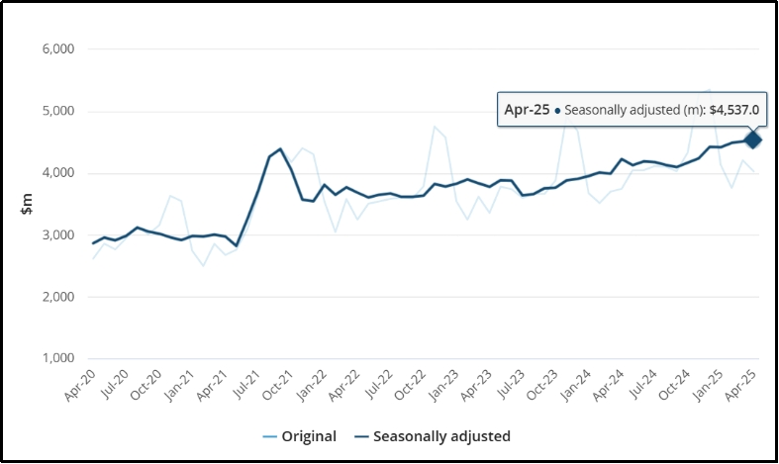
Figure 7: Total online, original and seasonally adjusted
(Figure: ABS, 2025)
Internalisation Advantages
The benefits of internalisation are more aligned with keeping materials and content close, as Currys' customer value is based on seamless digital, retail, service and data. Direct control might help secure brand reputation, pricing discipline, customer experience, digital systems, customer data, after-sales and operational knowledge. It may also help to protect supplier connections and repair standards, as partners could get weaker and weaker in these aspects that differentiate Currys from product-centric opponents. Surana et al. (2024) identify emerging internalisation advantages in information and knowledge, supporting control where data-driven learning influences international performance. This applies to Currys as customer data, price data, service data and omnichannel behaviour can provide informed commercial decisions. But total internalisation would result in a centralisation of commitment, complexity, regulation, exposure, staffing issues and execution risk in Australia. Local partners may be able to offer market knowledge, access to supplies, regulatory expertise and flexibility, decrease mistakes and capital exposed during experimentation. However, such partnership reliance could compromise consistency in pricing, direct control of customer service, data management and quality of repairs, and the transfer of Currys retail expertise. Donnelly et al. (2024) also make the point that institutional differences necessitate resources, as ownership control cannot simply replace automatic local learning and adaptation. Selective internalisation is the best option overall, both in terms of maintaining control over strategically sensitive competencies and in situations when flexibility and knowledge matter more.

4. Entry Mode Strategy and Strategic Synthesis

4.1 Historical Pattern Recognition
The international expansion of Currys has been in an acquisition-style approach, but later restructuring reveals that ownership is not necessarily fixed permanently over time. It acquired Norwegian-listed Elkjøp in 1999, which gave it the Nordic brand, stores, suppliers, staff members and knowledge of the market (Currys plc, 2026a). This was further confirmed with the creation of Dixons–Carphone in 2014, where various functions were integrated instead of relying on exporting or greenfield development (Currys plc, 2026a) [Refer to Appendix 3]. This provided a fast and controllable way of access, but without having to invest in brand building, distribution networks, and supplier relationships on their own for overseas market entry. However, acquisitions also entailed integration problems, capital exposure, and reliance on management's skills to transfer systems without destroying valuable local capabilities overseas. Standardisation across culturally different national markets was clearly not required for ownership control, as indicated by Curry's decision to maintain separate Nordic marketing. Portfolio value exceeded geographic presence and ownership was still reversible, as seen in the Kotsovolos sale in 2024 for €200 million (Currys plc, 2026a). Wan et al. (2023) discovered that the level of control, requirements, risk exposure, performance, and survival modes displayed different characteristics between entry modes across markets. Therefore, their meta-analysis strengthens the idea of considering the purchase history of Currys to be an optional decision, and not as a natural one to replicate. Overall, Currys found that mergers and acquisitions tend to ease international scale and local access while integration discipline and portfolio flexibility play a role in value creation.

4.2 Strategic Fit and Justification
Experience of Currys in acquiring other retailers is still relevant to Australian circumstances, but a full acquisition at this time would bring unnecessary financial and operational risks. Australia has good institutions, and the comparative projection of Austrade's is 11.1% real GDP growth for 2019-2024, higher than the projected growth for advanced economies (Austrade, 2024). This market strength enables the validity of future demand, but cannot eliminate customer-acquisition expenses, geographical logistics, lesser-known competitors, or integration issues for Currys. Previously, OLI analysis demonstrated transferable service, digital, procurement, and customer capabilities, favouring meaningful control where these ownership advantages need to be translated into local capabilities. The researchers Zhang et al. (2023) conclude that the higher the institutional distance, the lower the equity commitment, and that outcomes vary due to contextual factors across countries. Although formally removed from the jurisdiction of Britain, differences in local consumer law, privacy requirements, work practices, and retail regulations remain. Committed capital for nationwide stores and warehouses, inventory and acquisition premiums seem to create higher financial risk, which seems to be the bigger threat at this time, while political risk would seem to be contained. This imbalance makes for low upfront investment as Currys can retain capital while they gain an understanding of which skills and capabilities in Australia can only be owned and are flexible. Local presence and scale would accelerate through acquisition, but before synergies were validated, there would be a material increase in downside financial risk for Currys. Multifactor productivity decreased by 0.5% in 2024–25, with performance in Australia not necessarily being high (Productivity Commission, 2026).
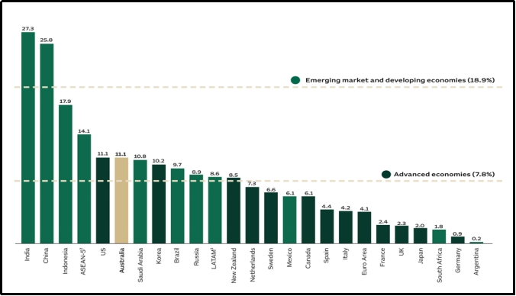
Figure 8: Change in real GDP, Selected economic
(Source: Austrade, 2024)
A full acquisition would allow for the most control over pricing, data, services, repairs, technology and the brand, but will also focus the risk on the downside. Low commitment of resources would be achieved through exporting, but low control over the fulfilment and after-sales service would severely impact the offer of Currys of a differentiated omnichannel service. The traditional joint venture would have shared resources and local knowledge, but with governance issues likely hindering pricing, technology transfer and customer-service uniformity. According to Kyriakopoulos et al. (2025), pressure on the economy is a factor that is likely to increase preference for a lower commitment structure in the form of a joint venture because it retains future options. Their evidence concerns emerging-market micromultinationals, so direct generalisation to Currys is limited, but the flexibility principle remains strategically relevant here. A staged strategic alliance, followed by majority acquisition, presents a better fit than an immediate full acquisition or permanently shared control. A local retail or logistics partner may first be able to lower market learning costs and also speed supplier relationships, making only a small and not truly irretrievable investment to test the waters of Australian demand. Currys needs to maintain ownership of digital businesses and customer data, as well as service levels and brand architecture, with a certain degree of handover across logistics and market-development activities. Currys could buy into ownership through a negotiated acquisition if they reach certain thresholds for pilot economics, service quality, and customer retention as well as regulatory compliance. The combination of control and flexibility, protection of transferable capabilities, and the transformation of uncertainty to learning before dedicating resources to nationwide expansion. Therefore, historical acquisition capability remains valuable, but Australia requires a staged version that preserves strategic options rather than mechanically repeating past practice.

4.3 Conclusion and Recommendations
Australia is an attractive place to make a controlled entry due to the stability of institutions, the digital demand, and the transferable capabilities of Currys, which offer a credible long-term value opportunity. Nevertheless, it is only because of the presence of established competitors, regulatory requirements, distance, operating expenses, and uncertain brand recognition that the countrywide ownership is needlessly risky. Currys has a history of acquiring companies and knows how to integrate, but the portfolio suggests that past ownership history should not be the basis for Australian entry. Exporting would preserve capital, but limited control over fulfilment, customer data, repairs, and service quality would weaken Currys differentiation substantially. A joint venture would share both financial and operational risk, with potential challenges in governance and later transferring capabilities. Hence, Currys needs to enter through a staged strategic alliance with selected local partners before going for majority acquisition after validation of the performance. The initial investment in resources needs to be fairly moderate digital access, metropolitan pilots, local fulfilment, service partnerships, and disciplined acquisition of customers. Local technologies, knowledge of customers, prices, standards of service, and branding should be maintained, and local learnings should occur before escalating into material ownership. Overall, staged entry best balances the risk, resources, control, flexibility, long-term strategic fit, and still maintains a credible path to reach the Australian scale.

Section 2: Reflective Account
Introduction
In this reflection, I will analyse how I researched and analysed the Currys Australian market-entry assessment over the complete project and strengthened my critical judgement throughout the process. I examine my research approach, theory use, challenges, and learning because these areas shaped my understanding of international business decisions. Reflections also highlight any gaps and useful tips that can greatly enhance my future academic research and professional decision-making.
Gibbs Reflective Cycle
This reflective cycle has six stages which give students linked steps to review experiences, to analyse results, to draw conclusions and to make improvement plans. This model was used as it enables structured reflection on actions, feelings, strengths, weaknesses, conclusions and future actions (Gibbs, 1988). I was able to use the cycle critically, describing my learning and changing judgement in each of the stages:
Description
The assessment requirements were first transferred to research questions on Currys, Australia, international strategy, OLI and appropriate entry modes. I compiled company data, official figures, evidence from regulators, academic research, lecture notes, readings and case notes and class discussion material. I used primary evidence to demonstrate company performance and for Australian conditions, and used peer-reviewed studies to explain and critique important findings. Before I could make a final strategic judgement, I grouped my evidence by political, economic, legal, cultural, ownership, location, internalisation and entry mode. This approach kept my research focused and traceable, although checking many sources required more time than I had initially expected overall.
Feelings
Initially, I was feeling comfortable beacuse Currys and Australia gave me enough pieces of evidence to work in several international business areas. However, my confidence reduced when sources used different measures, dates, and assumptions, sometimes pointing toward conflicting market conclusions. Avoiding description was also difficult because useful statistics did not always make clear what the evidence meant for the Currys. Critical reflection can enhance confidence when dealing with assumptions rather than taking initial impressions on faith (Awidi and Klutsey, 2025). This awareness inspired me to reevaluate both the quality and relevance of evidence as well as its meaning, before deeming the information effective for supporting my argument.
Evaluation
Some research options proved to be successful, with the official evidence being more accurate and the academic studies allowing me to test the company claims and prevent one-sided conclusions about the study. Comparing different sources did help when a favourable market factor was in contrast to high expenses, regulation, competition, or customer response. The studies on information literacy support my approach as higher evaluation skills relate to better information-seeking and continued learning (Tachie-Donkor and Ezema, 2023). My main weakness was collecting too much descriptive material early, leaving less time for deeper comparison and stronger synthesis later. Reflective practice can enhance individuals self-knowledge in this regard, recognising the importance of source evaluation as a professional skill (Denami and Adinda, 2023). Removed unnecessary evidence to narrow down Curry's point of opportunity, risk, control requirements, resource commitment, and recommended entry mode.
Analysis
My most significant learning was when I left behind labels of theories and instead used theory to test evidence and alternative explanations. Bartlett and Ghoshal helped me think in terms of global integration and local responsiveness rather than categorising Curry's in one and challenging the fit. Using Dunning's OLI framework, owners capabilities were matched with the Australian context, revealing that simply having the strength in ownership does not necessarily generate overseas competitive advantages. Therefore, I think it shifted my thinking because digital systems, sourcing knowledge, and the skills of service only make a difference when conditions in the local context support successful transfers. Practical elements were brought into play through class discussions, concepts were taken from lectures, and criticism was drawn from readings, with examples applied from cases. I have undertaken these topic lessons to consider acquisitions, exporting, partnerships, and ownership in the context of risk, flexibility, control, resources, and long-term strategic fit. Tight (2024) argues that reflection becomes weak when learners follow stages mechanically without questioning assumptions or changing their thinking. This criticism helped me utilize Gibbs for deeper judgement, separating the factual evidence from my interpretation, and checking out competing explanations about strategic moves.
Conclusion
I concluded that evidence synthesis is my main strength as I kept making a stronger link between statistics, theory, comparison and strategic meaning. My main limitation was research efficiency because early over-searching created repeated material and reduced time available for deeper evaluation later. I learned that international business models guide decisions, but they cannot replace context, evidence quality, or careful consideration of uncertainty.
Action Plan
I will make these lessons into concrete development actions to improve my future research to be faster, clearer, and more critically focused. Reflective practice becomes more effective when there are identified future actions and ongoing development related to the reflection. My plans involve research efficiency, source evaluation, application of theory, and more decisions based on evidence when completing future academic tasks.
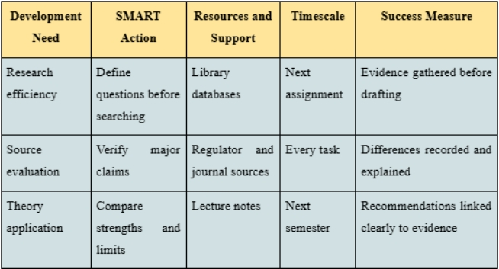
Table 1: SMART Personal Development Action Plan
(Source: Self-Developed)
These targets will be reviewed following each assignment, and evidence of improvement, ongoing difficulties, and additional actions required for further progress will be identified.
Overall Conclusion
This reflection show that my learning expanded through increased checking of sources, use of theories, comparing, and well-thought-out evaluation when assessing. I now realize that to become an effective international business analyst, evidence, context, critical thinking, and questioning of initial assumptions are important. I aim to use these lessons to help inform my future academic projects and career choices, both by supporting my ability to make decisions and judgements that are more well-informed and balanced with evidence.

References
ABS (2026). Monthly Household Spending Indicator, April 2026. 28 May. Available at: https://www.abs.gov.au/statistics/economy/finance/monthly-household-spending-indicator/apr-2026 (Accessed: 11 August 2026).
ABS (2026a). Wage Price Index, Australia, March 2026. 13 May. Available at: https://www.abs.gov.au/statistics/economy/price-indexes-and-inflation/wage-price-index-australia/mar-2026 (Accessed: 11 August 2026).
ACCC (2026). Rising contacts raise concerns about electronics and whitegoods sector compliance with consumer guarantee rights. 24 April. Available at: https://www.accc.gov.au/media-release/rising-contacts-raise-concerns-about-electronics-and-whitegoods-sector-compliance-with-consumer-guarantee-rights (Accessed: 11 August 2026).
ACMA (2026). Communications and media in Australia: How we use the internet. 19 February. Available at: https://www.acma.gov.au/sites/default/files/2026-02/How%20we%20use%20the%20internet%20-%20Executive%20summary%20and%20key%20findings.pdf (Accessed: 11 August 2026).
ADII (2025). The 2025 findings. Available at: https://digitalinclusionindex.org.au/the-2025-findings/ (Accessed: 11 August 2026).
Austrade (2024). Why Australia Benchmark Report 2024: Economic and business fundamentals. Available at: https://international.austrade.gov.au/en/why-australia/economic-business-fundamentals (Accessed: 11 August 2026).
Australia Post (2026). Australia Post eCommerce Report 2026. Available at: https://auspost.com.au/business/ecommerce/ecommerce-report (Accessed: 11 August 2026).
Australian Bureau of Statistics (ABS) (2025). Retail Trade, Australia, April 2025. 30 May. Available at: https://www.abs.gov.au/statistics/industry/retail-and-wholesale-trade/retail-trade-australia/apr-2025 (Accessed: 11 August 2026).
Australian Government (2026). Quarterly Report on Foreign Investment: 1 October to 31 December 2025. 29 May. Available at: https://foreigninvestment.gov.au/news-and-reports/reports-and-publications/quarterly-report-oct-dec-2025 (Accessed: 11 August 2026).
Awidi, I.T. and Klutsey, J.Q. (2025). ‘Using online critical reflection to enhance students’ confidence, motivation, and engagement in higher education’, Technology, Knowledge and Learning, 30, pp. 1499–1534. Available at: https://link.springer.com/article/10.1007/s10758-024-09751-4 (Accessed: 11 August 2026).
Bartlett, C. and Ghoshal, S., (2003).. Managing across borders. Manager, p.24.
Batsakis, G., Theoharakis, V., Li, C. and Konara, P. (2023). ‘Internationalization and digitalization: Their differing role on grocer and non-grocer retailer performance’, Journal of Retailing, 99(3), pp. 400–419. Available at: https://www.sciencedirect.com/science/article/pii/S0022435923000337 (Accessed: 11 August 2026).
Currys plc (2025). Currys Full Year Results 2024/25. 3 July. Available at: https://www.currysplc.com/media/fsxbvcaf/currys-plc-full-year-results-2024-25-result-statement.pdf (Accessed: 11 August 2026).
Currys plc (2025a) Currys Interim Results 2025/26. 18 December. Available at: https://www.currysplc.com/news-media/press-releases/2025/currys-interim-results-2025-26 (Accessed: 11 August 2026).
Currys plc (2026). Currys plc 2025/26 Peak Trading Update. 21 January. Available at: https://www.currysplc.com/media/hs0f1vhi/currys-plc-peak-trading-update-2025-26-presentation.pdf (Accessed: 11 August 2026).
Currys plc (2026a). Our History. Available at: https://www.currysplc.com/about-us/history/ (Accessed: 11 August 2026).
Denami, M. and Adinda, D. (2023). ‘The reflective practice at university: how to enhance students’ competencies awareness by using “reflective breaks”’, Reflective Practice, 24(4), pp. 413–432. Available at: https://www.tandfonline.com/doi/abs/10.1080/14623943.2023.2200927 (Accessed: 11 August 2026).
DFAT (2026). Using A-UKFTA to do business with the United Kingdom. Available at: https://www.dfat.gov.au/trade/agreements/in-force/aukfta/using-ukfta-do-business-united-kingdom (Accessed: 11 August 2026).
Donnelly, R., Purkayastha, S., Manolova, T.S. and Edelman, L.F. (2024). ‘Institutional distance, slack resources, and foreign market entry’, Journal of International Business Studies, 55, pp. 194–211. Available at: https://link.springer.com/article/10.1057/s41267-023-00647-6 (Accessed: 11 August 2026).
Gibbs, G. (1988). Learning by Doing: A Guide to Teaching and Learning Methods. London: Further Education Unit. Available at: https://cir.nii.ac.jp/crid/1571417125052979584 (Accessed: 11 August 2026).
Kyriakopoulos, P., Narooz, R. and Ji, J. (2025). ‘Ownership choices of emerging market micromultinationals (mMNEs) under uncertainty: A real option approach’, International Business Review, 34(6), 102403. Available at: https://www.sciencedirect.com/science/article/pii/S0969593125000162 (Accessed: 11 August 2026).
OAIC (2026). Data breach notifications increase to all-time high in 2025, new NDB stats show. 6 July. Available at: https://www.oaic.gov.au/news/media-centre/data-breach-notifications-increase-to-all-time-high-in-2025%2C-new-ndb-stats-show (Accessed: 11 August 2026).
Productivity Commission (2026). Annual Productivity Bulletin 2026. 19 February. Available at: https://www.pc.gov.au/ongoing/productivity-insights/bulletins/bulletin-2026/ (Accessed: 11 August 2026).
RBA (2026). Statement on Monetary Policy – May 2026. 5 May. Available at: https://www.rba.gov.au/publications/smp/2026/may/ (Accessed: 11 August 2026).
Surana, A., Chavan, M., Kumar, V. and Chirico, F. (2024). ‘The internationalization of digital platform firms: the platform-OLI (P-OLI) framework’, International Marketing Review, 41(5), pp. 886–910. Available at: https://www.emerald.com/imr/article/41/5/886/1224064 (Accessed: 11 August 2026).
Tachie-Donkor, G. and Ezema, I.J. (2023). ‘Effect of information literacy skills on university students’ information seeking behaviour and lifelong learning’, Heliyon, 9(8), e18427. Available at: https://www.cell.com/heliyon/fulltext/S2405-8440(23)05635-9 (Accessed: 11 August 2026).
Tight, M. (2024). ‘Reflection: an assessment and critique of a pervasive trend in higher education’, European Journal of Higher Education, 14(2), pp. 324–342. Available at: https://www.tandfonline.com/doi/abs/10.1080/21568235.2023.2193345 (Accessed: 11 August 2026).Wan, C., Sousa, C.M.P., Lengler, J. and Tan, Q. (2023) ‘Entry mode choice: A meta-analysis of antecedents and outcomes’, Management International Review, 63(2), pp. 193–246. Available at: https://link.springer.com/article/10.1007/s11575-022-00499-6 (Accessed: 11 August 2026).
Zhang, W., He, X., Wang, T. and Wang, K. (2023) ‘Institutional distance and the international market entry mode: A meta-analysis’, Journal of International Management, 29(1), 100990. Available at: https://www.sciencedirect.com/science/article/pii/S1075425322000655 (Accessed: 11 August 2026).

Appendices

Appendix 1: Performance Summary of Currys PLC
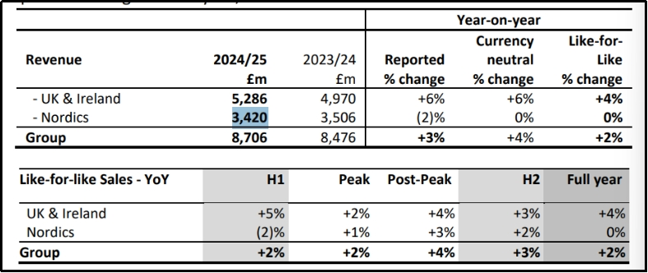
Figure 9 : Performance Summary of Currys PLC
(Source: Currys plc, 2025)

Appendix 2:Unboxing how Australians shopped in 2025
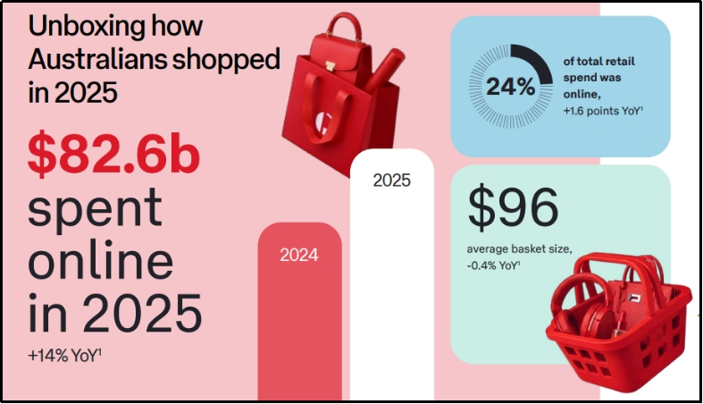
Figure 10: Unboxing how Australians shopped in 2025
(Source: Australia Post, 2026)

Appendix 3: Acquisition of Norwegian-listed Elkjøp Group in 1999
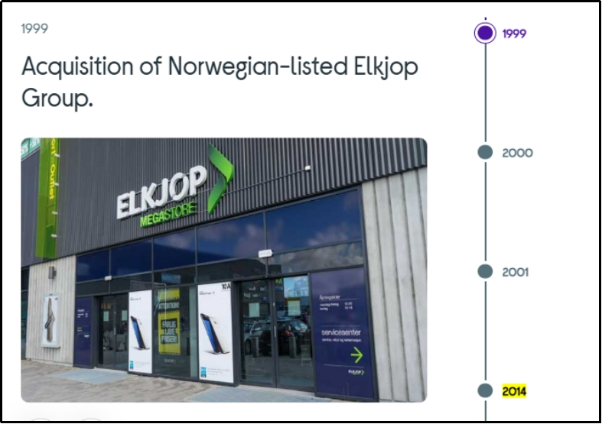
Figure 11: Acquisition of Norwegian-listed Elkjøp Group in 1999
(Source: Currys plc, 2026a)

