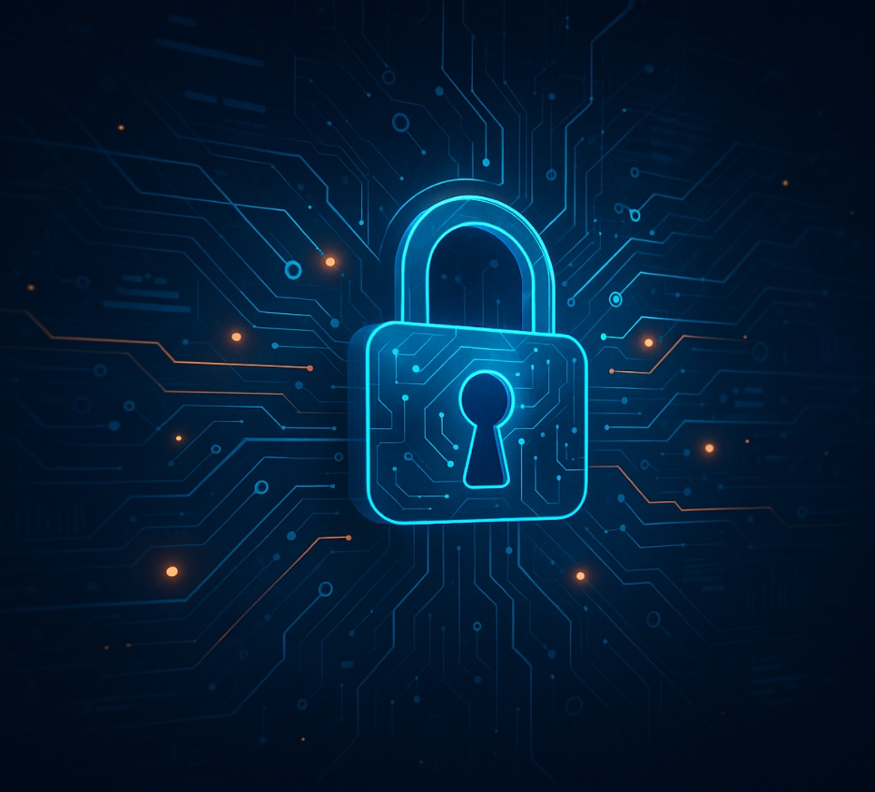
ANA CHICAIZA ASIMBAYA (2115194)
Advanced Cybersecurity – ACCB6000
University of Wales Trinity Saint David
London Campus

Evolving Blue Team Operations for Effective Threat Detection and Response

Table of Contents

ABSTRACT 2
INTRODUCTION 3
SIEM-CENTRIC DETECTION: STRENGTHS AND LIMITATIONS 4
INCIDENT RESPONSE: FROM REACTIVE PLAYBOOKS TO CONTINUOUS READINESS 5
THREAT HUNTING AND PROACTIVE DEFENCE 6
Human factors and SOC optimisation 7
CONCLUSION 8
REFERENCES 9

ABSTRACT

The rapid growth of cyber-attacks on UK organisations, with 50% of businesses reporting a breach or attack in 2024, compared to 32% among smaller firms previously, underlines the critical importance of mature blue-team operations for threat detection and response [1]. Modern Security Operations Centers (SOCs) depend on Security Information and Event Management (SIEM) platforms, incident response (IR) processes, and threat hunting to detect, investigate, and contain attacks. However, empirical studies show persistent gaps, including alert fatigue, limited cloud visibility, and human-factor weaknesses [2]–[4]. This report critically appraises current blue-team methodologies, tools, and strategies, drawing on recent surveys, threat landscape reports, and academic work. It argues that while SIEM-centric SOCs have improved detection speed and automation, their effectiveness is constrained by poor data quality, immature metrics, and overreliance on signature-based analytics. Case studies and surveys highlight the shift towards proactive hunting, AI-assisted analysis, and unified platforms combining SIEM with Extended Detection and Response (XDR). Yet these advances also introduce new challenges around analyst trust, skills, and governance. The report concludes that the most effective blue teams blend robust engineering (telemetry, playbooks, metrics) with human-centric practices such as structured threat hunting, continuous training, and realistic red-team exercises.

INTRODUCTION

Recent national and industry reports agree that organisations face a high and growing level of cyber risk. The UK Cyber Security Breaches Survey 2024 reports that around half of businesses identified cyber-attacks, with particularly sharp increases among smaller organisations [1]. Verizon’s 2024 Data Breach Investigations Report (DBIR) similarly finds that ransomware and extortion account for roughly a third of breaches, affecting over 90% of industries [2]. ENISA’s threat landscape reporting for the EU emphasises continuous, campaign-style operations in which attackers rapidly exploit newly disclosed vulnerabilities [3]. In this environment, blue teams—SOCs, incident responders, and defenders—must detect and contain attacks quickly, while accepting that complete prevention is unrealistic. Their effectiveness depends not just on tools, but on how telemetry, processes, and people integrate in practice.

SIEM-CENTRIC DETECTION: STRENGTHS AND LIMITATIONS

SIEM platforms remain the technical backbone of most SOCs, aggregating logs from endpoints, network devices and cloud services for correlation and alerting [4], [5]. Modern architectures integrate threat intelligence feeds, User and Entity Behaviour Analytics (UEBA), and, increasingly, machine learning models to reduce noise and highlight anomalies. Case studies in both industry white papers and academic work show that centralized SIEM deployment can significantly reduce mean time to detect by providing unified visibility and standardized playbooks [5], [6]. For example, one SOC metrics framework demonstrates how tracking time from detection to containment across SIEM alerts helped identify bottlenecks in analyst triage, leading to measurable improvements [6].
However, SIEMs also embody several weaknesses. First, many organizations ingest large volumes of low-quality or redundant logs, which inflate costs and produce excessive alerts with limited context [4]. This contributes to alert fatigue, where genuinely malicious activity is missed because analysts are overwhelmed. Second, static correlation rules struggle with novel attack techniques and “low-and-slow” campaigns, particularly in cloud-native environments where ephemeral workloads and microservices create complex telemetry [3], [7]. Third, integration across on-premises, multi-cloud and SaaS platforms is often incomplete, resulting in “blind spots” that adversaries can exploit. These limitations show that SIEM is necessary but not sufficient; blue teams must complement it with better engineering, tuning and proactive analysis.

INCIDENT RESPONSE: FROM REACTIVE PLAYBOOKS TO CONTINUOUS READINESS

Incident response frameworks, such as those aligned with NIST guidance, define structured phases: preparation, detection, analysis, containment, eradication, and recovery [7]. Surveys of IR teams by SANS indicate progress: more organisations now have formal IR plans, dedicated teams, and post-incident reviews than at pre-pandemic baselines [7]. In practice, strong IR capability allows blue teams to limit dwell time and business impact when SIEM or endpoint tools raise an alert. For example, DBIR case data show that swift containment actions—such as isolating endpoints and revoking credentials—can prevent ransomware from spreading across entire networks [2].
Yet empirical evidence suggests IR is still often reactive and siloed. Many organisations treat incident response as a technical exercise rather than a cross-functional capability involving legal, HR, and senior management, which delays decision-making and communication [7]. Post-incident “lessons learned” are not consistently translated into updated playbooks, new SIEM detection rules, or improved asset inventories. Additionally, ENISA’s reporting highlights that supply-chain and third-party incidents expose weaknesses in IR coordination across organisational boundaries [3]. enisa.europa.eu+1 To move beyond checkbox compliance, blue teams need continuous exercises—such as tabletop simulations and red/blue exercises—that test both technical steps and organisational decision-making.

THREAT HUNTING AND PROACTIVE DEFENCE

SANS’ 2023 SOC survey reports that around 75% of SOCs detect incidents before external notification, and a non-trivial portion attributes this to proactive threat hunting rather than passive alert triage [4]. Threat hunting involves forming hypotheses (“If an attacker abused this cloud identity, what traces would they leave?”) and actively searching across logs, endpoints and network flows. This practice can reveal stealthy behaviours such as lateral movement using legitimate tools, which might bypass conventional rule-based alerts [4], [8].
Academic and industry work increasingly explores AI-augmented threat hunting, where machine-learning models and large language models (LLMs) help analysts sift through large telemetry sets and generate candidate queries [8], [9]. Experimental platforms combining SIEM, XDR and AI-driven analytics show promise in reducing triage time and highlighting anomalous behaviours that would be difficult to find manually [8]. However, these systems can introduce “black-box” reasoning and over-reliance risks: if analysts do not understand why detections are raised, they may either ignore important alerts or accept false positives uncritically [9]. High-performing blue teams therefore treat AI as an assistant, embedding it within rigorous validation workflows and peer review rather than delegating decisions entirely.

Human factors and SOC optimisation
Across multiple reports, the “human element” remains central. DBIR data consistently show that a majority of breaches involve human actions, such as phishing clicks, misconfigurations, or credential misuse [2]. At the same time, SOC analysts themselves operate under a high cognitive load. Recent work on SOC metrics suggests that many organisations measure only basic operational statistics (number of alerts closed, incidents handled) rather than deeper indicators such as false-positive rates, knowledge reuse, or analyst burnout [6]. Blue-team fundamentals research also notes a lack of standardisation in SOC roles and training paths, which complicates career development and creates skill gaps in areas such as cloud forensics and OT (operational technology) security [5], [10].
Concrete examples illustrate these issues. In several publicised incidents, misconfigured cloud storage or exposed administrative interfaces were exploited despite the presence of advanced tools, because responsibility for configuration was unclear between IT and security teams [3]. Conversely, organisations that run regular red-team vs blue-team exercises report improved detection coverage and faster response, as defenders gain hands-on experience with realistic attacker techniques [10]. Optimising blue-team performance, therefore, requires investment in training, clear role definitions, psychologically safe cultures for reporting mistakes, and metrics that value quality of detection over sheer volume of tickets closed.

CONCLUSION
Overall, the literature shows that blue team operations have matured significantly, with SIEM-centric SOCs, structured incident response, and proactive threat hunting improving detection speed and resilience in an increasingly hostile threat landscape [1] [4]. Nonetheless, important limitations remain: SIEM deployments are often noisy and fragmented; incident response can be reactive and organisationally isolated; and human factors, including skills, fatigue, and communication, constrain the impact of technical investments. Emerging approaches—AI-assisted analytics, unified SIEM/XDR platforms, and red-team exercises—offer promising enhancements but also create new dependencies and trust challenges [7] [9]. The most effective blue teams adopt a socio-technical perspective: engineering high-quality telemetry and playbooks, measuring what truly matters, and continuously developing their people through realistic practice and cross-functional collaboration. For organisations seeking to improve cyber resilience, investing in balanced, evidence-based blue-team operations is no longer optional; it is essential.

REFERENCES

[1] | I. a. T. Department for Science, “Cyber Security Breaches Survey 2024,” UK Government, London, 2024.
[2] | V. E. Solutions, “2024 Data Breach Investigations Report,” Verizon, New York, 2024.
[3] | E. U. A. f. C. (ENISA), “ENISA Threat Landscape 2024,” ENISA, Athens, Greece, 2024.
[4] | C. e. a. Crowley, “SANS 2023 SOC Survey,” SANS Institute, 2023.
[5] | R. Meier, “Blue Team Fundamentals: Roles and Tools in a Security Operations Center,” Independent Publication, 2024.
[6] | J. e. a. Forsberg, “Technical Performance Metrics of a Security Operations Center,” Computers & Security, 2023.
[7] | S. Institute, “SANS 2023 Incident Response Survey,” SANS Institute , 2023.
[8] | “Unified Threat Detection Platform with AI, SIEM and XDR,” 2025.
[9] | A. e. a. Dijk, “Next Steps in Cyber Blue Team Automation—Leveraging AI for SOC Operations,” in CyCon, 2025.
[10] | “Red Team vs Blue Team: Assessing Cybersecurity Resilience Through Simulated Attacks,” 2020.

