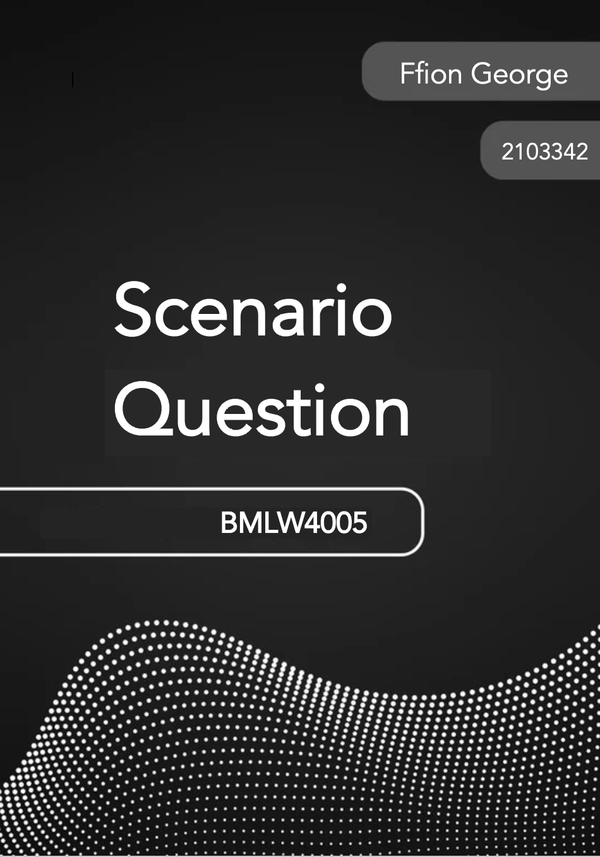
Within the scenario question there are a range of different offences. Each offence will be addressed as they arise, discussing the Actus Reus and Mens Rea elements of each potential offence in order to identify which offences Vinnie may potentially be liable for.

The first offence Vinnie may be liable for is burglary. Burglary is defined under section 9 (1) (a) of the Theft act 1968 as “a person is guilty of burglary if he enters any building or part of a building as a trespasser and with intent” (UK Legislation). Under burglary the actus reus requirements are that he must have entered any building or part of a building as a trespasser. As of Ryan [1996] (Law Teacher, 2021) it was established that only entry needed to be effective. The problem question states that Vinnie took it upon himself to go into the elderly man’s bedroom, meaning entry occurred. Entering a building or part of a building is next to be determined. In B v. Leathley [1979], the court determined that a freezer container in a farmyard qualified as a building through the definition from a case predating the TA 1968 (Stevens v. Gourley, 1859) that to be a building a structure must have some degree of permanence. Vinnie entered the elderly man’s bedroom which amounted to entry into a building or part of a building. Section 9 (1) (a) requires the defendant to be a trespasser upon entry. According to Jones and Smith [1976] (Law teacher, 2021), even if an individual has permission from the occupier to enter, they may still be considered trespassers if the permission was given but exceeded by the defendant. This shows that at the time of entry Vinnie was a trespasser due to his ulterior motive, showing liability for Section 9 (1) (a) Burglary. Vinnie may also be liable to theft. Vinnie saw the elderly man’s watch and decided to take it with the purpose of selling it. Section 1(1) states that a person is guilty of theft if he dishonestly appropriates property belonging to another with the intention of permanently depriving the other of it. This is evident as Vinnie intends to sell the watch, leaving the elderly man permanently deprived of the item. The actus reus of theft requires the appropriation of property belonging to another. Appropriation is defined under Section 3 (1) as any assumption by a person of the rights of an owner. It also requires property, the watch can be deemed property under section 4 (1) TA 1968 where it states that property includes money and all other property, including intangible property. The last element of actus reus for theft is that it belongs to another. Section 5 (1) states that property shall be regarded as belonging to any person having possession or control of it or having in it any proprietary right or interest. Since the watch belonged to the elderly man and had been taken from his room it is evident that the actus reus has been met for theft. The mens rea elements of the offence require the defendant to have dishonestly and intentionally deprive the other of it. Dishonestly as stated under Section 2 (1) (b) TA 1968 is not to be regarded as dishonest if he appropriates the property in the belief that he would have the other’s consent. The elderly man had not consented to Vinnie taking his watch or selling it and it is unlikely that the defendant thought that the elderly man would consent to this. Ghosh [1982] established that being dishonest was a mindset as opposed to a behaviour (Law Teacher, 2024). The defendant can be seen to intentionally permanently deprive the elderly man as Section 6 (1) states that a person appropriating property belonging to another without meaning the other permanently to lose the thing itself is nevertheless to be regarded as having the intention of permanently depriving the other of it if his intention is to treat the thing as his own to dispose of regardless of the other’s rights. Vinnie took the watch to sell therefore evidencing that he intended to permanently deprive the elderly man of his property.

The second offence that Vinnie may be liable for is Basic Criminal Damage. Criminal Damage is defined under Section 1 (1) of the Criminal Damage Act 1971 as “A person who without lawful excuse destroys or damages any property belonging to another intending to destroy or damage any such property or being reckless as to whether any such property would be destroyed or damaged shall be guilty of an offence” (Legislation UK, 2024). In order to determine whether he is liable for the offence the actus reus and mens rea must be determined first. The actus reus of element of basic criminal damage as stated under Section 1 (2) of the CDA 1971 requires the defendant to have committed damage or destruction of property that belongs to another without lawful excuse (CDA 1971). The first part of the actus reus of this offence requires the defendant to have caused damage to property belonging to someone else. This can be established as Vinnie caused visible damage to the car which belonged to Louise. The last element of the actus reus requires the defendant to have committed the offence without lawful excuse. S.5 (2) (a) (CDA 1971) states that if at the time of the act or acts that are alleged to constitute the offence, he thought that the person or people he thought were entitled to consent to the destruction of or damage to the property in question had given their consent, or that they would have given their consent if they had been aware of the circumstances surrounding the destruction or damage. This signifies that no lawful excuse applies to his liability for the offence. Since the actus reus has been established, a mens rea for the offence also needs to be established to form criminal liability. The mens rea of basic criminal damage is set out within S.1 (1) of the Criminal Damage Act 1971, where it states that the defendant must have intention or recklessness to destroy or damage property belonging to another. When considering intention or recklessness the level of blameworthiness must be considered. There are 4 levels of blameworthiness, intention – be it direct or indirect, recklessness, negligence and strict liability. Vinnie purposely damaged Louise’s car in anger, amounting to direct intention as in terms of the mens rea of the offence it was Vinnie’s aim or purpose to bring about that prohibited result.

The third offence that Vinnie may be liable for is assault, which is defined as any act, and not mere omission to act, when a person intentionally or recklessly inflicts the apprehension or causes another to suffer immediate unlawful violence (S.39 CJA 1988), and is evidenced in Fagan V Metropolitan Police Commissioner [1968] (Law Teacher, 2020). The elements of actus reus required for liability of assault include some conduct on part of the defendant and that the victim apprehended immediate unlawful violence, such as in Ireland: Burstow [1998] (Law Teacher, 2021) where the defendant was liable for assault as the defendant made a number of silent telephone calls to the victim which made the victim apprehend the immediate unlawful personal violence due to fear. The actus reus for this offence is clear in Vinnie’s case due to the fact he takes a gun out of his drawer and tells them to get away from the door or he’ll shoot, ultimately inflicting the fear upon them that if they do not do as he says he will shoot one of them. The mens rea of assault requires the defendant to intentionally or recklessly cause the victim to apprehend immediate unlawful personal violence. When Vinnie states that he will shoot he does this with direct intention as his aim is to get the police to apprehend immediate unlawful personal violence. Due to both the actus reus and mens rea of assault having been met, Vinnie may be liable for assault.

The last offence that Vinnie may be liable for is murder. In the problem question it states that Vinnie puts the gun through the letterbox and aims the gun at a police officer and shoots, however kills his next-door neighbour Mrs Quinn. This results in a transfer of malice such as in R v Saunders (1573) (VLex, 2024). When the mens rea of one offence can be applied to another, the theory of transferred malice applies. Vinnie shot at the police however the shot missed and instead hit and resulted in the death of Mrs Quinn. Vinnies mens rea can be transferred to the killing of Mrs Quinn through the operation of transferred malice even though Vinnie had no intention of killing Mrs Quinn he is still accountable for her murder. Murder is defined by common law rather than by statute. The legal definition comes from Sir Edward Coke “When a person of sound mind and discretion, unlawfully kills and reasonable person under the King’s peace with malice aforethought” (Study Rocket, 2019) The actus reus of murder includes unlawfully killing another person under the King’s peace, this is evident as Vinnie killed Mrs Quinn under the King’s peace and with no lawful defence. The mens rea of murder is the intention to kill or cause grievous bodily harm. This is evidenced as Vinnie had previously made threats to shoot therefore, he was fully aware of what could happen.

The actus reus and mens rea for the offences mean that Vinnie could be deemed liable for assault, burglary, criminal damage and murder.

Reference list
Criminal Damage Act 1971.Section 1 (1) Available at: https://www.legislation.gov.uk/ukpga/1971/48/contents [Accessed 14 Apr. 2024].
Criminal Damage Act 1971.Section 1 (2) Available at: https://www.legislation.gov.uk/ukpga/1971/48/contents [Accessed 17 Apr. 2024].
Criminal Damage Act 1971.Section 5 (2) (a) Available at: https://www.legislation.gov.uk/ukpga/1971/48/contents [Accessed 17 Apr. 2024].
Criminal Justice Act 1988.Section 39. Available at: https://www.legislation.gov.uk/ukpga/1988/33/section/39 [Accessed 19 Apr. 2024].
Law Teacher (2013a). B v Leathley - 1979. Available at: https://www.lawteacher.net/cases/b-and-s-v-leathley.php#citethis [Accessed 8 Apr. 2024].
Law Teacher (2013b). R v Ryan - 1996. Available at: https://www.lawteacher.net/cases/r-v-ryan-1996.php [Accessed 3 Apr. 2024].
Law Teacher (2019). R v Ghosh – 1982. Available at: https://www.lawteacher.net/cases/r-v-ghosh.php [Accessed 12 Apr. 2024].
Law Teacher (2021a). R v Ireland and Burstow. Available at: https://www.lawteacher.net/cases/r-v-ireland-and-burstow.php [Accessed 16 Apr. 2024].
Law Teacher (2021b). R v Jones and Smith – 1976. Available at: https://www.lawteacher.net/cases/r-v-jones-and-smith.php [Accessed 15 Apr. 2024].
Law Teacher (2020). Fagan v Metropolitan Police Commissioner. Available at: https://www.lawteacher.net/cases/fagan-v-mpc.php [Accessed 16 Apr. 2024].
Study Rocket (2019). Murder. Available at: https://studyrocket.co.uk/revision/a-level-law-aqa/criminal-law/murder#:~:text=Murder%20is%20a%20common%20law [Accessed 1 May 2024].
Theft Act 1968.Section 9 (1) (a) Available at: https://www.legislation.gov.uk/ukpga/1968/60/section/9#:~:text=9%20Burglary.&text=(2)The%20offences%20referred%20to,the%20building%20or%20anything%20therein. [Accessed 3 Apr. 2024].
Theft Act 1968.Section 1 (1) Available at: https://www.legislation.gov.uk/ukpga/1968/60/section/1/1991-02-01 [Accessed 15 Apr. 2024].
Theft Act 1968.Section 3 (1) Available at: https://www.legislation.gov.uk/ukpga/1968/60/section/1/1991-02-01 [Accessed 11 Apr. 2024].
Theft Act 1968.Section 4 (1) Available at: https://www.legislation.gov.uk/ukpga/1968/60/section/1/1991-02-01 [Accessed 23 Apr. 2024].
Theft Act 1968.Section 5 (1) Available at: https://www.legislation.gov.uk/ukpga/1968/60/section/1/1991-02-01 [Accessed 21 Apr. 2024].
Theft Act 1968.Section 2 (1) (b) Available at: https://www.legislation.gov.uk/ukpga/1968/60/section/1/1991-02-01 [Accessed 22 Apr. 2024].
Theft Act 1968.Section 6 (1) Available at: https://www.legislation.gov.uk/ukpga/1968/60/section/1/1991-02-01 [Accessed 17 Apr. 2024].
VLex (2024a). R v Saunders. Available at: https://vlex.co.uk/vid/r-v-saunders-793568053 [Accessed 15 Apr. 2024].
VLex (2024b). Stevens v Gourley. Available at: https://vlex.co.uk/vid/stevens-v-gourley-806550133 [Accessed 8 Apr. 2024].

