ECAD6008
Name: Kelsey Tucker
Student Number: 1800913
Assignment Title: Critically reflect on your pedagogical progress demonstrated through required elements of the Professional Learning Passport, identifying a specific area for professional development and justifying next steps for improvement.

Targed/Target 1 | Make sure you support your claims with references.
Targed/Target 2 | Revise your use of the Harvard referencing system.
Targed/Target 3 | Make sure you are tentative with your language.

Contents:
Part 1: Reflection on Subject Knowledge development pp. 2-6
Part 1: Reflection on Progression in learning pp .7-10
Part 1: Reflection on Four Purposes in learners pp. 11-12
Part 2: Critical Reflection pp.13-17
Reference List pp. 18-20
Appendix no. 1-4 p. 21

Part One
Part1: Professional Learning Passport

Reflection on Subject Knowledge Development (Tab 5)
Asset One: Numeracy
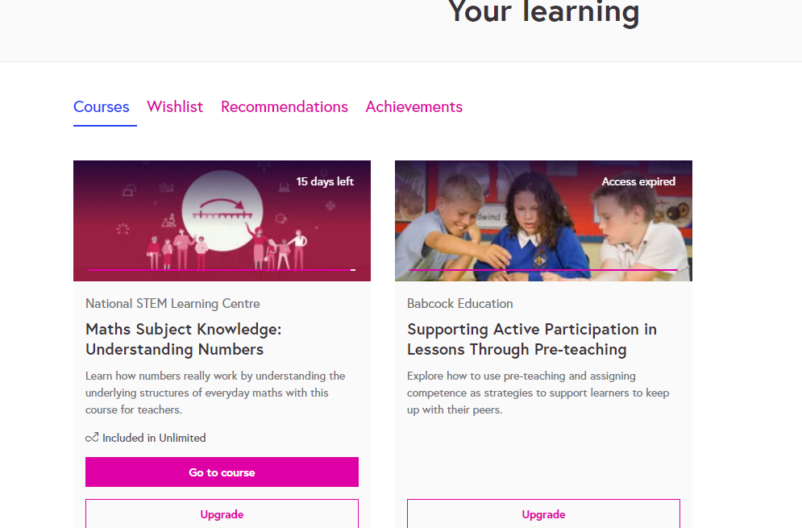
This is where I was able to access the Maths Subject Knowledge: Understanding Numbers course on the Futurelearn website.

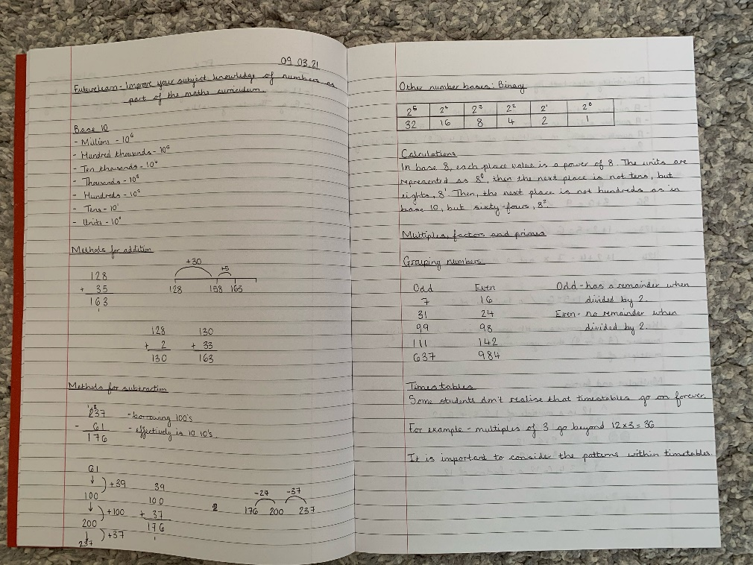
Here is evidence of my notes I made throughout the Futurelearn Maths course. I kept track of each weekly session in this notebook.
Examples include different methods for addition and subtraction, as well as multiples, factors, and primes.

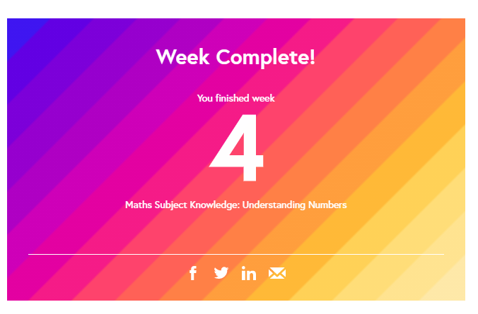

This piece of evidence is a screenshot taken from when I completed the four-week Futurelearn Maths course. This screenshot supports that I completed all four weeks of the course.

As maths is something I have particularly struggled with confidence wise during my placements and having received feedback on PTE2 that my confidence in teaching maths needed to be improved, I decided to further my own personal subject knowledge by completing a Futurelearn Maths course. Futurelearn states that this course looks at improving your subject knowledge of numbers as part of the maths curriculum. Although the maths on this course was not at a primary school level, it did in fact support me personally in my development and confidence of my own mathematical understanding. The course was a four-week course with each week having a different focus. Throughout the course it explored methods to help develop deeper understanding of mathematical concepts. I had access to video tutorials and examples of number problems; prompts to share answers and discuss the questions in comments; weekly practice questions to check understanding; and links to teaching resources. The first week of the course looked at the history of numbers, how they developed in different civilisations and we introduced a different number basis. In week two, we found patterns in the times tables. We discovered the visibility rules and delved into factors, multiples, and prime numbers. In week three, we worked with a range of different numbers, including negatives, sets and pi. We also explored the order in which you perform operations. In the final week, we looked at Fibonacci sequences, arithmetic and geometric sequences, square and triangle numbers, and we also found happy numbers and perfect numbers (Futurelearn, 2021).
As a result of completing this maths course, my confidence in understanding and teaching maths improved significantly on PTE3. I was able to confidently deliver maths lessons most days during PTE3, allowing me to continuously improve my understanding and teaching in this area. This course has been beneficial to my learning and understanding of maths.

Asset Two: Welsh language development

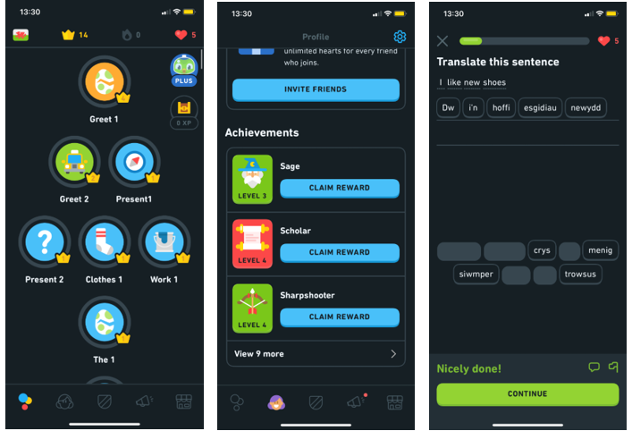

These are screenshots taken from the Duolingo app. The screenshots show how the app works to help develop a language. On this app, I chose to develop my Welsh language skills to support my development as a student-teacher. This app has supported my development and confidence in a variety of different topics.

Duolingo is a language learning platform and educational app. The app is free and accessible to use on different devices, such as a mobile phone and an iPad. You can choose which language you want to learn and for the purpose of my teaching degree, I chose to improve my Welsh language skills through this app.
There are different aspects of the Welsh language that you can learn on the app. For example, greetings, clothes, work, numbers, and animals. The app offers different levels like a game, so with each area you are learning (e.g., clothing) you can work your way up the levels of learning with each level getting more difficult. I have personally enjoyed this app and found it very beneficial in developing my Welsh language skills. It has allowed me to work on my Welsh language skills whenever it suits me as I am able to access the app whenever through my mobile phone device.
This app has allowed me to build my confidence in the Welsh language, both with understanding it and speaking it. The Duolingo languages app has been a great and enjoyable way to improve my Welsh language knowledge and development.

Asset Three: Subject Knowledge- Humanities

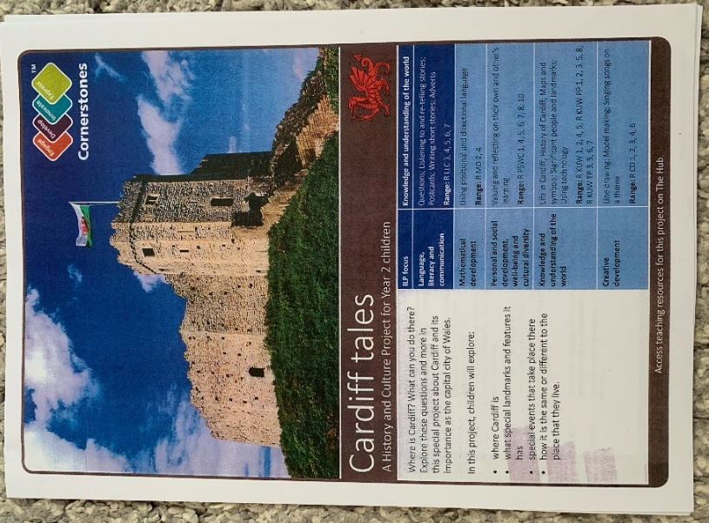
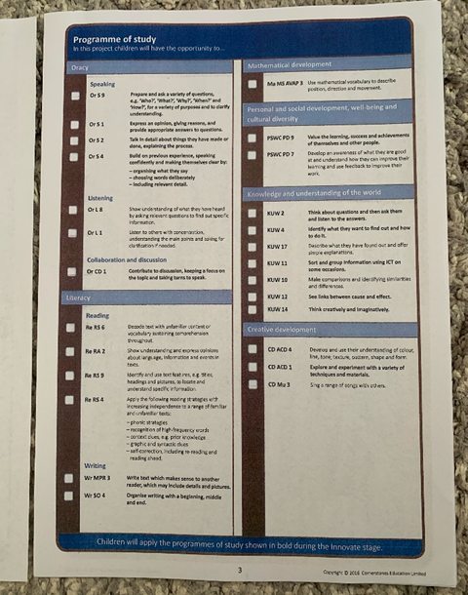
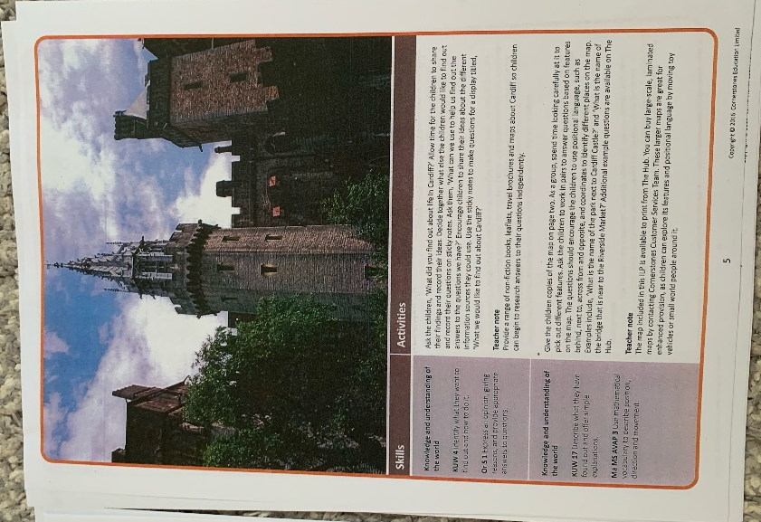
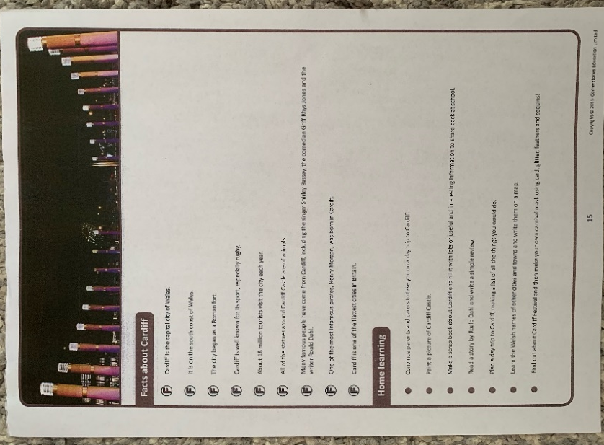

These images are examples of the Cardiff Tales book for my PTE3 school’s topic for the term. The booklet includes the Programme of Study as well as lesson ideas. This booklet helped me develop my knowledge and understanding of delivering lessons under the Humanities AoLE which met the topic of ‘Cardiff Tales.’

While on PTE3, my Year 2 class' topic for the term was 'Cardiff Tales.' My class mentor gave me a Cornerstones Cardiff Tales booklet which includes all information which covers the topic. The Cardiff Tales topic was a History and Culture Project for Year 2 children, allowing me to develop my knowledge and understanding of teaching the Area of Learning Experience (AoLE) of Humanities.
The topic allowed the children to explore where Cardiff is, what special landmarks and features it has, special events that take place there and how it is the same or different to the place that they live. The booklet supported my Subject Knowledge Development in the Humanities AoLE as it allowed me to see what type of lessons I could teach to meet the outcomes of the History and Culture Project. The booklet also includes a Programme of Study in line with the current curriculum. It highlights how the topic will develop the children's oracy, listening, reading, and writing skills under literacy. It also provides cross-curricular experiences as it develops the childrens mathematical development, personal and social development, well-being and cultural diversity, knowledge and understanding of the world and creative development. As you can see, this topic covers everything across the curriculum.
By having a range of ideas in the booklet on what to teach in this topic, it made planning and preparation for the Humanities lessons easier, as well as allowing me to include cross-curricular themes. It allowed me to develop my own personal understanding on Cardiff and its landmarks as well as how I could effectively plan and prepare to deliver sessions to cover the Cardiff Tales topic.

Reflection on Planning for Progression (Tab 7)
Professional Learning Experience Template 1: Weekly Phonics lessons in the POD
Pedagogy Standard: Advancing: Progression in Learning
What did you do and why?
This experience is based off of my delivery of phonics lessons on my first half of PTE3. These phonics lessons were completed by myself every Wednesday when I was in the school POD with eight Year 2 children teaching face-to-face.
This experience of delivering weekly phonics lessons in the POD links with the QTS Standard of Progression in learning as each week the children were looking at a different phonics sound, progressing through each one.
On the first week of my placement, I delivered a phonics lesson on the 'ar' sound. The children participated in a Bingo game of the different 'ar' words. The aim of this activity was to provide the children with a fun learning experience. The children really enjoyed this activity as they became competitive with wanting to be the winner. As the Bingo sheet included both the words and images for the words, it appropriately supported the lower ability children as they were able to make the link between the picture and the word.
On the second week of my placement, we looked at the phonics 'y' (ee) sound. For this, I decided to create another fun activity which included a board game of different 'y' words. I sat with the children and went through each word on the board game with them, ensuring that they were all able to identify the words and pronounce them correctly. This acted as good support for the lower ability children. I was also able to support the lower ability children throughout the game with helping them sound out the word they had landed on.
On the third week of my placement, we looked at the phonics 'ay' sound. For this, I modelled different 'ay' words on the whiteboard and drew pictures to go with them. The children had to complete a picture and sentences worksheet for this sound. The lower ability children had four boxes in which they had to draw pictures and then write sentences for each. The middle and higher ability children had six boxes in which they had to draw pictures and then write sentences for each. These children were encouraged to extend their sentences.
The series of phonics lessons demonstrates progression in learning as the children have continued looking at different sounds. This has supported their ability to develop in their understanding of different sounds in the English language.
What have you learned?
This experience is relevant to the QTS Standard of Progression in Learning as each week, I introduced a new phonics sound to the children. This allowed Progression in Learning as the children were developing their knowledge and understanding of the different sounds. The children were able to learn different words with the sound that they were learning. For example, they learnt a list of 'ay' words such as 'play' and 'playground.' They then were able to draw pictures to go with their chosen 'ay' words, as well as write sentences for each. This was great for their Progression in Learning as the children were able to think of sentences including the 'ay' word.
Within the new Curriculum for Wales (2022), there is a big emphasis on progression in learning. In Successful Futures (2015), it states that having Areas of Learning and Experience (AoLE's) from 3-16 should promote and underpin continuity and progression and help to make the structure easier to understand (Donaldson, 2015, p.39). This relates to my experience of delivering the phonics lessons as it follows the Progression Steps in the AoLE of Languages, Literacy and Communication. This activity met the What Matters Statement of 'Understanding languages is key to understanding the world around us.' The Progression Steps that I was working towards under this statement were Progression Step 1- 'I am beginning to develop my knowledge of grapheme-phoneme correspondence' and Progression Step 2- 'I can use grapheme-phoneme correspondence when reading.' The Progression Steps supports Progression in Learning and the activities I completed with the children as they were able to understand different grapheme-phoneme words as well as progressing to read them.
Through this experience, I have learned that it is important to provide Progression in Learning, following the Progression Steps highlighted in the new Curriculum for Wales 2022. This experience has also allowed me to develop my knowledge and understanding of providing learning experiences which meet Progression in Learning following the Progression Steps for learners. The series of phonics lessons show my ability to plan for Progress in Learning for all learners of different abilities within my class.
What next?
As a result of this experience, I understand how Progression in Learning relates to phonics. It is interesting to see how the children understand the different phonics sounds and words, with a handful of children knowing the alternative sounds and spellings too. Moving forward, phonics will be something I will be continuing planning and delivering in the second part of PTE3 after half-term. Each week we will continue to look at the different phonics sounds and spellings, looking at lists of words and putting them into sentences. By doing this, they will also be working on developing their writing skills, remembering to start all sentences with capital letters and end all sentences with full stops. The higher ability children will also be ensuring that they extend their sentences using connectives and adjectives.
I will also be personally looking at developing my confidence of teaching a phonics session to the whole class as I have only had the opportunity to teach the eight POD children so far. It will be a great experience to get to know the rest of the class and see how I manage the different levels of abilities within the whole class.
For additional information, please see Appendix 1.

Professional Learning Experience Template 2: Year 2 Poetry
Pedagogy Standard: Advancing: Progression in Learning
What did you do and why?
As part of the Language Scheme of Work for Year 2, whilst on PTE3 I decided to plan a series of poetry lessons to teach the children. I researched different types of poetry, e.g., acrostic, rhyming and shape. After reading around each type of poetry, I decided that I would plan my series of lessons based on shape poems. Shape poems are poems that I had not come across before and so they interested me. Shape poetry is a form of visual poetry where the text is arranged into a specific shape, making it perfect for creative writing activities. I looked into the features of a shape poem and decided to go from there when planning my series of lessons.
I planned a series of 5 poetry lessons which were completed over 3 days one week and 2 days the following week. Firstly, I introduced shape poetry using an interactive PowerPoint on the IWB. As a class, we discussed what a shape poem is and the features of a shape poem. The first lesson involved the children having to text-mark a shape poem. The shape poem was about an ice-cream. They had to highlight the similes and alliteration in the poem.
The second lesson involved looking closer at similes. The children were given prompts to write a list of similes. For example, 'I am as fast as ......'
The third lesson involved looking closer at alliteration. As a class we discussed alliteration and looked at some examples. The children then had to complete 'Awesome Alphabet Alliteration' where they had to think of some alliteration for each letter of the alphabet.
The fourth lesson involved making a 'Shape Poem Plan.' Our shape poem was based on Castell Coch to tie in with the term's topic of 'Cardiff Tales.' As a class we came up with some adjectives, similes, and alliteration to describe Castell Coch. The children then wrote the plan into their books, using a lot of their own ideas.
The fifth and final lesson involved writing the Shape Poem as a class. I had the children open their writing books to their plan from the previous day and the children all shared their ideas. As a class we voted on certain ideas and wrote them all into a poem. The children then copied the class poem into their castle shapes which I then stuck into their writing books.
What have you learned?
In relation to meeting this QTS Standard, I have learned that it is important to appropriately plan for progression in learning. I could not have introduced shape poetry to the class and had them write one the same day as it would not have been to the standard that it was at the end of the series of lessons. By having the series of lessons, each focusing on different features of a shape poem, it allowed the children a greater understanding. It allowed the children to develop their knowledge and understanding of using adjectives as well as introducing them to similes and alliteration, something of which they were not so familiar with. I particularly found the series of poetry lessons to be appropriate for the intended outcome which was to write a shape poem on Castell Coch. It meant that I knew the outcome and how to get the children to achieve it. I knew I needed to break it down for them and teach each element in its own lesson to allow them to build a sound knowledge and understanding of poetry, specifically shape poetry.
The Successful Futures (2015) document discusses the importance of progression in the new Curriculum for Wales (2022). The structure of the new Curriculum for Wales (2022) should 'promote progression in children and young people's learning' (Donaldson, 2015, p.35). This links with my series of poetry lessons as I ensured that the children had a series of lessons, with different focuses, to support their Progression in Learning of shape poetry.
What next?
As a result of this experience, I will ensure that all future lessons are planned with ‘progression in learning’ in mind, as this will help ensure that pupils are developing previous and new knowledge and skills. I felt the progression in learning was suitable for the focus of poetry. I researched around different types of poetry to ensure I had a sound knowledge and understanding on what it was that I wanted to teach and how I was going to teach it. I was able to appropriately plan for progression in poetry by teaching the different features of shape poetry. My planning and delivery of the series of poetry lessons were successful and this was agreed by my class mentor. She explained that she had not taught shape poetry before and that I have given her some ideas for her own teaching going forward.
For additional information, please see Appendix 2.

Reflection on Planning for the Four Purposes (Tab 7)
Professional Learning Experience Template 1: Kindness Tree lesson on Feel Good Friday
Pedagogy Standard: Advancing: Four Purposes for learners
What did you do and why?
During a well-being session on Feel Good Friday, I planned and delivered a lesson where the children were able to discuss what it means to be kind, how we can be kind to somebody and how we feel when somebody is kind to us. This promoted one of the Four Purposes of 'healthy, confident individuals' as the children were able to reflect on kindness and how being kind makes them feel. The main activity involved the children having to think of different acts of kindness and write them on a leaf which I had cut out and prepared for each child. They were able to think of a range of different acts of kindness following our discussion during the introduction. For example, the children discussed sharing with each other, tucking a chair in for a friend and many more. The children were keen to give me different ideas and they were able to use their neat handwriting when writing on their leaves. The leaves that each child had written on were then glued onto our class 'Kindness Tree' that I had created beforehand.
The main aim of this kindness session was to get the children to think of acts of kindness for our kindness tree. The purpose of the kindness tree was for it to be displayed on the wall outside the classroom. This meant that the children were able to see the random acts of kindness each day when entering the classroom. The children were informed that they should aim to complete one random act of kindness each day from the Kindness Tree display, and they would then be rewarded dojo's for doing so. This was successful and it was very fulfilling to see the children thrive off completing different acts of kindness from the Kindness Tree display, especially as it promoted one of the Four Purposes for learners of ‘healthy, confident individuals.’
What have you learned?
The Kindness Tree lesson allowed an opportunity to develop one of the four purposes for learners through the AoLE of Health and Well-being. The Kindness Tree lesson was a great way to encourage healthy, confident individuals as the children were focusing on what it meant to be kind and how they can be kind. Kindness promotes positive mental health as being kind to people makes you feel better yourself. Acts of kindness can also boost feelings of confidence and happiness too. By completing acts of kindness, it can encourage others to do the same too which can contribute to a more positive class community. This was clearly evident following this activity when the children would choose an act of kindness to complete each day. This experience was important for the children in order to ensure that they grow into healthy, confident individuals who are ready to lead fulfilling lives as valued members of society. This experience was also particularly important as the new Curriculum for Wales 2022 places a big emphasis on the importance of planning lessons which promote the Four Purposes for learners.
What next?
I would personally like to deliver a similar lesson again where the children think of acts of kindness for a Kindness Tree as I felt it was a great way to get the children to focus on being kind, as well as promoting ‘healthy, confident individuals’ in my learners. By having the Kindness Tree displayed outside of the class, it meant that the children were able to see it as they entered the classroom each day. By also encouraging the children to complete an act of kindness each day from the Kindness Tree display, with the reward of dojo's, it further promoted their health and well-being, as well as being healthy, confident individuals. I would also like to further develop my knowledge and understanding of the importance of the health and well-being AoLE and how I can support pupil progress and development in this area.
For additional information, please see Appendix 3.

Professional Learning Experience Template 2: Welsh Carousel of activities
Pedagogy Standard: Advancing: Four Purposes for learners
What did you do and why?
Over a series of weeks, I delivered Welsh sessions on a Friday. This involved a carousel of activities which the children would undertake in their ability groups. The topic focus was 'Y Tywydd' (the weather). The rotation activities included a focus group writing activity with myself; a stomp game with the TA which worked on developing their oracy; a reading activity in the reading corner where they used both books and iPads for scanning QR codes; and a writing activity where they created Y Tywydd posters.
I planned effectively for this Welsh carousel with my class mentor, ensuring that reading, writing, and oracy were focuses of the activities. The activities promoted one of the Four Purposes for learners of 'ambitious, capable learners' as the aims were to develop the children’s confidence in the Welsh language, allowing them to communicate effectively in different forms and settings. The activities allowed the children to build up a body of knowledge and have the skills to connect and apply that knowledge in different contexts. The activities planned also gave the children a sense of independence and a responsibility for their own learning.
What have you learned?
I have learned that it is important to ensure that lessons and activities are planned around the four purposes for learners as these four purposes are held at the heart of the Curriculum for Wales 2022. It is important that these four purposes are integrated within lessons to ensure that children are developing these purposes. The activities helped support the development of ‘ambitious, capable learners’ as the children were able to improve on their confidence and independence in the use of the Welsh language. It is also important to provide children with the opportunities to develop as ambitious, capable learners.
What next?
As a result of this experience, I will ensure that all future lessons are planned with at least one of the ‘four purposes for learners’ in mind as these play a key role in the development of children and young people in the new Curriculum for Wales 2022. I believe that by implementing the promotion of one or more of the four purposes for learners in my planning and teaching during placement, it has had a real benefit on all children within my class. I also believe that I have personally been able to develop my own knowledge and understanding on how best I can plan and prepare for promoting the four purposes within my lessons. Going forward, I will ensure that when I am promoting the four purpose of ‘ambitious, capable learners,’ I plan effectively to allow all children to become equipped and ready to learn throughout their lives.
For additional information, please see Appendix 4.

Part Two
Introduction
The Area of Health and well-being was chosen to be further studied and explored for this assignment as during my final Professional Teaching Experience (PTE3), I came to realise the importance of promoting positive mental well-being through the school’s whole-school approach of ‘Feel Good Friday.’ Throughout PTE3 I had many opportunities to plan and deliver health and well-being focused lessons, including a gratitude jar; yoga; and a kindness tree. These lessons promoted the Area of Learning and Experience (AoLE) of Health and Well-being under the new Curriculum for Wales (2022). This also links in with targets from the Professional Learning Passport (PLP) which includes the Qualified Teacher Status (QTS) Standards of Pedagogy: Influencing: Learning outcomes and well-being and Pedagogy: Advancing: Four purposes for learners. Implementing health and well-being lessons in schools further supports pupils to become ‘healthy, confident individuals’ which is one of the four core purposes of the Curriculum for Wales (2022) as outlined by Graham Donaldson in ‘Successful futures’ (Donaldson, 2015). Through this assignment, I will critically reflect on a whole-school approach to health and well-being and aim to further develop my knowledge and understanding in a specific area which I have identified for professional development. By further developing my understanding of how to promote health and well-being in primary schools, it shows a willingness to actively participate in necessary research to enable myself to become an outstanding trainee teacher (Grigg, 2010).
Critical Discussion of Chosen Aspect
Mental health is said to affect many children and young people across the United Kingdom with 1 in 8 children having a mental health disorder, meaning that roughly three children in every classroom is suffering with poor mental health (New Figures Show A Rise In Young People's Mental Health Problems Since 2004, 2021). The new Curriculum for Wales (2022) has set out the implementation of Health and Well-being as one of the Six Areas of Learning and Experience to ensure the fostering of positive health and well-being in children and young people across Wales. The Draft Statutory Guidance for Health and Well-being in the new Curriculum for Wales (2022) highlights that the proposed purpose of the AoLE is about the “physical, psychological, emotional and social aspects of our lives” (Draft Curriculum for Wales (2022), 2019 p.3). Promoting the Health and Well-being AoLE within schools across Wales can support pupils understanding and allow them to acknowledge that having both good health and well-being will act as a positive aid in facilitating successful learning (Draft Curriculum for Wales, 2022).
The Health and Well-being AoLE states that by engaging in this specific Area of the new Curriculum for Wales (2022) it can help to encourage a whole-school approach that “enables health and well-being to permeate all aspects of school life” (Draft Curriculum for Wales 2022). A whole-school approach to health and well-being involves full commitment from all areas of the school, including senior leaders, teachers, and school staff, ensuring that everyone is working together in partnership (Whole-school approach: Mentally Healthy Schools, 2021). Estyn’s Healthy and Happy (2019) report shows that there is already around two-thirds of primary schools in Wales who have implemented an all-encompassing whole-school approach to underpin the importance of pupils’ health and well-being within schools (Estyn, 2019).
Through the implementation of a whole-school approach to health and well-being, there are a number of strategies that can support the approach. An example of this is from Estyn (2017) which looked at how one particular school has adopted a whole-school approach to well-being. The school implemented activities to promote children’s health and well-being, including happiness jars; mood boards; and mindfulness. These activities have been said to have a positive impact on the school’s learners as it has allowed them to contribute to their emotional, social, and academic development (Estyn, 2017).
As laid out in the PSHE Association’s Teacher Guidance (2019), all pupils should appreciate that “mental wellbeing is a normal part of daily life, in the same way as physical health” by the time they reach the end of primary school (PSHE Association, 2019 p.16). It is important to recognise that by making conversations about mental health a normal aspect of everyday school life within the classroom (Anna Freud, 2021), it can support the importance of getting children to view talking about mental well-being as common practice. For instance, having pupils complete daily emotional check-ins as they arrive in the classroom, can promote their emotional literacy. Emotional literacy is defined as having the ability to recognise and talk about your own feelings, as well as recognising the feelings of others around you (Steiner, 2003).
The Partnership for Well-being and Mental Health in Schools (2015) advises on two areas to focus on promoting health and well-being in schools. The first being how schools can promote both social and emotional learning, and the second being how schools can provide suitable support for individuals who may suffer from more serious mental health difficulties (Weare, 2015). The school-based, whole-school approach of The Thrive Approach involves a distinct way of working with children to ensure that there is support for their healthy social and emotional development (Thrive 2019). The approach uses evidence from Bowlby’s theory of attachment (Bowlby,1969) to support their aim of building relationships based upon trust between adults and children. The Thrive Approach states that “emotionally resilient children will engage with learning” (Implementing Thrive, 2021) which supports the purpose and aims of the approach itself. The Thrive Approach has been proved to be beneficial to meeting the needs of children’s overall well-being as it helps to boost resilience in young people (Hart and Heaver, 2015). Resilience has been defined as having the ability to be exposed to a level of threat or adversity and respond through positive adaptation to that said threat (Luthar et al, 2000). Despite this, it is thought that there are some key issues with the implementation of The Thrive Approach within educational settings. As it is identified as a whole-school approach, it requires a lot of commitment from all stakeholders involved to embed the approach for it to be successful (Hart and Heaver, 2015). Furthermore, the Thrive Approach also requires training to be undertaken by staff within the schools to ensure that everyone is unified in their implementation of this approach, which can prove to be quite costly for some schools.
Research shows that children who have “higher levels of emotional, behavioural, social and school well-being, on average, have higher levels of academic achievement and are more engaged in school, both concurrently and in later years” (Gutman and Vorhaus, 2012 p.3). Without a doubt, the relationship between education and health is an important one (Zimmerman and Woolf, 2014) which needs to be considered when teaching and supporting the elements of health and well-being. A whole-school approach to health and well-being can be of benefit to support pupils’ development in this AoLE. Implementing a whole-school approach has been said to have significant impacts, in line with three of the Welsh Government’s Seven Wellbeing goals (Wellbeing of Future Generations (Wales) Act, 2015). These include ‘a resilient Wales; a healthier Wales; and a more equal Wales’ (Welsh Government, 2021, p.8).
A benefit of a whole-school approach is the impact it can have on academic learning, including improved motivation, engagement, and commitment to learning (Whole School Approach to Positive Mental Health and Wellbeing, 2021). This can support Carol Dweck’s Growth Mindset Theory (2006) where children believe that their intelligence can be developed through hard work and effort. Additionally, a whole-school approach can also be considered as a beneficial way to promote health and well-being as it requires support from all stakeholders, including staff, governors, and parents. This can be understood through Bronfenbrenner’s The Five Ecological Systems (1977) which depicts how the environment of the child is arranged in different structures, all of which can have an influence on the child. The Mesosystem focuses attention on the importance of positive relationships between a child’s parents and teachers in order to positively influence the child’s development (Bronfenbrenner, 1977).
However, according to the Framework on embedding a whole-school approach to emotional and mental well-being (2021), a whole-school approach to health and well-being can only become successful if staff well-being is also considered, as poor staff well-being can have an adverse impact on learner’s well-being (Welsh Government, 2021, p.37). This could potentially act as a limitation to a whole-school approach if schools are not well equipped to provide appropriate measures to promote staff well-being along with pupil well-being.
Furthermore, implementing a whole-school approach to health and well-being is recommended as something that should be done as a staged process as opposed to trying to achieve everything at once (Demkowicz and Humphrey, 2019). It is important to note how the new Curriculum for Wales (2022) places a significant emphasis on the importance of progression in children and young people’s learning throughout the curriculum as developed by Graham Donaldson in ‘Successful Futures’ (Donaldson, 2015). As progression is viewed as a vital aspect of the new Curriculum for Wales (2022), it is important that schools share an understanding on the expectations of progression, including how it may look for each individual learner (Hwb, 2021). For instance, by using a whole-school approach to promoting health and well-being, it can ensure that all school staff have the same understanding and expectations of progression in this AoLE, resulting in positive impacts on the learners throughout the school.
Subsequently, an effective whole-school approach to health and well-being should be one in which there is a plan in place for how improving the health and well-being of pupils is going to take place, rather than trying to aim for a ‘quick fix’ like the Piecemeal Approach to health and well-being (Worth-it, 2021). For this reason, planning an appropriate whole-school approach to health and well-being in schools could be done through a ‘Four Stage Approach’ as proposed by Stirling and Emery (2016). This approach involves looking at what a school already has in place to support health and well-being, then understanding the significance of a shared commitment to the development of health and well-being in the school. The focus should then be on building relationships within the approach and developing strategies to support health and well-being, resulting in how it is going to be implemented and how the process can be evaluated throughout (Stirling and Emery, 2016).
Conclusion
A whole-school approach has been found to be a beneficial way of meeting the requirements of the Health and Well-being AoLE which is supported by the Welsh Government (Wales: Mentally Healthy Schools, 2021). The evidence in this assignment has shown that the Health and Well-being AoLE of the new Curriculum for Wales (2022) is a positive step forward in the promotion and development of children and young people’s mental health in Wales. Promoting the Health and Well-being AoLE has also been found to support the four purposes for learners as these are held at the heart of the new Curriculum for Wales (2022). Implementing activities in my future teaching such as happiness jars and mindfulness (Estyn, 2017) can ensure the promotion of all aspects of the four purposes for learners, especially the importance of promoting ‘healthy, confident individuals’ (Donaldson, 2015).
It must be understood that each individual’s path in life varies, meaning that there will be both positive and negative outcomes during each phase of childhood. And so, we must ensure that children who are suffering poor mental health due to negative experiences, are offered the correct support to ensure that these issues can be dealt with to prevent further issues later on in life (Erikson, 1959). Therefore, based upon the findings, one method that I will engage with in future teaching will be that of a daily emotional check-in. This method will allow me to recognise any child who may be suffering with poor mental health, to ensure that any further interventions can be put in place to support the child.
In line with my research findings, I will ensure that mental health and well-being is viewed as a normal part of daily life (PSHE Association, 2019), where children within my class feel comfortable and confident to discuss any issues and worries, they may have. Not only will this ensure that I meet the outcomes of the Health and Well-being AoLE of the new Curriculum for Wales (2022) but will also have a positive impact on my learners and their learning outcomes.

Reference List
Annafreud.org. (2021) Talking Mental Health Information Sheet for School Staff. Anna Freud National Centre for Children and Families. [online] Available at: Talking mental health | Metal health toolkit for teachers | Starting conversations about mental health | Anna Freud Centre [Accessed 27 April 2021]
Bowlby, J. (1969) Attachment and loss: Vol. 1. Attachment. London, England.
Bronfenbrenner, U. (1977) Toward an experimental ecology of human development. American Psychologist.
Demkowicz, O. & Humphrey, N. (2019) Whole school approaches to promoting mental health: what does the evidence say? London: EBPU. [online] Available at: evidencebriefing5_v1d7_completed_24.10.pdf (ucl.ac.uk) [Accessed 27 April 2021]
Donaldson, G. (2015) Successful Futures: Independent review of curriculum and assessment arrangements in Wales, Welsh Government. Available at: successful-futures.pdf (gov.wales) [Accessed 15 April 2021]
Dweck, C. S. (2006) Mindset/ The New Psychology of Success. Random House.
Erikson, E. H. (1959) Identity and the life cycle; Selected papers, with a historical introduction by David Rapaport. New York: International University Press.
Estyn. (2017) A preventative approach to support wellbeing. [online] Available at: A preventative approach to support wellbeing | Estyn (gov.wales) [Accessed 28 April 2021]
Estyn.gov.wales. (2019) Healthy and Happy: School impact on pupils’ health and wellbeing. [online] Available at: Healthy%20and%20Happy%20report%20En_0.pdf (gov.wales) [Accessed 20 April 2021]
Futuregenerations.wales. (2021) Well-being of Future Generations (Wales) Act 2015- The Future Generations Commissioner for Wales. [online] Available at: Well-being of Future Generations (Wales) Act 2015 – The Future Generations Commissioner for Wales [Accessed 28 April 2021]
Grigg, R. (2010) Becoming an Outstanding Primary School Teacher, Pearson Education Limited.
Gutman, L & Vorhaus, J. (2012) The Impact of Pupil Behaviour and Wellbeing on Educational Outcomes. London: Department for Education. Available at: The Relationship between Children’s Wellbeing and their Educational Outcomes (basw.co.uk) [Accessed 20 April 2021]
Hart, A. & Heaver, B. (2015) Resilience Approaches to Supporting Young People’s Mental Health: Appraising the Evidence Base for Schools and Communities. Brighton; University of Brighton/BoingBoing. [online] Available at: bb-guide-to-school-community-resilience-programmes-2015a.pdf (boingboing.org.uk) [Accessed 20 April 2021]
Hwb.gov.wales. (2021) Developing a vision for curriculum design. Hwb. [online] Available at: Developing a vision for curriculum design - Hwb (gov.wales) [Accessed 28 April 2021]
Hwb.gov.wales. (2021) Supporting learner progression: assessment guidance. Hwb. [online] Available at: Supporting learner progression assessment guidance - Hwb (gov.wales) [Accessed 27 April 2021]
Implementingthrive.org. (2021) [online] Available at: Education - The Thrive Approach [Accessed 20 April 2021]
Luthar, S. S., Cicchetti, D. & Becker, B. (2000) The construct of resilience: A critical evaluation and guidelines for future work. Child Development.
Mentallyhealthyschools.org.uk. (2021) Whole-school approach: Mentally healthy schools. [online] Available at: Whole-school approach : Mentally Healthy Schools [Accessed 20 April 2021]
PSHE Association. (2019) Teacher guidance: teaching about mental health and emotional wellbeing. [online] Available at: Mental Health guidance online version (Updated July 2019).pdf (pshe-association.org.uk) [Accessed 27 April 2021]
Steiner, C. (2003) Emotional Literacy; Intelligence with a Heart. [online] Dgek.de. Available at: Steiner - Emotional Literacy; Intelligence with a Heart (dgek.de) [Accessed 28 April 2021]
Stirling, S. & Emery, H. (2016) A whole school framework for emotional well being and mental health: A self-assessment and improvement tool for school leaders. Partnership for Well-being and Mental Health in Schools. National Children’s Bureau, London. [online] Available at: NCB-School-Well-Being-Framework-Leaders-Tool-FINAL.pdf (norfolkepss.org.uk) [Accessed 27 April 2021]
Thrive. (2019) Introducing the Thrive Approach. [online] Available at: Thrive-Approach-Brochure.pdf (implementingthrive.org) [Accessed 20 April 2021]
Weare, Katherine. (2015) What works in promoting social and emotional well-being and responding to mental health problems in schools? Partnership for Well-being and Mental Health in Schools. [online] Ncb.org.uk. Available at: ncb_framework_for_promoting_well-being_and_responding_to_mental_health_in_schools_0.pdf [Accessed 28 April 2021]
Welsh Government. (2019) Draft Statutory Guidance Area of Learning and Experience Health and Well-being, Hwb. [online] Available at: 35002 Curriculum for Wales: Health and Well-being English [Accessed 15 April 2021]
Welsh Government. (2020) Area of Learning and Experience Health and Well-being, Hwb. [online] Available at: Health and Well-being: Introduction - Hwb (gov.wales) [Accessed 15 April 2021]
Welsh Government. (2021) Framework on embedding a whole-school approach to emotional and mental well-being. Education Wales, Welsh Government: Cardiff. [online] Available at: WG42005 (gov.wales) [Accessed 21 April 2021]
Welsh Government. (2021) Whole-school approach to mental health and wellbeing framework guidance: impact assessment. [online] Available at: Whole-school approach to mental health and wellbeing framework guidance: impact assessment | GOV.WALES [Accessed 28 April 2021]
Worthit.org. Wellbeing and Resilience. Whole School System for Positive Mental Health and Wellbeing. [online] Available at: Whole School Approach to Positive Mental Health & Wellbeing - Our Model (worthit.org.uk) [Accessed 21 April 2021]
YoungMinds. (2021) New Figures Show A Rise In Young People’s Mental Health Problems since 2004. [online] Available at: New Figures Show A Rise In Young People's Mental Health Problems Since 2004 (youngminds.org.uk) [Accessed 15 April 2021]
Zimmerman, E. & Woolf, S. (2014) Understanding the Relationship Between Education and Health. National Academy of Sciences. [online] Available at: Final BPH-UnderstandingTheRelationship (1).pdf [Accessed 21 April 2021]

Appendix 1
Reflection on Planning for Progression (Tab 7)

Template 1: Weekly Phonics sessions in the POD
To see assets linked to the Weekly Phonics sessions in the POD, please see the PLP link: https://v3.pebblepad.co.uk/spa/#/public/kwhG4Zqt9yWkgk6wR3xkHy5pww
Appendix 2
Reflection on Planning for Progression (Tab 7)

Template 2: Year 2 Poetry
To see assets linked to Year 2 Poetry, please see the PLP link: https://v3.pebblepad.co.uk/spa/#/public/kwhG4Zqt9yWkgk6wR3xkHy5pww
Appendix 3
Reflection on Planning for the Four Purposes (Tab 7)

Template 1: Kindness tree lesson on Feel Good Friday
To see assets linked to Kindness tree lesson on Feel Good Friday, please see the PLP link: https://v3.pebblepad.co.uk/spa/#/public/kwhG4Zqt9yWkg5r4qbZmbkwxpw

Appendix 4
Reflection on Planning for the Four Purposes (Tab 7)

Template 2: Welsh Carousel of activities
To see assets linked to Welsh Carousel of activities, please see the PLP link: https://v3.pebblepad.co.uk/spa/#/public/kwhG4Zqt9yWkgGtwW43bssMwnc

