What do we mean by criticality? (15-03-24)

- Delivering Critical Analysis

The literature review of a dissertation should include critical analysis. You cannot simply juxtapose the literature you find. You have to evaluate and draw conclusions from it.

In other words simply listing authors and theories is not good enough.

DO NOT CONFUSE

Please note that Critical Management Studies is a subdivision of Management studies that looks at problems in a holistic critical way. It is often based on sociology theory, philosophy, post modernism and cultural studies.

Rather than simply looking at a problem and direct solutions, CMS critics will look at the “problem” in the context of the system that surrounds it.

In other words if we tried to look at solutions to the ethical problem of trust or ethical marketing, we need to evaluate the capitalist system which often rewards unethical behaviours and is not fully regulated, which will impact on the agents we are studying and the solutions we might try to offer.

https://cms.aom.org/home#:~:text=Critical%20Management%20Studies%20is%20characterised,of%20prevailing%20forms%20of%20organization.

Being critical in your literature review does not mean you have to adopt this approach. However it is good to know that this option is available and is often an effective way to criticise systems.

At the Paragraph level
Try expressing your voice in each paragraph of your literature review. Write strong paragraphs. In strong paragraphs your voice can be heard in the topic sentence, development (where you analyse and compare/contrast the sources, sometimes as individual pieces, sometimes in a synthesis) and, even more easily, in the concluding sentence, where you present the "therefore" of the paragraph.
“Therefore it may be seen/concluded/etc……..”
Note your voice must not take over in the sense of being a political or personal reflection without evidence or simply relaying your opinions.
All arguments must be backed by good references (using refereed journal articles). See the CRAAP guide below.
However we know in the modern era there are troubles even with academic papers. See the discussions and scandals of the “Paper Mills”.
What are Paper Mills? MDPI (2022) https://blog.mdpi.com/2022/05/09/paper-mills/
Research Avenue (2024) “Help”https://researchavenue.co.uk/publication?gad_source=1&gclid=CjwKCAjwkuqvBhAQEiwA65XxQHsvmrC-a4jFB7E4Na0F5yLDVlz-UucnMOoiMHDZcEEEP9yorWQ3IxoCr_sQAvD_BwE
It gives “help” in writing papers. WARNING! WARNING!#
A more academic view.
https://www.science.org/content/article/fake-scientific-papers-are-alarmingly-common

There also some scandals in corrupt articles/research and academic falsifying papers.
Academic research papers withdrawn.
Retraction Watch (2024) https://retractionwatch.com/

Nature (2023) More than 10,000 research papers were retracted in 2023 — a new record https://www.nature.com/articles/d41586-023-03974-8

BBC (2024) ‘The situation has become appalling’: fake scientific papers push research credibility to crisis point. https://www.theguardian.com/science/2024/feb/03/the-situation-has-become-appalling-fake-scientific-papers-push-research-credibility-to-crisis-point

Predatory Publishing- pay for publishing, where the refereeing might be suspect.
There has always been some cost for academics or their universities to journals for publishing and conference attendance. However this is more serious and may indicate that many papers published are rubbish so long as the journal fee is paid.

Cambridge University (ND) What do we mean by the term 'predatory publisher'?

https://osc.cam.ac.uk/about-scholarly-communication/author-tools/considerations-when-choosing-journal/predatory-publishers#:~:text=There%20is%20no%20one%20standard,as%20peer%20review%20and%20editing

IOWA State University (2016) Understanding Predatory Publishing. https://instr.iastate.libguides.com/predatory

Susan A. Elmore, S.A. & Eleanor H. Weston, E.H. (2020) Predatory Journals: What They Are and How to Avoid Them. https://www.ncbi.nlm.nih.gov/pmc/articles/PMC7237319/

Table 2.
Helpful Tips to Determine if a Journal or Publisher is Predatory
- Are there spelling or grammatical mistakes or other questionable characteristics on their website or in the solicitation email?
- Is the peer review process clearly stated on the website?¹⁷
- Does the website clearly state the publishing fees?¹⁸
- Is the journal indexed in databases that you use,¹⁸ such as MEDLINE¹⁹ for biomedical journals?
  - Note: not all journals with articles in PubMed are indexed for MEDLINE.²⁰ To check if a journal is indexed for MEDLINE, check the journal’s page in the NLM Catalog—you can do this by following the link for journal in the article’s record in PubMed. If the NLM Catalog listing says the journal is “Currently indexed for MEDLINE,” this means that all articles published in this journal will appear in PubMed.
- Can you easily contact the publisher?¹⁸
- Are the time-stamps of incoming emails consistent with the working hours of the reported country of origin?
- Does the phone number have the correct country code?
- Is the journal a member of the Committee on Publication and Ethics (COPE)²¹ or Open Access Scholarly Publishers Association (OASPA),²² or listed in the Directory of Open Access Journals (DOAJ)?²³

Nevertheless journal papers are the best source.
Your skill will be in evaluating, analysing them and synthesising to your own research needs. The literature review starts the process. See past memos on the Rationale for the Literature review.

How to express criticality at the paragraph level:
- Identify the significance of the sources, and why the points they are making are relevant.
- Make connections between the sources.
- Compare and contrast sources, literatures.
- Accept/adopt points made by the sources, with reasons.
- Reject the points made by the sources, with reasons (e.g., limitations in the methodology; out of date; limited scope; geographical delimitation).
- Indicate the position you are taking in your own work on the theories and concepts presented by the sources.
- Show how limitations in the existing literature create a research gap for you.
- Organise the materials, synthesising them in an original way, that sheds new light on the topic.

At the Literature Review level.
Try to take ownership of the literature review. Remember the purposes of the review (providing background on the subject you are researching and identifying a gap in the existing literature on this subject). Thus, throughout the review:
- Identify the key themes relevant to your subject matter.
- Identify the most logical and effective order for your themes.
- Relate the sources back to the dissertation's research question.
- Shed new light on the topic.
- Draw conclusions on the existing literature.
- Identify gaps in the literature.
Your literature review should present an argument (which you can recap in the concluding paragraph of the literature review). For instance,
"The literature says/illustrates/reveals that... there are debates in the literature as of... it can be understood from the literature that... however, there are gaps in the literature... the literature does not specifically address (specific sector/location/population)... there is a lack of independent/recent studies on... therefore in order to answer the research question(s) (you can repeat the question) this dissertation uses method xyz, as illustrated in the next section (if applicable)".
Manchester University’s academic phrase bank is a great resource for learning new words and phrases.
Hopefully we will follow this section when analysing Zineldin (2000)

Being critical
As an academic writer, you are expected to be critical of the sources that you use. This essentially means questioning what you read and not necessarily agreeing with it just because the information has been published. Being critical can also mean looking for reasons why we should not just accept something as being correct or true. This can require you to identify problems with a writer’s arguments or methods, or perhaps to refer to other people’s criticisms of these. Constructive criticism goes beyond this by suggesting ways in which a piece of research or writing could be improved.
… being against is not enough. We also need to develop habits of constructive thinking.
Edward de Bono

- Highlighting inadequacies of previous studies
- Identifying a weakness in a single study or paper
- Offering constructive suggestions
- Introducing problems and limitations: theory or argument
- Introducing problems and limitations: method or practice
- Using evaluative adjectives to comment on research
- Introducing general criticism
- Introducing the critical stance of particular writers

2. Evaluating the Quality of Studies
Assess the quality of studies
CRAAP test
Think of how CRAAP the text you are reading is!
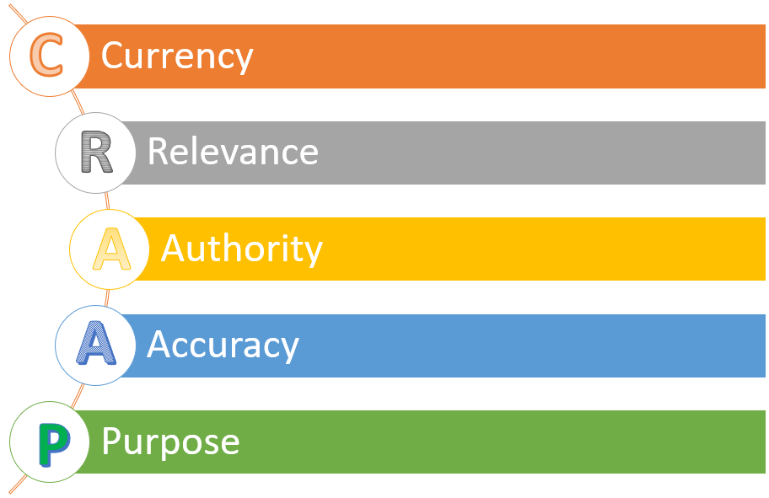
CRAAP = Currency, Relevance, Authority, Accuracy, Purpose
Currency
How recent/old is your source? In certain fields it is very important that the sources are as recent as possible. In others, like history, a source or document from the past may be more valuable.
Relevance
Is the text relevant to your dissertation? Does it help fill some section and answer your research question?
Authority
Who is the source of the information? Where was it published? Was it peer-reviewed?
Accuracy
What evidence is the source relying on? Is the evidence up to date? Is the evidence correctly interpreted? Is the argument made in the source logical? Is the methodology sound?
Purpose
What's the purpose of the source? Is there an agenda? If it's a company report, it may try to portray the company in a positive light. If it's a government report, it may try to defend government policies.
Triple perspective
In order to better evaluate a piece of work, you need to compare it with other sources dealing with the same topic(s). This is a main function of the literature review. Try to adopt a triple perspective:
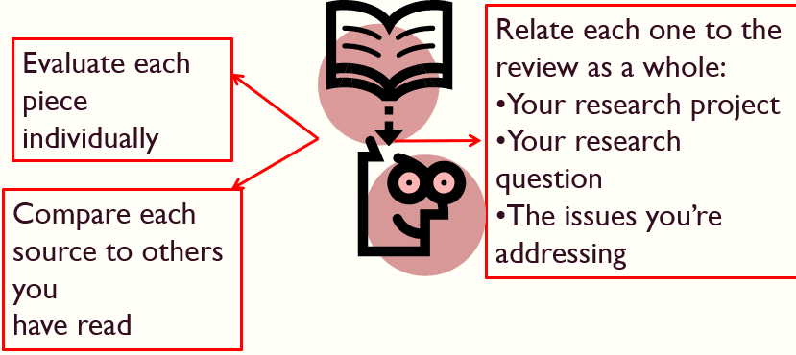
For more information on the triple perspective and critical reading visit the Critical Reading Guide.

- Critical Reading
To apply critical thinking when you read, try doing the following:
- Read the text carefully, asking questions.
- Check the evidence used in the text, especially if the source is not peer-reviewed.
- Compare with other sources dealing with the same topic.
- Evaluate and draw your own conclusions.

a) Read Carefully and Question the Text

When you read critically you need to question and engage with the text. This takes time and requires deep reading. (You may firstly undertake an initial skimming/scanning of the text to check that it is useful before launching into critical reading).
In order to evaluate the source you are reading, you can ask the following questions:
- Is it an academic source? Who are the authors? Are they authoritative? Could they be biased, and/or have an agenda?
- What is the argument / conclusion / message / opinion of the source?
- What is the evidence? Is it up to date? Are the methods appropriate? (See also the box below)
- Does the evidence support the argument? Is the text logical?
- Is there anything missing/omitted? Something else that should have been considered?

"analysing the results" by Paul Keller is licensed under CC BY 2.0

b) Check the Evidence
What is the evidence used by the source you are using? Facts, data, primary sources, other secondary sources?
Check if the evidence is:
- credible
- up to date
- complete (as opposed to omitting/neglecting/overlooking anything)
- accurate
- reported correctly (or has the evidence been interpreted, manipulated, or taken out of context)
- using appropriate methods
Remember that even quantitative evidence can be misleading. Statistics can be abused, presenting a partial perspective to bolster weak arguments.
This notion underlies the popular quip (attributed by Mark Twain to Benjamin Disraeli): "There are three kinds of lies: lies, damned lies, and statistics."

c) Compare the Text with Other Sources
Literature on the same topic
In order to better evaluate a piece of work, you need to compare it with other sources dealing with the same topic(s). What do other authors say about the topic(s) discussed in the source you just read? Expose yourself to different authors and perspectives.
The more you read, the more likely you are to reach a sound judgment on the topic you are studying!
See also the guides on researching and comparing and synthesising sources.
Literature commenting on the source you are reading
You can also check if there is some literature directly commenting on the text you read. Use Google Scholar for forward citation tracking (finding newest sources that cite a particular source) to help you find what other literature comments on a certain source.

d) Evaluate and Use the Source
Once you have critically read the text, think of what conclusions you can draw from the points it makes.
When you read for your assignment, keep in mind your purpose, that is, to retrieve information that you will analyse and discuss in your own writing.
If something is relevant, make sure you take notes and record the reference. The reading will be part of your analysis of the topic you are writing about, and may be reported in your final text, perhaps as a quote, paraphrase, summary or synthesis.
If something is irrelevant, don't dwell on it!

Critical Reading Video
In the following video Doug Specht, Senior Lecturer at the Westminster School of Media and Communication, presents steps for critical reading:
- Question
- Evaluate
- Locate the text in the discipline

e) Last Tips on Critical Reading
You can become a better critical thinker by keeping these points in mind:
- Be honest with yourself
- Resist manipulation
- Get involved in the academic debate
- Ask questions and challenge ideas
- Base judgments on evidence
- Be intellectually independent


