Title: Individual Business Model Canvas Count with Entrepreneurial Reflection using Appropriate Academic Models.
Name:MARIANA MURESAN
Student ID:2210334
Module Title: Entrepreneurship BMIH5001
Lecturer’s Name: Chris Wilkin
[Word Count: 2000]

Part 1: Essay

Introduction

In its broadest sense, the tourism and hospitality industry include everything having to do with tourists, whether they are directly involved or not. The hospitality sector include not just hotels and resorts but also events, restaurants, and catering. Investing in a firm or a novel business idea requires knowledge of the market and consumer habits. In this article, we will use the Business Model Canvas (BMC) to analyze the Fresh Food Restaurant business idea. This essay will review BMC's components and provide insight into the motivating aspects that will determine the company's and its choices' success. In order to prove the concept's worth and suitability, the essay will also include relevant instances from the business world.

Discussion of Business Model Canvas for Fresh Food Restaurant
The opulent furnishings and delectable seafood at Fresh Food Restaurant are designed to provide an unforgettable dining experience. The innovative restaurant will take design cues from the fantasy world of the Netflix series "Scissor seven”, promising to appeal to fans of both anime and cuisine. The restaurant aspires to whisk its customers away to the magical realm adored by anime fans with its exquisite seafood dishes. Fresh Food Restaurant is the perfect spot for those looking for a top-notch meal and a fantastic themed dining experience, thanks to the inventive combination of their two loves—seafood and the One Piece series. This idea is fundamental to a restaurant's character and helps set it apart from competitors in the hospitality industry.
Fresh Food Restaurant will forge strong relationships with seafood and area farm suppliers as well as anime merchandise makers to provide a steady supply of high-quality food and appropriately themed décor. Sustainable practices will be advanced via the restaurant's partnership with local farmers and fisherman. In addition, according to Arviv et al. (2023), the restaurant's day-to-day operations will mostly center on three things: creating menus, preparing food, and experimenting with new culinary methods. It will also make an effort to attract fans of anime and seafood. To make delectable seafood meals, you'll need trained chefs. Using only high-quality foods, such fresh seafood, is crucial to the restaurant's image. Fresh Food Restaurant unique atmosphere inspired by anime and excellent seafood will be its selling points. Hasan and Leon (2022) found that the trendy ambiance and manga-themed furnishings attracted both foodies and manga fans. Customers will come from all walks of life, including families, large groups, anime fans, individuals celebrating special occasions, and those who follow the local seafood scene (Williams, 2021).
Personalized service, loyalty programs, and active participation in social media will help Fresh Food Restaurant establish and maintain connections with its customers. Customers will be more likely to take part if you host events, give them discounts, and ask for their opinions. Social media, online booking, live events, word of mouth, and review websites are just a few of the ways the restaurant reaches out to its varied customer base. Interaction with customers and promotion of the brand will be facilitated by these mediums (Moshood et al., 2022). Annual income is mostly driven by sales of food and beverages, retail sales, fees for hosting events, and subscriptions to loyalty programs. The expenses include a wide range of items, such as raw materials, seafood, labor, rent, utilities, advertising, and compliance with applicable rules and regulations (Castellini et al., 2022). Keeping these expenses in check is critical to preserving product quality and sustaining profitability. For the purpose of performance evaluation and data-driven decision-making, Fresh Food Restaurant will track vital metrics like as customer satisfaction ratings, table turnover rates, reservation and occupancy rates, and social media engagement. With these decisions in place, Fresh Food Restaurant will be better equipped to provide its customers with a satisfying meal, maintain a healthy profit margin, and secure its future.
Several crucial elements have contributed to Fresh Food Restaurantsuccess and have been influenced by strategic choices. According to Guo et al. (2022), providing high-quality fish in a restaurant with an anime motif is a major USP. The present trend in the restaurant sector is for consumers to seek out remarkable and unforgettable meals, and this uniqueness appeals to a specific client base (Biswas and Verma, 2022). Those who like seafood and are fans of One Piece will find that this restaurant caters to their need for variety and customization in their meals. The restaurant's concept and design are two of many factors that contribute to the creation of an unforgettable and fascinating supper (Attanasio et al., 2022). Moreover, the restaurant will be an ideal place for families to spend quality time. Many themed restaurants have found that by incorporating a theme into their interior design and atmosphere, they may attract more customers, strengthen relationships with existing ones, and ultimately increase their revenue (McMullen et al., 2021). The fact that Fresh Food Restaurant will successfully divide its customers into several groups is also crucial. Among its many target demographics, it will provide services tailored to the specific interests of anime fans, seafood connoisseurs, and experts in fine dining. Customer happiness and loyalty may be enhanced by targeting certain groups via more personalized advertising and service delivery (Alzoubi et al., 2022).
The restaurant uses a multi-channel marketing strategy that includes social media, neighborhood events, online reservations, and word-of-mouth referrals (Prakasa et al., 2023) to build brand awareness and maintain customer interactions. The restaurant plans to use a variety of marketing strategies to get people excited about and interested in its goods. Retail revenues, food and drink sales, event hosting fees, and loyalty program memberships all contribute to restaurants' good financial situations (Qiu et al., 2022). In order to be successful during times of market volatility, Entrepreneur magazine recommends diversifying your income sources. Sustainable sourcing, achieved via partnerships with regional farmers and fisherman, exemplifies the growing environmental consciousness of consumers (Mahafzah et al., 2020). Crowley et al. (2023) found that environmentally conscious customers are more likely to dine at sustainable establishments. In Addition to this, the publicity will be done on television along with this different social networks will also be used. With that in terms of traditional marketing banners and posters will be used for creating awareness related to the business. Client loyalty and repeat purchases are further enhanced by highlighting personalised service and offering avenues for consumer feedback. Customers are more satisfied with modern companies that take an active role in their interactions with them (Elf et al., 2022). In order for a business to succeed in the long run, it is crucial that its customers be satisfied. Customers will be happy and operations will run smoothly thanks to data-driven decisions based on important metrics like table turnover rates and customer happiness ratings (Ioannou et al., 2023). Data analytics improves a company's success as a whole since it increases the likelihood that the business will make well-informed choices.
Undoubtedly, the Fresh Food Restaurant concept's success can be attributed to a multi-channel marketing strategy, targeted advertising, and distinctive value propositions. One Piece, a prominent manga and anime series, served as inspiration for the anime-themed eating experience, which sets it apart (Nicolau et al., 2020). This unique service has generated a lot of excitement in the restaurant industry, attracting in not just anime fans but also customers seeking something a little bit different and personalized (Majeed et al., 2022). The Final Fantasy Eorzea Café in Tokyo does this quite well by transporting its guests to the virtual world of video games. This approach has resulted in unprecedented expansion and devoted patronage.
Additionally, Fresh Food Restaurant has to be able to divide its customers into different groups. The restaurant promotes and provides services to a certain demographic: anime fans, seafood lovers, and fine dining enthusiasts. This demographic has a wide range of tastes and experiences when it comes to eating out. When it comes to marketing to certain demographics, Starbucks is head and shoulders above the competition (Nemmaniwar, 2022). The variety of services and items offered by Starbucks allows it to cater to a wide range of customers, from students seeking a peaceful place to study to busy executives in need of a fast pick-me-up. Social media, local events, internet reservations, and word of mouth are all part of Baratie's multi-channel approach, which mirrors modern marketing practices (Wu, 2023). By facilitating online ordering and delivery via a number of channels and technology, Pizza Domino, for instance, revolutionized the fast food sector.

Conclusion
Ultimately, Fresh Food Restaurant success can be traced back to a succession of deliberate choices driven by fundamental principles. The restaurant's unique selling point—a combination of high-quality fish and an anime-themed dining experience—satisfies the desire for unique and personalized eating experiences. Giving customers a chance to voice their opinions and get a response increases the likelihood that they will remain loyal and satisfied. Productivity and output are both enhanced by data-driven decision-making. With its capacity to provide customers with an immersive and one-of-a-kind eating experience without sacrificing efficiency or quality, Fresh Food Restaurant is poised to become a long-lasting and promising firm in the hospitality sector.

Part 2: Reflection Essay
(GIBBS REFLECTIVE MODEL)
Based on the "general enterprising tendency test" score of 56%, it indicates that the individual possesses a moderate inclination towards enterprising traits. Enterprising tendencies usually encompass qualities such as a willingness to take risks, the ability to lead, and a strong understanding of business. A 56% score suggests a well-rounded approach to enterprising qualities, but there is still potential for further growth. It may be advantageous for the person to contemplate the particular aspects of entrepreneurial inclinations evaluated in the test and investigate methods to improve those abilities.
Three basic needs—accomplishment, power, and affiliation—drive people, according to McClelland's Theory of Needs, which is applicable to comprehending entrepreneurial motives. Achieving lofty objectives and achieving success are at the heart of an entrepreneur's quest for accomplishment. The want to exert influence and take the lead is what drives entrepreneurs with an intense demand for power. Finally, for some entrepreneurs, the value of social ties and relationships is emphasized by the need of affiliation. By comparing what I went through in the entrepreneurship class to McClelland's theory of needs, I was able to identify the desire for accomplishment as the driving force for my increasing interest and energy. This class did more than just increase my horizons; it also ignited a fire under me to take on difficult business challenges.
- Description
Upon enrolling in the entrepreneurship course, I found myself lacking knowledge and uncertain about the potential for learning from this particular course. Furthermore, as the course commenced and I began attending the classes, my fascination with entrepreneurship also grew over time. The initial classes provided me with valuable insights into the characteristics of successful entrepreneurs. I learned that their ability to think creatively and solve problems for others by observing their surroundings is a key factor in their success. Additionally, I found myself perplexed by the final project of this course, which required us to collaboratively create a sustainable business plan.
- Feelings
I initially felt uncertain and inexperienced during the first class, but as time went on, my curiosity and enthusiasm for the course grew. I was truly amazed to discover numerous inspiring entrepreneurial stories, and the way these individuals devised innovative solutions to address personal challenges left me astounded. It filled me with a sense of surprise, excitement, and motivation to embark on a similar path.
- Evaluation
Overall, it was a fulfilling experience, brimming with valuable insights and opportunities for personal growth. I was able to expand my understanding and acquire a wealth of new knowledge, which greatly enriched my intellectual pursuits. I gained valuable insights into the qualities that make entrepreneurs successful and the significance of connecting with like-minded individuals and accomplished businessmen. This course and the project have greatly improved my communication and teamwork skills. I have learned the importance of working effectively and cooperating with other team members to achieve successful results. I feel like there is need for autonomy that is need for 17%, which is not a high score. However, it will help me in order to work higher on independency percentage in any personal, educational or professional environment.
- Analysis
The course not only expanded my knowledge and skills, but also ignited a sense of motivation and encouraged me to think outside the box. In the later part of this course, we delved into the theories surrounding entrepreneurship and their role in guiding and evaluating entrepreneurs' ability to generate fresh and inventive ideas. According to McMullen et al. (2021), several significant theories are worth considering. One such theory is the innovation theory, which emphasizes the importance of thinking uniquely and fostering innovation. Another theory is the need for achievement, which centers around an entrepreneur's drive to achieve success. Lastly, the social capital theory highlights the value of addressing and resolving problems faced by individuals. My creative tendency is 58% that is neutral, which in regard can make me a less creative person among the group of people and in regard to my new venture. However, I will work towards all the low scores.
- Conclusion
The experience of taking an entrepreneurship course was both enlightening and invaluable, as it expanded my understanding and allowed me to evaluate areas where I can improve my skills and traits. It greatly improved my ability to communicate effectively, solve problems, work well in teams, and build professional connections. This course has helped me develop a mindset that is both analytical and creative, enabling me to generate business ideas that address individual challenges and problems.
- Action Plan
In the future, if I get any chance to attend the entrepreneurship course, I will likely pay more focus on developing an innovative business plan and will learn how to implement the business plan. Hence, I plan to read books in order to explore more and be patient what happens in my life. I will also plan to take online classes on soft skills, which I have scored low in the test. Further, I will try to also explore professional experience in regard to my field.

References
Alzoubi, H., Alshurideh, M., Kurdi, B., Akour, I. and Aziz, R., 2022. Does BLE technology contribute towards improving marketing strategies, customer satisfaction and loyalty? The role of open innovation. International Journal of Data and Network Science, 6(2), pp.449-460.
Arviv, B., Shani, A. and Poria, Y., 2023. Delicious–but is it authentic: Consumer perceptions of ethnic food and ethnic restaurants. Journal of Hospitality and Tourism Insights. p.p. 20-26.
Attanasio, G., Preghenella, N., De Toni, A.F. and Battistella, C., 2022. Stakeholder engagement in business models for sustainability: The stakeholder value flow model for sustainable development. Business Strategy and the Environment, 31(3), pp.860-874.
Biswas, A. and Verma, R.K., 2022. Engine of entrepreneurial intentions: revisiting personality traits with entrepreneurial education. Benchmarking: An International Journal, 29(6), pp.2019-2044
Castellini, G., Vezzulli, F., Lambri, M., Sacchettini, G., Graffigna, G., Marques, A. and Capri, E., 2022. Perceptions and Liking Distortion from Information about the Nutritional Upgrades in Biofortified Seafood Products. Foods, 11(18), p.2808.
Crowley, E., Stovall, S.A., Johnston, N. and Weathers, J., 2023. Lifestyle or profit? The complex decision-making criteria for local food entrepreneurs. Agriculture and Human Values, pp.1-14.
Elf, P., Werner, A. and Black, S., 2022. Advancing the circular economy through dynamic capabilities and extended customer engagement: Insights from small sustainable fashion enterprises in the UK. Business Strategy and the Environment, 31(6), pp.2682-2699.
Guo, H., Guo, A. and Ma, H., 2022. Inside the black box: How business model innovation contributes to digital start-up performance. Journal of Innovation & Knowledge, 7(2), p.100188.
Hasan, G. and Leon, W., 2022. Effect Of Promotion Strategy, Price, Advertising, Quality Service, Customer Trust On Seafood Purchase Decision In Batam Mediation By Product Quality. In Conference on Business, Social Sciences and Technology (CoNeScINTech) (Vol. 2, No. 1, pp. 172-184).
Ioannou, I., Kassinis, G. and Papagiannakis, G., 2023. The impact of perceived greenwashing on customer satisfaction and the contingent role of capability reputation. Journal of Business Ethics, 185(2), pp.333-347.
Mahafzah, A.G., Aljawarneh, N.M., Alomari, K.A.K., Altahat, S. and Alomari, Z.S., 2020. Impact of customer relationship management on food and beverage service quality: The mediating role of employees satisfaction. Humanities & Social Sciences Reviews, 8(2), pp.222-230.
Majeed, M., Asare, C., Fatawu, A. and Abubakari, A., 2022. An analysis of the effects of customer satisfaction and engagement on social media on repurchase intention in the hospitality industry. Cogent Business & Management, 9(1), p.2028331.
McMullen, J.S., Brownell, K.M. and Adams, J., 2021. What makes an entrepreneurship study entrepreneurial? Toward a unified theory of entrepreneurial agency. Entrepreneurship theory and practice, 45(5), pp.1197-1238.
Moshood, T.D., Nawanir, G., Aripin, N.M., Ahmad, M.H., Lee, K.L., Hussain, S., Sanusi, Y.K. and Ajibike, W.A., 2022. Lean business model canvas and sustainable innovation business model based on the industrial synergy of microalgae cultivation. Environmental Challenges, 6, p.100418.
Nemmaniwar, P., 2022. Case Study on Starbucks. Available at SSRN 4301032.
Nicolau, J.L., Guix, M., Hernandez-Maskivker, G. and Molenkamp, N., 2020. Millennials’ willingness to pay for green restaurants. International Journal of Hospitality Management, 90, p.102601.
Prakasa, A.R., 2023. Proposed Communitized Digital Marketing Strategies to Enhance Brand Awareness for Cafe in Tangerang (Study Case: El Primero Cafe & Meet). International Journal of Current Science Research and Review, 6(02), pp.1168-1180.
Qiu, S., Wu, L., Yang, Y. and Zeng, G., 2022. Offering the right incentive at the right time: Leveraging customer mental accounting to promote prepaid service. Annals of Tourism Research, 93, p.103367.
Williams, S., 2021. FT Guide to Business Start Up: The most comprehensive guide for entrepreneurs, 32nd Ed., Financial Times Press: Harlow.
Wu, H., 2023. Leveraging Data Analytics and Consumer Insights for Targeted Marketing Campaigns and Personalised Customer Experiences. Journal of World Economy, 2(3), pp.33-44.

Appendix 1 - (Get2Test)
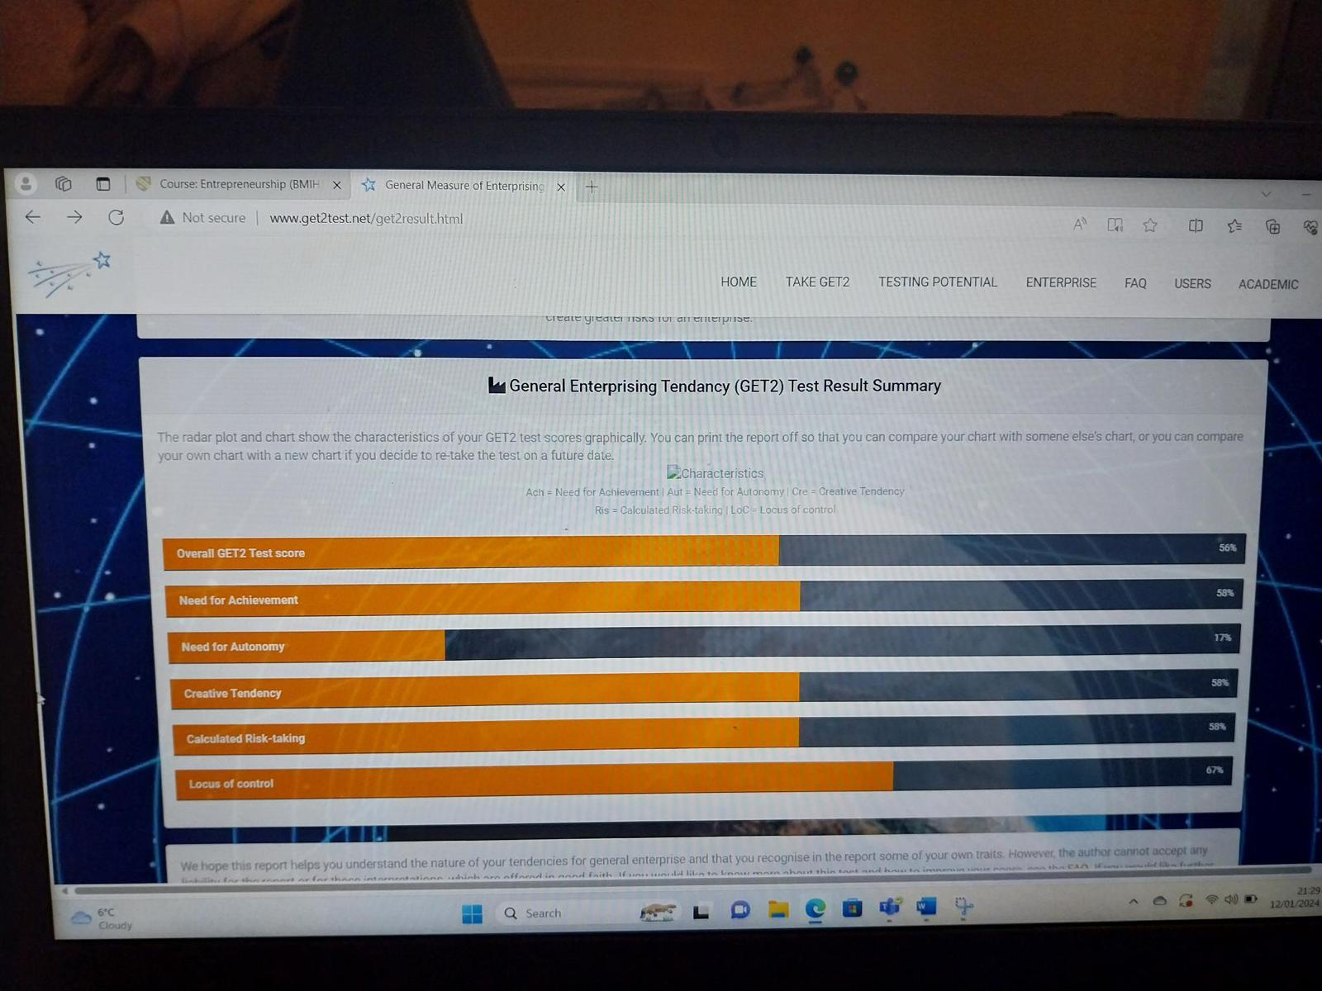

Appendix 2 - (BUSINESS MODEL CANVAS)


