DS 1 Template

My Screenshots/Photos
- Please add 4–6 screenshots or photos of your digital life.
- You can use your phone or laptop.
- For each screenshot, write one or two sentences explaining what it shows.

Screenshot/Photo 1
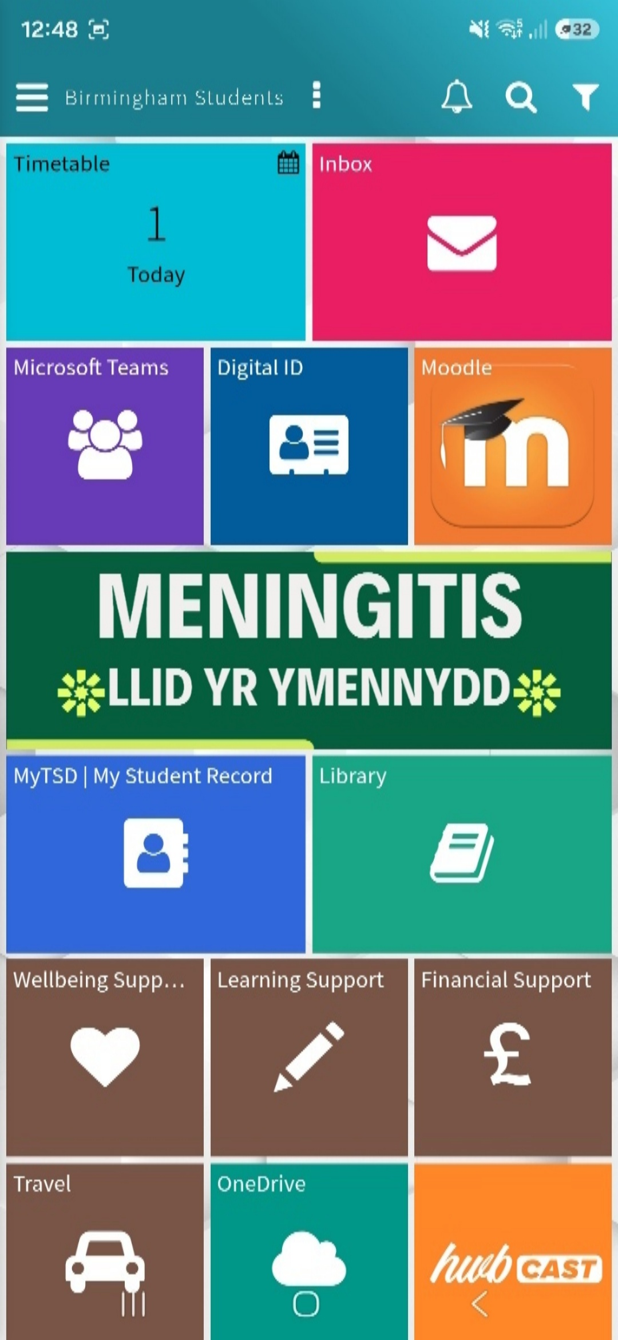

This screenshot shows the UWTSD student app that I use for my studies. I use it to access my timetable, Moodle, Microsoft Teams, emails and other university services

Screenshot/Photo 2
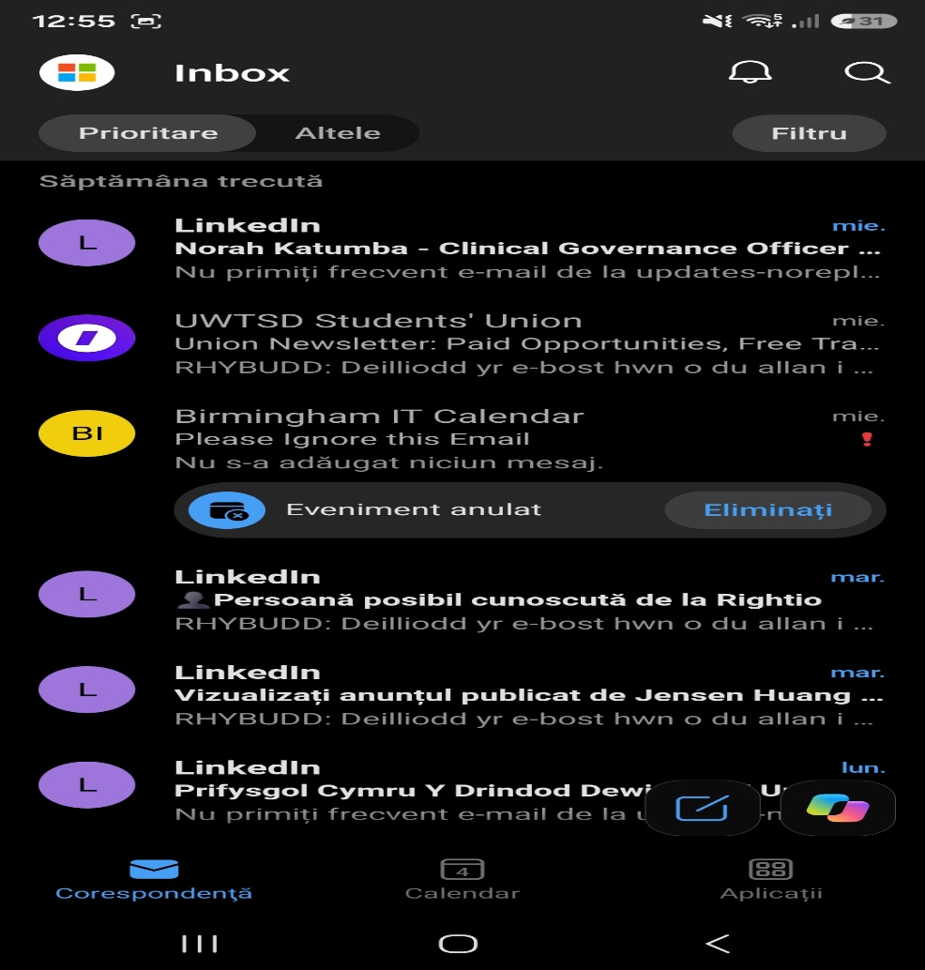
This screenshot shows my Outlook inbox. I use email to receive important university messages, updates and information about my studies.

Screenshot/Photo 3
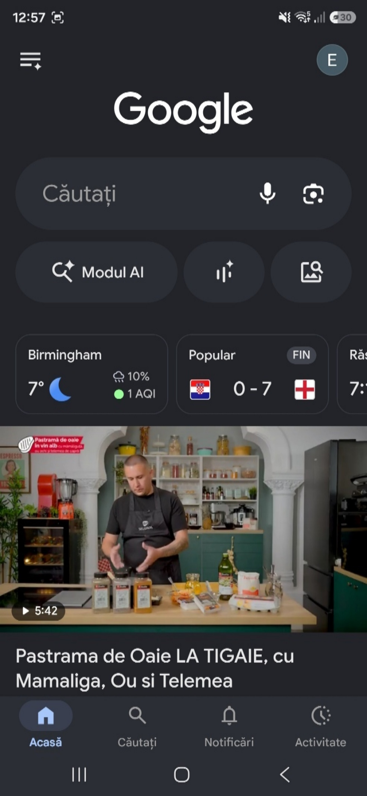
This screenshot shows Google on my phone. I use it every day to search for information and to help me with my studies.

Screenshot/Photo 4
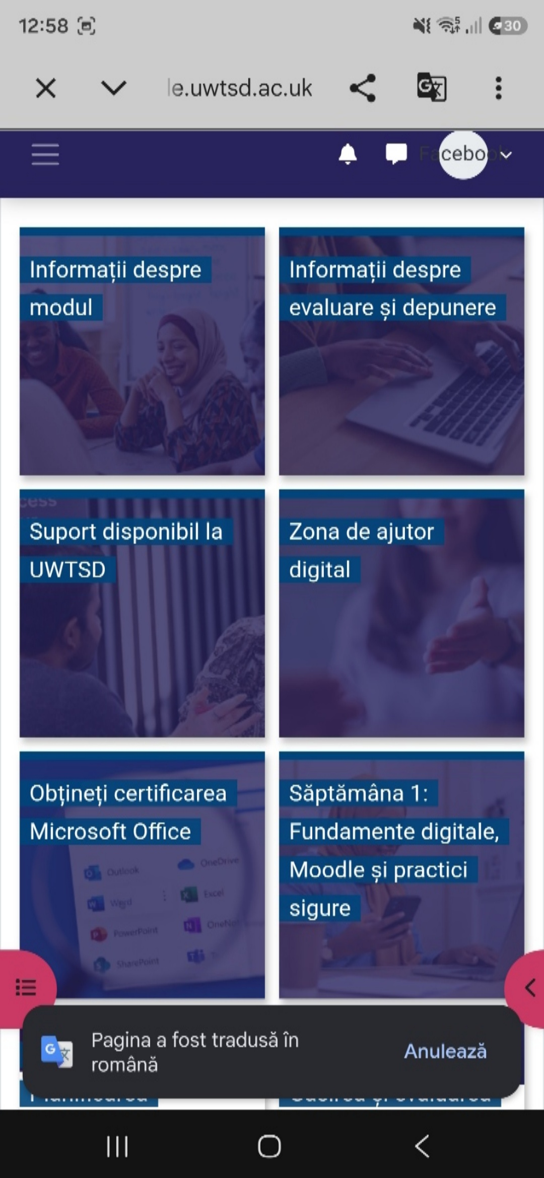
This screenshot shows my UWTSD Moodle page. I use Moodle to access my course materials, assessments and study support.

Screenshot/Photo 5
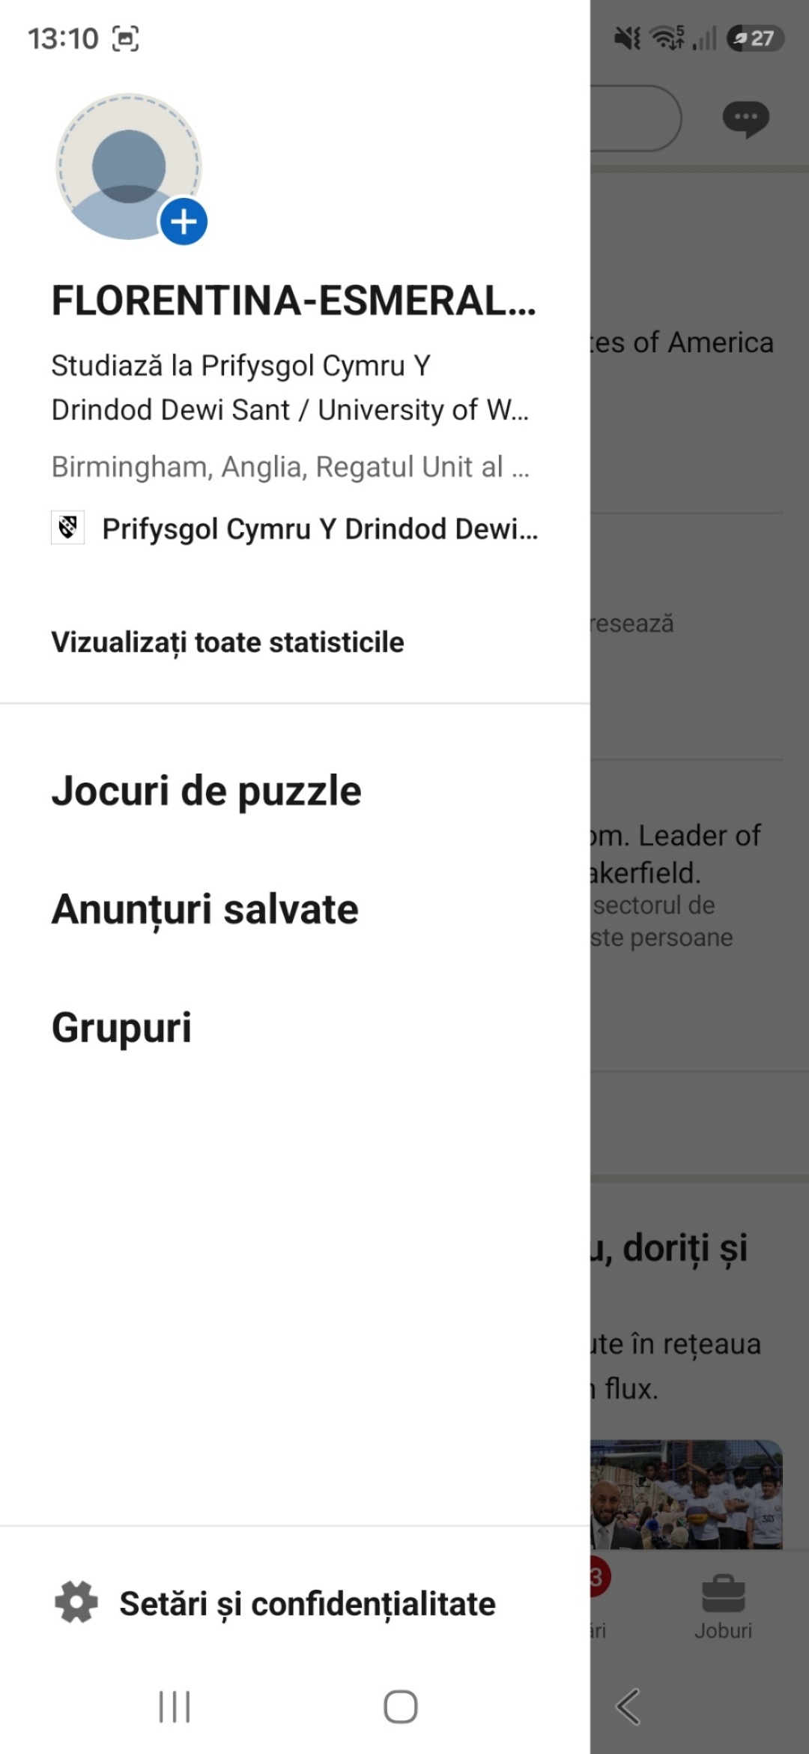
This screenshot shows my LinkedIn profile. I use LinkedIn to build my professional profile, connect with people and explore career opportunities.

Screenshot/Photo 6
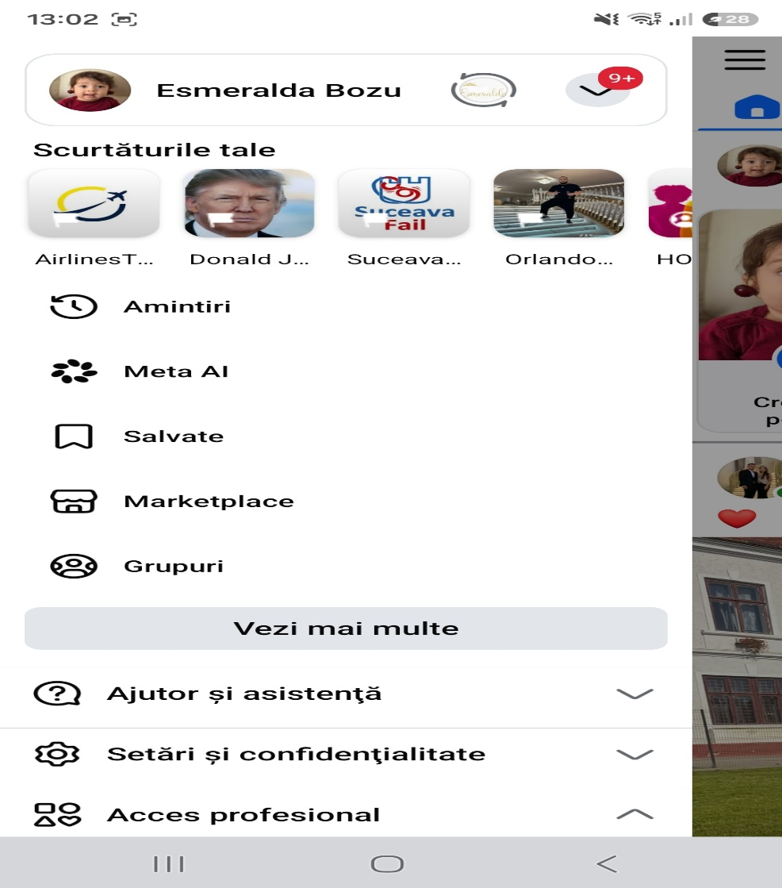
This screenshot shows Facebook on my phone. I use it to communicate with friends and family and to stay connected with other people.

My Short Reflection
- Write 5–8 simple sentences about your digital life.
- You can use the sentence starters below if helpful.
I use my phone every day.
I use Google to find information.
I use Moodle for my studies.
I use Outlook to read my emails.
I use social media to talk to people.
I want to improve my digital skills.
- Digital skills are important for my future

Sentence starters
- I use digital tools to …
- I feel confident when I …
- I want to improve …
- I often use these tools: …
- I sometimes feel nervous about …
- I hope this module will help me …
- Digital skills are important for me because …
You can write more if you want.

Submission Checklist
Before you submit, please check:
​​​ ☒ I added 4–6 screenshots
☒ I wrote short sentences for each screenshot
☒ I wrote my short reflection
☒ My work is my own
☒ My file opens correctly
​​☒ My file opens correctly

