

History and Theory – Landesgartenschnau.

School of Architecture, Built and Natural Environment
Course: BSc Architecture

Name: Riham Ghaleb
Student Number: 2204330
Module code: ACAA5003
Word count: 2424
Date: 01/04/2025

Contents

Introduction. 2
Chapter 1. 4
Chapter 2. 5
Chapter 3. 6
Conclusion. 6
Reference List: 8
Bibliography: 10

List of Figures.
Figure 1, Image of The Peak Concept Art, Hong Kong, by Zaha Hadid. (Adapted from ZHA, 1982). | 3
Figure 2, Image of Cardiff Opera House Model, by Zaha Hadid. (Adapted from ZHA, 1996). | 4
Figure 3, Image of Landesgartenschnau, Germany, by Zaha Hadid. (Adapted from ZHA, n.d.). | 5
Figure 4, Image of Heydar Aliyev Centre, Azerbaijan, by Zaha Hadid. (Adapted from ZHA, 2012). | 6
Figure 5, Image of Investcorp Building, Oxford, by Zaha Hadid. (Adapted from Hayes, L., NAARO, 2016). | 7
Figure 6, Image of Investcorp Building, Oxford, by Zaha Hadid. (Adapted from Hayes, L., NAARO, 2016). | 8
Figure 7, Image of Landesgartenschnau, Germany, by Zaha Hadid. (Adapted from ZHA,1997). | 9
Figure 8, Image of Landesgartenschnau, Germany, by Zaha Hadid. (Adapted from ZHA, n.d.). | 10
Figure 9, Image of Landesgartenschnau painting, Germany, by Zaha Hadid. (Adapted from ZHA,1997). | 12

Introduction.
Who is Zaha Hadid?
Zaha Hadid was a world-renowned architect whose influence on contemporary architecture and design innovation remains extremely relevant today. Born in 1950 in Baghdad, Iraq, moving through schools from Iraq to Switzerland, and growing to study mathematics at the American University of Beirut, Hadid always had an interest in travelling, learning, and eventually creation. These interests led to her exciting transition into enrolling at London’s Architectural Association in 1972. An exciting time for her to study architecture when a new direction of postmodernism and deconstructing modernist styles had skyrocketed, Hadid graduated in 1977 and was swiftly invited by Koolhaas and Zenghelis to be a business partner, although she left soon after. Hadid was described to be in her own orbit creatively, ultimately leading to the creation of her own business to explore this creativity, which will be discussed further in the essay. (Hopkins, O. 2016. p.114, p.115). Being labelled as the “Queen of the Curve”, Hadid used grandeur, sweeping curves and unusual geometric forms in several of her unique, innovative designs, which eventually led to her legendary status further into her career, and even still in the current day conversation (Link, J. 2021). Hadid’s futuristic and intense style featuring sharp forms, curved facades and brutalist materials (Rethinking The Future, 2022)., had set her apart from other architects at the time of her firm’s opening in 1979 (ZHA, 2016), and in turn gained her a status of prestige and recognition. Key moments of Hadid’s career that immensely elevated her status include the proposed leisure club design in Hong Kong, “The Peak”, which she had won a competition for in 1982 (Pes, J. 2017). This design brought Hadid international attention for the dynamic, dramatic style she presented while maintaining an element of natural form within the design through the various materials scattered on site in a geological, rock-like manner, adjacent to a mountainous landscape. (Serrazanetti, F. Matteo, S. 2017. p.24).

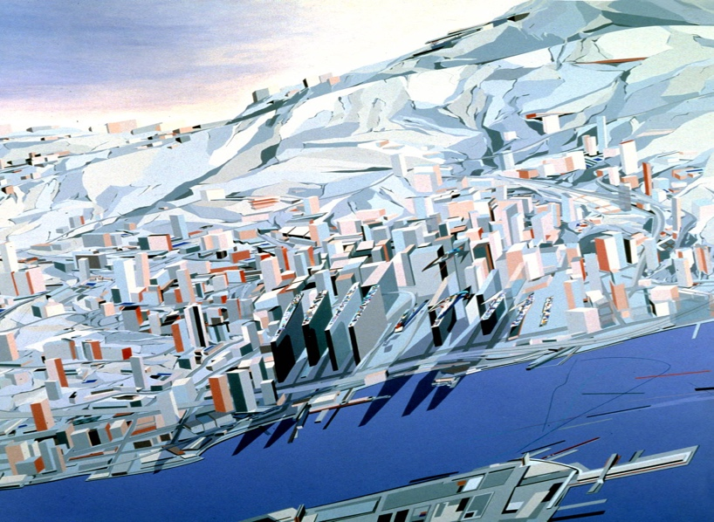
Figure 1, Image of The Peak Concept Art, Hong Kong, by Zaha Hadid. (Adapted from ZHA, 1982).

This recognition most certainly elevated her career very early on. Moreover, the centre never actually being built also raised several questions, which in turn brought more attention to her and her work. This is not the only time Hadid’s work had won a competition but ultimately was not followed through, as her proposed idea for an Opera House in Cardiff Bay was also eventually rejected after winning a competition, resulting in the construction of the Wales Millennium Centre instead (Bottoms, J. 2024). This controversy similarly garnered great attention to her work in 1994 and brought her name into many more conversations regarding gender, race, and status in architecture. Moreover, Zaha Hadid became the first woman to win the Pritzker Architecture Prize, skyrocketing her already rapidly growing fame and success (Broome, A. 2024).

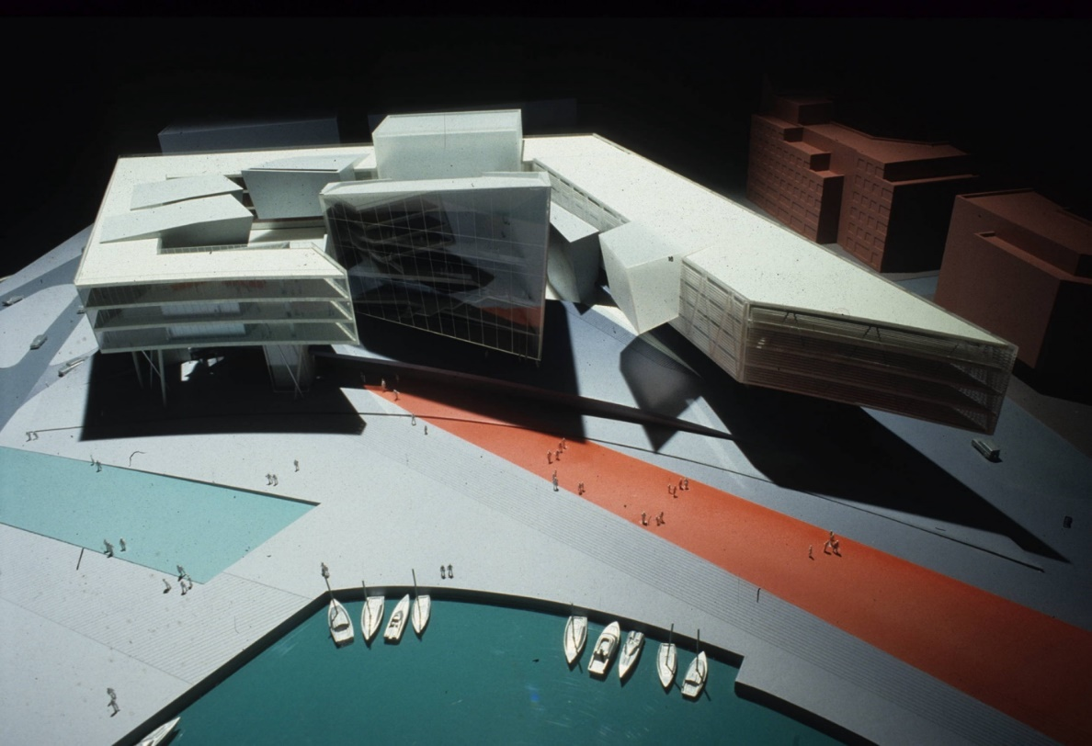
Figure 2, Image of Cardiff Opera House Model, by Zaha Hadid. (Adapted from ZHA, 1996).

Landesgartenschnau, otherwise known as “Landscape Formation One”, is an important building designed and constructed in the late 90’s during the postmodernist movement in Weil am Rhein, Germany (Betsky, A. 1998. p. 151). Designed by Zaha Hadid in 1997 and completed in 1999, the Landesgartenschnau was designed to be an exhibition pavilion for an international garden show held on Vitra Campus in Germany (Thames & Hudson, Betsky, 2017, p.89). The building aimed to incorporate free form, fluidity and smoothness into the design while remaining true to the natural forms the structure is inspired by, such as rivers, forests, mountains and canyons. This was a way to metaphorically portray the usage of the building while remaining visually subtle and tastefully executed. The buildings style takes inspiration from deconstructivism, and postmodernist works by challenging the traditional forms of architecture and designing using geometry, dynamic shapes and free-form lines. This essay will divulge into the Landesgartenschnau, and critically analyse the form, architectural significance, usage, and landscape of the project.

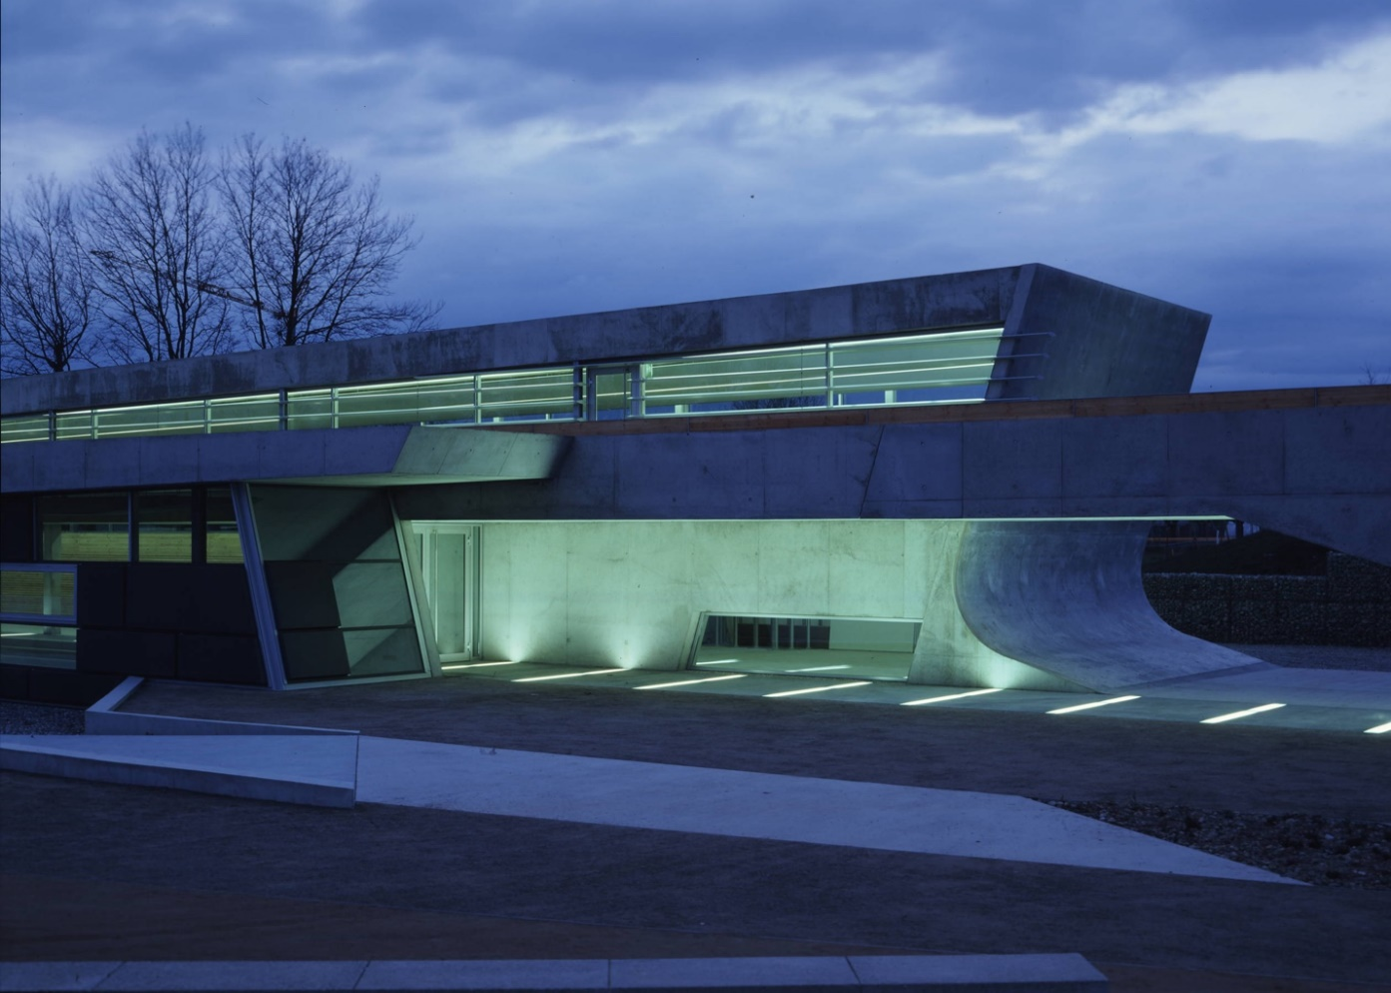
Figure 3, Image of Landesgartenschnau, Germany, by Zaha Hadid. (Adapted from ZHA, n.d.).

Chapter 1.
Previous Works.
Before the discussion of the Landesgartenschnau building, also known as Landscape Formation One, it is important to recognise a few other prolific Zaha Hadid works in order to have a firmer grasp on her style and prominence. One of Hadid’s most famous works, and arguably her most recognisable, is The Heydar Aliyev Centre in Baku, Azerbaijan. Constructed in 2007 and opened in 2012, this building complex covers an area of 57,000m² (ZHA, 2012), a height of 74m (Okraji, N. 2018), however despite the structures incredibly large size, the mixed-use centre manages to sit beautifully on the site without any sort of overwhelming visual imposition.

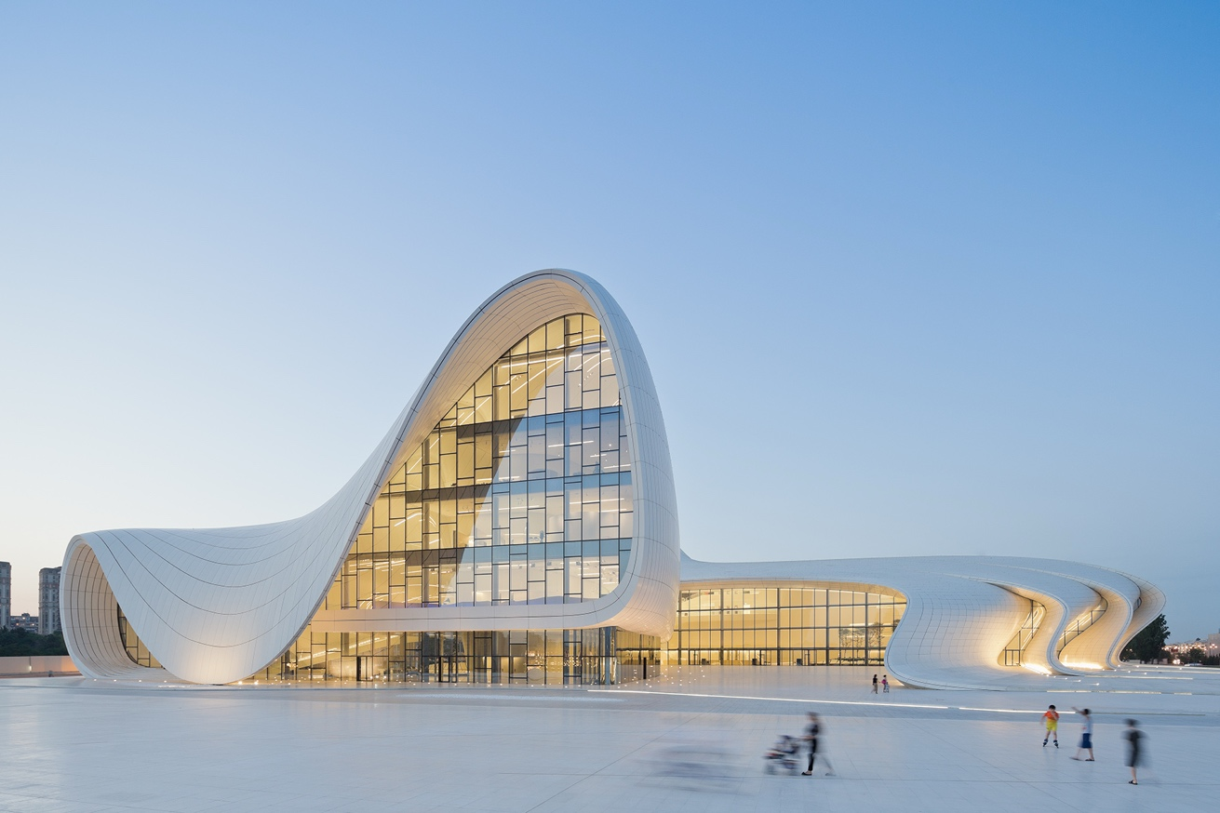
Figure 4, Image of Heydar Aliyev Centre, Azerbaijan, by Zaha Hadid. (Adapted from ZHA, 2012).

Due to the simple, sleek materials of reinforced concrete, steel frame structure and monolithic cladding (Czarnowska-Pazdur, A. 2025), the structure has an airy and light ambience to it which is only elevated by the large glazing which allows a significant amount of natural sunlight in. All these elements contribute to the delicacy the centre holds, allowing it to blend nicely with its environment. Moreover, the futuristic curves, intense yet feminine geometry and technology-based aesthetic of the building further leans into the unique, innovative style that Hadid possessed, while maintaining its spatial awareness by appearing to curve from the ground out into a structure, truly embedding itself into the site (Frearson, A. 2013). To continue, another impressive piece of Hadid’s work is her Investcorp Tunnel, an extension to St Antony’s college’s Middle East Centre, located in Oxford, England. The 1,200m² tunnel cost £11 million to build, and is situated directly next to the existing Victorian-style library (Frearson, A. 2015), creating an intense juxtaposition that is impossible to miss.

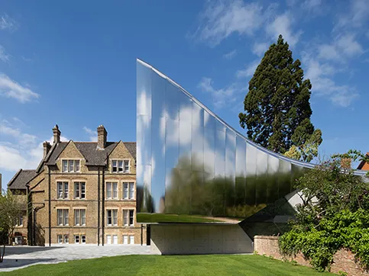
Figure 5, Image of Investcorp Building, Oxford, by Zaha Hadid. (Adapted from Hayes, L., NAARO, 2016).

The tunnel demonstrates a flashy, large, modern silhouette that sits proudly on the site. The thorough glass cladding has a reflective, mirror-like effect which further leans into the futuristic characteristics of Hadid’s style. Moreover, the mirrored exterior allows for the surrounding site to be beautifully reflected onto the tunnels cladding, resulting in a very innovative and positively unusual facade which almost looks like an edited image of the site, embedding itself further into the landscape. This is very clearly a Zaha Hadid building, with all her ultra-modern, recognisable traits on display, while also demonstrating her iconic curvature and feminine architecture in terms of form and beauty. The Investcorp tunnel was one of Zaha Hadid’s last buildings, before her untimely death in 2016 (Davies, C., et al. 2016), adding an extra layer of significance to it on top of the already meaningful link of the Middle East Centre being designed by a renowned and proudly Middle Eastern architect.

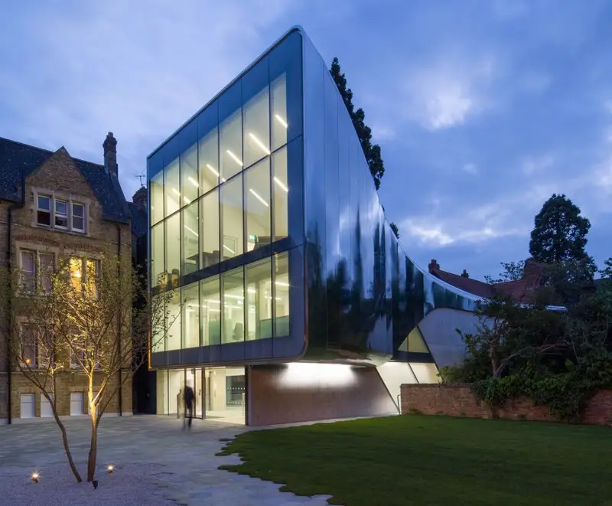
Figure 6, Image of Investcorp Building, Oxford, by Zaha Hadid. (Adapted from Hayes, L., NAARO, 2016).

Chapter 2.
About Landesgartenschnau.
As previously mentioned, the Landesgartenschnau is located in the Vitra Campus in Weil am Rhein, Germany, a famous site for other renowned architectural works by the likes of Frank Gehry, Herzog & de Meuron, SANAA, Tadao Andao and others (VDM, 2024). The building exemplifies her radical work style and is a clear example of postmodernism, specifically deconstructivism, as it opposes the more widely accepted principles of architecture such as simplicity and reservation, with sharp forms and flamboyant figures. The client, The State Garden Exhibition organisation, formed this project and requested a pavilion which demonstrated innovative and interesting architecture while remaining intertwined with its site.

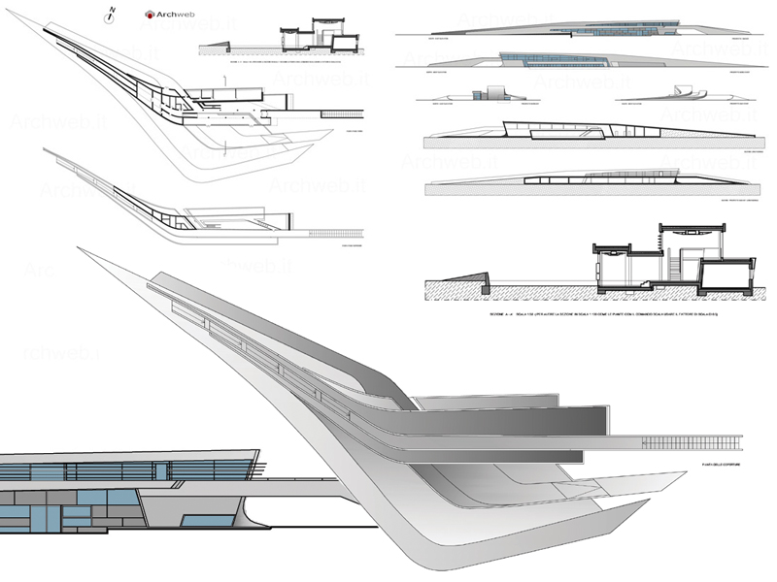
Figure 7, Image of Landesgartenschnau, Germany, by Zaha Hadid. (Adapted from ZHA,1997).

The Landesgartenschnau building is approximately 140 metres long with an area of 845m², following a large curve that begins at the North of the site across to the South (MCH, 2010). The large sweeping curve expresses Hadid's design philosophy gracefully as the structures form is entirely fluid and organic, naturally emerging from the landscape it is upon and blending in seamlessly in regard to its form, contrasting the minimalist, eye-catching materials of primarily concrete and glass which stand out visually. The roof of the structure is partially green, partially gravel covered (ArchWeb, 2010), creating a further sense of natural form, as it gives the appearance of the building physically growing out from the terrain it is situated on and taking some of that environment with it. To add to this, the structure specifically intended to mimic its natural surroundings and environment (Singhal, S. 2012), rather than simply existing alongside any other buildings, again battling the connotation that buildings should be an isolated entity. Furthermore, Hadid was also rejecting the principle that buildings must be visually identical with one another to avoid clashing or standing out, instead encouraging the design of buildings that are harmonious with the natural elements and topography it is laid upon. The landscape of the site is immensely important to this project, as the design is entirely dedicated to appearing as though it is emerging from the ground, similar to the Heydar Aliyev Centre, as previously discussed. This was achieved by ensuring the entire design was a direct response to the site and its topography (Varady, S. 2004. p.85). The 140m span of the building directly mirrors the sweeping curves of the terrain and merges the structure with the gently curved landscape it is inspired by.

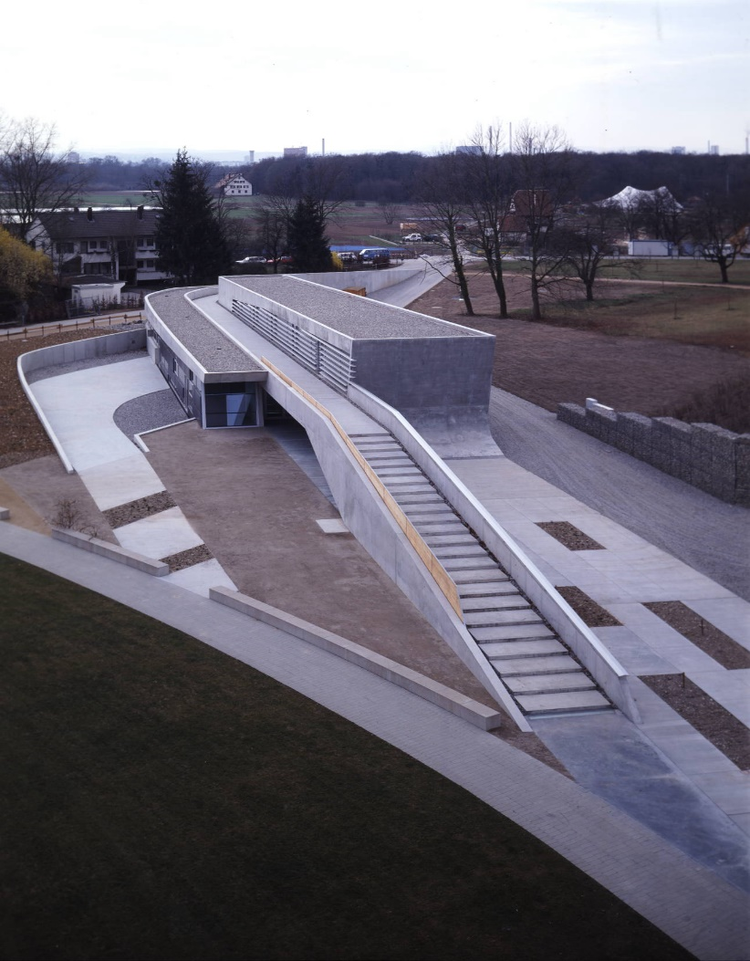
Figure 8, Image of Landesgartenschnau, Germany, by Zaha Hadid. (Adapted from ZHA, n.d.).

The design also features pathways that smoothly weave in, around, and on top of the building (Varandy, S. 2016), successfully intertwining the pedestrian passageways into and around the structure, causing much more organic and fluid walking routes, and creating a free, open and engaging circulation (Archiweb, 2007). This decision also allows for much more exploration and socialisation to occur as it pivots from the inherited need to keep everyone on a uniform, singular route and instead encourages movement and observation, once again mirroring its organic environment. Furthermore, this link between the environment, landscape and nature often links to much of Hadid's work, in which she aims to translate these organic forms into her style regularly, as seen with her iconic curves and fluidity (Schumacher, P. 2004). This is not the only form of nature Hadid exhibits in the Landesgartenschau building, such as the large quantity of glass embedded throughout the building which allows natural light into the structure while also offering wide, uninterrupted views of the outdoors from any users inside the building (Kasdan, B. 2016). This relationship that is formed between the interior and exterior of the building is deliberate to create an extra sense of nature within the structure. Moreover, the building also demonstrates a commitment to the environment and the ecology of the site as it has since become the space used by the Trinational Environmental Center (TRUZ), an environmental organisation based in Germany which strive to promote environmental awareness and education in and around it's area (TRUZ, 2001).

Chapter 3.
Impact on Surroundings.
The Landesgartenschau building also has a particular impact on its surroundings architecture. Being situated in the Vitra Campus of Weil am Rhein reflects the building's purpose and sense of familiarity with its surroundings due to most of the region's architecture being known for its avant-garde and eccentric style. The Land does not impose onto the site in an aggressive, stand-out manner, nor does it quietly blend into the background of its site. It proudly sits and presents itself clearly amongst its surroundings and has unique features that bring it out instead, such as its embedded landscape and free form, and it does so in a confident manner. Moreover, the building is also not an isolated, stand-alone structure, which Hadid was adamant on avoiding. It integrates itself into its landscape in an unconventional, innovative way, almost as though it is an extended piece of the terrain. This sense of extension is common in Hadid's work, as previously mentioned with the Heydar Centre, and the Landesgartenschau is no exception. The boundaries of built structure and naturally occurring terrain is blurred by the design and does so successfully. Moreover, its presence in the Vitra Campus of Weil am Rhein remains prolific to this day, further exemplifying the success the building and the ultimate goal to integrate seamlessly into its landscape.

Conclusion.
Final Thoughts.
In conclusion, the Landesgartenschnau is an extremely unique building that definitively holds more significance than possibly meets the eye. The carefully designed form which is specific to the site's topography and the successfully executed intention to mirror the terrain the building sits on was very deeply thought out and adds a truly organic element to the architecture. In addition, the usage of humble, brutalist materials such as concrete and exposed steel frames further impose a feeling of quietness, in comparison to a heavy portion of her architecture, such as the Investcorp building, which is very flashy and shimmery (Frearson, A. 2015), especially in its material usage rather than its form necessarily. Furthermore, the addition of greenery and gravel on the roof of the structure further embeds itself into the nature of the site, truly representing itself as one with the ground and natural earth beneath the structure. The intertwining, non-linear pathways also rectify the same idea of appreciating the surrounding environment, while demonstrating another important objective of the building, which is to create a sense of community and to allow free movement. The fluidity of the paths allowing for more interaction with the building, the interior and exterior, the site and even with other people around it, is all meaningful and links perfectly to the usage of the building. These elements create a certain peaceful atmosphere in and around the building and is a perfect environment for an environmental event to take place. Overall, the Landesgartenschnau is an undeniably iconic and recognisable piece of architecture which successfully executed its original purpose and has progressed onto providing a further purpose in its future, regarding its current use as an environmental organisation's headquarters. The deconstructivism of the building is entirely due to the post-modernist movement that took place in the 1970’s, as most of Hadid’s work followed, and proudly challenges the norms of architecture. These expected principles include simplicity, modernity and quietness of a building, while attempting to blend in seamlessly with the environment in order to not stand out or impose on the site. Although this style of architecture is not necessarily unideal, the postmodernist movement shattering this established a new sense of self-awareness and radicalism surrounding style (VAM, 2012), and Zaha Hadid’s work very much so portrays this in the Landesgartenschnau building.

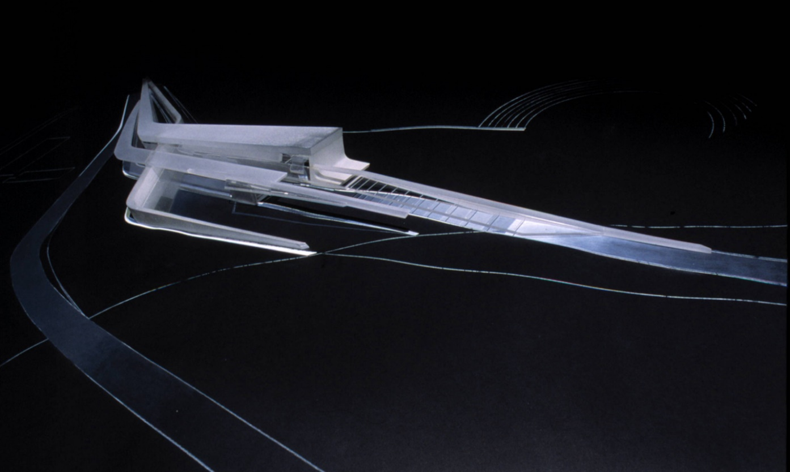
Figure 9, Image of Landesgartenschnau painting, Germany, by Zaha Hadid. (Adapted from ZHA,1997).

Reference List:
Archdaily, (2015). The Investcorp Building. https://www.archdaily.com/636998/the-investcorp-building-zaha-hadid-architects (Accessed 31/03/25).
Archello, (n.d.). Stimluating Concrete. https://archello.com/project/phaeno-science-center-wolfsburg?utm_ (Accessed 29/03/25).
Archiweb. (n.d.). Landscape Formation One. https://www.archiweb.cz/en/b/landscape-formation-one?utm_ (Accessed 31/03/25).
Archweb, (2016). LF1 Landesgartenschau. https://www.archweb.com/en/architettures/lf1landesgartenschau/#:~:text=The%20building%20occupies%20845%20square,Hadid%20Architects%20without%20any%20competition (Accessed 29/03/25).
Betsky, A., (1998) The Complete Buildings and Projects. p.151.
Betsky, A., Thames & Hudson., (2017). THE COMPLETE ZAHA HADID EXPANDED AND UPDATED. pp.114-115.
Bottoms, J., (2024). Wales Millennium Centre/s controversial history 20 years on. https://www.southwalesargus.co.uk/news/24236816.wales-millennium-centres-controversial-history-20-years/ (Accessed 28/03/25).
Broome, A., (2024). 20 years: Architect Zaha Hadid becomes the first female recipient of the Pritzker Prize. https://britishonlinearchives.com/posts/category/notable-days/745/20-years-architect-zaha-hadid-becomes-the-first-female-recipient-of-the-pritzker-prize (Accessed 29/03/25).
CityHunt, (2025). Landscape Formation One. https://www.mycityhunt.com/cities/weil-am-rhein-de-4837/poi/landscape-formation-one-11177?utm_ (Accessed 31/03/25).
Czarnowska-Pazdur, A., (2025). Ecological Properties of Glass Fibre Reinforced Materials Based on Architecture of Zaha Hadid. p.6. https://iopscience.iop.org/article/10.1088/1757-899X/471/8/082054/pdf#:~:text=The%20main%20structure%20of%20the,and%20composite%20beams%20and%20decks. (Accessed 31/03/25).
Frearson, A., (2013). Heydar Aliyev Centre – by Zaha Hadid Architects. https://www.dezeen.com/2013/07/11/heydar-aliyev-centre-by-zaha-hadid-architects/ (Accessed 31/03/25).
Hidden Architecture., (n.d.). The Peak Leisure Club. https://hiddenarchitecture.net/the-peak-leisure-club/ (Accessed 28/03/25).
Hopkins, O., (2016) Breaking the Mould of British Architecture. MAVERICKS. p.113-115.
Kasdan, B., (2016). Zaha Hadid... https://medium.com/%40BKasdan/zaha-hadid-31406a30a641 (Accessed 31/03/25).
Link, J., (2021). Zaha Hadid, architecture’s “Queen of Curves”. https://www.autodesk.com/design-make/articles/architect-zaha-hadid?utm_ (Accessed 28/03/25).
Pes, J., (2017). How a design for Hong Kong launched Zaha Hadid’s career. https://www.theartnewspaper.com/2017/02/01/how-a-design-for-hong-kong-launched-zaha-hadids-career (Accessed 28/03/25).
Pritzker Prize., (2016). Biography: Zaha Hadid. https://www.pritzkerprize.com/biography-zaha-hadid#:~:text=She%20moved%20to%20London%20in%201972%20to,joined%20the%20Office%20of%20Metropolitan%20Architecture%20(OMA).&text=She%20began%20her%20own%20practice%20in%20London,a%20leisure%20and%20recreational%20center%20in%201983. (Accessed 28/03/25).
Rethinking The Future, (2022). Zaha Hadid Architects: 30 Projects That Define Zaha Hadid’s Style. https://www.re-thinkingthefuture.com/top-architects/a295-30-projects-that-define-zaha-hadids-style/ (Accessed 29/03/25).
Schumacker, P., (2004). Digital Hadid: Landscape in Motion. https://patrikschumacher.com/digital-hadid-landscapes-in-motion/?utm_ (Accessed 31/03/25).
Serrazanetti, F.,Matteo, S., (2017). ZAHA HADID Inspiration and Process in Architecture. p.24.
Singhal, S., (2012). Landesgartenschau in Weil am Rhein, Germany by Zaha Hadid Architects https://www10.aeccafe.com/blogs/arch-showcase/2012/02/22/landesgartenschau-in-weil-am-rhein-germany-by-zaha-hadid-architects/?utm_ (Accessed 31/03/25).
TRUZ. (n.d.) Der Fachbereich Grenzüberschreitender Naturschutz https://www.truz-naturschutz.org/ (Accessed 31/03/25).
VAM. (2014). What is Postmodernism? https://www.vam.ac.uk/articles/what-is-postmodernism#:~:text=Postmodernism%20had%20begun%20as%20a,%2C%20the%20'designer%20decade'. (Accessed 31/03/25).
Varady, S., (2004). Sweep. The article titled "In Zaha Hadid's Landesgartenschau building a new expression" Architectural Review (Issue 68). https://stephenvaradyarchitraveller.com/wp-content/uploads/2018/02/lf1-by-zaha-hadid-ar-68-review-by-stephen-varady.pdf (Accessed 31/03/25).
Varady, S., (2016). Weil am Rhein: LF1 (Germany). https://stephenvaradyarchitraveller.com/2018/02/04/weil-am-rhein-lf1-germany/ (Accessed 31/03/25).
Zaha Hadid Architects, (2012). Heydar Aliyev Centre. https://www.zaha-hadid.com/architecture/heydar-aliyev-centre/ (Accessed 31/03/25).
Zaha Hadid Architects, (2016). Zaha Hadid (1950-2016). https://www.zaha-hadid.com/people/zaha-hadid/#:~:text=She%20founded%20Zaha%20Hadid%20Architects,was%20not%20her%20modus%20operandi (Accessed 29/03/25).
Zaha Hadid Architects, (2025). Cardiff Bay Opera House. https://www.zaha-hadid.com/architecture/cardiff-bay-opera-house/ (Accessed 31/03/25).
Zaha Hadid Architects, (2025). Landesgartenschnau/Landscape Formation One. https://www.zaha-hadid.com/architecture/landesgardenschau-landscape-formation-one/ (Accessed 31/03/25).
Zaha Hadid Architects, (2025). The Peak Leisure Club. https://www.zaha-hadid.com/architecture/the-peak-leisure-club/ (Accessed 31/03/25).

Bibliography:
Farrell, T., Furman, A,N., (2017). Revisiting Postmodernism.
McClean, V., et al., (2018). Zaha Hadid Architects Evolution.
Pritzker Prize., (n.d.). Zaha Hadid. https://www.pritzkerprize.com/laureates/2004?utm_ (Accessed 28/03/25).
Solomon, R., (2006). ZAHA HADID.
Vitra Design Museum, (2025). Vitra Campus. https://www.design-museum.de/en/information/vitra-campus.html?desktop=306& (Accessed 28/03/25).
Weston, R., (2011). 100 Ideas that Changed Architecture.

