Task 1: Locating Sources
Identify and locate three different sources (a report, a journal article, and a website) related to the question
“What employability skills do business graduates need to succeed in the modern workplace?”
Show how you used keywords, search terms, and Boolean operators to find them, and explain how you know which type of source each one is and why it is appropriate for the research question.

Source Type & Why It Is Appropriate | URL/DOI | What search engine did you use? Google/Online Library/Library AI Assistant | Keywords/Boolean Operators Used
Article that is peer rreviewed. | https://librarysearch.uwtsd.ac.uk/permalink/44WHELF_UWTSD/1bmis16/cdi_doaj_primary_oai_doaj_org_article_2fcd3a7b3b3b4b3dae8350f58af054b4 | University library. | Employability skills in the modern workplace.  Business graduates.

Task 2: Evaluating Information (CRAAP Test)
Your colleague has forwarded you a source from a peer reviewed journal, and they are not sure whether it is appropriate to use and has asked for your help. Your task is to evaluate the source by using the CRAAP Test to assess its appropriateness.
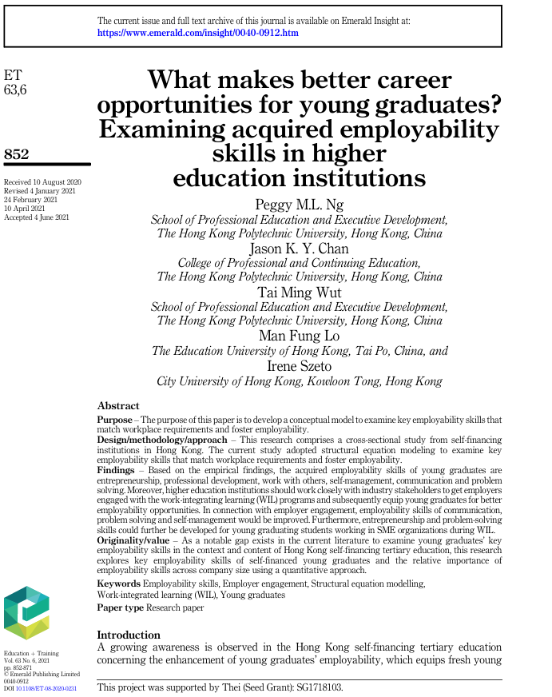

CRAAP Test
Currency | The article was accepted on the 4 June 2021.
Relevance | The current article studies the structural equation of key employability stills that match the workplace requirements.
Authority | M.L. Ng,P., Chan,J., Wut,T.,Tunglo,M. and Szeto,I..
Accuracy | The article it is peer reviewed.
Purpose | The articles purpose it is to develop a conceptual model to examine the key employability skills that will match with the moderns workplace and will help future graduates to foster better skills for employability market.

Task 3: Source Analysis
Your manager has provided you with a short extract from a source and has asked you to analyse the source by Identifying one strength, one weakness, and providing a brief explanation of the strength and weakness identified.
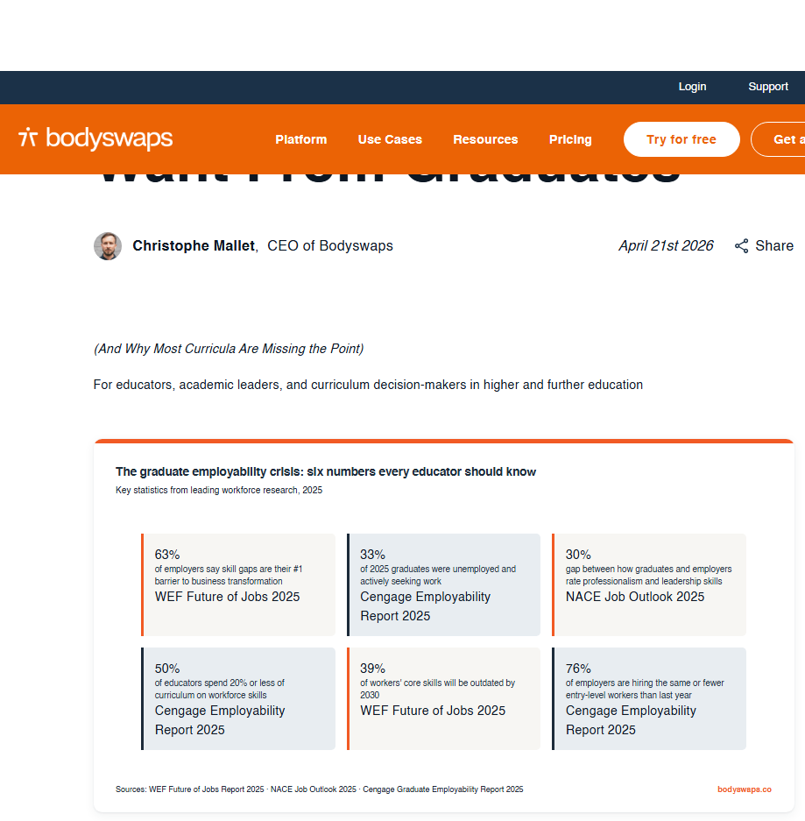
.

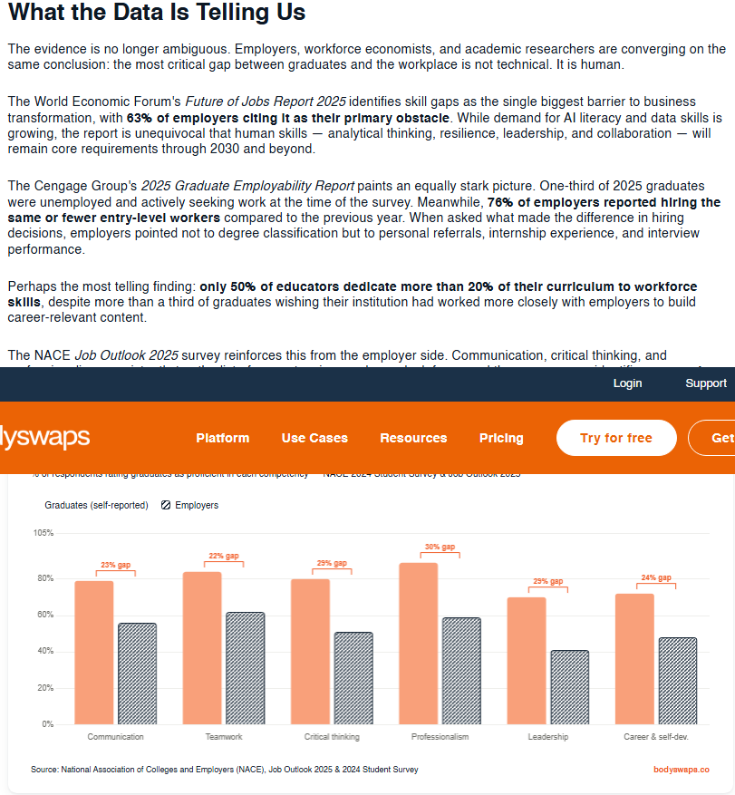

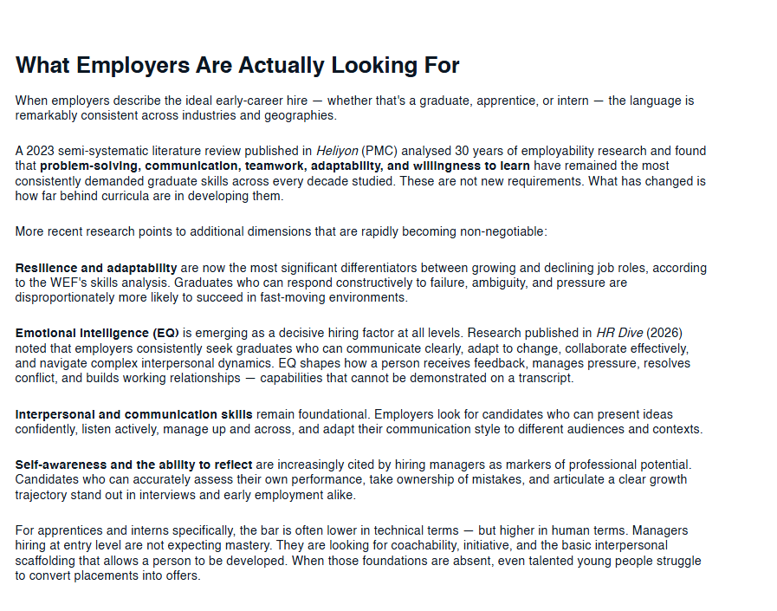

Please click the link, if you wish to read the article online.
What Employers Actually Want From Graduates

Strength of the Source: We have the date in that supports the article and that will show us the actual issue that we are dealing with( human).
The date it is supported by the numbers( 63% of the employers).the article shows that the primary shills are still important like problem solving, communication, team work adaptability and willingness to learn.

Weakness of the Source: The article

